In-vitro combined treatments of cypermethrin and ultraviolet irradiation in rat lymphocytes culture

Mohamed A. Noaishi*

*Mammalian Toxicology Department, Central Agricultural Pesticides Lab. (CAPL), Agricultural Research Center, Ministry of Agriculture, Egypt.

noaishi@gmail.com

Abstract: The present study was undertaken to evaluate the effect of UV-irradiation to increase the mutagenic effect of synthetic pyrethroid insecticide, cypermethrin. The study was performed in rat lymphocyte cultures to investigate the mutagenic effect of this irradiation. The chromosomal aberrations (CAs) assay has been used to evaluate the genotoxicity of these treatments. Artificial UV irradiation at 254nm was used. The exposure periods were 60 and 120 min as short and long exposure times and the UV-lamb was switched off for 1min at each 5min of exposure. Two concentrations level of commercial cypermethrin (cyperko® 20% EC) were used. The treatments were performed as individual of cypermethrin or UV-irradiation exposure and in combination between them. Results of our study revealed that the individual treatment of cypermethrin showed slight significant increase (p <0.05) at low concentration dose 10µg/ml and highly significant (p <0.001) at high concentration dose 20µg/ml. The individual exposure to UV-irradiation showed significant increase (p <0.05) only at long exposure time. Furthermore the results of combined exposure between cypermethrin UV-irradiation made synergistic action effect that obvious at low dose 10µg/ml of cypermethrin with UV-irradiation (60 min) induced significant increase (p <0.01) than their effects of each alone. More addition the combination at high dose 20µg/ml and long exposure time (120 min) induced highly significant increase (p <0.001). It could be concluded that the confirmation of well known effects of UV-radiation in DNA damage and the concentration of cypermethrin that are low genotoxic in individual treatment can cause harmful mutagenic effect when combined with exposure to UV-radiation. So, the workers or farmers, working all time in the open field and subjected to sun light and exposed to the pesticides contamination may be at high risk if they are not protected by safety measures when exposure to these combined mutagens.

[Mohamed A. Noaishi. In-vitro combined treatments of cypermethrin and ultraviolet irradiation in rat lymphocytes culture. New York Science Journal 2013;6(7):13-18]. (ISSN: 1554-0200). http://www.sciencepub.net/newyork.

Keyword: Ultraviolet, irradiation, cypermethrin, lymphocytes, rat, chromosomal aberrations.

1. Introduction
Many pesticides have been tested for mutagenicity by a variety of in vitro and in vivo assays, while testing for genotoxicity is usually performed on single agent, either chemical or physical agent but exposure of humans often involves combinations of agents (Stopper and Lutz, 2002). At the present time, our knowledge of biological interaction is incomplete. Therefore, a variety of experimental studies are necessary to assess health risk from exposure to combination of environmental agents (Sexton and Hattis, 2006). Experimental work and biological monitoring provide useful tools to estimate the genetic risk deriving from an integrated exposure to a complex mixture of chemical and physical agents (Bolognesi, 2003). One of these physical agents is the light coming from the sun which is a magical source of energy for us, but the cumulative effects of sunlight exposure put us at higher risk of cellular damage e.g. early wrinkling, age spots, actinic keratoses, and skin cancer including melanoma which is the most serious type (Butler and Fosko, 2010). Also the effect of sunlight had previously been noted in the nineteenth century where rural outdoor workers and sailors were found to be more prone to skin cancer (Hockberger, 2002). This light has the total frequency spectrum of electromagnetic waves given off by the sun, particularly ultraviolet, visible, and infrared radiations (Mark and Farmer, 1995). The wavelength of light that fall between the ranges of about 400nm–100nm is called ultraviolet rays UV. These rays are further classified in mainly three groups known as UV-A (400nm–320nm), UV-B (320nm-280nm) and UV-C rays (280nm–100nm). UV-C rays never reach earth and absorb by the atmosphere mainly in the ozone layer. Only a few percentages of UV-B rays reaches earth along with most part of the UV-A rays. The UV-A and UV-B rays that reach to land are seriously harmful to skin. UV-B is absorbed directly by DNA and leads to the formation of pyrimidine dimmers and if these mutations are not repaired that appear to have a role in a photo-carcinogenesis. So the exposure to UV can cause not only sunburn but also lead to skin cancer (Cadet et al., 2005). More addition those working in the open field and subjected to these rays are in serious risks especially since the mid-1970s, human activities have been changing the chemistry of the atmosphere in a way that reduces the amount of ozone layer in the stratosphere which is the layer of atmosphere ranging from about 11 to 50 km in altitude and prevents most of dangerous radiations from reaching to the Earth (Monks, 2013). This means that more ultraviolet radiation can pass through the atmosphere to the Earth surface, particularly at the poles and nearby regions during certain times of the year. So, it is important to study the effect of these physical agents that may increase a health hazard of individuals who working in the open field and subjected to more than one of mutagenic agent.
On the other hand the majority of pesticides used in Egypt are traditional insecticides. One of these is cypermethrin witch is recently back to use in agriculture after it banned for several years in Egypt. In an epidemiological study, population exposed to cypermethrin in cotton fields showed ill health effects such as severe giddiness, nervous, skin and eye disorders, neonatal deaths and congenital defects. Cypermethrin can also elicit a range of neurotoxic, immunotoxic and genotoxic effects and reproductive toxicity in various experimental systems (Yousef et al., 2003). Cypermethrin caused an increase in the number of cells with abnormal chromosomes in both bone marrow and spleen (Institoris et al., 1999). All of the above mentioned make cypermethrin is one of the most common contaminants in the ecosystem.
The aim of the present study is to assess the effect of UV-irradiation to increase the mutagenic effect of the cypermethrin that applied in vitro in rat lymphocyte cultures. The chromosomal aberrations assay in rat lymphocytes cultures has been used to assess the genotoxicity of these treatments.

2. Material and Methods
2.1 Experimental design
Blood samples were collected from eye vein of adult male rats. Cultures were prepared according to (Sinha et al., 1998). Four cell populations of rat lymphocyte culture were used as 4 replicates, 100 cells each, representing 400 examined spread metaphases for each treatments. In this study, there were three main groups (a, b, and c) which were further subdivided into two subgroups. Subgroups (a) were treated with low and high doses of cypermethrin. Subgroups (b) were treated by UV-irradiations at short and long time exposure. Subgroups (c) were treated with combined treatments of cypermethrin and UV-irradiations. In addition to group (d) without treatments and was kept as control.

2.2 Cypermethrin Treatments
Local made commercial cypermethrin (Cyperko 20% EC) was used. The formulation diluted to working solution 10% before treated to each culture tube. After lymphocytes stimulated with phytohaemagglutinin and cultured for 48h two concentration levels 10 and 20 µg/ml were used as low and high doses treatments then complete the incubation period for 72hrs.

2.3 UV Lamb and irradiation system
UV irradiation performed by using a UV-Labsystem instrument Fig (1). After 48 hrs of incubation period, incubated cells exposed to UV irradiation at 254nm. The exposure periods were 60 and 120 min. as short and long exposure times and the UV-lamb was switched off for 1min at each 5min of exposure., the distance from the lamp and lymphocyte cultures adjusted to be approximately 30 cm to yield illuminance Level 5000 lux and power 10 J/m2, according to the manual structure of the instrument. After irradiation time ended the cells complete the incubation period for 72hrs.

2.4 Combined treatments of cypermethrin and UV-irradiations
After lymphocytes cultured for 48 hrs low dose 10 µg/ml of cypermethrin was treated with short time exposure of UV-irradiation (60 min) and high dose 20 µg/ml of cypermethrin was treated with long time exposure of UV-irradiation (120 min) then complete the incubation period for 72hrs.

2.5 Chromosomal aberration analysis
Cells with chromosomal aberrations are called aberrant cells. The chromosomal aberrations (CAs) scored in our study are classified into structural and numerical aberrations. Structural aberrations, were recorded as chromatid-type included breaks, deletion, and gap.Chromosome-type included dicentrics, ring, end to end association and centromeric attenuation. Numerical aberrations included polyploidy (4n). Two slides per sample and fifty metaphases per slide were examined for chromosome aberrations, according to the guidelines recommended by the EPA Gene-Tox Committee (Preston et al., 1981).
2.6 Statistical analysis
The data obtained in this study were calculated and statistically analyzed, according to Studen’s t-test (Venables and Ripley, 2002), using statistical software.

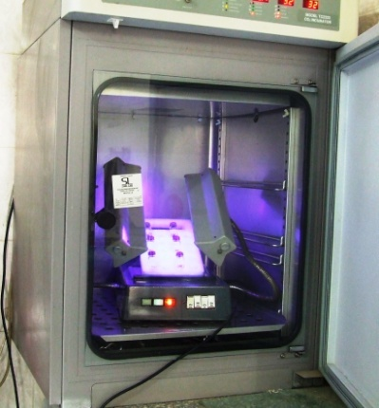
Fig (1) the incubator chamber demonstrate the UV-irradiation technique
3. Results
The obtained data are presented in Table (1) and illustrated in figure (2). In addition to micrographs of some types of aberrations obtained from our results in figure (3). The results revealed that the treatments with cypermethrin alone showed slight significant increase of aberrant cells at low dose 10µg/ml (p <0.05) compared to the control group, but at high doses 20µg/ml showed high significant increase (p <0.001). Although, the UV-irradiation at short exposure time (60 min) did not induce significant effect, the long exposure time (120 min) induced slight significant increase (p <0.05). More addition the combined treatments of cypermethrin and UV-irradiations induced synergistic action effect that obvious at low dose 10µg/ml of cypermethrin with UV-irradiation (60 min) induced significant increase (p <0.01) than their effects of each alone. More addition the combination at high dose and long exposure time induced highly significant increase (p <0.001). On the other hand the most frequent aberrations were observed centromeric attenuation (c-a), followed by chromosome association(c-a), and chromatid gap (tg), while end to end association was the lowest aberration scored. Numerical aberrations which showed as a polyploidy (4n) were scored in negative control group but the treatments with cypermethrin and UV-irradiation increased the percentage of polyploidy in all treatments.

Table ( 1 ) : Chromosomal aberrations induced in rat lymphocyte cultures after individual and combined treatments of cypermethrin and UV-irradiations
Treatments |  | Types of structural aberrations |  |  |  |  | Numerical aberration  Polyploidy  (4n) | Total aberrant cells/ 400 scored metaphases | Mean ± S.E.
 |  | tg | tb | ede | c-s | c-a | Numerical aberration  Polyploidy  (4n) | Total aberrant cells/ 400 scored metaphases | Mean ± S.E.
ª Control group |  | 2 | 1 | 0 | 1 | 1 | 8 | 13 | 3.25 ± 0.629
Cypermethrin | Low dose  10 µg/ml | 4 | 3 | 2 | 4 | 5 | 8 | 26 | 6.50 ± 0.957 *
Cypermethrin | High dose  20 µg/ml | 6 | 1 | 5 | 6 | 11 | 7 | 36 | 9 ± 0.816 ***
UV-irradiations | short exposure  time (60 min) | 3 | 3 | 0 | 3 | 3 | 6 | 11 | 2.75 ± 0.854
UV-irradiations | Long exposure  time (120 min) | 5 | 4 | 0 | 2 | 5 | 6 | 22 | 5.5 ± 0.645 *
Cypermethrin + UV-irradiations | 10 µg/ml +  60 min UV-exposure | 6 | 4 | 1 | 7 | 8 | 8 | 34 | 8.5 ± 0.866 **
Cypermethrin + UV-irradiations | 20 µg/ml +  120 min UV-exposure | 5 | 5 | 4 | 8 | 10 | 14 | 46 | 11.5 ± 0.866 ***
Values are from four replicates in each treatment and the last column represent mean ± S.E. of aberrant cells per 100 spread metaphases/treatment
*** Significant at p < 0.001; ** Significant at p < 0.01; * Significant at p < 0.05
ª Control group, the samples without treatment
Abbreviations: tg, chromatid gap; tb, chromatid break; ede, end to end association; c-s, chromosome association; c-a, chromosome attenuation
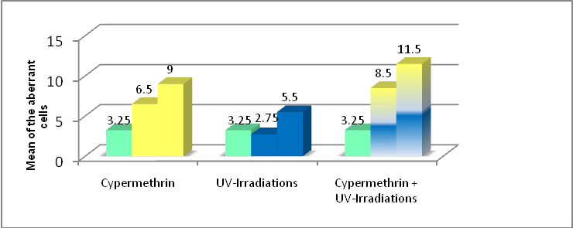
Fig (2) Correlation between individual and combined treatments of cypermethrin and UV-irradiations and the mean of the aberrant cells induced in rat lymphocyte cultures

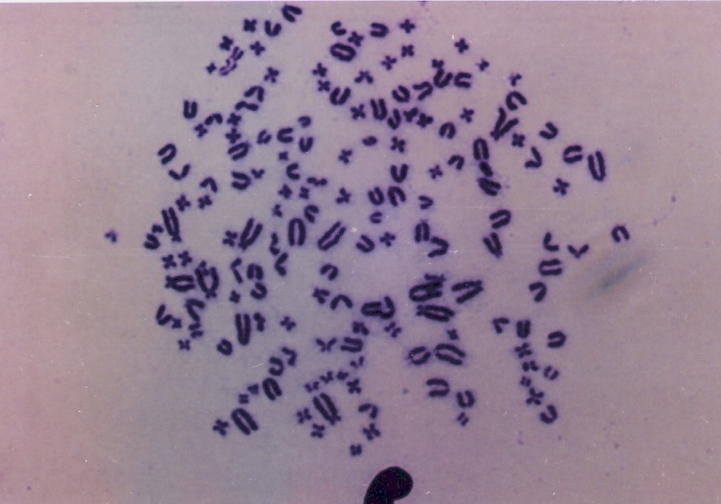
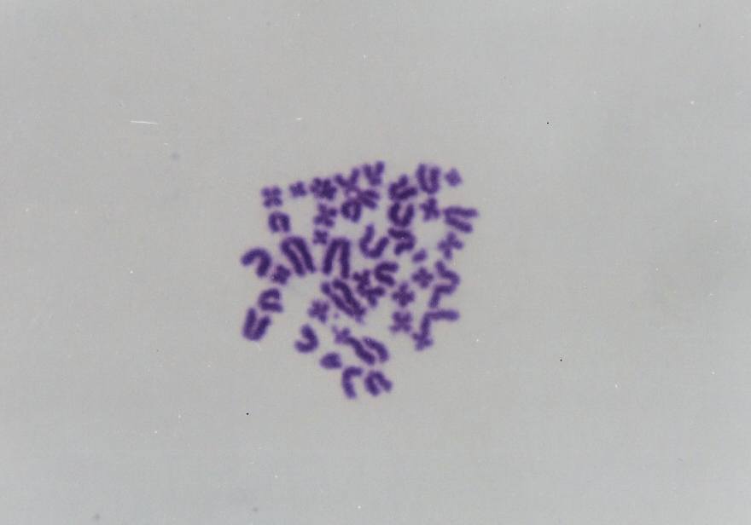
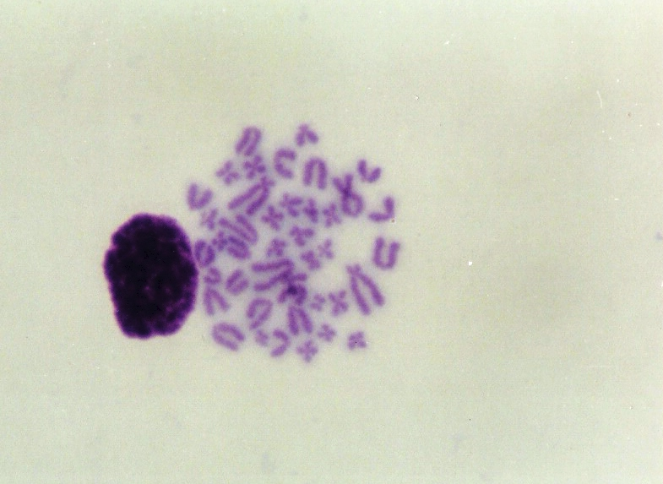
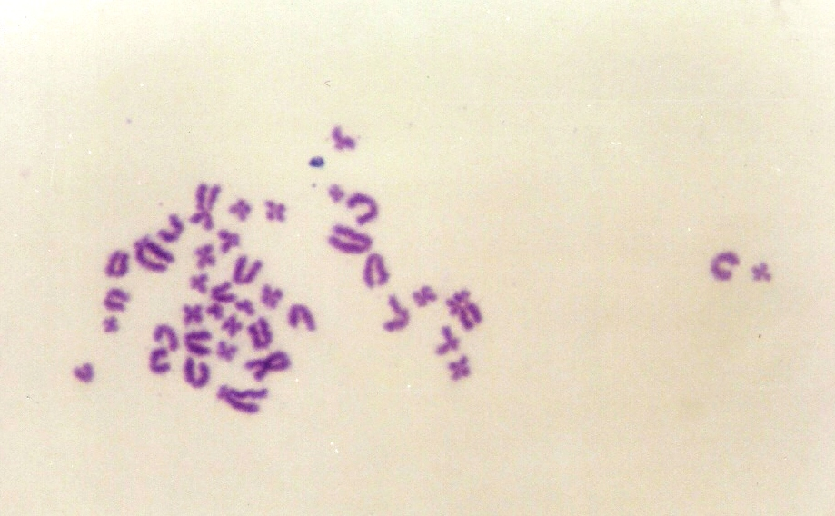
d
a
b
c

Fig (3) Rat lymphocytes metaphases, showing (a) chromosomes association & centromeric attenuation; (b) end to end association; (c) chromosomes association; and (d) polyploidy.

4. Discussion
4.1 Effect of the cypermethrin treatment
In this study we provide the unique combination of insecticide cypermethrin with UV-irradiation in rat lymphocytes cultured. The present study showed increased of chromosomal aberrations in rat lymphocytes cultures after treatment with commercial formulation of cypermethrin. However, (Hoellinger et al., 1987) found no significant increased of micronuclei were observed in rat bone marrow after acute treatment of technical cypermethrin. Also Cypermethrin did not increase chromosomal aberrations in rat bone marrow (Nehéz et al., 2000). In-vitro treatments of technical cypermethrin have been conducted on Salmonella strains with and without metabolic activation and did not show mutagenic response. Although many previous studies indicated no mutagenic effect of cypermethrin especially when active ingredient was used, commercial formulations showed mutagenic effect. Cypermethrin has been reported to be genotoxic in mouse spleen cultures and bone marrow (Amer et al., 1993). Recently (Chakravarthi et al., 2007) reported cypermethrin showed increase in frequency of chromosomal aberration in human lymphocytes cultures and caused increase in the comet tail length with increase in concentration. So, it is obvious the active ingredient of cypermethrin may be not has mutagenic effect as it is but when treated as formulation it has genotoxicity effect. This different may due to the additives of commercial formulations and may increase the toxicity and genotoxicity of the formulations.
4.2 Effect of the exposure to UV irradiation
Many previous findings showed high detrimental effects of UV rays on living cells. The acute effect of UV-irradiation on normal human skin can induce sunburn (erythema), tanning, or pyrimidine dimmers at molecular genetics level. And the chronic exposure to UV irradiation leads to photoaging, and ultimately photocarcinogenesis then leads to the development of skin cancers (Matsumura and Ananthaswamy, 2004). Also Green et al., (1999) studied the effect of UV-A and UV-B on human lymphocytes samples from people exposed to sunlight at different periods and they found that the freshly isolated human lymphocytes samples were exquisitely sensitive to UV-B irradiation, because of their low deoxyribonucleotide pools and defect to remove the pyrimidine dimers from their DNA. The present study showed slight significant increase (p<0.05) in (CAs) only at long exposure dose of UV-irradiation. But short exposure dose did not induce significant induction in (CAs) when compared with the control group. May be the mainly reason of that is due to the thickness of glass vessel of culture that was approximately 1mm and can reduce the rays go into the vessel culture and reach to the cells.
3.3 Effect of cypermethrin and UV-irradiations Combination
The results of the combined exposure between cypermethrin and UV-irradiation showed moderately and highly significant increase at both low and high doses (p <0.01 and p <0.001) respectively. So our results confirm the investigation that the UV exposures induce synergetic effect of genotoxicity. On the other hand, few articles have been written about the interaction between chemical and physical agent. Abdel-Aziz et al. (2004) studied the in vivo combined effect of cypermethrin and 650 nm diode laser irradiations on DNA of rat liver cells. The combination showed a synergistic effect of both low and high doses level of cypermethrin and diode laser irradiations. Also the combination between two chemical agents has been studied. Nehez et al. (2000) reported that the cypermethrin and lead combination induced a significant increase of structural chromosomal aberrations in male rat bone marrow. So occupational exposure to various mutagens either chemical or physical agent may increase mutagenic effect and the results of this study provide further investigation about the combined effect of two different of mutagen agents which made greater in genotoxicity than that caused by individual agent.

5. Conclusion
It could be concluded that the commercial formulation of cypermethrin may be more genotoxcity than active ingredient. In addition to the well known effects of UV-radiation in DNA damage and the fact that stimulates pyrimidine dimmers. The given results indicate concentration of cypermethrin that are low genotoxic in standard test can cause harmful mutagenic effect when combined with UV-radiation. Furthermore the workers or farmers, working all the time in the open field and subjected to sun light and exposed to pesticides contamination may be at high risk if they are not protected by safety measures when exposure to these combined mutagens.

References
Abdel-Aziz M, Badr Y, Kamal N, El-Khatib N (2005): In-vivo combined effect of cypermethrin and diode laser irradiation: comet assay measurements of DNA damage in rat liver cells. Arab J. Biotech., 8;(2):293-306.
Amer SM, Ibrahim AA, El-Sherbeny KM 1993: Induction of chromosomal aberrations and sister chromatid exchange in vivo and in vitro by the insecticide cypermethrin. J Appl Toxicol 13(5):341-345.
Bolognesi C (2003): Genotoxicity of pesticides: a review of human biomonitoring studies. Mutat. Res, 543(3): 251-272.
Butler ST, Fosko SW (2010): Increased prevalence of left-sided skin cancers. J Am Acad
Cadet J, Sage E, and Douki T (2005): Ultraviolet radiation-mediated damage to cellular DNA. Mutat Res; 571: 3-17.
Chakravarthi K, Naravaneni R, Philip GH (2007). Study of Cypermethrin Cytogenesis effects on Human Lymphocytes Using In-Vitro techniques. J. Appl. Sci. Environ. Manage. 11(2) 77-81
Green MH, Petit-Frere C, Clingen PH, Bentham G, Cole J, Arlett CF(1999): Possible effects of sunlight on human lymphocytes. J Epidemiol. 9(6 Suppl):S48-57
Hockberger, PE (2002): A history of ultraviolet photobiology for humans, animals and microorganisms.Photochem. Photobiol.76 (6): 561–579.
Hoellinger H, Lecorsier A and Sonnier M (1987): Cytotoxicity, cytogenotoxicity and allergenicity tests on certain pyrethroids. Drug Chem. Toxicol. 10: 291-310.
Institoris L., Undeger U., Siroki O., Nehez M., Desi I. (1999): Comparison of detection sensitivity of immuno- and genotoxicological effects of sub-acute cypermethrin and permethrin exposure in rats, Toxicology 137: 47–55.
Mark N and Farmer KC (1995): Sun damage and prevention. Electronic Textbook of Dermatology. The Internet Dermatology Society, retrieved on line in 02-06-2008. Dermatol. 63(6):1006-10.
Matsumura Y, Ananthaswamy HN. (2004): Toxic effects of ultraviolet radiation on the skin. Toxicol Appl Pharmacol. 15;195(3):298-308.
Monks (2013): Our changing atmosphere: available at http://www.nerc.ac.uk/publications/other/documents/changingatmosphere.pdf (accessed 2 Feb 2013)
Nehéz, M., Lorencz, R. and Dési, I. (2000): Simultaneous action of cypermethrin and two environmental pollutant metals, cadmium and lead, on bone marrow cell chromosomes of rats in subchronic administration. Ecotoxicol. Environ. Saf. 45: 55-60.
Sexton K and Hattis D (2006): Assessing Cumulative Health Risks from Exposure to Environmental Mixtures-Three Fundamental Questions. Environ Health Perspect 115:825–832
Sinha AK., Gollapudi BB, AnnLinscombe VA and McClintock ML (1989): Utilization of rat lymphocytes for the in vitro chromosomal aberration assay. Mutagenesis. 4(2):147-53.
Stopper H and Lutz WK (2002):Induction of micronuclei in human cell lines and primary cells by combination treatment with gamma radiation and ethyl methanesulfonate. Mutagenesis,17(2): 177-181.
Venables, WN, Ripley BD (2002): Modern Applied Statistics with S, Fourth Edition, Springer
Yousef MI, El-Demerdash FM, Kamel KI, Al-Salhen KS, (2003): Changes in some hematological and biochemical indices of rabbits induced by isoflavones and cypermethrin, Toxicology 189: 223–23.

