New York Science Journal 2013;6(7) http://www.sciencepub.net/newyork

Synthesis and characterization of smart acrylamide nanocomposite hydrogel
Fateme Akbari Razin ¹, Ahamd Amirshaghaghi ¹
^{1.} Department of Chemical Engineering, Ahar Branch-Islamic Azad University, Ahar, Iran
Fa_Akbari2002@yahoo.com

Abstract: A poly(acrylamide-co-acrylic acid ) [Poly(AAm-co-AAc)] hydrogel was prepared by copolymerising
acrylamide (90-100 mol) with acrylic acid ( 0-10 mol ). In this work monomers acrylamide, acrylic acid, N,N'-
methylene-bis-acrylamide (cross linker), persulphates (initiator) and N,N,N',N'-tetra methyl ethyl diamine (accelerator) are used to obtain gel at room temperature. Highly stable and uniformly distributed silver nanoparticles have been obtained with hydrogel networks as nanoreactors via in situ reduction of silver nitrate (Ag/Tio₂). The pH value of each solution was obtained by adding either hydrochloric acid or sodium hydroxide. The hydrogels were characterized by using scanning electron microscope (SEM).
[Akbari Razin F, Amirshaghaghi A. Synthesis and characterization of smart acrylamide nanocomposite hydrogel. N Y Sci J 2013;6(7):34-36]. (ISSN: 1554-0200). http://www.sciencepub.net/newyork. 7
Keywords: Hydrogel; Swelling behavior; pH sensitive hydrogel; Silver nanoparticles

1. Introduction
Hydrogels are three dimensional polymer networks that are highly hydrophilic, yet they are insoluble in water [Tanaka, 1987]. When fully
hydrated can contain over 95% water, therefore they
are, in effect, parcels of water that can be easily
handled.
Hydrogels Intelligent polymers are materials that
undergo physical or chemical changes in response to
external stimuli, such as stress, temperature or pH.
Hydrogels can be formed, that respond to changes in
pH by incorporating pH-responsive polymers as
pendant groups that can accept or donate protons in
response to pH changes [Qiu & Park, 2001].
PH-responsive polymers are polyelectrolytes and
have pendant acidic (carboxyl) or basic (amine) groups
that ionize just like acid or base groups on monoacids
or monobases [McGann, 2009].
The apparent dissociation constant (K_{a}) for
the polyelectrolytes is different from the
corresponding monoacids or monobases due to the
electrostatic effects from neighboring ionized groups [Qiu & Park, 2001]
Hydrogels sensitive to pH respond to a pH close to the pK_{a} of the hydrogel [Brondsted &
Kopecek, 1992]. The PAAm hydrogel contains amide
(-CONH₂) functional groups. The amide functional
groups are considered neutral; however, when the gel
is placed into a NaOH solution, it swells. In the NaOH
solution some of the side chains undergo an alkaline
hydrolysis reaction, which converts the amide groups
into carboxylic acid (-COOH) groups [Tanaka, 1981].
In the basic solution the carboxylic acid
pendent chains ionize to form the carboxylate ion (-
COO⁻). These negatively charged groups repel each
other which generate electrostatic repulsion forces.
http://www.sciencepub.net/newyork 34

These forces cause the polymer chains to be forced
away from each other, allowing more water to enter
the gel resulting in the hydration of the polymer
chains. Once the carboxylate ions are formed an influx
of counterions occurs inside the gel to diminish the
net negative charges inside the hydrogel causing the
concentration of ions to be higher inside the hydrogel
then in the surrounding solution. This causes a
difference in osmotic pressure and results in a flux of
water into the hydrogel resulting in the swelling of the
hydrogen.
2. Materials and Methods
2.1. Preparation of P(AAm-co-AAc) hydrogel and
P(AAm-co-AAc) hydrogels-silver nanocomposites.
P(AAm-co-AAc) hydrogel composed of
PAAm and PAAc were prepared by free radical
solution polymerization in the presence of a
Acrylamide and acrylic acid monomers (AM, AA)
and N, N'- methylene-bis-acrylamide(MBA, cross
linker) and N,N,N',N'-tetra methylethyl diamine
(TEMED, accelerator), Potasiom persulphates (KPS,
initiator). Feed composition is given in Table 1. The
total monomer concentration was kept at 4.0 M in
each solution.
To prepare P(PAAm-co-AAc) hydrogels-
silver nanocomposites, accurately weighed dry P(PAAm-co-AAc) hydrogels were equilibrated with water for 3 days and these P(PAAm-co-AAc)
hydrogels were transferred to another beaker containing 10 ml of 5 mM Ag/TiO₂ aqueous
solutions, allowed to equilibrate for 1 day. Here,
most of the silver ions are exchanged from
solution into hydrogel networks by anchoring
through -COOH, -CONH₂, -OH groups of
hydrogel chains and rest of metal ions were occupied in free-network spaces of hydrogels.
newyorksci@gmail.com

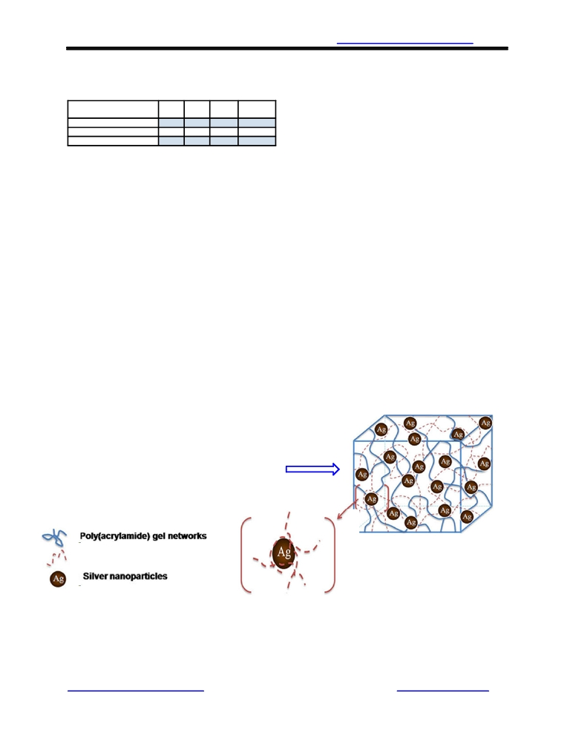

New York Science Journal 2013;6(7) http://www.sciencepub.net/newyork

AAc) hydrogels were allowed to swell in the

Table 1, feeds composition of P(PAAm-co-AAc)
hydrogel
Polymer AM AA MBA TEMED
(mol/L) mol/L) (mol/L) (V/V)
PAAm 4 - 0.4 0.2
Poly(AM-co-5 mol% AA) 3.8 0.2 0.4 0.2
Poly(AM-co-10 mol % AA) 3.6 0.4 0.4 0.2

2.2. Swelling studies
P(PAAm-co-AAc) hydrogel and P(PAAm-
co-AAc) hydrogels-silver nanocomposites disks
were soaked in solutions of differing pH at room
temperature for 24 h. The pH value of each solution
was obtained by adding either hydrochloric acid or
sodium hydroxide. After the hydrogel disks had
equilibrated in each solution the degree of swelling
was measured by equilibrated weighing each disk.
The swelling ratio (Q) of the gels was calculated
from equation: Q = W_{e}/W_{d}, where W_{e} is the weight
of water in the swollen hydrogel and W_{d} is the dry
weight of the pure hydrogel.
3. Results and Discussion
In this study, we have developed smaller size and finer distribution of silver nanoparticles
in P (PAAm-co-AAc) hydrogel networks
composed of poly(acrylamide) with acrylic acid
polymeric chains. The advanced feature of this
methodology is that the nanoparticles simply
prepared at room temperature in presence of green
stabilizers. In these experiments, the P(PAAm-co-

P(PAAm-co-AAc)
hydrogels
Silver nanoparticles stabilized
Ag/Tio₂ solutions and reduced, throughout the gel
networks. the PAM cross-linked networks act as
reservoir for metal ions uptake and the ions are
anchored through carboxylic, amide, and
hydroxyl groups of carbohydrate polymers and
thereby holds large amounts of metal ions in
their network and facilitate the reducing process
as well as helps in stabilization. The
carbohydrate polymers in hydrogel networks
arrest the agglomeration of silver nano particles.
The concept of silver nanoparticles synthesis in
P(PAAm-co-AAc) hydrogel networks is
schematically presented in Fig 1. It is quite
interesting to point out that silver nanoparticle
are formed exclusively inside the hydrogel
networks and no particles formation is observed
in the surrounding medium, that strictly confirm
that hydrogel networks are binding to the silver
ions as well as storing the nanoparticles without
releasing into the media. The basic feature of
hydrogel is that it can absorb and hold huge
amount of water/solvent in its network structures
and release over a period of time (usually from
weeks to months). This special property is very
important to load the metal ions and formation
of metal nanoparticles from reduction reaction.
Fig. 2 Shoes the effect of pH on the equilibrium
swelling ratio of the P(AAm-co-AAc) and P(AAm-
co-AAc)-Ag nanocomposite.

Ag/TiO₂

by acrylic acid polymeric chains insidethe hydrogel

Silver nanoparticles formed throughoul
AAc Chains P(PAAm-co-AAc) hydrogel network

Fig 1. Synthesis of silver nanoparticles throughout P(AAm-co-AAc) hydrogel networks

http://www.sciencepub.net/newyork 35 newyorksci@gmail.com

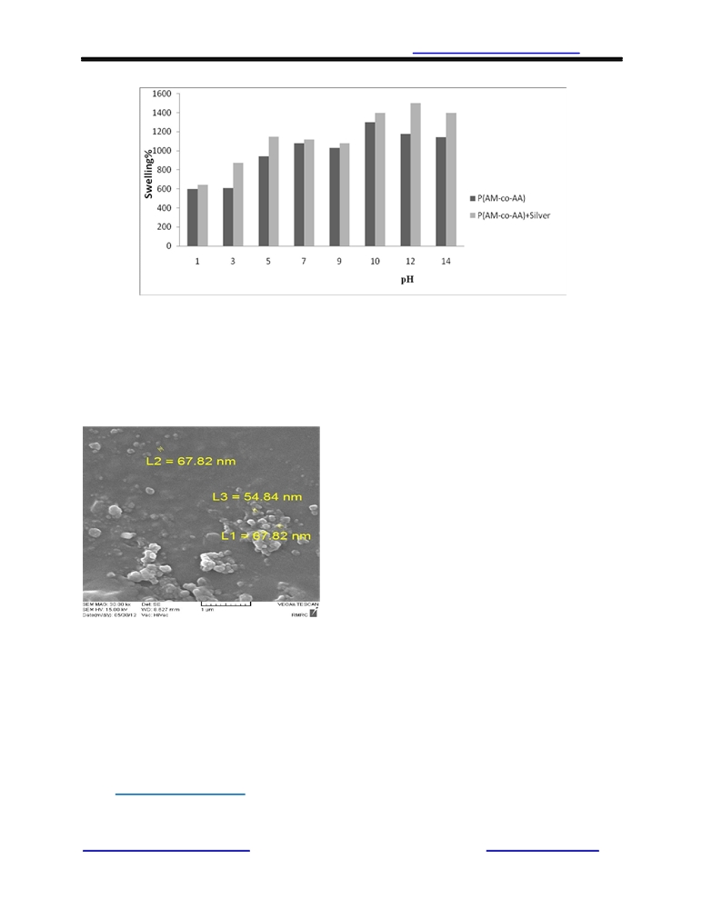

New York Science Journal 2013;6(7) http://www.sciencepub.net/newyork

Fig. 2. Effect of pH on the equilibrium swelling ratio of the P(AAm-co-AAc) and P(AAm-co-AAc)-Ag
nanocomposite

The finer details of the particles and their
morphology were investigated by scanning electron
microscopy (SEM). The micrograph (Fig. 3.)
exhibited an average silver nanoparticle diameter between 50-70 nm.

Fig. 3. SEM image of the P (AAm-co-AAc)-Ag/Tio₂

Acknowledgement
I am grateful to the Department of Chemical Engineering, Ahar Branch-Islamic Azad University for their Laboratory facilities extended to me for carrying out my research work.

Corresponding Author:
Fateme Akbai Razin
Department of Chemical Engineering, Ahar Branch-
Islamic Azad University, Ahar, Iran
Email: Fa_Akbari2002@yahoo.com

http://www.sciencepub.net/newyork

References
1. Tanaka T. Encycl Polym Sci Engng 1987;7:514 -
31.
2. Qiu, Y. and Park, K, Environment-sensitive
hydrogel for drug delivery. Advanced Drug
Delivery Reviews, 2001. 53: p. 321-339.
3. McGann, M.J., C.L. Higginbotham, L.M. Geever,
and M.J.D. Nugent, Thesynthesis of novel pH-
sensitive poly(vinyl alcohol) composite
hydrogelsusing a freeze/thaw process for
biomedical applications. International Journal of
Pharmaceutics, 2009. 372: p. 154-161.
4. Brondsted, H. and J. Kopecek, pH-Sensitive
Hydrogels - Characteristics and Potential in Drug
Delivery in Polyelectrolyte Gels. 1992, American
Chemical Society. p. 285-304.
5. Tanaka, T., Gels, in Scientific American. 1981. p.
124-138.
6 Geckeler KE, Rosenberg E, editors. Functional
Nanomaterials. Valencia, USA: American
Scientific Publishers; 2006.
7 Shipway AN , Willner I. Chem
Commun 2001; 2 0:20 35.
8 Daniel M -C , Astruc D . Chem Rev
2004;104:29 3.
9 Kim JW , Lee JE, Ryu JH, Lee JS, Kim SJ,
Han SH, et al. J Polym Sci Part a 20 04;
42:25 51.
10 Zhang J, Xu S, Kumacheva E. J Am
Chem Soc 2004; 1 2 6:7 908.

5/5/2013

36 newyorksci@gmail.com

