Evidence of Some Tectonic Events in Koton Karifi, North-Central Nigeria, from Aeromagnetic Data.

Abdulsalam N.N. ¹, Mallam A. ², Ologe O. ³

^{1, 2} Department of Physics, University of Abuja, Nigeria
³ Department of Chemical and Geological Sciences, Al-Hikmah University, Ilorin, Nigeria
nassnaeem@gmail.com, toyin.ologe@gmail.com

Abstract: Total field aeromagnetic anomaly data obtained for the Koton-Karifi area, Nigeria were used for the present study. The original data were part of the aeromagnetic map of the total magnetic field intensity in half-degree sheet acquired from the Nigerian Geological survey Agency (NGSA). The superimposed ground – levelled aeromagnetic anomaly map on the geology of the area suggests a NE-SW fault line, marking a boundary between the migmatites and granitoids. It is therefore suggested that the metamorphic phase change at this boundary was a major tectonic event in the area.
[Abdulsalam N.N., Mallam A., Ologe O. Evidence of Some Tectonic Events in Koton Karifi, North-Central Nigeria, from Aeromagnetic Data. N Y Sci J 2013;6(7):61-70]. (ISSN: 1554-0200). http://www.sciencepub.net/newyork. 11

Keywords: Horizontal ground level; geology; fault; fracture; super impose.

1. Introduction
The Koton-karifi area of Nigeria (Figure 1 and 2) is part of the entire Nupe basin, Nigeria and is the SE edge of this basin lying between latitudes 8⁰:00’N and 8⁰:30’N and longitudes 6⁰:30’E and 7⁰:00’E.
This trough is filled with Upper Cretaceous sediments and is mainly occupied by the sandstones. The original rock of the area could have been subjected to considerable erosion before the Upper Cretaceous beds were laid down. The sandstones consist of unfossiliferous shallow water sandstones and pebble beds. It is possible that these sandstones could have covered a larger area (continuous to the Sokoto Basin) than now (Russ, 1957). Tertiary earth movements could have impacted low dips to this formation leading to erosion over wider areas. The youngest rocks of the area are laterites and alluvial, terrace and terrestrial deposits of tertiary and recent age (Russ, 1957). The aeromagnetic survey is the oldest potential field method used for subsurface mapping. The aeromagnetic geophysical method plays a distinguished role when compared with other geophysical methods in its rapid rate of coverage and low cost per unit area explored. The main purpose of the aeromagnetic survey is to detect minerals or rocks that have unusual magnetic properties which reveal them by causing anomalies in the intensity of the earth’s magnetic field (USGS, 1997). The aeromagnetic survey is applied in mapping these anomalies in the earth’s magnetic field and this is correlated with the underground geological structure. Faults usually show up by abrupt changes or close spacing in orientation of the contours as revealed by the magnetic anomalies which is the basis for this study. For subsurface mapping, residual magnetic anomaly maps are useful since they identify the presence of intrusive, lava flows, or igneous plugs which are areas of concerns in this study (Selley, 1998).

2. Geological Settings of The Study Area
The general stratigraphy and sedimentation processes consist of the lithologies overlying the Precambrian Basement complex. The sequence is divided into a number of formations and lithologies characteristics of the age group. The Precambrian to probably Palaeozoic rocks are the oldest rocks and form the basement complex (Adeleye, 1976).
During the upper cretaceous times, depositional cycle started with overlying of the Nupe Group (undifferentiated sandstones) in the Santonian. Adeleye (1976) gave the remaining sedimentary succession as follows. Sandstone formations of Bida and Lokoja followed in succession up to the end of Santonian. During this period, there were no severe crustal movements to alter the geometry of the layers at the end of each depositional cycle. Thus these formations overlie conformably on one another.

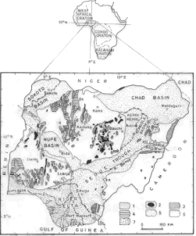

N

Figure 1: Geological Map of Nigeria
1 = Cretaceous-Recent sediments; 2=Younger Granites; 3 = Older Granites; 4 = Undifferentiated Metasediments; 5 = quartzite and quartzite schist; 6 = Undifferentiated basement complex and 7 = Tertiary volcanics (From Geological map of Nigeria 1994: compiled by the Geological Survey of Nigeria). Inset is the study area: the Koton Karifi Area of the Nupe Basin, Nigeria

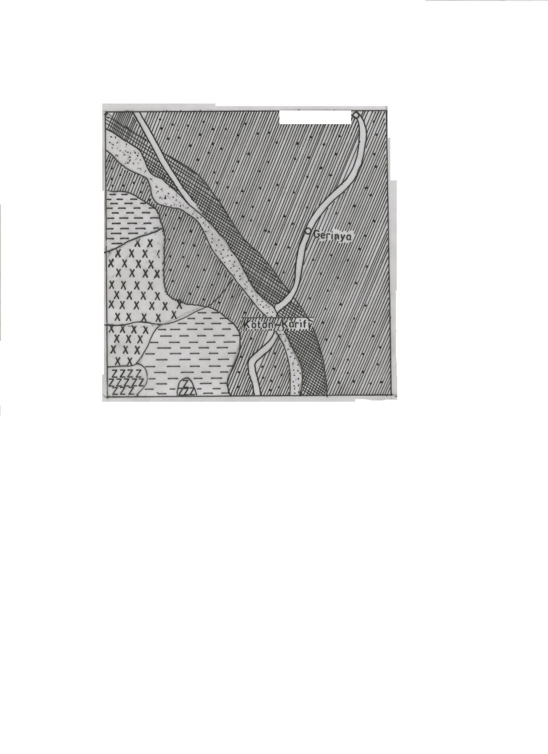

14 km

N

Figure 2: Geological Map of Koton – Karifi from Geological Map of Nigeria 1994: Compiled by the Geological Survey of Nigeria)

At the beginning of the Maastrichtian, the Agbaja (around Niger/Benue confluence) and Batati (around Bida) formations were deposited conformably over the Mamu formation. The Agbaja and Batati formations comprise ironstones of the minnette-type of iron ores (Adeleye, 1976). These ironstones have identical properties to the iron ores of minnette-type of Europe and America, which contain 1.3 – 0.8% phosphorus, small percentage of alumina, sulphur and silica (Adeleye, 1976). The depositional sequence is followed by Ajali sandstones and the coal seams and sandstones making the Nsukka formation. The Quarternary deposits are the recent alluvium, laterites, terrace and terrestrial gravels and sands (Russ, 1957).
The sedimentary facies of the area and the description of the major formational lithologies and structural expositions of the area have been given by Adeleye (1976), as a gently down-warped trough whose buried Basement Complex has a high relief with sedimentary formations of more than 300m thick. The epeirogenesis responsible for the basin genesis seems closely connected with crustal movements of the Santonian orogeny of South-eastern Nigeria and the nearby Benue Valley (Adeleye, 1976). The earlier periods of sedimentation and intrusion in the Precambrian represent a complex vast period of history in the area (Russ, 1957). These earlier sediments and some minor intrusion must have been subjected to several periods of metamorphism.
3. Materials and Methods
Total field aeromagnetic anomaly data obtained for the Koton-Karifi area, Nigeria were used for the present study. The original data were part of the aeromagnetic map of the total magnetic field intensity in half-degree sheet acquired from the geological survey of Nigeria (GSN). These surveys were conducted by consultants on behalf of GSN between 1974 and 1976 covering nearly the entire country. The main aim of these surveys was to assist in mineral and ground water development through improved geological mapping. Flight line direction was NNW-SSE at profile spacing of 2km and tie line spacing of 20km at an altitude of about 152 m (500 ft). The lines were flown in an ENE-WEW (N60E).
The first step in the present analysis was to digitize the map (Sheet 227: Koton-Karifi) covering the survey area with a digitizing interval of 1km. Digitizing was done manually, reading values at intersections of north-south and east-west grid lines.
The next step in our analysis was to recontour the map to check for any misreading and to produce the total – field aeromagnetic intensity map (figure 3). The contouring was done using the Golden Software 2D Surface Mapping Program (Surfer Version 7.0).
The removal of the broad field, particularly the normal geomagnetic field accomplishes the final stage in this step of data treatment. The application of Gauss powerful techniques of potential field theory to a detailed analysis of the Earth’s magnetic field permits the description of the various complexities of the geocentric dipole field of the Earth (Cain 1968). The global model of the Earth’s magnetic field, called the International Geomagnetic.

N

Figure 3: Total Field Aeromagnetic Map (Sheet 227) of Koton-Karifi
(Contour Interval is 5nT: Actual values are obtained by adding 25000nT to contour values; regional correction based on IGRF (epoch date Ist January, 1974) has not been made)

Reference Field (IGRF) is based on the derivation, up to a certain degree of the so-called Gauss coefficients in the expression of the potential of the field. Coefficients of the spherical harmonic expansion of the magnetic field of the Earth are regularly updated to fit data from magnetic observatories or satellite data. The internationally agreed values are published every five years as the IGRF.
Magnetic surveying consists of (1) measuring the terrestrial magnetic field at predetermined points (2) correcting the measurements for known changes and (3) comparing the resultant value of the field with the IGRF value. The difference between the observed and the IGRF is called a magnetic anomaly. Thus correct removal of the IGRF from the observed field is the first step in the interpretation of magnetic data. The computation of the IGRF in the project area follows.
More than 95% of the Earth’s magnetic field can be represented by the field of a theoretical magnetic dipole at the centre of the Earth inclined at about 11.5º to the axis of rotation (Slack et al., 1967, Merrill and McElhinny 1983, Cain 1989, Lowrie 1997). The magnetic poles of the Earth are defined as the locations where the inclination of the magnetic field is $±$90º. The magnetic moment of this fictitious geocentric dipole can be calculated from the observed field. The residual field resulting from the difference between this dipole field and the observed field can then approximate the effects of smaller magnetic dipoles.
The Earth’s core-generated magnetic field has associated with it a geomagnetic potential U (r,θ,φ,t), which can be expressed in spherical coordinates in terms of a spherical-harmonic expansion of the following form (Quinn et al., 1995):

$U(r,θ,φ,t)=R\sum_{n=1}^{N}{{\left(\frac{R}{r}\right)}^{n+1}\sum_{m=0}^{n}{\left\{g_{\text{nm}}(t)\text{cos}(mφ)+h_{\text{nm}}(t)\text{sin}(mφ)\right\}P_{n}^{m}(θ)}}$ (3.1)

Where the spherical coordinates (r,θ,φ) correspond to the radius from the centre of the Earth, the co-latitude (i.e., 90º-latitude), and the longitude. In equation 3.1, N is the highest degree for the chosen model as R is the mean radius of the Earth (6371.2 km); g_{nm}(t) and h_{nm}(t) are referred to as the Gauss’ coefficients at time t, where t is the time in years (e.g., 1974.312). $P_{n}^{m}(θ)$represent a particular Schmidt-normalized associated Legendre polynomial of spherical-harmonic degree n and order m. These are polynomials in terms of the cosine of the co-latitude,θ. The Gauss’ coefficients are slowly varying functions of time and are expressed in the form of a Taylor series expansion, where only terms up to first order in time are retained so that:

$g_{\text{nm}}(t)=g_{\text{nm}}(T_{\text{Epoch}})+{\overset{˙}{g}}_{\text{nm}}(t−T_{\text{Epoch}})$ T_{Epoch} ≤ t ≤ T_{Epoch} + 5 (3.2a)
$h_{\text{nm}}(t)=h_{\text{nm}}(T_{\text{Epoch}})+{\overset{˙}{h}}_{\text{nm}}(t−T_{\text{Epoch}})$ T_{Epoch} ≤ t ≤ T_{Epoch} + 5 (3.2b)

Where T_{Epoch} is the base epoch of the model, which for the 1975 is 1975.0. Thus g_{nm}(T_{Epoch}) and h_{nm}(T_{Epoch}) are the Schmidt-normalized Gauss coefficients of the IGRF at the model’s base epoch, while the Schmidt-normalized secular variation (SV) Gauss’ coefficients, ${\overset{˙}{g}}_{\text{nm}}$ and ${\overset{˙}{h}}_{\text{nm}}$(where the dot represents differentiation with respect to time, i.e., $\frac{d}{\text{dt}}$), are the annual rates of change of the main field (MF) Gauss’ coefficients g_{nm} and h_{nm} and are evaluated at the middle of the model’s lifespan (i.e., at T_{Epoch} + 2.5). The MF Gauss coefficients and SV field Gauss coefficients are collectively referred to as spherical-harmonic coefficients.
Figure 3.2 shows the IGRF values computed and contoured for the Koton Karifi, Area, Nigeria at approximately 150 m above ground level for epoch date 1st January 1974 using the 1975 IGRF model. The algorithm used was based on Cain (1968) following the implementation of Cordell et al., (1992) modified for use on an IBM compatible PC.
The map (Figure 4) shows a pattern composed of lines plunging NE-SW increasing in value with nearly uniform gradient from about 32640 nT in the NW to about 32760 nT to SE. This map is the reflection of the effect of the geomagnetic dipole field around the Koton Karifi, area, Nigeria.
The International Geomagnetic Reference Field is considered to be the best available representation of the main field for any particular epoch (Langel 1992, Luyendyk 1998, Minty et al. 2003) and is now almost universally accepted as the background against which magnetic anomalies are reported (Tarlowski et al. 1996).
The IGRF values (Figure 4) are subtracted from the observed magnetic field intensity values (Figure 3) for the study area. This results in a composite aeromagnetic anomaly map shown in Figure 5.
The composite aeromagnetic anomaly map (Figure 5) shows values ranging from –200 to 250nT. The map shows a central linear belt which runs from the western to the eastern ends and apparently separating the area into two: with the southern dominated by convolutions and the northern dominated by smoothed network of contours. This prominent belt is likely very significant in the area and will be further investigated.

N

Figure 4: The main Field (IGRF) over Koton Karifi Area
{The epoch date of Ist January 1974 was used for 1975 IGRF model values of contours are in gammas (nanotesla)}

N

Figure 5: Total field aeromagnetic anomaly map of Koton-Karifi area (sheet 227).
The main field in form of IGRF (IGRF model 1975 of epoch date 1 January 1974) has been removed; Contour Interval is 5nT.

4. Results and Discussion
The total-field aeromagnetic map of the Koton Karifi Area, Nigeria is displayed in Figure 5. This was obtained when the main field (Figure 4) was removed from the data. This initial process in the interpretation of the magnetic data is very important and significant.
Figure 6 seems to suggest a NE-SW fault line depicted from a thresholded ground-levelled aeromagnetic anomaly superimposed on the geology. This inferred fault seems to mark a boundary between the migmatites and granitoids. It is therefore pertinent that the metamorphic phase change at this boundary was a major tectonic episode in the area. The large arrow (Figure 6) indicates the direction of an abrupt intervening episode that likely interrupted the continuity of the pre-existing fault. This oblique fault might be due to reported widespread Santonian episode that affected most part of eastern Nigeria culminating in the emplacement of the Abakaliki anticlinorium (Uzuakpunwa 1974).

N
Figure 6: Output of the horizontal gradient computation

Ground levelled residual aeromagnetic total field magnetic Intensity data over the Koton-Karifi Area, Nigeria. (Contour interval is 200nT/km)



14 km
N

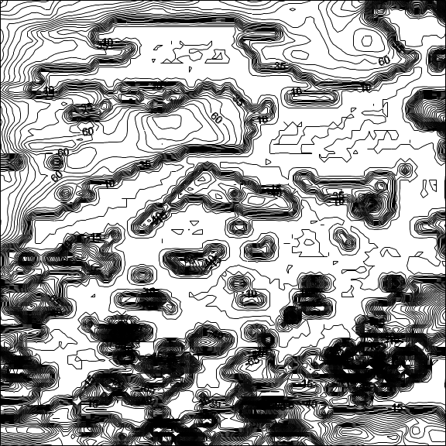

Figure 7: The ground-levelled Aeromagnetic Anomaly data over the Koton Karifi Area, Nigeria.
Data were thresholded to emphasize the dinant contours. An inferred fault is shown (NE-SW direction) and is charted on the geology.The big arrow indicates a direction of a later distortion of this pre-existing fault.

Conclusion
The superimposed ground – levelled aeromagnetic anomaly map on the geology of the area suggests a NE-SW fault line, marking a boundary between the migmatites and granitoids. It is therefore suggested that the metamorphic phase change at this boundary was a major tectonic event in the area. The interruption of this fault (Figure 7) is a further evidence of the impact of the Santonian episode which was said to have affected the greater part of eastern Nigeria.
References
- Adeleye, D. R. (1976), The geology of the Middle Niger Basin, In: Geology of Nigeria (C. A. Kogbe, Ed.), Elizabethan Publishing Co. Lagos, 283-287.
- Cain, J. C. (1968), Computation of the main geomagnetic field from spherical harmonic expansions, NASA Data users note NSSDC 68-11.
- Cain, J. C. (1989), Geomagnetic field analysis: In (James, D. E. Ed.) The Encyclopedia of Solid Earth
- Sciences Van Nostrand Reinhold, New York, pp. 517 – 522.
- Cain, J. C., Hendricks, S. J., Langel, R. A. and Hudson, W. V. (1967), A proposed model for the International Geomagnetic Reference Field 1965, J. Geomag. & Geoelect. 19, 335-355.
- Cordell, L., Phillips, J. D. and Godson, R. H. (1992), U. S. Geological Survey potential field geophysical software, version 2.0. Open File Report 92-118.
- Langel, R. A. (1992, International Geomagnetic Reference Field: 1991 revision, Geophysics 57, 956-959.
- Lowrie, W. (1997), Fundamentals of geophysics, Cambridge University Press, Lond., 354p.
- Luyendyk, A. P. J. (1998), Processing of airborne magnetic data, AGSO J. Australian Geol. Geophys. 17, 31-38.
- Merrill, R. T. and McElhinny, M. W. (1983), The Earth’s magnetic field, Academic Press, London.
- Minty, B. R. S., Milligan, P. R., Luyendyk, A. P. J. and Mackey, T. (2003), Merging airborne magnetic surveys into continental-scale compilations, Geophysics 68, 988-995.
- Quinn, J. M., Coleman, R. J. and Nigro, J. M. (1995), The Joint US/UK 1995 Epoch World Magnetic Model, Naval Oceanographic Office, Stennis Space Center, MS; Technical Report #314.
- Russ, W. (1957), The geology of parts of Niger, Zaria and Sokoto Provinces: Geol. Surv. of Nigeria Bull. No. 27.
- Selley, R.C., 1998. Elements of Petroleum Geology. 2nd Edn., Academic Press. San Diego, USA, pp: 90-97.
- Slack, H. A., Lynch, V. M. and Langan, L. (1967), The geomagnetic elements, Geophysics 32, 877 –892.
- Tarlowski, C., McEwin, A. J., Reeves, C. V. and Barton, C. E. (1996), Dewarping the composite aeromagnetic anomaly map of Australia, using control traverses and base stations, Geophysics 61, 696-705.
- United States Geological Survey (USGS), 1997. Introduction to Potential Fields: Magnetics.

Uzuakpunwa, A. B. (1974), The Abakaliki pyroclastics-Eastern Nigeria: new age and tectonic implications, Geol. Mag. 111, 65-70.

5/29/2013

