Some Bacteriological and Biochemical Studies on Subclinical Mastitis in Buffaloes

Aliaa A. E. Mohamed¹, Ahlam K.A Wahba¹, Ragaa A.S.R.faisal² and Yousreya H. M³

¹Buffalo Diseases Research Department, ²Biochemistry Department and ³Mycoplasma Department

Animal Health Research Institute Dokki-Giza-Egypt
Aliaa.abdelrahman27@yahoo.com

Abstract: A total of (180) positive california mastitis test (CMT) out of (240)buffalo milk samples collected from (60) cases of subclinically mastitic dairy Egyption buffaloes were examined bacteriologically for the detection of the causative microbial agent including Mycoplasma species.Comparison of different diagnostic procedures including culture techniques, CMT, polymerase chain reaction(PCR), evaluate the role of milk serum enzymes (Alkaline Phosphatase (ALP), Lactate Dehydroginase (LDH), Gamma Glutamyle Transferase (GGT) and Aspartate Aminotransferase (AST)) as well as electrophoretic pattern in whey milk were studed.The result of this study revealed that Staphylococcus aureus was the most common bacteria followed by Escherichia coli then Streptococcus agalactiae, while Mycoplasma bovis was the most detected mycoplasma species. All the isolates were sensitive to Streptomycin, Amikacin, Gentamycin and Ofloxacin. On the other hand, negative isolates were sensitive to Colistin and Ciprofloxacin. All isolates were resistant to Ampicillin and Tetracycline. Milk serum biochemical studies revealed that GGT, LDH and ALP activities were increased significantly in subclinically mastitic buffalo’s whey milk. However, the concentration of AST was insignificant compared to its concentration in healthy buffalo’s whey milk. The electrophoretic pattern of whey milk protein recorded five fractions. Mastitis caused a significant increase in non-casein protein concentration of whey milk. Also, the protein content of serum albumin and immunoglobulin in whey milk increased in mastitic buffaloes compared with healthy ones. Alternatively, the major whey proteins (beta-globulin and alpha globulin) were significantly decreased. Based on the current study, it could be concluded that despite of California mastitis test (CMT) is still the gold standard for SCM diagnosis, the changes in the whey milk enzymes’ activities that associated with the presence of pathogenic bacteria and mycoplasma species in subclinically mastitic buffaloes are associated with SCM.Therefore, such milk enzymatic changes could be used as indicators for SCM (especially in early lactation and dry periods where CMT could not be detected it in such periods.

[Aliaa A. E. Mohamed, Ahlam K.A Wahba, Ragaa A.S.R. faisal and Yousreya H.M. Some Bacteriological and Biochemical Studies on Subclinical Mastitis in Buffaloes. N Y Sci J 2013;6(7):71-79]. (ISSN: 1554-0200). http://www.sciencepub.net/newyork. 12

Key words: Buffalo, subclinical mastitis, PCR, whey milk, enzymes activity, bacterial causes, mycoplasmal causes, electrophoretic pattern.

1. Introduction
Buffalo and cattle are mostly reared for milk production the mastitis decreases the milk production and sometimes causes bloody milk alone or mixed with mucus may cause milk unfit for consumption.It is one of the most important reasons for termination of lactation and unwanted culling of dairy buffalo (McDowell et al., 1995).
Mastitis namely, clinical and subclinical, is an economically damaging disease of the dairy industry, which causes physical, chemical and bacteriological alteration in the milk and blood along with morphopathological changes in the mammary gland (Guha et al., 2012). The causes of mastitis involve a complex relationship of three major factors, that is, host resistance, bacterial agents and the environmental factors (Gera and Guha, 2011).
The dominant bacterial isolates in a revious study of subclinical mastitis were Staphylococcus species (62.9%), Streptococcus species (15.5%) and Escherichia coli species (12.4%) (Yuan et al., 2012). It is concluded that major causes of buffalo’s subclinical mastitis are teat skin opportunistic bacteria (Mehdi and Jamal, 2012).
In Egypt, Mycoplasma spp.were isolated from mastitic milk of cows and buffaloes by several researchers, (El-Ebeedy et al., 1985 and Eissa, 1986) their studies reported that severe outbreak of Mycoplasma bovis mastitis in herds of Friesiancows. Mycoplasma bovis is the most important aetiological cause of Mycoplasmosis in cattle in Europe.
Despite susceptibility to mastitis is low in buffaloes when compared to cattle (Saleh, 2005).
Subclinically infected cows are intermittent shedders of organisms and may cycle through low and high shedding patterns during lactation period. However, milk culture may yield no bacteria from truly subclinically infected glands due to the presence of very low numbers of pathogens when samples are collected (Cai et al., 2003).
As a common perception, the inflammation of udder strikingly augments the somatic cell count (SCC) in milk, leading to low-grade processing characteristics and reduced acceptance of dairy products due to changes in components and properties of raw milk. Indeed, rise in the leucocyte number in milk and in the mammary gland, as a response to the assaulting pathogens or to their metabolites leads to an increase in SCC (Atasever, 2012). For this reason, the most reliable index next to bacterial culture examination, subclinical mastitis (SCM) detection is by somatic cell count (SCC) (Guha et al., 2012). Apositive diagnosis of mastitis should fulfill two criteria, appositive bacteriological test and an inflammatory cellular change (Katsoulos et al., 2010). Cell counts are used for the latter purpose.The invasion of polymorphonuclear leukocytes and macrophages is one of the essential body defence against clinical and subclinical mastitis.During the inflammatory process,these cells and damaged cells of the udder tissues secret enzymes such as lactate dehydrogenase or lysosomal enzymes(Oliszewski et al., 2002). Also, the inflammatory products tend to damage udder parenchyma which results in a release of intra-cellular enzyme activity (Babaei et al., 2007). The albumin, total protein and globulin are altered in mastitis milk than in normal one (Seleim et al., 2002).
It has been previously shown that milk samples could serve as substrate for the amplification of specific DNA sequences using PCR (Lipkin, 1993). These PCR methods offer the option of identification of bacteria within hours. PCR can also improve the level of detection because of its ability to detect low numbers of organisms.
The aim of this study is to evaluate the biochemical analysis of some whey milk constituents of mastitic buffaloes compared to healthy ones to be used as diagnostic indicators for SCM(especially in early lactation and dry periods that could not be detected by CMT).These biochemical studies were carried out in parallel with bacteriological, mycoplasmal and biomolecular studies.
2. Materials and method
Animals:
The current work was carried out in 60 animals collected from some private farms of dairy buffaloes (Elsharkia and Giza) governorates during the period of 2011-2012.
Milk Samples:
A total of 240 milk samples (50ml each) collected aseptically in sterile mcCarteney bottles from 60 buffaloes of which 180 were positive to CMT and used in this study (Blood and Henderson, 1986). Each sample was divided into four parts, each part put in a sterile McCartney bottles. One was incubated at 24 h for bacteriological examination,the second part for detection of biochemical analysis,the third part for mycoplasmal examination and the last part for PCR testing.
California Mastitis test:
California mastitis test (CMT) was carried out according to (Schalm and Noorlander, 1957). According to the changes of colour and grade of gel formation,its results were interpreted as negative, trace, 1+, 2+, and 3+, as described by (Schalm et al., 1971).
Bacteriological Examination:
Milk samples were incubated aerobically at 37ºC for 24 hrs then centrifuged at 3000 rpm for 20 minutes, the supernatant fluid was discarded and a sterile loopfull from the sediment was streaked onto the surface of mannitol salt agar, blood agar, MacConkey agar and Edwards media, The plates were incubated at 37ºC for 24-48 hrs, then examined for bacterial growth, the growing surface colonies were purified, picked up and identified according to (Finegold and Baron. 1986). The organisms identified biochemically by biochemical tests using the API Staph and Strep systems accordingly. Furthermore, the isolates were serologically identified by polymerase chain reaction.
Mycoplasmal Examination:
Milk samples were cultured by inoculation on broth media then plated on PPLO agar media (Sabry and Ahmed, 1975) and incubated at 37°C for 3-7 days. Genus determination (Freundt et al., 1973), biochemical characterization of the isolated purified strains was carried out,(Erno. and Stipkovits, 1973). The film and spot formation according to (Fabricant. and Freundt,1967). The isolates were serologically identified by growth inhibition (Clyde, 1964), and polymerase chain reaction (Sambrook et al., 1989)
Antibiogram technique:
Antibiotic sensitivity test for all isolated bacteria and mycoplasma was done using standard disc technique according to (Boone and Castenholz, 2001).
Preparation of DNA for PCR: using the Dneasy Tissue kit from Qiagen Cat No 51104.
PCR primers: PCR primers were supplied by Sigma USA.
The Sequence of bacteria Primers were the following:-
Universal primer for bacteria:
Uni 678:5'- GGA ATT CCA TGT GTA GC-3'.
Uni 888:5'- GAG TGC TTA ATG CGT TAG CT-3'
Staph primer
Sau 3275'- GGA CGA CAT TAG ACG AAT CA -3'
Sau 1645'- CGG GCA CCT ATT TTC TAT CT-3'
Ecoli primer
Eco 223 E. coli5'- ATC AAC CGA GAT TCC CCC AGT-3'
Eco 455E. Coli 5'-TCA CTA TCG GTC AGT CAG GAG-3'
16S gene of Mycoplasma from milk buffalo:
65 muniv F 5'- AGA CTC CTA CGG GAG GCA GCA-3'
16Smuniv R 5-ACT AGC GAT TCC GAC TTC ATG-3'
Mycoplasma Vsp A specific gene for M.bovis was used (Alberto et al., 2006).
MYBF: 5'- CTT GGA TCA GTG GCT TCA TTA GC -3'
MYBREV: 5'-GTC ATC ATG CGG AAT TCT TGG GT -3'
PCR amplification for bacteria:
PCR was performed in Bio-Rad thermal cycler. All reactions were carried out in a final volume of 50 µl.
A pre-PCR step at 94°C for 2 min was applied. A total of 35 PCR cycles were run under the following conditions: denaturation at 94°C for 45 s, annealing (56°C in Uni, 64 ºC in Eco and Sau) for 1 min, and extension at 72°C for 2 min. After the final cycle, the preparation was kept at 72°C for 10 min to complete the reaction. The PCR products were stored in the thermocycler at 4°C until they were collected. The PCR-amplified product was analyzed by electrophoresis on a 1.7% agarose gel stained with 0.5 ug of ethidium bromide/ml. Gels were visualized under UV illumination and photographed (Samboork et al., 1989).
The PCR amplification protocol used for ruminant mycoplasma and VSP was as follow:
Pre-PCR step for 5 minute at 94 °C, then 35 cycles of denaturation for 45 sec at 94 °C, annealing for 1 min. at 60 °C, and extension for 1.5 min at 72 °C, a final extension step at 72°C held for 5 min.. The PCR-amplified product was analyzed by electrophoresis on 1.5 % agarose gel then DNA was visualized usingUV fluorescence after ethidium bromide staining and then photographed.

Biochemical examination:
Defatted milk samples (whey milk) were used for enzyme assays,they were prepared from the milk according to the technique of(Kumar and Mikolajcik 1972).The enzymes activities of GGT were determined according to(Persijn and van der Slik, 1976), LDH(Caud and Wroblewski 1985), AST (Reitman and Frankel 1957) and ALP (Belfield and Goldberg 1971).The milk serum total protein was determined as described by (Sonnen Wirth and Jaret, 1980). The milk Serum protein electrophoresis was carried out according to (Davis, 1964).The obtained data were statistically evaluated using student’s-t- test according to (Snedecor and Cochran., 1982).
3. Results
1-Microbiological and Molecular studies:
In the present study, it was found that 180 milk samples out of 240 samples were positive for California mastitis (CMT). Table (1) shows the incidence of bacterial and mycoplasmal pathogens isolated from positive CMT milk samples. The biochemical characterization and serological identification for all isolated strains,showed that the incidence of. coagulase negative staph(23.3%), coagulas positive staph (7.8%), Strept. agalactia (4.4%), Strept. dysagalactia (5.6%), streptuberis (3.3%), enteroccocus species(8.95%),E.coli (13.9%), Klebsiella species (2.2%) and the bacteriologically negative samples (12%). While the incidence of Mycoplasma in the studied dairy buffaloes after the biochemical characterization and serological identification of species, 30 strains were digitonin sensitive, this means that they belonged to Genus Mycoplasma. However, 24 strains (13%) were glucose negative, arginine negative and film &spot positive and identified as Mycoplasma bovis. On the other hand two strains (1.1 %) were seriologically identified as M.bovirihinis, they were glucose positive, arginine negative, film& spot negative.Moreover,,four strains(2.2%) were were seriologically identified as Mycoplasma arginini,they were arginine positive, glucose and film & spot negative. Another, 4 tested strains (2.2%) were digitonin negative, they were identified as Acholeplasma by the current biochemical.
Table (2): shows the antibiogram of the isolated organisms of milk samples from subclinically mastitic buffaloes, it was clear that all the isolates were resistant to Ampicillin and Tetracycline and sensitive to Streptomycin, Amikacin, Gentamycin and Ofloxacin. Nevertheless, gram negative isolates were sensitive to Colistin and Ciprofloxacin.
Identification by polymerase chain reaction (PCR).
Bacterial primer amplification:
Universal primer pairs Uni 678 plus Uni 888 a product of 210 bp was observed (Fig1)while Sau 327 plus Sau 1645 was given a product at 1,318 bp(Fig2) and Eco 223 plus Eco 455 was given a product at 232 bp (Fig3).
Mycoplasmal primer amplification:
The sequence of 16S gene was amplified a product at 1000 base pair (Fig4), while a specific gene of M. bovis amplified a product at 342 bp(Fig5).

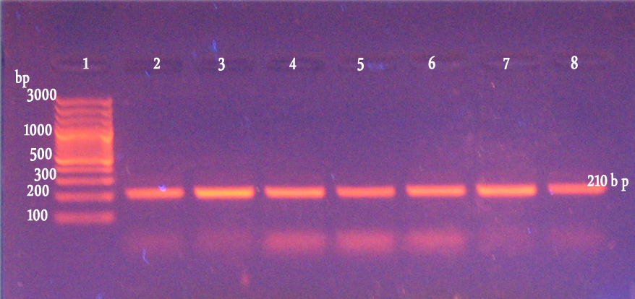  Fig(1):PCR ampliﬁcation of puriﬁed bacterial  DNA by using Universal primer  Lane (1):100 bp DNA Ladder  Lane 2-8: samples from milk buffalo | 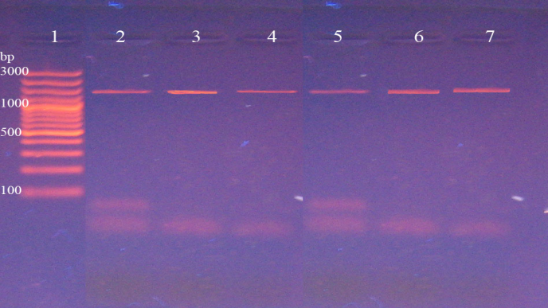  Fig(2):PCR ampliﬁcation of puriﬁed baterial DNA by using Sau primer  Lane (1):100 bp DNA Ladder  Lane 2-8: samples from milk buffalo
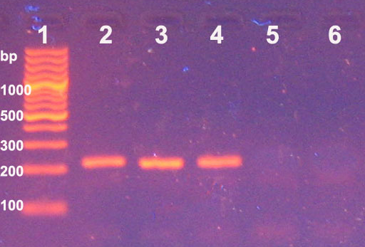  Fig(3):PCR ampliﬁcation of puriﬁed bacterial DNA by using E-coli primerLane (1):100 bp DNA LadderLane 2-6 samples milk buffalo  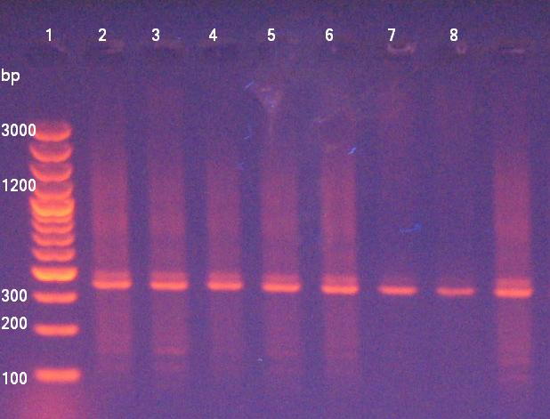  Fig(5): Electrophoretic pattern of VspA gene of Mycoplasma from milk buffalo  Lane (1):100 bp DNA Ladder  Lane 2-8: samples from buffalo | 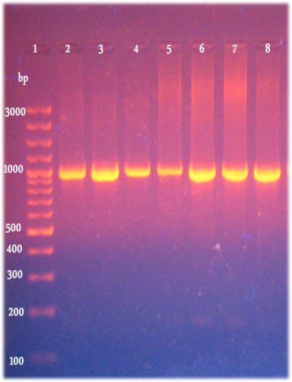  Fig(4)Electrophoretic pattern of 16SrRNA: gene of Mycoplasma from milk buffalo Lane (1):100DNA Ladder  Lane 2-8: samples from buffalo Milk.

2-Biochemical study of some milk serum constituents:
a-Clinical biochemical analysis:
Table(3)shows that LDH,ALP and GGT enzyme activities were significantly increased in SCM whey milk. However, the activity of AST was non-significantly changed in SCM buffaloes compared to healthy ones.
b-Milk serum immuno electrophoretic analysis:
Table (4) shows that an electrophoretic pattern of whey milk contains five fractions. Mastitis caused a significantly increased in non-casein total protein concentration of whey milk. Also, the content of milk serum albumin and immunoglobulin in whey milk were significant increased in mastitic buffaloes compared with that of healthy ones. While, the major whey proteins (beta- and alpha globulin) were significantly decreased in SCM-buffaloes compared with the healthy ones.

Table (1): Incidence of bacterial and mycoplasmal pathogens isolated from positive milk samples for CMT:
Species | Number | Incidence%
Staph.coagulase –ve  Staph.coagulase+ ve  Strept.agalactia  Strept.dysagalactia  Strept.uberis  Enterococcus species  E.coli  Klebsiella spp.  Acholeplasma spp.  Mycoplasma. bovis  Mycoplasma.bovirhinis  Mycoplasma.arginini  Negative samples for Bacterial Exam.. | 42  14  8  10  6  16  25  4  4  24  2  4  21 | 23.3  7.8  4.4  5.6  3.3  8.9  13.9  2.2  2.2  13  1.1  2.2  12
Total | 180 | 100

Percentages were calculated according to total positive samples for CMT.

Table (2): Antibiogram of the isolated milk organisms
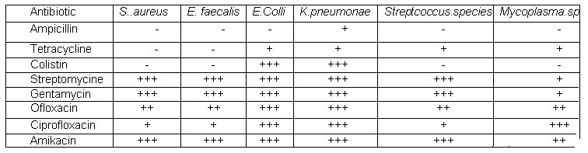
N.B:(0-30 %)= -, (35-45)=+, (65-75%)=++, (75-100 %)=+++

Table (3): The activities of some milk serum enzymes in mastitic and healthy buffaloes:
Milk enzyme  Groups | AsparatateAminotransferase (AST)(IU/L) | Alkaline phosphatase (ALP)(IU/L) | Gamma Glutamyl Tranferase (GGT)(IU/L) | LactateDehydrogenase (LDH-)(IU/L)
Control buffaloes | 21.40±2.80 | 282.8± 30.72 | 228.40± 42. | 83.264± 8.98
Mastitic buffaloes | 21.20 ^{NS}±3.22 | 551.6*± 90.71 | 754.60***±60 | 188.502**± 22.32
N.B.: *= Significant change between means (at P≤ 0.05), **= highly significant change between means (at P≤ 0.01),
***= very highly significant change between means (at P≤ 0.001); NS= non- significant change between means.

Table (4): The different protein fractions of why milk of mastitic and healthy buffaloes as determined by Immuno-electrophoresis:
Protein fractions of  milk Animal Groups | Total protein | β-Lact.  globulin | α-Lact.  globulin | Serum albumin | Immunoglobulin | Other  protein
Control buffaloes | 1.54 ±.034 | 0.51± 0.052 | 0.278± 0.026 | 0.289 ± 0.02 | 0.240± 0.025 | 0.22± 0.02
Mastitic buffaloes | 1.77***±0.01 | 0.486***±0.03 | 0.158*±0.035 | 0.43 ^{NS}±0.03 | 0.37 ^{NS} ±0.02 | 0.33 ^{NS} ±0.01
N.B.: *= Significant change between means (at P≤ 0.05), **= highly significant change between means (at P ≤ 0.01), ***= very highly significant change between means (at P ≤ 0.001),NS= non- significant change between means.

4. Discussion
Subclinical mastitis is one of the most serious diseases of cattle, as the infected animal shows no obvious symptoms and secretes apparently normal milk for a long time, during which causative organisms spread infection in the herd, This represents an important feature of the epidemiology of many forms of bovine mastitis (Bakken and Gudding, 1982). Early diagnosis of mastitis is a must for reduction of production losses and for enhancing the prospects of recovery. Also, the identification of subclinically infected gland is urgently required for successful control of mastitis in dairy animals (Ahmed et al., 2008).The present study was designed to investigate subclinical mastitis in the main Egyptian dairy animals which are buffaloes th produce 65% of dairy product with special concept to find a practical marker for its early diagnosis From table (1) we can find that the incidence of subclinical mastitis in buffaloes depending on the bacterial cultivation was the highest in S. aureus (31.1%), E. coli infection (13.9%), followed by, Enterococcus spp.(8.9%), S. dysgalactiae (5.6%) and S. agalactiae (4.4%) and Klebsiella spp.(2.2%). This comes in agreement with (El-Khodery and Osman, 2008) who reported that the bacteriological examination of buffaloes milk samples with acute mastitis revealed that coliform bacteria was the most common pathogen followed by S. aureus then S. uberis, and S. agalactiae. This also the results came to some extent with (Ahmed et al., 2008) who reported high incidence of bacteria isolated from milk samples of Egyptian buffalo-cows suffering from sub-clinical mastitis where the most prevalent isolates were E. coli (94.99%), S. epidermidis (78.33%), C. bovis (55%), Klebsiella spp. (51.67%), S. uberis (46/67%), S. aureus (33.33%) and S. agalactiae (31.67%).
An efficient vaccine against bacterial species causing bovine mastitis (BM)is not yet available, and prevention subclinical mastitis as a measure of control needs sensitive, rapid, and specific tests to identify the main bacteria that cause heavy losses in the dairy industry. Conventional procedures for the identification of BM pathogens are labor-intensive, and most of the commercial identification systems are not designed to identify important veterinary pathogens (Watts, 1989). We aimed to develop a detection and identification test for BM pathogens that produced results in 1 day, did not need a culture step, Sensitivity of the PCR assay in detecting DNA from milk new methods using PCR based on the 16S region sequences have been successfully applied for the identification of bacteria (Bentley, and Leigh. 1995 and Forsman et al., 1997). The major advantages of PCR lay in the possibility of using only nanograms of nucleic acid samples, allowing the elimination of culture as well as rapidity, and easy analysis. The present work concerned with the incidence of Bacterial and Mycoplasmal mastitis in dairy buffaloes in of Egypt. PCR assay is a good alternate culture, where it is rapid, sensitive, specific and can detect non-viable bacteria. (Biddle et al., 2004). In this work, the test directly performed from milk samples without a culture step, and is speciﬁc for E. coli, S. aureus.For mycoplasma two PCR assays used, a common 16S rRNA gene, (Königsson et al., 2002) used for detection of mycoplasmas from ruminant, while Vsp A gene specific for M. bovis.(Alberto et al., 2006). The isolated mycoplasma needed to be investigated with molecular tests specific for any of the suspected species. However, the presence of M. bovis in dairy herd need to be established quickly to prevent an epidemic event that could lead to significant economic losses. The neuroendocrine system and immune system metabolism interact to co-ordinate physiological responses to infection and inflammation (Ma et al., 2006; Gera and Guha, 2011b).
The CMT is a reliable, easy, rapid and cheap tool helping in diagnosis and still the gold-standard screening test for high somatic cell count(SCC) as it directs attention to individual mammary quarter that is secreting milk of high (SCC) (Leslie et al., 2002; Abdel-Rady and Sayed, 2009) but CMT not suitable in early lactation so the measurment of enzyme activiting appear to be suitable diagnostic method for identifying SCM in early lactation or in dry period (Babaei et.al.,2007). Mastitis is associated with changes in physical, chemical, bacteriological and organoleptic properties of milk, besides causing health hazards to the public (Riaz Hussain et al., 2012).It can be observed from Table (3) that the concentration of AST was non significantly changed comparable in infected and normal milk, which agrees with the previous findings of Babaei et al. (2007) and Gera et al. (2011)in why milk. Our study found significant elevation of ALP, GGTand LDH enzymes activities in mastitic milk compared with healthy one, this result is partially agree with (Chemale., 1986) which found an increased amount of ASTand GGT in53 milk samples of cows,which had been affected dy E-coli mastitis while our result is hand to hand with (Babaei et al., 2007) who found increase in ALP and LDHenzyme activities whey milk in the early diagnosisof subclinical mastitis.
In SCM the whey milk might characterized by the presence of leucocytes, and interstitial cells damaged during inflammation, particularly from disintegrated Leukocytes by bacterial toxins (Katsoulos et al., 2010 and Mohammadian, 2011). Table (4) showed that mastitis caused a significant increase (P≤ 0.001) in total protein concentration of whey milk. This mainly as a result of increased concentration of albumin and immunoglobulins in whey milk derived from blood (Ishikawa et al., 1982). Bacterial toxins alter the permeability of the secretory epithelium and capillary wall and the blood components are allowed to pass into milk by diffusion through the leaky blood milk barrier (Schultz,1977).The major whey proteins, (beta- and alpha-globulin) were significantly decreased while the content of serum albumin and immune globulin in milk increased significantly(P≤ 0.001and P≤ 0.05)respectively in mastitic why milk compared with healthy one. These results are in agreement with the results previously recorded in subclinical mastitic whey milk by(Rashed et al., 2002). The present effects can be attributed to both inflammatory damage of the mammary secretory tissue and destruction of blood-milk permeability barrier which restrict in transfer of protein from interstitial fluid into milk (Katsoulos et al., 2010).

Conclusion
Based on the current study,it could be concluded that dispite the CMT still the gold standard for daignosis of SCM, it could not detect disease in early lactation and dry periods, so it may be recommended that the changes of whey milk enzymes activities(GGT, ALP and LDH)which are associated with the presence of isolated pathogenic bacteria and mycoplasma species(as confirmed by the current molecular study)could be used as indicators for the subclinical mastitis in buffaloes especially in early lactation and dry periods.

References
- Abdel-Rady A, Sayed M (2009): Epidemiological studies on subclinical mastitis in dairy cows in Assiut Governorate. Veterinary World 2:373-380.
- Ahmed WM, Sherein I, Ghada M Nabil (2008): Observations on sub-clinical mastitis in buffalo- cows with emphasis on measuring of milk electrical resistance for its early detection. Global Veterinaria 2:41-4
- Alberto, A.; Addis, M.F.; Chessa, B.; Cubaddu, T.; Profiti, M.; Rosati, S.; Ruiu, A. andPitau, M (2006):Molecular and antigenic characterization of a Mycoplasma bovis strain causing an outbreak of infectious keratoconjunctivitis. J. Vet. Diagn. Invest. 18: 41-51.
- Anand Kumar P (2009): Evaluation of PCR test for detecting major pathogens of bubaline mastitis directly from mastitic milk samples of buffaloes. Trop Anim Health Prod 41:1643–1651.
- Atasever S (2012): Estimation of correlation between somatic cell count and coagulation score of a bovine milk. Int. J. Agric. Biol. 14:315–317.
- Babaei, H., N. Mansouri, M. M. Molaei, A. Kheradmand and M. Sharifan. (2007): Assessment of lactate dehydrogenase, alkaline phosphatase and aspartate aminotransferase activities in cow's milk as an indicator of subclinical mastitis. Vet. Res. Commun. 31: 419-425.
- Bakken G, Gudding R (1982): The interdependence between clinical and subclinical mastitis. Acta Agri.Scandin 32:17
- Belfied, A. and Goldberg, D.M. (1971):”Method for determination of alkaline phosphatase.:Enzyme, 12:561-564.
- Bentley, R. W., and J. A. Leigh. (1995): Development of PCR-based hybridization protocol for identification of streptococcal species. J. Clin. Microbiol. 33.
- Biddle M.K., Fox L.K., Hancock D.D., Gaskins C.T. and Evans M.A.,(2004): Effects of storage time and thawing methods on the recovery of Mycoplasma species in milk samples from cows with intramammary infections, Journal of Dairy Science 87 933–936
- Blood DC, Henderson JA (1986) Veterinary medicine, 3rd ed., London: BaillierTindall and Gassel.
- Cabaud, P. G and Wroblewski, F., (1958): Colorimetric measurement of Lactic dehydrogenase activity of body fluids. American Journal of Clinical Pathology,30,234-236.
- Boone, D. R. and Castenholz, R.W.(2001): Bergey,s Manual of systemic Bacteriology second Ed.Vol. (1), USA.
- Cai HY, Archambault M, Gyles CL, Prescott JF (2003): Molecular genetics methods in the veterinary clinical bacteriology laboratory: current usage and future applications. Animal Health Research Reviews 4: 73–93.
- Chemale C.A.(1986): Endotoxin Best immung in Blut und beim Rindunter besondere Berucksichtigung der Koli-Mastitis.Aus der klinik fur Geburtshilfe und Gynakologie des Rindes. Hannover.1986.
- Clyde, W. A. (1964): Mycoplasma species identification based upon growth inhibition by specific antisera. J. Immunol., 92: 958 - 965. Forsman, P., A. Tilsala-Timisjarvi, and T. Alatossava. 1997. Identification of staphylococcal and streptococcal causes of bovine mastitis using 16S–23SrRNA spacer regions. Microbiology 143:3491–3500.
- Davis, B.J. (1964): Direct electrophoresis (Method and application to human serum protein). Ann. N.Y.Acad.Sci.121,404-427.
- Eissa, S. I. (1986): Some studies on Mycoplasma mastitis in cattle and buffaloes in Egypt. Ph. D. thesis, Alexandria. University.
- El-Ebeedy, A. A.; Gad, A. S.; Amal Rashwan; Mostafa A.; El-Ahl S.S and Ismail, S. and Allam, N. M. (1985): Isolation of Mycoplasma bovis from an outbreak of bovine mastitis in Egypt. J. Egypt. Vet. Med. Ass. 45 (1), 247-253.
- El-Khodery SA, Osman SA (2008): Acute coliform mastitis in buffaloes (Bubalus bubalis): clinical findings and treatment outcomes. Trop Anim Health Prod 40:93-9.
- Erno, H. and Stipkovits, L. (1973): Bovine mycoplasmas: Cultural and biochemical studies. Act. Vet. Scand., 14: 450 – 463.
- Fabricant, J. and Freundt, E. A. (1967): Importance of extension and standardization of laboratory tests for the identification and classification of mycoplasmas. Ann. N. Y. Acad. Sci.: 143:50 - 58.
- Finegold SM, Baron EJ (1986):”Diagnostic Microbiology” 7th Edition. The C.V. Mosby Co. St. Louis, London. The biochemical characterization and serological identification.
- Forsman, P., A. Tilsala-Timisjarvi, and T. Alatossava. (1997): Identification of staphylococcal and streptococcal causes of bovine mastitis using 16S–23SrRNA spacer regions. Microbiology 143:3491–3500.
- Freundt, E.A; Anderson, BE.; Erno, N.; Kunze, M. and Blank, F.T. (1973): The sensitivity of Mycoplasmatales to sodium polyanethol sulphate and digitonin. Zbl.Back. Parasit. Infehtkr. Hyg. L. Abt. Drig. A.225:104-112
- Guha A, Gera S, Sharma A (2012): Evaluation of milk trace elements, lactate dehydrogenase, alkaline phosphatase and aspertate aminotransferase activity of subclinical mastitis as and indicator of subclinical mastitis in riverine buffalo (Bubalus bubalis). Asian-Austral. J. Anim. Sci. 25:353-360.
- Gera, S.and A. Guha. (2011) b: Evaluation of lactate dehydogenase, alkaline phosphatase and aspartate aminotransferase activity in milk as an indicator of subclinical mastitis in Holstein x Haryana cows. Ind. J. Vet. Res. 20:48-53.
- Ishikawa, H.; Shimizu, T.; H.; Saito, N. and Nakano, I. (1982): "Protein composition of whey milk from subclinical mastitis and effect of treatment with levamisole."J.Dairy Sci., 65 (4):653-658.
- Katsoulos, p. D., G. Christodoulopoulos, A. Minas, M. A. Karatzia, K. Pourliotis and S. K. Kritas. (2010): The role of lactate dehydrogenase,alkaline phosphatase and aspartate aminotransferase in the diagnosis of subclinical intramammary infections in dairy sheep and goats. J. Dairy Res.77:107-111.
- Königsson, M. H; Bölske G. and. Johansson, K.E (2002): Intraspecific variation in the 16S rRNA gene squences of Mycoplasma agalactiae and Mycoplasma bovis strains, Veterinary Microbiology 85 pp. 209–220
- Kumar, S and Mikolajcik, E. M. (1972): Electrophoretic immunoelectrophoretic and ultracentrifugal characterization of protein in whey fractions." J. Dairy Sci., 9:1237-1242.
- Leslie KE, Jansen JT, Lim GH (2002): Opportunities and implications for improved on-farm cow side diagnostics. Proc De Laval Hygiene Symp 147-160.
- Lipkin, E., A. Shalom, H. Khatib, M. Soller, and A. Friedmann. (1993). Milkas a source of deoxyribonucleic acid and as a substrate for the polymerase chain reaction. J. Dairy Sci. 76:2025–2032
- Ma, J. L., J. F. Wang, L. X. Wu, T. Lai and Y. H. Zhu. (2006): Changes in micromineral, magnesium, cytokine and cortisol concentration in blood of dairy goats following intra-mammary inoculation with Staphylococcus aureus. J. Dairy Sci. 90:4679-4683.
- Mohammadian, B. 2011. The effect of subclinical mastitis on lactate dehydrogenase in dairy cows. Int. J. Anim. Vet. Adv. 3:161-163.
- McDowell, R.E., Wilk, J.C., Shah, S.K., Balain, D.S. and Metry, G.H. (1995). Potential for commercial dairying with buffaloes. North Carolina State University, USA.
- Mehdi Chavoshi,Jamalhusaini(2012):Buffalo subclinical mastitis bacterial pathogens in Iran. International conference on Bionedical Engin. and Technol. vol.34(2012).
- Oliszewski R, MS Nunez De Kairuz, SN Gonzalez De Elias and GOliver, (2002): Assessment of β- glucuronidase levels in goat’s milkas an indicator of mastitis: comparison with other mastitis detection methods. J Food Prot, 65: 864-866.
- Persijn, J. P. and van der Slik, W. 1976. A new method for thedetermination of gamma-glutamyltransferase in serum. Journal of Clinical Chemistry and Clinical Biochemistry 14: 421-427.
- Rashed, M.A.;Mogda, K., Mansour, K. H. and Koritum, Kh.M. (2002): Biochemical changes in blood and milk of mastitic cows.Egypt.J. Comp. Clinic. Path., 15:74-83.
- Reitman, S. and Frankel, S. (1957): ”Acolorimetric determination of serum glutamic oxaloacetic acid glutamic pyruvic transaminase.” Am. J. Clin. Path., 28:56-58.
- Riaz Hussain, Ahrar Khan, M. Tariq Javed and Farzana Rizvi (2012): possible risk factors associated with mastitis in indigenous cattle in Punjab, Pakistan. Pak.Vet. J,2012,32(4):605-608.
- Sabry, M. Z. and Ahmed, A. A.(1975): Evaluation of media and culture procedure for the primary isolation of Mycoplasma from female genitalia of farm animals. J. Egypt. Vet. Med. Assoc. 35, 18-34. Erno, H. and Stipkovits, L. (1973). Bovine mycoplasmas: Cultural and biochemical studies. Act. Vet. Scand., 14: 450 - 463.
- Saleh IA (2005): Studies on milk production of buffaloes. Ph. D. thesis, Fac. of Agric. Mansoura Univ. Egypt.
- Samboork, J., E. Fritsch and T. Maniatis, 1989. Molecular cloning: A laboratory manual, second edition. Cold Spring Harbor Laboratory Press.

- Schalm OW, Noorlander DO (1957) Experiments and observation sleading to development of the California mastitis test. J. Am. Vet. Med. Assoc.130:199–204.
- Schalm OW, Carrol, Jain NC (1971): Bovine mastitis. 1st Ed. Lea and Febiger, Philadelphia, USA.
- Schultz, L. H. (1977): Somatic cells in milk physiological aspects and relationship to amount and composiyion of milk. J. of Ford Protection, 40:125-131.
- Seleim RS, Rashed Amany YM, Fahmy BGA (2002): Mastitis pathogens: attachment-related virulence features, whey protein markers and antibiotic efficacy in cows. Vet. Med. J. Giza 50:405. 17.
- Sendecor, G. W. and W. G. Cochran (1982. Iowa s): Statistical methods.7th.ed tate Univ. press. Ames, Iowa.
- Sonnen wirth, A.C and Jaret, L. (1980): Gradwal's Clinical Laboratory Methods and Diagnosis. Vol. (1) 8th.ed, pp258-259. The C.V. Mosby Co. St. Louis, Toronto, London.
- Watts, J.L., 1989. Evaluation of the Minitek Gram-Positive Set for identification of streptococci isolatedfrom bovine mammary glands. J. Clin. Microbiol., 27: 1008-1010.
- Yuan-Yuan Chen, Zheng-TaoYang, Wen-Bo Liu, Qiao-Cheng Chang, Li-Guo Wang and Nai-Sheng Zhang, (2012): Prevalence and Major Pathogen Causes of Dairy Cows Subclinical Mastitis in Northeast China. Journal of Animal and Veterinary Advances, 11: 1278-1280.

5/28/2013

