Decreasing the Error of Sales Forecasting by Fitting the Data

Hassan Soltani

Department of Management, Neyriz Branch, Islamic Azad University, Neyriz, Iran

Abstract: This research plan was done in the industrial production company named Beta. This company owns four branches; therefore, the population is Beta Company and its four branches and 2007, 2008, 2009, 2010 and 2011 were selected as samples. The method was the analytical-descriptive; therefore, data analysis was done in several stages as follows;A: Sales forecasting for 2007, 2008, 2009, 2010 and 2011 with different methods including Naïve, simple moving average, weighted moving average and exponential smoothing methods. B: Error of sales forecasting of the above-mentioned methods are calculated and compared. C: Since the Company owns four branches, at this stage, the statistics of customers’ referring each branch per hour is regarded as the independent and the real sales amount per hour as the dependent variables. D: using the mathematical relations, we achieve an equation with which the company can forecast the sales rate and minimize the error of prediction, which is called as “fitting”. E: Finally, the results achieved from fitting are compared with the predictions to determine whether fitting data can affect the error of sales forecasting. The results show that fitting the sales data results in decreasing the error of sales forecasting by using the least square method.
[Hassan Soltani. Decreasing the Error of Sales Forecasting by Fitting the Data. N Y Sci J 2013;6(8):8-10]. (ISSN: 1554-0200). http://www.sciencepub.net/newyork. 2

Keywords: Fitting data, Sales forecasting, Error of prediction

1. Introduction
Sales forecasting is an organizational activity that is stated as the first step in marketing programs and is executable for all the work domains and is considered as an art and a comparative advantageous which results in prioritizing of the organization. Even if the prediction does not always have a formal and correct form, it plays a significant role in programming and decision-making. Therefore, prediction is considered as a useable activity for the high-rank management and for all the internal tasks of the organization especially the marketing. Every manager deals with prediction in his decision-making. Some of these predictions are easy yet some complicated and difficult. The predictions can be done for a short-time or a long-time period. Of course, prediction never fit with reality and the predictor should try to minimize the error of prediction (Tull, D. S. (1967).
The scholars of management have invented different techniques for forecasting so far and gave them to the managers. Each technique has its own application through which more successful forecasts can be done. Managers should try to select a responsive forecasting model which is in accordance with the activities and needs of the organization. In most of the cases a simple model can present better results than a complicated model. Therefore, one of the main issues managers are dealing with is forecasting the future events so that they present and administer appropriate programs through getting aware of the changes (Gardner, E.S. and Anderson, E.A. (1997).
Every successful research must be provided with necessary information. The information is adapted through collected data. The connective circle is between one question and finding a scientific response and adapting information. Data collection methods depend on the research question and the research type (Coope, I.D. (1993).
In descriptive research, variables are chosen and observed; they are not usually manipulated by the researcher; therefore, no condition is created for the events. The population is extensive and unlimited in such researches and sampling is the main element of these researches. The domain of descriptive researches is unlimited and extensive. Therefore, some scholars believe that they include all types of research methods except the historical and experimental methods. The researcher tries to report whatever is seen without any manipulation or mental inference and to take the objective results from the situation (Armstrong, J. S., Brodie, R. and McIntyre, S. (1987).
The researcher’s aim is the objective, real and regular description of the specifications of a situation or a subject in descriptive researches. In other words, in such researches the researcher tries to report “what there is” without any interference or mental inference and takes the objective results from the situation. The reason for carrying out such researches is to answer such questions as “how much”, “which”, “what is happening?” The descriptive research describes and interprets what there is and pays attention to the conditions or the available relations, common ideas, current procedures of observed effects or developing procedures and its attention is firstly focused on the present; although, the past events and works that are related to the available conditions are also studied and examined.

Table1: of Error of Forecasting in Different Forecasting Methods (2007-2011)
Year | Simple Average Method | Moving Average Method | Moving Weighted Average Method | Exponential Smoothing Method | Naïve Method
2007 | 13612 | 7000 | 4663 | 5323 | 7100
2008 | 12696 | 6621 | 6486 | 10243 | 4700
2009 | 5536 | 6966 | 5783 | 6253 | 6800
2010 | 9043 | 5767 | 10033 | 5768 | 5400
2011 | 7051 | 7298 | 6566 | 8227 | 4750

Figure 1: Comparing Diagram of Error of Forecasting in Different Forecasting Methods (2007-2011)

Fitting Data:
This method defines the mathematical relation between dependent and independent variables and the simplest relation is a linear relation.

$\begin{aligned}\frac{\sum{y_{i}}}{n}=\frac{\sum{α}}{n}+\frac{β\sum{X_{i}}}{n}⇒\bar{y}=α+β{\bar{X}}_{i} , a=\bar{y}−β{\bar{X}}_{i} \\ \frac{δ\sum{e_{i}^{2}}}{\text{δβ}}=−2\sum{X_{i}}(y_{i}−α−{βX}_{i})=0 \\ \sum{X_{i}y_{i}}=α\sum{X_{i}}+{βX}_{i}^{2} \\ \sum{X_{i}y_{i}}−\bar{y}X_{i}=β(\sum{X_{i}^{2}}−\bar{X}\sum{X_{i}}) \\ β=\frac{\sum{X_{i}y_{i}−\bar{y}\sum{X_{i}}}}{\sum{X_{i}^{2}}−\bar{X}\sum{X_{i}}}\end{aligned}$And
$$\begin{aligned}β=\frac{n\sum{X_{i}}y_{i}−\sum{X_{i}y_{i}}}{n\sum{X_{i}^{2}}−(\sum{X_{i}})^{2}} \\ α=\frac{\sum{y_{i}−β\sum{X_{i}}}}{n} \\ α=\bar{y}−β\bar{X}\end{aligned}$$
$y_{i}^{e}=α+β_{1}X_{1}+β_{2}X_{2}$, if there is a relation between a dependent and independent variable, the estimated equation is used.
$$\begin{aligned}\sum{e^{2}}=\sum{[y_{i}−(α+β_{1}X_{1}+β_{2}X_{2}]^{2}} \\ \frac{δ\sum{e^{2}}}{\text{δα}}=−2\sum{(y_{i}−α−β_{1}X_{1}−β_{2}X_{2}})\end{aligned}$$
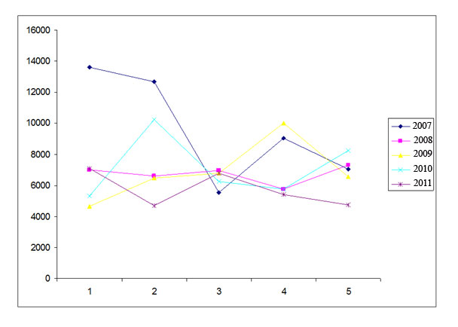
The necessary condition for minimizing the collection of squares is that the derivate is zero. As a result we will have:
$$\begin{aligned}\sum{y_{i}}=\sum{α+β_{1}}\sum{X_{1}}+β_{2}\sum{X_{2}} \\ \frac{δ\sum{e^{2}}}{{\text{δβ}}_{1}}=−2\sum{X_{1}}(y_{i}−α−β_{1}X_{1}−β_{2}X_{2})=0 \\ \sum{X_{i}y_{i}}=α\sum{X_{1}}+β_{1}\sum{X_{1}^{2}}+β_{2}\sum{X_{1}X_{2}} \\ \frac{δ\sum{e^{2}}}{{\text{δβ}}_{2}}=−2\sum{X_{2}}(y_{i}−α−β_{1}X_{1}−β_{2}X_{2})=0 \\ \sum{X_{2}y_{i}}=α\sum{X_{2}}+β_{1}\sum{X_{1}X_{2}}+β_{2}\sum{X_{2}^{2}}\end{aligned}$$
If the guaranteed equation is $y_{i}^{e}=α+α_{1}X_{i}+α_{2}X_{i}^{2}$the sum of squares will be:
$$\text{min}=\sum{e^{2}}=\sum{(y_{i}−α−α_{1}X_{i}−α_{2}X_{i}^{2}})^{2}$$
$$\frac{δ\sum{e^{2}}}{\text{δα}}=−2\sum{(y_{i}−α−α_{1}X_{i}−α_{2}X_{i}^{2}}=0$$
The necessary condition for minimizing is that the derivatives are equal to zero. Therefore we will have:

$$\begin{aligned}\sum{y_{i}}=\sum{α+α_{1}}\sum{X_{i}}+α_{2}\sum{X_{i}^{2}} \\ \frac{δ\sum{e^{2}}}{{\text{δα}}_{1}}=−2\sum{(y_{i}−α−α_{1}X_{i}−α_{2}X_{i}^{2}})−X_{i}=0\end{aligned}$$
$\begin{aligned}\sum{X_{i}y_{i}}=\sum{{αX}_{i}+α_{1}}\sum{X_{i}^{2}}+α_{2}\sum{X_{i}^{3}} \\ \frac{δ\sum{e^{2}}}{{\text{δα}}_{1}}=−2\sum{(y_{i}−α−α_{1}X_{i}−α_{2}X_{i}^{2}})−X_{i}^{2}=0\end{aligned}$$\sum{X_{i}^{2}}y_{i}=\sum{{αX}_{i}^{2}}+α_{1}\sum{X_{i}^{3}}+α_{2}\sum{X_{i}^{4}}$

In order to achieve the estimated equation that is related to branches of the related company, we should regard the information of company’s customers as well as the real sales rate per hour as the criterion. The following amounts have been calculated;
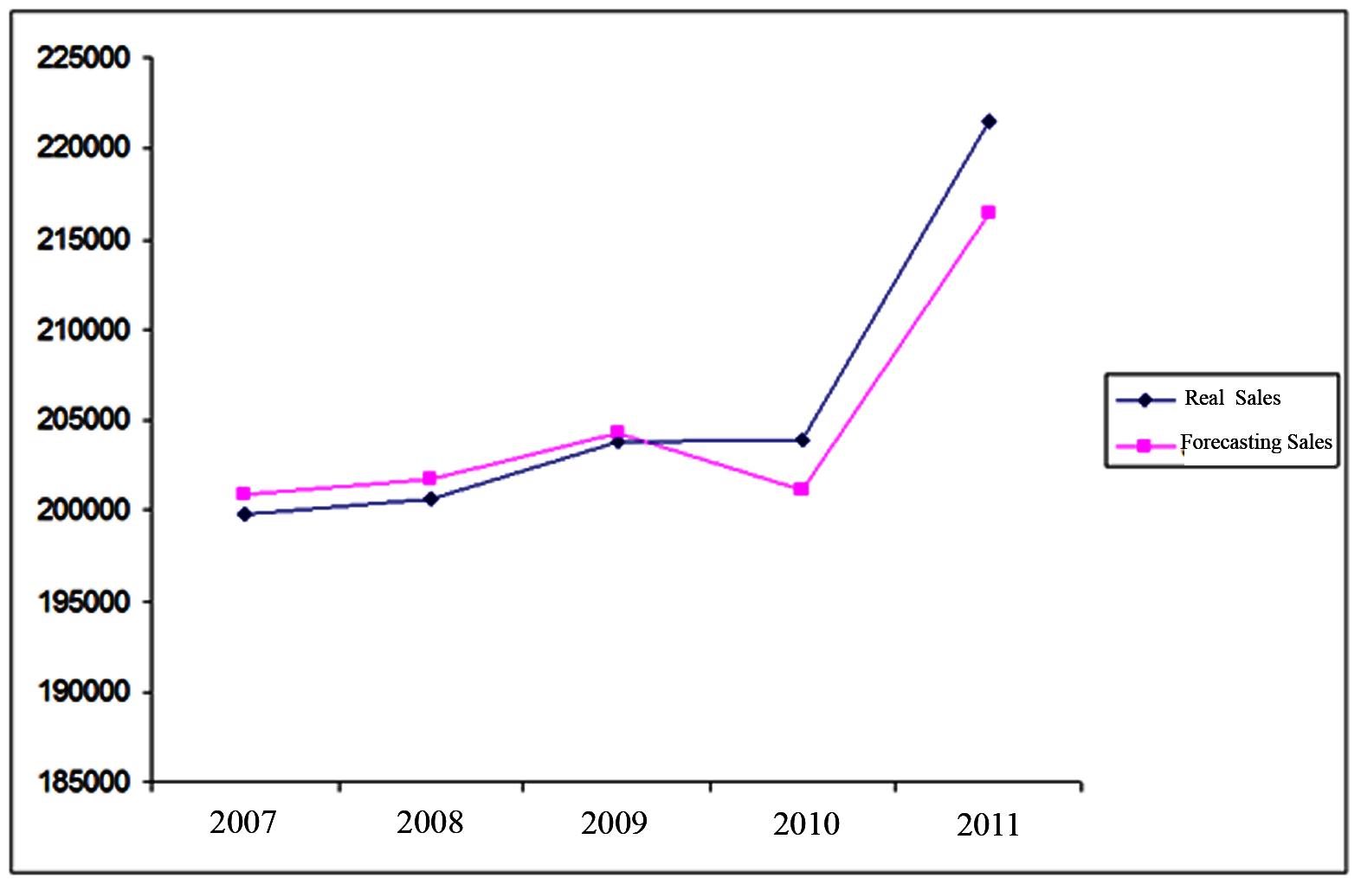
$\begin{aligned}\sum{X_{i}}=\text{129}\sum{y_{i}}=\text{199800}\sum{X_{i}^{2}}=\text{4205} \\ \sum{X_{i}^{3}}=\text{138483}\sum{X_{i}^{4}}=\text{4604897}\sum{X_{i}y_{i}}=\text{6480400} \\ \sum{X_{i}^{2}}y_{i}=\text{212425400}\end{aligned}$
Regarding the calculations the main equation of forecasting is as follows;
$$y_{i}=\text{199442}+0\text{.}\text{004}X_{i}+0\text{.}\text{085}X_{i}^{2}$$
Now, based on the achieved forecasting equation, we calculate the forecasting amount per year;
1. Calculating the rate of sales forecasting for 2007
The real sales rate in 2007 is equal 199800 although the amount of forecasted sales is equal to 200856 based on the above-mentioned equation. The error of forecasting in 2007 is equal to 1077.
2. Calculating the rate of sales forecasting for 2008
The real sale rate in 2008 is equal to 200600 although the sales forecasting amount was equal to 201756 and the error of forecast is equal to 1156 in 2008
3. Calculating the rate of sales forecasting for 2009
The real sale rate in 2009 is equal to 203800 although the sales forecasting amount was equal to 204257 and the error of forecast is equal to 457 in 2009.
4. Calculating the rate of sales forecasting for 2010
The real sales rate in 2010 is equal to 203900 although the sales forecasting amount was equal to 201132 and the error of forecast is equal to 2768 in 2010.
5. Calculating the rate of sales forecasting for 2011
The real sale rate in 2011 is equal to 221500 although the sales forecasting amount was equal to 216427 and the error of forecast is equal to 5037 in 2011.

The Comparison Table of Real and Forecasting Sales after Fitting the Data (2007-2011)
Year | Real Sale | Forecasted Sale | Error of Forecasting
2007 | 199800 | 200856 | 1056
2008 | 200600 | 201756 | 1156
2009 | 203800 | 204257 | 457
2010 | 203900 | 201132 | 2768
2011 | 221500 | 216427 | 5037

Figure 2. The Diagram of Comparing Real and Forecasting Sales after Fitting Data (2007-2011)

Acknowledgements:
Author is grateful to the Department of Management, Neyriz Branch, Islamic Azad University for financial support to carry out this work.

Corresponding Author:
Hassan Soltani
Department of Management, Neyriz Branch, Islamic Azad University, Neyriz, Iran

References
- Armstrong, J. S., Brodie, R. and McIntyre, S. (1987). “Forecasting methods for marketing,” International Journal of Forecasting 3: 355-76.
- Coope, I.D. (1993). "Circle fitting by linear and nonlinear least squares". Journal of Optimization Theory and Applications 76 (2): 381.
- Gardner, E.S. and Anderson, E.A. (1997). “Focus forecasting reconsidered,” International Journal of Forecasting, 13: 501-08.
- Hanke, John E. and Wichern, Dean W. 2005.Business Forecasting, Pearson Education, New Jersy.
- Schnaars, S. P. (1984) ‘Situational factors affecting forecast accuracy,” Journal of Marketing Research, 21: 290-7.
- Tull, D. S. (1967) “The relationship of actual and predicted sales and profits in new-product introductions,”Journal of Business 40: 233-50.

6/18/2013

