Synthesis and Characterization of LaMnO₃ Nanofibers by Electrospinning Techique

¹Zin Min Myat, ²Than Than Win, ³Yin Maung Maung and ⁴Ko Ko Kyaw Soe

¹Department of Physics, Dagon University, Myanmar,²Department of Physics, University of Yangon, Myanmar, ³Department of Physics, Kyaingtong University, Myanmar, ⁴Pro-Rector, Yangon Institute of Education, Myanmar
¹archewtt@gmail.com, ²thannthannwinn@gmail.com,³dryinmgmg@gmail.com, ⁴dr.kokokyawsoe@gmail.com

Abstract: This paper aimed to prepare the synthesis of LaMnO₃ nanofibers by electrospinning technique using a solution that contained polyvinyl alcohol (PVA) and a sol-gel solution of LaMnO₃. LaMnO₃/PVA perovskite-type nanofibers were obtained after annealed at 500°C, 600°C, 700°C and 800°C for 2h respectively. Thermal properties of LaMnO₃ samples were examined by TG-DTA. Phase formation and crystal structure of LaMnO₃ nanopowders were characterized by X-ray diffraction (XRD). FESEM images revealed that LaMnO₃ as-spun nanofibers on Al foils were attracted to be between 60-120 nm in diameters with electrospinning set-up for 15 min. The crystal structure, fiber diameters and morphology of LaMnO₃ nanofibers were influenced by the calcination temperatures. The qualifications of LaMnO₃ nanofibers were successfully yielded by the electronspinning technique as final products.
[Zin Min Myat, Than Than Win, Yin Maung Maung and Ko Ko Kyaw Soe. Synthesis and Characterization of LaMnO₃Nanofibers by Electrospinning Techique. N Y Sci J 2013;6(9):101-106]. (ISSN: 1554-0200). http://www.sciencepub.net/newyork. 17

Keywords: Electrospinning set-up, LaMnO₃ Nanofibers, TG-DTA, XRD and FESEM.

- Introduction
In recent years, nanotechnology has become one of the most important and popular fields in research area of science subjects. On nanoscale, chemistry, physics, biology, electronic, material science and engineering subjects start to converge and the distinctions as to which property a particular discipline contribute to understanding and exploiting the possibilities offered by nanotechnology. Nanoscale materials have been used for many decades in several applications and apportunities. (D.H.Reneker, and I. Chun, 1995)
Polymeric nanofibers can be made using the electrospinning process, which has been described in the literature and in patents. Electrospinning is a relatively simple technique to produce nanofibers from polymer solutions. Electrospinning uses an electric field to draw a polymer melt or polymer solution from the tip of a capillary to a collector. The electrospinning process has been documented using a variety of polymers. (J.Doshi., D.H Renker, 1995, I. Chun, et al 1999). Nanofibers are successfully grown by electrospinning method as a non-woven mat. Nanofibers can be identified as fibers having diameter between tens and hundreds of nanometers. (G.Srinivasan et al 1995, Sauther BP 2005) The electrospinning process is an interesting and well-investigated physical phenomenon and has been an attractive subject for theoretical investigations an attractive subject for theoretical investigations of several groups. Nowdays, electrospun nanofibers have many advantages such as filtrations, affinity membranes, recovery of metal ions, tissue engineering scaffolds, energy storage sensors and protective clothing. (Fang et al 2008) Nanofibers of electrostatic polymers have received great attention recently because of their unique and useful properties. New and unrelated properties may arise from size confinement which may be important for several applications in electronic devices, optics and biomedical materials. (A.G Mac Diarmid, et al 2001, M.H Yun, et al 2004, G.E Wnek, etal 2003). Nanotechnology is the engineering of systems and materials at the molecular scale. As far as nanomaterials are concerned LaMnO₃ nanofibers is one of the candidates which has been attracting due to its numerous interesting properties. (A. Barnabe, et al 2004) Perovskite-type LaMnO₃ hav e attracted a great interest for the development of environment friendly catalytic materials. At high temperature, LaMnO₃ has simple cubic provskite type. Based on this type, LaMnO₃ nanofibers were successfully characterized by electrospinning technique. (E.A Kotomin 2003, E Heifets, 1998, S Amoruso, et al 2005).

- Material and Methods
LaMnO₃ powder was firstly prepared by using pyrolysis method. The raw materials of lanthanum chloride, manganese chloride were chosen as starting materials. All chemicals were analytical grade and directly used as received without further modification. Distilled water was used as solvent. Firstly, LaCl_{3.}7H₂O and MnCl₂. 4 H₂O solutions were mixed together and stirring with magnetic stirrer for 6 h at room temperature. During strirring, (NH₄)₂CO₃ ammonium carbonate was poured drop by drop in this mixture solution until to get nomogeneous and appropriate solution. The precipitates were collected by filtration to obtain the cream of LaMnO₃ composite mixture. Thus LaMnO₃ powder was obtained when calcinations temperature was 1000 °C for 30 min. After that, these powders were operated by ball-milling for 35 h to reduce the particle size. The crystallization quality as well as out-of-plane and in-plane orientation was characterized by X-ray diffraction (XRD) Thermal analysis of LaMnO₃ powder was studied by TG-DTA.
In this research, the flowchat of experimental procedure of LaMnO₃ nanofibers was shown in figure 1. Polymeric LaMnO₃ nanofibers can be made by using electrospinning method. LaMnO₃ powders, PVA and distilled water were chosen as the starting chemicals and solvent. LaMnO₃ nanofibers were formed by calcinating of composite fibers, sol-gel process was used. 0.75 g of LaMnO₃ was mixed in 10 g of PVA. These mixtures were dissolved in 50 cc of distilled water at room temperature. Then, these solutions were stirred vigorously to gel the homogeneous precursor sol-gel by magnetic stirrer for 3 h at room temperature. After stirring, the temporary solutions were kept at room temperature for 24 h, a viscous gel of PVA/ LaMnO₃ composite was obtained, and that sol-gel was determined by measuring its viscosity. The solution gel was expected to be viscous enough for electrospinning process.

.
Lanthanum
Chloride
Manganese
Chloride
Ammonium
Carbonate

LaMnO₃
nano particles
Poly vinyl
Alcohol (PVA)

LaMnO₃
sol-gel
used electrospinning technique

LaMnO₃
Nanofibers

Figure 1. Flowchart of preparation of LaMnO₃ Nanofibers.

- Preparation of Electrospinning set-up for LaMnO₃ Nanofibres
Electrospinning is a technique that can be used to produce nanofibres under the influence of an high electric field. With the production of nanofibres, nanotechnology extends its application to a vast area. Nanofibres can be made of Lanthanum Manganite by electrospinning technique. Home-made electrospinning set-up was firstly constructed. The high voltage applied in this work was 10 kV ~ 30 kV. The home-made electrospinning apparatus contained a needle or spinneret, high voltage power supply and a grounded collector. High voltage power supply which was transferred from 21 inches TV fly pad (219 x 6 M, Toshiba) indirectly. To obtain the capable of producing the high voltage in the range 10 kV ~ 30 kV, 60 of 10 MΩ resistors were used in series connection. It was known by using high voltage probe that produces maximum voltage 30 kV but the operating voltage was 27 kV. A syringe holder and a collector were kept in the cylindrical shape of glass tube, length of 36.3 cm and inside diameter was 8.45 cm, 10 cm apart from each other. DC voltage generator of positive terminal was connected with hypodermic needle (0.55 mm x 25 mm) and the circular shape of Al collector which was connected by negative terminal of power supply as system ground. In order to create an electric field the system must contain along with the charged needle, a grounded plate. This conductive plate completes a circuit and allows a strong electric field to be created between the needle and the plates. This grounded plate also serves as the collector for the completed nanofibre web that is fabricated during the electrospinning process. The schematic diagram of electrospinning set-up was shown in figure 2.
Before supplying the power, glass tube was created as vacuum condition by using vacuum pump and also tested by vacuum tester.
The electrospinning process was taken place in a cylindrical shape glass tube. There are basically three components such as high voltage supplier, capillary tube and a metal collecting screen. In the electrospinning process, a high voltage was applied to create an electrically charged jet of colloidal solution which solidified to leave a fibre. One electrode was placed into the spinning solution and the other attached to a colloidal solution. This induced a charge on the surface of the liquid. In this way a charged jet of liquid was ejected from the tip of the capillary tube. A voltage was applied to the polymer solution which causes a jet of the solution to be drawn toward a grounded collector. The fire jets dry to form polymeric fibres, which can be collected on a web. The electrospinning process has been documented using a variety of LaMnO₃ nanofibres forming polymers. And then, it was heat-treated at 500 °C, 600 °C, 700 °C and 800 °C for 2 h respectively.

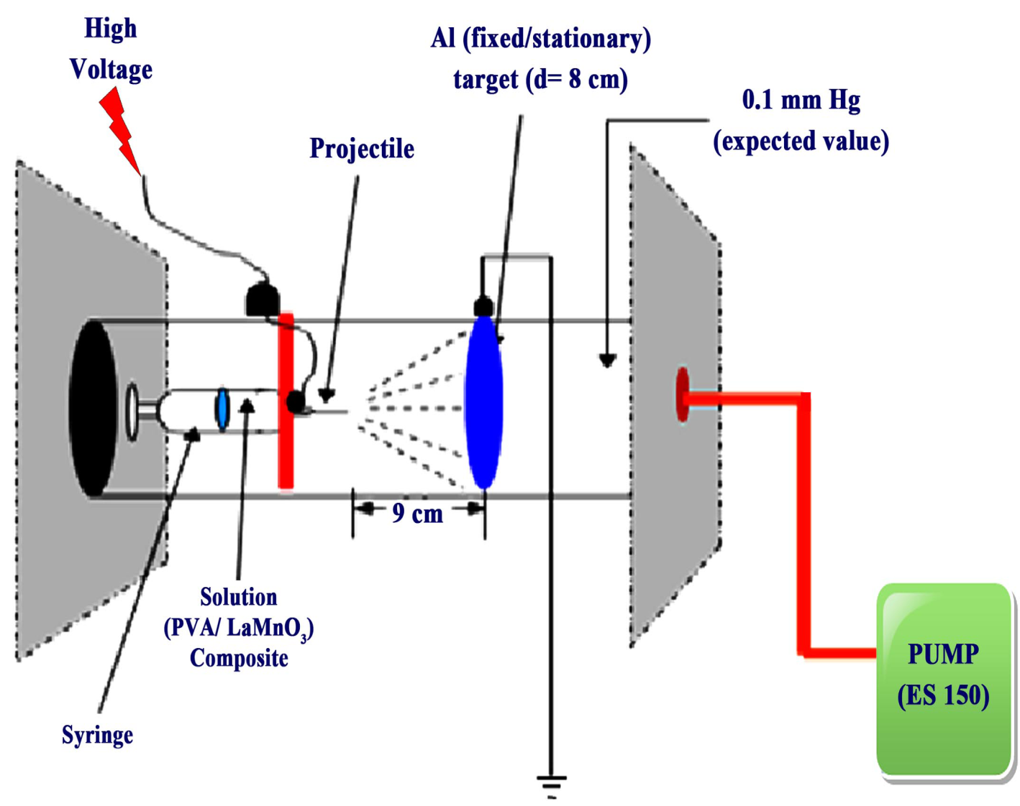

Figure 2. Schematic diagram of electrospinning set-up

- Results
Thermal analysis curve of LaMnO₃ powder was shown in figure 3 (a) and (b). It was noted that the DTA of the LaMnO₃ of mixed carbonate showed four district endothermic peaks in DTA curve. The endothermic peak at 170°C may be due to the loss of moisture from the LaMnO₃ composite sample. The endothermic peak at 170 °C corresponds to do the decomposition takes place in three steps corresponding to the endothermic peaks at 170 °C, 260 °C and 400 °C which finally results in MnO₃ formation. TGA is a simple analytical technique that measures the weight loss of a sample as a function of temperature. The endothermic peak was formed at about 440 °C on DTA curve. Thus LaMnO₃ sample was crystalline at about 440 °C. The TGA analysis of the LaMnO₃ powder was in agreement with the DTA peaks showing distinct regions mentioned in the DTA.

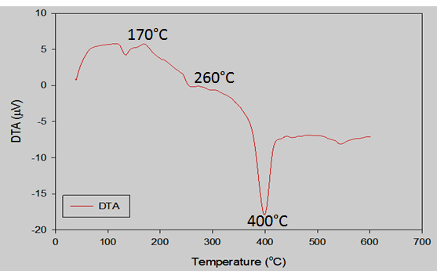
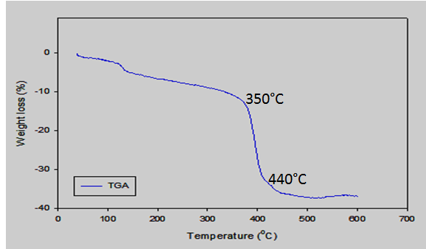

Figure 3 (a) DTA analysis of LaMnO₃ nanopowder Figure 3 (b) TGA analysis of LaMnO₃ nanopowder

The lanthanum manganite (LMO) nano- powder was obtained and XRD technique was used to examine toward studying phase analysis, powder structure,crystallographic investigation and lattice parameters. XRD was performed using monochromatic CuKα radiation (λ = 1.54056Å) operated at 40 kV (tube voltage) and 20 µA (tube current). Sample was scanned from 10° to 70° in diffraction angle 2θ with a step-size of 0.02°. XRD measurement of LaMnO₃ nanopowder was shown in figure 4.There were extra peaks on pattern of all powders because the results clearly proved the influence of the solvents on the product composition and agreed with the typical LaMnO₃ pattern of perovskite structure. All peaks were found to be well matched with the diffracted of standard. The intensity of (020) reflection was much stronger than that of remaining LaMnO₃ peaks. The XRD measurement showed that all peaks of LaMnO₃ were consisted with that LaMnO₃ standard (JCPDS) powder having an orthorhombic structure.
The average crystallite size of LaMnO₃ powders were in the range of 42.39 nm. By analyzing XRD measurement, all the peak heights and peak positions were in good agreement with library file of XRD machine.

Figure 4. XRD patterns of LaMnO₃ nanopowder at 1000 °C

The PVA/LaMnO₃ composite fibres on aluminium foil were carried out to examine by FESEM images. In order to study the morphology and nano structural properties of fabricated LaMnO₃ nanofibres with different temperature for 15 min and were depicted in figure 5 (a-d). The as-spun composite nanofibres appeared quite smooth and each individual nanofibre was quite uniform in cross section. These nanofibres were found in the formation of aligned structure. The diameter of nanofibres calcined at 500 °C was ~ 65-70 nm in figure 5 (a). After calcination at above 500°C, the nanofibres remained as continuous structure and their diameter appeared to be increased with increasing calcinations temperature at 600 °C, 700 °C and 800 °C. In contrast, the image of the nanofibres calcined at 600 °C, 700 °C and 800 °C showed in figures 5 (b-d) that each fibre contains small LaMnO₃ particles of ~75-78 nm, ~85-95 nm and~110-120 nm in diameter. According these results, the morphology and size of the fibres were varied strongly with increased of calcination temperatures.
The diameter of the fibres increasing and the surface changes rough gradually after sintered at 600 °C, 700 °C and 800 °C for 2 h respectively. The average diameter of the precursor’s LaMnO₃ nanofibres was found between 60 nm-120 nm. With the calcination temperatures increased gradually fibre diameter was thicker and fibre surface was extremely rough. This is due to that fibre composition at the beginning was composed of small grains and with the rise of temperature small grain grew up to a large grain and grew again toward surround. When the temperature reached 800 °C which observed that the long-grain completely grew together and the diameter of the fibres were increased ~ 120 nm. The variation in diameter of the fibres with different temperatures for 15 min was shown in figure 6.

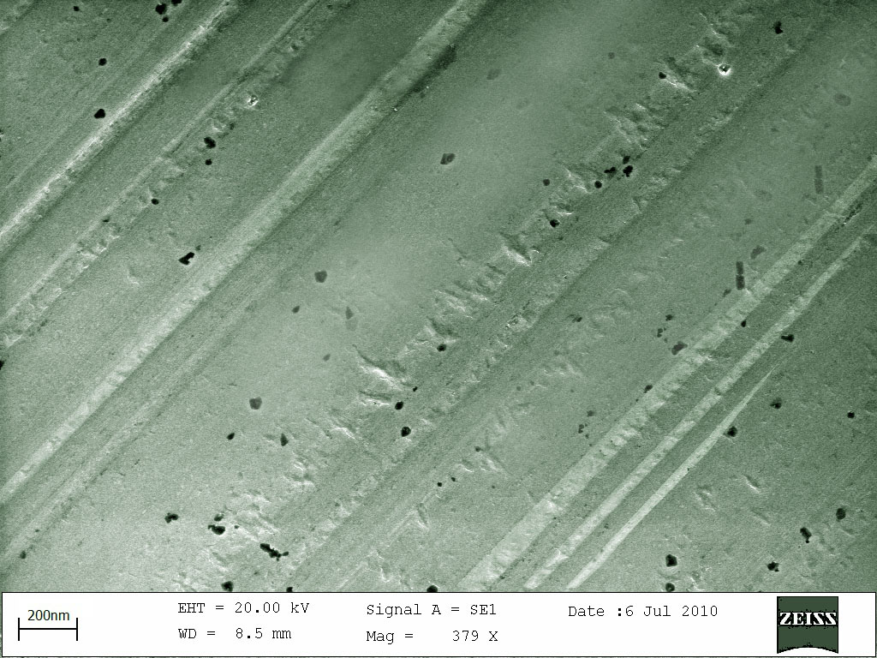

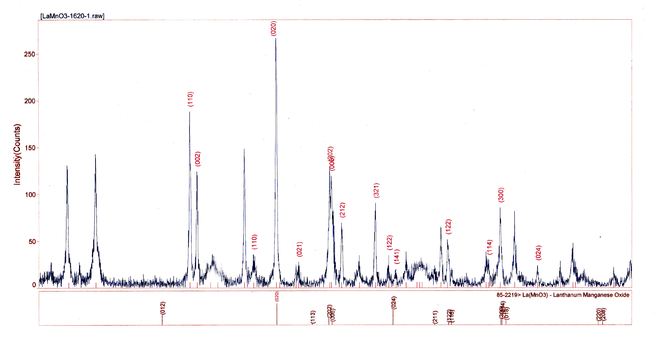

Figure 5(a) FESEM image of LaMnO₃ nanofibres at 500 °C
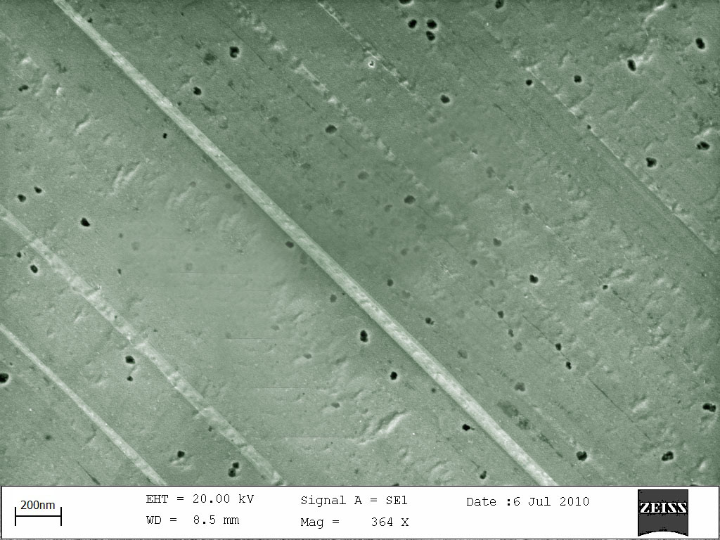

Figure 5 (b) FESEM image of LaMnO₃ nanofibres at 600 °C
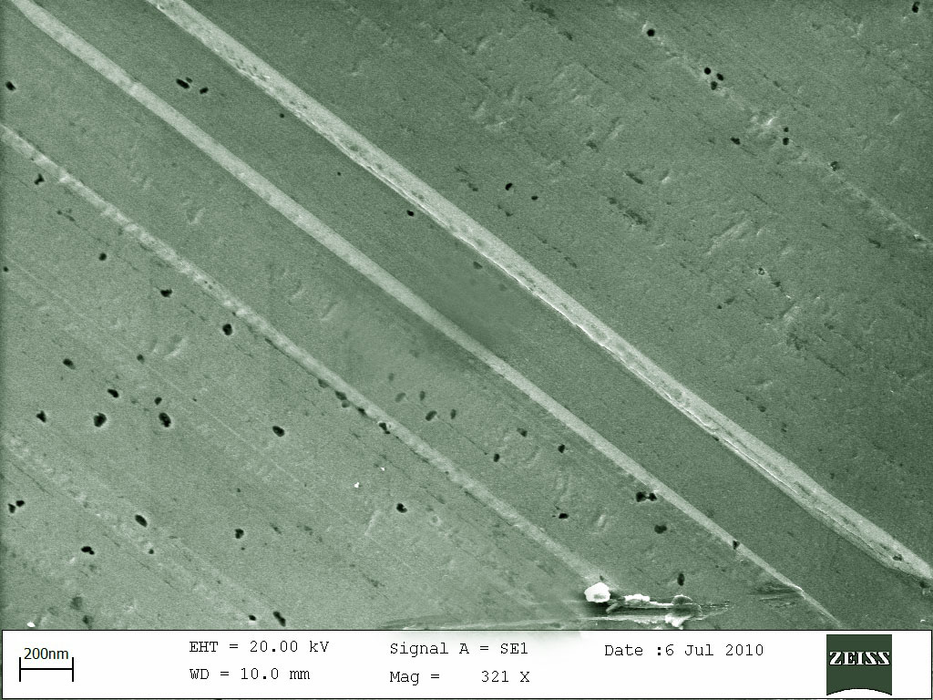

Figure 5(c) FESEM image of LaMnO₃ nanofibres at 700 °C

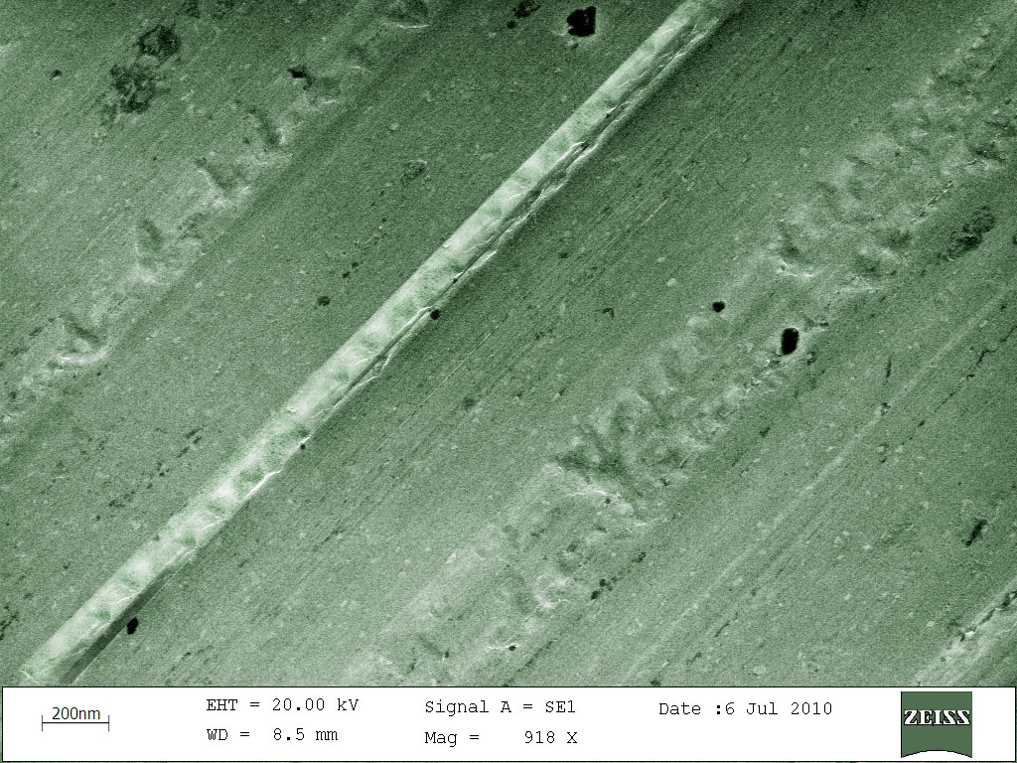

Figure 5(d) FESEM image of LaMnO₃ nanofibres at 800 °C

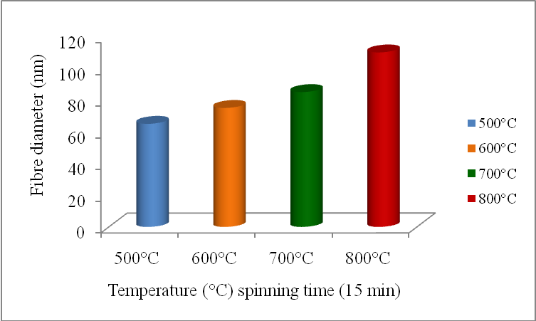
Figure 6. Temperature dependene of LaMnO₃ nanofibers

- Discussion
Synthesis and characterization of LaMnO₃ nanofibers were successfully prepared by using electrospinning technique. The advantages of electronspinning process are its technical simplicity and its easy adaptability. TG-DTA results revealed that the crystalline behavior of LaMnO₃ nanopowders were expected to start at 440°C. from XRD profile, there were extra peaks on pattern of all powders because the results clearly proved the influence of the solvents on the product composition and agreed with the typical LaMnO₃ pattern of perovskite structure. The intensity of (020) peak was much stronger than that of remaining peaks with orthorhombic structure. Therefore the most dominant (020) peak may have a much higher intensity than the other peaks in the diffraction patterns so as to have a reasonable intensity for all peaks. According to FESEM images, with the calcinations temperatures increased gradually, fiber diameter was thicker and fiber surface was gradually rough. Thus, the fiber diameters and morphology of the LaMnO₃ nanofibers should have dependences on temperatures to improve the fiber productivity. It should be universal for processing polymer solutions of different properties. Horizontal set up electronspinning has been shown the ability to mass produce nanofibers and it is also the most suitable design for practical applications. In this research work, considerable efforts had been successfully implemented to increase the productivity of electronspun LaMnO₃ nanofibers while precisely controlling dimentions and morphology of the fibers.

Acknowledgements
This research work was fully supported by Department of Physics, University of Yangon, Myanmar.(2012-2013).

Corresponding Author:
Dr Yin Maung Maung
Department of Physics,
Kyaingtong University
E-mail: dryinmgmg@gmail.com

Authors' and References’ Information
[1] Name: Zin Min Myat (Demonstrator) Dangon University, Myanmar Office Address: Department of Physcis, Dangon University, Myanmar Phone: +51-09448052319
[2] Name: Dr Than Than Win (Lecturer)University of Yangon Office Address: Department of Physics, University of Yangon, Myanmar Phone: +51-095059602
[3] Name: Dr Yin Maung Maung (Lecturer) Kyaingtong University, Myanmar Phone: +51-0973084418
[4] Name: Dr Ko Ko Kyaw Soe (Pro-Rector) Yangon Institute of Education, Myanmar.
[5] Dr Thet Naing Oo (Post Doctoral Researcher) Nagaoka University of Technology Department of Electrical Engineering Email: tnaingoo@gmail.com. Tel:+81-258-47-1611(Ext 5321).
[6] Dr Tin Aung, Professor and Head (Rtd), Department of Physics, University of Yangon Email:mintha.7@gmail.com

References
- D.H. Reneker, and I. Chun, "Nanometre Diameter Fibers of Polymer, Produced by Electrospinning" Nanotechnology, Volume 7, 1996, pages 216-233
- J. Doshi, and D.H. Reneker, "Electrospinning Process and Applications of Electrospun fibers", Journal of Electrostatics, Volume 35, 1995 pages 151-160
- I. Chun, et al, "Carbon Nanofibers from Polyacrylonitrile and mesophase pitch", Journal of Advanced Materials, Volume 31, Number 1, January 1999, pages 36-41
- G. Srinivasan et al 1995 polym Int 36 (2) 195-201
- B P Sautter 2005 "Continuous Polymer Nanofibres using Electrospinning” PhD Thesis Department of Mechanical Engineering University of Illinois Chicago
- J. Fung et al 2008 Applications of electrospun nanofibers, Volume 53, Number 15, page 2265-86
- A.G Mac Diarmid, et al 2001 Synthetic metals, 119, page-27
- M.H. Yun, et al 2004 Nanoletters, Volumey, Page-419
- G.E Wnek, et al 2003 Nano letters, volume 3, page -213
- A. Barnabe. et al "law temperature sysnthesis and structural characterization of over stoichiomatric LaMnO3 Perovskite," Materials Research Bulletin, Vol.39 2004 725-735
- E.A Kotomin. et al, Phys.Chem.Phys.5 2003 4180
- E Heifets, et al, J.Phys; Cond. Matter 10 1998 L 347.
- S Amoruso. et al 2005 ppl. Surf.Sci. 248 2005 45.

7/23/2013

