Isolation and identification of volatile substances in Alphonso mango leaves repellent to Kilifia acuminata (Signoret) (Hemiptera: Coccidae)

Abd Elrahman M. Monzer, Hesham A. Srour and Ahmed M. Abd El-Ghany

Plant Protection Research Institute, Agricultural research Center, Dokki, Giza, Egypt
hamsor98@hotmail.com

Abstract: Leaves of Alphonso mango cultivar showed a repellant effect toward the mango shield scale Kilifia acuminata (Signoret) in the laboratory bioassay. The volatile components of Alphonso leaf were extracted with hexane and fractionated with tow successive silica gel column chromatography using tow different solvent systems. Results of chemotaxis assay and gas chromatographic/mass spectrometric (GC-MS) analysis of the isolated fractions showed that α-pinene, β-pinene and d-limonene are three volatiles present in Alphonso leaves and possess insect-repellant properties. It is suggested that the combined action of α-pinene, β-pinene and d-limonene could be responsible –at least in part -for non-preference of K. acuminata to leaves of Alphonso mango cultivar.
[Abd Elrahman M. Monzer, Hesham A. Srour and Ahmed M. Abd El-Ghany. Isolation and identification of volatile substances in Alphonso mango leaves repellent to Kilifia acuminata (Signoret) (Hemiptera: Coccidae)]. N Y Sci J 2013:6(12):84-91]. (ISSN: 1554-0200). http://www.sciencepub.net/newyork. 14

Keywords: Mangifera indica, Kilifia acuminata, volatiles, repellent, α-pinene, β-pinene, d-limonene

1. Introduction
Mango, Mangifera indica, is considered one of the most important fruit crops in Egypt for both local consumption and exportation (Solimana et al., 2007). Mango trees are liable to be infested with several serious pests including the Mango shield scale Kilifia acuminata (Signoret) (Hemiptera: Coccidae) (Salem, 1994). Badawy et al. (2000) mentioned that K. acuminata attacks mango trees in Egypt, excretes large amount of honey dew and cause severe damage to leaves and fruits. Heavy infestation resulted in leaves drop and branches dryness. However, studies showed that different mango cultivars are differ in their susceptibility to the attack by several insect pests (Salama et al,. 1970 and Hennessey and Schnell. 2001). Our previous studies showed that trees of Alphonso mango cultivar were completely free of most of insect pests including both Iceria seychellarum and K. acuminata than the other Egyptian mango cultivars, even in tree closely adjacent to heavily infested Sultani and Baladi cultivars of mango trees (Monzer et al, 2006 & 2007, Salem et al, 2006 & 2007). Peña and Moyhuddin (1997), Chen et al., (2002) and Monzer et al, (2006) suggested that the presence of certain repellent volatile substance in leaves of particular mango cultivars could explain their avoidance by specific insect pests. Accordingly, this study was conducted to verify this assumption and to identify the volatiles repellent to K. acuminata in leaves of Alphonso mango cultivar if present. A better understanding of the cues that elicit or inhibit host-plant selection by K. acuminata could lead to increase the efficacy of its control strategies.

2. Materials and Methods
Sample Collection:
Leaves of Alphonso cultivar of mango (M. indica) were collected from a Fisher mango orchard located in El-Saff, Giza Governorate. Fresh mature leaves were hand-plucked from three trees packed in plastic bags, hermetically sealed, labeled, and transported in icebox to the laboratory. Healthy leaves were maintained at –20°C until extracted (within one week).
Sample extraction:
Two hundred grams from leaves were homogenized in a Tempest homogenizer, and were extracted with hexane in a Romo shaking apparatus for 48 hours, filtered using Whatman filter paper no. 2 in a Buchner funnel and the solvents removed by vacuum distillation in a rotary evaporator under reduced pressure at 45ºC.
Isolation of bioactive components:
The bioactive components in hexane extract of Alphonso leaves were isolated by column silica gel column chromatography (Kieselgel 60, 0.015-0.04 mm, 100g) as described by Kirchner, (1978). Extract was eluted initially with n-hexane then introducing n-hexane: ethyl acetate (90:10 v/v, respectively), gradually increasing ethyl acetate concentration by 10% to 100%. Then methanol was employed to remove components not removed by the other mobile phases. The obtained fractions were placed under stream of nitrogen to facilitate drying. Fractions which showed bioactivity against the experimental insect were re-chromotographed using similar silica column but eluted with n-hexane-CH₂Cl₂ as a solvent system. For each fraction, the column was eluted successively with 100% n-hexane, and n-hexane-CH₂Cl₂ mixtures, initially at 1% CH₂Cl₂ in n-hexane and increasing CH₂Cl₂ by 1% to 10% then by 10% to 100% CH₂Cl₂.
Analysis of Fractions complexity:
As soon as column chromatography was completed, the obtained fractions were concentrated under a stream of nitrogen for complexity analysis using thin layer chromatographic plates (TLC) and visualized by spraying with vanillin reagent according to the method mentioned by Kirchner (1978).
Gas Chromatographic-Mass Spectrometric (GC-MS) Analysis:
GC-MS was carried out with a HP 5972A mass spectrometer (Electron impact detector) coupled to HP-6890 GC equipped with a split-split less injector and a HP-5MS capillary column (30 m x 0.32 ID, 0.25 µm film thickness). Helium was used as the carrier gas at a flow rate of 1 ml/min. Injector temperature was 250°C; detector temperature was 280°C, and split less mode was chosen. Oven temperature was programmed from 50°C (2 min) to 80°C at 1.5°C/min and to 250°C at 10°C/min. Data were collected with HP Chemstation software (A.03.00) and searched against the Wiley registry of mass spectral data. All compounds reported was confirmed by comparison of their fragmentation patterns with those of authentic standards and also with those cited in the literature.
Laboratory Bioassays:
a) Chemotaxis Assay:
Chemotaxis experiments were designed to determine the response of K. acuminata toward Alphonso leaves and their extracts according to the procedure described by Monzer et al (2006). Fresh leaves of Alphonso mango cultivar were cut to small pieces (~1 cm² each) and 5 leaf pieces were placed near the edge of 10-cm diameter Petri dish. Five pieces (~1 cm² each) of filter paper were placed on the opposite side of the dish to serve as control. Ten K. acuminata crawlers were then placed in the center of the dish, 4 cm away from both leaf and paper pieces. Dish was covered and maintained at room temperature. After 24 hours, number of nymphs on Alphonso leaf pieces and on the filter paper pieces was counted. The same experiment was conducted but with hexane extract and its sub-fractions. In such case, five filter paper pieces (~1 cm2 each) were impregnated by 0.2 ml of each extract, allowed to dry and were placed near the edge of the Petri dish opposing to 5 pieces of filter paper that was previously impregnated by 0.2 ml of the corresponding solvent and dried. A chemotaxis index (CI), for each test dish was calculated after 24 hours according to Sakuma and Fukami (1985) as follows:
CI = (NT-NC)/(NT +NC)
Where CI = chemotaxis index, NT = number of nymphs counted on and near the extract side of the Petri plate arena and NC = number of nymphs on and near the solvent-target side. CI value can range from +1.0 to –1.0; values close to 0 indicate that the test material had no effect on K. acuminata chemotaxis, positive values indicate attraction to, and negative values indicate repellence by the test material.
Statistical Analysis
The entire assays were repeated three times each with three replicates and the results were combined for statistical analysis. The results are presented as percentage, although actual number of insects was used for statistical tests. Statistical significance was determined by analysis of variance (Duncan Multiple Range Test at P<0.05) using the software package Costat, (Costat, 1992). Results are recorded as mean ± standard deviation (SD).

3.Results and Discussion:
Chemotaxis Assays
Before extraction, preliminary tests were conducted to determine the response of K. acuminata to Alphonso leave materials. The calculated chemotaxis indices (Table 1) indicated that there was a significant repellence from Alphonso leaves with CI of (-) 0.98 ± 0.20). Also, crude hexane extract showed a repellence effect on K. acuminata with CI of (-) 0.87±0.18
Isolation of bioactive compounds in hexane extracts of Alphonso leaves:
GC/MS analysis (Fig. 1) showed that crude hexane extract contains many overlapping compounds, thus, it was subjected to fraction using silica gel column (CC₁) and hexane: ethyl acetate as solvent system. A total of 12 fractions were collected (from H_{Alf-1} to H_{Alf-12}), all of them were subjected to bioactivity screening. The only fraction that showed a significant behavioral effect on K. acuminata nymphs was the fraction assigned H_{Alf-2} with CI of (-) 0.98 ± 0.05 indicating significant and strong repellant effect (Table 2).
Sub-fractionation of H_{Alf2}:
After exploring the complexity of the bio-active fractions HAlf₋₂ by TLC a second silica gel column chromatography (CC2) was carried out on them employing hexane-DCM as a solvent system. Five sub-fractions with different TLC pattern were obtained, assigned as H_{Alf-2a}, to H_{Alf-2e} and were subjected to bioassays. K. acuminata nymphs were found to be repelled from both sub-fractions H_{Alf-2a}, and H_{Alf-2b} as reflected by their highly negative CI values (Tables 3). GC/MS analysis of H_{Alf-2a} sub-fractions showed two peaks (Fig .2) assigned as C₁ and C₂ and were identified as α-pinene and β-pinene, respectively according to their MS fragmentation pattern (Fig 3 and 4 ). GC analysis of sub-fraction H_{Alf-2b} showed one peak (Fig 5) assigned as C₃ with fragmentation pattern similar to that of d-limonene (Fig 6)
Alpha-pinene, β-pinene, and d-Limonene, are a widespread volatile monoterpenes that has been previously reported in several mango fruit verities from different countries (Aboul-Enein et al., 1983; Ansari et al., 1999a, b&c; and Lalel et al., 2003). However, this is the first report on the repellent effect of such compounds from Alphonso mango leaves on K. acuminata. Previous studies on bioactivity of α-pinene, β-pinene and limonene against various insect showed that these compounds posses different activity depending on the target insect species. Several reports mentioned that α-pinene, β-pinene and limonene, possess repellent properties against certain insect species such as Hylurgops palliatus Gyll and Hylastes ater Payk (Perttunen, 1957), aphid species (Aphis sp.) (Zhang and Cao, 1991), housefly, Musca domestica and German cockroach, Blattella germanica (L.) (Liao, 1999), spruce beetles, Dendroctonus rufipennis (Kirby) and Icerya seychellarum (Monzer et al., 2006). In contrary, the same three compounds were reported as attractive to other insect species such as Pieris brassica (Mitchell, 1977), Dendroctonus frontalis (Moser and Browne, 1978), Epuraea bickhardti and E. boreella (Schröder, 1993.) Pieris rapae (Honda et al., 1998) Ips pini (Erbilgin et al., 2003 and Dahlsten, 2004), Thanasimus undatulus, Enoclerus sphegeus, and Temnochila chlorodia (Zhou et al., 2001). In conclusion, results of this study suggested that α-pinene, β-pinene and limonene were the main volatiles in Alphonso leaves repellant to K. acuminata and their combined action could be responsible –at least in part for non-preference K. acuminata to leaves of
Alphonso mango cultivar.

Table 1: Response of K. acuminata nymphs to Alphonso leaves and their crude hexane extract.
 | Chemotaxis indices (CI)†)
Alphonso leaves | (-) 0.98 ± 0.20a
Hexane extract | (-) 0.87±0.18a
Absolute values of CI were used for statistical analysis. Values (Mean ± SD) followed by different litters are significantly differ (P<0.05)
† Negative CI values indicate repellence by the test material

Table 2: Bioactivity of the eluted fractions from hexane extract of Alphonso leaves.
Fractions | Solvent system | Chemotaxis indices (CI)†
H_{Alf-1} | Hexane (100%) | (-) 0.12 ± 0.10a
H_{Alf-2} | Hexane/EA (90/10) | (-) 0.98 ± 0.05b
H_{Alf-3} | Hexane/EA (80/20) | (-) 0.9 ± 0.12a
H_{Alf-4} | Hexane/EA (70/30) | (-) 0.08 ± 0.10a
H_{Alf-5} | Hexane/EA (60/40) | (-) 0.08 ± 0.09a
H_{Alf-6} | Hexane/EA (50/50) | (-) 0.06 ± 0.08a
H_{Alf-7} | Hexane/EA (40/60) | (-) 0.10 ± 0.06a
H_{Alf-8} | Hexane/EA (30/70) | (-) 0.08± 0.06a
H-_{Alf-9} | Hexane/EA (20/80) | (-) 0.07 ± 0.08a
H-_{Alf-10} | Hexane/EA (10/90) | (-) 0.09 ± 0.10a
H-_{Alf-11} | EA (100%) | (-) 0.05 ± 0. 03a
H-_{Alf-12} | Methanol (100%) | (-) 0.11 ± 0.12a
Absolute values of CI were used for statistical analysis. Values (Mean ± SD) followed by different litters are significantly differ (P<0.05)
† Negative CI values indicate repellence by the test material

Table 3: Bioactivity of the sub-fractions of H_{Alf2}.
Sub-fraction | Chemotaxis indices (CI)†
H-_{Alf-2a} | (-) 0.53 ± 0.16a
H-_{Alf-2b} | (-) 0.32 ± 0.19b
H-_{Alf-2c} | (-) 0.12 ± 0.12c
H-_{Alf-2d} | (-) 0.1 ± 0.11c
H-_{Alf-2e} | (-) 0.05 ± 0.09c
Absolute values of CI were used for statistical analysis. Values (Mean ± SD) followed by different litters are significantly differ (P<0.05)
† Negative CI values indicate repellence by the test material

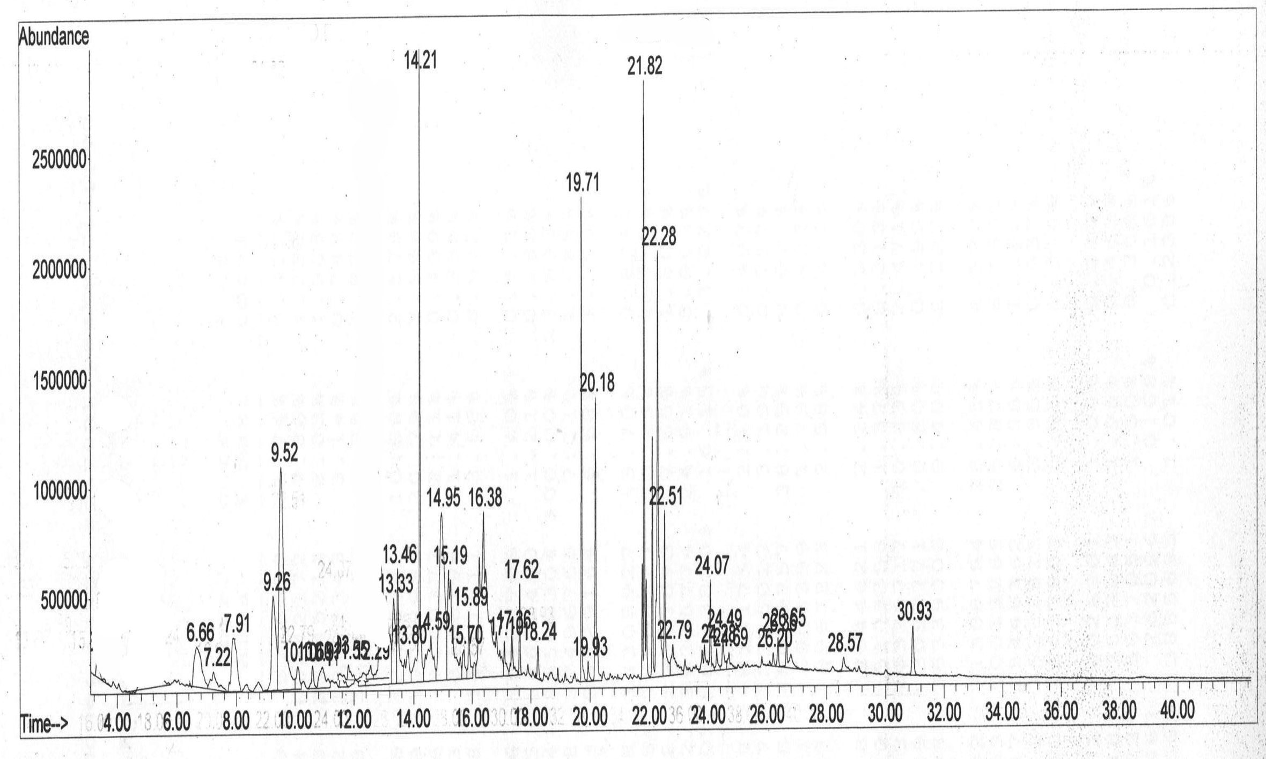
Figure (1): GC-MS spectra of crud hexane extracts of Alphonso leaves.

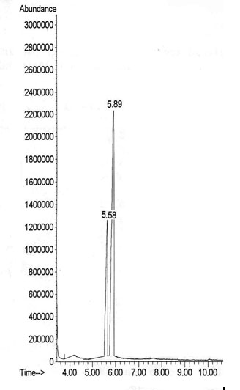
Figure 2. GC spectrum of fraction H_{Alf-2a},

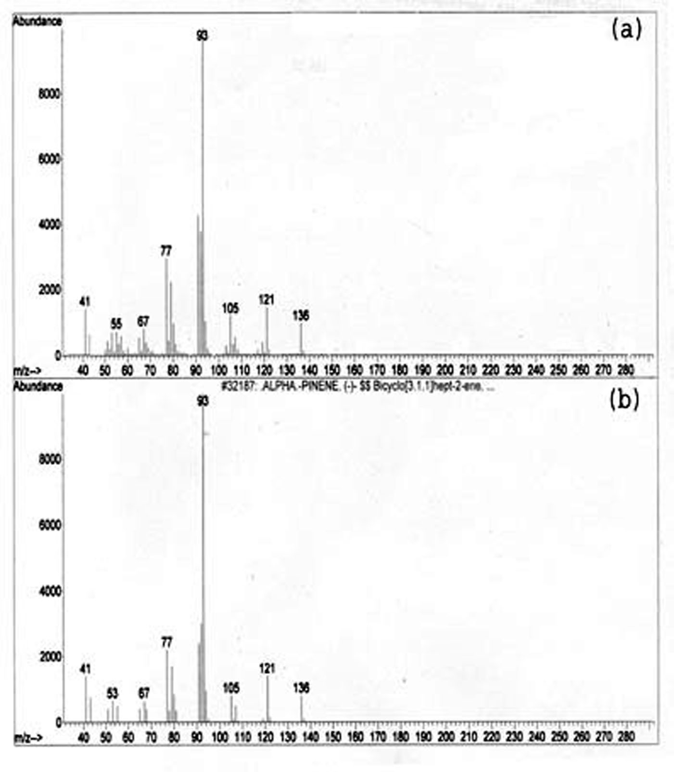
Figure 3. Mass spectral data of a) compound C₁, b) Wiley lib spectral data of α-pinene
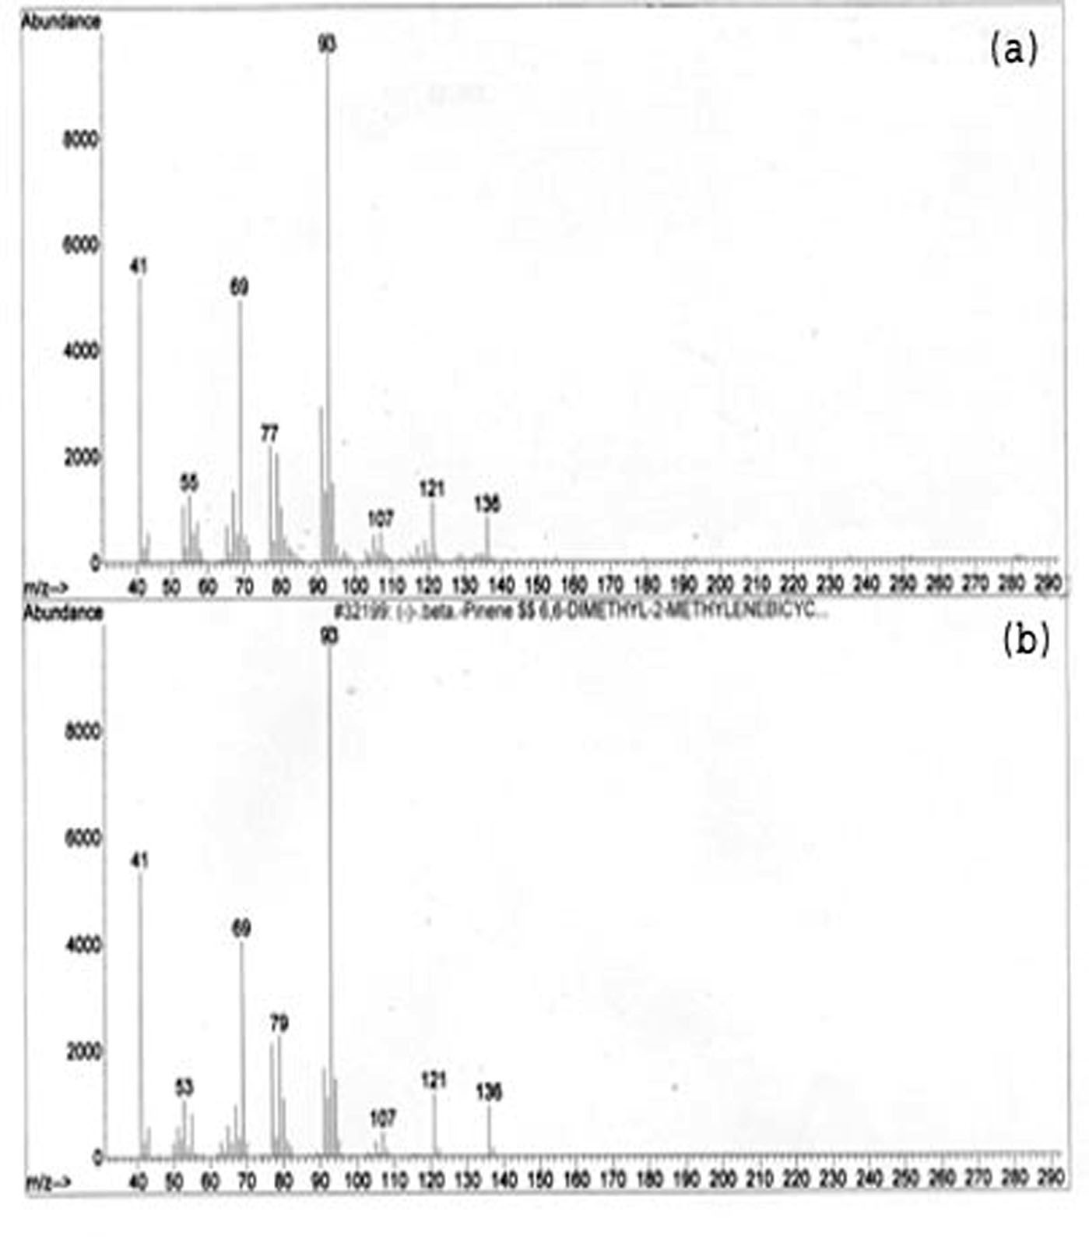
Figure 4. Mass spectral data of a) compound C₂, b) Wiley lib spectral data of β-Pinene
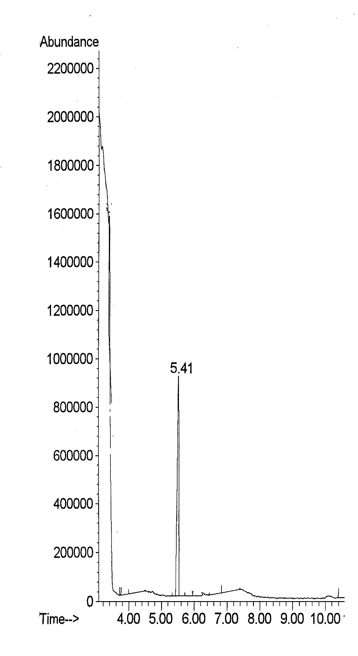
Figure 5. GC spectrum of to H_{Alf-2b}

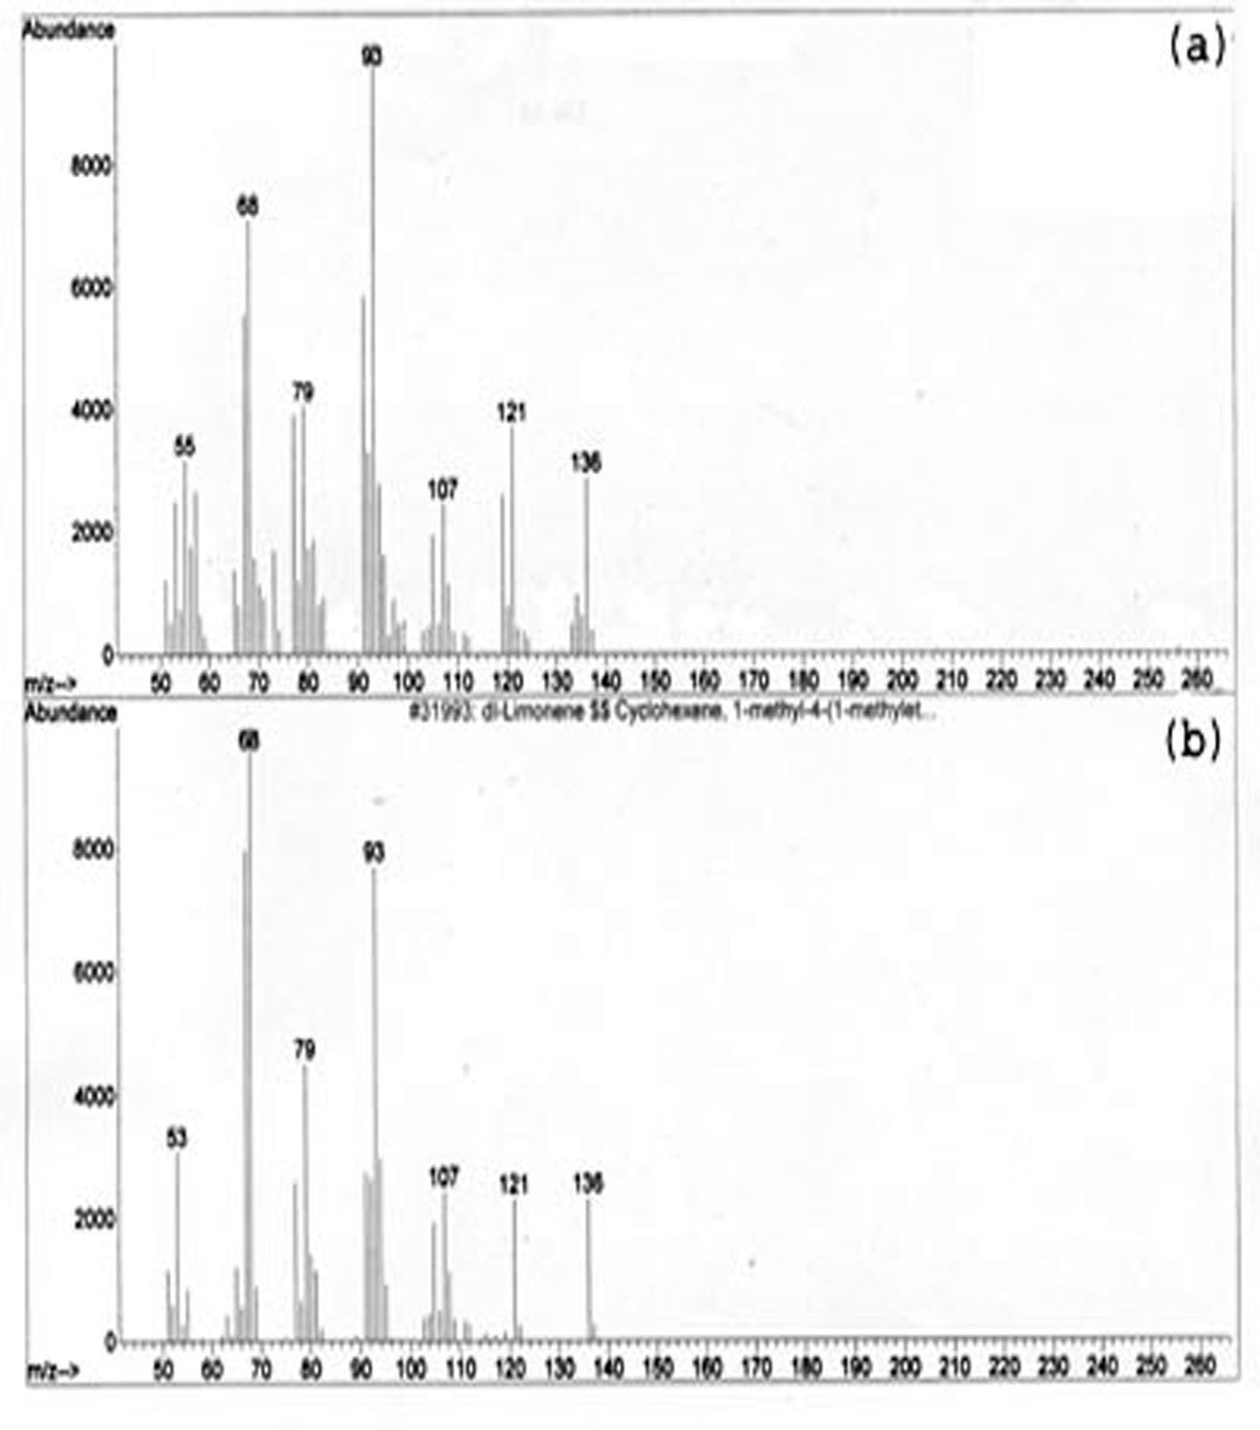
Figure 6. Mass spectral data of a) compound C₃, b) Wiley lib spectral data of limonene

References
Aboul-Enein, A.M., Salem, H.M. and Zaharan, M.M.. 1983. Effect of gamma irradiation on mango volatiles during ripening. Chem. Mikrobiol. Technol. Lebensm. 8: 60-63.
Ansari S.H., Negueruela A.V., Perez M.J. and Ali M..1999a. Volatile constituents of the fruits of three mango cultivars, Mangifera indica L. J. Essential Oil Res., 11(1): 65-68.
Ansari S.H., Negueruela A.V., Perez M.J. and Ali M. 1999b. Volatile constituents of mango (Mangifera indica) fruits cultivar “Bombay.” J. Med. Arom. Plant Sci., 21(4): 931-933
Ansari S.H., Ali M., Porchezhian E., Negueruela A.V., and Perez M.J. 1999c. Volatile constituents of mango (Mangifera indica Linn.) fruits - cultivar “Totapari”. Indian J. Natural Prod., 15(2): 18-22.
Badawy, M. A.; A. A. Barakat.; E.I. Hemly; S.M. El-Imery and Fayza, A. M. Kwaiz, (2000): Field evaluation of certain organophsphorous insecticides against mango soft scale insect, Kilifia acuminata (Signoret) and its residues in mango fruits. Bull Ent. Soc. Egypt, Econ. Ser., 27: 17 – 27.\
Chen, Z., T.E. Kolb and K.M. Clancy. 2002. The role of monoterpenes in resistance of Douglas fire to western spruce budworm defoliation. J. Chem. Ecology, Vol. 28 (5):897-919.
Costat, 1992. Software package, Costat, Graphics and Statistics Software for Scientists and Engineers (Cohort Inc), Berkeley, CA, USA.
Erbilgin, N., Powell, J.S., and Raffa, K.F. 2003. Effect of varying monoterpene concentrations on the response of Ips pini (Coleoptera: Scolytidae) to its aggregation pheromone: implications for pest management and ecology of bark beetles. Agric. Forest Entomol. 5:269-274.
Hennessey M. K. and R. J. Schnell. 2001. Resistance of immature mango fruits to Caribbean fruit fly (Diptera: Thephritidae). Florida Entomologist 84(2): 318-320.
Honda, K., Ômura, H., and Hayashi, N. 1998. Identification of floral volatiles from Ligustrum japonicum that stimulate flower-visiting by cabbage butterfly, Pieris rapae. J. Chem. Ecol. 24:2167-2180.
Kirchner, J.G. 1978. “Thin Layer Chromatography” Techniques of Chemistry Series, Volume number XIV, 2nd Edition, Edmond S. Perry (Ed.), , A Wilet-Interscience Pub., New York
Lalel H.J.D., Singh, Z., Tan, S.C. 2003. The role of ethylene in mango fruit aroma volatile biosynthesis. J. Hortic. Sci. Biotech., 78: 485-496.
Liao, S.C. 1999. Mortality and repellency effects of essential oils from citrus against the housefly and German cockroach. Zhonghua Kunchong, 19 (2): 153-160.
Mitchell, J.D. 1977. Diffential host selection by Pieris brassica (the large white butterfly) on Brassica oleracea (the wild cabbage). Entomol. Exp. Appl. 22:208-219.
Monzer M.A.; M.S. Salem, S.F.M. Moussa, M.E. Nour and M.I. El-Said (2007). Seasonal fluctuation of the Seychelles fluted scale, Iceria seychellarum (Westwood) on four mango cultivars in Egypt. Egypt. J. Agric. Res., 85(1): 77-88.
Monzer M.A.; M.S. Salem, M.I. El-Said and A.M. Abd El-Ghany (2006). Resistance of Alphonso mango cultivars to the Margardoid mealybug, Iceria seychellarum (Westwood) in relation to leaf quality. I. Leaf secondary metabolites. Egypt. J. Agric. Res., 84(1): 17-29.
Moser, J.C., and Browne, L.E. 1978. A nondestructive trap for Dendroctonus frontalis Zimmermann (Coleoptera: Scolytidae). J. Chem. Ecol. 4:1-7.
Pena, J. E., and A. I. Moyhuddin. 1997. Insect Pests, p.327-362. InR. E. Litz (ed.). The mango. CAB Inter-national, Wallingford, UK.
Perttunen, V. 1957. Reactions of two bark beetle species, Hylugops palliatus Gyll. and Hylastes ater Payk. (Col., Scolytidae) to the terpene alpha-pinene. Ann. Entomol. Fenn. 23:101-110.
Sakuma, M. and Fukami H. 1985. The linear track olfactometer: An assay device for taxes of the German cockroach, Blattella germanica (L.) (Dictyoptera: Blattellidae) towered their aggregation pheromone. Appl. Entomol. Zool. 20: 387–402.
Salama H.S., Wassel G. and Saleh M. 1970. Resistance of some varieties of mangifera Indica L. due to scale insects infestation. Current-Science, (39): 497-501.
Salem, H.A. 1994. Factors contributing to the distribution and level of attack of scale insects which infectious some different varieties of mango fruit trees. M.Sc. thesis, Fac. Agric., Zagazig Univ., Egypt.
Salem, M.S.; M.I. El-Said.; A.M. And El-Ghany and M.A. Monzer, M 2006. Susceptibility of five mango cultivars to Iceria seychellarum (Westwood) in relation to leaf quality: III. Nutrients and inhibitors. Egypt. J. Agric. Res., 84(3): 697-711
Salem, M.S.; M.A. Monzer, M.E. Nour and M.I. El-Said. 2007. Susceptibility of five mango cultivars to Seychelles fluted scale, Iceria seychellarum (Westwood) in relation to leaf quality: III. Leaf toughtness and anatomic characteristics. Egypt. J. Agric. Res., 85(1): 89-100.
Salem, H.A. 1994. Factors contributing to the distribution and level of attack of scale insects which infectious some different varieties of mango fruit trees. M.Sc. thesis, Fac. Agric., Zagazig Univ., Egypt.
Schröder, L.M. 1993. Attraction of Epuraea bickhardti St.-Claire Deville and E. boreella (Zetterstedt) (Coleoptera, Nitidulidae) to ethanol and alpha-pinene. Entomol. Fenn. 4:133-135.
Solimana, M.M, Kwaizb F.A. and Shalbya E.M. 2007. Efficiency of certain miscible oils and chlorpyriphos methyl insecticide against the soft scale insect, Kilifia acuminata Signoret (Homoptera: Coccidae) and their toxicities on rats. Archives Of Phytopathology And Plant Protection 40(4): 237-245
Zhang, S. and Cao R. 1991. A study on the interactions among several plant secondary compounds and aphids. J Environ. Sci. (China); 3(1): 89-94.
Zhou, J.L., Ross, D.W., and Niwa, C.G. 2001. Kairomonal response of Thanasimus undatulus, Enoclerus sphegeus (Coleoptera: Cleridae), and Temnochila chlorodia (Coleoptera: Trogositidae) to bark beetle semiochemicals in eastern Oregon. Environ. Entomol. 30:993-998.

8/11/2013

