Enhancement of lactose removing ability via Beta-galactosidase mutagenesis

Essam A. Abdel-Azeem ¹, Kamal M. Khlil ², Mohammed A. Khedr ¹, Usama M. Badr ² and Said E. Desouky ¹*

^{1.} Botany and Microbiology Department, Faculty of science, Al-Azhar University, Cairo, Egypt
^{2.} Genetics and Cytology Department, National Research Center, Giza, Egypt
*dr_saidesouky@yahoo.com

Abstract: Lactose intolerance (LI) is a disturbing problem for patient who can’t digest lactose owing to deficiency in their intestinal β-galactosidase enzyme. β-galactosidase enzyme is a one of hydrolysis enzymes that splits lactose into glucose and galactose and each of them are easily digested in intestine. Two possible processes can be used for solving LI problem, the augment of lactase or the addition of probiotics that have the ability to metabolize lactose. To accomplish the two goals, sixteen Escherichia coli strains were investigated for their ability to produce β-galactosidase enzyme and the highest β-galactosidase producer strain, MS-29, was selected for UV manipulation. The enzyme productivity of the best 5 mutants, MS-29-M3, MS-29-M4, MS-29-M30, MS-29-M40 and MS-29-M44, were increased more than one fold. To check lactose removing ability, potent mutants were cultivated on various milks including cow’s milk, goat’s milk and drinkable yogurt with lactose content as 4, 3 and 6% respectively. Lactose removing ability was enhanced by all mutants and complete lactose removing from goat’s milk samples was done successfully within 72h cultivation. MS-29-M3, best mutant either in β-galactosidase productivity or lactose removing ability, could be recommended as lactase producer strain and LI probiotic.
[Abdel-Azeem EA, Khlil KM, Khedr MA, Badr UM and Desouky SE. Enhancement of lactose removing ability via Beta-galactosidase mutagenesis. N Y Sci J 2013;6(12):163-168]. (ISSN: 1554-0200). http://www.sciencepub.net/newyork. 26

Keywords: Escherichia coli; β-galactosidase; lactose; UV mutation; lactose intolerance

1. Introduction
Lactose intolerance (LI) is the inability to metabolize lactose due to lack of required lactase enzymes in the digestive system. It can be found in many animals, including human beings, and it can causes osteoporosis, calcium deficiency and several other types of nutritional and health problems. People suffering from LI have to avoid lactose-containing foods such as milk and milk products, which are generally considered as a one of the important sources of nutrients for human beings, especially in developing countries, as they contain high-quality proteins and various minerals ( Chuan, et al., 2012). LI also defined as gut pain and distension, borborygmi, flatus, and diarrhea induced by lactose. (Campbell, and Matthews, 2001; Kretchmer, and Memorial, 1971; Fauchi, et al., 1998; Jarvis and Miller, 2002). LI also causes nausea and vomiting with many patients presenting with constipation because of reduced intestinal motility rather than diarrhea also it may be a cause of a range of systemic symptoms including headaches and light headedness, loss of concentration, difficulty with short term memory, severe tiredness, muscle and joint pain, various allergies, heart arrhythmia, mouth ulcers, sore throat, and increased frequency of micturition. (Grimbacher, et al., 1997; Matthews, and Campbell, 2004 and Carolyn, 2010).
The lactose hydrolyzing enzyme, β-galactosidase facilitates the reaction between the disaccharide molecules (Lactose) and water, thereby cleaving the oxygen bridge resulting in the production of two simple sugars (Glucose and Galactose). β-galactosidase is encoded by the LacZ gene of the lac operon in E. coli and catalyzes the hydrolysis of Β-galactosides at an optimal pH of 7.2. Although it has fairly strict specificity at the galactosyl position, it is adept at hydrolyzing β-D-galactopyranosides with a wide variety of glycols with divergent chemical composition (Mariotti et al., 2008 and Gong, et al., 2009). The enzyme has many application in food science including: Low lactose dairy product, Low lactose yogurt, Sweetened yogurt, Low lactose concentrate for ice cream, Lactose processing of acid and sweet whey, Food syrups and sweetener manufacture, Lactase treatment during cheese (Shukla, 1975). In dairy industries, β-galactosidase has been used to prevent crystallization of lactose, to improve sweetness and to increase the solubility of the milk product for lactose-intolerant people and the production of galacto-oligosaccharides for use in probiotic food stuffs (Kara, 2004; Gaur et al., 2006; Maksimainen et al., 2011 and Guerrero, et al., 2013). It is also important for the utilization of cheese whey, which would otherwise be an environmental pollutant. The transglycosylation activity has been used for the synthesis of galacto-oligosaccharides and galactose containing chemicals in recent years (Akcan, 2011). Some people cannot tolerate and digest lactose due to the lack of β- galactosidase in their intestine. Consuming milk and dairy products by these people leads to cramp, flatulence, vomiting, etc. so one valuable source of food would be unavailable for more than half of the people in the world due to lactose intolerance. Since lactose intolerance is affecting a large portion of the people (up to 50 million in USA), a cheap source of β-galactosidase for effective production of lactose-hydrolyzed dairy products has a substantial potential (Jelen and Kalab, 2001).
Several investigators used UV as physical tool for induction of mutation in prokaryotes cyclobutane pyrimidine dimers and pyrimidine-pyramidone or photoproducts are most important pre-mutational DNA lesions induced by UV radiation. Other lesions, such as DNA strand breaks and thymine glycols are also induced by UV treatment (Brockrath et al., 1987). in our study, we hypothesis to gain E. coli mutants by UV mutagenesis that have much greater lactose removing ability from some dairy products to be suitable for lactose malabsorption treatment through investigation of β-galactosidase enzyme activity.

2. Materials and Methods
2.1. Culture media
2.1.1. LB Broth (Laura Bertani Broth) is used for the growth, maintenance and fermentation of Escherichia coli strains (Bertani, 1951).

2.1.2. Macconkey Agar medium is a ready medium from (SRL). This medium used for differentiate between lactose and non-lactose fermenting E. coli strains (Mazura-Reetz et al., 1979).

2.1.3. M9 minimal medium
This medium is used to detect the utilization of lactose as only carbon source and composed of 12.8 g Na₂HPO₄, 3 g KH₂PO₄, 0.5 g NaCl, 10 g NH₄Cl, 20.0 g Agar 0.49 g MgSO_{4.}7H₂O, 0.015 g CaCl₂.2H₂O, 0.01 g FeSO₄.7H₂O, 0.01 g Thiamine and 2 g Lactose / liter (Sambrook et al., 1989).

2.2. Bacterial strain
E. coli UV mutants were grown overnight in LB medium supplemented with lactose solution with different concentrations (0.5%, 1%, 1.5% and 2%) in shaker incubator at 37ºC until the turbidity reach 1.26 OD 600 then centrifuged and cell pellet re-suspended in 1 ml 0.85 NaCl buffer for assay of colorimetrically enzyme activity by ONPG method.

2.3. Enzyme assay for β-galactosidase activity
β-galactosidase activity was determined using O-nitrophenyl β-D-galactopyranoside (ONPG) as a substrate. β-galactosidase activity was assayed at 40°C by incubating 20 μl of suitably diluted enzyme with 480 μl of 22 mM ONPG in 50 mM phosphate buffer pH 6.5 as the substrate for 15 min (Volkin and Klibanov, 1989). The reaction was stopped by adding 750 μl of 0.4 M Na₂CO₃ and the O-nitrophenyl (ONP) released was determined by reading the increase in absorbance at 420 nm. One unit of β-galactosidase activity (U) was defined as the amount of enzyme releasing 1 μ mol/min of ONP from ONPG under the given conditions (Kara, 2004 and Princely et al., 2013).

2.4. Ultraviolet (UV) Treatment
Cells suspension of overnight culture was prepared by shaking for 5 min. Cells were exposed to Ultraviolet Irradiation (UV) at a distance of 20 cm for 1, 3, 5 and 7 min. Philips T-UV-30W lamp type number 57413 p/40 was used. After irradiation the treated suspension was protected from light for 1h. One ml from treated cells with suitable dilution were plated on LB (Witkin, 1969).

2.5. Gravimetric quantitative method for lactose determination
This method is based on the interaction between reducing sugar (lactose) with Fehling I, II and produce Cu₂O which equivalent to the amount of sugar present in the sample when compared with Hammond’s table (Kolusheva and Marinova, 2011).

3. Results
3.1. Selection of β-galactosidase producing bacterial strain(s) using different growth media
Sixteen E. coli strains were used in our objective. These strains were tested for their β-galactosidase productivity on five different solid media; LB, macconkey and M9 minimal media supplemented with 1 % lactose, glucose, galactose. From Table (1) we noted that, all investigated strains showed β-galactosidase productivity varied from 0.02 until 0.9 U/ml except MS -29 strain which produced 2.28 U/ml also it can grow in presence and absence of lactose in growth media, therefore strains, MS -29 was selected as the best β-galactosidase producer strain and subjected to UV mutagenesis experiment.

3.2. Selection of Remarkable β-galactosidase producer Mutant(s) after UV irradiation
Strain MS-29 treated with UV for 1, 3, 5 and 7min. Mutants were selected on LB agar. After UV treatment, about 300 mutants were isolated and tested for their ability grow on presence and absence of lactose as sole carbon source and to ferment lactose on Macconkey agar medium. Twenty five mutants

were selected and tested for their ability to produce β-galactosidase using LB + 1% lactose medium with ONPG assay. Out of 25 mutants were selected, five mutants, MS-29-M3, MS-29-M4, MS-29-M30, MS-29-M40 and MS-29-M44 prove to be the best β-galactosidase producer mutants, they produced more than 200% compared with MS-29. MS-29-M3 proved to be the best β-galactosidase producer mutant and enzyme productivity was increased 2.7 fold compared with UV treated strain, MS-29.

Table 1. β-galactosidase productivity and bacterial strains growth ability on different media.

Strain code | Media |  |  |  |  | Enzyme activity  (U/ml)*
Strain code | LB | M9  +Glu | M9  +Lac | M9  +Gal | Mac | Enzyme activity  (U/ml)*
MS- 1 | NG | NG | NG |  |  | 0.21
MS -2 | NG | NG | NG |  | NG | 0.02
MS -3 | NG | NG | NG |  |  | 0.28
MS -4 | NG | NG | NG |  | NG | 0.14
MS -5 | NG |  | NG |  | NG | 0.16
MS -6 | NG | NG | NG |  |  | 0.23
MS -7 | NG | NG |  | NG |  | 0.15
MS -8 | NG |  |  |  |  | 0.11
MS -9 | NG |  |  |  |  | 0.22
MS -10 | NG |  |  |  |  | 0.32
MS -11 | NG |  | NG |  |  | 0.02
MS -12 | NG |  | NG |  |  | 0.15
MS -18 | NG |  |  |  |  | 0.19
MS -27 | NG |  |  |  |  | 0.90
MS -28 | NG |  | NG | NG |  | 0.33
MS -29 | NG | NG | NG | NG | NG | 2.28
LB; Laura Bertani Broth, NG; normal growth on agar plate. *Enzyme activity was determined with ONPG assay by using LB + lactose 1% three times and data was represented by mean with P value < 0.05.

3.3. Investigation of lactose removing from dairy products with different lactose concentration
Five mutants that showed more than 2 fold β-galactosidase productivity higher than WT MS-29, 2.28 U/ml, were cultivated with some dairy products until 96h including cow’s milk, goat’s milk and drinkable yogurt with different lactose concentration as 4, 3 and 6 % respectively. This assay was done according to Kolusheva and Marinova (2011). Lactose hydrolysis ability of wild and mutants on cow’s milk was showed in figure (1), MS-29-M3 was able to remove lactose with 1.11 fold of WT MS-29 after 24h, 1.56 fold after 48h. It was 1.33 fold of WT MS-29 after 72h and 1.7 fold after 96h of fermentation. In the case of Goat's milk, except MS-29-M4, other mutants have the ability to remove lactose absolutely within 72 h, while MS-29-M4 has ability to removing lactose within 96h. MS-29-M3 was successfully able to remove lactose as 2.16 folds of WT MS-29 after 24h while it was four folds after 48h. After 72 h MS-29-M3 was three folds of WT MS-29 as showed in figure (2). In yogurt samples, MS-29-M3, M4 and M40 were the best mutants in lactose removing ability, while M30 and M44 were showed less ability in lactose removing than wild type MS-29. MS-29-M3 was the best of all in lactose removing with 129.4% of wild type MS-29 after 24h, while it was 1.55 fold after 48h in comparison with wild type MS-29. After 72, it was 1.7 fold of wild type MS-29 and finally after 96h it was 1.73 fold of wild type MS-29 as showed in figure (3).

4. Discussion
Probiotics is a living microorganisms that could be assist in treatment or preventing a disease. Until now, there are no will established treatments for LI patients, except avoidance of lactose rich dairy products which may lead to other sophisticated problems like intestines disturbance or Ca intake (Carolyn, 2010). The main reason of LI attributed to lactase malfunction which contributed us to hypothesis the employment of β-galactosidase high producer mutants to act as probiotics for LI or could be used in large scale production of lactase. to obtain

our objective, Sixteen E. coli strains were tested on different media; M9 minimal medium supplemented with 1% glucose and galactose as a sole carbon source to select strains that could be utilize lactose and produce β-galactosidase enzyme in spite of excess of glucose or galactose that act as a repressors of lac operon, also during our primary selection we used lactose in different concentration as well as without lactose which enabled us to select strain that can produce β-galactosidase enzyme constitutively.
Wide range of β-galactosidase production was detected when WT MS-29 was treated with UV with different times, 1, 3, 5 and 7 min. A hight producer mutants were isolated. Some of them were produce 200% more than WT MS-29. MS-29-M3 Mutant proved to be the best β-galactosidase producer. It produce more than 270% compared with UV treated strain (WT MS-29). An suggested explanation for the results obtained in the present study is that, UV doses were enough to induce SOS functions and most incorrect bases may not be removed by photorepair (Kornberg and Baker, 1992). Volff et al. (1997) suggested that nitrosoguanidine (NTG) and UV rays were used to induce mutation which are thought to be located in the structural genes of the enzymes responsible for the biosynthesis. However, Kornberg and Baker (1992) reported that, most prokaryotes, and in all eukaryotes examined, highly conserved protein systems that recognize DNA mismatches and certain DNA lesions play critical roles in maintenance of genetic stability. These long patch mismatch-repair systems decrease DNA replication error rates 100- to 1000-fold, by recognizing and correcting base/base and insertion/deletion-loopout mismatches that escape proofreading by DNA polymerase. Martinez and Baquero (2000), explained that the mutation process in bacterial populations is not a static event. A complex network of factors influences the rate and type of mutants that can be selected under pressure. Furthermore, the existence of mutations that produce mutator phenotypes in bacteria and the capability of some antibiotics to increase mutability greatly complicate studies of the effects of population dynamics on the emergence of antibiotic-resistant mutants in bacteria. Moreover, Liu et al., (2000) used UV doses too low to induce SOS functions, most incorrect bases opposite occasional photoproducts may be removed by mismatch repair. Whereas in heavily irradiated (SOS-induced) cells, mismatch repair may only correct some photoproduct/base mismatches, so UV mutagenesis remains substantial. However all previous we need further study and more investigation to confirm about mutants kind and stability. β-galactosidase enzyme producing mutants were showed acceptable stability with wide range of pH and temperature (data not shown) which could be used in lactase production in industrial fermentation. Finally, we achieved E. coli mutants have the ability to remove lactose absolutely from some dairy product within 72h that may be used as a probiotic strains or lactase producers in large scale.

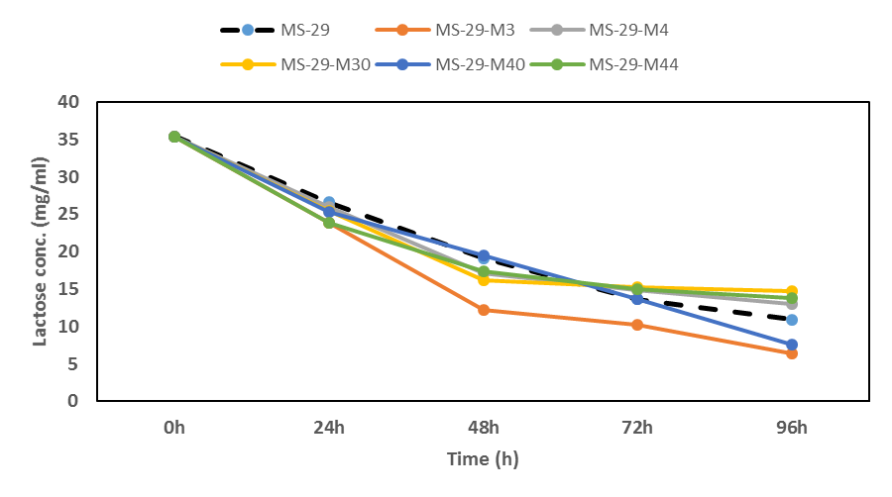

Figure 1. Lactose residual removing from cow’s milk by the β-galactosidase producing mutants.

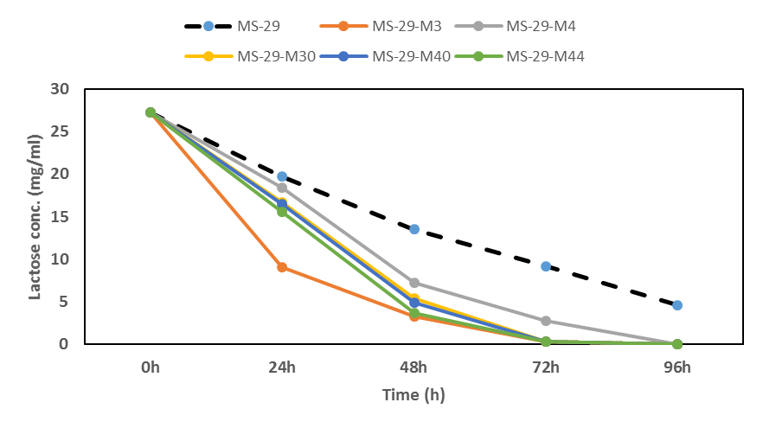

Figure 2. Lactose residual removing from goat’s milk by the β-galactosidase producing mutants.

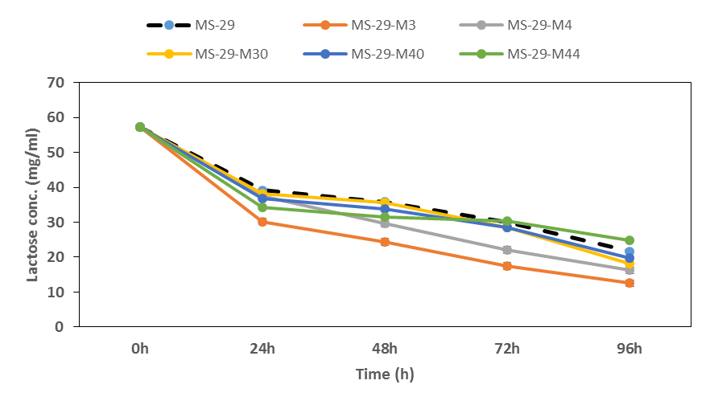

Figure 3. Lactose residual removing from Yogurt by the β-galactosidase producing mutants.

Corresponding Author:
Dr. Said E. Desouky
Botany and Microbiology Department
Faculty of science
Al-Azhar University, Cairo, Egypt
E-mail: dr_saidesouky@yahoo.com

References
- Akcan, N. (2011). High level production of extracellular β-galactosidase from Bacillus licheniformis ATCC 12759 in submerged fermentation. African Journal of Microbiology Research, 5: 4615-4621.
- Bertani, G. (1951). Studies on lysogenesis.I.The mode of phage liberation by lysogenic Esherichia coli .J.Bacteriol.62: 293-300.
- Brockrath, R.; Ruiz-Rubio, M. and Bridges, B. A. (1987). Specificity of mutation by UV light and delayed photoreversal in mucus-defective Escherichia coli. K-12 a targeting intermediate at ptrimidine dimers. J. Bacteriol. 169: 1410-1416.
- Campbell, A. K. and Matthews, S.B. (2001). Lactose intolerance and the MATHS syndrome: What are the and how can I cope? Pembrokeshire: Welston Press, The Lancet, 356: 511.
- Carolyn, M. (2010). Lactose Intolerance and Health. Minnesota Evidence-based Practice Center, Minneapolis, MN.
- Chuan, H.; Wu, Z. C. and Fang, P. X. (2012). Construction and Secretory expression of β-galactosidase gene from Lactobacillus Bulgaricus in Lactococcus Lactis. Biomed Environ Sci.; 25(2): 203-209.
- Fauchi, A. S.; Braunwald, E. and Isselbacher, K.J. (1998). Disorders of the gastrointestinal system. In: Harrison’s principles of internal medicine. 14th ed. New York: McGraw Hill,: 631.
- Gaur, R.; Pant, H., Jain, R. and Khare, S. K. (2006). Galacto-oligosaccharide synthesis by immobilized Aspergillus oryzae β-galactosidase. Food Chemistry, 97(3): 426–430.
- Gong, H. Z.; Little, B.; Kovar, G. J., Chen, H.; Xie, W.; Schutz-Geschwender, A. and Olive, D. M. (2009). β-galactosidase activity assay using far-red-shifted fluorescent substrate DDAOG. Anal. Biochem. 386: 59-64.
- Grimbacher, B.; Peters, T. and Peter, H. H. (1997). Lactose-intolerance may induce severe chronic eczema. Int Arch Allergy Immunol; 113: 516–18.
- Guerrero, C.; Vera, C. and Illanes, A. (2013). Optimisation of synthesis of oligosaccharides derived from lactulose (fructosyl-galacto-oligosaccharides) with β-galactosidases of different origin. Food Chemistry 138: 2225–2232.
- Jarvis, K. K. and Miller, G. D. (2002). Overcoming the barrier of lactose intolerance to reduce health disparities. J. Nat. Med Assoc. 94: 55–66.
- Jelen, B. D. P. and Kalab, M. (2001). Disruption of Lactobacillus delbrueckii ssp. Bulgaricus I 1842 cells for lactose hydrolysis in dairy products: a comparison of sonication, high-pressure homogenization and bead mllling. Innov. Food Sci. & Emerg. Tech., 2.23-30.
- Kara, F. (2004). Release and Characterization of Β galactosidase from Lactobacillus plantarum. M.Sc. Thesis, Middle East Technical University, Turkey.1-122.
- Kolusheva, T. and Marinova A. (2011). Fast complexometric method for analysis of reducing sugars obtained during starch hydrolysis. Journal of the University of Chemical Technology and Metallurgy, 46: 75-80
- Kornberg, A. and Baker T. A. (1992). DNA Replication. W. H. Freeman and Company, New York.
- Kretchmer, N. and Memorial, l. (1971). Lactose and lactase a historical perspective Gastroenterology; 61: 805–13.
- Liu, X.; Mann D. B.; Suquet, C.; Springer D. L. and Smerdon, M. J. (2000). Ultraviolet damage and nucleosome folding of the 5S ribosomal RNA gene. Biochemistry 39: 557–566.
- Maksimainen, M.; Nina H. and Johanna M. K. (2011). Crystal structures of Trichoderma reesei b-galactosidase reveal conformational changes in the active site. Journal of Structural Biology 174: 156–163.
- Mariotti, M. P.; Yamanaka, H.; Araujo, A. R. and Trevisan, H. C. (2008). Hydrolysis of Whey Lactose by Immobilized β- galactosidase. Brazilian Archives of Biology and Technology, Vol. 51, n. 6: 1233-1240.
- Martinez, J. L. and Baquero, F. (2000) Mutation frequencies and antibiotic resistance. Antimicrobial Agents and Chemotherapy, 44(7): 1771-1777.
- Matthews, S. B. and Campbell, A. K. (2004). Lactose intolerance in the young: A new systemic lactose intolerance: A new perspective on an old problem. Wales College of Medicine, Cardiff University, Heath Park, Cardiff CF14 4XN, UK.
- Mazura-Reetz, G. T.; Neblett, and Galperin, J. M. (1979). MacConkey Agar: CO₂ vs. ambient incubation. Abst. Ann. Mtg. American Society for Microbiology. C179.
- Princely, S.; Saleem, N.; John, J. K. and Dhanaraju1, M. D. (2013). Biochemical characterization, partial purification, and production of an intracellular β-galactosidase from Streptococcus thermophilus grown in whey. European Journal of Experimental Biology. 3: 242-251.
- Sambrook, J.; Fritsch, E. F. and Maniatis, T. (1989). Molecular Cloning 2nd Ed., Vol. 3, p. A.3 Filename: "Minimal"06/09/97.
- Shukla, T. P. (1975). β-galactosidase technology: a solution to the lactose problem. CRC. Crit. Rev. Food Technol., 5: 325.
- Volff, J. N.; Viell, P. and Altenbuchner, J. (1997). Artificial circularization of the chromosome with concomitant deletion of its terminal inverted repeats enhances genetic instability and genome rearrangement in Streptomyces lividans. Mol Gen Genet.;253:753–760.
- Volkin, D. B. and Klibanov, A. M. (1989). Minimizing protein inactivation. In: Creighton TE, editor. Protein function: a practical approach. Oxford: Oxford University Press; 1989. p. 1–24.
- Witkin, E. M. (1969). Ultraviolet-induced mutation and DNA repair. Annual Review of Genetics. 487-514.

11/30/2013

