Comparative Studies on Four Cereal Genotypes 2- Micromorphological Characteristics of Leaf and Grain by Using S.E.M.

Abou- Taleb S. M.¹ and Abd – El Maksoud H. S. ²

¹Agricultural Botany Department, Fac. of Agric., Cairo University.
²Flora and Phyto-taxonomy Researches Department, Horticulture Research Institute, Agricultural Research Center, Giza.
Salamaflora@gmail.com

Abstract: This study was performed on four cereal genotypes in Egypt. These genotypes are; Triticum durum Desf (Beni Sweif), T. aestivum L.(Sakha 93), Secaj cereale (Rye) and Triticale spp. (Triticale). The aim of this study is to distinguish the similarity and dissimilarity between these species. This study includes number of taxonomic evidences or characters to establish the relationships among the above mentioned species. These characters were; 1) morphological descriptions and Scanning Electron Microscope (SEM) survey on the leaf (adaxial and abaxial surfaces of epidermis). 2) morphological descriptions and Scanning Electron Microscope (SEM) survey on grain of the studied genotypes.3) based on macro-and micro-morphological characters the numerical analysis showed a considerable degree of similarity among the studied genotypes.

[Abou- Taleb S. M. and Abd – El Maksoud H. S. Comparative Studies on Four Cereal Genotypes 2- Micromorphological Characteristics of Leaf and Grain by Using S.E.M. N Y Sci J 2013;6(12):186-192]. (ISSN: 1554-0200). http://www.sciencepub.net/newyork. 30

Key words: botany, cereal genotypes, grain morphology, leaf morphology, SEM, taxonomy

1.Introduction
Each leaf of Gramineae comprises the sheath, wrapping around the subtending leaf, and a lamina (blade). At the junction of the sheath and lamina, there is a membranous structure, the ligule, and a pair of small hairy projections, the auricles. The base of the leaves on the culm is thickened to form a hard knot or pulvinus.( Kirby & Appleyard, 1987)
The leaf is divided at the ligule into a cylindrical sheath and the flat blade or lamina. The sheath is tubular at the base, but nearer to the blade it is split and the margins overlap. The lamina has a fairly well-marked midrib, along which runs the major vascular bundle of the leaf. It divides the blade into two subequal parts, each of which has a number of parallel lateral ribs or veins. Each vein marks the position of a vascular bundle, and the tissue over the bundle is raised producing a ridge so that the adaxial surface of the blade is corrugated. The abaxial surface is more or less flat. The midrib extends down into the sheath for a short distance as a pronounced ridge. The leaf blade naturally assumes a twist, and just below the tip, usually about two-thirds along the leaf, there is frequently a constriction. This constriction is produced by the constraint upon growth produced by the closely investing ligule of the subtending leaf during development. The ligule is a thin colourless flap of tissue about 1 to 2 mm in length, which encircles the leaf or the culm above it beyond where the blade diverges. Associated with the ligule are the auricles, two small earlike projections fringed with unicellular hairs. At the base of the leaf sheath of the culm leaves, there is a thicker zone called variously the joint knot or pulvinus. It is considerably thicker and generally lighter green than the sheath above or the stem below. The node of the stem is below the joint and its position is marked by a slight constriction of the stem. The joint has an important function, lifting the ear of a lodged stem off the ground and restoring it to a more or less vertical position.( Bonnet, 1966).
Leaf shape and size change with leaf position. The lowermost leaf on the main shoot has parallel sides to within 1 cm or so of the tip so that the tip itself is characteristically blunt. The leaves above the first have more or less parallel sides for about two-thirds their length above which they taper to a sharp point. The last leaf produced upon the culm, the flag leaf, tapers from about the lower third, giving the leaf an elongated ovate shape. (Esau, 1953).
El-Khanagry (2003) purposed a key to identify 49 species of grasses belonging to 33 genera by using vegetative of leaves as well as trichomes and cuticular ornamentations. However, the gross morphological characters of the leaf have been used for identification purposes. With increased sophistication of classification systems it has become increasingly important to have more elaborative means for identification. The leaf has not lost its importance as a taxonomic tool but rather has proved to be more useful when a fuller understanding of all its characteristics are known and appreciate.
The great variations in the morphology and the different ornamentations of the seed coat support the study of taxa delimitation and may solve and facilitate many taxonomic problems. Netolizky (1926) confirmed also that the morphology of seed coat surface should be the principles of natural classification of the flowering plants. Vaughan (1968) suggested that the structure of the mature seeds, especially the coat structure is considered the more taxonomic useful information. Yossef et al. (2003), reported that the tribe Panicoideae included both species of genus Echinochloa, in the time, where Setaria pumila stay away under another tribe by using Scanning Electron Microscope on grain of 14 Gramineae species. El-Khanagry et al. (2006) purposed a key to identify 9 species of grasses by using grains and spikes features using the Scanning Electron Microscope (SEM). El-Sgai (2006) purposed a key to identify 11 species of grasses belonging to 6 genera by using SEM on grains.
The aim of this study is to distinguish the taxonomic relationship between four cereal genotypes grown in Egypt; namely, Triticum durum Desf (Beni Sweif), T. aestivum L.(Sakha 93), Secaj cereale (Rye) and Triticale spp. (Triticale). Morphological descriptions and Scanning Electron Microscope (SEM) survey on the leaf and grain surfaces of the studied genotypes were investigated. Based on macro-and micro-morphological characters the numerical analysis showed a considerable degree of similarity among the studied genotypes.

2. Materials and Methods
In this study, four cereal genotypes were studied. The fresh leaves and grains of each genotypes were used in this study. which were planted in Fac. of Agric., Cairo University. The detailed surface scan features was examined by using Scanning Electron Microscope (SEM) with different magnifications. Scanning was carried by JEOL- JSM T 100 Model Scanning Electron Microscope, Central Laboratory, National Information and Documentation Center (NIDoC), Dokki, Giza, Egypt. The studied genotypes are; Triticum durum (Beni Sweif), T. aestivum (Sakha 93), Secale cereale (Rye) and Triticale spp. (Triticale). The present investigation aimed to represent the taxonomical relationships among the studied genotypes. Taxonomical evidences and characters which will explore this relationships were gathered from the following different sources during this study; morphological descriptions and Scanning Electron Microscope (SEM) on the surfaces of leaves. and grains. All these data were analyzed by using numerical analysis technique called NTSYS-PC.", version1.5 program (Rohlf, 1993) which resulted in a form of dendrogram representing the relationships among the studied species.
3. Results and Discussion
The species under consideration were studied and the results were gathered according to the following aspects:
- Macromorphological and Scanning Electron Microscope (SEM) descriptions of leaf (adaxial and abaxial Surfaces ) for each genotypes.
- Macromorphological and Scanning Electron Microscope (SEM) descriptions of the grain for each genotypes.
Triticum durum Desf. (Beni Sweif)
1) The leaf
The adaxial epidermis is a complex tissue with several cell types The bulliform (bubble-shaped) cells are the largest cells lying between the veins at the bottom of the furrows. Flanking the bulliform cells are long cylindrical cells with a smaller diameter than the bulliform cells, alternating in a regular manner with stomata. There is usually a single row of stomata between each rank of bulliform cells and the vascular tissue. Each stoma is made up of two characteristic shaped guard cells (dumbbell- shaped) and has two associated accessory cells, depressed. The stoma length varies from 39 to 45 µm. The frequency of stomata varies from about 63/mm² to 109/ There are more on the adaxial surface and are more densely distributed towards the tip. On the other flank of the row of stomata, over the veins there are long cylindrical cells characterized by thickened wavy walls. The long cells are interspersed in a regular manner by short cells of two types, cork cells and silica cells. Hairs short, vinca, unicellular occur mainly over the veins and on either side of the row of stomata. rugose sculpture pattern (Fig. 1A). The abaxial epidermis has fewer cell types, mainly the long cylindrical cells with wavy walls interspersed by short cells. Smooth. Stomata occur in the same position relative to the veins as in the adaxial epidermis and superficial. Sulcate sculpture pattern. (Fig. 1B).
2) The grain
Grain elliptic shape, 6.5 x 3.5 mm in dimensions, surface smooth, short hairs at base, base broad raised and round, creamy, prominent dorsal hump or ridge. scalariform sculpture pattern of epidermal cells. Raised anticlinal walls and usually 4 gonal, raised boundaries, straight with regular channels. Outer periclinal walls are concave with delicate furrows. Junction point conspicuous, terminal, broad, rounded and dark brown (Fig. 2A&B).

T. aestivum L. (Sakha 93)
(Syns. T.sativum Lam, T.hybernum L., T. vulgare Vill.)

1) The leaf
The adaxial epidermis is a complex tissue with several cell types The bulliform (bubble-shaped) cells are the largest cells lying between the veins at the bottom of the furrows. Flanking the bulliform cells are long cylindrical cells, alternating in a regular manner with stomata. There is usually a single row of stomata between each rank of bulliform cells and the vascular tissue. Each stoma is made up of two characteristic shaped guard cells and has two associated accessory cells. The stoma length varies from 42 to 51 µm. The frequency of stomata varies from about 56/mm2 to 99/mmThere are more on the adaxial surface and are more densely distributed towards the tip. On the other flank of the row of stomata, over the veins there are long cylindrical cells characterized by wavy walls, depressed. The long cells are interspersed in a regular manner by short cells of two types, cork cells and silica cells. Short, few, unicellular hairs occur mainly over the veins and on either side of the row of stomata. (Fig. 3A).The abaxial epidermis has fewer cell types, mainly the long cylindrical cells with wavy walls interspersed by short cells. Stomata occur in the same position relative to the veins as in the adaxial epidermis, superficial and, although smooth. Sulcate sculpture pattern on both epidermis Surfaces. (Fig. 3B).

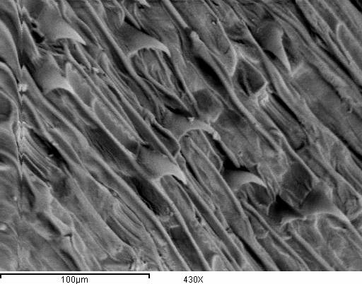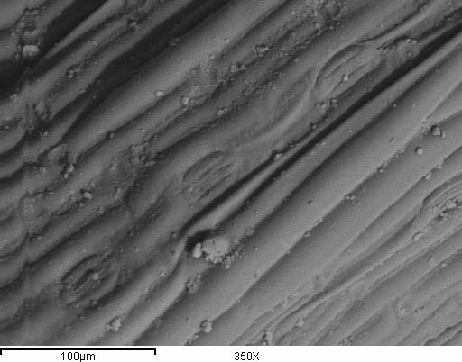
A B
Fig. (1):Scanning electron micrographs of leaf blade of Triticum durum Desf. (Beni Sweif) A: Surface of adaxial epidermis, B: Surface of abaxial epidermis
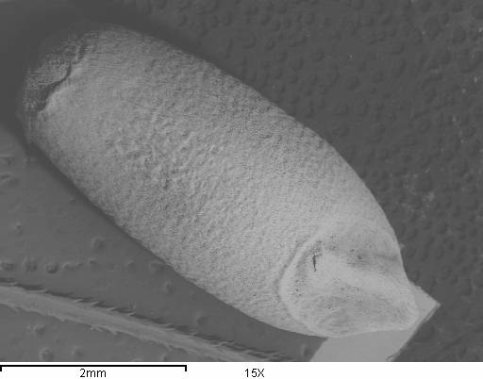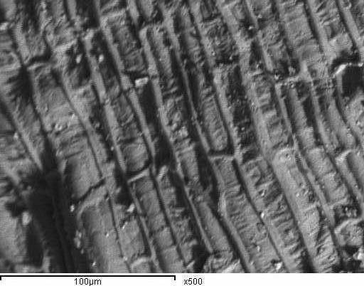
A B
Fig. (2): Scanning electron micrographs of grain; grain shape (A) and surface sculpture patterns (B) of Triticum durum

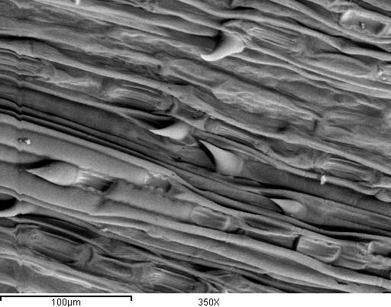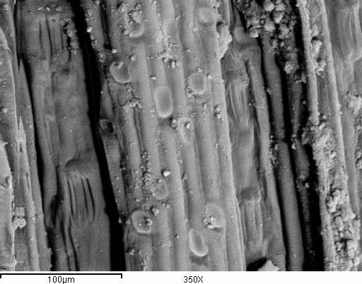
A B
Fig. (3):Scanning electron micrographs of leaf blade of T. aestivum L. (Sakha 93) A: Surface of adaxial epidermis, B: Surface of abaxial epidermis

2) The grain
Grain elliptic shape, 6.8 x 3.5 mm in dimensions, surface smooth, long hairs at base, base broad and depraised, creamy, dorsally curved without a hump or ridge. Rugose- scalariform sculpture pattern of epidermal cells. Raised anticlinal walls and usually 4-5 gonal, raised boundaries, straight or sinuous with regular channels. Outer periclinal walls are concave with delicate furrows. Junction point conspicuous, terminal, broad, rounded and conical (Fig. 4A&B).

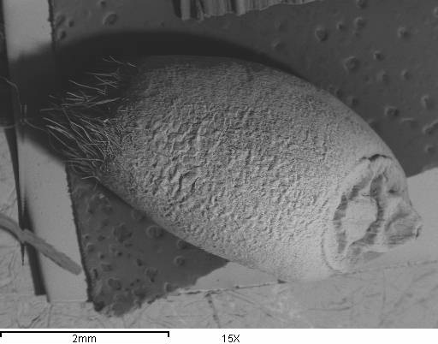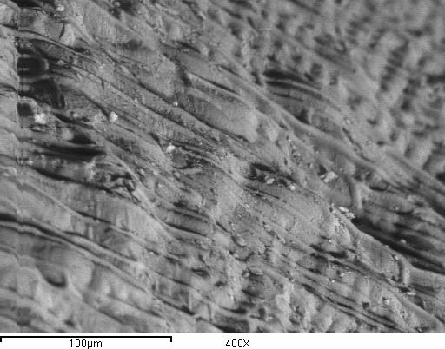
A B
Fig. (4): Scanning electron micrographs of grain; grain shape (A) and surface sculpture patterns (B) of Triticum aestivum

Secale cereale L. (Rye)
( Syns; Secale fragile M. Bieb. )
1) The leaf
The adaxial epidermis is a complex tissue with several cell types The bulliform (bubble-shaped) cells are the largest cells lying between the veins at the bottom of the furrows. Flanking the bulliform cells are long cylindrical cells with a smaller diameter than the bulliform cells, alternating in a regular manner with stomata. There is usually a single row of stomata between each rank of bulliform cells and the vascular tissue. Each stoma is made up of two characteristic shaped guard cells and has two associated accessory cells. The stoma length varies from 40 to 46 µm. The frequency of stomata varies from about 68/mm2 to 109/mmThere are more on the adaxial surface and are more densely distributed towards the tip and semi- depressed. On the other flank of the row of stomata, over the veins there are long cylindrical cells characterized by straight walls. The long cells are interspersed in a regular manner by short cells of two types, cork cells and silica cells. Short, dancey, unicellular hairs occur mainly over the veins and on either side of the row of stomata. (Fig. 5A).The abaxial epidermis has cell types, mainly the long cylindrical cells with straight walls interspersed by short cells. Stomata occur in the same position relative to the veins as in the adaxial epidermis, superficial, and although hairs occur, they are more frequent than on the adaxial epidermis. Sulcate-glebulate sculpture pattern on both epidermis surfaces. (Fig. 5B).

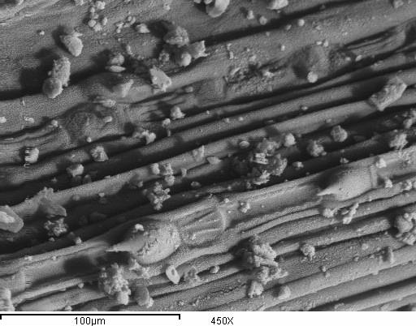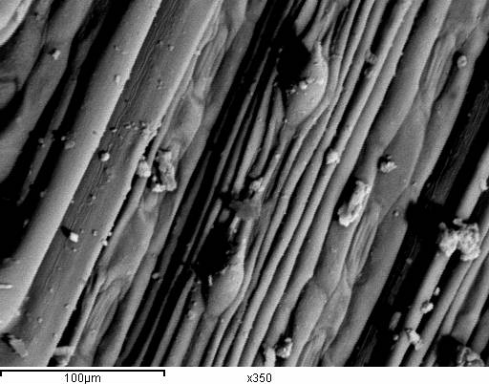
A B
Fig. (5):Scanning electron micrographs of leaf blade of Secale cereale L. (Rye) A: Surface of adaxial epidermis, B: Surface of abaxial epidermis

2) The grain
Grain linear to oblong shape, 6 x 2 mm in dimensions, surface smooth, glossy, hairs at base few and short, base broad and depraised,,, creamy. Scrobiculate-striate sculpture pattern of epidermal cells. Raised anticlinal walls and usually 4-6 gonal, raised boundaries, straight or sinuous with regular channels. Outer periclinal walls are concave or convex. Junction point conspicuous, semiterminal, narrowness, triangular and rounded. (Fig. 6A&B).

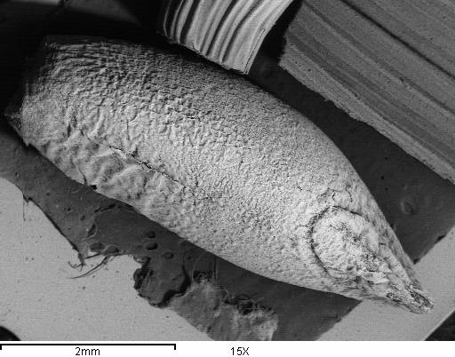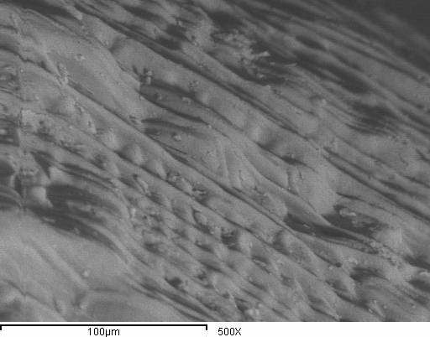
A B
Fig. (6): Scanning electron micrographs of grain; grain shape (A) and surface sculpture patterns (B) of Secale cereale L. (Rye)

Triticale spp. (Triticale).
1) The leaf
The adaxial epidermis is a complex tissue with several cell types and smooth. The bulliform (bubble-shaped) cells are the few cells lying between the veins at the bottom of the furrows. Flanking the bulliform cells are long cylindrical cells with a more diameter than the bulliform cells, alternating in a irregular manner with stomata. There are usually a two to three rows of stomata between each rank of bulliform cells and the vascular tissue. Each stoma is made up of two characteristic shaped guard cells and has two associated accessory cells. The stoma length varies from 42 to 51 µm. The frequency of stomata varies from about 68/mm² to 119/mm², semidepressed and are more densely distributed towards the tip. On the other flank of the row of stomata, over the veins there are long cylindrical cells characterized by wavy walls. The long cells are interspersed in a irregular manner by short cells of two types, cork cells and silica cells. Short, thin, unicellular hairs occur mainly over the veins and on either side of the row of stomata. Sulcate- rugose sculpture pattern on adaxial epidermis. (Fig. 7A).The abaxial epidermis has fewer cell types, smooth, mainly the long cylindrical cells with wavy or stright walls interspersed by short cells. Stomata occur in the same position relative to the veins as in the adaxial epidermis, superficial or depressed and, although the fewer hairs occur, they are less frequent than on the adaxial epidermis. Sulcate sculpture pattern on abaxial epidermis. (Fig. 7B&C).
2) The grain
Grain linear to oblong shape, 9 x 2 mm in dimensions, surface smooth, hairs at base long and dancy, base broad and raised, creamy, dorsally curved without a hump or ridge. Scalariform-rugulose sculpture pattern of epidermal cells. Raised anticlinal walls and usually 4-5 gonal, raised boundaries, straight or sinuous with regular channels. Outer periclinal walls are concave. Junction point conspicuous, terminal, narrowness, conical and rounded. (Fig. 8A&B).
Numerical Analysis
Data obtained from the micro and macro morphological characters of leaf and grain surfaces were analyzed by using a Single Linkage Clustering analysis technique (Sneath and Sokal, 1973). The final results of analysis will represented in a form of dendrogram, (Fig. 9). The dendrogram shows the level of similarity in which the studied species have been shared, in other words, determining the similarity or dissimilarity distance between these species.
From the illustrated dendrogram, it could be stated that the studied species, according to the similarity or dissimilarity distance, split into two main clusters, the first includes the two cereal genotypes; Triticum durum and T. aestivum which linked together at similarity level of 1.13. The second cluster, which started at similarity level quit closer to the previous level (1.12), included Triticale spp. and Secale cereale. The four cereal genotypes at 1.19 similarity level as they all species belong to the same family.
Finally it could be concluded that the more close cereal genotypes to each other.

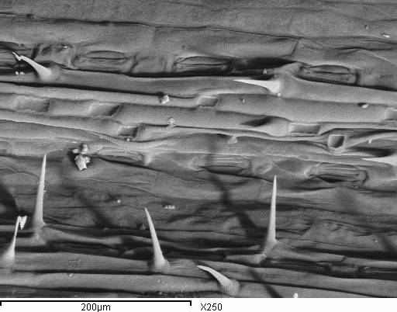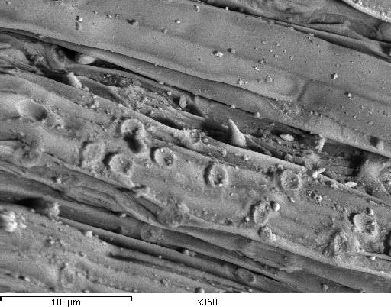
A B
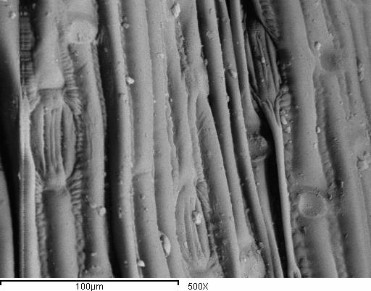
C
Fig. (7):Scanning electron micrographs of leaf blade of Triticale spp. (Triticale).A: Surface of adaxial epidermis, B&C: Surface of abaxial epidermis

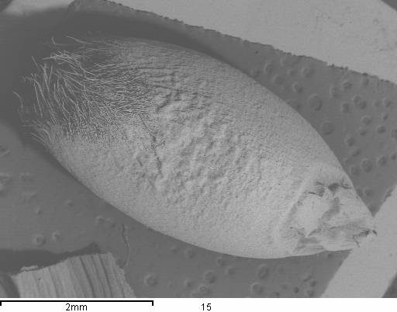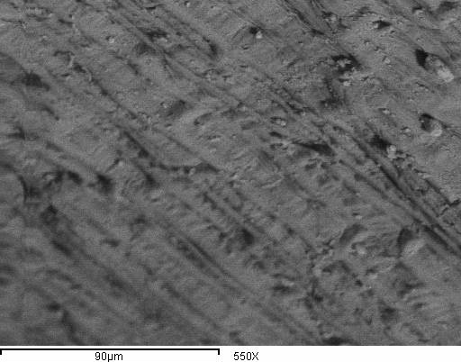
A B
Fig. (8): Scanning electron micrographs of grain; grain shape (A) and surface sculpture patterns (B) of Triticale spp. (Triticale).

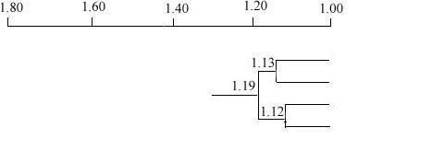
Triticale spp
Triticum durum
T. aestivum
Secale cereale
Fig.(9): the dendrogram of operational taxonomic units (otus) based on morphological attributes of leaf and grain using numerical analysis.

References
Bonnet, O.T. 1966. Inflorescence of maize, wheat, rye, barley and oats: their initiation and development. Agricultural Experiment Station Bulletin 721. College of Agriculture, University of Illinois.
El-Khanagry, S.S.G. 2003. Field key for identification of some Egyptian grasses by vegetative characters. The 2nd Conference of Agriculture & Biological Research Division, National Research Center, Egypt, (3): 547-557.
El-Khanagry, S.S.G. ; A. Z. Sabh; M. U. El-Sgai and Hanan S. Abd-El Maksoud, 2006. Taxonomic assessment of some species of Poaceae (Gramineae).. J. Agric. Sci. Mansoura Univ., 31 (10): 6261-6273.
El-Sgai, M. U. 2006. Comparative morphological and ultrastructural studies on grain of some Poaceae species. J. Agric. Sci. Mansoura Univ., 31 (1); 175-191.
Esau, K. 1953. Plant anatomy. London, Chapman & Hall.
Kirby, E.J.M. & Appleyard, M. 1987. Cereal development guide. Stoneleigh, Kenilworth, UK, NAC Cereal Unit. 85pp.
Netolizky, F. 1926. Anatomic der Angiospermen. Bd. 10 in Hand buch der Pflanzenanatomie. Abt, 2nd Edit. K. Linbauer, Berlin. 845 pp.
Rohlf, F. J. 1993. NTSYS-PC. Numerical taxonomy and multivariate analysis system. Exeter Software, New York.
Sneath, H.A. and R.R. Sokal 1973. Numerical Taxonomy the principles and practice of numerical classification. Freeman and Co., San Francisco. 359 pp.
Vaughan, J.G. 1968. Seed anatomy and taxonomy. Proc. Linn. Soc., London. 179: 251-255
Youssef, Fadia, A.; A. M. Khattab; S. H. Rabie and Abd-El Maksoud, Hanan, S. 2003. Using grains as an evidence for taxonomy of some species of Poaceae. J. Agric. Sci. Mansoura Univ., 28 (5): 3479-5303.

12/11/2013

