Optimization and Characterization of Tannin Acyle Hydrolase Produced by Aspergillus flavus var. columnaris Using Solid State Fermentation Technique

Roushdy M.M. ¹, Desouky S.E.¹*, Esmael M.E.², El-Louboudy S.S.^{1, 2}, Elshikh H.H.^{1, 3}

^{1.} Botany and Microbiology, Faculty of Science, Al-Azhar University, Cairo, Egypt
^{2.} Fermentaion Biotechnology & Applied Microbiology (Ferm-BAM) Center, Cairo, Egypt
^{3.} Regional Center for Mycology and Biotechnology (RCMB), Cairo, Egypt
*dr_saidesouky@yahoo.com

Abstract: Tannin acyl hydrolase (TAH), commonly referred as tannase (EC. 3.1.1.20) is involved in tannins biodegradation, has important roles in various applications, particularly in food and pharmaceutical industries. Twenty six fungal isolates were screened for their tannase production. One isolate (TL1) produced 0.34 U/ml of tannase was found to be the most potent and subjected for further identification to be identified as Aspergillus flavus var. columnaris. A medium optimization was carried out for maximum tannase productivity, 5.18 U/ml, under solid state fermentation (SSF) i.e. substrate concentration of 0.3 g/ml of wheat bran (WB), pH 3.8 , incubation period 4 days at 30°C. The best carbon & nitrogen sources were maltose and NH₄Cl respectively. Different heavy spore suspension inocula were tested and 0.5 ml/10 ml was the best one that gave maximum tannase production with concentration of 3% of tannic acid. Different purification steps were carried out with purification folds of 5.8 times from the origin and 4.7 % of recovery yield. The purification steps were followed by Amino acid analysis of the purified tannase which indicated that, Phenyle alanin represented the highest one i.e. 947.6 μg/ml. SDS-PAGE of the purified enzyme revealed that the molecular weight of tannase was about 68 KDa. Optimization of the purified enzyme was achieved at enzyme thermostability 40°C, pH stability 6 when incubated for 80 min with (1.84 mg/ml) of methyle gallate in the presence of 1 ml of tannase produced by Aspergillus flavus var. columnaris.
[Roushdy MM, Desouky SE, Esmael ME, Elboudy SS, Elshikh HH. Optimization and Characterization of Tannin Acyle Hydrolase Produced by Aspergillus flavus var. columnaris Using Solid State Fermentation Technique. N Y Sci J 2014;7(3):88-98]. (ISSN: 1554-0200). http://www.sciencepub.net/newyork. 14

Keywords: Tannin acyle hydrolase, Aspergillus flavus var. columnaris, Solid state fermentation

1. Introduction
Tannin acyl hydrolase, commonly known as tannase, catalyzes the hydrolysis of the ester and depside bonds in hydrolysable tannins such as tannic acid to release glucose and gallic acid (Lekha and Lonsane, 1997). Tannase can be obtained from plant, animal and microbial sources however, in industrial application, microbial production for tannase preferred for its stability (Bhat et al. 1998; Purohit et al. 2006; Manjit et al. 2009). Several agro-industrial waste and by-products such as orange bagasse (Martins et al. 2000) cane bagasse (Silva et al. 2002) wheat bran (WB) (Cavalitto et al. 1996) and other food processing waste (Zhen and Shetty, 2000) are effective substrates for depolymerizing enzyme production by solid-state fermentation which proved to be cheaper, less technologically oriented. In comparison to other methods, extraction is much easier with the release of negligible amount of liquid effluent (Hadi et al. 1994; Ellaiah et al. 2002).
Untraditional fruit juices (pomegranate, cranberry, raspberry, etc.) have been acclaimed for their health benefits, in particular, for its disease-fighting antioxidant leather industry (Orlita, 2004). The presence of high tannin content in these fruits is responsible for haze results from protein–polyphenol interaction, tannase can be potential when applied to remove haze and improve color, bitterness, and astringency of the juice upon storage (Rout and Banerjee, 2006). Tannase also participates in preparation of animal feeding (Nuero and Reyes, 2002) and in potentially used for the degradation of tannins present in the effluents of tanneries, which represent serious environmental problems (Van de-Lagemaat and Pyle, 2001). Other important application of tannase is the production of propylgallate and gallic acid (Kar et al. 2002). Propylgallate is considered as good antioxidant and in food industry as some dyestuffs (Sharma and Gupta, 2003). Gallic acid possesses a wide range of biological activities, such as antioxidant, antibacterial, antiviral, analgesic. It also shows cytotoxic activity against cancer cells, without harming normal cells (Beniwal and Chhokar, 2010). During our study, we selected the most potent tannase producer fungal isolate that was identified as Aspergillus flavus var. columnaris since we deeply studied culture condition optimization for tannase production and studied the general properties and characteristic of purified enzyme.

2. Materials and Methods
2.1. Inoculum preparation
Fungal spore suspension was prepared by addition of 10 ml sterile distilled water to a fully sporulated culture. The spores were dispersed using a sterile inoculation loop under strict aseptic conditions and the number of viable spores in the suspension was determined using chambers of haemocytometer. The suitable volume which contains the needed number of spores was calculated.

2.2. Enzyme production in solid state fermentation (SSF)
The medium for production of tannase was prepared according to Vincent, (1970) using the following ingredients (g/l): NaNO₃, 2.0; KH₂PO₄, 1.0; MgSO₄.7H₂O, 0.5 and KCl, 0.5, Agar, 30 and tannic acid 1% (w/v), the medium was adjusted at pH 5 and sterilized at 121 ⁰C for 15 minutes. One agar disc of the fungal isolates (Previously grown on Czapec Dox agar medium) was inoculated onto the surface of each agar plate and incubated at 30°C for 3 days. Fungal growth and their surrounding clearing zones were observed and taken as criteria for determining the tannase activity (Bradoo et al. 1996).

2.3. Substrates
Several agricultural wastes which incorporated in the media for enzyme production were obtained from different farms located in Qalyubia governorate of Egypt. Rice straw, sugar cane bagasse and wheat bran were kept in tightly closed jars and maintained at room temperature in dry place. After cutting or slicing, they were dried at 60°C in hot air oven for 48 h. The dried materials were then finely ground and sieved to pass 80 meshes and screened for selection of the suitable substrate for tannase production. Three grams of the selected substrate(s) were moistened with 10 ml of Dox medium supplemented with 1% tannic acid for further using in solid state fermentation process.

2.4. Identification of the most potent fungal isolates
The most potent fungal isolate was selected and identified by examination of its growth characterization macroscopically and microscopically. Identification was done in the Regional Center for Mycology and Biotechnology (RCMB) according to the identification keys of Domsch et al. (1993) and Samson et al. (2000).

2.5. Tannase recovery and assay
For tannase recovery, 0.05 M of citrate buffer (pH 5.0), was added to the fermented substrate and frozen overnight. The mixture was ground in a pestle mortar and crude enzyme was separated from fermented biomass by centrifugation at 4000 rpm at 4°C for 20 min (Paranthaman et al. 2009). Obtained tannase was assayed by the method described by (Sharma et al. 2000). The method is based on chromogen formation between gallic acid (released by the action of tannase on methyl gallate) and rhodanine (2-thio-4-ketothiazolidine). The resulted pink color was measured at 520 nm using a spectrophotometer. The enzyme activity was calculated from the change in absorbance as the follow equation:

DA₅₂₀ = (test -blank) - (control -blank)

One unit of the enzyme was defined as a micromole of gallic acid formed per minute under defined reaction conditions.

2.6. Optimization of tannase production
The productivity of the crude enzyme was studied at the following culture conditions; different incubation temperatures (i.e. 25, 30, 35, 40, 45, 50 and 55ºC), different pH values (i.e. 3, 3.4, 3.8, 4.2, 4.6, 5, 5.4 and 6), different incubation periods (i.e. 1, 2, 3, 4, 5 and 6 days). Incorporation of carbohydrates in the presence of tannic acid also was studied. Several carbohydrates (glucose, xylose, sorbitol, maltose, manitol, cellulose, lactose, cellibiose, galactose, arabinose, starch, dextrin, sucrose and inuline) were separately incorporated at concentration of 1% into the production medium in the presence of 1% tannic acid. For the determination of the highest production of tannase, various nitrogen sources were tested. Since, sodium nitrate that was constituted in the basal medium was replaced by equivalent amounts of ammonium molybdate, ammonium dihydrogen ortho-phosphate, urea, potassium nitrate, ammonium chloride, ammonium sulphate, ammonium oxalate, yeast extract and peptone. After the incubation period in last all experiment the enzyme activity was determined. In a trial to study the effect of inoculum sizes on tannase productivity, different inoculum sizes of heavy spore suspension of the fungal isolate were applied (i.e. 0.25, 0.5, 1.0, 2.0, 3, 5.0, and 10.0 ml) per 10 ml of medium. Finally, the optimal concentration of tannic acid in the production medium was investigated. Different concentrations of tannic acid were applied (i.e. 0.25 0.5, 1, 2, 3, 4, 5, 6 and 7 %) to the production medium. At the end of incubation period, tannase productivity was assayed as previously mentioned.

2.7. Tannase purification steps
2.7.1. Spores-free filtrate (SFF) collection and fractionation
At the end of incubation period (4 days), tannase was extracted and centrifuged at 4000 rpm for 20 min and the resulted precipitate was collected. The SFF was gently treated with Acetone, methanol and ethanol making different concentration (v/v) 20, 40, 60, 80 % for each solvent. Continuous gentle stirring was performed in ice for 10 - 15 minutes then followed by centrifugation at 5000 rpm (4ᴼC) for 15 min. The supernatant was decanted and the precipitate was gently resuspended into two pellet volume of cold buffer (Bollag and Edelestein, 1991). For each one (acetone, methanol and ethanol concentration) enzyme activities and protein content were determined and the specific activity for each fraction was calculated. Total protein concentrations, of the same culture filtrate, were determined and expressed as mg per ml with bovine serum albumin as a standard according to Lowry et al. (1951).

2.7.2. Dialysis and column chromatography
The SFF was dialyzed against distilled water for 24 hour after that it was dialyzed against sucrose to achieve more concentrated crude enzyme to be subjected for next purification steps. The dialyzed enzyme preparation was applied onto a column packed with sephadex G200. This was equilibrated with citrate buffer adjusted at pH: 5 then eluted with the same buffer. Preparation of the gel column and the fractionation procedure was carried out as mentioned by Soliman, (2003). Sharp peeks of the fractions obtained after applying sephadex G-200 column were collected and tested for their activities and protein content.

2.7.3. Properties of the purified tannase
The purified tannase was subjected for studying its properties including determination of its molecular weight using sodium dodecyl sulfate-polyacrylamide gel electrophoresis (SDS-Page) technique described by Laemmli, (1970). The amino acids content of the purified tannase was analyzed (the experiment was carried out in The National Center of Researches, Cairo, Egypt) according to the method described by Winders and Eggum, (1966). Different parameters that influencing tannase activity were investigated included: thermostability (20 - 80°C) for 2h, pH stability at different pH values between 3.0 and 9.2 [different buffers were used: 0.5M citrate buffer (pH 3.0, 4.0, 5.0 and 6.0); 0.2 M phosphate buffer (pH 7.0 and 8.0) and 0.2M Carbonate-Bicarbonate buffer (pH 9 and 9.2)]. Optimum incubation period, optimum substrate concentrations of methyle gallate and optimum enzyme concentrations also were investigated.

2.8. Statistical analysis
Prior to the statistical analysis, normality of data was checked with Shapiro-Wilk’s test and equal variance within samples was analyzed by Levene’s Median test to check for the assumptions of normal distribution and homogeneity of variances. Data then analyzed using a one-way model of analysis of variance (ANOVA). Due to the significant differences between levels, all pairwise multiple comparisons were performed using Holm-Sidak test. Results are presented as means ± standard error. Statistically non-significant differences, unless otherwise indicated, are denoted with horizontal bars. A p-value < 0.05 was considered statistically significant for all tests.

3. Results
3.1. Selecting of the most potent tannase producer strain on different agro-industrial wastes
Twenty six fungal isolates were isolated from different soil samples from Qalyubia governorate of Egypt. These isolates were purified, and subjected to a screening program in order to evaluate their ability of tannase production by observing the hydrolysis of tannic acid around the fungal colonies on tannic acid agar plates. Fungal isolates showed different abilities for tannic hydrolysis to gallic acid and glucose. Four high potent isolates that showed diameter more than 30 mm around fungal isolate were investigated for their tannase productivity using different agro-industrial wastes as recorded in (Table 1).
It was clear that, the fungal isolate TL1 gave the highest value (0.3481 U/ml) when allowed to grow on Wheat bran (WB). The fungal isolate TL1 was selected for further identification to be identified as Aspergillus flavus var. columnaris (Figure 1).

3.2. Optimization of fermentation process
3.2.1. Effect of different concentration of wheat bran (WB) on tannase production
It was found that, maximum tannase production from A. flavus var. columnaris under SSF achieved maximum value (0.3481 U/ml) at concentration of range 0.2- 0.3g/ml (p _{0.3-0.2} = 0.269: Holm-sidak test) of WB and 1% of tannic acid (Figure 2-A). WB concentrations below and above this concentration gave value gradually decreasing as compared to that of optimal one.

Table 1. Studying of fungal tannase production using different agro-industrial wastes using solid state fermentation technique.

No. | Isolates code | Rice straw (RS) | Sugarcane bagasse(SB) | Wheat bran(WB)
 |  | Tannase production U/ml
1 | TL1 | 0.1782 ± 0.0071* | 0.1642 ± 0.0018 | 0.3481 ± 0.0640
2 | TL3 | 0.1258 ± 0.0050 | 0.1619 ± 0.0033 | 0.1699 ± 0.0126
3 | T.A | 0.1564 ± 0.0063 | 0.1256 ± 0.0053 | 0.1855 ± 0.0020
4 | ROS2 | 0.0435 ± 0.0017 | 0.1551 ± 0.0053 | 0.1774 ± 0.0028
*Data represented as a mean ± standard error

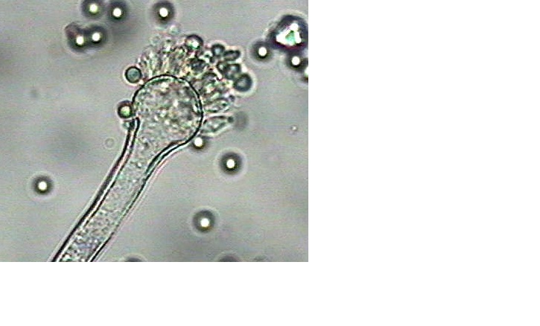

Figure 1. Identification of the fungal isolate (TL1) was found to be A. flavus var. columnaris

3.2.2. Effect of incubation temperature on tannase production
The maximum tannase production (0.3450 U/ml) was obtained at 30ᴼC. The optimum temperature for the enzyme activity was found to be 30ᴼC, at which the enzyme activity was the highest (Figure 2-B).

3.2.3. Effect of pH values on tannase production
Results showed in figure (2-C) revealed that, the maximal enzyme production (0.4283 U/ml) was obtained at pH 3.8. The optimum pH value for the enzyme activity was ranged from 3.8 - 4.2, at which the enzyme activity was the highest.

3.2.4. Effect of incubation period on tannase production
It seems from the recorded results in figure (2-D) that, the enzyme production started after 72 h of incubation and progressively increased with time, the maximal tannase productivity (0.4379 U/ml) was observed at the end of 4-5 days of incubation, thereafter, the enzyme production started decreasing.

3.2.5. Effect of adding different nitrogen source on tannase production
The results represented in figure (2-E) showed that, maximum tannase production (0.4986 U/ml) was obtained with ammonium chloride while ammonium sulphate, ammonium oxalate and urea caused decreasing to tannase production when compared to the control.

3.2.6. Effect of adding different carbon sources on tannase production
It was found that maltose was the best carbon source for tannase production (Figure 2-F) since this carbon achieved high value to tannase (0.5215 U/ml). On the other hand, addition of cellulose and xylose didn’t affect tannase production. The rest carbon sources caused decreasing to tannase production compared to the control.

3.2.7. Effect of inoculum size on tannase production
The obtained results (represented in figure 2-G) revealed that, the optimal inoculum sizes needed to produce the highest yield of tannase (0.53 U/ml) was 0.5 ml.

3.2.8. Effect of concentrations of tannic acid on tannase production
Various concentrations of tannic acid (0.25 - 7 %) were used in fermentation medium to find out the optimum concentration for obtaining a maximum tannase production. Results represented in figure (2-H) showed that 3% of tannic acid was suitable for obtaining maximum tannase production 5.18 U/ml. Tannic acid concentrations above and below this concentration caused decreasing in tannase production.

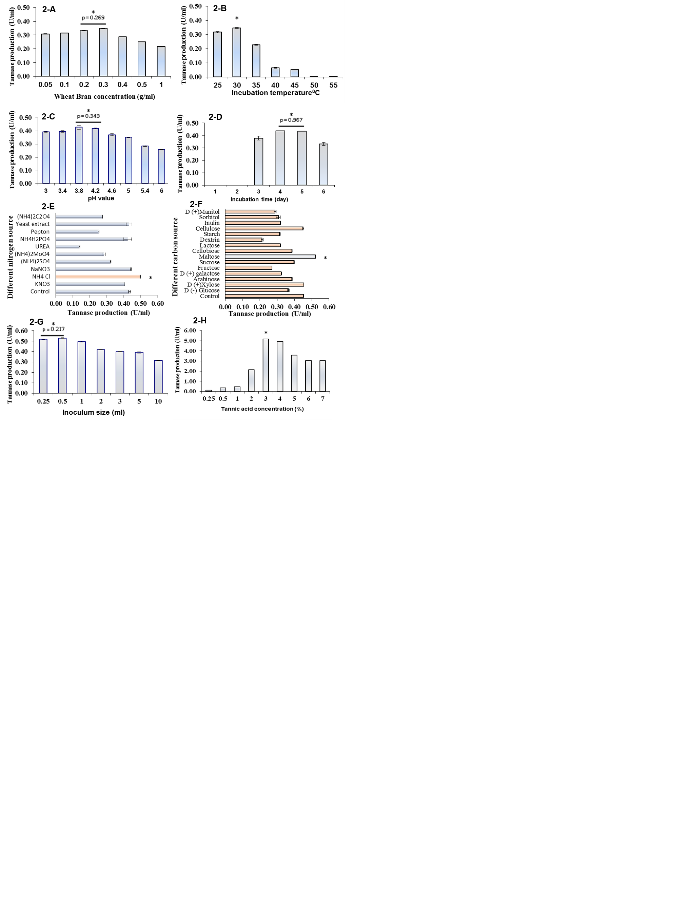

Figure 2. Effect of substrate concentration of waste (A), incubation temperatures (B), pH values (C), incubation time (D), different nitrogen source (E),carbon sources (F) , inoculums size (G), and (H) different concentration of tannic acid on tannase productivity. (*); significantly optimum or best conditions, statistically non-significant differences in a pair or multiple wise comparisons are denoted with horizontal bars to represent a range.

3.3. Tannase purification
In a trial to precipitate tannase by organic solvents (i.e. methanol, ethanol and acetone) at different concentrations (20 - 80%), we found that, the most active enzyme protein preparation was obtained at methanol concentration of 60% for tannase enzyme (enzyme activities reached up to 7.43U/ml and protein content 0.74 mg/ml corresponding to specific activity of 10.00 U/mg/Protein). A decrease in specific activity was recorded above this concentration. This resulted in raising the purification fold (5.8 times from the origin) and the enzyme yield (4.7%).

3.3.1. Amino acids analysis of the purified enzyme
Data shown in figure (3) indicated that, Phenyle alanin having highest value (947.6 μg/ml) followed by Leucine and Glutamic acid, (933.36 and 798.96μg/ml) respectively.

3.3.2. Estimation of tannase molecular weight
The purified enzyme was subjected to SDS-PAGE electrophoresis. The results indicated that, the tannase enzyme from A. flavus var. columnaris was separated into one protein band with molecular weight of 68 KDa (Figure 4).

Table 2. A summary of the purification steps of tannase produced by A. flavus allowed growing on WB and tannic acid substrate at 30ºC under SSF.
Purification  Steps | Volume  (ml) | Protein content (mg/ml) | total protein  ( mg) | tannase activity  U/ml | total activity  (U) | Specific activity(U/mg protein) | Purification fold | Yield %
SFF | 550 | 1.74 | 871 | 5.63 | 2815 | 3.23 | 1.0 | 100
Precipitation  methanol | 100 | 0.74 | 74.0 | 7.43 | 743.0 | 10.0 | 3.1 | 26.4
Dialysis against sucrose | 10 | 1.45 | 14.5 | 8.46 | 84.55 | 5.82 | 1.8 | 3.00
Sephadex G-200 | 25 | 0.23 | 7.0 | 4.41 | 132.4 | 18.8 | 5.8 | 4.70

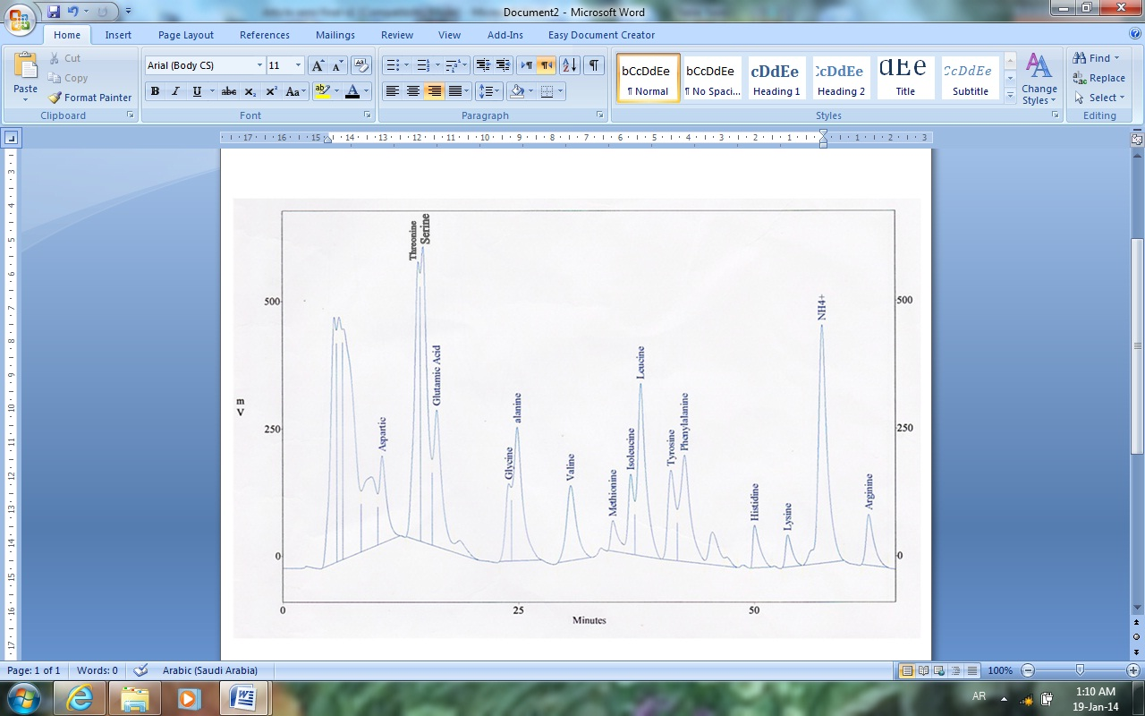

Figure 3. Amino acids analytical data of the purified tannase.

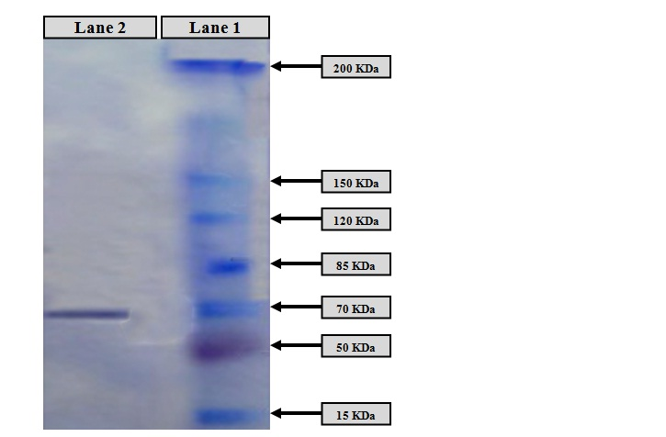

Figure 4. SDS-PAGE of the purified tannase: Lane (1): MW of standards in KDa, Lane (2): Purified tannase.

3.4. Characterizations of the purified tannase
3.4.1. Temperature stability
The results of purified enzyme represented in figure (5-A) indicated that, the enzyme was stable at low temperatures (5 to 25°C) for several hours up to 40°C for 1 h. Increases in temperature may increases the rate of denaturation of the enzyme with the loss of secondary and tertiary structure.

3.4.2. pH stability
The pH stability for the enzyme, clarified that tannase from A. flavus was stable up to pH 5. The purified tannase showed high stability in the range of 6 - 7 (Figure 5-B).

3.4.3. Effect of different incubation times
Purified tannase was investigated for various incubation times (5 - 80 min) and the effect of incubation time on tannase activity was determined. Data recorded in figure (5-C) reported that, the maximum tannase activity (13.8 U/ml) was obtained at 5 min.

3.4.4. Effect of different methyl gallate concentrations
Different concentrations (1.84 to 14.72 mg/ml) of methyl gallate solution was prepared in 0.05 M citrate buffer (pH=5) and the effect of substrate concentration on tannase activity was determined. Data represented in figure (5-D) showed that, maximum tannase activity14.08 U/ml was obtained at concentration of 1.84 mg/ml of methyle gallate.

3.4.5. Effect of different concentration of tannase
Different concentration of purified tannase range from (0.125 - 4 ml) was used to determine the optimum concentration that has ability to achieve maximum tannase activity). The data showed that maximum tannase activity (12.99 U/ml) was obtained at 1 ml of tannase (Figure 5-E).

4. Discussion
Tannin acyle hydrolase is an industrially important enzyme that is mainly used in food and pharmaceutical industry. In the present work, we carried out primary and screening test for selection of the most potent tannase producer fungal isolate, this isolate was TL1 and identified as Aspergillus flavus var. columnaris. The culture conditions for the production of tannase enzyme from A. flavus strain were evaluated and standardized. These culture conditions used for the production and purification tannase enzyme from A. flavus then we deeply studied, the properties and characterizations of purified tannase enzyme.
By studying the parameters that enhancing the production of tannase, we found that the maximum tannase production from A. flavus var. columnaris under SSF achieved maximum value (0.3481 U/ml) while grown on WB (0.3 g/ml) in the presence of 1% of tannic acid. At higher concentrations a decline of enzyme productivity was observed. This might be explained according to Haq et al. (1998) who stated that, at higher concentrations of substrate may lead to thickening (viscosity) of production medium that resulted in bad mixing of air which was essential for growth of organism, and subsequently the production of enzyme. On the other hand, El-Fouly et al. (2010) who reported that maximum enzyme synthesis under S.S.F. from A. niger AUMC 4301 was attained in the presence 1 g/ml of WB and 3% tannic acid.
The optimum temperature for tannase was found to be 30 ⁰C, at which the enzyme activity was the highest. This result is in accordance with Deepanjali et al. (2012) who reported that maximum tannase activity produced by A. niger was observed at an incubation temperature of 30°C. Also Yamada et al, (1968) reported an optimum of 30ºC for tannase production by A. flavus.

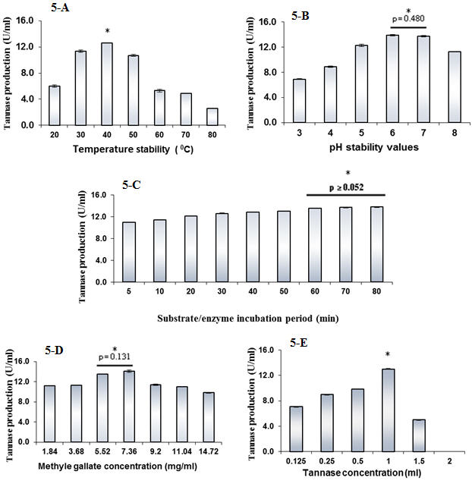

Figure 5. Effect of thermostability (A), pH stability (B), substrate/enzyme incubation time (C), substrate concentration (D), and enzyme concentration (E) on tannase activity. (*); significantly optimum or best conditions, statistically non-significant differences in a pair or multiple wise comparisons are denoted with horizontal bars to represent a range.

The optimum pH values for the enzyme activity were found to be in the range of 3 to 5. Bajpai and Patil, (2008) reported that initial pH of 3.3 to 3.5 were optimal for maximum gallic acid production by A. fischeri. On the other hand, Mohan et al. (2012) reported that maximum tannase enzyme production by A. flavus was obtained at pH 5.This may be due to that, by increasing pH of moistening agent, the enzyme production may decreased which may be due to the fact that tannase is acidic glycoprotein having an isoelectric point at about pH 4.0 (Mukherjee and Banerjee, 2006).
The maximal tannase productivity (0.4379 U/ml) was observed at the end of 96 h of incubation, thereafter, the enzyme production started decreasing. The decrease in enzyme activity after 96 h may be due to reduced nutrient level of medium affecting the metabolic activity and enzyme synthesis, inhibition and denaturation of the enzyme as explained by Gautam et al. (2002).
Maximum tannase production (0.4986 U/ml) was obtained by addition of ammonium chloride (instead of sodium nitrate) to the production medium. On the other hand, the production of tannase was obviously inhibited by the addition of ammonium sulphate. This could be due to the toxicity of sulfate ion itself on fungal growth (Kumar et al. 2007). Maltose was the best carbon source (0.5215 U/ml) for tannase production.
Our results also revealed that, the optimal inoculum sizes needed to produce the highest yield of tannase (0.5282 U/ml) was 0.5 ml. Rintu Banerjee et al. (2004) stated that the optimum volume of induced inoculums required for maximum tannase production was 3 ml, and a lesser amount of inoculum was insufficient for the complete utilization of the total available substrate.
Results also showed that 3% of tannic acid was suitable for obtaining maximum tannase production 5.1854 U/ml. Excessive tannic acid may act as repressor and prevents synthesis of mRNA. In addition, the increase of tannic acid causes an increase of heat building up and reduces aeration which in turn may decreases productivity of tannase (Banerjee et al., 2005).
In a trial to precipitate tannase by organic solvents (i.e. methanol, ethanol and acetone) at different concentrations (20 - 80%), we found that, the most active enzyme protein preparation was obtained at methanol concentration of 60% for tannase enzyme (enzyme activities was reached up to 7.43 U/ml and protein content 0.74 mg/ml corresponding to specific activity of 10.00 U/mg/Protein). A decrease in specific activity was recorded above this concentration. Purification of tannase using G-200 Sephadex column chromatography technique resulted in raising the purification fold 5.8 times from the origin. Beena et al. (2010) observed that, purification of tannase from A. Awamori when applied on sephadex G-200 column chromatography raised the purification folds to 6.73 times, while Mahendran et al. (2006) noted that, purification of tannase from Paecilomyces variotii by fractionation on sephadex G-200 column was 30.5 purification fold.
Amino acids analysis of the purified enzyme showed that, Phenyle alanin having highest value (947.6 μg/ml) followed by Leucine and Glutamic acid, (933.36 and 798.96μg/ml) respectively. The results also indicated that, the tannase enzyme from A. flavus var. columnaris was separated into one protein band with molecular weight of 68 KDa. Deepanjali et al. (2012) mentioned that purified tannase produced by A. niger was of molecular mass of 66 kDa.
The results of purified tannase indicated that, the enzyme was stable up to 40°C. The present study is in accordance with (Andrea et al. 2012) who reported that, the optimal temperature for the activity of tannase (TAH I) was in the range between 30 and 35°C and the activity at 40°C was above 90% of the maximal activity. Similar observations were reported for tannase from A. oryzae, Aspergillus sp. and Penicillium chrysogenum (Lekha and Lonsane, 1997; Iibuchi et al. 1968; Rajakumar and Nandy, 1983). Increase in temperature increases the rate of denaturation of the enzyme with the loss of secondary and tertiary structure.
The pH stability for the purified enzyme was up to pH 6. This is in accordance with Abdulhameed et al. (2005) who reported that tannase activity was found to increase with the increase in pH and the optimum activity was at pH=6 . The enzyme was active over a wide range of pH (4 – 8). The effect of pH on the enzyme activity is determined by the nature of the amino acids at the active site, which undergoes protonation and deprotonation, and by the conformational changes induced by the ionization of other amino acids. Enzymes are very sensitive to changes in pH and they function best over a very limited range, with a definite pH optimum. On the other hand, Andrea et al. (2012) who reported that tannase enzyme was stable over a large pH range and presented optimal activities at pH 5.0-6.0.
Our data revealed that, the maximum tannase activity (13.8 U/ml) was obtained after 80 min of incubation while Abdulhameed et al. (2005), reported that an increase in activity of purified tannase produced by Aspergillus niger ATCC 16620 along with the increase in incubation time and the maximum activity 3.9 U/mL was obtained at 15 and 20 min of incubation.
The effect of different concentrations of methyl gallate on tannase activity was determined and the maximum tannase activity (14.08 U/ml) was obtained at concentration of 7.36 mg/ml of methyle gallate, while Abdulhameed et al. (2005), reported that enzyme tannase activity from A. niger ATCC 16620 was maximal at 0.01 M of methyl gallate.
Different concentration of purified tannase range from (0.125-4) ml was used to determine optimum concentration that has ability to achieve maximum tannase activity. Data showed that maximum tannase activity 12.99 U/ml was obtained at concentration 1ml of tannase enzyme. Dave et al. (2011) reported that maximum tannase activity was obtained at concentration of 2 ml of tannase enzyme.

5. Conclusion
This study suggested that tannic substances concentrated in agro-industrial wastes can potentially be utilized by low cost bioremediation systems using microbial cultures. The knowledge about the optimum environmental factors/ conditions could help to employ biotechnological approaches efficiently to clean up the soil environment polluted by such wastes.
Corresponding Author:
Dr. Said E. Desouky
Botany and Microbiology Department
Faculty of Science,
Al-Azhar University, Cairo, Egypt
E-mail: dr_saidesouky@yahoo.com

References
- Abdulhameed, S.; Shegal, G.K.; and Ashok P. 2005: Purification and Characterization of Tannin Acyl Hydrolase from Aspergillus niger ATCC 16620. Biotechnol. 43(2): 133–138.
- Andrea, M.C.; Marina, K. K.; Monique, C. M.; Cristina, G. M.; Cinthia, G. B.; Adelar B.; and Rosane M. P. 2012: Production, purification and characterization of tannase from Aspergillus tamari. African Journal of Biotechnology 11(2):391-398
- Bajpai, B.; and Patil, S. 2008:“A new approach to microbial production of gallic acid,” Brazilian Journal of Microbiology, 39 (4):708–711.
- Banerjee D, Mukherjee G, Patra KC. 2005: Microbial transformation of tannin rich substrate to gallic acid through co-culture method. Bioresource Technol, 96:949-953.
- Beena, P. S; Soorej, M.B.; Elyas, K. K.; Sarita, G.B.; and Chandrasekaran, M. 2010: “Acidophilic tannase from marine Aspergillus awamoriBTMFW032,”Journal of Microbiology and Biotechnology, 20(10):1403–1414
- Beniwal, V.; and Chhokar, V. 2010: Statistical Optimization of Culture Conditions for Tannase Production by Aspergillus awamori MTCC9299 under Submerged Fermentation. Asian J.of Biotechnol. 2(1): 46-52.
- Bhat, T. K.; Singh, B.; and Sharma, O. P.1998: “Microbial degradation of tannins—a current perspective,” Biodegradation, vol. 9, no. 5, pp. 343–357, Biotechnol. And Bioprocess Eng. 13: 571-576.
- Bollag, D.M.; and Edelstein, S.T. 1991: protein methods, wiley interscience, New York,N.Y, 143-160.
- Bradoo, S.; Gupta, R.; and Saxena R. K. (1996): Screening of extracellular tannase producing fungi: development of a rapid and simple plate assay. J. Gen Appl. Microbiol, 42: 325–9.
- Cavalitto, S.F.; Arcas, J.A.; and Hours, R.A. 1996: Pectinase production profile of Aspergillus foedidus in solid state cultures at different acidities. Biotechnol. Lett., 18: 251-256.
- Dave, A.; Modi, H. A.; and Chavada, N. 2011: Study and Isolation of Tannase Enzyme Production Bacteria from Tea Waste Dump Soil Site. International Journal of Pharmaceutical and Applied Sciences, 2(1):20-22
- Deepanjali, L.; Divya S.; Verma1, H. N.; and Joy, J.G. 2012: Production,characterization and purification of tannase from Aspergillus niger, J. Microbiol. Biotech. Res., 2 (4):566-572.
- Domsch, K. H.; Gams, W.; and Anderson, T. H. 1993: Compendium of Soil Fungi, 1, IHW-Verlag,Germany.
- El-Fouly, M. Z.; El-Awamry, Z.; Azza A.M. Shahin; Heba A. El Bialy1; Naeem, E and Ghadeer El-Saeed, E. 2010: Biosynthesis and Characterization of Aspergillus niger AUMC 4301 Tannase. Journal of American Science, 6 (12): 709-721
- Ellaiah, P.; Adinarayana, K.; Bhavan, Y.; Padmaja, P.; and Srinivasulu, B. 2002: Optimization of process parameters for glucoamylase production under solid- state fermentation by a newly isolated Aspergillus species. Process Biochem., 38: 615-620.
- Gautam, P.; Sabu, A.; Pandey, A.; Szakacs, G.; Saccol, C.R. 2002: Microbial production of extracellular phytase using polystyrene as inertsolid support. Bioresour. Technol., 83:229-233.
- Hadi, T.A.; Banerjee, R.; and Bhattacharyya, B.C.1994: Optimization of tannase biosynthesis by a newly isolated Rhizopus oryzae. Bioprocess Engineering, 11: 239-243.
- Haq, I.; Ashraf, H.; Zahara, R.; and Qader, M.A. 1998: Biosynthesis of α-amylase by Bacillus subtilus GCB-12 using agricultural by products as substrates. Biolog. 44(1&2): 154-163
- Iibuchi, S.; Minoda,Y.; and Yamada, K. 1968: “Studies on tannin acyl hydrolase of microorganisms part III. Purification of the enzyme and some properties of it” Agricultural and Biological Chemistry, 36 (7): 803–809.
- Kar, B.; Banerjee, R.; and Bhattacharyya, B.C. 2002: Optimization of physicochemical parameters for gallic acid production by evolutionary operation-factorial design technique, Process Biochem,37:1395-1401 media. Bioorganic and Medicinal Chemistry Letters, 13(3): 395-397.
- Kumar, R.; Sharma, J.; and Singh, R. 2007: Production of tannase from Aspergillus ruber under solid-state fermentation using Jamun (Syzygium cumini) leaves. Microbiol. Res. 162(4): 384-390.
- Laemmli, U.K. 1970: Cleavage of structural proteins during the assembly of the head bacteriophageT4.Nature, 227(259):680.5.
- Lekha, P.K.; Lonsane, B.K. 1997: Production and application of tannin acyl hydrolase: state of art.Adv.Appl.Microbiol, 44:215–260.
- Lowry, O.H.; Rosebrough, N.G.; Farr, A.L.; and Randall, R.J. 1951: Protein measurement with the folin phenol reagent. J. Bio. Chem., 193:265-275
- Mahendran, B.; Raman, N.;and Kim, D. J. 2006: Purification and characterization of tannase from Paecilomyces variotii: hydrolysis of tannic acid using immobilized tannase. Appl. Microbiol. Biotechnol, 70: 444-450.
- Manjit, S. K.; Anita. Y.; Krishan, S.K.; Aggarwal, N. K.; Gupta, R.; and Gautam, S.K. 2009: Optimization of cultural conditions for tannase production by Pseudomonas aeruginosa IIIB 8914 under submerged fermentation. World Journal of Microbiology and Biotechnology, 26(4): 599- 605.
- Martins, E.S.; Silva, R.; and Gomes, E. 2000: Solid state production of thermostable pectinases from thermophilic Thermoascus aurantiacus. Process Biochem., 37: 949-954.
- Mohan, K.; Viruthagiri, T.; and Arunkumar, C. 2012: Optimization of Submerged Fermentative Production of Tannase by Aspergillus flavus, International Journal of ChemTech Research, 4(4): 1461-1467.
- Mukherjee, G.; and Banerjee, R. 2006: Effects of temperature, pH and additives on the activity of tannase produced by a co-culture of Rhizopus oryzae and Aspergillus felids. World Journal of Microbiology & Biotechnology, 22(3):207-212
- Nuero, O. M.; and Reyes, F. 2002: Enzymes for animal feeding from Penicillium chrysogenum mycelial wastes from penicillin manufacture.Letters in Appl. Microbiol., 34(6): 413–416.
- Orlita, A. 2004: Microbial biodeterioration of leather and its control: a review. International Biodeterioration & Biodegradation. 53(3): 157-163.
- Paranthaman, R.;Vidyalakshmi R.; and Singaravadivel, K. 2009: Comparative study on the suitability of different substrates for Tannin Acyl Hydrolase production using Aspergillus oryzae. Pharm. Sci. & Res., 1 (4):36-42.
- Purohit, J.S.; Dutta, J.R.; Nanda, R.K; and Banerjee, R. 2006: Strain improvement for tannase production from co-culture of Aspergillus foetidus and Rhizopus oryzae. Bioresource Technol. 97(6): 795-801.
- Rajakumar, G.; and Nandy, S. 1983: Isolation purification and some properties of Penicillium chrysogenum tannase, Appl. Environ. Microbiol. 46 (1983): 525–527.
- Rout, S.; and Banerjee, R. 2006: Production of tannase under mSSF and its application in fruit juice debittering. Indian journal of biotechnology, 5:346-350.
- Samson, R. A.; Hoekstra, E. S.;and Frisvad, J. C. 2000: In: Introduction to food- and airborne fungi. 6th ed. Utrecht, Netherlands: Centra albureau voor Schimmelcultures, 389 p.
- Sharma, S.; and Gupta, M.N. 2003: Synthesis of antioxidant propyl gallate using tannase from Aspergillus niger van Teighem in non aqueous media. Bioorganic and Medicinal Chemistry Letters, 13(3): 395-397.
- Sharma, S.; Bhat, T.K.;and Dawra, R.K. 2000: A spectrophotometric method for assay of tannase using rhodanine. Anal. Biochem. 279 (1): 85- 89.
- Silva, D.; Martins, E.S.; Silva R.; and Gomes, E. 2002: Pectinase production from Penicillium viridicatum RFC3 by solid state fermentation using agricultural residues and agro-industrial by-product. Braz. J. Microbiol., 33: 318-324.
- Soliman, A.M. 2003: Microbial thermostable proteases from environmental wastes produced under solid state fermentation conditions. M.Sc. Thesis Bot. & Microbiol. Dept., Fac. of Sci., Al- Azhar University, Cairo, Egypt. Stability studies of protease from Bacillus cereus BGL. Enzyme Microb. Technol. 32: 513-8.
- Van de-Lagemaat, J.; and Pyle, D.L. 2001: Solid-state fermentation and bioremediation: development of a continuous process for the production of fungal tannase. Chem. Eng. J. 84: 115-123.
- Vincent, J.M. 1970: A manual for the practical study of Root Nodule Bacteria, Oxford, 1-166.
- Winders, K.; and Eggum, B.O. 1966: Protein hydrolysis: Description of the method used at the department of animal physiology in Copenhagen .Acta Agric. Scandinavia, 16: 115-119 .
- Yamada, H.O.; Adachi, M.; Watanabe, M.; and Sato, N. 1968: Studies on fungal tannase, Part I: Formation, purification and catalytic properties of tannase of Aspergillus flavus. Agr. Biol. Chem. 32 (9): 1070–1078.
- Zhen, Z.; and Shetty, K. 2000: Solid state production of polygalacturonase by Lentinus edodes using fruit process in wastes. Process Biochem, 35: 825-830.

3/12/2014

