Application of Integrated Geophysical Methods to Delineating Probable Area of Metallic Mineralization at Wadi El Homer at the South of Marsa Alam City, South Eastern Desert, Egypt

Adel A.A Othman.,¹ M. Fathy.,¹ M. Mebed., ² M. El Rahmany.,¹and Ali. F. Hammam.²

¹Geology Dep. Faculty of Science, Al-Azhar University., Cairo, Egypt, ²Egyptian Mineral Resources Authority, Cairo, Egypt
Geo_alifathy@yahoo.com

Abstract: The present work elucidates and delineates promising buried the occurrence of mineral deposits in wadi El Homer. The area under consideration is located south Marsa Alam, South Eastern Desert, Egypt. An initial geophysical survey consists of magnetic, self potential (SP) dc-electrical resistivity and chargeability (IP) were developed on one survey grid at selected location based on geological evidences to obtain four different types of maps. The data were put under specific treatments of application of certain processing. The results which obtained from the initial stage have be under consideration, consequently some promising sites were anticipated by combining the results of the initial stage of geophysical surveys performed in the selected area. Consequently, six detailed 2-D electrical resistivity and induced polarization tomography measurements were carried out along profiles over cross some of these selected promising sites. The survey results indicate the possibility of two types of mineralization, disseminated metallic mineralization and concentrated metallic mineralization, being present in the area which was explored.

[Adel A.A Othman., M. Fathy., M. Mebed., M. El Rahmany, and Ali. F. A. Hamam. Application of Integrated Geophysical Methods to Delineating Probable Area of Metallic Mineralization at Wadi El Homer at the South of Marsa Alam City, South Eastern Desert, Egypt. N Y Sci J 2014;7(4):71-81]. (ISSN: 1554-0200). http://www.sciencepub.net/newyork.

Keywords: Integrated Geophysical Method; Delineating Probable Area; Metallic Mineralization

1. Introduction
This study area of wadi El Homer lies at the south Marsa Alam in the southern Eastern Desert of Egypt, between latitude 24○ 19│ 55││ – 24○ 20│ 25││ and longitude 35○ 10│ 45││ – 35○ 11│ 04││ and cover about 0.24 km² (Fig. 1). The area of study is dominantly occupied by the Precambrian Basement complex rocks which consist of low-moderate to moderate rugged mountainous terrain forming a conspicuous trend of NW-SE, which runs parallel to Red Sea. The summit elevation in this area is up to 274 meters above sea level. Occasionally, the area is traversed and dissected by a dentritic drainage pattern. Most wadis flow into the Red Sea. Also, the area is characterized by dykes forming positive feature and some wadis and ridges which are normally structural controlled by faults. Previous reconnaissance geologic studies indicated conditions favorable for the occurrence of mineral deposits.
2. Geological Setting

On the basis of the field observations, structural and intrusive relationships and major unconformity, the rock units outcropping in the area comprises varieties of basement rocks (Fig. 2) arranged beginning with the oldest:
Meta-andesite:

These rocks are characterized by dark grey to green color, highly fractured locally epidotized and chloritized. The meta-andesite are fine grained locally deformed and contains some cubes of pyrite and iron oxides along its joints surfaces. These rocks are introduced by acidic dykes in many places of various thickness and width. The acidic dykes also contains pyrite and iron oxides along its joint surfaces. Pyrite is widely distributed in the area and the occurrences are probably economic importance, and it was found on fine specks in dykes and volcanic rocks, also pyrite is appeared associated with rhyolite dykes in the area. Moreover, locally the meta-volcanic are intruded by some quartz veins included Cu-carbonates along its joints surfaces.
- Acidic young volcanics:
The acidic volcanic existence in this area may be related to young un-metamorphosed latter phase of volcanicity. Also, most probably the mineralized acidic dykes traversed the meta-volcanic rocks may be related to these type of acidic young volcanic.
These rocks are characterized by pale grey to reddish color, fine-grained with porphyritic texture, contains phenocrysts of quartz and feldspar in a fine-grained felsic groundmass.
- Hammamat sediments:
The Hammamat sediments outcrop on the margin of the coastal plain between Wadi Ranga and Wadi Mastoura. The sediments form a narrow elongate un-conformable outcrop of the meta-volcanic (Mustafa, 1996). The strike of these sediments is northerly and the sediment dip to the east between 30º- 40º. The sediments are distinctly bedded, and the bedding are expressed by alternation of fine-grained brick red or grayish- green siltstones, medium- grained brick-red greywackes and coarse-grained polymictic conglomeratic beds. There is isolation andesitic sill intruded into the Hammamat sediments at Wadi Ranga which is concordant with the bedding. The Hammamate group is interpreted as it was been deposited in separate inter-mountain basins as molasses-type sediments whose deposition was probably tectonically controlled by faulting (Afia, and Nassim, 1954). The prominent faults affected the area under study takes trends NE-SW, NW-SE and rarely E-W trend.
3. Structural setting

The structural features that are important in mineralization thinking are elucidate in minor and regional scales in certain locations in the area of study owing to the tectonic movement effect in the country rocks in the area under consideration. The study area was affected by both ductile and brittle deformation (Abd El Haleim, 1996). Ductile deformation is well preserved in the metavolcanic and related pyroclastics as well as in the Hmmamate sediments. The evidence for brittle deformation is well observed by faulting and dislocation of the rock units. Brittle deformation is represented by strike-slip and normal faults and fracture which are clearly highlighted in the area (Fig. 2).

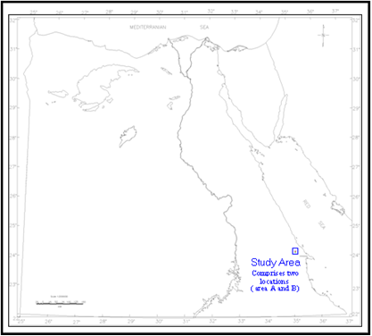

Fig. 1: Map of Egypt showing the location of the study area.

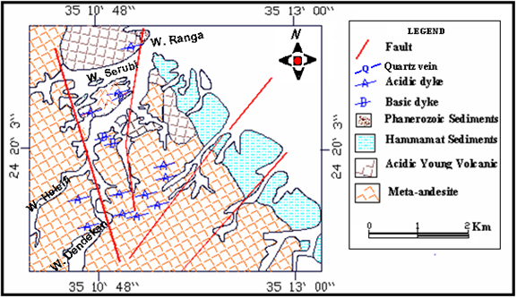
Fig.2: Geological map of wadi El Homer

4. Methodology
An integrated geophysical survey using the self-potential, electrical resistivity, chargeability and magnetic methods were undertaken over a one selected location of the study area to (1) locate and delineate new mineral resources, and(2) understand how the geological structure setting which affected the area under study can be controlled delineating the sites of the expected mineral occurrences in this area.
4.1 Total magnetic field (Magnetic)
4.1.1 Field Procedures and Data Reduction
The magneto metric survey was executed on one grid of nine profiles was established in the study area (Fig. 3). The spacing between every profile within the grid is 50 meters and the intensity of the total magnetic field was measured with a spacing of 10 meters along the profiles in every grid.
For this investigation, The ENVI–MAG (Scintrex, Canada) magnetometer with the idea to measure the total magnetic field of the earth along the nine profiles. The instrument has accuracy of 0.01 gammas.
The collected data were corrected from diurnal variations in the earth’s magnetic field and instrumental drift by using the reference point readings which were recorded by another magnetometer at base station every 1 minute during the field survey, this base station is located at selected site. This magnetic base station was supposed to be away from any deformation of structural disturbance and was given an arbitrary value equal zero. The resulting data set for were used to generate total intensity magnetic contour map (Fig. 4) by using Geosoft computer program.
4.2 Electrical surveys
Three different electrical explorations namely the self potential (SP), dc-resistivity and chargeability (IP) methods are applied in the course of fieldwork.
4.2.1 Self-Potential (SP) Method

4.2.1.1 Data Acquisition and Presentation:
The SP surveys were executed on one grid of nine profiles were established in the studied area (Fig. 3). The spacing between every profile within the grid is 50 meters and the intensity of the SP was measured with a spacing of 25 meters along the profiles in every grid.
Field equipment consists simply of a pair of non-polarizing electrodes connected via a high impedance millivoltmeter. Station spacing is 25 m. It has one electrode fixed in the infinity (is called reference electrode) and another electrode is moved on the stations located on the profile Dobrin, 1976 , 1990).
The data obtained from the (SP) survey is plotted as contour map (Fig. 11) by Geosoft program (Geosoft, 1995).
4.2.2 DC-Electrical Resistivity Method
The electrical surveys were applied using gradient configuration array. It has the two current electrodes fixed in the infinity and the two potential electrodes are moved on the stations located on the profile (Killer, 1966). IRIS Resistivity meter. Model ELREC-T that enables to give the apparent Resistiviy in Ohm-m directly was used for the collection of the gradient resistivity data and IP effect. Field data obtained is plotted as contour map by Geosoft program 1995 (ver.4.00.03) Fig. 12. The resistivity data were processed using the Res2Dinv 2D software program (Loke, 1998).
4.2.3 Induced Polarization (IP) Method
4.2.3.1 Field Measurements:
The induced polarization (IP) measurements were executed by using IRIS Resistivitymeter, Model ELREC-T that enables to give the apparent chargeability in msec directly and the mean quadratic error don’t greater than 5% was input in the sequence file for instrument measurements. It has the two current electrodes fixed in the infinity and the two potential electrodes are moved on the stations located on the profile. The data obtained is plotted as contour maps by Geosoft program (Geosoft, 1995).
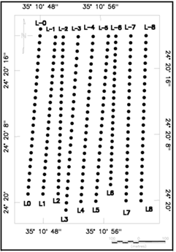
Fig. 3: Location map of geophysical measurements in wadi El Homer

5. Results of the Magnetic Survey
5.1 Qualitative Interpretation
Upward continuation of the magnetic data provides a convenient way of removing the effect of shallow sources and noise in grids without materially affecting the much lower frequency data (Nettlton, 1976) figure 5. Close inspection of the upward magnetic map reveals that the area can be subdivided into two lowest magnetic portions in the north and south parts of the area and one highest magnetic portion nearly at the extreme north central part of the area. On the other hand, the elongations of magnetic contour lines with irregular pattern and their gradients that separate the high magnetic central part of the area from the north and south parts of the magnetic low indicate that it is structurally-controlled by faults. It can be seen from the map that the general dominant trends are NEE-SWW and NE-SW trends, respectively. The anomalous features on the map demonstrates that the dominant trend of the main anomalous zones considered are about 70 and 20 degrees east of north, respectively.
5.2 Quantitative Interpretation
5.2.1 Magnetic image:
The total intensity magnetic data, displayed as a small-scale, grey – tone image (BANGLE map) in figure 6. Where, the Z values of the grid are converted to elevations by multiplying the grid Z values by the selected scale factor.
This magnetic image reveals strong positive magnetic anomaly nearly occupied the extreme north central part of the area with nearly east-west trend and has narrow branches in the extreme ends of it. This positive anomaly tends to be elongated shape in plan view. The large region of positive magnetic indicating a large increasing of total magnetic values that suggests uplift occurred in the basement rocks at the extreme central part of the area.

5.2.2 Second vertical derivative:
Close examination of the second vertical derivative map of wadi El Homer (Fig. 7) illustrates that, alternative positive and negative anomalies. The careful examination of this map indicates that, the major high magnetic anomalies zone occupied the extreme north central part of the area is continue to appear from upward continuation magnetic map to the second derivative one, but with short wavelengths. The sources of these magnetic anomalies on this map belief due to extremely shallow magnetic sources. This phenomenon infers that these anomalies originate from shallow depths.
The analysis of the second vertical magnetic anomalies map leads to the conclusion that the zones of high intensity anomaly are associated with a structurally-controlled by faults.. By combined analysis of the second vertical derivative anomalous map and the interpreted faults which delineated by tracing the results of using Euler Deconvolution technique illustrated that, the location of the interpreted faults will appear nearly at the same positions of the zero contours of the vertical second derivative map (Reid and Ganger, 1990).

5.2.3 Detection of Fault patterns of the studied area:
The depth to the detected faulting pictures (Fig. 8) of the subsurface structures ranges between 0 to -61 m with mean depth of 30.5 m and main trends NW- SE and NE-SW (Fig. 8).
Rose diagram has been constructed for the interpreted structural lineaments in order to assist in defining the principal structural trends in the study area. From all constructing rose diagrams (Fig. 8), it can conclude that the predominant directions are NW- SE and NE-SW.

5.2.4 Depth determination:
The parameters of the magnetic bodies were estimated along two profiles taken to across the strikes of the selected anomalies (Fig. 5) by using MAGMOD program version 3.3. The results of 2D magnetic models calculations along two profiles, the magnetic anomaly observed on profile M-M 1 is caused by a buried body is located at depth 71.6 meter and has half width and half length 9.3 and 266, respectively. But the parameters of the causative body to the anomaly which observed on profile M-M 2 are depth=30.3 meter, half width=7 meter and half length=202 meter.

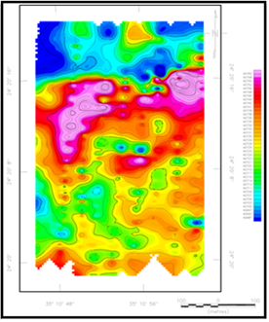  Fig.4: Observed total magnetic intensity map of wadi El Homer | 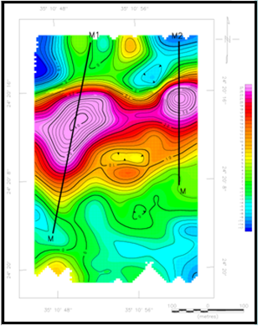  Fig.5: Magnetic data upward ontinued a level of 25 m above surface level, M- M1 and M-M2 selected profiles to represent the 2D models
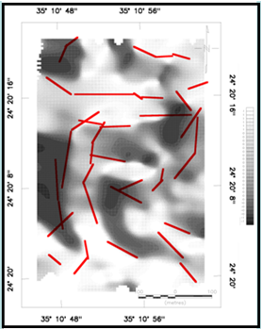 |  | 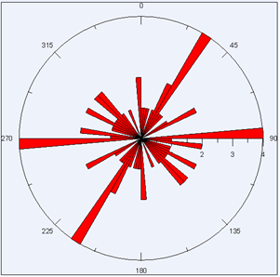
Fig. 6: Rose diagram of the structural lineaments and Pseudo – illumination shaded relief “BANGLE’ map (elevation=45º and Azimuth=45º), showing the interpreted faults are defined by the red heavier solid lines.

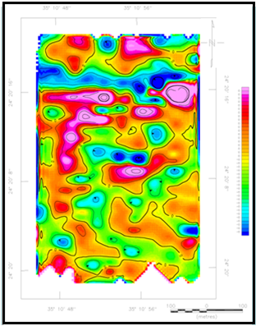  Fig.7: Second Vertical Derivative Anomaly of the Total Magnetic Intensity  Map Of wadi El Homer | 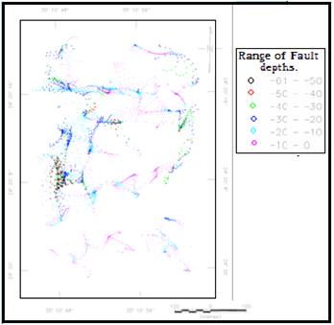  Fig.8: Fault Pattern at different depths Interpreted From The Magnetic  Anomaly Map Of wadi El Homer, using Euler Deconvolution Techniques (S.I= 0).


Fig.9: Magnetic anomaly profile (M-M1 on fig. 5) and the interpreted 2D model of the causative body.
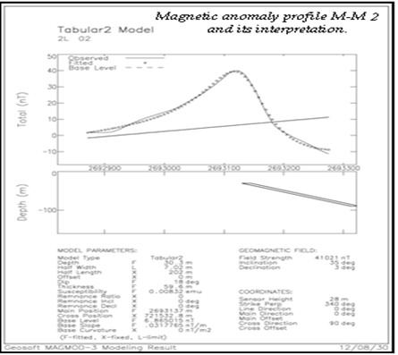

Fig.10: Magnetic anomaly profile (M-M2 on fig. 5) and the interpreted 2D model of the causative body.

6. Results of the Geoelectrical Data Interpretation
6.1 Results of the Reconnaissance Geoelectrical Surveys:
1-The SP, apparent resistivity and apparent chargeability maps (Figures 11, 12 and 13), shows several clusters of positive and negative distinct anomalies on the map. These anomalies appear mainly as circular, semicircular or slightly elongated shapes.
2-Two chargeability anomalies are clearly appears on the IP map which is quite conformable with the anomalies derived from the resistivity map but have somewhat less relief. The first one of these anomalies is prominent and strong and is situated at west of the central part of the study area, whereas the second anomaly is located in the west of the northern part of the area. On the other hand, these two anomalies are correlated nicely with the prominent high magnetic zone which observed on the magnetic map. The similarity in locating the geophysical anomalies on both maps gives a good support for the existence of near surface causative bodies (Loke and Barker, 1996) could be have economic interest. So, these results suggested that these locations must be follow by detailed geophysical survey measurements in order to locate metallic mineralization occurrences in the next stage.
3- Prominent apparent chargeability anomaly is highlighted in the west of the northern part of the area under consideration (Fig. 13) and coincides with low resistivity anomaly (Fig. 12). By correlating the anomaly with the faults that interpreted from magnetic data, it was realized that this IP anomaly may be is caused by the existence of suspect low resistive material hosted within the interpreted fault zone in this site.
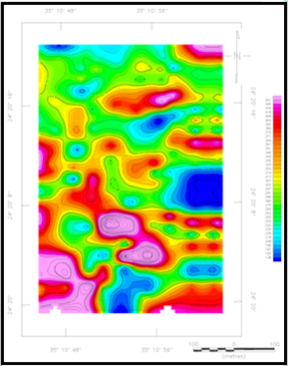  Fig. 11: SP anomalies contour map of wadi El Homer | 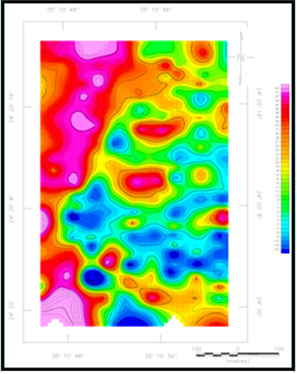  Fig. 12: Apparent resistivity contour map of wadi El Homer

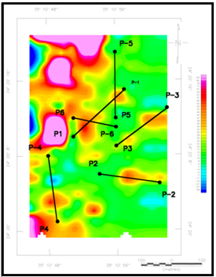
Fig. 13: Apparent chargeability contour map of wadi El Homer, showing locations of 2D resistivity and IP sections.

6.2 Results of Detailed Geoelectrical Surveys
The 2-D electrical resistivity and induced polarization tomography surveys were applied along selected profiles as the main prospecting in the detailed stage in the study area. The distribution of these resistivity and IP profiles is based on the results of a precise comparative study between the magnetic and SP, gradient resistivity and IP data, the location of the profiles are shown in Fig. 13.
- Line survey 2 was designated in a NW-SE direction, the resistivity and induced polarization results are shown on the 2-D inverse imaging plots figure 14 (A and B), in which two prominent broad, strong induced polarization anomalous zone extends from length 115 meter NW to 180 meter along the line, with the magnitude of the IP anomalous varying throughout and reached to more than 175 msec (Fig. 14-B). The source of this anomaly could be disseminated metallic mineralization. The top of the source of this promising anomaly lies at a depth about 21 meter from its center. Figure 14-A also indicates the presence of a fault contact and mineral fluid filled fractures, have been clearly appeared on the resistivity cross-section which obtained at this location.
- Line survey 3 was takes SW-NE trend. Examination of these sections revealed that, two small anomalous zones with semi-circular shapes, and its locations at 87 meter and 115 meter along the profile, respectively. The tops of the sources are appeared very closed from the surface. inverse model resistivity section along profile number 3 (Fig 14-D) illustrated that, there is lateral and vertical resistivity variability occurred nearly at length 130 meter along the line, this indicating that this site was affected by structural dislocation fault. Examination of this section revealed that, no interesting anomalies were found this refers to this site is more likely quite devoid of mineral deposits.
- Line survey 4 was takes SE-NW direction. These sections indicates that, two prominent chargeability anomalous zones occur as ellipse shapes with total length for every one is about 50 m. (Fig. 15-F). The chargeability anomalous zone observed in the right hand on figure 15-E has intense IP response and reflected chargeability value reached to 250 msec. On the other hand, the chargeability anomalous zone appeared in the left-hand on figure 15-F has chargeability value is about 80 msec. The most intriguing feature of these anomalies were quite conformable with high resistivity greater than 600 ohm.m as derived from the inverse model resistivity section, figure 15-E. These resistivity and chargeability anomalies zones are most probably have its origin of sphalerite mineralization deposits hosted within the basement rocks.
On the other hand, figure 15-E is appear a horizontal and vertical changes in electrical resistivity, which indicates the presence of a structural dislocation fault at that location and this is indicates to the expected target is controlled by this structure.
- Line survey 5 was taken nearly S-N direction. These sections reveals that an incomplete probable moderate to low chargeability anomalous zones are observed at the lower part of the chargeability section (fig. 15-H) with chargeability magnitude is about 80 msec. These anomalous zones may represent two sources, or alternatively, one source is situated at depth. Also, other small semicircular anomalous zones are appeared very near from the ground surface on the left-hand of 2-D induced polarization image (Fig 15-H).
Figure (15-G&H ) suggest that an definite amount of disseminated metallic mineralization would be expected, so further prospecting is be needed at the site to determine the lateral extent and the depth to the lower boundary of that expected mineral deposits.
Lines survey 1 and 6 were takes SW-NE and NW-SE trends and they have lengths 235 meter and 135 meter, respectively figure (16-I, J &K).
Examination of these sections revealed that, no interesting anomalies were found this refers to this site is more likely quite devoid of mineral deposits.

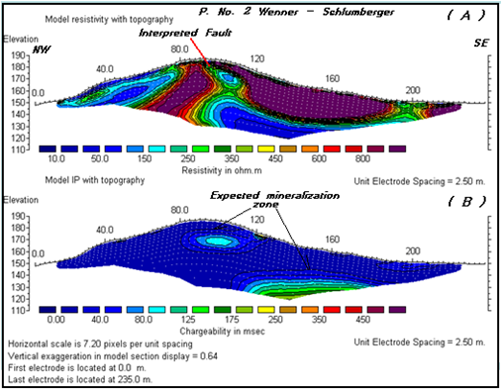
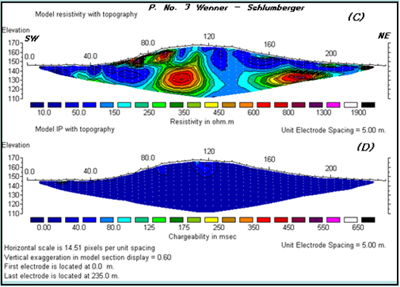
Fig. 14: A combined inverse 2-D model electrical resistivity and IP tomography sections along profiles number 2 and 3 in wadi El Homer

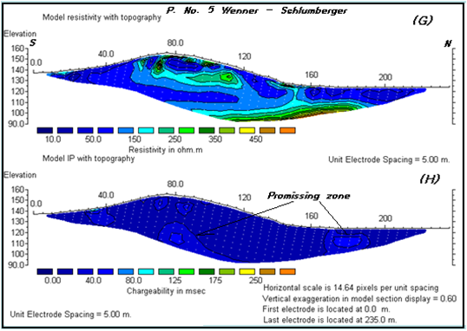
Fig. 15: A combined inverse 2-D model electrical resistivity and IP tomography sections along profiles number 4 and 5 in wadi El Homer
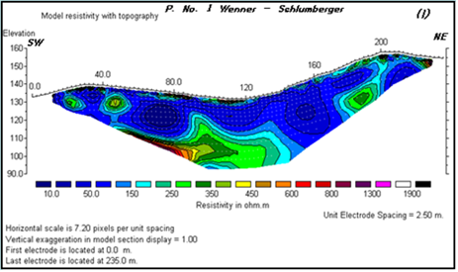
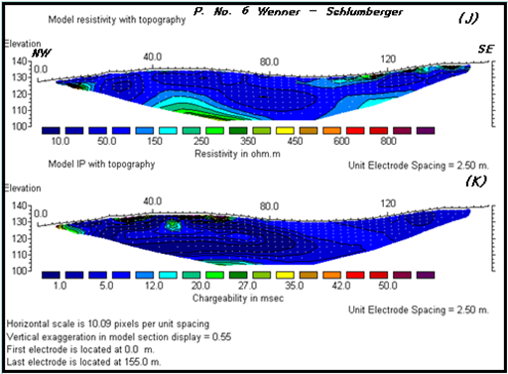

Fig. 16: A combined inverse 2-D model electrical resistivity and IP tomography sections along profiles number 1 and 6 wadi El Homer

Conclusion
Our evaluation of the geophysical survey conducted at one location in the area under consideration provides the area considered as a good location for the mineral ore occurrences and the geological structural situation of the area may be a controlling feature on the ore deposition. Consequently, detailed geophysical survey program, involving the application of surface magnetic to give a clear picture on the structure pattern affecting the area followed by selective properly locations for resistivity and induced polarization surveys by using non-contacting electromagnetic technique (EM) and detailed gravity survey, a subsequent gravity survey will proved to be of considerable value in guiding the extensive drilling program which will follow and in predicting the amount of ore which to be expected in each anomalous area. The former geophysical surveys must be combined with detailed geological and geochemistry surveys and the results should be check up by drilling test, are recommended for future exploration at the area under consideration.

Acknowledgment
The author would like to extend his deep thanks to the authorities of Egyptian geological survey for this unfailing help and providing the raw data used to execute the present study.
Also many thanks go to all the colleagues in the Geology Department Faculty of Science Al-azhar University for their encouragement and help.

References
Dobrin, M. B. 1976: Introduction to geophysical prospecting. Mc-Graw-Hill Book company, New York.
Dobrin, M. B. and Savit, C. H. 1990: Introduction to geophysical prospecting. Mc-Graw-Hill Book company, New York.
Eid Abd El Haleim, Ali A. Khyamy and Said A. El Shabasy (1996): The geology of the northern part of Hamata – Shait sheet, Eastern Desert, Egypt (sheet No. NG 36 D). Internal Report, Geol. Surv. Egypt, No. 1/96.
GEOSOFT V. 4.00.03, (1995): Software for mapping and processing system for earth science. Geosoft Inc., Toronto, Canada.
Keller, G. V. and Frank, C. F. 1966: Electrical methods in geophysical prospecting. Pergamon, London, p 519.
Loke, M. N. and Barker, R. D. 1996 a: Rapid leastsquares inversion of apparent resistivity pseudosection using aquas:- Newton method. Geophysics prospecting, Vol. 44, p 131-152.
Loke, M. H., (1998): RES2DINV, V.3.4, rapid 2-D resistivity inversion computer program using the least-squares method. ABEM instrument AB, Bromma, Sweden.
Loke, M.H., Electrical Imaging Survey for Environmental and Engineering Studies: A Practical Guide to 2-D and 3-D Survey. USM, Penang, Malaysia, (2003).
Loke MH, Dahlin T, A comparison of the Gauss Newton and quasi-Newton methods in resistivity imaging inversion. - J. of Applied Geophysics 49: 149-162, (2002)
M.O. Mostafa, H. A. Mohamed, A. F. Abd El-Moula, S. A. Attia and M. A. Moussa (1996): Geology of Tarafawi-Abu Ghusun area, South Eastern Desert, Egypt. Final report of expedition 7/93. Internal Report, Geol. Surv. Egypt, No. 2/96.
Mohamed S. Afia, Shafik Nassim, Ahmed A. Foda and Monir Fahim (1954): Geological prospecting work carried out in Wadi-Hamata Area, South Eastern Desert. Internal Report, Geol. Surv. Egypt, No. 4/54.
Nassim, S., Afia, M. S., Fahim, M., and Foda, A. A., (1954): Report on the prospecting work carried out in wadi Hamata area south Eastern desert Dept. Min. and Qura., Min. res. Sec., Cairo.
Res 2D inv. Ver. 3.4 (1998): Resistivity and IP inversion, by M. H. Loke.

4/21/2014

