Optimal Time Varying Fuzzy Boundary Layer Thickness for Decouple Sliding-mode Control Base on Moving Switching Surface Using Pareto set

Iman Ashkani

MSc in Mechanical Engineering, Applied Design Trends, Guilan University
ashkaniiman@gmail.com

Abstract: DSMC is a type of sliding-mode control method for controlling the Single-Input/Multi-Output (SIMO) systems. In general, boundary layer thickness is established to decrease the chattering of input control in sliding mode controllers. Also, the control gain is a significant factor influence the control performance of variable structure systems. For this purpose, the behavior of the sliding surfaces and the influence of base surface boundary layer in DSMC method are demonstrated. However, Fuzzy Logic Controller (FLC) is utilized in order to obtain gain and boundary layers. In order to design the time-varying boundary layer thickness on each surface, the distance of dynamic trajectory and the angle between the vectors are the inputs of FLCs. Also, in order to accomplish the optimum results, the non-dominated sorting genetic algorithm-II (NSGA-II) is employed. This leads to achieving a set of best results called Pareto set, which not only optimizes the DSMC parameters, but also designs the details of the FLCs structures.

[Iman Ashkani. Optimal Time Varying Fuzzy Boundary Layer Thickness for Decouple Sliding-mode Control Base on Moving Switching Surface Using Pareto set. N Y Sci J 2014;7(8):28-39]. (ISSN: 1554-0200). http://www.sciencepub.net/newyork. 6

Keywords: Sliding-mode, Fuzzy Logic, Optimization, Genetic Algorithm, NSGA-II

1. Introduction
Sliding mode control, first named as Variable Structure Control (VSC), was initially introduced by Emelyanov and quite a few researchers in former USSR the early 1950’s [1, 2]. The phase plane method and the strategy of differential equation with a nonanalytic Right-hand side were inaugurated and documented in [3]. A systematic mathematical theory for differential equation by discontinuities are Established by Fillipov [4, 5]. Direct switching Function Approach for the reaching condition is well documented. The Lyapanov Function [6], the Reaching Low, the Fixed-Order switching scheme [7], Free-Order switching scheme, Decenteralized switching scheme, multi-input/multi-output systems, discrete-time models, large-scale and infinite-dimensional systems are other successful achievements in this field. Phase-Locked loop control, Process control [8-10], Power converters, Digital implementation [11], Remote vehicle [12], Load frequency control of power system [13-16], Guidance [17], Pulse-width modulation control [18] and Servomechanisms [19-21], are all effective achievements. In order to reduce and decline the chattering, satisfying the reaching condition Direct approach, Lyapanov Function approach, Reaching Low Approach and the continuation Approach are pointed out in [22, 23].
All the Sliding-mode controllers contain two principal and cardinal sections. The first section is the reaching mode or reaching condition, which is also called nonsliding mode. The second section is the sliding condition in which the trajectory essentially tends to the origin of the phase plane. In addition, Moving Switching Surface (MSS) is moved with a certain motion to the phase plane step by step, Rotating via Shifting [37], or by a constant acceleration or constant velocity [38] to overcome the reduction of disturbances influence through the reaching phase. The results have demonstrated control scheme with the MSS guarantees faster error convergence than fixed sliding line controllers. In fact, the robustness of sliding mode controllers is guaranteed nearly by eliminating the reaching phase.
The second principal section in each sliding mode controllers is sliding condition. In sliding mode controllers, it is assumed that the controller is able to switch from one structure to another extremely fast. Although, it is practically impossible to achieve high-speed switching control because of the switching delay and physical limitation of actuators. As a result of this unconstitutional control switching between structures during sliding condition, the chatter appears instead of sliding condition. In addition, chatter appears during sliding trajectory along the switching surface as a main trouble in the second part of sliding controllers. In order to overcome and decline this chattering, a boundary layer is introduced near the sliding surface due to sliding condition. On the other hand, chattering can be declined due to a boundary layer; tracking performance and robustness are compromised.
The Decouple Sliding-Mode Control (DSMC) has provided the simple and actual way to accomplish symptomatic stability for a class of forth-order nonlinear Single Input/Multi Output (SIMO) systems such as (Ball Beam) - (Inverted Pendulum) – (TORA) etc [42]. For this purpose, the whole system has decoupled into two second order subsystems. Each subsystem has a separate control objective expressed in terms of a sliding surface. The detail of MSS motion directly depends on dynamic trajectory system on constant base surface. The time varying boundary layer concept of the constant base surface during the trajectory on this surface is quality and quantity of MSS motion in the phase plane. This means the guidance of forced MSS motion in the phase plain is capable. Therefore, it is leading to the best convergence control to the equilibrium point by designing appropriate time varying boundary layer thickness.
Fuzzy Logic was first introduced by Zadeh in a theme of fuzzy sets [43]. GA’s are powerful search techniques introduced by Holland [41]. Assemblage of a fuzzy controller is accomplished by the perseverance of some parameters which include the numbers and center values of the input and output membership functions, and linguistic control rules. Fig.1 illustrates the component of Fuzzy logic control system.

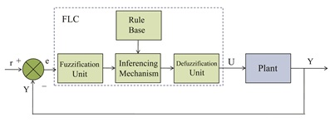
Fig.1. Mamdani's Fuzzy Logic Control system portray

The inspiration of Pareto front or set of optimal solutions is that the solutions are non-dominated to each other but are preferable to the rest of solutions in the search space. After all, this paper will focus on these sections. 2. Boundary layer thickness for second-order sliding-mode control, which introduces definitions of boundary layer in sliding mode controllers. 3. Decouple Sliding-Mode Control (DSMC), the definitions. 4. The GAs strategy and their applications in optimization are pointed. 5. Multi-objective optimization and the basic definitions are notified. Sections 6, is the modeling system and computer simulation and discussions. For this purpose Inverted pendulum system is modeled. At last, sec.7 includes the conclusion.

2. Boundary layer thickness for second-order sliding-mode control
A variable structure control, called sliding mode is a nonlinear controller which is changed to achieve robust control characteristic between switching surface [26, 27]. Before the emergence of early stages of sliding-mode structure its foundation had been laid-Elements of the basis consist of the qualitative theory of differential equations and the theory of oscillation [25]. In order to achieve this purpose, designing the appropriate surface in the phase plane is the most principal section of SMC. In fact, faster convergence and the system robustness during sliding condition are impressible characteristics of designing Surface in the phase plane. Broadly, from mathematical point of view, the sliding mode is a converter, which converts the equation of the system in the state space of$R^{n}$ to sliding condition degree of $R^{m}$space [40]. For this purpose the definitions of the simple second-order sliding mode system is demonstrated. Here is the second-order nonlinear system:
$\text{plant}:\overset{¨}{x}(t)=f(x,t)+b(x,t)u(t)+d(t)$ (1)
$\text{Model}:\overset{¨}{x}(t)=\hat{f}(x,t)+\hat{b}(x,t)u(t)$ (2)
Where $x$ is generally the state vector, $u(t)$is the control input which is applying to the system, $d(t)$is the disturbance via external disturbances and the dynamic$f(x,t)$ (presumably nonlinear function or time-varying) is not precisely known, but estimated as$\hat{f}(x,t)$. The estimation error on $f(x,t)$ is bounded by a known function$F(x,t)$. Similarly, the disturbance $d(t)$ is bounded by a known function $D(x,t)$[39].
$\left|f(x,t)−\hat{f}(x,t)\right|≤F(x,t)$ (3)
$\left|d(t)\right|≤D(x,t)$ (4)

Substituting $\tilde{x}=x−x_{d}$ as the tracking error in the variable, the (5) is achieved.
$\tilde{x}=x−x_{d}={\left[\tilde{x},\tilde{\overset{˙}{x}}\right]}^{T}$ (5)
In fact, (5) demonstrates the tracking error vector. Likewise, a time-varying surface$s(t)$is defined in the $ℜ$state-space.
$s(x,t)=\left(d/\text{dt}+C\right)\tilde{x}=\tilde{\overset{˙}{x}}+C\tilde{x}$ (6)
Where (6) is structured on scalar equation$s(x,t)=0$ and$C$ is a strictly positive constant. As we know, the main problem in the sliding condition is a decline the chattering during trajectory of dynamics. Establishing a boundary layer thickness in the vicinity of sliding surface is a powerful strategy in this field, which is well documented in [40]. By applying this method, chattering will completely decline. Decreasing the tracking error's quantity is the drawback of this strategy. In order to overcome this disease, the time-varying boundary layer is substituted to a fixed layer. By applying time-varying boundary layer thickness, the reaching condition equation is changed to (7).
$\tilde{x}(t)=x(t)$ (7)
Where,$η$ is positive constant strictly and$ϕ(t)$ is the boundary layer thickness. The term of$\overset{˙}{ϕ}\left|S\right|$ in (7) contemplates the fact that the boundary layer attraction condition is more stringent during boundary layer expansion$\left(\overset{˙}{ϕ}>0\right)$ and vice versa. When all trajectories commencing inside $ϕ_{0}(t=0)$ stay inside $ϕ(t)$ for all$t≥0$. In this case, $u(t)$ is interpolated inside $ϕ(t)$ as demonstrated in Fig.3. The most applicant approximation $\left|θ_{\text{max}}−θ_{\text{min}}\right|$ of a condition law achieves as $\overset{˙}{s}(x,t)=0$ [7], [40].
Definition 1. "A domain $Q$ on the manifold $s=0$ is a sliding-mode domain if for each $ε>0$ , there is a $δ>0$ , such that any motion starting within an $n$-dimensional $δ$-vicinity of $Q$ may leave the $n$-dimensional $ε$-vicinity of $Q$ only through the $n$-dimensional $ε$-vicinity of the boundary of $Q$", Fig.3 [28].
Definition 1 describes the sliding region in $ℜ^{n}$space. By the way, while the system trajectory wobbles on the sliding surface, it produces chattering in a bounded region $Q$ (sliding mode region). In addition, since a minimum value of$ϕ$ is greater than the maximum of chattering, chattering will decline or will be deleted due to the system trajectory. Hence, the $S$-trajectory stays in the range of $−ε≤S(x,t)≤ε$, where $\left|ε\right|$ is maximum value of $Q$. In this condition, while $S$is inside boundary layer$ϕ$, $ϕ$ is changed to domain $ε≤ϕ≤ε+ω(t)$ in which$(ω(t)≥0)$. Hence, the upper bound value of $ϕ$ can be characterized by a fixed boundary layer $K_{\text{max}}βC$ . Consequently, a bounded region of $ϕ$ can be substituted into$ε<ϕ≤K_{\text{max}}βC$ . Chattering does not take place in the system trajectory since the upper bound value of $ϕ$ is greater than the maximum value of chattering. [40]

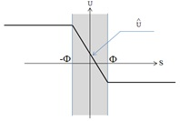

Fig.2. Boundary layer thickness and control input
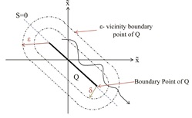

Fig.3.Two-dimensional demonstration of region of sliding mode

3. Decouple Sliding-Mode Control (DSMC)

3.1. Decouple Sliding-Mode Control method (DSMC)
The Decouple Sliding-Mode Control (DSMC) was initially introduced and created in order to control and stabilize the Single-Input/Multi-Output (SIMO) systems [29]. In general, according the definition of these systems, two or more links must be controlled and stabilized. One of the most famous strategies has been described for this achievement [30]. This method is mathematically extremely convoluted and intricate. However, the DSMC was established in order to overcome this decline. Consider a nonlinear forth-order system in the state space of (8).
$\begin{aligned} \\ {\overset{¨}{x}}_{1}=f_{1}(x_{1},t)+b_{1}(x_{1},t)\text{.}u_{1}+d_{1}(t) \\ {\overset{¨}{x}}_{2}=f_{2}(x_{2},t)+b_{2}(x_{2},t)\text{.}u_{2}+d_{2}(t)\end{aligned}$ (8)
Where $x$is state vector, $f_{1}(x),f_{2}(x)$and $b_{1}(x),b_{2}(x)$ are nonlinear functions and $u_{1},u_{2}$are input controls for each subsystem. $d_{1}(t),d_{2}(t)$are external disturbances which are bounded as$\left|d_{1}(t)\right|≤D_{1}(t),\left|d_{2}(t)\right|≤D_{2}(t)$. In order to control the system, the appropriate sliding surfaces are defined for each subsystem. The drawback of this method is that by applying the input control to each surface, one link is controlled. This means the control action controls each link separately. Hence, the intermediate value is employed to connect and couple whole subsystems. This intermediate value is named as$Z$.
$S_{1}=C_{1}({\tilde{x}}_{1}−Z)+{\tilde{\overset{˙}{x}}}_{1}$ (9)
$S_{2}=C_{2}\text{.}{\tilde{x}}_{2}+{\tilde{\overset{˙}{x}}}_{2}$ (10)
$Z=Z_{u}\text{.}\text{sat}\left(S_{2}ϕ_{2}\right)$ (11)
Where $S_{1}$is the principle surface or controllable surface. $S_{2}$is the subsidiary surface which only transfers the dynamics variations. ${\tilde{x}}_{1}=\left[x_{1}−x_{1d}\right],{\tilde{x}}_{2}=\left[x_{2}−x_{2d}\right]$ are the tracking errors. $Z$is an intermediate value in order to transfer signals of the dynamic variations on the subsidiary surface to principle surface. $Z_{u}$is scalar and limited to the proper range of ${\tilde{x}}_{1}$ [29].

3.2. Decouple Sliding mode from geometric point of view
As already discussed, the moving switching surface essentially operates to pass the initial conditions, and is subsequently moved towards a predetermined switching surface. During the MSS control process, the input of these systems is restructured uninterruptedly, as an interesting feature of this type of surface.
As illustrated in Fig.5, the input control applies continuously on the surface like $S=0$ is$u_{0}$. On the other hand, the input control which is accomplished on $S=\text{CZ}$is demonstrated by$u=u_{0}+u_{A}$. In which $u_{0}$, as the control input, applies and exploits upon$S=0$, and $u_{A}$ is the control input which is added to $u_{0}$ to gesture on the Moving Switching Surface $S=\text{CZ}$ [38]. However, as demonstrated in sec.3 according to the MSS definition, in DSMCs from the geometric point of view, the surface which is controlled is MSS. Equation (12) evidences this fact.
$S_{1}=(C_{1}{\tilde{x}}_{1}+{\tilde{\overset{˙}{x}}}_{1})−C_{1}Z$ (12)
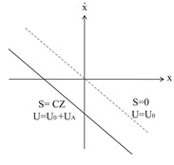
(a)
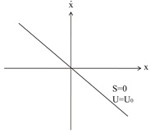
(b)
Fig.4. (a) Input $u_{0}$ exploits on constant surface$S=0$ (b) Input $u_{0}+u_{A}$ exploits on the (MSS)$S=\text{CZ}$

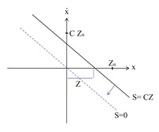

Fig.5. Position of MSS$S_{1}=C_{1}Z$

As a consequence, the term of$(C_{1}{\tilde{x}}_{1}+{\tilde{\overset{˙}{x}}}_{1})$in (9) describes a constant surface category in the phase plane of $(x_{1},x_{2})$. $−C_{1}Z$ is adding to the surface $S_{1}$ in order to act as the MSS treatment literally, as can be seen in Fig.5. Moreover, according to variation of intermediate value, the $S_{1}$ shifts simultaneously during the phase plane. This means that by restructuring the position of $S_{1}$ which depends on the variation of intermediate value in the phase plane, the input on the surfaceis restructured consequently (See Fig.7 (a) and (b)). While the system trajectory varies upon the surface$S_{2}$ , the motion of the MSS continues. Time duration of motion of MSS depends on the convergence of dynamic trajectory upon the constant surface$S_{2}$. Therefore, for transferring signals from constant surface, the intermediate value is responsible for moving MSS toward the phase plane.
By this fact, the intermediate value is used to couple the whole subsystems in order to achieve stability. Hence, the boundary layer thickness which is established and structured in intermediate value, leading to transfer variations smoothly from the constant surface, to main MSS surface. Consequently, the smooth motion in the phase plane is capable for the MSS.

3.3. Moving Switching Surface (MSS)$S_{1}$
As demonstrated in Fig.6, and (9), the $S_{1}$ in the DSMC technique is a Moving Switching Surface (MSS) demeanor. Therefore, the trajectory of the dynamics slides toward the moving switching surface as a stable region and boundary layer domain. According to definition 1, to alleviate the chattering and tracking error, the appropriation time varying boundary layer is conceived, Fig.6.
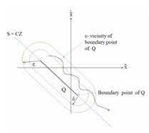

Fig.6. Two-dimensional demonstration of MSS region, $S=\text{CZ}$

3.4. BASE constant surface$S_{2}$
Basically, the boundary layer concerning the sliding surface is used to relieve the chattering [40] and $S_{2}$ is a base surface only in DSMC strategy. Consequently, the MSS wriggles in the phase plane while the trajectory wobbles all through the boundary layer of the base surface. Fig.7 (a), (b).
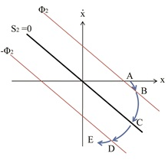
(a)
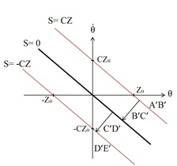
(b)

Fig.7. (a) Trajectory on the base surface, $S_{2}$ (b) Motion of MSS,$S_{1}$during sliding trajectory on the base surface

Exploiting the time varying boundary layer on the base surface causes restructuring of the MSS in contrast to the constant boundary layer thickness. Fig.8. For instance, Fig.8 (a), (b) and (13), (14) indicate the structure of deteriorate time varying boundary layer conscious declines of the trajectory towards the base surface; therefore, leads to precipitation of motion of the MSS to the center. Additionally, type of MSS motion in the phase plane is impressible of constant surface boundary layer variation. Also, the quality of MSS is effective robustness and leading to faster convergence of the system.
$Z↑=\text{sat}\left(\frac{S_{2}↓}{ϕ_{2}↑}\right)\text{.}Z_{u}$ (13)
$S_{1}↓=(C_{1}x_{1}+x_{2})−C_{1}Z↑$ (14)

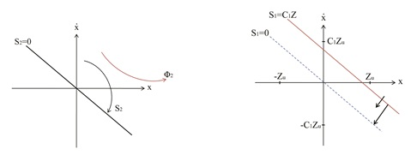
(a) (b)
Fig.8. (a) Increase boundary layer concern surface$S_{2}$ (b) Impulse wriggle of MSS$S_{1}$

4. Genetic algorithm
GA's initially were developed by Holland [41]. The GA's are optimization techniques and exploratory search established on the principles of population genetics and natural evolution. Unlike many classical optimization strategies, GA's do not rely on computing local derivatives to conduct the search process. In fact, their only requirement is an objective or cost function. GA's are also more probable to reach at the global because they work on a population of points as inconsistent to conventional optimization techniques which exploit a point by point search approach. In general, GA comprises three essential operators: selection (reproduction), crossover and mutation. At first, the concerned parameters are encoded into a population of chromosomes. In fact, the encoder is a converter which converts the real values to the set of binary strings. The GA then runs using the three operators iteratively in a random technique with respect to the fitness of the chromosomes to perform the basic tasks of copying and intercommunicating portion of chromosomes, and finally discover and decode the best chromosomes delegating the solution to the problem. Encyclopedic introductions and overviews to GA's can be found in [31, 32].

5. Multi-objective optimization base on NSGA
Multi-objective optimization is called vector optimization or multi-criteria optimization. It has been defined to search a vector of decision variables satisfying constraints to achieve optimal values to all objective functions [33]. Generally, Pareto front or set are the set of optimal solutions in the objective function space. This strategy is established for a set of solutions that are in contrast to each other whereas preferable to the rest of the solutions in the search space. In other words, it is unattainable to discover a single solution to be preferable to all other solutions according to all objectives. Hence, restructuring the vector of design variables in such a Pareto front comprising these contrast or non-dominated solutions could not lead to the progress of all objectives simultaneously. Mathematically, the multi-objective can be defined as follows.
Find the vector $S^{}=[s_{1^{}},s_{2^{}},\text{.}\text{.}\text{.},s_{n^{}}]^{T}$ in order to optimize
$F(S)=[f_{1}(S),f_{2}(S),\text{.}\text{.}\text{.},f_{K}(S)]^{T}$ (15)
Subject to $m$ inconformity constrains
$g_{i}(S)≤0$And$ϕ_{1}$ (16)
And $p$equality constraints $h_{j}(S)=0$ and $j=1,\text{.}\text{.}\text{.},p$. Where, $S^{}∈ℜ^{n}$is the design variable or vector of decision and $F(X)∈ℜ^{k}$is the vector of objective functions. Plus it is assumed that all objective functions are to be minimized without loss of generality. In order to convert the Pareto optimization, the following definitions are required:

5.1. Pareto dominance's definition
A vector $Δ=[δ_{1},δ_{2},\text{.}\text{.}\text{.},δ_{k}]∈ℜ^{k}$dominates vector $Σ=[σ_{1},σ_{2},\text{.}\text{.}\text{.},σ_{k}]∈ℜ^{k}$(respected by$Δ≺Σ$) if and only if $∀i∈\left\{1,2,\text{.}\text{.}\text{.},k\right\},δ_{i}≤σ_{i}∧∃j∈\left\{1,2,\text{.}\text{.}\text{.},k\right\}:δ_{j}<σ_{j}$ . This implies that there is at least one $δ_{j}$ which is smaller than $σ_{j}$ whilst the rest of $δ$s are either rather spartan than or equal to the corresponding $σ$ s.
5.2 Definition of Pareto set
A point $S^{}∈Θ$ ( is an achievable domain in $ℜ^{n}$ satisfying equations (21) and (22)) implying to be Pareto optimal (minimal) considering all $S∈Θ$ if and only if$(S^{})≺F(s)$. It is able to be readily restated as$∀i∈\left\{1,2,\text{.}\text{.}\text{.},k\right\}$, $∀S∈Θ−\left\{S^{}\right\}f_{i}(S^{})≤f_{i}∧∃j∈\left\{1,2,\text{.}\text{.}\text{.},k\right\},f_{j}(S^{})≤f_{j}(S)$ alternatively. In other words, the solution $S^{}$ is said to be Pareto optimal (minimal) if no other solution can be found to dominate $S^{}$ corresponding to the definition of Pareto dominance.

5.3. Pareto set's definition
With regard to MOP, a Pareto set $P^{}$is a set in the decision variable space compromising all the Pareto optimal vectors, $P^{}=\left\{S∈Θ|∃S'∈Θ:F(S')≺F(S)\right\}$. This means, there is no other $S'$in $Θ$ that dominates any$S∈P^{}$.
5.4. Pareto front's definition
In MOP, the Pareto front ${\text{PF}}^{}$ is a set of vectors of objective functions which are acquired using the vectors of decision variables in the Pareto set$P^{}$, that is, ${\text{PF}}^{}=$ . As a consequence, the Pareto front is converted as a set of the vectors of cost functions from$P^{}$.
Evolutionary Algorithms (EAs) have been employed in a broad variety for multi-objective optimization due to their natural possessions suited for these types of problems. Generally, the most principal benefits of this strategy is their parallel or population-based search achievement. Consequently, most troubles and deductions without the classical methods in MOPs strategy are eliminated. It is very significant in EAs that the genetic variety within the population be preserved essentially. This principal theme in MOPs which has been explained and overviewed can be found in [34]. Consequently, the premature convergence of Multi Objective Evolutionary Algorithms (MOEAs) can be prevented, and the solutions are directed and distributed along the true Pareto front if such genetic variegation is well provided. Recently, the Pareto-based approach of NSGA-II has been used in a broad variety range of engineering MOPs [44]. According to the efficient of non-dominance ranking procedure in discovering different levels of Pareto frontiers, it includes a simple content and operation. Nevertheless, the crowding achievement in such a state-of-the-art MOEA applies powerful for two-objective optimization problems as a diversity-preserving operator, but this is not the case for problems with more than two cost functions. The main reason for this drawback is different crowding square side convergence or enclosing hyper-boxes during sorting procedure for each cost function. Hence, in this strategy, the general crowding distance of an individual computed may not exactly find the correct measure of diversity or crowding property. In order to select an exact number of individuals of that specific front, a crowded comparison operator is used in NSGA-II to discover the superior solutions to fill the rest of the new parent population slots. The crowded comparison procedure is established on density estimation of solution surrounding a particular solution in population or front. For this purpose, the solution of the Pareto front is initially sorted in each objective direction in the increasing order of that objective value. It should be noted that in a two-objective Pareto optimization process, if the solution of a Pareto front is sorted in a decreasing organization with respect to one objective, these solutions are then spontaneously organized in an increasing organization with respect to the second objective. Hence, the hyper-boxes environment of an individual solution remain unchanged in the objective-wise sorting procedure of the crowding distance of NSGA-II in the two-objective Pareto optimization problem. However, in multi objective Pareto optimization problem with more than two objectives, this sorting procedure of individuals based on each objective in this algorithm will cause different enclosing hyper-boxes. Thus, the overall crowding distance of an individual computed in this way may not exactly reflect the true measure of diversity or crowding property for the multi-objective Pareto optimization problems with more than two objectives. Therefore, the general crowding distance of an individual computed in this method does not accurately reflect the correct measure of diversity or crowding property for the multi-objective Pareto optimization problems with more than two objectives. Consequently, it is able to be used for any number of objective functions (especially for more than two objectives) in the MOPs. Trying to overcome the limitations of basic MOPs such as several runs to find the Pareto set front or quantification of the importance of each objective and the limitation of crowding distance [44] method , the $ε−\text{elimination}$have been created and introduced with outstanding results in the broad variety of searching the set of optimum points[34].

5.5. -Elimination strategy
In the -elimination diversity approach that is exploited to substitute the crowding distance assignment achievement in NSGA-II, all the clones and -similar individuals are distinguished and simply eliminated from the current population. As a consequence, based on a pre-defined value of as the elimination threshold ( =0.1 has been used in this paper), all the individuals are eliminated in a front within this limit of a particular individual. It is important that such -similarity must exist both in the space of objectives and in the space of the associated design variables. This will ensure that very dissimilar individuals in the space of design variables having -similarity in the space of objectives will not be eliminated from the population. Eventually, it is more helpful to explore the search space of the given MOP [35, 36].

6. single-inverted pendulum system
The most famous type of single input-multi output control system can point to inverted-pendulum. The dynamic equations and the structure of this system are illustrated in (17) and Fig.9 respectively.

${\overset{˙}{x}}_{1}=x_{2}$
${\overset{˙}{x}}_{2}=\frac{m_{t}g\text{sin}x_{1}−m_{p}L\text{sin}x_{1}\text{cos}x_{1}x_{2^{2}}+\text{cos}x_{1}\text{.}u}{L\text{.}\left(\frac{4}{3}m_{t}−m_{p}{\text{cos}}^{2}x_{1}\right)}+d$
${\overset{˙}{x}}_{3}=x_{4}$
${\overset{˙}{x}}_{4}=\frac{\frac{4}{3}m_{p}{\text{Lx}}_{2^{2}}\text{sin}x_{1}+m_{p}g\text{sin}x_{1}\text{cos}x_{1}}{\frac{4}{3}m_{t}−m_{p}{\text{cos}}^{2}x_{1}}+\frac{4}{3\text{.}\left(\frac{4}{3}m_{t}−m_{p}{\text{cos}}^{2}x_{1}\right)}u+d$ (17)

Where,$x_{1}=θ$,$x_{2}=\overset{˙}{θ}$ are the pole position and the angle velocity. $x_{3}$and$x_{4}$are the CART position and CART velocity from the equilibrium point, respectively, by this fact that $m_{t}=m_{c}+m_{p}$,$L=0\text{.}5m$, $m_{c}=1\text{kg}$, $m_{p}=0\text{.}\text{05}\text{kg}$, $g=9\text{.}8m/{s^{2}}$. For the Start points:
$x_{1,S}=−{\text{60}}^{0};x_{2,S}=0;x_{3,S}=0;x_{4,S}=0$,
$S_{1}$ and $S_{2}$are defined as illustrated in (18).
$S_{1}=C_{1}\left(x_{1}−Z\right)+x_{2}$ $z=Z_{u}\text{.}\text{sat}\left(S_{2}/ϕ_{2}\right)$ $0<Z_{u}<1$,
$S_{2}=C_{2}x_{3}+x_{4}$ (18)
As illustrated in Fig.10, the Pareto Set has achieved for multi-objective optimization process by employing two couple cost functions (53).
$F_{1}=0\text{.}\text{95}\int{\left|x_{1}\right|\text{.}τdτ}+0\text{.}\text{05}\int{\left|x_{2}\right|\text{.}τdτ}$
$F_{2}=0\text{.}9\int{\left|x_{3}\right|dτ}+0\text{.}1\int{\left|x_{4}\right|dτ}$ (19)
Equations (19) reflect the fact that the effect of time in $F_{1}$ is much more important. This causes the time trapoze to converge the system to equilibrium point faster. In order to minimize CART displacement with respect to POLE settling time, the cost function has been chosen for$F_{2}$. Moreover, the coefficients which are selected in (19) illustrate the importance of position and velocity. Figs.11, 12 and Table 1 illustrate that the POLE position in point C converges faster than point B and A with regarded to cost function $F_{1}$. On the other hand, the CART position in point A converges faster than point B and C.
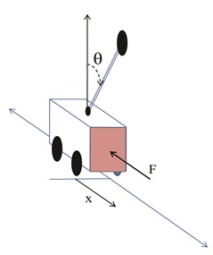

Fig.9. Portray of Inverted-Pendulum system

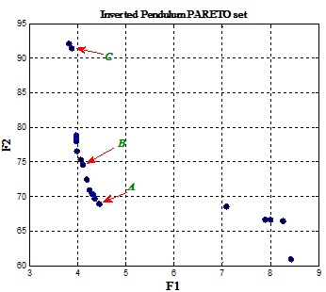
Fig.10.Inverted Pendulum Pareto Set.
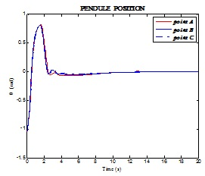
Fig.11. POLE position comparison of settling time, point A, B and C
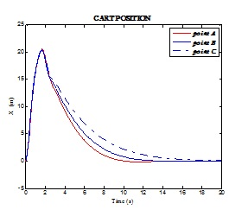
Fig.12. CART position comparison of settling time, point A, B and C

6.1. Single inverted-pendulum time varying boundary and constant boundary layer
As shown in Fig.10, the points of Pareto set are achieved from multi-objective optimization process. Each of them can be selected as the optimum point. We choose point B as the optimum result because of its less settling time both in CART position and POLE position compared to another choice. Fig.16, 17 and Table 2 evidence this fact. The inverted-pendulum with time varying boundary layer thickness is much more effective from settling time and stability point of view.
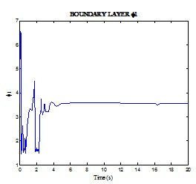
Fig.13. Fuzzy boundary layer$φ_{1}$
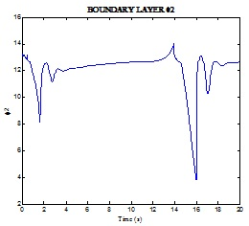
Fig.14. Fuzzy boundary layer$φ_{2}$
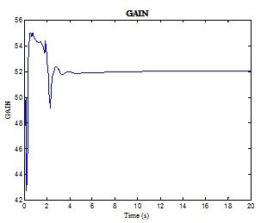
Fig.15. Fuzzy GAIN
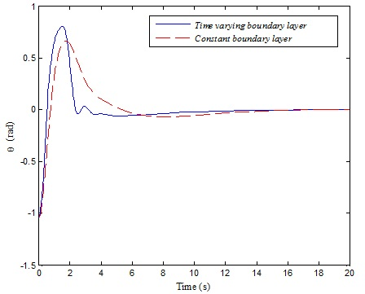
Fig.16. POLE position time varying and constant boundary layer thickness
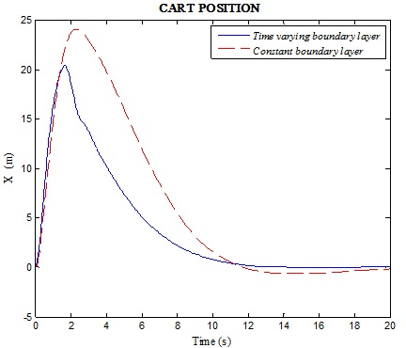
Fig.17. CART position, time varying and constant boundary layer thickness

Where, in constant boundary layer thickness, the parameters are illustrated as below.
$C_{1}=2\text{.}\text{8288},C_{2}=0\text{.}\text{2658},Z_{u}=0\text{.}\text{9136}$, $φ_{1_{\text{max}}}=6\text{.}\text{564}$, $φ_{2_{\text{max}}}=\text{14}\text{.}\text{09}$, $\left(η=\text{24}\text{.}\text{31}>K_{\text{max}}\text{.}β/C_{1}\right)$.
Where,$β={\left({b_{\text{max}}}/{b_{\text{min}}}\right)}^{1/2}$,$t_{s}=0\text{.}\text{05}$.

Table 1. Cost functions and comparison points of Pareto set for Inverted Pendulum system
POINT | POLE Position Settling time (s) | CART Position settling time(S) | Cost Function F1 | Cost Function F2
A | 7.545 | 9.955 | 7.084 | 68.5118
B | 6.649 | 13.25 | 4.1109 | 74.4963
C | 2.365 | 19.45 | 3.8298 | 92.0592

Table 2. Comparison of settling time, constant and time varying boundary layer for Inverted Pendulum system
Inverted Pendulum system | POLE position Settling Time(s) | CART Position Settling Time(s)
Time Varying Boundary Layer (Point B) | 6.649 | 13.25
Constant Boundary Layer | 10.51 | 19.49

7. Conclusion
Decouple Sliding-Mode Control (DSMC) is a simple efficient method in sliding mode control for systems like Single Input-Multi output (SIMO). The effort in this paper is concentrated on the nature of behavior of its illustrated details. Therefore, taking a mandatory move on Moving Switching Surface (MSS) which was via Shifting Switching Surface (SSS), convergence and stability were achieved. This important process was conducted through alteration of boundary layer during trajectory of dynamics on base surface. The results were taken into TORA and Inverted Pendulum systems and were compared with the constant boundary layer that proved this issue. In order to reduce tracking–error, the time varying boundary layers were designed on MSS. Fuzzy Logic Control was employed to design time varying boundary layers and sliding mode control Gain. The powerful Multi objective optimization and NSGA-II were also to design the details of FLCs and parameters DSMC as collective replies Optimum Sets that contrast each other.

References
[1] S.V.Emelyanov ,Variable Structure Control Systems. Moscow : Nauka (in Russian),1967.
[2] Y. Itkis , Control Systems of Variable Structure. New York: Wiley,1976.
[3] A. A. adronov, A. A. Vitt, S.E Khaikin, Theory of Oscillation. Moscow: Fizmatgiz. ( in Russian), 1959.
[4] A. F. Filippov," Differential equations with discontinuous right-hand side, Mateimaticheskii Sbornik, vol. 51, no. 1, pp. 99-128 (in Russian), 1960.
[5] Yu. I. Neymark, " Note of A. F. Fillippov's paper, " in Proc. 1st IFAC Congr., Izd. ANSSSR, 1961 ( in Russian).
[6] Y. Itkis, Control Systems of Variable Structure. New York: Wiley, 1976.
[7] -, Sliding Modes and Their Application in Variable Structure Systems Moscow : Nauka ( in Russian) ( also Moscow: Mir, 1978, in English).
[8] J. C. Kantor, " Nonlinear sliding-mode controller and objective function for surge tanks," Int. J. Contr., vol. 50, no. 5, pp. 2025-2047, 1989.
[9] S. Kawata, A. Ymamoto, M. Masubuchi, N. Okabe, and K. Sakata., " Modeling and sliding mode temperature control of a semi-batch polymerization rector implemented at the mixer," in Proc. 11th IFAC World Congr., vol.6, 1990, pp. 112-117.
[10] G. E. Young and S. Rao, " Robust sliding-mode control of a nonlinear process with uncertainty and delay ," J. Dynamic Syst., Measur. Contr., vol.109, pp. 203-208, 1987.
[11] G. M. Aly and W. G. Ali , " Digital design of variable structure control systems," Int. J. Syst. Sci., vol.21,no.8,pp.1709-1720.
[12] B. E. Platin, " An application of variable structure systems with sliding mode to a remotely operated vehicle," In proc. 11th IFAC World Cong., vol.8, 1990,pp.105-111.
[13] N. N. Bengiamin and W. C. Chan, 1982, " Variable structure control of electric power generation, " IEEE Trans. Power Apparatus Syst., vfol. PAS-101, no.2, pp.376-380,1982.
[14] W. C. Chan and Y. Y. Hsu, " Automatic generation control of interconnected power systems using variable-structure controllers," Proc. IEE, Pt. D. vol. 128, no.5, pp.269-279,1981.
[15] A. Kumar, O.P. Malik, and G.S. Hope, " Discrete variable structure controller for load frequency control of multiarea interconnected power systems," in IEE Proc., Pt.C, vol.134,no.2,pp.116-122,1987.
[16] A.V. Sivaramakrishnan, M. V. Hariharan, and M. C. Srisailan, " Design of variable structure load-frequency controller using pole assignment technique," Int. J. Contr., vol.40, no.3,pp. 487-498,1984.
[17] S. D. Brierley and R. Longchamp," Application of sliding-mode control to air-air interception problem," IEEE Trans. Aerosp Syst., vol.26, no.2, pp.306-325, 1990.
[18] H. Sira – Ramirez and P. L. Arenas," Dynamical discontinuous feed bach control of nonlinear systems, " IEEE Trans. Automat. Contr., vol. AC-35, no.12,pp.1373-1378,1990.
[19] H. G. Kwatny and K.-K. D. Young, " The variable structure servomechanism," Syst. Contr. Lett., vol.1, no.3, pp.184-191, 1981.
[20] C. Namuduri and P. C. Sen," A Servo-control system using a self-controlled synchronous motor ( SCSM) with sliding mode controller, " Trans. On Industry Applications, vol. IA-23, no.2, pp. 283-295, 1987.
[21] K.-K. D. Young and H. G. Kwantny, " Variable structure servomechanism design and its application to over speed protection control," Automatica, vol. 18, no.4, pp. 385-400, 1982.
[22] J.-J. E. Slotine, " Sliding Contrller design for nonlinear systems," Int. J. Contr., vol.40, no.2, pp. 421-434, 1984.
[23] J.-J. E. Slotine and S. S. Sastry," Tracking control of nonlinear systems using sliding surfaces with application to robot manipulators, Int. J. Contr., vol.38, no.2, pp. 465-492, 1983.
[24] G. N. Nikolski, " On automatic stability of slip on given course," in Proc. Central Communication Lab., no.1, pp.34-75, 1934 ( in Russian).
[25] J. Y. Hung ,W. Gao. and J. C. Hung, :’Variable Structure Control :A survey ‘ , IEEE Trans. Ind. Electron., 1993, 40, (1), pp. 2-22.
[26] R. A. Decarlo, S. H. Zak, G. P. Mathews, Variable structure control of nonlinear multivariable systems: a tutorial, Pro. IEEE, 76 (1988) 212-232.
[27] W. Gao, J. C. Hung, Variable structure control of nonlinear systems: a new approach, IEEE Trans. Ind. Electron. 40(1993) 45-55.
[28] R. A. Decarlo, Variable structure system with sliding modes, IEEE Trans. Automat. Control AC-22(1977) 212-222.
[29] J.C. Lo, Y. H. Kuo, Decoupled fuzzy sliding-mode control, IEEE Trans. Fuzzy Syst. 6(3)(1998) 426-435.
[30] H. K. Khalil, Nonlinear Systems. New York: MacMillan, 1992.
[31] D.E. Goldburg, Genetic Algorithms in Search, Optimization and Machine-Learning. Ann Arbor, MI: Addision-Wesley, 1989.
[32] L. Davis, A Handbook of Genetic Algorithms. New York: Van Nostrand Reinhold, 1990.
[33] Osyczka, A., Multicriteria optimization for engineering design, In Design Optimization, edited by J.S. Gero, 193-227, 1985 (Academic Press : NY).
[34] Toffolo, A. and Benini, E., Genetic diversity as an objective evolutionary algorithms. Evol. Comput., 2003, 11(2), 151-167.
[35] Nariman-Zadeh, N., Atashkari, K., Jamali, A., Pilechi, A., Yao, X., “Inverse modeling of multi-objective thermodynamically optimized turbojet engine using GMDH-type neural networks and evolutionary algorithms”, Engineering Optimization , vol.37, pp. 437-462(26). 2005.
[36] Atashkari, K., Nariman-Zadeh, N., Jamali , A., “ Thermodynamic Pareto optimization of turbojet using multi-objective genetic algorithm” , International Journal of Thermal Science, vol. 44, No, 11, pp. 1061-1071, Elsevier, 2005.
[37] Choi, S. B., Cheong, C.C. and Park, D. W, Moving Switching Surface for robust control of second-order variable structure systems. International Jurnal of control 58.,1993, pp.229-45.
[38] Bartoszewicz, A. 1996: Time-varying sliding modes for second-order systems. IEE Proceeding of Control Theory Application 143, 455-62.
[39] H. Lee, E. Kim, H. J. Kang, M. Park: A new sliding-mode control with fuzzy boundary layer. Fuzzy Sets and Systems 120(2001) 135-143.
[40] J. J. Slotine, W. Li, Applide Nonlinear Control , Printice-Hall, Engelwood Cliffs, NJ, 1991.
[41] . H. Holland, Adaptation in natural and Artificial Systems, Ann Arbor, MI : Michigan Press, 1975.
[42] L. C. Hung, H. Y. Chang, Decouple sliding-mode with fuzzy-neural network controller for nonlinear systems, International Jounal of Approximate Reasoning 46(2007) 74-97.
[43] L. A. Zadeh, “ Fuzzy Sets” , Inf. Contr., vol.21, pp.338-353, 1965.
[44] Deb, K., Agrawal, S., Pratap. A. and Meyarivan, T., “A fast and elitist multi-objective genetic algorithm: NSGA-II“, IEEE Trans. On Evolutionary Computation 6(2): 182-197, 2002.

6/24/2014

