Investigation effects of Genistein on the expression of genes, FASN, XIAP -1, Smac / diablo, XAF, MMP-2, MMP-9 involved in apoptosis and metastasis in cell lines MCF-7, MDA-MB-231

Parisa Saifzadeh¹ (Corresponding author), Mohammad Fazilati²

^{1.} MA in Biochemistry, Payam Noor University of Isfahan, Isfahan, Iran
^{2.} Associate professor in Biochemistry, Department of Biochemistry, Payam Noor University, Tehran, Iran
parisasaifzadeh26@yahoo.com

Abstract: Cells were cultured in medium environment with various concentrations of Genistein. Cell proliferation was determined by MTT. Toxicity rate and Genistein was assessed by LDH test, and then RNA was extracted and performed through cDNA Synthesis and Real-time PCR and finally the resulting data were analyzed. The results showed that Genistein inhibited the invasion and proliferation of cancer cell cycle regulation and apoptosis, but it also has the ability to reduce angiogenesis in cancer, reduce the size of blood vessels and endothelial cell growth Vascularization Gary angiogenesis facilities are a useful tool for reducing metastasis cancer. This study examines the expression of XAF-1, XIAP-1, Diablo, FASN, MMP-2, MMP-9, which are involved in the mechanisms of metastatic breast cancer cell line MCF-7 and two MD-MBA231 treated with genistein that have been discussed. Our studies showed that genistein induced expression of smac/Diablo that genistein induced apoptosis as well as expression of XAF-1; reduced expression (XIAP-1) is induced apoptosis.
[Parisa Saifzadeh, Mohammad Fazilati. Investigation effects of Genistein on the expression of genes, FASN, XIAP -1, Smac / diablo, XAF, MMP-2,MMP-9 involved in apoptosis and metastasis in cell lines MCF-7,MDA-MB-231. N Y Sci J 2014;7(9):72-84]. (ISSN: 1554-0200). http://www.sciencepub.net/newyork. 14

Keywords: Genistein - apoptosis - metastasis - cell lines MCF-7 and MDA-MB-231

1. Introduction
What is cancer?
Cancer is known as a major public health problem and would be one of the most common causes of death in all over the world. Approximately, 16 million new cases are identified in the 500 thousand related cancer deaths around the world (48, 51). Cancer is related to age and the incidence of cancer increases as age goes up (7, 60, and 61). Over 90% of deaths occur due to cancer metastasis. Primary tumors by surgery, chemotherapy or adjunctive therapy are well cured. But the stage metastatic cancers that have become resistant to treatment are the main cause of resistance for mortality rate among patients with metastasis (21, 43).
What is Breast Cancer?
Breast cancer is a malignant tumor that starts from cells of the breast, the disease occurs almost entirely in women, but men also can be affected (2, 3, and 4). High frequency of breast cancer in developed countries is often diagnosed and treated using chemotherapy or assistance is currently being improved. Still, each year approximately 87,000 women die from breast cancer in Europe (15, 23, 36, and 44).
The situation Breast cancer in Iran and the world:
Breast cancer is the second leading cause of death worldwide and the third leading cause of death after cardiovascular disease and accidents in Iran (4, 14). Breast cancer is the most common cancer after lung cancer (23% of all cancers) and most deadly cancer among women (16% of cancer deaths). United States of America have 226870 surgeries in women with breast cancer and about 39,510 deaths from breast cancer in 2012 (23, 44). Breast cancer is the leading cancer among women in the country. So that in 1996 ranked first among cancers in women is common and according to the latest official statistics, in 2003, with the outbreak of bark invoked 15.9 percent remains devoted to the first rank and the prevalence of breast cancer in the provinces; with 20.61% in the second thousand most common in Yazd Province (1, 18, 42).
Signs and Symptoms Breast cancer:
- Most common: lump or thickening in breast which is often painless.
- Discharge or bleeding.
- Change in size or contours of breast.
- Change in color or appearance of areola.
- Redness or pitting of skin over the breast, like the skin of an orange (39, 40).
What Are the Risk Factors for Breast Cancer?
1. Age, 2. Race, 3.Individual or family history of breast cancer, 4.A history of ovarian cancer (3, 4, 25), 5.A genetic predisposition (mutations to the BRCA1 or BRCA2 genes cause 2% to 3% of all breast cancers), 6.Estrogen exposure, 7.Atypical hyperplasia of the breast, 8.Lobular carcinoma in situ (LCIS), 9.Lifestyle factors (obesity, lack of exercise, alcohol use), 10.Radiation. Some biomarkers that indicate the risk of local recurrence or spread systemically, such as VEGF and UPA and cathepsin D correlated significantly with age, but the other markers bio that reflects genetic instability, such as aneuploidy, P53, or ones that growth rate of the tumor showed merits. As like as ki-76, positive significant inverse association with age at diagnosis of breast cancer are vital (25). In 40% of cases of breast cancer in BRCA1 mutation home and BRCA2 mutations in 30% of breast cancers are of this type. The cumulative risk of breast cancer in carriers of BRCA1 and BRCA2 gene mutations between 50 to 70 % (8, 10, and 12) BRCA2 gene mutations in the BRCA1 breast cancer than are men. (11, 16, 41, 57) BRCA2, BRCA1 is involved in DNA repair and tumor suppressor genes are considered (50).
Diet and breast cancer:
Mediterranean diet in which wheat breads and cereals are good, vegetables, fruits, fish, olive oil, many nuts are used. With 16% lower risk of death from cancer in women 49-40 years old (but not in younger women), and reducing the recurrence of colorectal adenomas (precursor to colon cancer) in women (but not men). Western diet containing high-energy foods with a high content of processed meats, milk, sugar and fatty foods are associated with cancer and cancer risks increase (38).
Phytoestrogens associated with breast cancer:
Phytoestrogens are natural plant foods contain estrogen, which have estrogen-like activity and high levels are found in compounds such as soy.Materials not only reduces the activity of estrogen in soy is not a direct effect in preventing the progression of breast cancer. Active substances found in soybeans chemically very similar drug called Tamoxifen, which is used in reducing the progression of breast cancer specialists soy especially for women who have a family history of breast cancer are justified. (56) If some of these tips to reduce the risk of breast cancer: - Age at first pregnancy, age less than 30 - Breast-feeding: The protective effect of prolonged breastfeeding on breast cancer prevention is better especially if breastfeeding for more than 6 months. -Not drinking alcohol and smoking -Having a healthy weight -A balanced diet and fat loss diet -Physical activity and exercise properly- No consumption hormone after postmenopausal. Early detection is a key factor for patient survival in breast cancer screening is particularly important that leading to diagnosis at an early stage and helps prevent disease progression. Unfortunately we do not screened regularly by women. Unfortunately we do not screened regularly by women, for example, in a study on female teachers in Isfahan in 2010 was 54.5% Women of BSE and 60.9% did not perform screening mammography. These results indicate that low screening of women in society and the need to implement appropriate training programs to increase screening behavior in women, it is necessary. In this context, a study was conducted on university students showed positive effects of educational videos to raise awareness and attitudes of students toward itself (39, 40).
Phytoestrogens:
Among these plants, Phytoestrogen (isoflavones, Coumestans) as the most common estrogenic compounds have been identified. Plant lignan in mammals are also weak estrogenic compounds, phytoestrogens were added later (35, 54). Phytoestrogens are compounds which comprise several groups including the lignan, isoflavonoids, Coumestans and resorcylic acid lactones (RALs) could be. The most interesting compounds as isoflavonoids phytoestrogens (daidzein, genistein and Coumestans and metabolites such as Equol) are. It appears that the estrogenic activity of these compounds directly related to the structural similarity between the isoflavonoids and estrogens (22 and 24). It appears that the estrogenic activity of these compounds directly related to the structural similarity between the isoflavonoids and estrogens (22, 24). Two subtypes of ER, ie, α and β, have been identified as the cellular distribution and concentration in target tissues are different. Bond tightly to the ER and subsequent events "is complex and depends on tissue and cells and environment. As well as estrogen, phytoestrogens can be bonded to these receptors and Coumestans isoflavones bind or react with receptors in the power of α and β estrogen are different. Genistein, daidzein and Coumestans as natural selective estrogen receptor have been identified as a regulator with a greater affinity for ERβ than ERα bands are important effects in some tissues under the influence of estrogen on the brain, the heart, the reproductive system have kidney and bone. The molecular structure of genistein and β - estradiol are similarities, especially phenolic ring A and 4′-hydroxyl (-OH), 7′-hydroxyl (-OH) is the same in both. These similarities genistein's ability to bind to estrogen receptors and sex hormone-band proteins confirmed,Thus, genistein can also work to time estrogen and anti-estrogen (due to competition with estradiol binding protein) Structural similarities between genistein and tamoxifen (an anti-estrogen and a synthetic protective factors for cancer in women at high risk of breast cancer) is also considered (13). Studies show that the risk of colon cancer with increasing intake of soy foods is reduced; Biochanin A and genistein also found that colorectal cancer cells inhibit their growth. The inhibition of cell growth through the activation of apoptosis occurs is dependent on light (22, 24). Genistein is an isoflavone that is a biologically active compound found in many plants. Favorite, especially soybeans and soybean products are vital. Genistein consumption by reducing the level of cholesterol and triglycerides which prevent from cardiovascular disease were considered. By ingesting genistein reduces bone loss by activating bone-building process is. Osteoporosis is a common disease, thus helping postmenopausal women; Genistein is structurally similar to 16-β-estradiol structure that allows it to bind to the estrogen receptor beta. (With more dependence) and their estrogen-like effects to their works harder considered. Estrogens receptors are stimulated by genistein reduce menopausal symptoms. Genistein also reduces cardiovascular heart disease in type 2 diabetes. Due to estrogenic and antioxidant and anti-cancer properties are important (20, 29). Genistein has a great effect on prostate cancer, breast cancer. In fact, the low incidence of breast cancer in East Asian countries, the area is a diet high in soy. Two main chemical phytoestrogens in the diet of people find that the lignan (enterodiol and enterolactone) and Iso flavone (daidzein, genistein and Glystein). Main lignan phytoestrogens are present in the Western diet (6). Soy isoflavone genistein is the most studied, especially its antioxidant activity, in others think that genistein is a potent antioxidant than daidzein, by concentrations of dietary genistein was found to indicate that the amount of that value can be poor due to the weak estrogenic and anti-estrogenic effects have (59). Estrogenic activity of Genistein, in the natural environment, a third Glystein and 4 times higher than before are nominated (37). Genistein inhibits breast cancer by increasing apoptosis and also with obesity and Fatty acid synthesis enzyme inhibition can prevent of breast cancer, Tests in the invitro, natural and clinical has been carried on genistein by micro-molar concentrations. Studies have shown that genistein inhibited cancer invasion, proliferation, cell cycle regulation and apoptosis. But it also has the ability to reduce angiogenesis in cancer. Reducing blood vessel volume, vascularization (blood vessel formation) in endothelial cell growth and angiogenesis facilitation tool for reducing cancer metastasis done. The broad anti-angiogenesis effects of genistein with
To test the role Genistein in the development of angiogenesis inhibitors, reduce Pro- angiogenesis factors, reducing the DNA binding activity of HIF (Hypoxia-Inducible Factor), reducing the expression of VEGF in pancreatic cancer cells to HIF, VEGF expression in cancer cells, while states hypoxia is defined. Genistein has the ability to act as a typical inhibitor of hypoxia inducing factor.
Materials and Methods:
- Cell Culture 2. Genistein Treatment 3. MTT assay 4. LDH assay 5. RNA extraction 6. cDNA synthesis 7.Realtime-PCR 8. Data analaysis
Cell culture : For cell culture medium was prepared by the following method: First, Powder PRMI - 1640 (GIbco) as the amount to be taken by the company, 10.4gr of powder in one liter of distilled water, autoclaved and poured by estirer was mixed. To the extent 2gr sodium bicarbonate solution is added to the order GIBco Company, then it was dissolved in a solution of sodium bicarbonate, PH cell culture medium is at about (7.2 to 7.4), and the medium put to the PH range, and cultured under the hood filters, then we kept it in the refrigerator at 4 ° C.
Genistein Treatment:
We cultured the cells in the flask, and then the cells were collected and counted their charges. We used to count the neobar lam, falcon cell plate to the bottom of a 1 ml culture medium was added, and we matched it, Then 10 µl removed it and we moved to neobar lam, then the lames are counted by optical microscopy, then we calculate the average, and we multiply 10000, then to Plate 96 – well Elisa has added to the cell plate,
MTT assay:
This is a colorimetric assay that measures the reduction of yellow 3-(4, 5-dimethythiazol-2-yl) - 2,5-diphenyl tetrazolium bromide (MTT) by mitochondrial succinate dehydrogenase. The MTT enters the cells and passes into the mitochondria where it is reduced to an insoluble, coloured (dark purple) formazan product. The cells are then solubilised with an organic solvent (eg. isopropanol) and the released, solubilized formazan reagent is measured spectrophotometrically. Since reduction of MTT can only occur in metabolically active cells the level of activity is a measure of the viability of the cells, Materials: PBS, MTT (5 mg/ml in PBS) – filter and keep dark, prepare freshly, Acidic isopropanol (0.1N HCl in absolute isopropanol),96-well plate (flat bottom), Procedure: 1. Plate cells (104 – 106 cells) in 200 ml PBS in 96-well (flat bottom).2. Add 20 ml of MTT solution, mix well.3. Incubate for 4h in 37C in dark.4. Remove aliquot for analysis; add 200 ml acidic isopropanol and mix well.5. Incubate additional 1h in 37C in dark.6. Read plate in ELISA Reader – measure OD in 570nm (background wavelength is 630nm).
LDH assay:
LACTATE DEHYDROGENASE (LDH) is an oxidoreductase which catalyzes the interconversion of lactate and pyruvate. When disease or injury affects tissues containing LDH, the cells release LDH into the bloodstream, where it is identified in higher than normal levels. Therefore, LDH is most often measured to evaluate the presence of tissue or cell damage. The non-radioactive colorimetric LDH assay is based on the reduction of the tetrazolium salt MTT in a NADH-coupled enzymatic reaction to a reduced form of MTT which exhibits an absorption maximum at 565 nm. The intensity of the purple color formed is directly proportional to th enzyme activity.
Method 1 - (Total LDH): 1. Remove cultures from incubator into a laminar flow, hood or other sterile work area. 2. Add 1/10 volume of LDH Assay Lysis Solution (Catalog Number L2152) per well and return plate to incubator for 45 minutes. 3. Centrifuge plate at 250 g for 4 minutes to pellet debris. 4. Transfer aliquot to clean flat-bottom plate and proceed with enzymatic analysis.
Method 2 - (LDH Release):
- Remove cultures from incubator into a laminar flow, hood or other sterile work area. 2. Centrifuge plate at 250 g for 4 minutes to pellet cells. 3. Transfer aliquot to clean flat-bottom plate and proceed with enzymatic analysis.
Enzymatic Analysis:
- Prepare the Lactate Dehydrogenase Assay Mixture by mixing equal volumes of LDH Assay Substrate Solution (Catalog Number L2402), LDH Assay Dye Solution (Catalog Number L2277), and 1´ LDH Assay Cofactor Preparation. Prepare the Lactate Dehydrogenase Assay Mixture at time of use, extended storage of the assay mixture is not recommended. 2. Remove an aliquot of the medium for testing (approximately half of the volume of the culture medium). Add the Lactate Dehydrogenase Assay Mixture to each sample in a volume equal to twice the volume of medium removed for testing. 3. Cover the plate with an opaque material to protect from light (e.g., aluminum foil or a box) and incubate at room temperature for 20–30 minutes.4. The reaction can be terminated by the addition of 1.10 volume of 1 N HCl to each well. 5. Spectrophotometrically measure absorbance at a wavelength of 490 nm. Measure the background absorbance of the multiwell plates at 690 nm and subtract this value from the primary wavelength measurement (490 nm).6. Tests in multiwell plates can be read in a plate reader or the contents of individual wells can be transferred to appropriate sized cuvettes for spectrophotometric measurement.(62,63)
RNA extraction:
Materials Required: 1.Reagents, 2.Chloroform (without any additives, such as isoamyl alcohol), 3. Isopropyl alcohol. 4. 75% Ethanol (in DEPC-treated water) 5. RNase-free water or 0.5% SDS solution.(the SDS solution must be prepared using DEPC-treated, autoclaved water. DEPC inactivates the RNases by the covalent modifications of the histidine residues).
Procedure: 1. Homogenization: Growth medium on the cells was discarded and cells were washed with ice cold 1X PBS. The monolayer was then covered with 1 ml of l TRIzol and the cells were lysed and homogenized by repeated pipetting. 2. Phase Separation: The homogenized samples were incubated for 5 minutes at 15 to 30°C for the complete dissociation of nucleoprotein complexes.0.2 ml (200 microliters) of chloroform per 0.75 ml of TRIZOL LS Reagent was added. The tubes were shaked vigorously by hand for 15 seconds and incubated them at 15 to 30°C for 2 minutes. The samples were centrifuged for 15 minutes at no more than 12,000 g (4°C).The aqueous phase was transferred to other tubes (Following centrifugation, the mixture separates into a lower red, phenol-chloroform phase, an interphase, and a colorless upper aqueous phase. RNA remains only in the aqueous phase. The volume of the aqueous phase is about 70% of the volume of TRIZOL LS Reagent used for homogenization.) 3. RNA Precipitation: The RNA was precipitated from the aqueous phase by mixing with 3 microliter of glycogen and 500 microliter of isopropyl alcohol. The mixture was centrifuged for 30 minutes at 12,000 × g (2 to 8°C). (The RNA precipitate forms a gel-like pellet on the side of the tube at bottom). 4. RNA Wash: The supernatant was removed. The RNA pellet was washed once with 75% ethanol, adding 900 microliter of 75% ethanol per 0.75 ml of TRIZOL LS Reagent used for the initial homogenization. The sample were inverted and mixed and centrifuged at 12,000 rpm for 30 minutes at 4 degree. 5. Redissolving RNA: The RNA pellet was dried. RNA was dissolved in RNase-free water (or 0.5% SDS solution) by passing the solution through the pipette tip for a few times, and incubating for 10 minutes at 55 to 60°C.
Note: 0.5% SDS should not be used if RNA will undergo further enzymatic reaction. DNA can also be in 100% formamide (deionized) and stored at -70°C.
cDNA synthesis:
The ability to synthesize DNA from an RNA template, via reverse transcription, enables researchers to study RNA with the same molecular approaches used for DNA investigations. cDNA generated by reverse transcription can be amplified using polymerase chain reaction (PCR). The combination of reverse transcription and PCR (RT-PCR) allows the detection of low abundance RNAs in a sample. In the first step of the PCR process, the cDNA is denatured by heating to 95°C, which disrupts the hydrogen bonds between complementary strands, yielding single-stranded molecules. The temperature is then lowered in order to allow primers complementary to the sequence(s) of interest to anneal. The DNA polymerase included in the reaction will then begin DNA synthesis. At this point, the temperature is raised to the optimal activity temperature of the DNA polymerase (usually 72°C) to synthesize a new strand complementary to the template. The process of denaturing, annealing, and extension can be repeated multiple times, with a two-fold increase in the amount of DNA molecules with each cycle. Because PCR can selectively amplify a template, it is an important method for detecting specific nucleic acid molecules in a particular cell or small populations of cells. PCR Products can be used in many downstream applications, such as cloning into plasmid vectors and sequencing using next generation sequencing platforms. All steps are performed on ice. The following materials arranged in a sterile tube and nuclease free throw.

Table1: material for cDNA synthesis
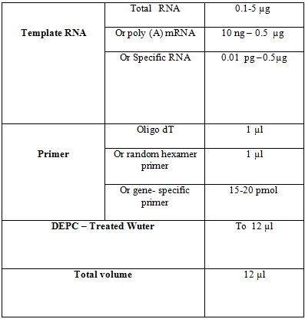

Later, the following materials are added to the set-up, Centrifuges are mixed up. At the end of the cDNA synthesis reaction at 70 ° C for 5 min to terminate. C DNA can be synthesized at -20 ° C for less than a week at -70 ° C for longer and keep it. Finally, Real-time-PCR, and the data are analyzed.

Table2: material for cDNA synthesis
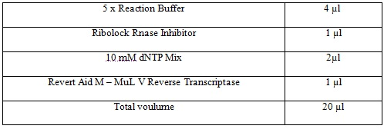

Realtime-PCR:
Polymerase chain reaction (PCR) allows the exponential copying of part of a DNA molecule using a DNA polymerase enzyme that is tolerant to elevated temperatures. 1. MRNA is copied to cDNA by reverse transcriptase using an oligo dT primer (random oligomers may also be used). In real-time PCR, we usually use a reverse transcriptase that has an endo H activity. This removes the mRNA allowing the second strand of DNA to be formed. A PCR mix is then set up which includes a heat-stable polymerase (such as Taq polymerase), specific primers for the gene of interest, deoxynucleotides and a suitable buffer.2. cDNA is denatured at more than 90 degrees (~94 degrees) so that the two strands separate. The sample is cooled to 50 to 60 degrees and specific primers are annealed that are complementary to a site on each strand. The primers sites may be up to 600 bases apart but are often about 100 bases apart, especially when real-time PCR is used.3. The temperature is raised to 72 degrees and the heat-stable Taq DNA polymerase extends the DNA from the primers. Now we have four cDNA strands (from the original two). These are denatured again at approximately 94 degrees.4. Again, the primers are annealed at a suitable temperature (somewhere between 50 and 60 degrees).5. Taq DNA polymerase binds and extends from the primer to the end of the cDNA strand. There are now eight cDNA strands.6. Again, the strands are denatured by raising the temperature to 94 degrees and then the primers are annealed at 60 degrees. 7. The temperature is raised and the polymerase copies the eight strands to sixteen strands.8. The strands are denatured and primers are annealed.9. The fourth cycle results in 32 strands. 10. Another round doubles the number of single stands to 64. Of the 32 double stranded cDNA molecules at this stage, 75% are the same size that is the size of the distance between the two primers. The number of cDNA molecules of this size doubles at each round of synthesis (exponentially) while the strands of larger size only increase arithmetically and are soon a small proportion of the total number of molecules. After 30 to 40 rounds of synthesis of cDNA, the reaction products are usually analyzed by agarose gel electrophoresis. The gel is stained with ethidium bromide, Ethidium bromide is a dye that binds to double stranded DNA by interpolation (intercalation) between the base pairs. Here it fluoresces when irradiated in the UV part of the spectrum. However, the fluorescence is not very bright. Other dyes such as SYBR green, which are much more fluorescent than ethidium bromide, are used in real time PCR. In this presentation, we shall be using SYBR green to monitor DNA synthesis. SYBR green is a dye that binds to double stranded DNA but not to single-stranded DNA and is frequently used in real-time PCR reactions. When it is bound to double strand DNA it fluoresces very brightly (much more brightly than ethidium bromide). We also use SYBR green because the ratio of fluorescence in the presence of double-stranded DNA to the fluorescence in the presence of single-stranded DNA is much higher that the ratio for ethidium bromide. Other methods can be used to detect the product during real-time PCR, but will not be discussed here. However, many of the principles discussed below apply to any real-time PCR reaction.
Results:
Test MTT assay: The results of MTT at a concentration of 25, 50, 75 and 100 µmol/ml, respectively, and blue shaded area in the diagram below, These results indicate that concentration of 100 µmol/ml Genistein highest inhibitory effect is on cell lines MCF-7, MDA-MB-231.

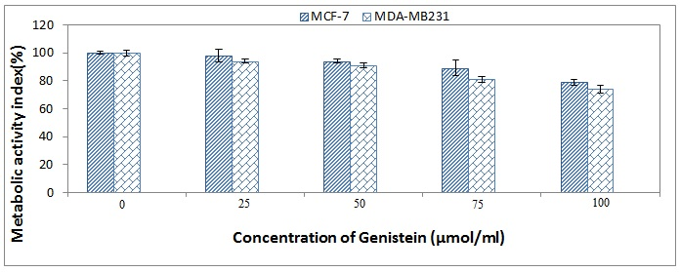
Figure 1: Diagram of MTT assay at different times

Test LDH assay: Results in concentrations of 25, 50, 75 and 100 µmol/ml at 24, 48 and 72 hours, respectively, in blue color charts and the shaded area as shown below. These results indicate that genistein concentration of 100 µmol/ml compared to control DMSO concentrations is most toxic effect on the cell line MCF-7, MDA-MB-231.

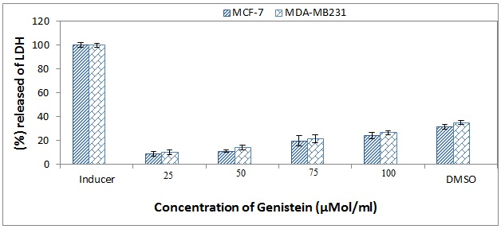
Figure 2: Diagram of LDH assay at different times

RNA extraction: To check the status of the extracted RNA, extracted using electrophoresis and quantified using the optical density was measured by Nanodrop 1000 is as follows Figure (3,4,5)

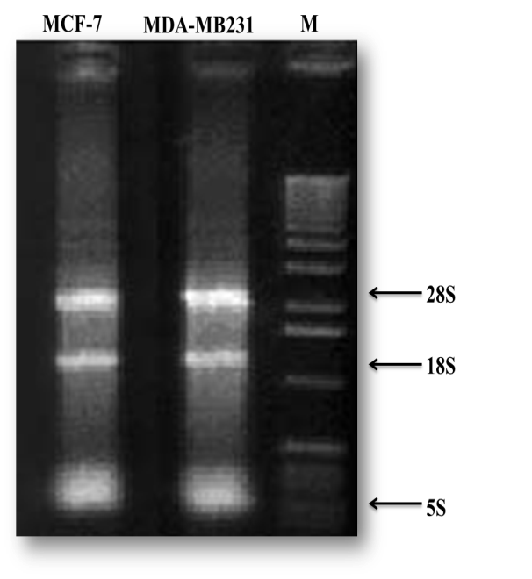
Figure 3: Electrophoresis of RNA on agarose gel, 5.1% percent. There are three bands indicate good quality of the extracted RNA.
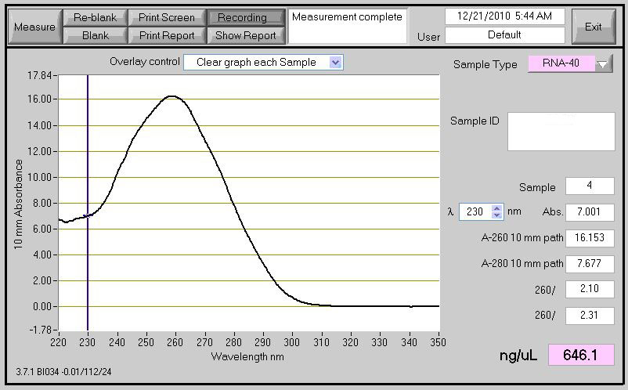
Figure 4: Diagram obtained from the RNA of cells in the Nanodrop

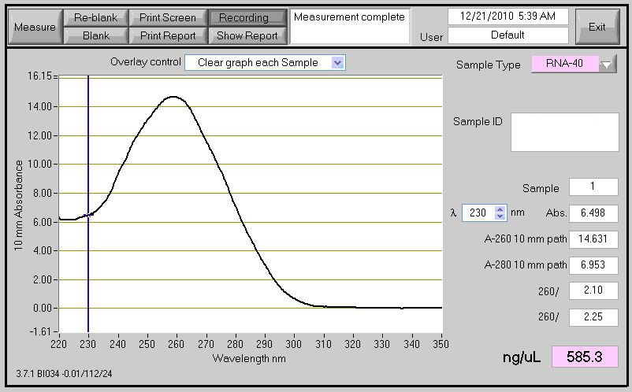
Figure5: Diagram obtained from the RNA of cells in the Nanodrop

Results of cDNA synthesis and quality assessment cDNA:
After ensuring the quality of RNA, cDNA synthesis was performed them with the HPRT gene. No non-specific bands were observed, which indicates that the correct cDNA made.

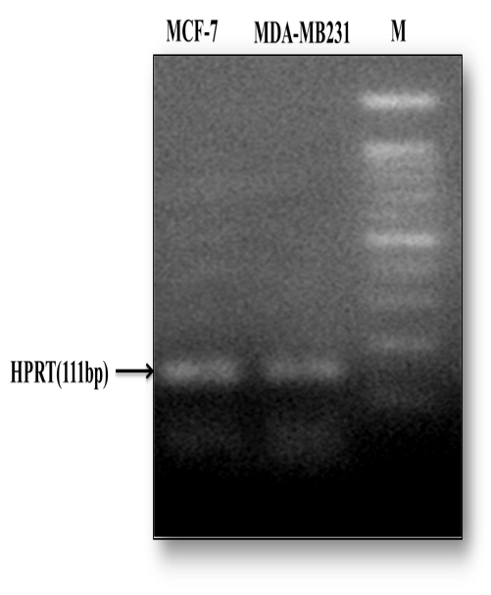
Figure 6: Quality of cDNA synthesis on 2% agarose gel to control gene expression in HPRT cDNA samples is extracted. Row M is the size marker 100bp.

Results of Real Time-PCR: For genes XAF-1, XIAP-1, Diablo, FASN, MMP-2, MMP-9 as well as control gene HPRT Realtime PCR was performed. After melting curve to show the specific products (Figure 9) and obtain CT (Figure 10) was drawn diagrams of the gene expression changes (Figure 9).

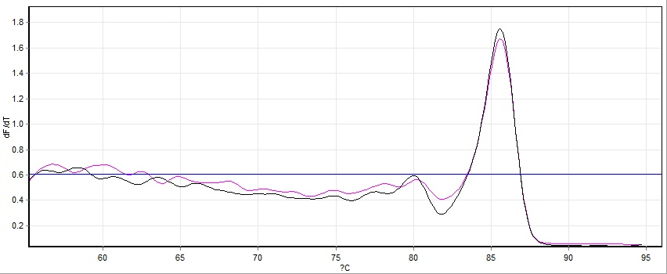
Figure 7: Melting curve related To HPRT gene.

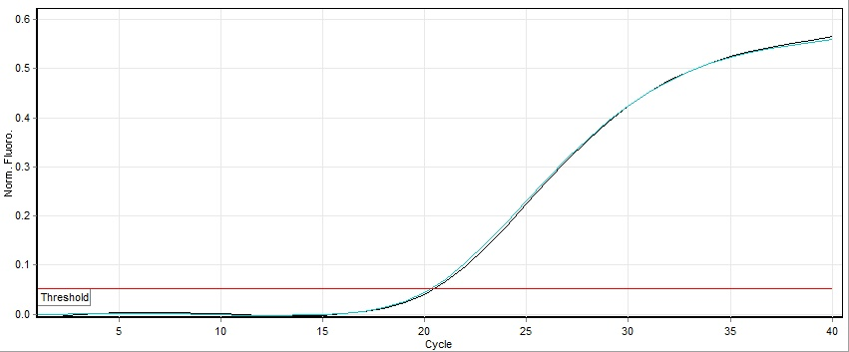
Figure 8: Obtaining Cycle Thershold

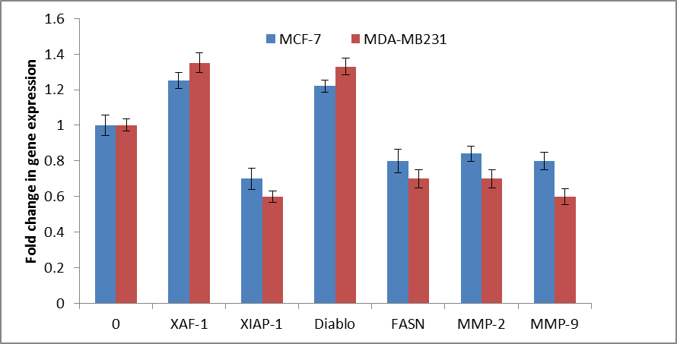
Figure 9: Study rate expression XAF-1, XIAP-1, Diablo, FASN, MMP-2, MMP-9 in both cell lines MCF-7 and MDA-MB231 100μmol/ml concentrations of genistein-treated compared with control (zero concentration). Statistical comparison of the expression levels of P <.05 were investigated.

Discussion:
Every year breast cancer allocated to most statistics deaths from cancer, Tumors in breast cancer after initial therapy in many cases changed their behavior and even surgery cannot be claimed that the risk of disease did not threaten.(49) According to cancer often upset and regulated within the cell and between cells is the hemostatic settings. so we can expect upset the balance between genes that have been studied that can be encountered with respect to genes that can affect will lead to more aggressive tumors and metastases out of the gene expression can be combined (26). The ability of cancer cells to migrate and invade the cells are classified into two categories of benign and malignant if a malignant tumor to reach a blood vessel or lymphatic metastasis can occur and the tissue will grow further. The ability of malignant tumors to invade healthy tissue and spread in the body that cause these tumors are fatal (17). Hence, in this study have been discussed reviews gene expression of XAF-1, XIAP-1, Diablo, FASN, MMP-2, MMP-9, which are involved in the mechanisms of metastatic breast cancer in both cell line MCF-7 and MD-MBA231 treated with genistein. Genistein increases Smac/DIABLO, Smac/DIABLO protein promotes caspase-dependent apoptosis by inhibition of inhibitor of apoptosis protein (IAP) family members. The role of smac /DIABLO in breast cancer has not been yet established.overexpression of Smac/DIABLO gene enhances apoptosis induced by paclitaxel, doxorubicin, etoposide, tamoxifen, and irradiation in breast cancer cells. XIAP-1 suppresses apoptotic cell death by binding to caspases and inhibiting their functions.XAF-1 antagonizes XIAP activities.XAF-1 is therefore believed to play an important role in the major apoptosis-related pathways. XAF-1 also serves as a candidate tumour suppressor gene. Genistein increases XAF-1, Genistein Blocking Fatty acid synthase (FASN) activity causes cytotoxicity in human cancer cells overexpressing FASN. Anti-FASN compounds exhibit in vitro anticancer activity. FASN phosphorylation by HER2 plays an important role in breast cancer progression and may be a novel therapeutic target in HER2-overexpressing breast cancer cells. MMP2 & MMp9 expression have shown important role in metastasis and angiogenesis in tumor growth and cancer progression. Also their expression reflects tumor stage and metastasis of breast cancer. This study has been designed to reduce the ability of genistein in the regulation of matrix metalloproteinase (MMP2 & MMp9), (5, and 19). MMp9 inhibited in vitro during genistein treatment in both cell lines MCF-7, MDA-MB-231 breast cancer and cell lines glial tumors and pancreatic cancer. (27, 28, 47, 53).

Future prospects:
Further studies to understand the molecular role of Genistein on XAF-1, XIAP-1, Diablo, FASN, MMP-2, MMP-9 expression are considered. XAF-1, XIAP-1, Diablo, FASN, MMP-2, MMP-9 expression are studied in vivo and animal model. The relationships of our genes with other genes involved in metastasis are important.

References:
1. About Breast cancer - A Quick Guide. (2011). Cancer Research uk.
2. A woman’s Guide to Breast cancer treatment (2010). California Department of public health.
3. Abeloff MD, Wolff AC, Weber BL, et al.(2008) Cancer of breast. In : Abeloff MD, Armitage Jo, Lichter AS,et al. clinical oncology 4th, philadelphia, pa: Elsevier :1875-1943.
4. American cancer Society (ACS).. (2011). Cancer facts 8 figures,Atlanta: American cancer society(4 ).
5. Banerjee S, Li YW, Wang ZW, Sarkar FH (2008). Multi- targeted therapy of cancer by genistein. Cancer letters, 269, 226-242.
6. Barret J (1996). Phytoestrogens: Friends or foes. Environ Health perspect, 104, 478-482.
7. Ben- portal I, T. m., cares VJ et al (2008). An embryonic stem cell –like gene expression signature in poorly differentiated aggressive human tumors. Nat Genet, 40, 499-507.
8. Berry DA et al. (1997). Probability of carrying a mutation of breast – ovarian cancer gene BRCA1 based on family history. J Nat1 cancer Inst, 89, 227-238.
9. Buchler P, G. T., Mouria T, Buchler MC, Buchler MW, Friess H,Pandol TJ, Reber HA, Buhler MW, Hines OJ (2003). Prevention of metastatic pancreatic cancer growth in vivo by induction of apoptosis with genistein a naturally occurring isoflavonoid. Pancrease, 26, 264-273.
10. Burke W et al. (1997). recommendations for follow up care of individuals with an inherited predisposition to cancer BRCA1 and BRCA2. JAMA, 277, 997-1003.
11. Chapman DD,(2007)Cancer genetics. Semin oncol Nurse 23(1), 2-9.
12. Couch FJ et al. (1997). BRCA1 mutations in women attending clinics that evaluate the risk of breast cancer. N Engl J med, 336, 227-238.
13. Dicko M. ( 2006 )Biochemical characterization of the major sorghum grain peroxidase. Febs Journal.;10:1742-1751.
14. Emami Rezavi S, Aghajani H, Haghazali M, Nadali F, Ramazani F, Dabiry E, et al. (2009). The most common cancer in iranian women. Iranian journal of public Health, 38(1), 109-112.
15. Enrique Espinosa Arranz, J. A. F. V., Angelo Gamez-pozo and pillar Zamora. (2012a). Gene signatures in breast cancer Translational oncology, 5, 398-403.
16. Fonlkes WD(2007)Clinically relevant biology of hereditary breast cancer.Semin oncol 34(5):379-83.
17. Georgiadis D, Y. A. (2008). Specific targeting of metzincin family members with small-molecule inhibitors: progress toward a multifarious challenge. Bioorganic & medicinal chemistry., 16(19), 8781-8794.
18. Harirchi I, Kolahdoozan S,Karbakhsh M, Chegini N, Mohseni SM,Montazeri A, et al. (2011). Twenty years of breast cancer in iran:downstaging without a formal screening program. Ann Qncol, 22(1), 93-97.
19. Huang XK, C. S., Xu L, Liu YQ, Deb DK, Platanias LS, Bergan RC, (2005) Genistein inhibits p38 map kinas activation matrix metalloproteinase type2, and cell invasion in human prostate epithelial cells. Cancer Research, 65, 3470-3478.
20. Huaghes CL(1998)Phytochemical mimicry of Reproductive Hormones and modulation of Herbivore fretility by phytoestrogens.Environ Health perspect 78:171-178.
21. J, G. G. a. M. (2006) Cancer metastasis,building a frame work. Cell, 127(4), 9-679.
22. Karuppannan Bashkaran, Embong Zunaina1, Shaharuddin Bakiah, Siti AmrahSulaiman, KNS Sirajudeen4 and Venkatesh Naik5. Anti-inflammatory and antioxidanteffects of Tualang honey in alkali injury on the eyes of rabbits: Experimental animal study. BMC Complementary and Alternative Medicine 2011, 11:90.
23. Kelly westbrook, vered Stearns. (2013). Pharmacogenomics of breast cancer therapy an update,. pharmacology & therapeutics, 139, 1-11.
24. Knight DC, Eden JA. Phytoestrogens-a short review.Maturitas J.of the climacteric& postmenopause.1995;22:167-175.
25. Klauber Demore N.(2005)Tomur biology of breast cancer in young women.Breast cancer 23:9-15.
26. Kolokotroni EA, S. G., Dionysiou DD, Georgiadi EC, Desmedt C, Graf NM, editors. ( 2008). Translating multiscale cancer models into clinical trials: Simulating breast cancer tumor dynamics within the framework of the “Trial of Principle” clinical trial and the ACGT project. BioInformatics and BioEngineering.
27. Kousidou OC, Mitropoulou TN,Roussidis AE, Kletsas D, Theocharis AD, Karamanos NK (2005) Genistein supresses the invasive potential of human breast cancer cells through transcriptional regulational of metalloproteinases and their tissue inhibitors. International Journal of Oncology 26:1101-1109.
28. Kumi– Diaka JK,Hassanhi M,Merchant K, Horman V,(2006)Influence of genistein isoflavone on matrix metalloproteinase-2 expression in prostate cancer cells.Journal of Medicinal Food 9:491-497.
29. Leclerq G, Heuson JC(1979) Physiological and pharmacological.
effects of estrogens in breast cancer.Biochim Biophys Acta 560:427-55.
30. Lee W-Y, Huang S-C, Tzeng C-C, Change T-L, Hsu K-F (2007). Alteration of metastasis- related genes identified using an oligonucleotide microarray of genistein- treated Hcc 1395 breast cancer cells. Nutrition and cancer an international Journal, 58, 239-246.
31. Li YW,Che MX,Bhagat S,Ellis KL,Kucuk O, Doerge DR,Abrams J,Cher ML,Sarkar FH (2004) Regulation of gene expression and inhibition of experimental prostate cancer bone metastasis by dietary genistein.Neoplasia 6:354-363.
32. Li YW, S. F. (2002a). Down regulation invasion and angiogenesis- related genes identified by cDNA microarray analysis of PC3 prostate cancel cells treated with genistein. Cancer letters, 186, 157-164.
33. Li YW, S. F. (2002b). Inhibition of nuclear factor kappa B activation in PC3 cells by genistein is mediated via Akt signaling pathway. Clinical cancer Research, 8, 2369-2377.
34. Li YW, Upadhyay S, Bhuiyan M, Sarkar FH (1999). Induction of apoptosis in breast cancer cells MDS-MB-231 by genistein oncogene, 18, 3166-3172.
35. Lof M, Wiederpass E. Epidemiologic evidence suggests that dietary phytoestrogen intake is associated with reduced risk of breast, endometrial,and prostate cancers. Nutrition Research 2006;26:609-619.
36. Malvezzi M,Arfe A,Berruccio P,Levi F,La Vecchia C, Negri E(2011)European cancer morrality predictions for the year2011.Ann Oncol 22:947-956.
37. Messina M,(2003)A close look at soybeans.4th edition Nutritional Prospectives 176-17.
38. Molokai EA, Perkins A. (2008). Preventing cancer. Primary care: clinics in office practice, 35, 609-623.
39. Moodi M,Balali Moodi M,Sharifirad GR, Shahnazi H,Sharifzadeh GR.(2011) Evaluation of breast self-examination program using Health Belief model in female students.IRMS 16(3):316-22.
40. Moodi M,Sharifirad GR,Hassanzadeh A, Charkazi AR, Shahnazi H,Tahergorabi Z. (2011) Investigation of breast cancer screening behaviors using the stage of change model and it is relationship with psycho-cognitive Factors among Isfahan female teachers.health promotion perspectives J 1:114.
41. Mooler P et al. (2007). surveillance for familial breast cancer differences in outcome according to BRCA mutation status. Int J cancer, 121(5)
42. Mousavi SM,Gouya MM,Rmazani R,Davanlou M, Hajsadeghi N,Seddighi Z(2009) Cancer incidence and mortality in Iran.Ann oncol 20(3):556-63.
43. Noori Dalloii MR. (2009,2012). Medical molecular Genetic in the third millennium Tehran: samer publishing.
44. National cancer Institue breast (2012). SEER state fact sheet.
45. Paves JM,Farmer RL,Bergan RC(2010) Inhibition of cancer cell invasion and metastasis by genistein.Cancer and Metastasis Review 29:465-482.
46. Po LS, Wang TT,Chen ZY,Leung LK(2002) Genistein induced apoptosis in MCF-7 cel involves change in Bak and BCL-2 without evidence of anti-oestrogenic effects. British Journal of Nutrition 88:463-469.
47. Puli S, Lai JCK,Bhusham A(2006)Inhibition of matrix degrading enzymes and invasion in human glioblastoma(U87MG)cells by isoflavones. Journal of Neuro-oncology 76:135-142.
48. Qigong Wu, Xiu Hou, Jun Xia, Xiujuan Quant, Lucio Miele, Fazlul H, Sarkar, Zhiwei Wang. (2013). Emerging roles of PDGF-D in EMT progression during tumorigenesis. Cancer treatment Reviews, 39, 640-646.
49. Rao R, E. D., Mayo HG, Balch C.. (2013). Axillary Node Interventions in Breast Cancer. JAMA: the journal of the American Medical Association, 310(13), 1385-1394
50. Scully R,et al(1997)Dynamic change of BRCA1subnuclear location and phosphorylation state are intiated by DNA damage. Cell 8:265-275.
51. Siegel R,Naishadham D,Jemal A.(2012)Cancer statistics. CA Cancer J Clin,62:10-29.
52. Singh AV, Franke AA,Blackburn GL,Zhou JR (2006) Soy phytochemicals prevent orthotopic growth and metastasis of bludder cancer in mice by alterations of cancer cell proliferation and apoptosis and tomur angiogenesis. Cancer Research 66:1851-1858.
53. Skogseth H,Follested T,Larsson E, Halgunset J (2006) Transcription Levels of invasion-related genes in prostate cancer cells are modified by inhibitors of tyrosin kinase. Apmis 114:365-371.
54. Sobizewska E, Szmigielski S. The role of selected cell growth factors in the wound healing process. Przegl Lek.1997;54(9):634-638.
55. Su SJ,Yeh TM,Chuang WJ,Ho CL,Chang KL, Cheng HL, Liu HS,Hsu PY,Chow NH(2005) The novel targets for anti-angiogenesis of genistein on human cancer cells. Biochemical Pharmcology 69:307-318.
56. Tice JA,Kerlikowske K(2009) Screening and prevention of breast cancer in primary care. Primary Care:Clinics in office practice 36:533-58.
57. Tommasi S et al. (2005). BRCA1 mutations and polymorphisms in a hospital based consecutive series of breast cancer patient from Apulia Italy. Mutat Res, 578(1-2), 395405.
58. Tophkhane C,Yang S,Bales W,Archer L,Osunkoya A,Thor AD,Yang X(2007)BCL-2 overexpression sensitizes MCF-7 cells to genistein by multipe mechanisms. International Journal of Oncology 31:867-874
59. Trock BJ, Hilakivi-Clarke L,Clarke R (2006) Meta-analysis of soy intake and breast cancer risk. J Natl Cancer Inst 98(7):459-71.
60. Wang, X. (2013). Discovery of molecular associations among aging,stem cell,and cancer based on gene expression profilling. Chinese journal of cancer, 32(4).
61. Xiasheng Wang (2013). Discovery of molecular associations among aging,stem cells, and cancer based on gene expression profilling. Chinese journal of cancer, 32(14.).
62. Decker, T., and Lohmann-Matthes, M-L., A quick and simple method for the quantitation of lactate dehydrogenase release in measurements of cellular cytotoxicity and tumor necrosis factor (TNF) activity. J. Immunol. Methods, 15, 61-69 (1988).
63. Legrand, C. et al., Lactate dehydrogenase (LDH) activity of the number of dead cells in the medium of cultured eukaryotic cells as marker. J. Biotechnol., 25, 231-243 (1992).

7/30/2014

