Bean yellow mosaic potyvirus potential on nodulation and N₂-fixation of faba bean plants

Ahmed R. Sofy ¹*, Mohamed S. Attia ¹, Abd El-Monem M.A. Sharaf ¹ and Khalid A. El-Dougdoug ²

^{1.} Botany and Microbiology Department, Faculty of Science, Al-Azhar University,11884 Nasr City, Cairo, Egypt
^{2.} Agric. Microbiology Department, Faculty of Agriculture, Ain Shams University,11241 Cairo, Egypt
*ahmd_sofy@yahoo.com

Abstract: This study was conducted to potency the effect of nodulated faba bean plants and Bean yellow mosaic virus (BYMV) infected on bacterial nodulation and nitrogen fixation in faba bean plants. Significant reduction in number, weight and size of nodules, leghemoglobin contents, nitroginase activity and nitrogen fixed in nodulated faba bean plants compared with healthy ones. The bacteroidal cells of root nodules (in situ) in healthy and BYMV-infected nodules ones were investigated using transmission electron microscope (TEM). It was found different distribution of nodules on root system. The infection threads of Rhizobium were usually present in the young central tissue cells near the meristem of infected nodules and healthy ones. Rhizobia entered through the epidermis and moved intracellulary through the cortical region. Infected mature nodules of faba bean roots. Significantly reduction and deformation and aggregated the bacterial reduced significantly of meristem, cortex, vascular tissue and deformation bacteroid cells. As well as the lateral showed both infected and non-infected cells mixed together. Vascular bundles were inversely collateral and distributed around the bacteroid cells. The bacteroids were enclosed in peribacteroid membrane in groups and showed prominent granules of polyhydroxybutyrate granules in their cytoplasm. The possible significance of these changes relative to the decreased efficiency of N₂-fixation is discussed.
[Sofy AR, Attia MS, Sharaf AMA and El-Dougdoug KA. Bean yellow mosaic potyvirus potential on nodulation and N₂-fixation of faba bean plants. N Y Sci J 2014;7(9):101-109]. (ISSN: 1554-0200). http://www.sciencepub.net/newyork. 17

Keywords: Viral infection; Vicia faba; Nodulation; leghemoglobine; R. leguminosarum bv. viceae; Nitrogenase activity; TEM

1. Introduction
Legumes plants can provide their own nitrogen requirements through nitrogen fixation in symbiosis with soil bacteria collectively known as rhizobia. These bacteria form root nodules on leguminous plants and convert atmospheric N₂ into a form usable by plants. Application of effective rhizobial strains as biofertilizers to improve legume production is an important approach in sustainable agriculture (Saharan and Nehra, 2011).
Faba bean is known to be naturally infected by many viruses. Among them Bean yellow mosaic potyvirus is the most serious problem (Makkouk et al., 2003; Elbadry et al., 2006). Faba bean inoculation with effective Rhizobial strain is a common practice that usually enhances nodulation, biological nitrogen fixation and improve crop yield. (Abo El-Soud e t al., 2003; Ghobrial et al., 2009).
Leghemoglobin is the heme protein complex, is likely to function in the symbiotic fixation process by facilitating diffusion and regulation of O₂ for the respiration of the nitrogenase containing Rhizobium bacteroids in nodule (Burns and Hardy, 1975). Nodules of Broad bean mottle virus-infected plants showed significant reduction in leghemoglobin content in comparison with those formed from healthy plants (Gomaa et al., 2006).
Faba bean plants challenging with BYMV prevented nodule formation and decreased drastically nitrogenase activity on roots of faba bean plants emerged from non-inoculated seeds. Moreover, Rhizobium-inoculated challenged plants showed very poor nodulation and lower nitrogenase activity as compared to plants of the corresponding unchallenged treatment. Infection by rhizobia can be divided into two phases; nonbacteroidal and bacteroidal (Elbadry et al., 2006). TU (1975) mentioned that during the first phase, an infection thread develops and the rhizobia are encased in the infection thread and are later released into the host cytoplasm. After the rhizobia enter the host, each cell acquires a membrane envelope (ME). The rhizobia with ME are termed bacteroids. They develop and multiply in the cytoplasm of the host cells.
The present investigation, therefore, provides information on BYMV-Rhizobium leguminosarum system to elucidate the interrelationship among virus, Rhizobium, and root nodule cells.

2. Material and Methods
2.1. Plant material
Seeds of (Vicia faba L.) cv. Giza 3 were obtained from Legume Crops Research Centre, Institute of Crop Production, Agriculture Research Centre. Seeds were sowing in a mixture of sand and clay soil (1: 3 w/w) in pots (30 cm in diameter) in a separated growth chamber.

2.2. Rhizobium strain
R. Leguminosarum PGPR (mixtures of ICARDA-441 and ARC-202) was kindly provided by Biofertelizer production unit, Soil, Water and Environment Research institute, Agriculture Research Center (ARC) Giza Egypt. It was streaked on slants of 100 ml yeast extract manitol agar bottles and incubated at 28ºC for 7 days. When the growth of rhizobia cover the entire surface of the slant agar, the growth was washed with saline solution (NaCl 0.85%). The suspension was shocked by magnetic stirrer for 15 min. The concentration of rhizobia in suspension was counted by most probable number (MPN).
Faba bean seeds were treated directly in the laboratory by inoculum of cell suspension containing 10⁹ CFU/ml culture (colony formation unit), using the rate of 2ml per one gram seeds. The treated seeds were incubated at 28ºC for 24 hr in petri-dishes before planting. The seeds were washed with water three times then soaked in gam material for formation biofilm of Rhizobium on surface seeds.

2.3. BYMV inoculation
A Bean yellow mosaic potyvirus Egyptian isolate was obtained from Virology Laboratory, Agricultural Microbiology Department, Faculty of Agriculture, Ain Shams University, Egypt. It was maintained on faba bean cultivar Giza 461. The virus was checked on Chenopodium amaranticolor L. and reisolated from a single lesion. Inoculum of the virus was prepared by grinding fresh leaves showing severe symptoms in 100 mM phosphate buffer (pH 7.5) with (1:2 w/v) using sterilized pestle and mortar. The first two leaves of plant -old faba bean plants were mechanically inoculated with the virus-inoculum. As well as another plants inoculated with the same buffer as a positive control. The results were confirmed using specific polyclonal antibodies of BYMV by double antibody sandwich enzyme-linked immunosorbent assay (DAS-ELISA) according to Clark and Adams (1977).

2.4. Nodule growth parameters
These parameters were done on five plants from each replicate belonging to each treatment at 45 (Stage I) and 75 (Stage II) days from seed cultivation. The root nodules were counted and size of nodules was measured by displacement of water. The fresh weight of nodules was determined as mg/g nodules. Leghemoglobin (L_{Hb}) content in nodules was determined according to El-Dougdoug (1982).
The nitrogenase activity in root nodules was assayed according to Dart and Harris (1972) using a PYEUNICAM gas liquid chromatography model 104 at Biofertelizer production unit, Soil, water and Environment Research Institute, Agriculture Research Center (ARC), Giza, Egypt. Nitrogenase activity was calculated as the following formula:

where: Inj. Vol.= Injection volume, R= Reading of peak and D.wt.= Dry weight of nodules. The results were presented as nmol/C₂H₄/g D.wt./hr.

2.5. Virus assay
BYMV-infected nodule roots of faba bean plants at 60 days were collected. These nodules were extracted in 0.1 Mm phosphate buffer (pH 7.0). The filtrates extracted were mechanically inoculated of ten faba bean seedling for each treatment and assay BYMV infectivity.

2.6. Ultrastrucural of nodules
The cytological changes created in faba bean root nodules healthy and infected with BBMV were investigated with a JOEL JM 100-C electron microscope (Electron Microscope Unit, the Regional Center of Mycology and Biotechnology, Al-Azahr University, Cairo, Egypt).
The selected tissue samples were fixed and processed for electron microscopy (Lin and Langenbeg, 1983) as follows: Samples were fixed for 4 hrs in 0.08 M cacodylate buffer pH 7.4 containing 5% glutaraldehyde and 4% paraformaldehyde. The fixed specimens were washed three times at half hour intervals with 0.1 M cacodylate buffer pH 7.4, 3% sucrose. These samples were post fixed in 1 % osmium tetroxide dissolved in a solution of 0.1 M cacodylate buffer pH 7.4 and 2% sucrose. Following three hours wash in 0.1 M cacodylate, 3% sucrose pH 7.4, samples were dehydrated in ascending concentration of alcohol series, sequentially followed by propylene oxide, then propylene oxide plus epoxy resin (1:1 V/V) and finally, embedded in epoxy resin. Thin sections were cut, then stained with uranyl acetate and lead citrate and viewed with a JOEL JM 100-C electron microscope (Electron Microscope Unit, the Regional Center of Mycology and Biotechnology, Al-Azahr University, Cairo, Egypt).

2.7. Statistical analyses
Experimental data were subjected to one way analysis of variance (ANOVA) and the differences between means were separated by the least significant difference (L.S.D) at 5% level of probability using M-state software (Snedecor and Cochran, 1982).

3. Results
The Bean yellow mosaic virus (BYMV) Egyptian isolate was confirmed by indicator plant (Ch. amaranticolor) which gave chlorotic local lesion (12-15 days, O.D. of DAS-ELISA at 405nm= 0.325) (Fig. 1). Faba bean plants were inoculated with Bean yellow mosaic virus (BYMV). BYMV induced systemic symptoms with mosaic associated with vein yellow (15-20 days, O.D. of DAS-ELISA at 405nm= 0.427) (Fig. 2).


Figure 1. Ch. amaranticolor mechanically inoculated with BYMV isolate showing chlorotic local lesion.

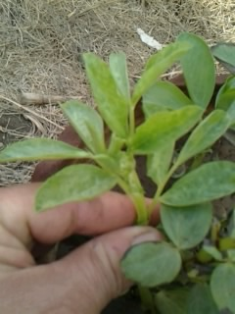

Figure 2. Faba bean plants showing systemic symptoms which inoculated BYMV.

R. leguminasarum isolate was confirmed microscopally and cultured on specific medium as well as formed true nodules on faba bean roots. Faba bean seeds were treated directly in the laboratory by inoculum of cell suspension containing 10⁹ CFU/ml culture using the rate of 2ml per one gram seeds. The treated seeds were incubated at 28°C for 72 hr in petri-dishes. After incubation the seeds were washed with water three times and left for during the formation biofilm of Rhizobium was observed on surface seeds.

3.1.Virus infectivity
The virus infectivity was determined by dilution end point assay of clarified infections sap, from root nodules. BYMV infectivity in root nodules was highest (1:10⁴) and dropped gradually with increasing age of faba bean plants.

3.2. Nodulation
The response of faba bean plants (V. faba L. cv. Giza 3) seeds bacterized with R. leguminosarum bv. viceae to infection with BYMV is quantified in table (1).
Significant reductions in response to viral infection were observed at the two stages 30 and 60 days of growth. The percentage of reduction 44.67, 50.91 (No. of nodules), 29.31, 20.0 (fresh weight) and 32.76, 32.82 (nodule size) at 30 and 60 days of growth, respectively. With respect to seed bacterization, it was found that, healthy nodulated plants showed the maximal number, size and fresh weight of root nodules. It was found that, treatment with R. leguminosarum showed significant increase in all nodule growth parameters (table 1). This was the case throughout the two stages of growth.
Regarding the leghemoglobin nodule contents, an appreciable and significant increase was observed in healthy nodulated plants compared to BYMV-infected nodulated plants. BYMV was gave highly significant decreased with 40% in leghemoglobin contents of infected root nodules related to healthy ones. The results in table (1) showed that, healthy nodulated plants showed significant increase in total nitrogen contents of root nodules, whereas, faba bean infected with Bean yellow mosaic virus, gave highly significant decreased in total nitrogen contents with 7.4%.
Nitrogenase quantification was revealed by GC (Fig. 3) whereas these peaks were appeared in both nodulated faba bean plant (R) at retention 2.729 and nodulated faba bean plant infected with BYMV (R + V) at retention time 2.709.
The inoculation of faba bean seeds with Rhizobium significantly improved plant performance in terms of plant nitrogenase activity. Moreover, Rhizobium-inoculated challenged plants showed very poor nodulation and lower nitrogenase activity with 35.47% as compared to plants of the corresponding unchallenged treatment.
Nodulation was observed in all the plants including unincoulated control, inoculated and virus infected. The presence of nodules in uninoculated plant roots, indicate the presence of indigenous rhizobial population in the soil. The root nodules were rough in texture white in color with red apex and distributed on main and lateral roots, while considered on lateral roots on BYMV-infected plants ones (Fig. 4). The morphology of root nodules showed variation in BYMV-infected nodules compared with healthy ones. For example infected nodules were elongated, bifurcate and branched compared to healthy nodules, where elongated and globes (Fig. 4).

Table 1. Nodulation quantitative of BYMV infected faba bean plants under greenhouse condition
Treatments  Parameters | Rhizobium |  | Rhizobium + Virus |  | % of relative virus infection
Treatments  Parameters | Stage I | Stage II | Stage I | Stage II | Stage I | Stage II
No. of nodules/plant | 43.38  a | 67.50  a | 24.00  b | 33.13  B | 44.67 | 50.91
F.wt. of nodule (g/plant) | 1.16  a | 1.70  a | 0.82  b | 1.36  ab | 29.31 | 20.00
Nodule size (mm/plant) | 4.56  a | 7.21  a | 3.07  b | 4.84  b | 32.76 | 32.82
Leghemoglobin (mg/g F.wt. of nodules) | - | 0.65  a | - | 0.39  b | - | 40.0
Nitrogen (mg/100g D.wt. root nodules) | - | 1.35  a | - | 1.25  b | - | 7.4
Nitrogenase activity (nmol. C₂H₄/g D.wt/hr) | - | 3000  a | - | 1921  b | - | 35.47
H= Healthy nodulated plants, I= Infected nodulated plants. Stage I and II = Growth period 45 and 75 days from seed cultivation and calculated as average from 3 replicates. The percentages of infection were calculated according to the following equation:

3.3. Ultrastructural
Mature nodules of BYMV infected faba bean could be differentiated into meristem, cortex, vascular tissue and bacteroid tissue compared with BYMV-infected ones. The lateral showed both BYMV-infected and non-infected cells and mixed together. Vascular bundles were inversely collateral and distributed around the bacteroid tissue. In the present work showed that greater space between bacteria and membrane envelope in healthy nodules than in BYMV-infected cells (compare Fig. 5 A and B). Ultrastrucure results in the present study show that BYMV-infected nodule cells had fewer ribosomes. On the other hand, cells with rhizobial infection thread had enormous of ribosomes. Also, ultrastrucure observation of faba bean healthy root nodule showed bacteria (B) inside the root cells. On the other hand, BYMV-infected nodule cells empty from bacteria (B). However, large number of polyhydroxybutyrate granules (FG) could also be localized within the uninfected zone in close proximity of the infected cells (Fig. 6 A and B). In healthy nodule cells bacteroids were enclosed in peribacteroid membrane in groups and showed prominent granules of polyhydroxybutyrate in their cytoplasm. While BYMV cause reduction in granules of polyhydroxybutyrate.
In a BYMV-infected faba bean plant, the nodules were systemically infected with the virus and not all the cells were infected rhizobia in contrast all the cells of healthy nodules were infected with rhizobia (Fig. 7 A and B). On the other hand, young merestematic cells of BYMV-infected and healthy were usually free from rhizobia cells (Fig. 5 A and B).
The presence of BYMV-infected nodules, in addition for the infectivity assay, was proven by sectioning of nodule tissue. These cells showed the presence of BYMV inclusion bodies crystal and bundle inclusions (Fig. 7 B) which were characteristic of BYMV infection.
BYMV-infected cells with or without rhizobial infection. Nodules cells free of rhizobia had fewer ribosomes (Fig. 5 B). On the other hand, the cells with rhizobial infection threads had enormous numbers of ribosomes (Fig. 6) and an extensive rough endoplasmic reticulum (ER) (Fig. 6). Although crystal and bundles were visible, their detailed structure s were difficult to resolve because of the high density of ribosome and endoplasmic reticulum (Figs. 5, 6). Mitochondria appeared to be more numerous in cells infected with rhizobia which was suggestive of high metabolic activity.

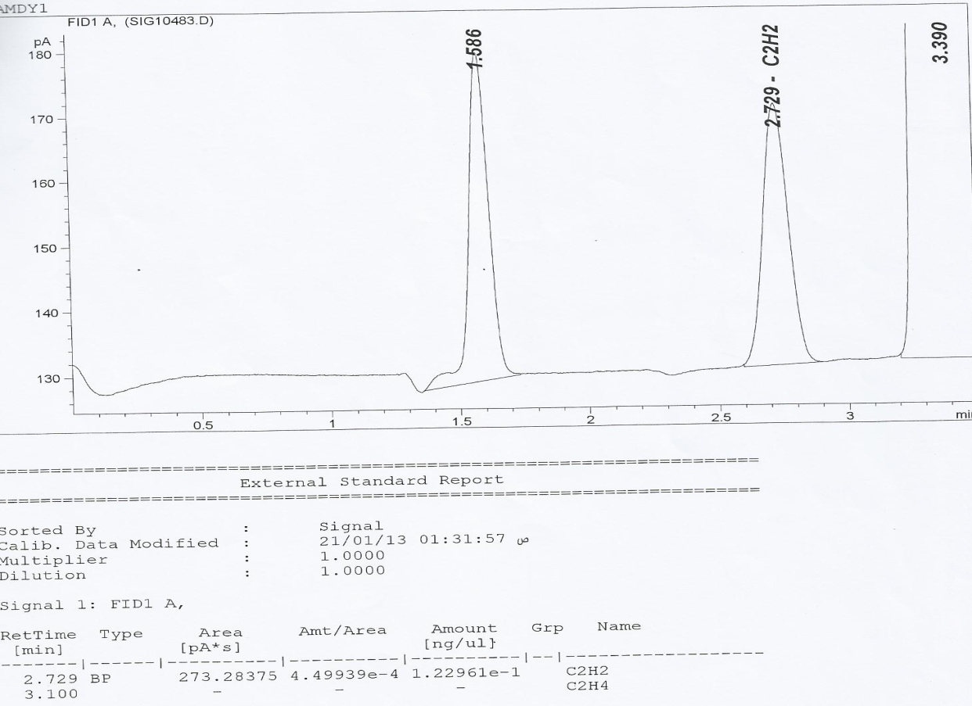
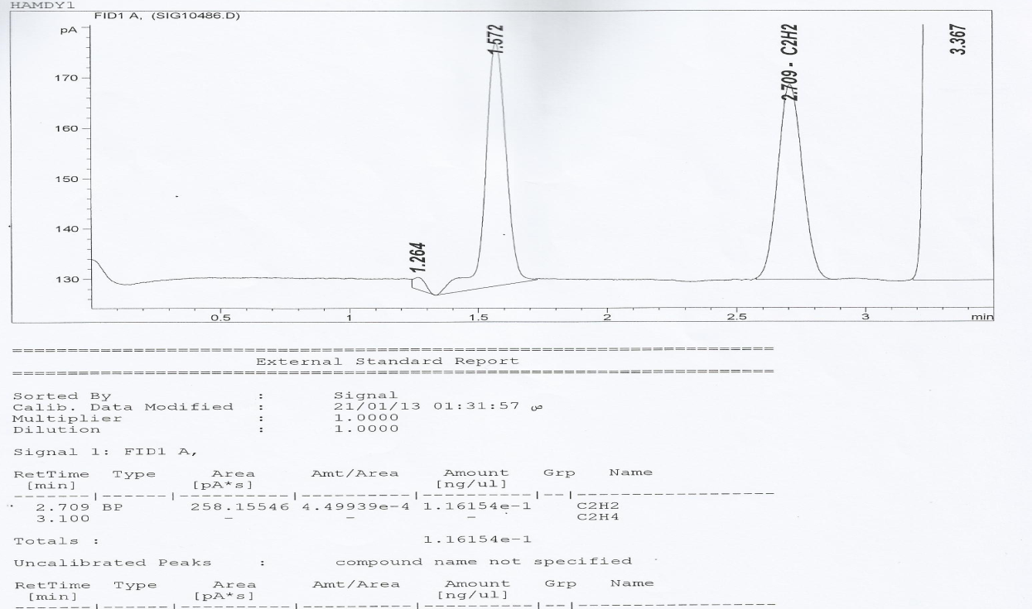
(A)
(B)

Figure 3. Nitrogenase quantification was revealed by GC whereas these peaks were appeared in both (A) Nodulated faba bean plant at retention 2.729 and (B) Nodulated faba bean plant infected with BYMV at retention time 2.709

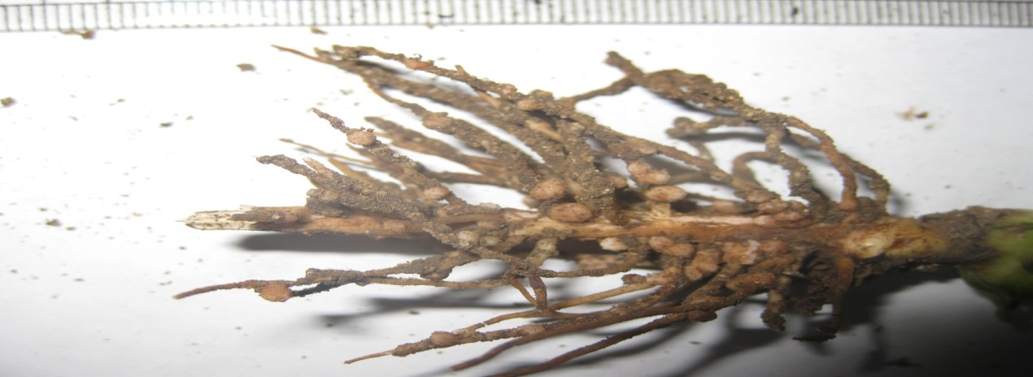
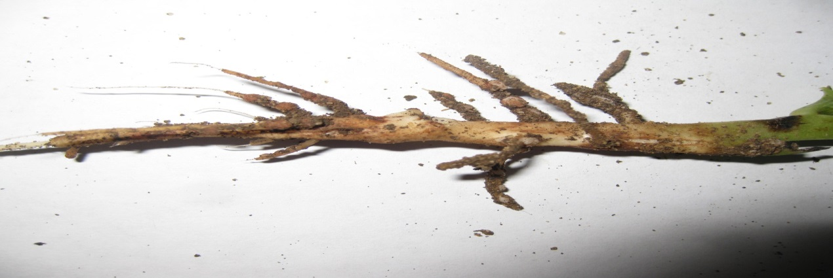
(B)
(A)

Figure 4. (A) Distribution of nodules on root of healthy nodulated faba bean plants. (B) Distribution of nodules on root BYMV-infected faba bean plants
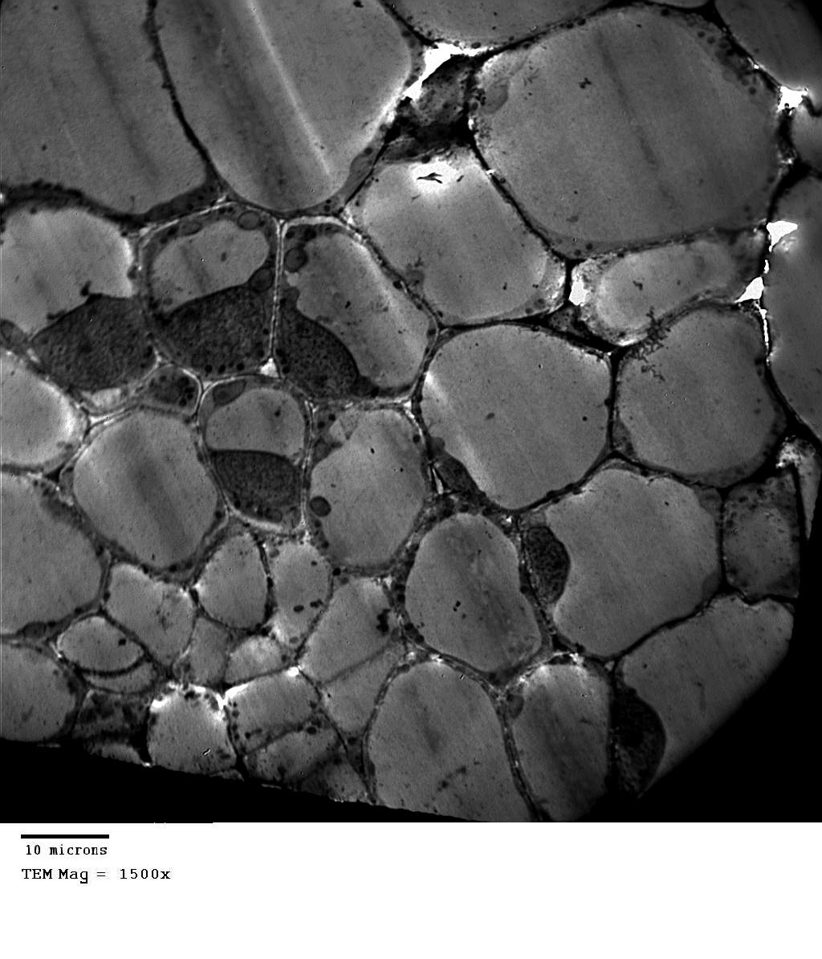
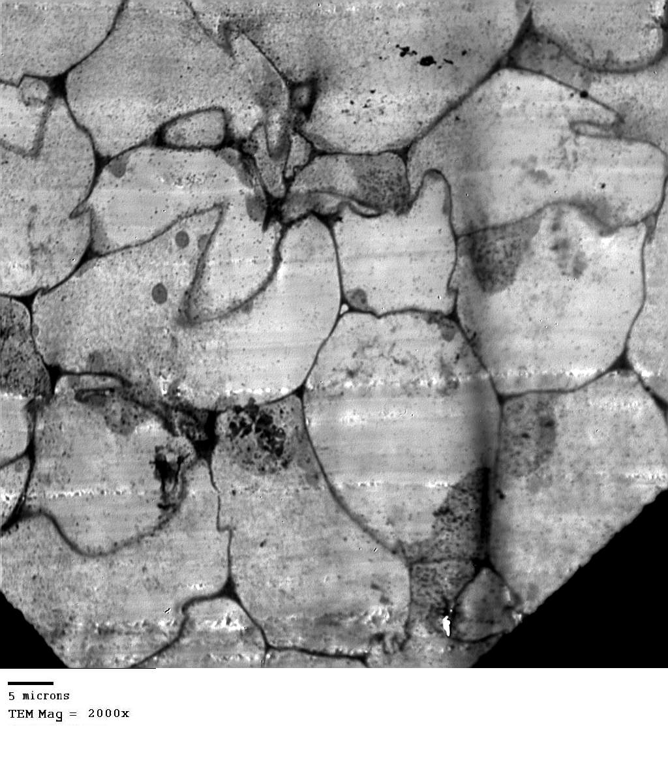
B

B
Ph

N

B
Ph
B
N
N

Figure 5. Portion of root nodule cells (A) Vascular tissue of healthy nodulated root showing bacteroidal cells and normal vascular tissue. (B) Vascular tissue of BYMV-infected nodulated root showing deformation of vascular tissue low and deformation of bacteroidal cell. N= neucleus, B= bacteroidal cells, Ph= phloem.

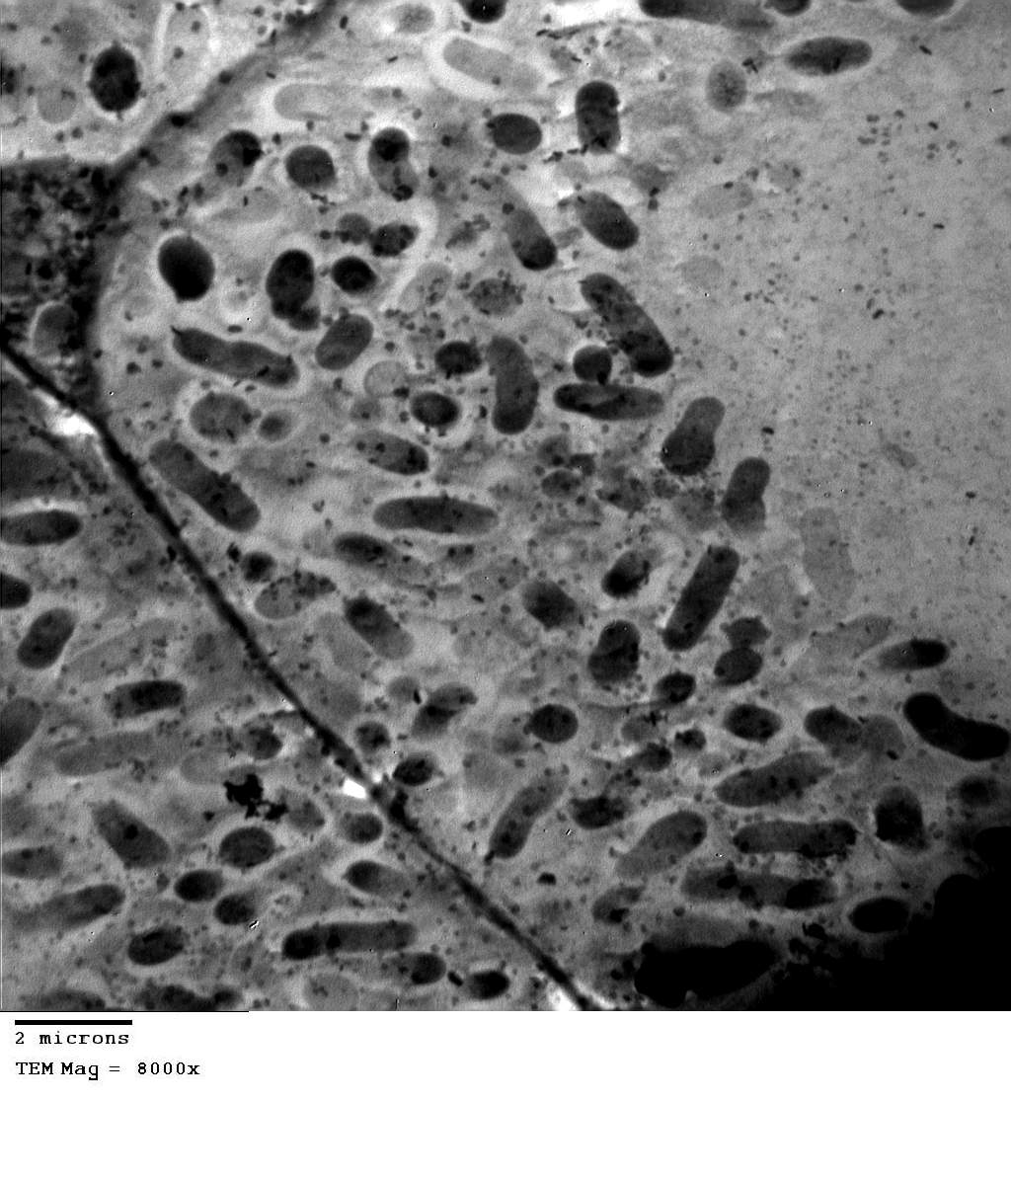
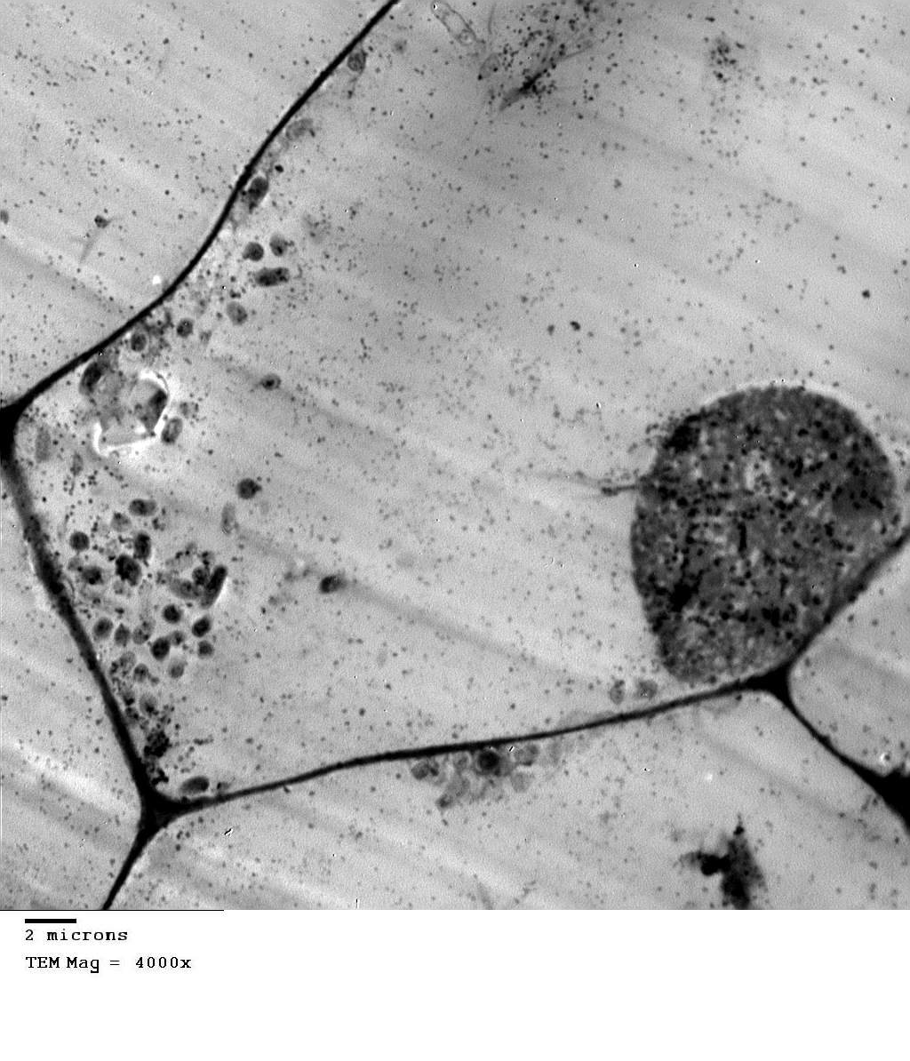

B
N

V
V

B

CW
IS

Figure 6. Cells of nodulated faba bean root (A) Healthy nodulated cells showing many number of bacteroidal cells stage (I,L) for R. leguminasarum as well as polyhydroxybutyrate granules. (B) BYMV-infected nodulated cells showing the low number and deformation of bacteroidal cells as well as inclusion bodies. CW= cell wall, N= neucleus, V= vacuole, IS=cellular interspace, B= bacteroidal cells.
H2
H3
B
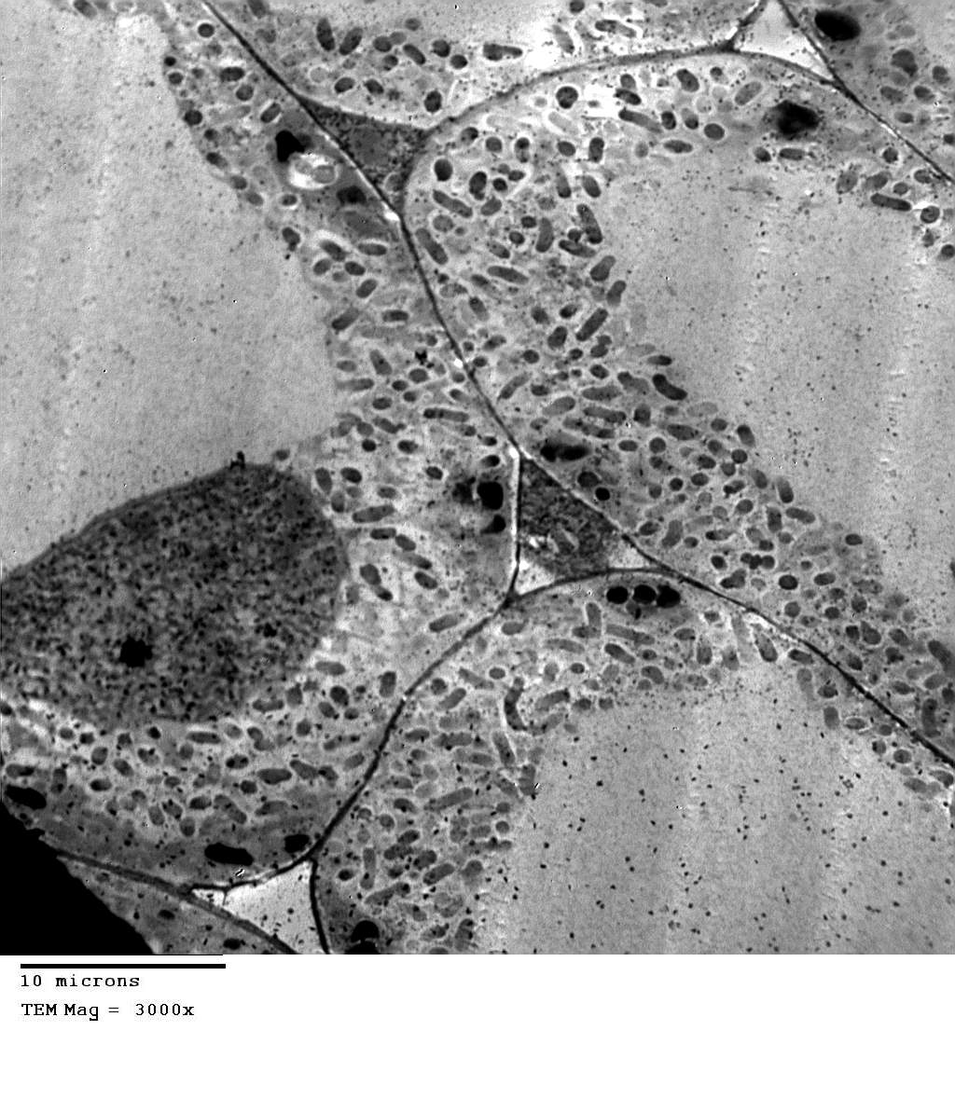
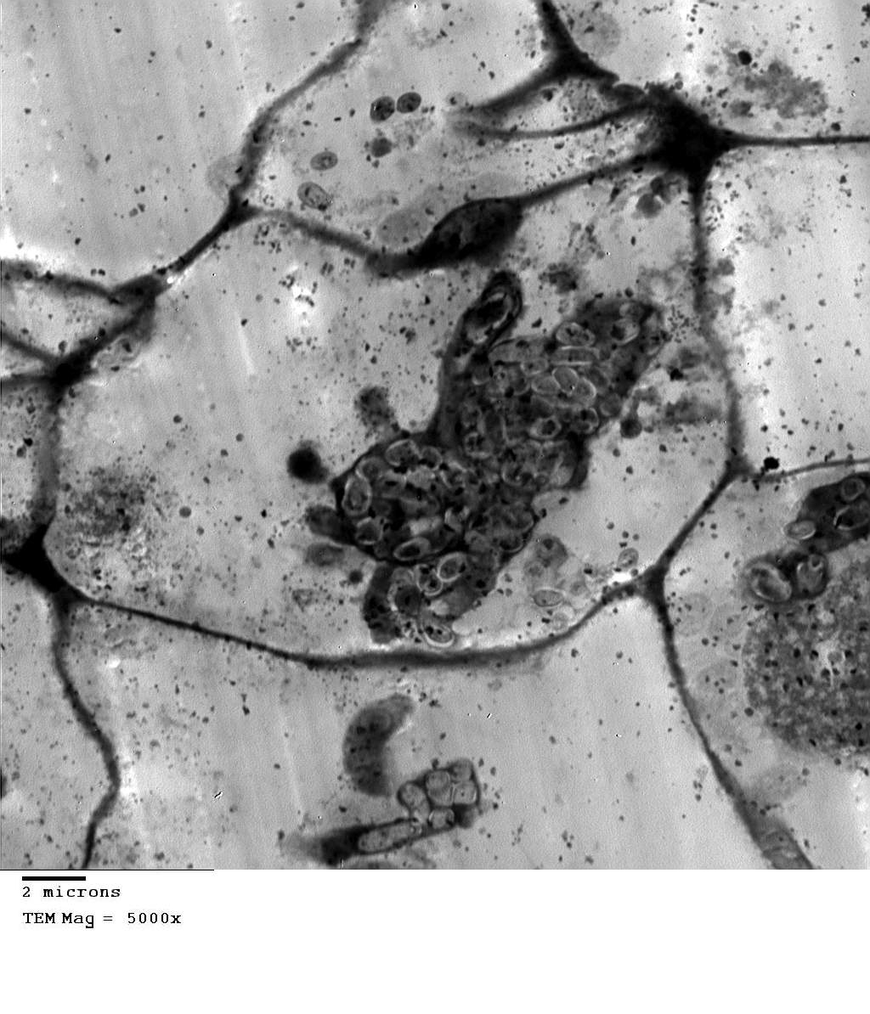

V
B
R

BYMV
N

Figure 7. Root nodule cells (A) Cells of healthy root nodule infected with bacterial cells (Bacteroid stage) and (B) Cells of BYMV-infected root nodules showing not all cells inoculated bacterial cells (Bacteroid stage). N= neucleus, V= vacuole, B= bacteroidal cells, R= Rhizobium.

3.3.1. Rhizobia in BYMV-infected cells
BYMV infection appeared to have little effect on the development of infection threads and release of bacteria from threads into the host cells. Infection threads of rhizobia were seen in BYMV-infected central tissue cells. The infection threads passed through the intracellular spaces and penetrated the cell wall. The bacteria were enclosed in thread wall. The thread walls were membrane-bound and were often thicker than the cell wall of control tissue cells (Fig. 6). Even through the bacteria were still enclosed in the infection threads and were not being released into the cytoplasm, metabolic changes of host cells apparently had been triggered. Unlike, the uninfected cells rhizobium infected cells were typified with abundant ribosomes and an extensive endoplasmic reticulum complex (Fig. 6).
The mode of release of bacteria from the infection thread into the cytoplasm was described as follows: firstly, a lateral wall-enclosed bulge developed on the thread and become filled with bacteria (Fig. 5 B); secondly, the bulge then extended but the wall material was no longer deposited and finally, bacterium as it moved into the cytoplasm (Fig. 5). The observation in respect to the development of rhizobial thread and the mode of releasing bacteria from the thread into the cytoplasm agreed closely in a virus-free system.

4. Discussion
Rhizobium species (PGPR) are widely used in agriculture for legume crops improvement because of their ability to fix atmospheric nitrogen in symbiosis with legumes. The potential for improving faba bean plant performance by inoculation with rhizobia has been investigated in the present study. Result also agreed with those of Osman and El-Sheikh (1994) in that BYMV caused a decrease in nodule number, fresh weight of nodules and size of nodules, whereas inoculation with rhizobia induced significant increase in these parameters. Elsheikh and Osman (1995) found that faba bean (Vicia faba) plants were infected with Broad bean mottle virus (BBMV) or Bean yellow mosaic potyvirus (BYMV) in a field experiment. Both viral infections significantly decreased, number of nodules, nodule fresh weight, and size of nodules/plant, and N₂ fixation. Ghobrial et al. (2009) mentioned that the difference in nodule number was reflected in the total fresh weight of nodules per plant.
Rhizobium species are widely used in agriculture for legume crops improvement because of their ability to fix atmospheric nitrogen in symbiosis with legumes. The potential for improving faba bean plant performance by inoculation with rhizobia has been investigated in the present study. BYMV-infected faba bean plants resulted in a significant decrease in leghemoglobin content, nitrogen, and nitrogenase activity as compared with Rhizobium inoculation. This results is in agreement with those of Gomaa et al. (2006) who found that nodules of Broad bean mottle virus-infected plants showed significant reduction in leghemoglobin content and nitrogenase activity in comparison with those formed from healthy plants. Whereas inoculation with Rhizobium has significantly increased these parameters. In addition, TU (1973) found that nodules of Soybean mosaic virus (SMV) infected soybean contained higher total N₂ than did their healthy counterparts, however, this increase accompanied by a decrease in leghemoglobin, indicating metabolic disturbance caused by the infection, probably indirect. The present study showed that inoculation with Rhizobium significantly improved plant performance in terms leghemoglobin, nitrogenase activity and plant nitrogen content as compared to unchallenged control plants. However, the coinoculated plants showed the best performance. Challenging with BYMV prevented nodule formation and decreased drastically nitrogenase activity on roots of faba bean plants emerged from non-inoculated seeds. Moreover, Rhizobium-inoculated challenged plants showed very poor nodulation and lower nitrogenase activity as compared to plants of the corresponding unchallenged treatment. This result could be very important practically since it may offer a simple, environmentally safe and economically accepted mean to protect faba bean plants from BYMV infection. However, additional studies are needed to confirm these results under field conditions.
The results obtained in this study indicated that R. leguminosarum might induce systemic resistance in broad bean plants against BYMV. However, further work should be conducted to demonstrate this effect. Rhizobia, with other PGPR, seem to be a promising management strategy for this disease, since they offer a simple, safe, and economically acceptable way to protect the plants against virus diseases.
One obvious and important difference is large space between the bacteria and the membrane envelope (ME) in healthy nodule cells than in BYMV-infected cells. This may be significant in view of the results (Bergersen et al., 1975) which indicate leghemoglobin is located in space between the symbiotic bacteria and the ME in the bacteroidal cells. A group of bacteria were enclosed in a common peribacteroid membrane. The bacteria contained prominent granules of polyhydroxybutyrate (PHB). Enclosure of a group of bacteria in a common peribacteroid membrane is a distinctive feature of infected cells in leguminous root nodules as reported by (Qadri and Mahmood, 2005).
This investigation shows the BYMV multiplies in vivo in the central tissue cells. However, BYMV infection did not seem to affect the growth of rhizobial infection threads and the processes of releasing into the nodule cells. These rhizobia later became bacteroids. Since BYMV multiplication took place in vivo in root nodules. Physiology of these nodule cells could be affected as some of the soluble N-compounds synthesized through Rihizobium leguminosarum symbiosis could be used as building blocks of viral protein and turned into insoluble viral protein. The higher total N₂ contents in nodules found in BYMV-diseased faba bean than that healthy ones reported by TU (1973; 1975), could, therefore be explained in part by the presence of large portions of insoluble viral protein. The synthesis of viral protein could decrease the translocation of soluble N-compounds to other parts of the plant and result in yield reduction of faba bean.

Corresponding Author:
Dr. Ahmed R. Sofy
Botany and Microbiology Department
Faculty of Science
Al-Azhar University,11884 Nasr City, Cairo, Egypt
E-mail: ahmd_sofy@yahoo.com

References
- Abo El-Soud AA, Ragab AA, Mekhemer GAA, Mikhaeel ET (2003). Response of faba bean to inoculation with N₂-fixers and phosphate dissolving bacteria as influenced by different sources of phosphorus. Egypt. J. Appl. Sci., 18(1): 73-90.
- Bergersen FJ, Turner GL (1975). Leghemoglobin and the supply of O₂ to nitrogen-fixing root nodule bacteroid: Studies of an experimental system with no gas phase. J. Gen. Microbiol.m 69: 31-47.
- Burns RC, Hardy RW (1975). Nitrogen Fixation in Bacteria and Higher Plants. pp. 116-122. Springer Verlag, New York. ISBN 0-387-07192-X.
- Clark MF, Adams A (1977). Characteristics of the microplate method of enzymelinked immunosorbent assay for the detection of plant viruses. J. of Gen. Virology, 34: 475-483.
- Elbadry M, Taha RM, Eldougdoug KA, Gamal-Eldin H (2006). Induction of systemic resistance in faba bean (Vicia faba L.) to Bean yellow mosaic potyvirus (BYMV) via seed bacterization with plant growth promoting rhizobacteria. J. Plant Dis. Prot., 113(6): 247–251.
- El-Dougdoug KA (1982). Effect of virus infection on nodulation and N₂-fixation of Soybean plants. M.Sc., Ain Shams Univ., Faculty of Agriculture, Agric. Microbiology Dept., Cairo, Egypt.
- El-Sheikh EAE, Osman AG (1995). Rhizobium leguminosarium inoculation decreases damage to faba bean (Vicia faba) caused by Broad bean mottle bromovirus and Broad yellow mosaic potyvirus. World Journal of Microbiology and Biotechnology 11: 223-227.
- Ghobrial WN, Mehesen AA, Abass JM, Shalaby ME, Omar AF (2009). Potential impacts of rhizobium and compost tea enriched with rhizobzcteria for enhancing protection of faba bean against Broad bean mottle virus (BBMV). J. Agric. Res. Kafer El-Sheikh Univ., 35.
- Gomaa HHA, Hazaa MM, El-Dougdoug KA, Abdel-Ghaffar MH (2006). Effect of Broad bean mottle virus infection on Faba bean nodulation and efficency of N₂–fixation. Arab Univ. J. Agric. Sci., Ain Shams Univ., Cairo. 14(1): 47-58.
- Lin NS, Langenberg WG (1983). Immunohistochemical localization of barley stripe mosaic virions in infected wheat cells. Journal of Ultrastructure Research, 84: 16-23.
- Makkouk KM, Rizkallah L, Kumari SG, Zaki M, Abul Enein R (2003). First record of Chickpea chlorotic dwarf virus (CpCDV) affecting faba bean (Vicia faba) crops in Egypt. Plant Pathology, 52(3): 413.
- Osman AJ, Elsheikh EAE (1994). Possibility of controlling Bean yellow mosaic virus on faba bean (Vicia faba L.) by Rhizobium inoculation. U.K.J Agric. Sci., Vol. 2, No.1.
- Qadri R, Mahmood A (2005). Ultrastructural studies on the root nodules of Albizia lebbeck (L.) Benth. Pak .J. Bot., 37(4): 815-821.
- Saharan BS, Nehra V (2011). Plant growth promoting rhizobacteria: a critical review. Life Sci. Med. Res., 21: 1-30.
- Snedecor GW, Chochran WG (1982). Statistical Methods. 7th ed. Iowa State Univ. Press. Iowa, USA.
- TU JC (1973). Electron microscopy of soybean root nodules infected with Soybean mosaic virus. Phytopathology, 63: 1011-1017.
- TU JC (1975). Structural similarity of the membrane envelopes of rhizobial bacteroids and host plasma membrane as revealed by freeze-fracturing. J. Bacteriol., 122: 691.

9/13/2014

