Restoration of Iranian houses with a special focus on the residential use (A Case Study of Madani historical House)

Maryam Manouchehri Naeini¹, Hamed Shafiei²

^{1.} University lecturer and expert of restoration in Isfahan University of Art
^{2.} Faculty member of Sheikh Bahaei University, Urban Development Group
shafiee@shbu.ac.ir

Abstract: Part of the urban identity depends on prosperity and continuity of life in the historical context of the city. This tissue is often damaged. As more people lose their native has been suffering from severe exhaustion. In order to maintain the historical context, it is necessary elements and main characteristics, the recognition and support. In order to use this and protect this precious seed shall be considered the soul space. There's an attempt in this paper to make special investigate of residential area use for Madani historic home and also current situation of Jamaleh region context which has undergone many changes in recent years, to restore Madani home with influence on Surrounding context, while investigate the role of residential space, new usage needs today's demands of ujrban historical context.
[Maryam Manouchehri Naeini, Hamed Shafiei. Restoration of Iranian houses with a special focus on the residential use (A Case Study of Madani historical House). N Y Sci J 2015;8(5):90-95]. (ISSN: 1554-0200). http://www.sciencepub.net/newyork. 14

Keywords: Restoration, Iranian house, soul of space, residential use, Madani House

1. Introduction
When by the result of cultural rift, discrete areas of the old nobility and its effects are visible everywhere and everything, the desire to find an original identity itself is increasing. Of these, the last architectural works like other options that have old signs of originality, need to recognize, report and protect the jewels have been sold and once again manifesting itself. Among the historic buildings, homes, most familiar human space, and a container for accepting the slightest foundation of society, considering the importance of the physical space needed to revive and begin considering the potential of the grain and the future value of its trademark to be transferred. This article is drawn from the studies MA thesis as revised plan residential house restoration of Madani house and feasibility of restoring performance art at the University of Isfahan.

Reasons for restoration
Ancient monuments reflect the spiritual message of the past. Humanity every day, and once the value of their heritage better understood, trying to take the necessary measures for the restoration and maintenance of buildings next to the post to bring originality. The leave is usually taken in the wake of the restoration of the missing and because non-residents and report on the situation was not available, former or new activities of malicious damage to the Kurds, However, as with restoration repair, or if the body is healthy and only need to restoration function, constant maintenance is carried out and the permanent care of the monument and the rehabilitation should be possible. Restoration or as a more accurate term rehabilitation refers to a process in which a historical property through repair or make changes to the applicability returned and finally, while providing a performance today, it means that parts and components to meet the unique values of historic, architectural or cultural remains (Fielden, 2003, 32). The processes of rehabilitation are done with special focus on the needs of the surrounding tissue, physical characteristics, economic conditions, cultural conditions, etc.

Purpose of the study
Always and everywhere art and architecture related to life in our country more than anywhere else, if the arrangement of architecture, always the life and at any time, to seek a way of life that architecture is dumped (Pirnia, 1995, 315).
Construction inspires any space in it. Following the spirit with the work of building it flows and it is tied to the user. The study aims to provide a way to preserve the historical and spiritual values is the monument to the spirit in the shadow of his body taken root in new user space that unfolds in the shadows.

Methods and research procedures
Research conducted in the main rely on theoretical concepts and deepen its analysis of the case study. For further enriched by means of example, the description and analysis has been done.

Definition and nature of restoration
Concept of restoration
Restoration in the community culture and history when it comes to the function of tradition, incomplete or stopped; in other words, on the need to revive that tradition is based, does not do its duty and function in society has been interrupted and must be aware of the possibilities and needs of contemporary society with planning all-out land, compensate the lack of function of tradition. (Haeri, 2010, 6)

Restoration
Process (operations and procedures) purpose is to promote the protection, survival and grant guarantee appropriate use for the exploitation of the cultural and historical sites, while maintaining the authenticity and integrity of the planning, design and run. (Committee charter document restoration and utilization of historical and cultural sites, 2009, 7).
It is important to restoration and reflection is significant is that (Building restoration its ability to survive and improve effect and its values, its capacity to adapt to contemporary needs (with consolidation of and management of the User or accordance User granted).
The success of rehabilitation and restoration require careful selection and proper use of it. As a general principle in the process of rehabilitation, the user allocation on the monument in the first place should be the primary user interface, compatible, and if not possible, close to it. (Committee charter document restoration and utilization of historical and cultural sites, 2009, 7).

Introduce of Madani House
Madani House located in the old neighborhood and historical sites of Jamaleh dating back to the Safavid period. The district covers an area of 117 hectares, which has a special value of the symbols of architecture, urban planning, public buildings, residential structure, orders and communication tracks, market, public and private spaces well. (Shafaghi, 2002, 408)
Jamaleh historical context attached to the other historic houses in a dense residential area. Unfortunately, many neighborhoods into war damage, and after the change and migration, tissue somewhat lost its original inhabitants, and the flavor is not original; but with grand usage in the value of architecture in the urban context, it gives a certain richness.

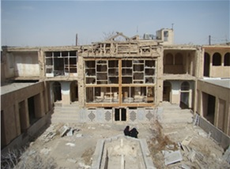
Figure 1: The central courtyard of predominantly Madani House

Madani House built in different periods of the Safavid on expanded and in some positions has been partly caused income and it has become discolored prototype. However, a positive note, registering the house in 1345 is on the list of national monuments and unfortunately in the past two decades has been haunted house conducted in the repair and restoration of the principles on the basis of originality, but to keep it there Rehabilitation. Consequently, this aid in tissue recovery not only a disappointment to the monuments that are in decline has increased.
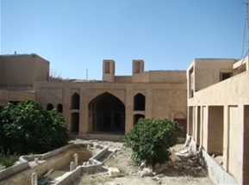
Figure 2: The interior yard and the southern balcony

Madani House is patronizing and its characteristics are:
1. The lack of direct visual contact with the interior space outside city
2. Different spaces of the house, such as yard or page element have organized indoor Rosen or openings so that the elements are open. (Memarian, 1996, 12)
This introspection is seen in most Iranian homes on the base has been laid and cultural climate and finally, create a safe environment for both households.
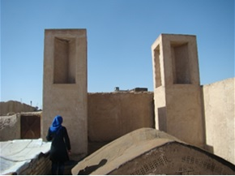
Figure 3: Wind catcher on the south side of Madani House

The type aristocratic houses with introvert, with both inside and outside built the interior of the larger and most important part of the house that is built on four fronts and special family and their privacy. The outer part is made on two fronts and is a place to entertain guests and do some paperwork and social.
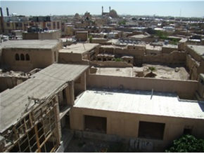
Figure 4: surrounding context of Madani House

The exterior and interior at three levels of height, the basement, the floor and the first floor of the building were located. Home is based on the north-south axis. The main areas to stay on the main winter and summer stay in a situation such as winter has settled and the difference is that the yard is located on the South side to be protected from direct sunlight in summer. (Parsi, 2008, 113) and home service spaces perpendicular to the main axis have layout. Iranian home advantage, the flexibility that is due to a variety of spaces. Types of open, closed and semi-closed and are seen in a house that defines space and space are presented.

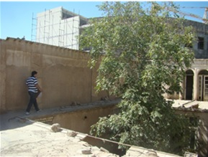
Figure 5: the outer courtyard of the civil house

Semi-enclosed spaces: spaces in front of them by an average of a row of doors, windows or windows with outdoor-related and where appropriate they can be relatively wide opening between built and open spaces created spaces. (Manuchehri Naini, 2014, 31)

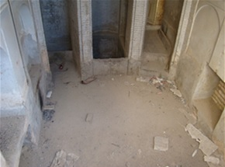
Figure 6: Well supplier of House

Indoor space: spaces that are quite distinct and separated by open spaces and only one entrance to the simplest form, one or more openings to provide at least light them outside functions. Madani House was no exception and spaces together and is interconnected with each other. For example, the kitchen as indoor, outdoor courtyard and semi-enclosed space, such as opening doors and windows to the courtyard with skylight completed; but others called the space covered by the joint decision of its connector. The interstitial space indoor (optional), which simultaneously played the role of each individual and connecting spaces and a collection of private and public spaces within a space of house building and conflict prevention activities have been together in this house. (Haeri Mazandarani, 2009, 91)
These spaces are very small to very large and middle-scale and medium in open spaces, closed and covered skilled Positioning together, and beauty effects have created in a variety of light, movement, temperature, privacy, etc.
In creating this organization, Iranian geometric geometry has been fully respected in Iran in addition to the interference principle, the establishment of order and general correlation between positive factors (Kiani, 2000, 386) As a result, positive impact on the human spirit that peace at home is a safe place will sense it.
A move that hierarchy in the hierarchy solves a simple geometry well in the space between the basic elements of life is very simple home is a function of a style of a hall, rooms, corridors, etc. to cover the whole house. (Ghasemi Sichani, 2012, 83)

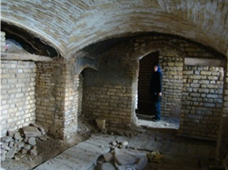
Figure 7: the kitchen in the basement of Madani House

Home includes a variety of flexibility, versatility and variability, and the concept of multi-functional small-scale to large-scale variability of the home, from changing rooms to change the constituent elements function rooms and indoor areas of the yard of Madani House and change the performance of its segments is analyzed. The concept of functional versatility and adaptability to changing seasonal and daily physical spaces defined includes all scales. Large-scale variability in different parts of the house and use it in different situations is true that all three species are defined, the time factor plays an important role. (Einifar, 2003, 60)
This flexibility is also capable of exploiting civil house to the yard so that more than the physical center focuses on the conceptual and functional elements of the package and neutral access to rooms and rooms allowing functional diversity.

External conditions and surrounding context of Madani House
Jamaleh is one of the old and historical regions dated back to the Safavid era. The center of the neighborhood by the market and the main historic market and the main bone connected and on the other hand, been considered places of origin and thriving city. Unfortunately, the side of the main structure of the community, including neighborhood Jamaleh region is somewhat disturbed and upset the hierarchy that it has been corrupted and causes a break in it. The former has no other flavor and the performance of the flow that is beyond the local scale and at the national and even international.
In this context the role of the former residential Jamale context is faded and most of Religious Education and residents are less dramatic in scale natives and immigrants often in the context that most of them mere religious knowledge.
Madani House in the neighborhood of Jamaleh is more valuable and has a lot of value indicators in the fields of history, architecture and art.
According to the spirit of the source of residential space and adjacent sets, the needs of the residential neighborhood and the changing role of the educational community - religious and openness in the context of mere religious knowledge, to stimulate the tissue and prevent further deterioration and restoration the environment. To the restoration and restoration to single seeds of similar value, texture is also a step towards empowering and enhancing the potential value to be taken.
In the map below, the use of religious and secular buildings; this in fact has appeared on the Madani House.
As you can see, most of the building has a religious or educational, and religious use.

Restoration of Madani House
Iranian home has safe and peaceful environment, global balanced and harmonious and infinite in the finite. The spirit of Madani House is rest. The direction of the space needed to organize educational applications is religious. Sum of two more civil expressed results for home use to be restoration while respecting the values and goals, historical, architectural, artistic, social and economic way of living is, however, this housing can be considered as permanent or temporary. The study surveyed all the options and selected the best option to restore the house, the hostel is in the context of the selected students in the spirit of the original house has been preserved.

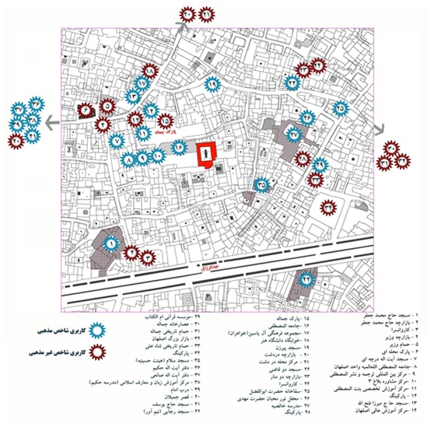
Figure 8: applications in the context of house (Manuchehri Naini, 2014, 169)

Conclusion:
It is better to use applied in the process restoration, the former Member or is the primary user, the other the space to meet the needs of the audience is laid empowerment is the soul rather than anonymous space in the building and in the context of the neighborhood is prevented.

References:
1- Ardalan, N. (2010). Unity, the publication of the soil, Tehran.
2- Parsi, F., (2008). Climate areas of architecture, Architect magazine, No. 48, Tehran.
3- Pakzad, J., (2006). Theoretical and urban design process, the Department of Housing and Urban Development, Tehran.
4- Pirnia, M. K. (2007). Soroush, Iranian-Islamic architecture students, Tehran.
5- Pirnia, M. K. (1995). Introduction to Islamic architecture, University of Science and Technology, Tehran.
6- Haeri, M.R. (2010) reviving culture - artifacts, Proceedings of the First National Conference on introducing the advantages and potentials for restoration and operation of historical sites and cultural.
7- Haeri Mazandarani, M.R. (2009). House of Culture research center architecture urbanism and architecture, Tehran.
8- Shafaghi, S., (2009). Of geography, University of Isfahan, Iran.
9- Einifar, A. (2003). A model to analyze the flexibility of traditional housing - the Fine Arts - Tehran University – Tehran.
10- Ghasemi Sichani, M. (2012). Madani House of Isfahan - Islamic Azad University – Isfahan.
11- Ghezelbash, A. (1985). ABC of Yazd Home Ministry of Planning and Budget - 119-Tehran
12- Kateb, F. (2005). Architecture of houses in Iran - Ministry of Culture – Tehran.
13- Code Committee document restoration and utilization of historical and cultural sites, 2009, the fund restoration and utilization of historical and cultural sites, Tehran.
14- Kiani, M. Y., 2000, Iran's Islamic architecture, the study and development books Humanities University (SAMT), Tehran.
15- Grouter, Y. (1996). Aesthetic in architecture - translation Pakzad, Jahānšāh - Shahid Beheshti University in Tehran – 624.
16- Naghizadeh, M. (2007). Conception of beauty and identity in the light of Islamic thought - Isfahan Municipality - 534 – Isfahan.
17- Memarian, G.H. (1996). Familiar with the building's architectural typology introverted architecture - University of Science and Technology, Tehran.
18- Memarian, G.H. (2008). Iranian architecture - Soroush Danesh- Tehran.
19- Manouchehri Naini, M. (2014). Reviewing the restoration of civil houses and the feasibility of restoring the building, repair MS Thesis, University of the Arts.
20- Mirmoghtadaei, M. (2007).inciples and methods of intervention in the context of urban wear Building and Housing Research Center of the Ministry of Housing and Urban Development – Tehran.
21- Bernard Melchiov Feilden,2003,Conservation of Historic buildings, Edition: 3, Avchitectural press committee B,200,12,1998/BS 7913 Guide to the principles of the conservcetion of Historic buildings, British standards.

4/24/2015

