Evaluation of the SWAP model for simulation of soil salinity under condition using of saline irrigation water and maize cultivation

Shiva Birgani, Amir Soltani Mohammadi, Saeed Boroomand Nasab

Department of Irrigation and Drainage, Faculty of Water Sciences Engineering, Shahid Chamran University, Ahvaz, Iran
Sh.birgani17@gmail.com

Abstract: This study was conducted to evaluate SWAP model for prediction of soil salinity under salinity stress on 2013-2014 in Ahvaz climatic condition. In the beginning, calibration and verification of SWAP model was done by using data from experimental field under maize cultivation. For this purpose, field experiment consists of five levels of salinity irrigation water (S₀: Control treatment, S₁, S₂, S₃ and S₄) with three replications was performed in Research Field of Water Sciences Engineering Faculty at Shahid Chamran University of Ahvaz, Iran. The experiment was arranged according to a randomized complete block design with split plot layout. During the cultivation, six times soil samples were collected from the depths of 0-30, 30-60 and 60-90 cm for all treatments to determine soil salinity. 70% of soil salinity data measured from control treatment used for calibration and 30% remaining data used for verification of model. Calibration and verification results show that the model can simulate soil salinity with high accuracy, also Coefficient of determination (R²) and the NRMSE for model calibration obtained 0.88 and 8.50 , respectively. The coefficient of determination (R²) and NRMSE for the model verification was obtained 0.74 and 7.86, respectively. The calibrated model used to simulation of soil salinity of S₁ to S₄ treatments. The coefficient of determination and NRMSE for S₁, S₂, S₃ and S₄ treatments, calculated 0.76, 0.88, 0.92 and 0.94 and 23.35, 12.98, 16.22 and 11.91, respectively. The results showed the acceptable accuracy and appropriate performance of SWAP model for simulation of soil salinity under using of saline irrigation water. Also with increasing the salinity of irrigation water, the Coefficient of determination (R²) between soil salinity measured and simulated with model increased .
[Birghani Sh, Soltani Mohammadi A, Boroomand Nasab S. Evaluation of the SWAP model for simulation of soil salinity under condition using of saline irrigation water and maize cultivation. N Y Sci J 2015;8(11):19-24]. (ISSN: 1554-0200). http://www.sciencepub.net/newyork. 4

Keywords: Soil Salinity, calibration, verification, SWAP model.

1. Introduction
Reduction of water resources and increasing of water salinity parallel to it, led to useful use of irrigation water and increasing of water use efficiency for sustainable agriculture. Using of saline water for irrigation cause the damaged to soil and decreased the yield. For sustainable agriculture, monitoring and determination effect of saline water irrigation on soil and distribution of salts in soil is necessary. A number of models have been used for short and longterm description of salt and water transport under different climatic, drainage, and crop conditions . Currently, the Soil–Water–Atmosphere–Plant (SWAP) model has been widely used. Mohamadi et al. (2013), Shahidi et al. (2014), Noory et al. (2011), Verma et al. (2012) and Kumar et al. (2015) after calibration and verification of SWAP, use of it for simulation of distribution of moisture and salinity in soil profile and claimed that the model predicted the moisture and salinity of the soil with high accuracy and can be used for management of irrigation. The purpose of this paper is calibration and verification of model and evaluating the effect of irrigation water salinity on efficiency of the model for simulation of salinity distribution in soil profile under corn cultivation in Ahvaz.

2. Material and Methods
A) SWAP Model
SWAP is a deterministic model that describes water, solute, and heat transport in the saturated–unsaturated zone. In the model, soil water flow in the soil matrix in the unsaturated–saturated zone, is described by the Richard’s equation (Verma et al., 2014). In this research used of 2.07 version of SWAP model.

B) Field Data
The data used for this study were obtained from a field test carried out in a research farm located in Water Sciences Engineering Faculty, Shahid Chamran University of Ahvaz ( 48◦40’ longitude, 31◦18’ latitude and 20m above sea level) during the 2013-2014. The mean (mean value for a 50 Years period, 1951 to 2010) annual rainfall in the area is 209.2 mm. The mean of maximum monthly temperature is in July (54◦C) and the mean of minimum monthly temperature is in January (1◦C).
Soil characteristics of the experimental site is shown in Table (1). The experiments were arranged according to a randomized complete block design layout with four replications and five irrigation water salinity. The five Salinity treatments were S₀ (non-saline water control treatment, 2dS.m⁻¹), S₁ (3.5dS.m⁻¹), S₂ (4.5dS.m⁻¹), S₃ (5.5dS.m⁻¹) and S₄ (6.5dS.m⁻¹). Irrigation schedule was carried out by measuring soil moisture content. Irrigation was performed when 50 % of the available soil water was depleted. Irrigation was conducted manually by connecting a hose to a water hydrant, with a flow meter to record the amount of water applied. Grains of maize (Zea mays L.) cv. Single Cross Mobin (SC616) was sown on February 24, 2014 on 75 cm apart furrows and harvested on around June 15, 2014. The seedling density was around 70000 plants ha⁻¹.

Table 1. Soil Physical and chemical analysis
Soil Depth (cm) |  | 0-30 | 30-60 | 60-90 | 90-120
Particle size (%) | Sand | 25.3 | 25.0 | 25.1 | 24.1
Particle size (%) | Silt | 52.1 | 51.5 | 51.7 | 52
Particle size (%) | Clay | 22.6 | 23.5 | 23.2 | 23.9
Texture |  | Silt- Loam | Silt- Loam | Silt- Loam | Silt- Loam
Bulk density (g.cm⁻³) |  | 1.40 | 1.55 | 1.60 | 1.75
Organic carbon nitrogen (%) |  | 0.12 | 0.08 | 0.08 | 0.08
Phosphorus (mg.kg⁻¹) |  | 10.0 | 10.5 | 10.1 | 10.1
Available potassium (mg.kg⁻¹) |  | 110 | 124 | 108 | 108
θV_{PWP} (%) |  | 15 | 15 | 15 | 15
θ_{VFc} (%) |  | 32 | 32 | 32 | 32

S₁ , S₂, S₃ and S₄ treatments were formulated using S₀ water as the base, to which different amounts of NaCl, CaCl₂, and MgCl₂ were added. S₁ to S4 treatment waters were constituently mixed with proportions of the three added salts to maintain an SAR value equal to SAR value of S₀. Ca to Mg ratio of S₁, S₂ , S₃ and S₄ waters were kept close to the Ca to Mg ratio of S₀ water (Henggeler, 2004). Chemical characteristics of the irrigation waters are shown in Table 2. Irrigation scheduling is shown in Table 3. Soil sampling was done six times from all treatments. Measurements were taken every 30 cm down to a depth of 90 cm. Dates of samplings are shown in Table 4.

Table 2. Chemical characteristics of the irrigation waters
Treatments | S₀ | S₁ | S₂ | S₃ | S₄
So₄⁻ (meq.L⁻¹) | 9.85 | 8.84 | 9.56 | 10.15 | 13.3
Cl⁻ (meq.L⁻¹) | 13.55 | 34.11 | 39.1 | 39.8 | 48.1
Hco₂⁻ (meq.L⁻¹) | 3.43 | 3.06 | 3.37 | 3.52 | 3.63
K⁺ (meq.L⁻¹) | 0.09 | 0.10 | 0.14 | 0.11 | 0.12
Na⁺ (meq.L⁻¹) | 13.42 | 20.13 | 22.8 | 24.1 | 27.9
Mg²⁺ (meq.L⁻¹) | 3.94 | 7.33 | 9.85 | 10.13 | 12.30
Ca²⁺ (meq.L⁻¹) | 8.11 | 15.79 | 17.91 | 20.16 | 25.13
pH | 7.40 | 7.40 | 7.30 | 7.50 | 7.40
EC (dS.m⁻¹) | 2 | 3.5 | 4.5 | 5.5 | 6.5

C) The calibration process
The data and information used in the calibration process were:
- Daily meteorological data from Ahvaz weather station.
- the irrigation data, measured in the field.
- Crop parameters including Maximum plant height, rooting depth, length of each growing stage, planting and harvesting date that measured. Also, Leaf Area Index (LAI) values were measured several times from each treatment and used in calibration process.
Soil parameters were estimated from RETC software. Initial soil moisture and initial salinity measured in the field.
In order to calibrate the model, 70% of control treatment measured soil salinity is used to simulate the distribution of root zone soil salinity. For this purpose, data collected on the dates 02/23/2014, 04/23/2014, 05/26/2014, 06/03/2014 were used and model calibration is carried out as follows:
1. Running the model for control treatment and determining the simulated soil salinity.
2. Comparing between simulated and measured soil salinities of aforementioned dates.
3. Making gradually changes to the amounts of soil hydraulic and solute transport parameters until the simulated soil salinity and measured was equal or very close to other.

Table 3. Irrigation scheduling
S₄ (mm) | S₃ (mm) | S₂ (mm) | S₁ (mm) | S₀ (mm) | Date
31 | 57 | 56 | 66 | 44 | 2/24/2014
31 | 57 | 56 | 66 | 44 | 3/03/2014
31 | 57 | 56 | 66 | 44 | 3/10/2014
31 | 57 | 56 | 66 | 44 | 3/15/2014
31 | 57 | 56 | 66 | 44 | 3/20/2014
31 | 57 | 56 | 66 | 44 | 3/25/2014
31 | 57 | 56 | 66 | 44 | 4/01/2014
37 | 49 | 50 | 48 | 50 | 4/09/2014
46 | 52 | 56 | 46 | 65 | 4/17/2014
66 | 78 | 74 | 68 | 79 | 4/24/2014
78 | 58 | 82 | 83 | 97 | 5/01/2014
65 | 79 | 72 | 61 | 74 | 5/11/2014
102 | 96 | 96 | 85 | 100 | 5/19/2014
79 | 93 | 95 | 69 | 78 | 5/27/2014
75 | 91 | 75 | 79 | 100 | 6/04/2014

Table 4. Date of sampling
No | Date
1 | 2/23/2014
2 | 4/08/2014
3 | 4/23/2014
4 | 5/10/2014
5 | 5/26/2014
6 | 6/03/2014

D) SWAP model verification
Model verification is done using 30 percent of remaining control treatment data (dates 04/08/2014, 05/10/2014). For this purpose, soil salinity is simulated using the calibrated model and then it is compared to the measured values of abovementioned dates.

E) Model examination parameters
To ensure the reliability of the model, three statistical indicators, namely, Normalized Root mean Square Error (NRMSE), Coefficient of Determination and Coefficient of Residual Mass (CRM) were used:
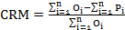 (1)
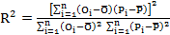 (2)
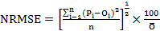 (3)
which P_{i} is the predicted values, O_{i} is the measured values, n is the number of predicted or measured values and is the average of measured values. CRM is a measure of tendency of the model to overestimate (negative value for CRM) or underestimate (positive value for CRM) the measurements.
The coefficient of determination (R²) is determined by a regression analysis between measured and predicted values. The R² value ranges from 0 to 1. R² = 1 indicates a perfect correlation between observed and simulated values.
The Normalized Root Mean Square Error (NRMSE) often expressed as a percentage, where lower values indicate less residual variance.

3. Results
A) Model calibration for soil salinity
Obtained results by calibration of SWAP model (Figure 1) showed that the model approximately simulates soil salinity values to measured values. Coefficient of determination, NRMSE and CRM values were 0.88,8.5 and 0.05 respectively which shows that the model is able to simulate soil salinity with acceptable accuracy. In this regard, during SWAP model calibration, Mohamadi et al. (2013) achieved the same results and reported data coefficient of determination (R²) as 0.89.

Figure 1. Relation between simulated and observed soil salinity simulated with SWAP during calibration.

B) SWAP model verification
Figure (2) shows an acceptable correlation between simulated values and observed values and coefficient of determination is 0.75. Droogers (2000) also achieved the same results and reported the coefficient of determination as 0.67.
NRMSE value for soil salinity was 7.86 which is acceptable. CRM was -0.05 which shows that the model overestimate soil salinity values.

Figure 2. Relation between simulated and observed soil salinity simulated with SWAP during verification.

C) Simulation of soil salinity for other treatments
Using calibrated and verified model, root zone soil salinity of S₁ to S4 treatments were simulated (Figure 3).
Figure 3 shows the correlation between the observed and simulated soil salinity values. For all treatments, there was a good agreement between simulated and observed values and the coefficient of determination (R²) for S₁, S₂, S₃ and S₄ were 0.76, 0.88, 0.92 and 0.94 , respectively.
NRMSE values for S₁, S₂, S₃ and S₄ treatments were 23.35, 12.98, 16.22 and 11.91 respectively which is acceptable for all treatments. CRM values for S₁, S₂, S₃ and S₄ treatments were
–0.07, 0.03, -0.08 and 0.01 respectively which shows that the model slightly overestimated soil salinity in S₃ and slightly underestimated in S₁, S₂ and S₄ treatments. Considering these results, by increasing irrigation water salinity, the difference between predicted values and measured values decreased. Also, by increasing irrigation water salinity, NSRMSE value decreases. This results show that by increasing irrigation water salinity, model accuracy will increase. Therefore, it can be concluded that the model works efficiently when using saline water. Noory et al. (2011) reported the coefficient of determination (R²) between measured and simulated soil salinity between 0.84 to 0.86 . Moreover, Soltani Mohamadi (2012) and Fakori Monazah et al. (2013) stated that the model has great ability in predicting soil salinity.

4. Discussions
In this study, SWAP model was calibrated and verified under corn cultivation condition using saline irrigation water. The results of this research showed that by increasing irrigation water salinity, the difference between simulated and measured values of soil salinity decreased and generally, the results showed that the model has the appropriate performance and the use SWAP is suggested to simulate the movement of soil moisture and salinity in future studies.

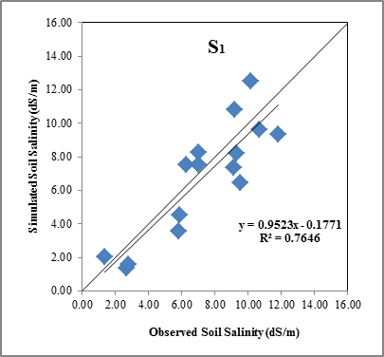

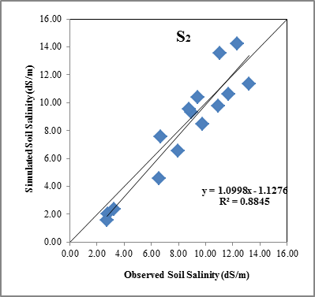

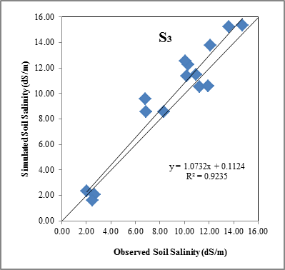

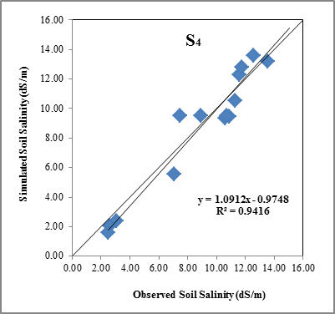
Figure 3. Correlation between observed and simulated soil salinity for treatments S₁, S₂, S₃ and S₄

Corresponding Author:
M.SC. Shiva Birgani
Department of Irrigation and Drainage
Faculty of Water Sciences Engineering, Shahid Chamran University, Ahvaz, Iran
E-mail: Sh.birgani17@gmail.com

References
- Droogers P. Estimating actual evapotranspiration using a detailed agro hydrological model. Journal of Hydrology. 2000; 229: 50-58.
- Fakori monazah N, Izad panah Z, Broomand nasab S.The evaluation SWAP model in simulation of distributed salinity in soil profiles under surface irrigation system. The First National Conference on Drainage and Sustainable Agricultural, 27 February, Tehran, Iran. 2013.
- Henggeler J C. The conjuctive use of saline irrigation water on deficit irrigation. Ph.D. Dissertation. Texas University. 2004.
- Kumar P, Sarangi A, Singh D K, Parihar S S, Sahoo R N. Simulation of salt dynamics in the root zone and yield of wheat crop under irrigated saline regimes using SWAP model. Agricultural Water Management. 2015; 148: 72-83.
- Mohamadi E, Delbari M, Chari M M, Mohamadi M. Simulation of water and solutes movement in soil using SWAP model. 2st International Conference on Modeling of Plant, Water, Soil and Air, 8-9 May, Kerman, Iran. 2013.
- Noory H, Van der Zee S E A T M, Liaghat A M, Parsinejad M, Van Dam J C. Distributed agro hydrological modeling with SWAP to improve water and salt management of the Voshmgir Irrigation and Drainage Network in Northern Iran, Agricultural Water Management. 2011; 98: 1062-1070.
- SHahidi A, Nahvi nia M M, Makari ghahrodi E, Parsi nejad M. The evaluation SWAP model to assess the impact of the irrigation with salty water on the soil moisture (A case study of the region of birjand). Journal of Soil and Water Science. 2014; 24(1): 17-27.
- Soltani Mohamadi A. Maize irrigation management in different growth stages under deficit irrigation and salinity stress in Ahwaz climatic condition. Ph. D. Dissertation, Shahid Chamran University of Ahvaz. Iran. 2011.
- Verma A K, Gupta S K, Isaac R K. Use of saline water for irrigation in monsoon climate and deep water table regions: Simulation modeling with SWAP. Agricultural Water Management. 2012; 115: 186-193.
- Verma A K, Gupta S K, Isaac R K. Calibration and validation of SWAP to simulate conjunctive use of fresh and saline irrigation waters in semi-arid regions. Environmental Modeling and Assessment. 2014; 19:45–55.

10/29/2015

