Assessment of Salmonella Contamination in Organic Chicken Meats sold and Slaughtered in Some Selected Markets in Rivers State, Nigeria

Omorodion NJP, Odu NN
Department of Microbiology, University of Port Harcourt, P.M.B. 5323, Port Harcourt, Nigeria.
*Corresponding author. Tel: +2349083622583,
E-mail: nnenna.omorodion@uniport.edu.ng,nnennaomorodion@gmail.com

ABSTRACT: The study was conducted to assess and compare the microbial quality of organic chicken meats purchased from two different markets in Port Harcourt, Nigeria. To determine for the presence of Salmonella spp., organic chicken meat comprising of the 5 wings and the 5 thighs, were analysed using the standard method , resulting isolates were exposed to various biochemical tests .Confirmed Salmonella spp. were subjected to various antibiotics. The results revealed that Salmonella spp. counts were higher in the thighs than the wings counts ranges from 4.5x 10⁴ to 8.0x10⁵ cfu/g for the thigh samples, 4.0x10⁴ to 7.5x10⁵cfu/g for the wings sample, the total viable counts ranges from1.12x10⁸-2.13x10⁹ cfu/g for the thigh samples, 1.03x10⁸ to1.37x10⁹ for the wings samples. The Salmonella spp showed resistance to Ampicillin and Augmentin 44%, Gentamicin, Ciprofloxacin, Ceftazidine, Cefuroxime 22.2%, and Ofloxacin 11%.High rate of susceptibility was counted against Nitrofurantoin 88.9%. The need for microbial assessment of organic chicken meat cannot be over emphasized so as to reduce possible health risk and contamination. Maintenance and strict hygiene during slaughter and processing will produce organic chicken meat parts with good quality and ensure safety to the consumer.

[Omorodion NJP, Odu NN. Assessment of Salmonella Contamination in Organic Chicken Meats sold and Slaughtered in Some Selected Markets in Rivers State, Nigeria. N Y Sci J 2016;9(4):75-80]. ISSN 1554-0200 (print); ISSN 2375-723X (online). http://www.sciencepub.net/newyork. 12. doi:10.7537/marsnys09041612

Keywords: Assessment, Salmonella, Contamination, Organic Chicken Meats, Slaughtered, Selected Markets

1. INTRODUCTION
Animal products provide about 5% of daily energy supply in Nigeria, considerably lower than the West African average of 9.5%. Poultry meat and eggs together provide 0.82% of total daily calories consumed on average (FAO, 2005). Poultry meat is the combination of muscle, tissue, attached skin, connective tissue, edible organs of avian species commonly used for food. Chicken and turkey are the major types of poultry meat. Poultry meat is one of the most popular food products worldwide. Several nutritional factors such as high level of protein and low fat content and favorable content of unsaturated fatty acids contribute to the popularity of poultry meat, of which sensory, dietary, and economic factors are important. It is known that Salmonella infection is the commonest hazard in food of animal origin where it is higher in chicken than red meat. Food of animal origin has been associated with large number of outbreaks. These include beef, chicken, turkey, pork, eggs, milk and products made from them. In addition, many different types of foods have been implicated in both cases and outbreaks. These foods were contaminated directly or indirectly with fecal matters from carriers (animals, birds, and humans) and eaten either raw or improperly cooked or contaminated following adequate heat treatment.
Cross-contamination at home and at food services are the major sites of contamination of foods with Salmonella. For organisms such as Salmonella that causes gastroenteritis their very presence in food is significant. In addition, the levels present may be very low. In these cases it is necessary to use presence/absence procedures rather than relying on enumeration techniques for detection. Presence/absence procedures allow the examination of larger portions of sample, typically 25g, by use of liquid enrichment procedures in selective and other media formulated to optimize the recovery of the target organism in the presence of other naturally occurring food microflora.
Dark meat which is referred to as “red muscle” is used for sustained activity-chiefly walking, in the case of chicken. The dark color comes from the protein myoglobin, which plays a key role in oxygen uptake and storage within cells. White muscle, in contrast, is suitable only for short bursts of activity such as for chicken, flying. Thus the chicken’s leg and thigh meat are dark, while its breast meat is white. The pH of chicken breast muscle is 5.7 to 5.9, and leg muscle is 6.4 to 6.7. The skin harbors many microorganisms while serving as a physical barrier to microorganisms (ICMSF, 1998).
Poultry meat can become contaminated by pathogenic bacteria such as Salmonella during handling, processing, marketing, or storage, resulting in foodborne illness if the product is improperly cooked or handled organic chicken are those grown without the use of synthetic chemicals and fertilizers. They have access to pastures and pesticide-free foods. Their food is free from antibiotics or genetically engineered grains and they are not raised with the use of hormones. Organic chicken are not.
Salmonella infections in poultry can be divided into host specific infections, non-host specific infections and infections with the sub genus Salmonella arizonae. Salmonella pullorum and Salmonella gallinarum are highly adapted to the host species and are of little public health concern. In most developed countries the incidence of S. pullorum and S. gallinarum is low due to adequate control measures. Pullorum disease in poultry is caused by Salmonella pullorum. It is an acute systemic disease of young chickens. It is spread from infected parent birds via the egg to the chick. Salmonella gallinarum causes fowl typhoid, an acute or chronic septicaemic disease of mature chickens but young chicks may be affected.
Paratyphoid Salmonella are non-host specific (e.g. S. enteritidis and S. typhimurium). They are the cause of Salmonella food poisoning in humans. Chicken are usually asymptomatic carriers of paratyphoid Salmonella bacteria. The organisms colonize the intestinal tract and sometimes the reproductive tract of carrier birds. This can lead to contamination of carcasses and eggs meant for human consumption. The most prevalent serotypes are Salmonella enteritidis and Salmonella typhimurium. Other serotypes such as Salmonella paratyphi B jara, S. agona and S. heidelberg are being isolated more frequently as a cause of food poisoning from chickens.
This study is aimed at compare the level of Salmonella contamination between the organic chicken wing and the organic chicken thigh, and compare and determine the occurrence of Salmonella spp. from chicken meat (organic chicken) sold in two different markets in Rivers State, Nigeria to determine the antimicrobial susceptibility pattern of Salmonella isolates from the organic chicken samples.

2. METHODS
2.1. Source and collection of samples: Organic chicken were purchased from different markets in Rivers State, Nigeria. Five wings and five thighs were selected from the different chicken. Location 1: Rumuokoro market and Location 2: Creek road market. The sample collected is wrapped aseptically in sterile polythene bags and transported in a cool pack at 4˚C within 2 hours of collection to the laboratory for analysis. Samples are categorized according to where they were purchased. Rumuokoro organic chicken thigh (ROCT¹) sample 1; Rumuokoro organic chicken thigh (ROCT²) sample 2; Rumuokoro organic chicken thigh (ROCT³) sample 3; Creek road organic chicken thigh (KOCT⁴) sample 4; Creek road organic chicken thigh (KOCT⁵) sample 5; Rumuokoro organic chicken wing (ROCW¹) sample 1; Rumuokoro organic chicken wing (ROCW²) sample 2; Rumuokoro organic chicken wing (ROCW³) sample 3; Creek road organic chicken wing (KOCW⁴) sample 4; and Creek road organic chicken wing (KOCW⁵) sample 5.

2.2. Bacteriological analysis of Salmonella spp from the different samples:
2.2.1. Culturing and Enumeration of Total Viable Counts: Total viable count gives a quantitative idea about the presence of different bacteria in the samples. The counts represent the number of colony forming units (cfu) per grams of the samples. It is achieved by plating in duplicates 0.1ml of dilutions 10⁻⁵ and 10⁻⁶ from the stock culture on nutrient agar and incubation at 37˚C for 24 hours. Counts of 30-300 colonies are accepted for a single plate.

2.2.2. Enumeration and Isolation of Salmonella spp: Salmonella spp. is isolated according to standard methods ISO-6579:2002 standard (ref.3). Twenty-five grams of the sample was added to 225ml of buffered peptone water (BPW). All the samples were incubated for 16-20 hours (overnight) at 37˚C. From the pre-enriched culture (stock culture), serial dilution was carried out and 0.1ml was plated out from dilutions 10⁻² and 10⁻³ in duplicates on Salmonella-Shigella agar by the spread plate method and incubated at 37˚C for 24 hours for enumeration of Salmonella count from the different samples. Also, 1ml of the pre enriched broth is transferred to selenite F broth and incubated at 37˚C. After 24 hours of incubation, one loopful from the enriched broth was streaked onto plates of Salmonella-Shigella agar and incubated at 37˚C for 24 hours. The plates are then examined for typical Salmonella colonies i.e. black colonies with slightly transparent zones.

2.2.3. Purification: Following the incubation period representing colonies from both the total viable count and of Salmonella spp., colonies were picked from the different plates based on different colonial characteristics, colonies are sub-cultured onto nutrient agar for purification and transferred onto nutrient agar slants and incubated at 37˚C for 24 h. The isolates are characterized presumptively by colonial morphology, pigmentation, Gram staining.

2.2.4. Identification: Suspected colonies are confirmed with conventional biochemical techniques as described by Wilfred et al. (2010). Biochemical testing includes motility test, indole test, methyl-red test, Voges-Proskauer test, reaction on triple sugar iron agar.

2.3. Antimicrobial susceptibility test: The sensitivity and resistance of the isolates to antibiotics was observed using the Kirby Bauer disc diffusion technique CLSI (NCCLS). Bacterial suspensions were inoculated on Mueller Hinton agar (HiMedia) by streaking the swab over the entire sterile agar surface. The procedure is repeated by streaking two more times, rotating the plate approximately 60˚ each time to ensure an even distribution of inoculum. The antibiotic discs were placed over the lawn of 150 mm plate incubated at 37˚C for 18-48 hours until moderate growth was seen on the agar plates. The clear zone around each antibiotic disc was measured in millimeter. The diameter zone inhibition is classified as being resistant, intermediate or sensitive. The following commonly in use antibiotics were used; Ceftazidime (CAZ) 30μg, Cefuroxime (CRX) 30μg, Gentamicin (GEN) 10μg, Ciprofloxcin (CPR) 5μg, Ofloxacin (OFL) 5μg, Amoxycillin/Clavulanate (AUG) 30μg, Nitrofurantoin (NIT) 300μg, Ampicillin (AMP) 10μg. Rapid Labs: CM-12-8NR1003.0

3. RESULTS
The results obtained showed the presence of Salmonella in about 90% of the sample of organic chicken thing and wing (Figure 1-5). Figure 1 shows comparison of log cfu/g of TVC in organic chicken wing and organic chicken thigh for 10⁻⁵ dilution. Comparison of log cfu/g of TVC in organic chicken wing and organic chicken thigh for 10⁻⁶ dilution is shown in Figure 2.

Figure 3 shows comparison of log cfu/g of Salmonella contamination in organic chicken wing and organic chicken thigh for 10⁻² dilution while Figure 4 shows comparison of log cfu/g of Salmonella contamination in organic chicken wing and organic chicken thigh for 10⁻³ dilution. From the results obtained, there is a significant difference in the incidence of Salmonella in organic chicken thigh which ranges from 4.5×10⁴ cfu/g to 9.3×10⁴ cfu/g and organic chicken wings which ranges from 4.0×10⁴ cfu/g to 7.9×10⁴ cfu/g (Figures 3 and 4 ).
Figure 5 shows comparison of the log cfu/g of the TVC samples from the different markets (rumuokoro market and creek road market). The log cfu/g values of 8.34 and 8.32 in Rumuokoro thigh samples are higher than that of Creek road with 8.18 and 8.01 and values of 8.05 and 8.05of the wing samples from Rumuokoro is lesser than that of Creek road with 8.08 and 8.15 (Figure 5).
Figure 6 shows percentage occurrence of the various pathogenic organisms isolated from organic chicken samples. E. coli (34.5%) was the most prevalent bacteria isolated, followed by Staphylococcus aureus (27.6%), Bacillus sp. (20.6%) and Serratia sp. (17.2%) was the least (Figure 6).
All the Salmonella isolates were exposed to different antibiotics and its antimicrobial drug response were studied as shown in Table 1. It showed that 88.9% of the Salmonella isolates were susceptibility to Nitrofurantoin. Ampicillin and Augmentin showed the highest resistance with 44.4%, followed by Gentamicin, Ciprofloxacin, Ceftazidime, and Cefuroxime with 22.2% while 11% was resistant to Ofloxacin (Table 1).

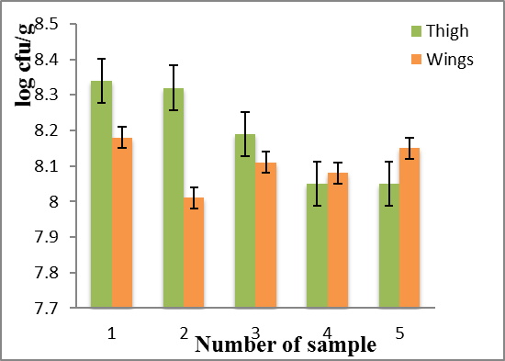

Figure 1: Comparison of log cfu/g of TVC in organic chicken wing and organic chicken thigh for 10⁻⁵ dilution

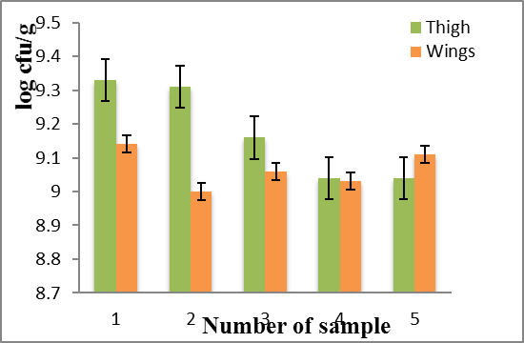

Figure 2: Comparison of log cfu/g of TVC in organic chicken wing and organic chicken thigh for 10⁻⁶ dilution
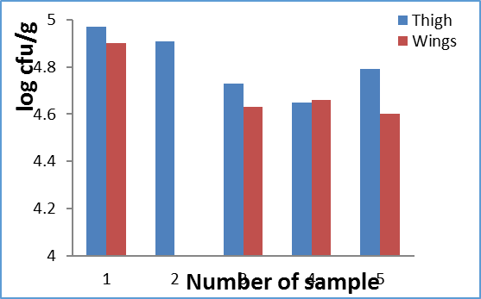
Figure 3: Comparison of log cfu/g of Salmonella contamination in organic chicken wing and organic chicken thigh for 10⁻² dilution

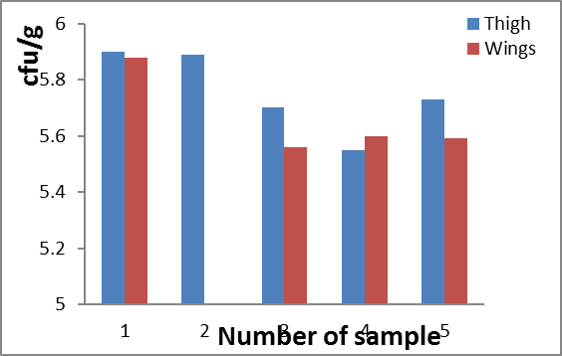
Figure 4: Comparison of log cfu/g of Salmonella contamination in organic chicken wing and organic chicken thigh for 10⁻³ dilution

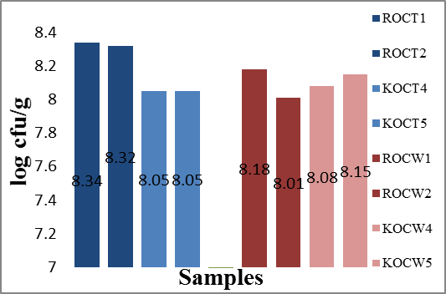
Figure 5: Comparison of the log cfu/g of the TVC samples from the different markets (rumuokoro market and creek road market)
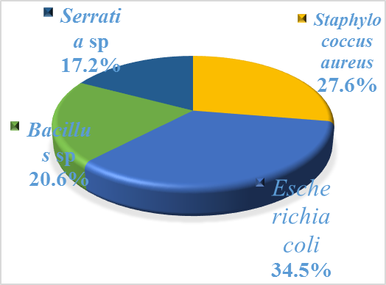
Figure 6: Percentage occurrence of the various pathogenic organisms isolated from organic chicken samples

Table 1: Antibiotic susceptibility pattern of Salmonella isolates
ISOLATES | GEN  (10μg) | AUG  (30μg) | CPR  (5μg) | CAZ  (30μg) | CRX  (30μg) | OFL  (5μg) | NIT  (300μg) | AMP  (10μg)
ROCT¹ | (S) | (R) | (I) | (S) | (R) | (S) | (R) | (I)
ROCT² | (I) | (I) | (S) | (R) | (S) | (S) | (S) | (I)
ROCT³ | (R) | (I) | (R) | (I) | (S) | (I) | (S) | (S)
KOCT⁴ | (I) | (S) | (S) | (I) | (R) | (S) | (S) | (R)
KOCT⁵ | (S) | (R) | (S) | (I) | (S) | (I) | (S) | (I)
ROCW¹ | (R) | (S) | (I) | (S) | (I) | (R) | (S) | (I)
ROCW³ | (I) | (S) | (R) | (S) | (S) | (I) | (S) | (R)
KOCW⁴ | (S) | (R) | (I) | (S) | (S) | (I) | (S) | (R)
KOCW⁵ | (I) | (R) | (S) | (R) | (I) | (S) | (S) | (R)
Keys: R – resistance, I – intermediate, S – susceptible.

4. DISSCUSSION
This present study aimed at comparing the level of Salmonella spp in organic chicken thigh and organic chicken wings sold in Rivers State, Nigeria. In this study, the presence of Salmonella was found in about 90% of the sample of organic chicken thing and wing. Pathogenic bacteria like Salmonella from food sources have been confirmed by different authors all over the world. Padungtod and Kaneene (2008) in Northern Thailand reported 57% and Bajaj et al. (2003) in India reported 69%. Their studies showed that Salmonella is more prevalent in chicken meat. Wilfred et al. (2012) in their study in Bangalore city reported a higher prevalence of Salmonella in chicken thigh meat compared to chicken meat obtained from breast. This is in agreement with our findings. This suggests that Salmonella counts were higher in thigh samples compared to wings sample.
From Figure 5, the thigh samples gotten from Rumuokoro market has lower bacteria count than the thigh samples from Creek road market. For the wings, samples gotten from Creek road market generally have lower bacteria count than the wing samples from Rumuokoro market. The sanitary/hygienic condition of Creek road market is probably better than that of Rumuokoro market. Contamination is probably during slaughter or processing. Thigh samples are more contaminated probably due to their proximity with the ground and pelvis (anus) of the chicken. The wing samples are less contaminated probably because of the dense number of feathers on the wings that may act as barrier to contaminants and which when flapped also could shed off microorganisms.
Pathogenic organisms isolated from the organic chicken samples include Escherichia coli, Staphylococcus aureus, Bacillus sp, and Serratia sp with Escherichia coli being the most isolated specie. According to The standards stipulated by the guidelines of PHLS (2000) and 1CMSF 1986 stated that the TAC in raw chickens should not exceed 6 or 7logCFU/g, while in Samonella should be absent in 25 g of the meat sample. In this study, the counts exceeded the stated limit. This similar to the study (Bhandari et al., 2013). The high TVC in the examined samples reported in this study indicate that the contamination of the product could be attributed to unsatisfactory sanitation during handling and processing.
The marked growth of bacteria concludes that organic chicken meat is not suitable for consumption, unless properly handled. The high total viable counts recorded in this study showed the microbial diversity in these places, condition of the market and the hygienic practice employed by meat sellers and butchers. The presence of Salmonella spp. demonstrates a potential health risk since the organisms are pathogenic and gives warning signal for the possible occurrence of food-borne intoxication The need for microbial assessment of fresh meats and other meat products processed and packaged for human consumption is therefore emphasized and recommended to reduce possible hazard which could result to diseases. Infected persons with Salmonella develop diarrhea, fever and abdominal cramps. Most persons recover without treatment. The infection usually resolves in 5-7 days and often do not require treatment with antibiotics other than oral fluids. In some persons, the diarrhea may be so severe that the patient needs to be hospitalized. In these persons, the Salmonella infection may spread from the intestines to the blood stream and then to other sites and can cause death unless the person is treated promptly with antibiotics such as Ampicillin, Trimethoprim-sufamethoxazole, or Ciprofloxacin. Persons with severe diarrhea may require rehydration with intravenous fluids.
Emerging drug resistance in foodborne bacteria is a great public health concern. In a study in Thailand by Minami et al. (2010), majority of Salmonella isolates exhibit resistance to tetracycline and streptomycin. Dione et al. (2009), reported that high rate of Salmonella resistance was counted against tetracycline (74.7%) and streptomycin (73.9%). In a study by Aslama et al. (2012), found that 29% Salmonella isolates from retail meats in Canada are susceptible to all antimicrobial used (Amoxicillin-Clavulanic acid, Ceftiofur, Ceftriaxone, Ciprofloxacin, Amikacin, Ampicillin, Cefoxitin, Gentamicin, Kanamycin, Nalidixic acid, Streptomycin, Trimethoprim/ Sufamethoxazole, Chloramphenicol, Sulfisoxazole, and Tetracycline). They confirmed that 29% of the Salmonella isolates from chicken have no resistance gene. In this study, 88.9% of the Salmonella isolates showed susceptibility to Nitrofurantoin. Ampicillin and Augmentin showed the highest resistance with 44.4% followed by Gentamicin, Ciprofloxacin, Ceftazidime, and Cefuroxime with 22.2%. 11% was resistant to Ofloxacin.
Extensive use of antibiotic in animals has contributed to increase in the resistance against antibiotics in different bacterial strains over the years. The result of this study showed that organic chicken thighs are highly prone for contamination compared to organic chicken wings irrespective of the processing conditions. The need for microbial assessment of organic chicken wings and thighs for production of food and other uses cannot be over emphasized to reduce possible contamination. Maintenance of strict hygiene during slaughter and processing is of prime importance to produce meat with good microbial quality and better shelf life, thereby ensuring safety to the consumers. The internal temperature for cooking chicken wing should be 165˚F and for chicken thigh 165˚F-175˚F. Bio-preservation and bio-control strategies should be adopted to cope with the problems related to antibiotics used in animal farming and food processing
Preventing Salmonella infection in organic chicken will decrease salmonellosis in humans. The World Health Organization (WHO) recognizes that the control of Salmonella infection from poultry products can take place in three areas; education of the public, improvements in slaughter hygiene and control of infection in the chicken themselves which involves monitoring of the chicken for Salmonella infection, taking needed action in cases of Salmonella outbreaks, effective biosecurity, maximizing the protective mechanisms of the individual chicken through vaccination and optimization of their intestinal flora. Organic chicken meat processing should be properly controlled. Contamination can be minimized by maintaining personnel hygiene during processing and using clean and safe water. In a large scale setting, product contamination can be minimized by the application of Hazard Analysis Critical Control Point (HACCP) principles in conjunction with Good Manufacturing Practices (GMP) and use of Standard Operating Procedures (SOP) for plant cleaning and disinfection. When processing is properly controlled, any contamination of the end-product with Salmonella is usually at a very low level and consistent with the requirement for a safe, acceptable, raw-meat product.

REFERENCES
- Aslama M, Checkley S, Avery B, Chalmers G, Bohaychuk V, Gensler G, et al. Phenotypic and genetic characterization of antimicrobial resistance in Salmonella serovars isolated from retail meats in Alberta, Canada. Food Microbiol. 2012;32:110–117.
- Bajaj B.K, Vibhor S, Sanjana K, Thatrur R.L (2003). Prevalence of Salmonella in poultry and meats and growth inhibition of Salmonella enteritidis by organic acids. Journal of Food Science and Technology. 40: 556-558
- Bhandari N, Nepali DB, Paudyal S 2013Assessment of bacterial load in broiler chicken meat from the retail meat shops in Chitwan, NepalInt J Infect Microbiol 2013;2(3):99-104

4/19/2016

- Dione MM, Ieven M, Garin B, Marcotty T, Geerts S. Prevalence and antimicrobial resistance of Salmonella isolated from broiler farms, chicken carcasses and street-vended restaurants in Casamanee, Senegal. J Food Prot. 2009;72(11):2423–2427.
- FAO (Food and Agricultural Organization). 2010. Available at http://www.fao.org/ag/agn/agns/
- ICMSF (International Commission in Microbiological Specification for Foods) 1978. Microorganisms in Foods 1. Their significance and methods of enumeration, 2nd Ed. Blackwell Scientific Publications. 138
- ICMSF (International Commission in Microbiological Specification for Foods) 1986. Microorganisms in Foods 2. Sampling for microbiological analysis: Principles and specific applications, 2nd Ed. Blackwell Scientific Publications. 152
- ICMSF (International Commission on Microbiological Specification for Foods) 1998. Poultry and poultry products. In: Microorganisms in Foods. Blackwell Scientific Publications.
- Minami A, Wanpen C, Chongsa-Nguan M, Seksun S, Shuko M, Kouichi T, et al. Prevalence of foodborne pathogens in open markets and supermarkets in Thailand. Food Control. 2010;21:221–226
- Padungtod P and Kaneene J.B (2006). Salmonella in food animals and humans in Northern Thailand. International Journal of Food Microbiology. 108: 346-354
- PHLS (2000): Guidelines for the microbiological quality of some ready-to-eat foods sampled at the point of sale. Comm. Dis. and Public Health 3(3): 163-167.
- Wilfred R.S, Nithin P. K, Naveen K.G.S (2012). Prevalence of food borne pathogens in market samples of chicken meat in Bangalore. International Food Research Journal. 19(4): 1763-1765

