Alkaloids and non-alkaloids identified from Crinum defixum Ker-Gawler medicinal plant leaves

^{1*}A. Elaiyaraja, ²G. Chandramohan

^{1*}Department of Chemistry, A.V.V.M. Sri Pushpam College, Poondi, Thanjavur 613 503, Tamilnadu, India.
²Department of Chemistry, Jairams Arts and Science College, Karur-3, Tamilnadu, India.
Email: raja_mscchem@rediffmail.com; Mobile: 9043571103

Abstract: The aim of the present study was to investigate the alkaloid and non-alkaloid compounds present in the Crinum defixum Ker-Gawler medicinal plant leaves. The plant was extracted for various solvents in increasing order of polarity from using n-hexane, chloroform, ethyl acetate, acetone, ethanol, butanol and methanol. The preliminary phytochemical analysis of various extracts of Crinum defixum Ker-Gawler leaves contains many bioactive chemicals like alkaloids, flavonoids, saponins, terpenoids, amino acids and phenolic compounds are qualitatively analyzed. Thus, the present study was performed to investigate the separation, identification of various classes of phytocomponents present in the various fractions of C.defixum Ker-Gawler leaves using FT-IR, GC-MS, NMR and MASS Spectral techniques.
[A. Elaiyaraja, G. Chandramohan. Alkaloids and non-alkaloids identified from Crinum defixum Ker-Gawler medicinal plant leaves. N Y Sci J 2016;9(10):96-104]. ISSN 1554-0200 (print); ISSN 2375-723X (online). http://www.sciencepub.net/newyork. 16. doi:10.7537/marsnys091016.16.

Keywords: Crinum defixum Ker-Gawler, Phytochemical screening, solvent extraction, Alkaloids, non-alkaloids.

1. Introduction
The plants of the genus Crinum (Amaryllidaceae) has used in Asian folk and traditional medicine as rubefacient, tonic and for treatment of allergic disorders and tumor diseases [1]. The genus of Crinum (Amaryllidaceae) is a big family and contains about 160 species, many of which have vanished [2]. Most of the Crinum species are common emetic, laxative, expectorant, diaphoretic, anti-asthmatic, analgesic, anti-inflammatory, anti-microbial and anti-tumor remedies in various folkloric medicines [3]. Already the Crinum genus has yielded more than 170 different compounds, most of which are alkaloids. These have shown significant analgesic, antitumor and antiviral activities [4]. Phytochemical investigations have resulted in isolation of several classes of compounds and have been focused predominantly on alkaloids whereas the non-alkaloid constituents are much less attention [5].
C.defixum Ker-Gawler (Amaryllidaceae) has abundantly growing on rivers and canals side’s in wet conditions. The C.defixum has commercial, economical and medicinal importance. The C.defixum Ker-Gawler is one of the Crinum genuses [6]. It is commonly known as Bon-naharu (Meaning wild garlic) and this plant genus having lot of medicinal activities. The leave extracts are used to treat pimples, body-ache, leprosy, paronychia itching, and otitis. The crushed bulbs are used to treating nauseant, emetic, emollient, diaphoretic, burns, whitlow and carbuncle [7]. The bulbs of this plant is fusiform, flowers are sessile, fragment at night and tinged with red [8]. The C.defixum is reported to contain the active constituents such as caranine, crinamine, crinine, galanthamine, galanthine, haemanthamine and hippestrine. The new alkaloid 5 α-hydroxyhomolycorine has also been reported in the recent years [9]. The ethanol and methanol extracts of the C.defixum Ker-Gawler have been reported to free radical scavenging, antianalgesic and antigenotoxic properties [10]. The main focus of this study was separation, identification of various classes of phytocomponents present in the various fractions of C.defixum Ker-Gawler leaves using FT-IR, GC-MS, NMR and MASS Spectral techniques.

2. Materials And Methods
2.1. Collection Of Plant Materials
The leaves of C.defixum Ker - Gawler were collected from Poondi village, Thanjavur District, Tamilnadu. The botanical identity (Voucher No: A.A.R 003 on 04-02-2013) of the plant of was confirmed by Dr. S.John Britto, Rapinat Herbarium, St. Joseph’s College, Tiruchirappalli.
2.2. Preparation Of Extracts
The fine powder (5 kg) was extracted with 95% ethanol at room temperature for ten days. The extract were filtered and concentrated under reduced pressure in a rotary evaporator and extracted for various solvents in increasing order of polarity from using n-hexane, chloroform, ethyl acetate, acetone, ethanol, butanol and methanol. After that the extract was taken in a beaker and kept in a water bath and heated at 30-40 ºC till all the solvent got evaporated. All the extracts were tested for the presence bioactive compounds by using standard methods. The dried extracts were subjected to preliminary phytochemicals and also confirmed by spectral analysis.

2.3. Phytochemical Screening
The preliminary phytochemical analysis of various extract of C.defixum Ker-Gawler plant leaves revealed the following phytochemicals (Table 1).

Table 1. Preliminary phytochemical constituents of C.defixum Ker-Gawler leaves.
S.N | Phytochemicals | Hexane Extract | Chloroform  Extract | Ethyl acetate Extract | Acetone  Extract | Ethanol  Extract | Butanol  Extract | Methanol  Extract
1. | Alkaloids | - | Present | Present | Present | Present | - | -
2. | Flavonoids | - | Present | - | - | - | Present | Present
3. | Terpenoids | Present | Present | Present | - | - | - | -
4. | Glycosides | - | - | - | - | - | - | -
5. | Saponins | - | Present | Present | Present | Present | - | -
6. | Steroids | Present | - | - | Present | - | - | -
7. | Carbohydrates | - | - | - | - | - | - | -
8. | Phenolic Compounds | Present | Present | Present | Present | Present | Present | -
9. | Tannins | - | - | - | - | - | - | -
10 | Amino acids | Present | - | - | Present | Present | Present | Present

3. Analysis of Phytocomponents
3.1. GC-MS analysis
Chromatography is the term used to describe a separation technique in which a mobile phase carrying a mixture is caused to move in contact with a selective absorbent stationary phase. Gas chromatography coupled with mass spectrometer is one of the most widely used techniques. The analysis was simple, sensitive and effective in separating components of mixtures. Identification of phytoconstituents present in the extract concentrate of the plants can be achieved through GC-MS.
3.2. FT-IR analysis
FT-IR (Fourier Transform- Infra red) spectra were obtained using Perkin Elmer FT-IR 450-4000 IN KBrb disc and absorption peaks in terms of wave numbers (cm⁻¹).
3.3. NMR analysis
NMR (Nuclear Magnetic Resonance) was acquired on Brucker at 300 and 400 MHZ (¹H) and 100 MHZ (¹³C). Chemical shifts were recorded as δ value (ppm) DMSO, D₂O and Chloroform using as an inert solvent. Perkin Elmer ICP-OES analysis was used for sodium and potassium.
Hence in the current investigation, identification of secondary metabolites of hexane, chloroform, ethyl acetate, acetone, ethanol, butanol and methanol extract of Crinum defixum Ker-Gawler leaves.

Table 2: A list of alkaloids and non-alkaloids isolated from Crinum defixum Ker-Gawler leaves.
S.N | Name of the phytocomponents | Solvent extraction | M.F | M.W | Spectral data | Activity
Alkaloids
1. | Piperazine, 1,4-bis (2-methoxybenzoyl)- | Ethanol | C₂₀H₂₂ N₂O₄ | 354.39 | GC-MS | Unknown alkaloid
2. | Piperazine-1-carboxylic acid, 4-(2-fluoro-4-(1-oxopropyl) phenyl)-, ethyl ester | Methanol | - | - | GC-MS | Unknown alkaloid
3. | Ethanone,1-(2,5 diphenyl-2H-1,2,3-triazol-4-yl 3-oxide)-,oxime | Acetone | - | - | GC-MS | Unknown alkaloid
4. | 7-(5-Cyclohexylpentyl) -6-hydroxy-5,8-quinolinedione | Acetone | - | - | GC-MS | Unknown alkaloid
Flavonoids
5. | 4',5,7-Trihydroxy isoflavone (Genistein) | Chloroform,ethyl acetate, butanol and methanol | C₁₅H₁₂O₅ | 272 | FT-IR, GC-MS, ¹H, ¹³C-NMR and MS | Antitumor agent, antioxidant, antiangiogenic and immuno- suppressive activities.
6 | 4H-1-Benzopyran-4-one, 2-(3,4-dihydroxyphenyl)-3,5,7-trihydroxy (Quercetin) | Ethyl acetate | C₁₅H₁₀O₇ | 302.236 | GC-MS | Prevention and treatment of cancer.
Steroids
6. | Estra-1,3,5(10)-  trien-17a'-ol | n-Hexane and Acetone | C₁₉H₂₆O₂ | 286.40 | GC-MS | Androgenic- alopecia  (Hairloss) activity.
Alkane
7. | Cyclodocosane, ethyl- | Methanol | C₂₄H₄₈ | 336.63792 | GC-MS | No activity reported.
Alkene
8. | 3-Eicosene, (E)- | Methanol | C₂₀H₄₀ | 280.5316 | GC-MS | No activity reported.
9. | 3- Octadecene, (E)- | Methanol | C₁₈H₃₆ | 252.4784 | GC-MS | No activity reported.
10. | 9-Hexacosene | Methanol | C₂₆H₅₂ | 364.6911 | GC-MS | Analgesic, antiinflammatory activities.
Acids and Esters
11. | Tridecanoic acid,  12-methyl-, methyl  Ester | n-Hexane | C₁₅H₃₀O₂ | 242.3975 | GC-MS | Antifungal,  Antibacterial activities.
12. | Tetradecanoic  acid,12-methyl-,  methyl ester | n-Hexane | C₁₆H₃₂O₂ | 256.4241 | GC-MS | No activity reported.
13. | Pentadecanoic  acid,14-methyl-,  methyl ester | n-Hexane | C₁₇H₃₄O₂ | 270.4507 | GC-MS | Antioxidant,  Antifungal,  Antimicrobial activities.
14. | 10-Octadecenoic  acid, methyl ester | n-Hexane | C₁₉H₃₆O₂ | 296.4879 | GC-MS | Antioxidant,  Antimicrobial activities.
15. | Heptadecanoic acid,  16-methyl-, methyl  Ester | n-Hexane | C₁₉H₃₈O₂ | 298.5038 | GC-MS | Used against  skin cancer  Protein.
16. | Octadec-9-enoic  Acid | n-Hexane | C₁₈H₃₄O₂ | 282.46136 | GC-MS | Antimicrobial,  anti-oxidant,  Cancer preventive,  Anemiagenic,  Anti-androgenic activities.
17. | 11-Eicosenoic acid,  methyl ester | n-Hexane | C₂₁H₄₀O₂ | 324.5411 | GC-MS | Antioxidant, Pesticide,  Nematicide activities.
18. | Eicosanoic acid,  methyl ester | n-Hexane | C₂₁H₄₂O₂ | 326.5570 | GC-MS | Alpha-glucosidase  Inhibitors activities.
19. | Docosanoic acid,  methyl ester | n-Hexane | C₂₃H₄₆O₂ | 354.6101 | GC-MS | Therapeutic,  Diagnostic activities.
20. | Methyl tetra  Decanoate | Chloroform | C₁₅H₃₀O₂ | 242.3975 | GC-MS | Antioxidant,  Cancer-preventive,  Hypercholester-  olemic,  Nematicide activities.
21. | 9-Octadecenoic acid(Z)-, methyl ester | Chloroform | C19H36O2 | 296 | GC-MS | Anti- inflammatory,  Antiandrogenic, Cancer  preventive, Dermatitigenic, Hypocholestero-  lemic, 5-Alpha reductase inhibitor,  Anemiagenic, Insectifuge activities.
22. | pentadecanoic acid, methyl ester | Ethyl acetate | - | - | GC-MS | Unknown
23. | 9, 12, 15-Octadecatrienoic acid, methyl ester,(Z,Z,Z)-, | Ethyl acetate | - | - | GC-MS | Unknown
24. | Dodecanoic acid, ethyl ester | Acetone | C₁₄H₂₈O₂ | 228.3709 | GC-MS | No activity reported.
25. | Hexadecanoic acid, ethyl ester | Acetone | C₁₈H₃₆O₂ | 284 | GC-MS | Antioxidant,  Hypocholesterolemic, Nematicide, Pesticide,  Lubricant,  Antiandrogenic,  Flavor activities.
26. | (E)-9-Octadecenoic acid ethyl ester | Acetone | C₂₀H₃₈O₂ | 310 | GC-MS | Antioxidant, anti-inflammatory activities.
27. | Pentadeca-  -noic acid, 14-methyl-, methyl ester | Ethanol | C₁₇H₃₄O₂ | 270.4507 | GC-MS | Antioxidant, Antifungal, Antimicrobial activities.
28. | n-Hexadecanoic acid | Ethanol | C₁₆H₃₂O₂ | 256.4241 | GC-MS | Antioxidant, Hypocholesterolmic, Nematicide, Pesticide, Lubricant, Antiandrogenic, Flavor, Hemolytic,  5-Alpha reductase inhibitor activities.
29. | 10-Octadecenoic acid, methyl ester | Ethanol | C₁₉H₃₆O₂ | 296.4879 | GC-MS | Antioxidant, Anti-microbial activities.
30. | Octadecanoic acid, methyl ester | Ethanol | C₁₉H₃₈O₂ | 298.50382 | GC-MS | Potent Antifungal,  Anti-microbial activities.
31. | 9,15-Octadeca  dienoic acid, methyl ester,(Z,Z)- | Ethanol | C₁₉H₃₄O₂ | 294.47206 | GC-MS | No activity reported.
32. | Oleic Acid | Ethanol | C₁₈H₃₄O₂ | 282.47 | GC-MS | Antibacterial, Cancer preventive,  Anemiagenic, Insectifuge,  Anti-androgenic,  Dermatitigenic activities.
33. | Octadecanoic acid, 3-oxo-, methyl ester | Ethanol | C₁₉H₃₆O₃ | 312.49 | GC-MS | No activity reported.
34. | 9-Hexa decenoic acid, methyl ester, (Z)- | Butanol | C₁₇H₃₂O₂ | 268.4348 | GC-MS | No activity reported.
35. | 8-Octadecenoic acid, methyl ester | Butanol | C₁₉H₃₆O₂ | 296.49 | GC-MS | Antioxidant,  Anti-microbial activities.
36. | Dodecanoic acid, methyl ester | Methanol | C₁₃H₂₆O₂ | 214.3443 | GC-MS | No activity reported.
37. | 9-Hexa decenoic acid, methyl ester, (Z)- | Methanol | - | - | GC-MS | Unknown.
38. | 9-Octadecenoic acid, methyl ester,(E)- | Methanol | C₁₉H₃₆O₂ | 296 | GC-MS | No activity reported.
Others
39. | 4H-1-Benzopyran-4-one, 5,7-dihydroxy-3-phenyl- | Chloroformand butanol | - | - | GC-MS | Unknown
40. | Ethyl 5,8,11,14,17-icosa pentaenoate | Butanol | - | - | GC-MS | Unknown
41. | Methyl eicosa-5,8,11,14,17-pentaenoate | Methanol | - | - | GC-MS | Unknown
Activity Source**: Dr. Duke’s Phytochemical and Ethno botanical Databases, NCBI-Pubmed, ChemSpider (Royal Society of Chemistry) and other available literatures.

4. Alkaloids isolated from Crinum defixum Ker-Gawler leaves.

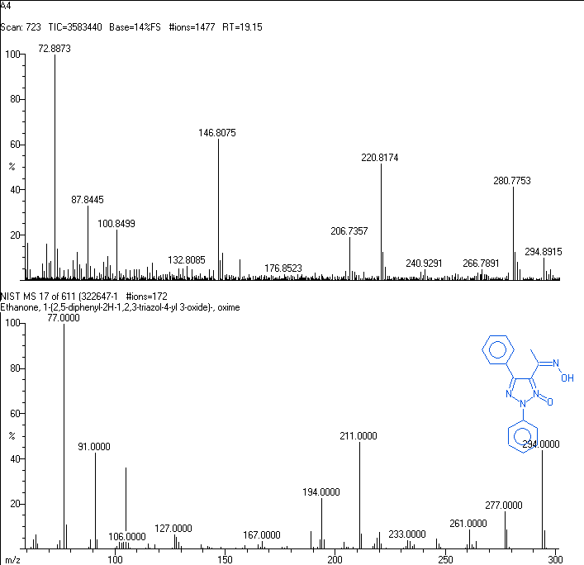
Fig 1. Mass spectrum of Ethanone,1-(2,5 diphenyl-2H-1,2,3-triazol-4-yl 3-oxide)-,oxime.

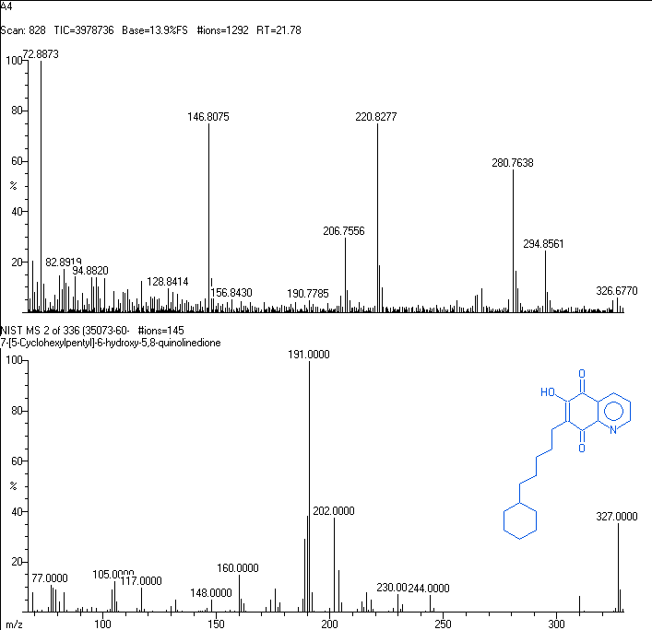
Fig 2. Mass spectrum of 7-(5-Cyclohexylpentyl)-6-hydroxy-5, 8-quinolinedione.

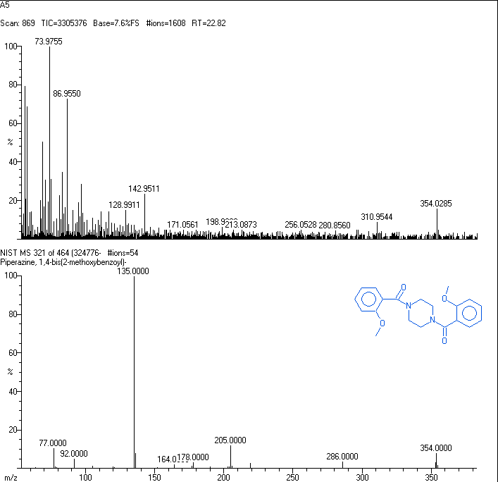
Fig 3. Mass spectrum of Piperazine, 1,4-bis(2-methoxybenzoyl)-.

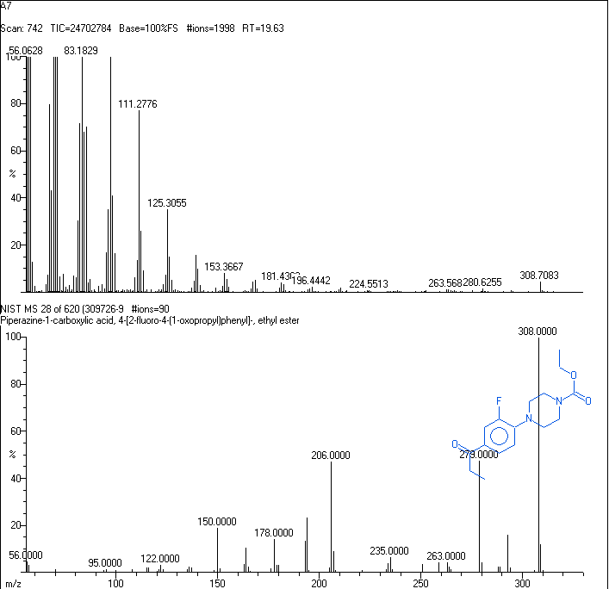
Fig 4. Mass spectrum of Piperazine-1-carboxylic acid, 4-(2-fluoro-4-(1-oxopropyl)phenyl)-, ethyl ester

5. Flavonoids isolated from Crinum defixum Ker-Gawler leaves.

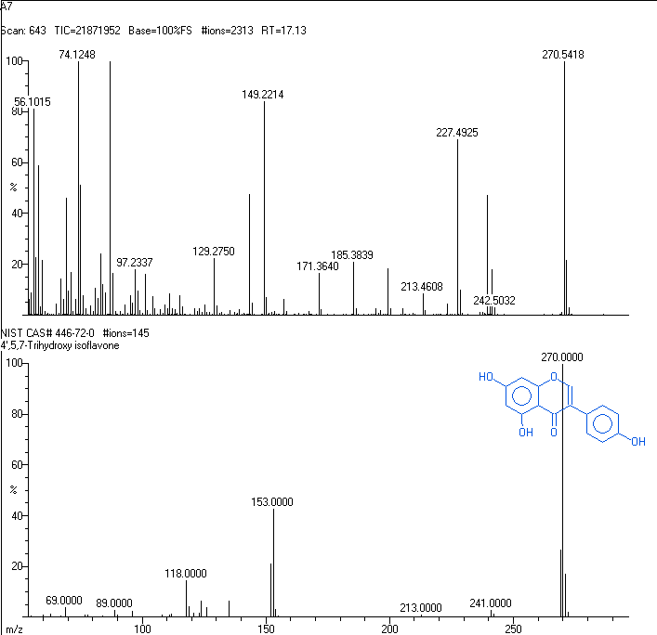
Fig 5. GC-MS- Spectrum of 4', 5, 7,-trihydroxy isoflavone
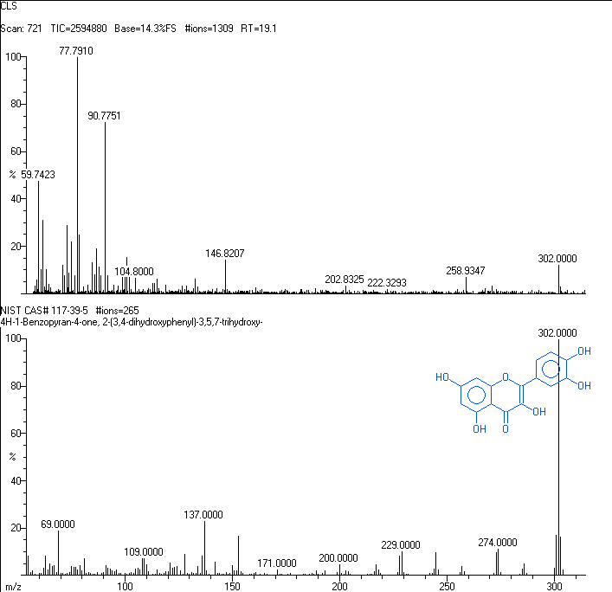
Fig 6. GC-MS- Spectrum of 4H-1-Benzopyran-4-one, 2-(3, 4-dihydroxyphenyl)-3,5,7-trihydroxy

6. Result and Discussion
N.Thi Ngoc Tram et al (2002)[20], reported that (-) Galanthamine, (+) Haemanthamine (3-Epicrinamine, Hemanthamine), Hipeastrine, (-) Lycorine (Narcissine, Galanthidine) types of alkaloids are reported that the after 1985. Recently a new alkaloid 5α-hydroxy homolycorine has also been isolated from Crinum defixum Ker-Gawler bulbs and M.Bordoloi et al,(2009) reported that (E)-N' –[(E)-2-butenoylhydrazide2 has been isolated from Crinum defixum Ker-Gawler root bulb. This Hydrazide compound imparted a clear dose dependent protective effect against the genotoxic effect of H₂O₂ with those reported in the previous literature.
In the present study the phytochemical analysis of Crinum defixum Ker-Gawler leaves has revealed a variety of chemical constituents such as alkaloids, flavonoids, steroids, acids, fatty acid esters and phenolic compounds are produced by this plant, the major phytoconstituent being amaryllidaceae type of alkaloids. In the current investigation the four new alkaloids of Piperazine, 1,4-bis (2-methoxybenzoyl)-(Ethanol fraction), Piperazine-1-carboxylic acid, 4-(2-fluoro-4-(1-oxopropyl) phenyl)-, ethyl ester(Methanol fraction), Ethanone,1-(2,5 diphenyl-2H-1,2,3-triazol-4-yl 3-oxide)-, oxime and 7-(5-Cyclohexylpentyl)-6-hydroxy-5,8-quinolinedione (Acetone fraction) and the flavonoids of 4',5,7-Trihydroxy isoflavone i.e., Genistein (Chloroform, ethyl acetate, butanol and methanol fractions) and 4H-1-Benzopyran-4-one, 2-(3,4-dihydroxyphenyl)-3,5,7-trihydroxy i.e., Quercetin (Ethyl acetate fraction) are first time identified from leaves of Crinum defixum Ker-Gawler under present study. The other non-alkaloidal constituents of steroids, fatty acid esters, acids and phenolic compounds are also identified the same. The identified compounds were used to determine their chemical and biological properties using Dr. Duke’s phytochemical and Ethnobotanical databases, NCBI-Pubmed, Chem Spider (Royal Society of Chemistry) and other available literatures.
The identified compounds are which contribute the activities like Antioxidant, Antimicrobial, Cancer preventive, Anemiagenic, Antiandrogenic, Therapeutic, Diagnostic, Antitumor agent, antiangiogenic and immunosuppressive, Analgesic and anti-inflammatory, Hypercholesterolemic, Nematicide, Antibacterial, Insectifuge, Dermatitigenic, Antifungal, Pesticide, Lubricant, Flavor, Hemolytic, 5-Alpha reductase inhibitor and Androgenic alopecia (hairloss) activities. Hence the plant Crinum defixum Ker-Gawler has a potential source of biologically important drug candidates.

7. Conclusion
The preliminary phytochemical analysis of various extract of Crinum defixum Ker-Gawler leaves contains many bioactive chemicals like alkaloids, flavonoids, saponins, terpenoids, amino acids and phenolic compounds (table-1). The Crinum defixum Ker-Gawler has rich in (Amaryllidaceae) alkaloids content in both bulb and leaves. The Amaryllidaceae alkaloids exhibit a range of biological activity, both pharmacological and microbiological. Among the most noted effects are: analgesic, central nervous system, anti-tumor, antiviral and anticholinergic. Hence the medicinal plant Crinum defixum Ker-Gawler leaves has a Phytochemically potent one.

8. Acknowledgement
I wish to express my deep sense of gratitude and most sincere thanks to Honorable Resource Person Dr.G.Chandramohan, Principal, Jairams Arts and Science College, Karur-3, Tamilnadu, India for providing support to finish my research work.

*Corresponding Author
A. Elaiyaraja
Department of Chemistry,
A.V.V.M. Sri Pushpam College, Poondi,
Thanjavur -613 503,Tamilnadu, India.
Email: raja_mscchem@rediffmail.com
Mobile: 9043571103

References
- Ghosal Sh., Saini K. S. and Razdan S. (1985), Crinum alkaloids: their chemistry and biology. Phytochemistry 24, 2141D2156.
- Benson, L., Handbook of Plant Classification, (Oxford and I.B.H publishing Co., New Delhi, Bombay, 1970) 793.
- Fennell CW and Van Staden J: Crinum species in traditional and modern medicine. Journal of Ethnopharmacology 2001; 78(1):15-26.
- Fangan, B.M., Nordal, I., 1993. A comparitive analysis of morphology, chloroplast-DNA and distribution within the genus Crinum (Amaryllidaceae). Journal of Biogeography 20, 55-61.
- Wildman WC: The Alkaloids: Chemistry and Physiology. Edited by R.H.F. Manske, Academic Press, New York, London, Vol. VI, 1960.
- Fennell CW and Van Staden J: Crinum species in traditional and modern medicine. Journal of Ethnopharmacology 2001; 78(1):15-26.
- K.R. Kirtikar, B,D. Basu, Indian Medicinal Plants,vol. IV (1975) Published by M/S Bishen Singh Mohendra Pal Sing, New Connaught Place, Dehradun, PP. 2473-2474.
- Hooker JD, Flora of British India, Published under the authority of the Secretary of state for India in Council, 1954.
- Nguyen TNT, Titorenkovab TV, Bankovab V, Handjievab NV, Popovb SS. Crinum L. Amaryllidaceae. Fitoterpia, 2002; 73: 183-208.
- Jeffs PW, Abou-Donia A, CampauD, Staiger D.Structures of 9-O-dimethyl-homolycorine and 5 α-hydroxyhomolycorine alkaloids of crinum defixum, C. latifolium Assignment of aromatic substitution patterns from ¹H-coupled ¹³C spectra, J Org Chem. 1985; 50: 1732-1737.

10/18/2016

