The Effect of Aging in Different Storage Media on the Microstructure of Pigmented Silicon

Lana A. Shinawi¹, Ayman A. Al-Dharrab² and Seham B. Tayel³

¹Associate Professor and Consultant Department of Oral and Maxillofacial Prosthodontics, Faculty of Dentistry, King Abdulaziz University, Jeddah, Saudi Arabia
²Associate Professor and Consultant Department of Oral and Maxillofacial Prosthodontics, Faculty of Dentistry, King Abdulaziz University, Jeddah, Saudi Arabia
³Professor and Consultant Department of Oral and Maxillofacial Prosthodontics, Faculty of Dentistry, King Abdulaziz University, Jeddah, Saudi Arabia
lshinawi@kau.edu.sa

Abstract: Background: The use of commercial maxillofacial polymers in facial prostheses is common among the most popular materials used in this field are the Polydimethyl Siloxanes. It is also known as Cosmesil silicon. However, little information is given on the exact chemical composition of this material. Objective: To analyse the internal structure and the surface characterization of the silicon polymer following immersion in various pH media on. Methods: In the current study, forty pigmented Cosmesil maxillofacial silicone discs were prepared according to manufacturer instructions and divided into four groups each containing ten discs. One group served as control, while the other three groups were aged in three different pH storage solutions. Quantitative analysis was performed using infrared spectroscopy IR while surface characterization specimens was conducted using scanning electron microscopy, SEM. Results: Smooth surface was observed in three of the groups compared to an irregular vacuolated surface in only one group. IR analysis revealed no significant changes. It was concluded that Cosmesil M511 silicon maxillofacial material is a methylene polymer containing silicon dioxide filler. The tested material was not highly affected by aging in various pH media as the changes were limited to the superficial surface of the specimens. Conclusion: FTIR spectroscopy revealed that the Cosmesil M511 silicone maxillofacial material is composed primarily of a methyle polymer with the addition of inorganic silicone dioxide filler. The internal structure of this polymer was not significantly affected by immersion in different pH media since the alterations were limited to the superficial surface of the specimens.
[Lana A. Shinawi, Ayman A. Al-Dharrab and Seham B. Tayel. The Effect of Aging in Different Storage Media on the Microstructure of Pigmented Silicon. N Y Sci J 2017;10(5):76-81]. ISSN 1554-0200 (print); ISSN 2375-723X (online). http://www.sciencepub.net/newyork. 11. doi:10.7537/marsnys100517.11.

Keywords: Fourier transform infrared spectroscopy, Maxillofacial Prosthesis, Rehabilitation.

1. Introduction
The restoration and rehabilitation of facial defects are very challenging as these defects usually result in multiple functional and psychosocial difficulties especially if they are secondary to the treatment of neoplasm. Maxillofacial prostheses are used to restore both function and facial form, thus improving patient’s self-esteem and psychology [1].
For decades, commercial maxillofacial polymers were used for the construction of facial prostheses owing to their favourable properties. Among the most commonly used polymers are: poly (methyl methacrylate), poly (vinyl chloride), chlorinated polyethylene, polyurethanes and silicones [2-5]. The polydimethyl siloxanes are popular materials for maxillofacial prostheses due their ease of fabrication [6, 7], realistic appearance, good biocompatibility, bio durability and low toxicity [8-10].
In spite of their superior physical and mechanical properties, these elastomers suffer from gradual discoloration of prostheses and degradation of physical, static and dynamic mechanical properties [8].
Silicone maxillofacial prosthesis can be categorized according to their methods of Vulcanization into 2 groups, those vulcanized at room temperatures and those vulcanized by heat. Since polydimethylsiloxane silicone elastomer is vulcanized at room temperature and is not time consuming, therefore it is the most commonly used to fabricate maxillofacial prosthesis [7].
The expected half-life of maxillofacial prosthesis is approximately six months with degradation of physical and colour properties of silicone maxillofacial prosthesis are being the most common reasons for replacement. Additionally, silicone elastomeric facial prostheses absorb perspiration (acidic, alkaline and sebum) [11-13].
Sunlight, temperature, moisture, pH, wind, dust, and pollutants are among the many environmental characteristics that cause degradation of silicone elastomers [14, 15].
Quantitative analysis of silicon maxillofacial material has been the aim of many studies. One of the applicable analytical techniques used is the Infrared spectroscopy (IR) and in particular Fourier transform infrared spectroscopy (FTIR) for the detection and characterizing of silicones polymer structural details. The magnitude of the silicon absorption peaks in the spectrum is an indication of the amount of material present [16, 17].
Although the biological safety of maxillofacial materials and the pigments they contain have been approved separately prior to their applications, studies regarding the effects of these pigments on the microstructure of the maxillofacial silicone elastomers are few. The aim of the current study was to study the effect of different pH media on the internal structure of the silicon polymer by FTIR and to analyse surface characterization of with scanning electron microscopy (SEM).

2. Materials and Methods:
Forty disc-shaped specimens of pigmented maxillofacial Silicone (Cosmesil Series maxillofacial rubber M511, Medical grade, Technovent, UK) were prepared according to the manufacturer’s instructions. The dimension of prepared discs were 25mm diameter and 3mm thickness [11], and the mixing ratio was 10 gm (part A) of silicon elastomer to 1gm catalyst (part B) (10:1 =11gm totally). 0.2% by weight pigments (Intrinsic Colorants pigments agents, Technovent, UK) were incorporated to obtain a homogenous mixture and colour [18, 19]. The mixture was then poured into the premade moulds in compliance with the specific dimensions required by International Standardization Specification ISO. The moulds were closed and polymerized in a dry heat oven at 100⁰ C for 1 hour.
The polymerized specimens were divided into four groups (Groups I, II, III, and IV) each consisted of ten samples. Group I represent a control group and stored in distilled water. Test group II was stored in (solution a), III (solution b) and IV (solution c). Both storage media solutions a and b for test Groups II and III respectively were prepared according to ISO specification [20, 21]. Where (Solution a) storage media was a simulated acid (acidic perspiration) with a pH = 5.5. This was composed of 0.5g L-histidine monohydrochloride monohydrate, 5g sodium chloride and 2.2g sodium dihydrogen orthophosphate dehydrate per litre of distilled water. (Solution b) storage media was simulated alkaline (alkaline perspiration) with a pH = 8.0. This contained 0.5g L-histidine mono-hydrochloride monohydrate, 5g sodium chloride and 5g disodium hydrogen orthophosphate dodececahydrate per litre of distilled water. Group IV (Solution c) storage media was simulated sebum prepared using 10% palmitic acid and 2% tripalmitin dissolved in 88% linoleic acid [22].
Aging of all samples was done by immersion of specimens in the storage solutions in an incubator at 37ºC for six months. Considering that the mean lifetime of the prostheses is 14–24 months, the aging period of 6 months represents 1 to 1.5 year of clinical use (since a facial prosthesis is worn on average for 8 to 12 hours daily [18].
Infrared spectrophotometer (IR):
The microstructure of all specimens was analysed using infrared spectroscopy (Shimadzu, IR spectrophotometer-8400S, Kyoto, Japan). All samples were mounted on a magnetic sheet. The beam entering the sample compartment was transmitted through the surface of the sample and to the detector for final measurement. The detector was designed to measure the special interferogram signal which is automatically digitized and sent to the computer where the fourier transformation takes place. The final IR spectra were collected on the FTIR using the software program IR solution.
Surface analysis (SEM):
The surfaces of all specimens were analysed using scanning electron microscope (SEM: JSM-6360LA, JEOL, Tokyo, Japan) Specimens were prepared by sputter-coated with gold by using sputtering device (SPI sputter coater structure, probe USA) and the cross sectional area was then examined at 10,000X magnification⁽²³⁾.

3. Results:
FTIR analysis of the control specimens displayed several peaks that map the chemical microstructure of the sample. Peaks resonating from 300-400 cm⁻¹ represent the inorganic phase of silicone dioxides which is considered to be the filler in the organic matrix of the dimethyl siloxane polymer.

Table 1. Results of FTIR analysis
Wave length | Assignments
300-400 | SiO2
1200-1300 | -CO group
1300-1400 | -CH₃ group
1500-1650 | C=C group
2000-3000 | -COOH group

The peaks resonating between1200-1300 cm⁻¹ indicate the presence of –CO group. Other peaks were recorded between 1300-1400 cm⁻¹ and indicate the presence of methylene group (-CH₃). Peaks resonating between 1500-1650 cm⁻¹ indicate the presence of C=C that believed to undergo polymerization as demonstrated by the small frequency of the peak. Finally the peaks resonating between 2000-3000 cm⁻¹ indicate the presence of –COOH stretch group (Table 1 and Figures 1-4 showing the results of the control group, solution a, solution b, and solution c respectively). When comparing the infrared spectrum of the control group with those infra-red spectra of the aging groups, there was no significant changes observed between them.

Image analysis:
SEM imaging of all groups at 10,000 X magnification was found to be similar in the control group, the simulated acid group and the simulated sebum samples. However, samples aged in simulated alkaline solution displayed an irregular vacuolated surface (Figures 5-8). The control group smooth surface also displayed some scattered particles believed to be Silicon dioxide. Similar scattered particles were recorded on the surfaces immersed in simulated sebum (group IV).

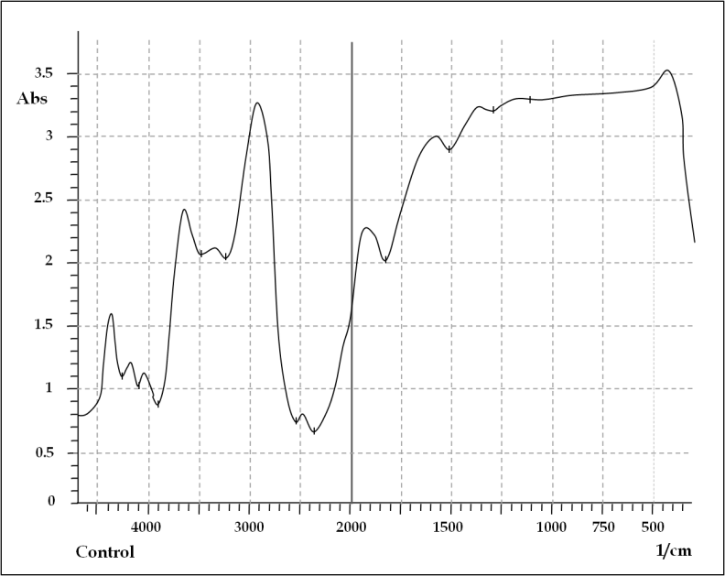

Figure 1. FTIR analysis for control Group I (distilled water)

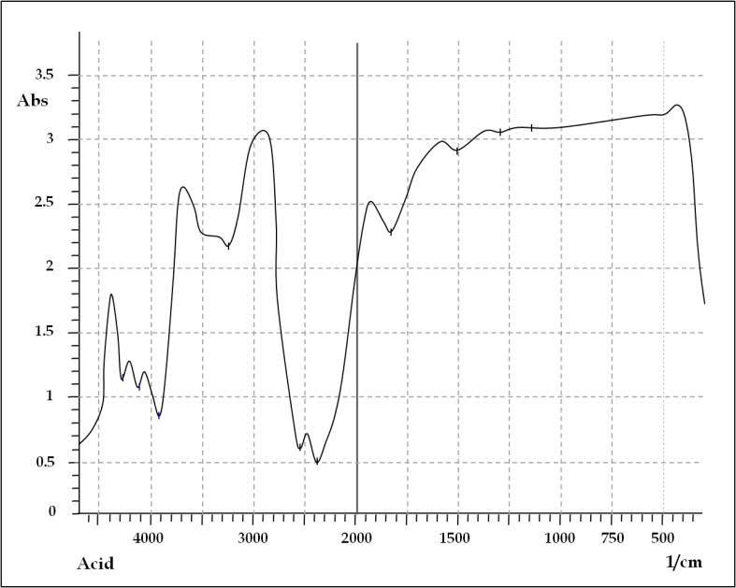

Figure 2. FTIR analysis for test Group II stored in a simulated acidic media (solution a)
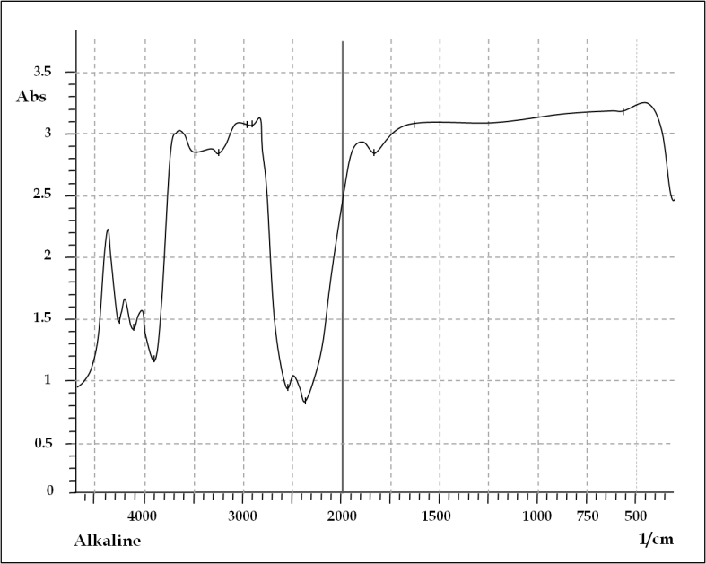

Figure 3. FTIR analysis for test Group III stored in a simulated alkaline media (solution b)
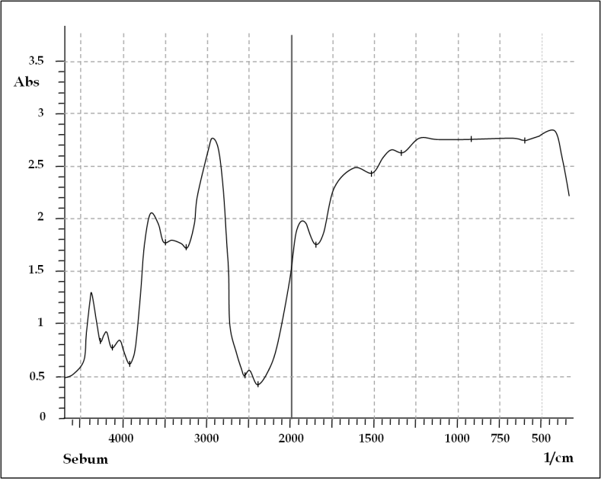

Figure 4. FTIR analysis for test Group IV stored in a simulated sebum media (solution c)
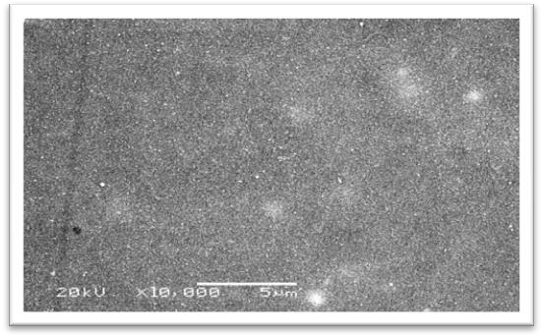

Figure 5. SEM of control group (distilled water) smooth surface with some scattered particles at (10,000 X) magnification

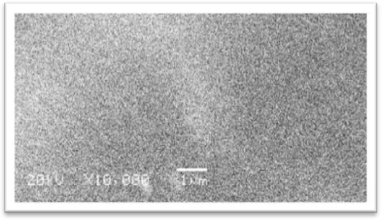

Figure 6. SEM of group II (simulated acid solution) smooth surface with no irregularities at (10,000 X) magnification

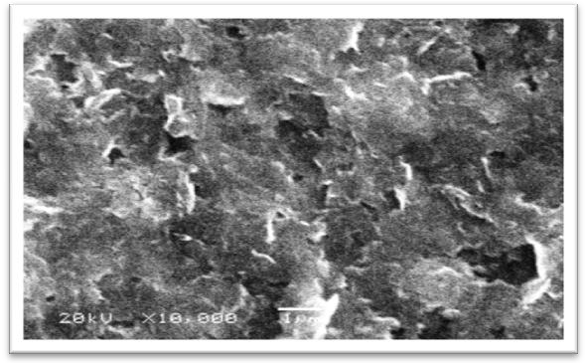

Figure 7. SEM of group III (simulated alkaline) showed irregular vacuolated surface at (10,000 X) magnification

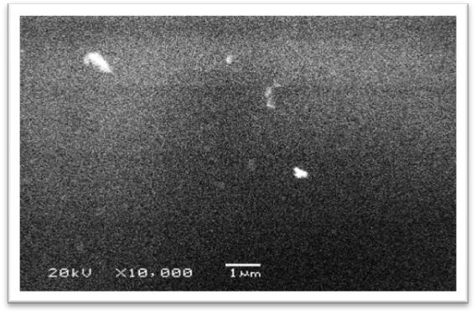

Figure 8. SEM of group IV (simulated sebum) showed smooth grazed surface with some scattered particles at (10,000 X) magnification

4. Discussion:
Facial prostheses are used to protect exposed tissues and cavities resulting from the massive destruction of facial tissue and to repair the large unsightly defects that cannot be successfully repaired by reconstructive surgical procedures [3].
FTIR provides valuable information regarding the complexity of the structure and the bonds of the molecules within the surface analysed. In the current study, quantitative analysis of Cosmesil M511 silicone maxillofacial specimens was conducted using FTIR spectroscopy to assess the influence of various simulated solutions on the degradation mechanism and to compare to other reports [14, 15]. FTIR is used for the chemical analysis because of its specificity and sensitivity. Additionally FTIR is an easily applied technique useful for the detection of silicone, its structure and filler content within the polymer, thus, providing information on the change in silicone [15-24]. FTIR provides a chemical fingerprint of the studied surface as the recorded absorption peaks correspond to the frequencies of vibration between the bonds of the atoms making up the material. One of the great advantages of FTIR spectroscopy is that any sample may be studied in any physical state (Liquids, pastes, powders, films, fibres and gas). Although the exact composition of commercial maxillofacial silicones is unknown, silicone polymers are usually made by repeating silicone to oxygen bonds [R₂SiO]_{n}, where R is an organic group such as methyl, ethyl, or phenyl. These materials consist of an inorganic silicone-oxygen backbone (-Si-O-SiO-Si-O-) with organic side groups attached to the silicone atoms [25-27].
In the current study, FTIR spectrum analysis revealed that the peak resonating at 300-400 cm⁻¹ in all samples represents the inorganic ingredient which is silicone dioxide considered to be the filler in the organic matrix. The superior strength of Cosmesil silicone may be attributed to the addition of silicone dioxide reinforcing filler which reduces silicone stickiness, increases its hardness and enhances its mechanical strength. It also acts as a material extender to reinforce the cross linked matrix.
The resonating peaks between 1300-1400 cm⁻¹ indicate the presence of (-CH₃), a methelyne group, suggesting that this material is a polydimethylsiloxane (PDMS) polymer. The presence of the organic group (CH₃) attached to an inorganic backbone gives silicone polymers a combination of unique properties making their use as fluids, resins and elastomers possible in numerous applications [26]. The double bond between two carbon atoms (C=C) at the resonating peaks 1500-1650cm⁻¹ disappeared in polymerized spectrum indicating complete polymerization.
The FTIR analysis of the control group compared with the aging groups showed no significant changes. This indicates that aging by immersion of the samples in different media did not affect the internal structure of the polymer suggesting that any changes occurring are limited only to the superficial surface of the specimens.
Surface analysis was achieved using SEM at higher magnification (10,000X) to correlate the microstructure findings of the surface to chemical, physical and biological properties of the material [23].
No major degradation was observed following aging since the smooth surface was found to be homogenous and less porous in groups I, II and IV. These findings may be attributed to the continuation of the polymerization process thus promoting a more complete polymeric chain making the silicone surface smoother with time and decreasing the influence of absorbed solutions on the cured surfaces [28, 29]. Samples in group III that were aged in alkaline media showed irregular vacuolated surface. It is most likely that hydrolysis occurred during the aging process causing the formation of the polymer chain are forced apart resulting in these changes (vacuoles). It has been reported that hydroxyl and carboxyl groups formed when Si-CH3 were broken by aging with loss of hydrophobicity [28-30].

Conclusions:
FTIR spectroscopy revealed that the Cosmesil M511 silicone maxillofacial material is based on a methyle polymer with complete polymerization as well as the presence of inorganic silicone dioxide filler. Cosmesil M511 silicone maxillofacial material was not highly affected by immersion in different pH media and the changes observed were limited to the superficial surface of the specimens.

Corresponding author:
Lana A. Shinawi
Associate Professor and Consultant Department of Oral and Maxillofacial Prosthodontics, Faculty of Dentistry, King Abdulaziz University, P.O. Box 80209, Jeddah 21589, Saudi Arabia
Tel / Fax +966-2-6403316,
E-mail: lshinawi@kau.edu.sa

References
1. Chang TL, G.N., Roumana E, John Beumer J., Treatment satisfaction with facial prostheses. J Prosthet Dent, 2005. 94: p. 275-80.
2. Bellamy KE, W.M., Designing a prosthesis to simulate the elastic properties of skin. Biomed Mater Eng., 2005. 15: p. 21–7.
3. Polyzois GL, T.P., Frangou MJ, Andreopoulos AG., Physical properties of a silicone prosthetic elastomer stored in simulated skin secretions.. J Prosthet Dent.., 2000. 83: p. 572–7.
4. Kiat-amnuay S, W.P., Roberts D, Gettleman L., Adhesive retention of silicone and chlorinated polyethylene for maxillofacial prostheses.. J Prosthet Dent., 2008. 99: p. 483–8.
5. Lemon JC, K.-a.S., Gettleman L, Martin JW, Chambers MS., Facial prosthetic rehabilitation: pre-prosthetic surgical techniques and biomaterials.. Curr Opin Otolaryngol Head Neck Surg., 2005. 13: p. 255–62.
6. Polyzois G, D.S., Winter R., A study of some mechanical properties of an RTV polydimethylsiloxane for extra oral maxillofacial prostheses.. Clinical Materials., 1992. 9: p. 21–9.
7. Virlogeux F, B.D., Delor-Jestin F, Baba M, Lacoste J., Evaluation of cross-linking after accelerated photo-ageing of silicone rubber.. Polym Int., 2004. 53: p. 163–8.
8. Eleni PN, K.I., Krokida MK, Polyzois GL., Color stability of facial silicone prosthetic elastomers after artificial weathering.. Dent Res J., 2008. 5: p. 71-9.
9. Maxwell RS, C.R., Sung W, Solyom D, Patel M., The effects of [gamma] radiation on the thermal, mechanical, and segmental dynamics of a silica filled, room temperature vulcanized polysiloxane rubber.. Polymer Degradation and Stability., 2003. 80: p. 443-50.
10. Mohammad SA, W.A., Rumsey DJ, Schricker SR., Maxillofacial materials reinforced with various concentrations of polyhedral silsesquioxanes. J Dent Biomech., 2010. 20.
11. Karayazgan B, G.Y., Evlioğlu G., Improved edge strength in a facial prosthesis by incorporation of tulle: A clinical report.. J Prosthet Dent., 2003. 90: p. 526-9.
12. Andres CJ, H.S., Brown DT, Bernal G., Effects of environmental factors on maxillofacial elastomers. (Pt 2).. J Prosthet Dent., 1992. 68(3): p. 519-22.
13. Fang S, Y.Z., Longquan S, Jingguang P., The test of the mechanical properties of SY-28. SY-20 and MDX-4–4210 silicone elastomers.. J US China Med Sci., 2006. 3: p. 36-40.
14. J., S., Importance of weathering factors other than UV radiation and temperature in outdoor exposure.. Polym Degradation Stability., 2002. 76: p. 455–65.
15. Pospisil J, P.J., Billingham NC, Marek A, Horak Z, Nespurek S., Factors affecting accelerated testing of polymer photostability.. Polym Degradation Stability., 2006. 91: p. 417–22.
16. Kirk-Othmer, K.-O., Encyclopedia of Chemical Technology. 5th ed ed. 2004: John Wiley & Sons.
17. Sundararajan R, M.A., Chaipanit N, Karcher T, Liu Z., In-service aging and degradation of 345 kV EPDM transmission line insulators in a coastal environment, IEEE Trans.. Dielectr. Electr. Insul., 2004. 11: p. 348- 61.
18. Mancuso DN, G.M., Santos DM. Color stability after accelerated aging of two silicones, pigmented or not, for use in facial prostheses., Color stability after accelerated aging of two silicones, pigmented or not, for use in facial prostheses.. Braz Oral Res., 2009. 23(2): p. 144-8.
19. Yu R, K.A.r., Craig RG., Physical properties of maxillofacial elastomers under conditions of accelerated aging.. J Dent Res., 1980. 59(6): p. 1041-7.
20. Ayman A. Al-Dharrab, S.B.T., and Mona H. Abodaya., The Effect of Different Storage Conditions on the Physical Properties of Pigmented Medical Grade I Silicone Maxillofacial Material. Dentistry., 2013. 28.
21. Standardization., I.O.f., Textiles-Tests for color fastness, Part E04: Color fastness perspiration. ISO, 2008. 105(E04).
22. Mohite UH, S.J., Land MF, Byrne G., Environmental factors affecting mechanical properties of facial prosthetic elastomers. Int J Prosthodont., 1994. 7: p. 479-86.
23. Santawisuk W, K.W., Sirisinha CH, Harnirattisai CH., Dynamic viscoelastic properties of experimental silicone soft lining materials.. Dent Mater J., 2010. 29(4): p. 454– 60.
24. YC., H.F.H.C.C., Residual monomer releasing from acrylic denture base in water. Chin Dent. J, 2000. 19: p. 17-22.
25. M., S.T.K., Silicone elastomers – their role in maxillofacial prosthetic rehabilitation. Int J App Basic Med Res., 2012. 2: p. 263-6.
26. E.G., R., Silicon and silicones. 1987: Spring-Verlag, New York.
27. W., L.M.P.R., RTV silicone elastomers in hand prosthetics: properties applications and techniques.. Prosthet and Orthotics Int., 1999. 23: p. 169-73.
28. Amin M, A.M., and Amin S., Hydrophobicity of silicone rubber used for outdoor insulation (an overview).. Rev. Adv. Mater. Sci., 2007. 16: p. 10-24.
29. J.E., M., Polymer Data Handbook. 1999: Oxford University Press, Oxford, UK.
30. Ahmadi-Joneidi I, R.M., Kahuri H, Sahragard J, Sayani A., Evaluation of actual field ageing on room temperature vulcanized silicone rubber coating of ceramic insulators on 230/63 Substation. Life Sci J., 2013. 10 p. 833-8.

4/26/2017

