Silica-scaled Synurophyceae and Chrysophyceae from Bagoé River (Côte d’Ivoire)

Amalan Sylvie N’DA¹*, Koffi KOMOÉ², Siaka BERTÉ¹, Essetchi Paul KOUAMÉLAN¹ and Valentin N’DOUBA¹

¹ Laboratory of hydrobiology, University Félix Houphouët Boigny, 22 BOX 582 Abidjan 22, Côte d’Ivoire
² Laboratory of botanic, University Félix Houphouët Boigny, 22 BOX 582 Abidjan 22, Côte d’Ivoire
sylvienda@yahoo.fr

Abstract: Synurophyceae and Chrysophyceae with silica scales from Bagoé River, in north of Côte d’Ivoire were studied by means of scanning electron microscopy. 10 taxa were recorded, 5 belonging to the genera Mallomonas Perty, 4 Synura Ehrenberg emend. Korshikov, 1 Paraphysomonas De Saedeleer. All the taxa recorded are new to Côte d’Ivoire. The scale dimensions, biogeographical distribution and occurrence in Côte d’Ivoire are also given.
[Amalan Sylvie N’DA, Koffi KOMOÉ, Siaka BERTÉ, Essetchi Paul KOUAMÉLAN and Valentin N’DOUBA. Silica-scaled Synurophyceae and Chrysophyceae from Bagoé River (Côte d’Ivoire). N Y Sci J 2017;10(6):66-73]. ISSN 1554-0200 (print); ISSN 2375-723X (online). http://www.sciencepub.net/newyork. 10. doi:10.7537/marsnys100617.10.

Keywords: Synurophyceae; Chrysophyceae; Côte d’Ivoire; Bagoé River; silica scales

1. Introduction
Silica-scaled chrysophytes are unicellular or colonial flagellate organisms that belong to two classes of the division Heterokontophyta: Chrysophyceae and Synurophyceae (Andersen, 1987). All taxa of the class Synurophyceae and many of the Chrysophyceae carry on their surface a silica armour formed by scales. The ultrastructure of these structures is essential for the species determination (Nemcová et al., 2011).
The Côte d’Ivoire freshwater algal flora, especially Silica-scaled (classes Chrysophyceae and Synurophyceae), is poorly documented. Only three EM investigations of the chrysophytes flora of Côte d’Ivoire have been published (e.g. Bourrelly, 1961; Da, 1992; Da, 2007). Nevertheless, Silica-scaled have been well studied elsewhere in Africa, i.e. Chad Republic, Kenya, Madagascar, Botswana, Zimbabwe, Cameroon and Nigeria (Wujek and Timpano, 1984; Wujek et al., 2004; Piatek and Mossebo 2008; Wujek et al., 2010).
In this study, the Silica-scaled algal flora from samples collected in Bagoé in north of Côte d’Ivoire, were examined using scanning (SEM) electron microscopy. Considering this lack of Knowledge, this present study aimed to amplify the existing information about the silica-scaled chrysophytes in the freshwater of Côte d’Ivoire and to provide basic information on ecology.

2. Material and Methods
Bagoé River, secondary tributary of the Niger River is a transboundary river that waters the north of Côte d'Ivoire and Mali. Beyond the Ivorian territory, it crosses the Baoule River to form the Bani River in Mali. Situated between the longitudes 5 ° 40 'and 7 ° 10' west and latitude 9 ° 15 'and 10 ° 50' north, Bagoé rises to Kokoum (in the city of Madinani, Côte d’Ivoire) to about 600 m (Avit et al., 1999; Adja et al., 2009). It flows first, following the west-east axis Madinani Boundiali, then take the northbound direction of Boundiali in Tengrela. It covers a distance of 230 km and covers a catchment area of ​​about 10,150 km² in Côte d’Ivoire (Avit et al., 1999; Adja et al., 2009). Its two main tributaries on the right bank are the Palée and Niangboué. Bagoé is under the influence of the Sudanese climate which includes two hydrological seasons, dry and rainy. It belongs to the transition from tropical regime (Savané and Konaré, 2010).
The samples were collected in the rainy season (October-November 2011) and in the dry season (March-April 2012) in thirteen selected stations throughout the river, to have a general knowledge of the algal flora populating of the Bagoé (Figure 1). The seaweed harvests were conducted between 8 am and 12 pm. They consisted of 10 buckets of water filter 10 liters capacity (100 l of water) using a plankton net of 20 microns vacuum mesh at each station. The physico-chemical parameters such as the water temperature (°C), the level of dissolved oxygen (mg/l), pH, conductivity (µS/cm) and the dissolved solids content (mg/l) were measured in situ before the algae crops.
Observations in the scanning electron microscope (M.E.B) required slide preparation. A drop of sample bound water is removed and mounted on a thin section then dried in an oven. Then, the slides were mounted, observed and photographed at M.E.B. ADOBE PHOTOSHOP enabled image processing and the constitution of the boards.
The identification of phytoplankton species was made on the basis of identification keys and various documents: Siver, 1987; Siver, 2002; Franceschini et al., 1996; Ito, 1997; Magda and Škaloud, 2004; Magda and Škaloud, 2005; Škaloud et al., 2012; Škaloud et al., 2013.

3. Results and discussion
Physicochemical parameters: Table 1 shows the physical and chemical conditions of each of the thirteen harvesting stations. The temperatures are relatively high with an average of 27.8 ± 1.4 C; an average oxygen content of 4.54 ± 0.9 mg/l; an average pH of 6.8 ± 0.3; low conductivities with an average of 53.57 ± 7.1 μS/cm and dissolved solids level low enough to 30.43 ± 6.9 mg/l.
Description of algae observed: For each taxon, scales of size, biogeographical distribution and presence in Côte d’Ivoire are provided.
NB: Rule scale bars in illustrations represent 2 µm.
Class Synurophyceae Andersen
Order Synurales Andersen
Family Mallomonadaceae Diesing
Genus Mallomonas Perty
Section Mallomonopsis (Matvienko) Asmund & Kristiansen
Series Matvienkoanae Asmund & Kristiansen
Mallomonas matvienkoae (Matvienko) Asmund & Kristiansen (Figures 2 a-b).
The outer face of the scales is in granular part, however the inner face is uniformly smooth. Scales of this taxon, which possessed a single large pore in the proximal region and lacked surface papillae.
Scales: 4.5-6.2 x 3.0-4.7 μm.
Cosmopolitan species.
Stations: Ba3 (Guinguereni) and Ba6 (Gbambiasso).
Series Peronoides Asmund & Kristiansen
Mallomonas bangladeshica (Takahashi & Hayakawa) Siver & Wolfe (Figure 2c).
Cells of this taxon, possessing scales with a "hemispherical ornament" (Takahashi and Hayakawa, 1979) or "grapnel-like" structure (Wujek and Timpano, 1984). The "grapnel-like" appendage was originally used by Takahashi and Hayakawa (1979) as the primary feature for distinguishing this taxon as a variety of Mallomonopsis peronoides, and later by Wujek and Timpano (1984) to raise the taxonomic rank to the specific level (i.e. Mallomonopsis bangladeshica). This species has been reported in Bangladesh (Takahashi & Hayakawa 1979), the U.S.A. (Wujek & Timpano 1984), Brazil and Zimbabwe (Cronberg 1989) and China (Kristiansen & Tong, 1989, 1991).
Scales: 4.3-4.4 x 2.6-3.1 μm.
Station: Ba6 (Gbambiasso).
Probably cosmopolitan.
Section Mallomonas Perty
Series Mallomonas Perty
Mallomonas acaroides Perty emend. Ivanov (Figure 2d).
Mallomonas acaroides is a cosmopolitan species with a very wide ecological amplitude and found in eutrophic environment (Kristiansen, 2002). All the scales are tripartite, composed of a dome, shield and flange, with a distinct V-rib separating the shield from the flange.
Scales 5.2-5.5 x 3.4-3.8 μm long and 3.42-.8.83µm wide. Mallomonas acaroides is very similar to Mallomonas crassisquama (Asmund) Fott. They have similar development of the secondary ornamentation of the shield. The most important difference between these two species is the presence of spines on the posterior scales of M. crassisquama and the absence of such spines in M. acaroides.
Stations: Ba3 (Guinguereni) and Ba6 (Gbambiasso).
Section Papillosae Asmund & Kristiansen
Series Papillae Asmund & Kristiansen
Mallomonas delanciana Silver (Figures 2e-f).
Cells are small, ovoid, range size from 10-14 x 8-9 µm 8 x 9 µm and are covered with dome scales each bearing single bristle.
Cosmopolitan species.
Stations: Ba3 (Guinguereni) and Ba6 (Gbambiasso).
Section Planae Momeu & Péterfi
Series Fastigatae Momeu & Péterfi
Mallomonas caudata Ivanov emend. Krieger (Figure 2g).
Scales: 6.5-7.2 x 5-6 μm.
Cosmopolitan species.
Stations: Ba3 (Guinguereni) and Ba6 (Gbambiasso).
Family Synuraceae Lemmermann
Genus Synura Ehrenberg emend. Korshikov
Section Petersenia Petersen & Hansen ex-Balonov & Kuzmin
Synura petersenii Korshikov (Figure 2h).
Cells: 10 to 19.7 x 7.2 to 14.3 μm; the cell body scales: from 3.4 to 4 x 1.6-2.2 μm; basal scales: 2.2-2.7 x 1-1.4 μm. The scales are 3.4-4 x 1.6-2.2 μm long and 1.6 µm wide, with a central ridge 2.4 µm long and 0.6 µm wide, and rim 2.4 µm long and 0.3 µm wide.
Synura petersenii is a cosmopolitan chrysophyte with a very wide ecological amplitude, and has been found on all six continents (Kristiansen, 2002).
Cosmopolitan species.
Stations: Ba3 (Guinguereni) and Ba6 (Gbambiasso).
Section Synura Balonov & Kuzmin
Synura curtispina (Petersen & Hansen) Asmund (Figure 2i).
Scales: 3.5-3.8 x 2.3-2.9 μm (without the thorns); thorns 1.9-2.6 μm in length.
Generally, the anterior one-third to one-half of the scales was covered with a secondary layer, and all spined scales had a series of parallel ribs along the anterior margin.
Cosmopolitan species.
Stations: Ba3 (Guinguereni) and Ba6 (Gbambiasso).
Synura echinulata Korshikov (Figures 2j, k, l).
Cells: 11.5 x 7.3 microns; the cell body scales: from 2.1 to 4.6 x 2.3-3.2 μm (without the thorns); Basal scales: from 2.8 to 1 x 0.5-2.3 μm; thorns 1.4 to 2.7 μm in length.
The scales have a labyrinthic apical pattern 23.5-3.8 x 2.3-2.9 µm long and 2 µm wide, with linear, narrower, delicate and closely spaced bars ornamenting the front part of the scale. The basal plate of the scale is ornamented with irregularly scattered holes. The scale has an apical spine 2 µm long and 0.4 µm wide. The tip of the spines narrows to a small tooth.
According Kristiansen and Preisig (2007), Synura echinulata is widely distributed around the world. Moreover, this species is both found in oligotrophic in eutrophic environments (Barreto et al., 2000) and this vis-à-vis low pH waters tolerance (Němcová et al., 2001).
Cosmopolitan species inventoried for the first time in the Côte d’Ivoire.
Stations: Ba3 (Guinguereni) and Ba6 (Gbambiasso).
Cosmopolitan species.
Stations: Ba3 (Guinguereni) and Ba6 (Gbambiasso).
Synura spinosa Korshikov (Figure 2m).
Cells: 13-23 x 9-17 μm.
Cosmopolitan species.
Stations: Ba3 (Guinguereni) and Ba6 (Gbambiasso).
Class Chrysophyceae Pascher
Order Chromulinales Pascher
Family Paraphysomonadaceae Preisig & Hibberd
Genus Paraphysomonas De Saedeleer
Paraphysomonas vestita (Stokes) De Saedeleer (Figure 2n).
Scales constructed of a circular plate (disc) with a central tapering spine terminating in a pointed tip the central spines from 1.4-10 µm long. The variations in size of discs and spines are greater than in specimens from other areas, where the quoted ranges were 1.0-2-5 µm for the diameter of discs and 2.0-10.0 µm for the length of spines (Korshikov, 1929; Bourrelly, 1957; Manton and Leedale, 1961).
Scales: 2.1-3 μm diameter; bristle: 5.1-8.4 μm long.
Cosmopolitan species.
Stations: Ba3 (Guinguereni) and Ba6 (Gbambiasso).

Table 1. Environmental parameters of the Bagoé River (Côte d’Ivoire).
Stations | Temperature (°C) | Dissolved Oxygen (mg/l) | pH | Conductivity μS/cm | TDS mg/l
Karakpo | 24.57 | 2.82 | 6.37 | 49.9 | 26.35
Ponondougou | 25.17 | 5.03 | 6.90 | 50.85 | 27.85
Guinguereni | 27.57 | 3.11 | 6.76 | 61.1 | 38.45
Samorasso | 27.55 | 4.99 | 7.12 | 54.2 | 38.1
Maranama | 28.46 | 5.02 | 6.68 | 49.55 | 25.2
Gbambiasso | 28.72 | 3.53 | 6.89 | 54.55 | 31.35
Kouto | 28.0 | 4.68 | 6.84 | 46.12 | 22.9
Oura | 28.27 | 4.51 | 6.88 | 53.95 | 43.05
Kantara | 28.6 | 4.62 | 6.85 | 55.35 | 28.95
Kanakono | 28.2 | 5.01 | 6.62 | 46.9 | 23.3
Sissingue1 | 29.65 | 4.68 | 6.75 | 50.55 | 25.35
Papara | 28.65 | 6.01 | 6.97 | 50.15 | 25.5
Doumbasso | 27.6 | 5.03 | 6.88 | 73.2 | 39.3

4. Conclusion
This study with electron microscopical allowed us to identify 10 taxa of Chrysophyceae and Synurophyceae in Bagoé River. Five taxa belonging to the genus Mallomonas Perty, four Synura Ehrenberg emend. Korshikov and one Paraphysomonas De Saedeleer. The number of species found during this investigation was low. At most stations no Silica-scaled chrysophytes were found at all. At 2 to 13 sampling sites only 1 to 4 were revealed. As the sampling was done, the influence of the actual weather conditions must be taken under consideration (e.g. heavy rains might have rinsed out the species). The chrysophyte flora in the Bagoé River consisted mainly of acidophilic (S. echinulata, S. spinosa and S. curtispina) or pH indifferent widely distributed taxa. Our results were the fourth fact of Knowledge to silica-scaled of chrysophytes from Côte d’Ivoire. All the taxa harvested for the first time in Côte d’Ivoire. The species have a cosmopolitan distribution. The present study provides an understanding of the Chrysophyceae and Synurophyceae ecology in Bagoé River. However, much of the necessary biological information about these Synurophyceae and Chrysophyceae from Côte d’Ivoire to reach a first reasonable overview on the ecological role of these phytoplankton in freshwater.

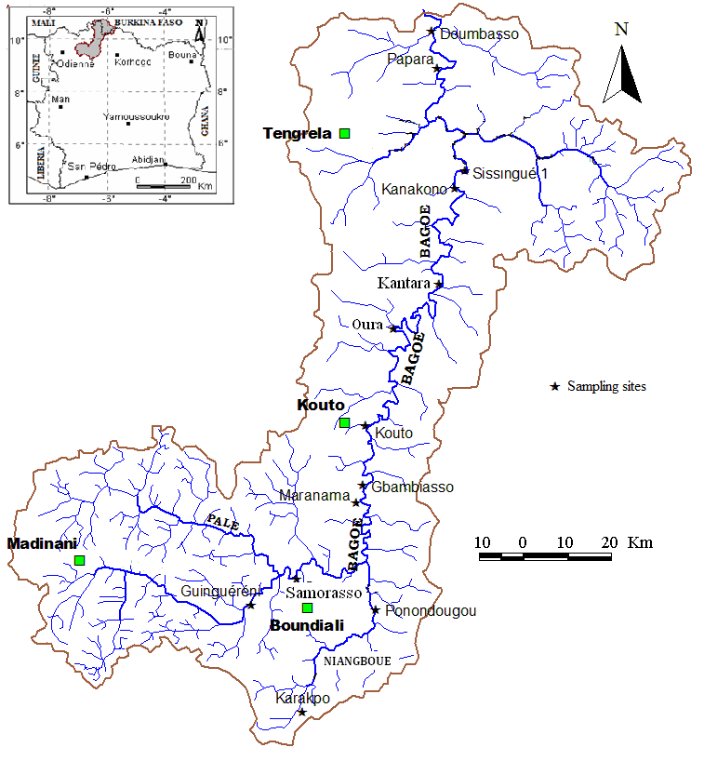
Fig. 1. Map of the Bagoé River (Côte d’Ivoire) and location of the sampling sites.

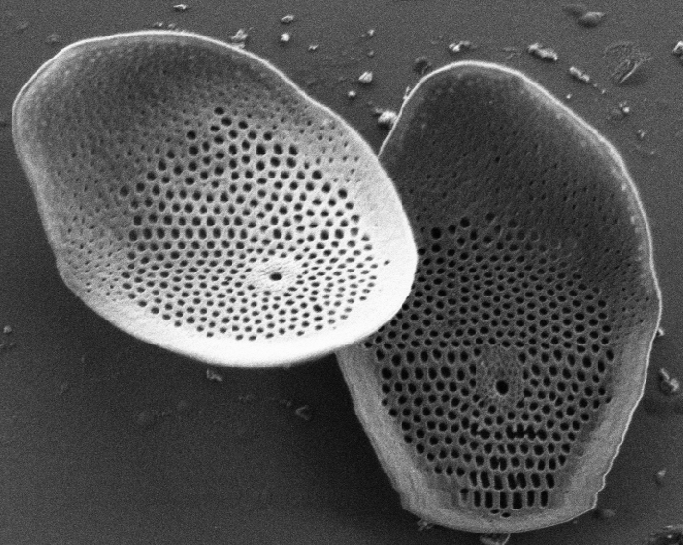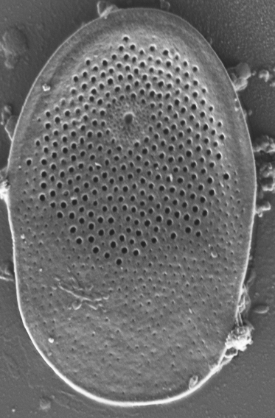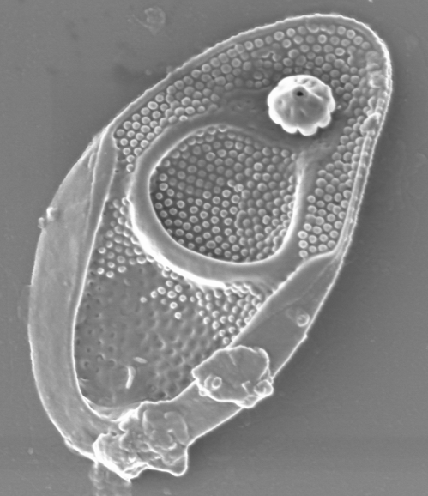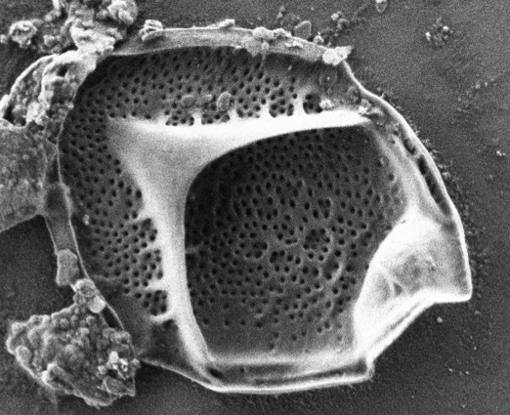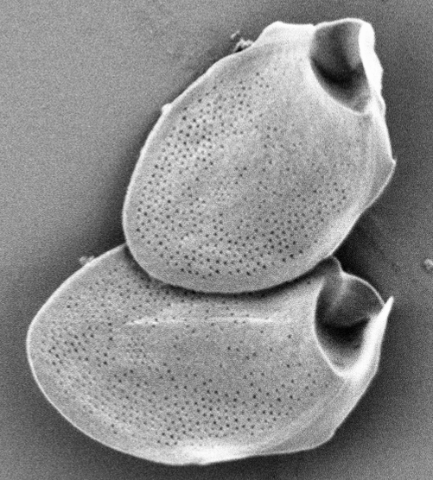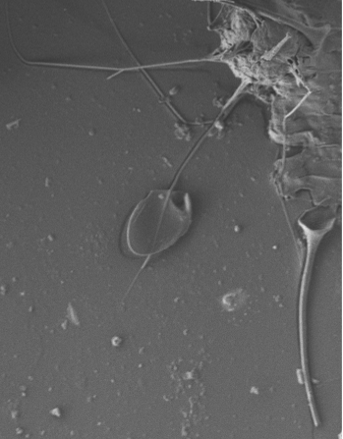
a
b
c
d
e
f
Figure 2: a-b Mallomonas matvienkoae-Scales bars; c Mallomonas bangladeshica- Isolated scales; d Mallomonas acaroides- Isolated scales; e Mallomonas delanciana- Isolated scales; f Mallomonas delanciana- Isolated scales and bristles.

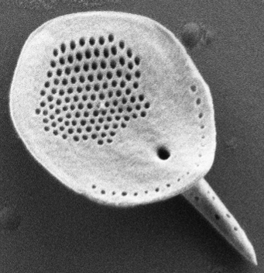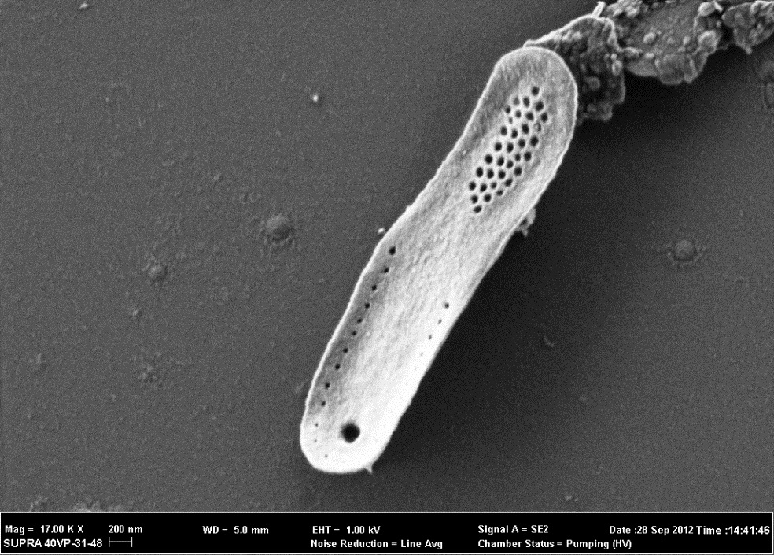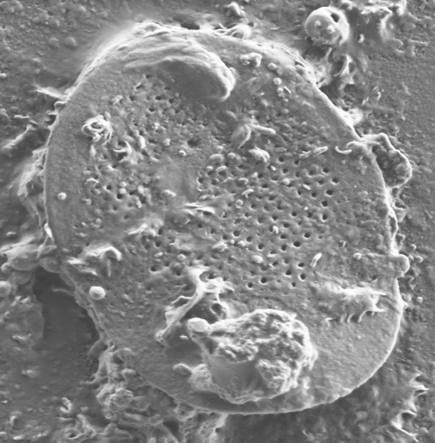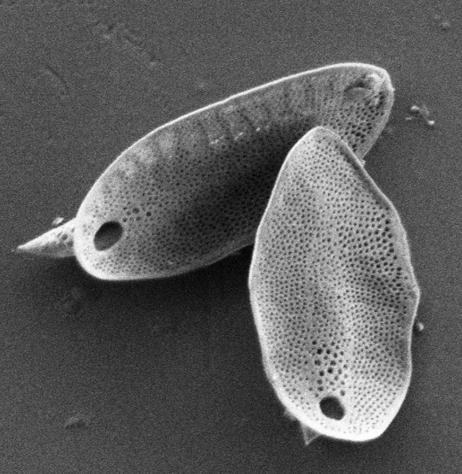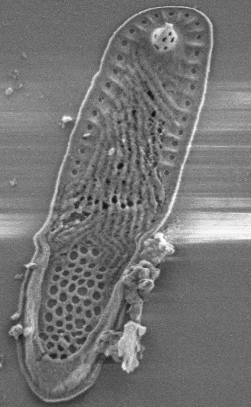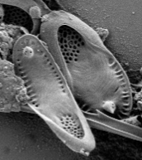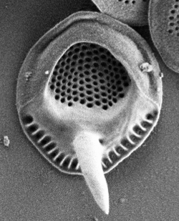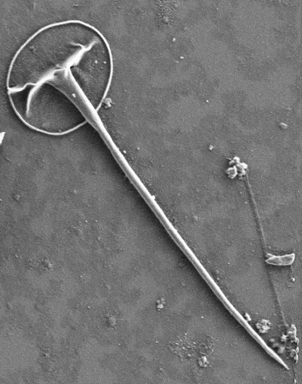
l
g
h
i
j
k
m
n
Figure 2 suite: g Mallomonas caudata- Isolated scales ; h Synura petersenii- Isolated scales ; i Synura curtispina- Isolated scales; j-k-l Synura echinulata-Scales bars ; m Synura spinosa- Isolated scales; n Paraphysomonas vestita- Isolated scales with bristle.
8
9

Acknowledgements:
We thank Mrs Duffi Kouamé and Soumahoro Losséni of PETROCI, for the assistance with S.E.M. We also thank to the person for facilitating access to rivers and the reviewers for constructive comments on the manuscript.

Corresponding Author:
Dr. N’DA Amalan Sylvie
Laboratory of hydrobiology
University Félix Houphouët Boigny,
22 BOX 582 Abidjan 22, Côte d’Ivoire
E-mail: sylvienda@yahoo.fr

References
- Adja MG, Jourda JPR, Youan TM, Kouamé K, Kouamé KJ, Kouamé KF, Saley MB, Dje KB, Biemi J. Diagnostic à la mi-saison sèche de l’état hydrique du bassin-versant de la Bagoé (milieu soudano-sahélien de Côte d’Ivoire) à l’aide d’images ETM + de Landsat. Sécheresse 2009; 20(3):253-261.
- Andersen RA. Synurophyceae classis nov., a new class of algae. Am. J. Bot. 1987;74(3):337-353.
- Avit JBLF, Pedia PL, Sankaré Y. Diversité biologique de la Côte d’Ivoire. Rapport de synthèse, Ministère de l’Environnement et de la Forêt 1999 : 276.
- Barreto S, Kristiansen J, Acs E. Silica-scaled chrysophytes during spring in the Kis-Balaton reservoir, Hungary. Acta Bot. Croat. 2000;59(2):337-339.
- Bourrelly P. Recherches sur les Chrysophycées. Morphologie, phylogenie, systematique. Rev. Algol. 1957;1:1-409.
- Bourrelly P. Algues d’eau douce de la République de Côte d’Ivoire. Bull. IFAN 1961; 23(2):283-374.
- Cronberg G. Scaled chrysophytes from the tropics. Beih. Nova Hedwigia 1989;95:191-232.
- Da KP. Contribution à la connaissance du phytoplancton de la mare et du complexe piscicole du Banco (Côte d’Ivoire). Thèse de Doctorat 3ème cycle, Université Nationale de Côte d’Ivoire, Abidjan, 1992:384.
- Da KP. Etude taxinomique du phytoplancton dulçaquicole des masses d’eaux lentiques et lotiques de quelques sites au Sud de la Côte d’Ivoire, entre les fleuves Bandama et Bia : apports de la microscopie électronique à balayage. Thèse de Doctorat d’État, Université de Cocody-Abidjan, Côte d’Ivoire, 2007:402.
- Dragana P, Zeljko K, Emilija K, Jovana M, Petar P, Milojko L, Gordona SS. Diversity of Chrysophyceae (Heterocontophyta) in the Zasavica River (Serbia) Arch. Biol. Sci. 2014;66(3):1195-1204.
- Franceschini IM, Couté A, Silver PA. Synurophyceae & Chrysophyceae à écailles silicieuses du rio Dinos, R.S. Brésil. Algol. Stud. 1996;80:59-95.
- Ito H. A floristic study of the Chrysophyta in the Kobe District, Hyogo Prefecture, Japan. Thesis of Kobe University 1997:163.
- Korshikov AA. Studies on the Chrysomonads. I. Arch. Prostistenkd. 1929;67:253-290.
- Kristiansen J. The genus Mallomonas (Synurophyceae): A taxonomic survey based on the ultrastructure of silica scales and bristles. Opera Bot. 2002;139:5-218.
- Kristiansen J, Preisig HR. Chrysophyte and Haptophyte algae. 2nd Part: Synurophyceae. In: Budel B, Gartner G, Krienitz L, Preisig HR, Schagerl M (eds), Süsswasserflora von Mitteleuropa 1/2, 2. Aufl. Spektrum Akad. Verlag, Berlin, Heidelberg. 2007:252.
- Kristiansen J, Tong D. Studies on silica-scaled chrysophytes from Wuhan, Hangzbou and Beijing, P.R. China. Nova Hedwigia 1989;49:183-202.
- Kristiansen J, Tong D. Investigations on silica-scaled chrysophytes in China. Verh.
- Internat. Verein. Limnol. 1991;24(4):2630-2633.
- Magda R, Škaloud P. Silica-scaled chrysophytes of Ireland, 2004:32.
- Magda R, Škaloud P. Silica-scaled chrysophytes of Ireland With an appendix: Geographic variation of scale shape of Mallomonas caudate. Nova Hedwigia 2005;128:101-124.
- Manton I, Leedale GF. Observations on the fine structure of Paraphysomonas vestita, with special reference to the Golgi apparatus and the origin of scale. Phycologia 1961;1:38-57.
- Nemcová Y, Bulant P, Kristiansen J. Mallomonas solea-ferrea and Mallomonas siveri (Chrysophyceae/Synurophyceae): two new taxa from the Western Cape (South Africa). Nova Hedwigia 2011;93 (3-4):375-384.
- Němcová Y, Kalina T, Neustupa J, Nováková S. Silica-scaled chrysophytes of the Krkonose Mountains (Czech Republic). Arch. Hydrobiol./ Algological Studies 2001;101:97-108.
- Piątek J, Mossebo DC. Mallomonas striata var. serrata and Synura petersenii F. Kufferathii, two silica-scaled chrysophytes new to Cameroon. Polish Botanical Journal 2008;53(2):139-143.
- Savané I, Konaré A. Climate. In: Konaté S, Kampmann D (eds): Biodiversity Atlas of West Africa, Vol. 3. Abidjan & Frankfurt/Main, Côte d’Ivoire. 2010: 124-125.
- Siver PA. The distribution and variation of Synura species (Chrysophyceae) in Connecticut, USA. Nord. J. Bot. 1987;7:107-116.
- Siver PA. Two new taxa in the Section Papillosea of the genus Mallomonas (Synurophyceae) from the Ocala national Forest, Florida, USA. Nord. J. Bot. 2002;22:123-128.
- Škaloud P, Kynčlová A, Benada O, Kofroňová O, Škaloudová M. Toward a revision of the genus Synura, section Petersenianae (Synurophyceae, Heterokontophyta): morphological characterization of six pseudo-cryptic species. - Phycologia 2012;51(3): 303-329.
- Škaloud P, Kristiansen J, Škaloudová M. Developments in the taxonomy of silica-scaled chrysophytes – from morphological and ultra structural to molecular approaches. Nordic Journal of Botany 2013;31(4):385-402.
- Takahashi E, Hayakawa T. The Synuraceae (Chrysophyceae) in Bangladesh. Phykos 1979;18:129-147.
- Wujek DE, Timpano P. The genus Mallomonopsis in the United States. Trans. Kans. Acad. Sci. 1984; 87 (3/4):27-32.
- Wujek DE, Adesalu TA, Nwankwo DI. Silica-scaled Chrysophyceae and Synurophyceae (Chrysophyta) from Nigeria. II. Lake Lekki. Tropical Freshwater Biol. 2004; 13:99-103.
- Wujek DE, Kadiri MO, Dziedzic RM. Silica-scaled Chrysophyceae and Synurophyceae from Nigeria. III. Chrysophytes from rivers of Edo State. Fottea 2010;10 (1): 93-98.

5/18/2017

