Improving physical properties of cotton fabric using reactive finishing agent

Ahmed Ibrahim Wally¹, Raafat Hassan Morsy Azzam² , Mohamed Mohamed Abdelazeam³ and Maysa Mohamed Reda³
¹ Textile Research Division, National Research center, Dokki, Cairo, Egypt.
²Textile Dyeing and Finishing Technology Department, Faculty of Applied Arts, Helwan University, Egypt.
³ Textile Dyeing and Finishing Technology Department, Higher Institute of Applied Arts, New Cairo, Egypt
Emil: muhammed.omran1993@gmail.com

Abstract: In this study will investigate a reactive finishing agent depending on modified starch with acrylamide, Different modification conditions will be studied to achieve methylol carbamoyl ethyl starch. The synthesized finishing agent with different concentrations will be applied onto the cotton fabrics at certain concentrations, physical properties of the treated cotton fabrics with the synthesized reactive finishing agent will be studied, An acceptable results were achieved with 10% reactive finishing agent.
[Ahmed Ibrahim Wally,Raafat Hassan Morsy Azzam,Mohamed Mohamed Abdelazeam and Maysa Mohamed Reda Improving physical properties of cotton fabric using reactive finishing agent NY Sci J2022;15(11):7-10] ISSN 1554-0200 (print); ISSN 2375-723X (online). http://www.sciencepub.net/newyork 02. doi:10.7537/marsnys151122.02.

Keywords: Starch, Cotton, Acrylamide and Carbamoyl.

- Introduction:
Starch is the most abundant carbohydrate reserve in plants, and it’s found in leaves, flowers, fruits, seeds and different types of stems and roots.¹ The commercial source of starch are the seeds of cereal grains (Corn, Wheat, Rice), certain roots (Potato, arrowroot, tapioca) the starch from each plant source vary in appearance, composition and properties, the starch is, therefore, described by its plant source as corn starch, potato starch, tapioca starch, wheat starc.² Starch is a kind of low cost, renewable and biodegradable polymer and has been applied in industries for the past few decades.⁴ Starch is rarely used in its real form and often used in its native form; most native starches are limited in their direct application because they are unstable with changes in temperature, pH and shear forces. Native starches show a strong tendency for decomposition and retrogradation, some starch granules are inert, one or some of the above mentioned shortcomings of the native starches.³
One of these attempts had made to synthesis methylol carbamoyl ethyl starch with low viscosity to insure the penetration of the reactive finishing agent onto cotton fabric

Raw Materials and chemicals:
-Corn Native Starch produced from Egyptian starch & glucose manufacturing co.
- Hydrochloric acid.
- Acrylamide.
- Anhydrous sodium sulfate.
- Sodium hydroxide.

- Formaldehyde.

- Ammoinum chloride.

- white 100% Cotton fabric washed with sodium hydroxide at 100 °C for 30 min.

3. Experimental Techniques:

3.1. Synthesis of methylol Carbamoyl ethyl starch(M.C.E.S): 3.1.1 starch hydrolysis:

Hydrolysis of starch by using HCl to damage the starch molecular weight structure that’s lead to a low viscosity was carried out in aqueous hydrochloric acid solution at 60c for 1 hour with the addition of starch slurry, After the time the product was neutralized with 0.8% NaOH then filtered and washed by water and finally dried in electric oven at 105°C.
3.1.2 Synthesis of carbamoyl ethyl starch:

Acidified cornstarch (500 gm) dry weight was dispersed in (1000 ml) water containing (5 gm) sodium hydroxide and (25 gm) anhydrous sodium sulfate. The Ph value of the dispersion obtained was (9) and the dispersion was transferred into 3 liter three-necked flask that was immersed in a thermo digital water bath.

A certain amount of acryl amide (50 gm) was dissolved in (70 ml) distilled water and the solution was added into the flask.

The reaction was carried out under continuous electric stirring at 45°C for 4 hour.
The product was neutralized by HCl, filtered and washed with ethanol/water mixture (70:30) for three times and finally with pure ethanol one time, finally the modified corn starch was dried at 60°C.
3.1.3 Methylolation of carbamoyl ethyl starch:

Carbamoyl ethyl starch (C.E.S) with (234 gm) dry weight was added to 468ml water.

The pH value of aqueous carbamoyl ethyl starch was adjusted to (9) by dilute solution of sodium hydroxide.

The equivalent amount of formaldehyde (30ml) was added to carbamoyl ethyl starch.

The reaction was carried out under continuous electric stirring at 60 °C for 2 hour; the reaction was left over night at room temperature.

3.2. Treatment cotton fabric with methylol carbamoyl ethyl starch:

3.2.1. A different two aqueous solution of methylol carbamoyl ethyl starch 4% - 8%

(Dissolved in hot water) are followed by addition of 1% ammonium chloride.

Cotton samples are padded in this mixture and squeezed to a accurate pick-up, then drying at 100°C for 265 sec, then thermally treated at 160°C for 3 min.

3.2.2. A different five aqueous solution of carbamoyl ethyl starch (2% - 5% - 7% - 10% -12%)

(Dissolved in hot water) are followed by addition of 1% ammonium chloride.

Cotton samples are padded in this mixture and squeezed to an accurate pick-up, then drying at 100°C for 265 sec, and then thermally treated at 160°C for 3 min.

Then pieces of cotton samples which treated with reactive finishing material (M.C.E.S) are washed by add to water containing 2gm/l non-ionic detergent at 40°C for 30 min.

4. Testing processes:

After hydrolysis of the starch, the viscosity measured by dispersed starch with distilled water to form 6% dispersion, then dispersion was heated to 90°C and maintained at the temperature for 20 min under stirring, and then viscosity of starch paste was measured by rotary viscometer to reach the ideal proportions of achieving the lowest possible viscosity to insure it’s penetration onto cotton fabric and the effect of all proportions has study as follow:

4.1 Studying the effect of hydrochloric acid (HCl) concentration.Onto the H.S viscosity.

4.2. Studying the hydrolysis time onto the H.S viscosity.

4.3. Studying the hydrolysis temperature onto the H.S viscosity.

4.4. Studying the efficiency of treatment the cotton fabrics with (M.C.E.S) onto the weight of the treated fabric.

4.5 studying the tensile strength and tear properties of the treated fabrics.

After washing and drying the samples are determined the weight w/m² of samples before and after finishing with reactive finishing material (M.C.E.S), ASTM D 5035; 1995 - Breaking strength & elongation – strip force and BS EN ISO 13937: pts.2 to 4: Tear properties of fabrics , And the results were measured.

Results and Discussion:

4.1. Relation between hydrochloric acid (HCl) concentrations on the H.S. viscosity:

The illustrated fig.1 show that: the viscosity of H.S., was decreased with the increase of HCl Concentration, as the minimum viscosity which is 83 mpa.s was achieved at 80 ml HCl, while the maximum viscosity which is 180 mpa.s was achieved at 20 ml HCl, this is may be due to the degradation that occurred onto the starch molecular.

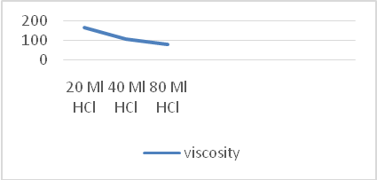

Fig(1): Relation between HCL Concentrations on H.S viscosity.

4.2. Relation between the hydrolysis time and the viscosity of starch:

The viscosity of H.S was decreased with the increasing the hydrolysis time, as the minimum viscosity which is 70 mpa.s was achieved at 120 min, while the maximum viscosity which is 177 mpa.s was achieved at 30 min

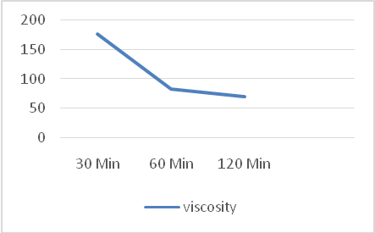

Fig (2): Relation between hydrolysis time and viscosity of starch

4.3. Relation between the hydrolysis temperature and the viscosity of starch:
From illustrated fig.3 show that: the viscosity of H.S starch decreased with the increase of temperature, as the minimum viscosity which is 70 mpa.s was achieved at 60 °C while at room temperature 28 °noticed no change in the viscosity.

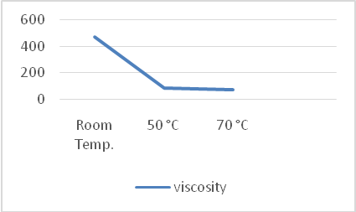

Fig(3) The effect of hydrolysis temperature on H.S viscosity.

According to these studies time, temperature and HCL concentration the optimum conditions of hydrolysis 900g native starch added in 1350 ml water is that: (80ml HCL, at temperature from 50:70°C, for time from 1:2 hour).

4.4 Studying the efficiency of treatment with (M.C.E.S) onto the weight of the treated fabric.

The cotton samples which treated with reactive finishing material (M.C.E.S) are added to water containing 2gm/l non-ionic detergent at 40°C for 30 min, where after each washing the weight of samples and the results were measured as follow:
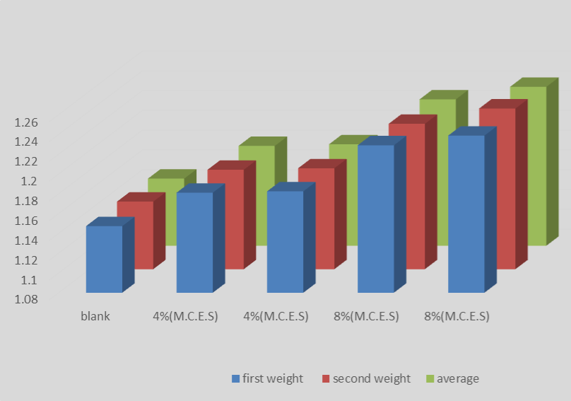
Fig(4) Relation between the Concentrations of finishing agent and the weight w/m² of the treated fabric

From fig.5 show that: the weight w/m² of treated fabrics were increased compared with the blank sample, as it shows an actually increase 2.87% and 6.9% when treated with finishing agent (M.C.E.S) 4% and 8% respectively.

4.5. Studying the tensile strength and tear properties of the treated fabrics:
4.5.1. Tear properties of fabric:
Fig.5 clarified that the tear of treated fabric was increase with increase of the finishing agent (M.C.E.S) from 2% until 10% then the tear was down again at 12%, it may be due to that at 10% the fabric was completely treated while at 12% the fabric has no more ability to react with finishing agent, generally all the results obtained were acceptable as the tear of all treated sample mostly increased, the best ratio is 10%.
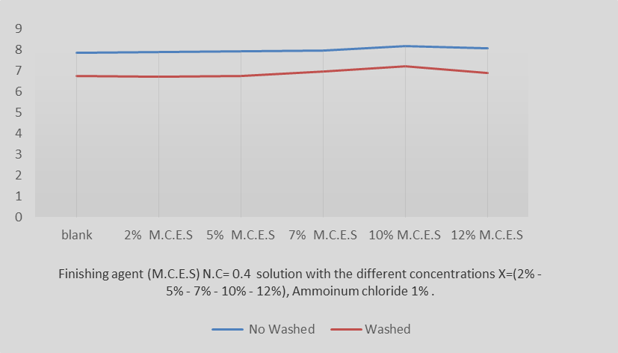
Fig (5) Relation between tear properties and finishing agent (M.C.E.S) Concentration at N.C= 0.406%.

4.5.2. Breaking strength & Elongation:
From illustrated fig.6 clarified that no sever loss in tensile strength of the fabric with no test at all finishing agent ratios as the T.S varies up and down the blank sample tensile strength with an acceptable limit.

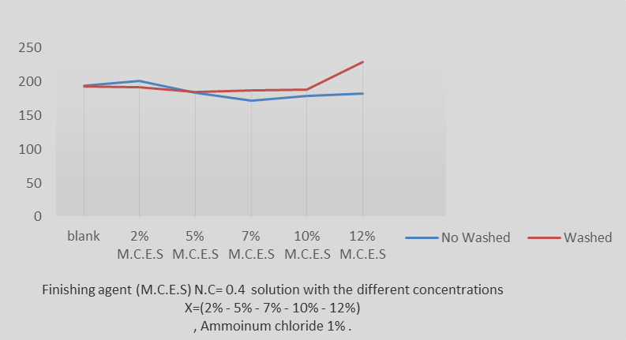Fig.6 Relation between T.S and finishing agent (M.C.E.S) Concentration at N.C= 0.406%.

Conclusion
In this study reactive finishing agent was synthesized with the possible low viscosity to ensure the penetration onto fabric and used for finishing cotton fabric and it is obvious the increase of weighting of fabric permanently in addition to increasing the physical properties of cotton fabric like tear strength of the fabric with low in tensile strength as a negative side of this treatment but still with an acceptable limit.

References
- S.C Alcazar, M.A Almeida, ’Physicochemical properties, modifications and applications of starches from different botanical sources’, Food Sci. Technol, Campinas, 35(2):215-236, Abr.-Jun. 2015.
- A.A Allam,’ ‘Ms.D. Thesis, Helwan University, 2001.
- K.Neelam, S.Vijay and S.Lalit, ‘Various Techniques For The Modification Of Starch And The Applications Of Its Derivatives’,
- International research journal of pharmacy, 3(5), 2012.
- D.P Hung, D.D Xuan, ‘Oxidized maize starch: characterization and its effect on the biodegradable films’, Vietnam journal of Sci. Technol, 55(4), 2017
- BS EN ISO 13937: pts.2 to 4: Tear properties of fabrics.
- ASTM D 5035; 1995 - Breaking strength & elongation – strip force.

11/20/2022

