**Jiang Gravitational Formula **

Chun-Xuan Jiang

China Aerospace Science And Technology Corporation

P. O. Box 142-206, Beijing 100854, P. R. China

J136211668701@163.com;

## Abstract: Using the space-time ring we establish the mathematical theory of space-time with subluminal and superluminal coexistence(SASC). Using two methods we deduce the Jiang gravitational formula. Tardyonic rotating motion produces the centrifugal force, but tachyonic rotating motion produces the centripetal force, that is gravity. Using it we establish the expansion theory of the universe and suggest the new universe model. Jiang gravitational formula changes all that. Using it we prove that in the universe there are no dark matters,no dark energies ,no gravitational waves,no quantum entanglements,no quantum computers,no Higgs particles and no black holes. We prove that the equivalence principle is not exist . Theory of everything has two forces :(1) the subluminal forces (electromagnetism and weak force) and (2) superluminal forces (gravity and strong force).Using it we prove that quantum information theory is unobservable and non-locality.

**[**Chun-Xuan Jiang. **Jiang Gravitational Formula .** *N Y Sci J* 2025;18(4):10-20]. ISSN 1554-0200 (print); ISSN 2375-723X (online). <http://www.sciencepub.net/newyork>. 02. [doi:10.7537/marsnys180425.02](http://www.dx.doi.org/10.7537/marsnys180425.02)

**Keywords:** space-time; mathematical theory; subluminal; superluminal coexistence(SASC); gravitational formula; motion; centripetal force; expansion theory; universe

PACS:04.90.+e,98.80.-k.

**1．The Mathematical Theory of the Space-Time With SASC**

Throughout history, the notion of space and time has undergone a number of dramatic transformation, thanks to figures ranging from Aristotle, Leibniz and Newton to Gauss, Poincare and Einstein. In the present understanding of nature, space and time form a single entity called space-time. In 1975 Jiang has established the mathematical theory of space-time with SASC. This theory plays a key role for the entire field of physics to unlock the deepest mysteries of the universe.

In the Universe there are two matters: (1) the observable subluminal matter called tardyon(locality) and (2)the unobservable superluminal matter called tachyon(non-locality) which coexist in motion. The Tachyon can be converted into the tardyon, and *vice versa*. The Tardyonic rotating motion produces the centrifugal force, but the tachyonic rotating motion produces the centripetal force, that is gravity. Using the tardyonic and tachyonic coexistence principle we deduce the Jiang gravitational formula,

For establishing the mathematical theory of the space-time with SASC. we first define the space-time ring [1,7-8]

 （1）

where  and  are the tardyonic space and time coordinates,  is light velocity in vacuum, .

(1) can be written as Euler form

 （2）

where  is the tardyonic invariance,  the tardyonic hyperbolical angle.

From (1) and (2) we have

  （3）

 （4）

From (3) we have

 （5）

where  is the tardyonic velocity.

Using the morphism , we have

 （6）

where  and  are the tachyonic space and time coordinates,  is the tachyonic invariance, the tachyonic hyperbolical angle.

From (6) we have

 （7）

. （8）

From (7) we have

 （9）

where  is the tachyonic velocity.

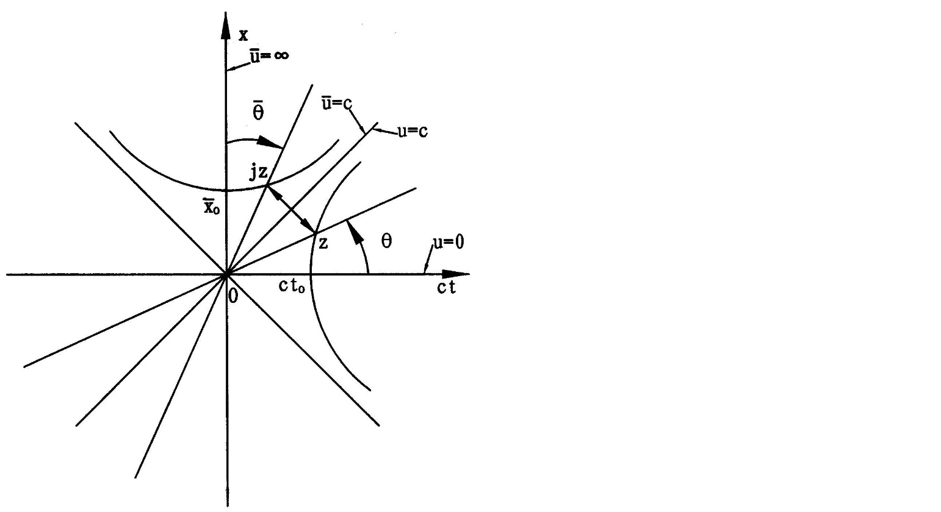

Fig. 1. The Mathematical theory of the space-time with SASC

Figure 1 shows the formulas (1)-(9).z is the subluminal space-time theory: locality,the classical information theory, classical computers and no classical gravitational theory. jz is the unobservable superluminal space-time theory:non-locality,no quantum information theory， no quantum computers and the quantum gravitational theory. is that tardyon can be converted into tachyon, but  is that tachyon can be converted into tardyon.  is the positive acceleration, but  is the negative acceleration, which coexist. At the ct-axis u=0 and x=0 we define the tardyonic rest time t. At the axis we define the tachyonic rest space

 （10）

Since at rest the tachyonic rest time  and , we prove that tachyon is unobservable and non-locality.

Fig.1 and (10) are the mathematical theory of space-time with SASC, which are the foundations of physics and cosmology. Using Fig.1 and (10) we prove that dark matter,dark energy,gravitational waves,quantum entanglements,quantum computers, black holes and quantum information theory do not exist.

Note.During the 30 years ,the field of quantum information theory has produced a variety of novel information technologies whose full potential is as yet unknown .They gave rise to the new fields of quantum information processing ,but the conceptual problems are not fully settled.The quantum information theories and experiments are mistake.The violation of Bell inequalities and 2022 Nobel prize in physics are mistake. The quantum computers are not exist.

From Fig 1 we can deduce Jiang gravitational formula.

**2.Jiang Gravitational Formula: **

Assume , from (5) and (9) it follows SASC [1-4,7-8]

. （11）

Using the analytical method we deduce the Jiang gravitational formula. Differentiating (11) by the time, we get

 （12）

 and  can coexist in motion, but their directions are opposite.

We study the tardyonic and tachyonic rotating motions. In 1673 Huygens discovered that the tardyonic rotation produces centripetal acceleration

, （13）

where  is rotating radius.

Substituting (13) into (12) we have the tachyonic centrifugal acceleration

 （14）

(13) and (14) have the same form. From (13) we get the tardyonic centrifugal force

 （15）

where  is the inertial mass.

From (14) we get the tachyonic centripetal force, that is gravity

, （16）

where  is the gravitational mass converted into by tachyonic mass .

(15) and (16) have the same form. (16) is the Jiang gravitational formula.

Using the geometrical method we deduce the Jiang gravitational formula..

**Figure 2** shows that the rotation  of body  emits tachyon mass , which forms the tachyon and gravitation field and gives the body  revolutions  and .



Fig.2. On body  the  and  coexistence [2]

From Fig. 2 .it follows

 . （17）

From (17) it follows the tardyon centripetal acceleration on the body [2-4],

. （18）

From Fig. 2. it follows

. （19）

From (19) and (11) it follows the tachyon centrifugal acceleration on the body [2-4],

. （20）

On body  the  and  coexistence.

From (18) it follows the tardyon centrifugal force on body [2-4],

, （21）

where  is body  inertial mass.

From (20) it follows the tachyon centripetal force on body , that is gravity [2-4,7-8],

, （22）

where  is the gravitation mass converted into by tachyon mass  which is unobservable, but  is observable.

(22) is the Jiang gravitational formula. In 1976[2] this simple thought made a deep impression on me. It impelled me to establish the new gravitational theory. On body the  and  coexistence.



Fig.3. On body  the  and  coexistence and the new Universe model

From Fig. 3, it follows

.（23）

From (21), (22) and (23) it follows

. （24）

Body  increases mass  and centrifugal force is greater than gravitation force, then body  expands outward.

From above we prove that equivalence principle is not exist.

Using Fig.3 we establish the new universe model.The universe has no beginning and no end.The universe is infinite.

1. Let body A be the earth center,body B is the moon;
2. Let body A be the sun center,body B is the Earth;
3. Let body A be the Galactic center,body B is the star in the milky way;
4. ......
5. Let body A be the universe center;body B is the star in the universe.

In Fig.3 on body B there is tardyonic centrifugal force and tachyonic centripetal force coexistence.

It is the universe foundations.All matter has unobservable tachyons to produce gravity. We should establish new cosmological theory and new particle physics theory.

From (22) it follows Newtonian gravitation formula. The  is proportional to body  mass , in (24)  is proportional to , is inversely proportional to the distance  between body  and body . It follows

, （25）

where  is constant

Substituting (25) into (22) it follows the Newtonian gravitation formula [2-4,7-8]

, （26）

where  is gravitation constant.

Note.Neither Newton nor any of his followers was ever able to give a convincing explanation of the origin of this gravity.We prove that the tachyonic rotating motion produces the centripetal force ,that is gravity.It is the quantum gravitational theory.

Now we study the freely falling body. Tachyonic mass  can be converted into gravitational mass , which acts on the freely falling body and produces the gravitational force

, （27）

where  is the Earth radius.

We have the equation of motion

, （28）

where  is gravitational acceleration,  is inertial mass of freely falling body.

From (28) it follows the gravitational coefficient

. （29）

Eötvös experiment  and Dicke experiment . Since the gravitational mass  can be transformed into the rest mass in freely falling body, we prove that the freely falling bodies fall with the same acceleration 。We prove the equivalence principle is not exist.

**3．The expansion theory of the universe**

Using Jiang gravitational formula we study the expansion theory of the Universe[7-8]. Figure 4 shows a expansion model of the Universe. The rotation  of body  emits tachyonic flow, which forms the tachyonic field. Tachyonic mass  acts on body , which produces its rotation , revolution and gravitational force

, （30）

where  denotes the distance between body  and body ,  is gravitational mass converted into by tachyonic mass  which is unobservable but  is observable.

The rotation of the body  around body  produces the centrifugal force

, （31）

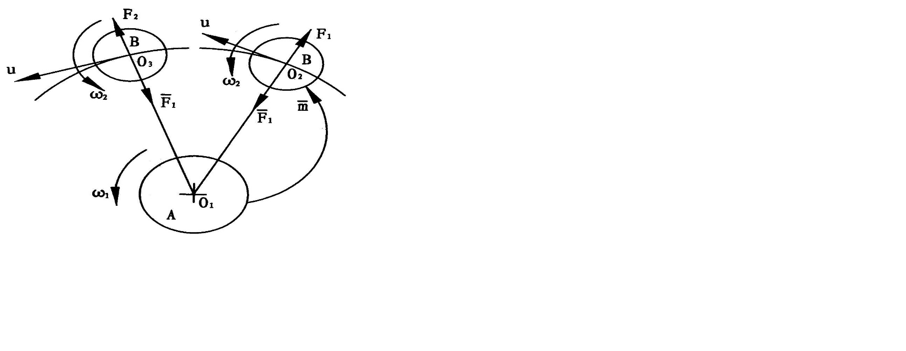

Fig. 4. A expansion model of the Universe

where  is the inertial mass of body ,  is the orbital velocity of body .

At the  point we assume

. （32）

From (32) it follows that the coexistence of the gravitational force and centrifugal force.

From (30)-(32) it follows the gravitational coefficient

 （33）

At the  point the tachyonic mass can be converted into the rest mass  in body , it follows

. （34）

Since , centrifugal force  is greater than gravitational force , then the body  expands outwards and its mass increases. This is a expansion mechanism of the Universe. From (31,32,34) we have



. (35)

From (35) we obtain the expansion acceleration



. (36)

Substituting (33) in (36) we obtain

 (37)

If body  is the Earth, then body is the Moon; if body  is the Sun, then body  is the Earth; …. It can explain our accelerating universe. In the universe there are no dark matter and no dark energy. This simple thought made a deep impression on me. It impelled me to establish a expansion theory of the universe .Dark energy responsible cosmic repulsion is wrong.

If the body  is the Sun and body  is the planet. We calculate the gravitational coefficients  as shown in table 1.

Table 1: Values of the gravitational coefficients 

|  |  |  |
| --- | --- | --- |
| Planet | (km/sec) |  |
| Mercury | 47.89 | 255.2 |
| Venus | 35.03 | 136.5 |
| Earth | 29.79 | 98.7 |
| Mars | 24.13 | 64.8 |
| Jupiter | 13.06 | 19.0 |
| Saturn | 9.64 | 10.3 |
| Uranus | 6.81 | 5.2 |
| Neptune | 5.43 | 3.3 |
| Pluto | 4.74 | 2.5 |

The gravitational field of the solar system is the origin of the planet mass. From it the planet acquire mass. In the universe there are no Higgs particles.the equivalence principle does not exist.

**4．Conclusion**

In summary. We deduce tardyonic and tachyonic coexistence principle. Using it we deduce the centrifugal formula and Jiang gravitational formula We establish the expansion theory of the universe . The Jiang gravitational formula is foundations of particle physics and cosmology.

Where did we come from? Where are we going? What makes up the universe? These questions have occupied mankind for thousands of years. Over the course of history, our view of the world has been changed. Theologians and philosophers, physicists and astronomers have given us very different answers. Where did we come from? We answer this questions this way , tachyons  tardyons[1], that is tachyons can be converted into the electrons and positrons which are the basic building-blocks of the elementary particles[5-6]. In the universe there are no Higgs particles and no quarks. The standard model of particle physics is wrong.The tachyons are the origin of mass. Where are we going? We answer this question this way , that is the tardyons produce tachyons[1]. The tardyons and tachyons make up the Universe.

Note. In 1976 Jiang found a gravitational formula[2] : , where  is the tachyonic mass. In 2004 Jiang studied the Universe expansion and found the Jiang gravitational formula , where  is gravitational mass converted into by tachyonic mass [7].

Newtonian gravity formula is based on empirical evidence. He did not explain what is gravity? how it works? The equivalence principle does not exist.

References

[1] Chun-Xuan Jiang, A theory of morphisms between the tardyon and tachyon, physics(Chinese), 4. (1975)119-125.

[2] Chun-Xuan Jiang, On nature for gravitation,(new gravitational formula) J. Beijing observatory (Chinese), 7(1976)32-38.

[3] Chun-Xuan Jiang, An approach on the nature of attractive force, Potential science (Chinese), 4(1982)19-20.

[4] Chun-Xuan Jiang, A unified theory of the gravitational and strong interactions, Hadronic J., 24(2001)629-638.

[5] Chun-Xuan Jiang, A simple approach to the computation the total number of hadronic constituents in Santilli model,Hadronic J.,3(1979)256-292.

[6] Chun-Xuan Jiang, A mathematical model for particle classification, Acta Math.Scien,8(1988)133-144.

[7] Chun-Xuan Jiang,New gravitational formula and expansion theory of the universe. In: new studies of space-time theory(Chinese),Dizi press,pp.254-259,2005.

[8] Chun-Xuan Jiang,New gravitational formula; The expansion theory of the Universe without dark energy. In: unsolved problems in special and general relativity,Education publishing,USA, p131-140,2013.

Acknowledgments

The author thanks professor Walter Lewin for his mails.

(1)From:”Walter H.G. Lewin”<[lewin@space.mit.edu](mailto:lewin@space.mit.edu)>

Date:Sun,10 Jun 2012 22:22:21-0400(EDT)

Subject:Re: Fwd.

To:123jiangchunxuan@gmail.com;lewin@mit.edu

Cc:luc@vanocken.be

Publish this in a refereed journal and once it is accepted buy yourself a first class ticket to Stockholm to pick up Nobel prize for physics.

(2)From:”Walter H.G. Lewin”<[lewin@space.mit edu](mailto:lewin@space.mit%20edu)>

Date: Sun,17 Jun 2012 06:19:37-0400(EDT)

Subject:Re

To:123jiangchunxuan@gmail.com

Cc:luc@vanocken.be

Dear Jiang

Thank for your email.

I suggest you submit your theory to a refereed journal.If it is accepted,then buy yourself a plane ticket to Stockholm to pick up a Nobel prize.

…..

Greetings.

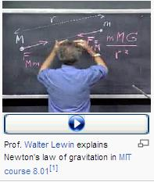

2024-07-07