An International Journal

**Biomedicine and Nursing**

**Acta Zhengzhou University Overseas Edition**

**ISSN 2379-8211 (print); ISSN 2379-8203 (online); Quarterly**

**Volume 11 - Number 2 (Cumulated No. 41), June 25, 2025**

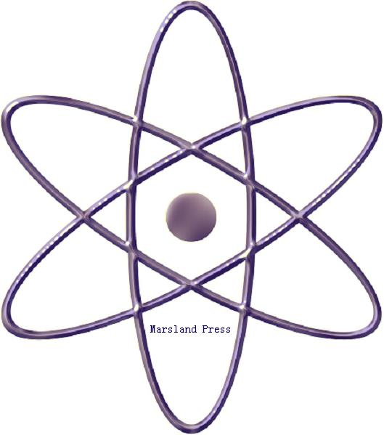

The 2nd Affiliated Hospital of Zhengzhou University, 2 Jingba Road, 2nd Affiliated Hospital of Zhengzhou University, Zhengzhou, Henan 450014, China. 011-86-371-6362-0736.

2316 Gunther Avenue, Suite 3-3, Bronx , New York 10469, USA; Tel. +1 718-502-6829; Fax: +1 718-513-0385

Marsland Press

310 West 18th Street, New York, NY 10011, USA

Websites: [http://www.nbmedicine.org](http://www.lifesciencesite.com/); <http://www.sciencepub.net/nurse>

E-mails; [nbmeditor@gmail.com](mailto:jacksun689@gmail.com); [editor@sciencepub.net](mailto:editor@sciencepub.net).

**Biomedicine and Nursing**

**Acta Zhengzhou University Overseas Edition**

**ISSN 2379-8211 (print); ISSN 2379-8203 (online); Quarterly**

**Volume 10 - Number 4 (Cumulated No. 39), December 25, 2024**

**General Information**

**(1) Goals**: As an international journal published both in print and on internet, **Biomedicine and Nursing** is dedicated to the dissemination of fundamental knowledge in all areas of biomedicine and nursing science and nursing practice. The main purpose of **Biomedicine and Nursing** is to enhance our knowledge spreading in the world under the free opinion/idea publishing principle. It publishes full-length papers (original contributions), reviews, rapid communications, and any debates and opinions in all the related fields.

**(2) What to Do**: The **Biomedicine and Nursing** provides a place for discussion of scientific news, research, theory, philosophy, profession and technology - that will drive scientific progress. Research reports and regular manuscripts that contain new and significant information of general interest are welcome.

**(3) Who**: All people are welcome to submit manuscripts in life science fields. Papers of other fields are also considered.

**(4) Copyright and Responsibility of Authors to their Articles:** When the manuscript(s) is submitted to the journal, the authors agree the following: All the authors have participated sufficiently in this work; The article is not published elsewhere; Authors are responsibility on the contents of the article; The journal and author(s) have the same right for the copyright of the article and either of the journal or author(s) can use it by anyway without noting the other party.

The 2nd Affiliated Hospital of Zhengzhou University, 2 Jingba Road, 2nd Affiliated Hospital of Zhengzhou University, Zhengzhou, Henan 450014, China. 011-86-371-6362-0736.

2316 Gunther Avenue, Suite 3-3, Bronx , New York 10469, USA; Tel. +1 718-502-6829; Fax: +1 718-513-0385

E-mails; [nbmeditor@gmail.com](mailto:jacksun689@gmail.com); [editor@sciencepub.net](mailto:editor@sciencepub.net).

Websites: [http://www.nbmedicine.org](http://www.lifesciencesite.com/); <http://www.sciencepub.net/nurse>



© 2025 Zhengzhou University / Marsland Press