An International Journal

Biomedicine and Nursing
Acta Zhengzhou University Overseas Edition
ISSN 2379-8211 (print); ISSN 2379-8203 (online); Quarterly

Volume 11 - Number 3 (Cumulated No. 42), September 25, 2025

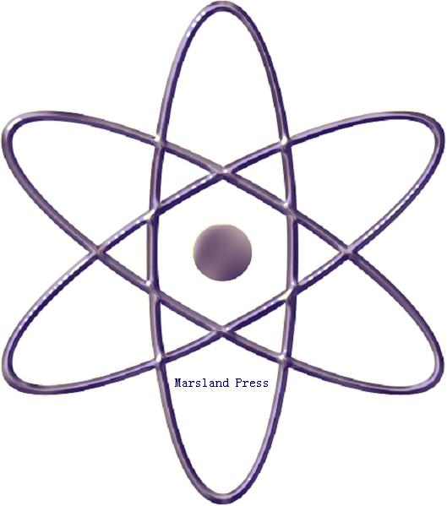

The 2nd Affiliated Hospital of Zhengzhou University, 2 Jingba Road, 2nd Affiliated Hospital of Zhengzhou University, Zhengzhou, Henan 450014, China. 011-86-371-6362-0736.
2316 Gunther Avenue, Suite 3-3, Bronx , New York 10469, USA; Tel. +1 718-502-6829; Fax: +1 718-513-0385

Marsland Press
310 West 18th Street, New York, NY 10011, USA

Websites: http://www.nbmedicine.org; http://www.sciencepub.net/nurse
E-mails; nbmeditor@gmail.com; editor@sciencepub.net.

Biomedicine and Nursing
Acta Zhengzhou University Overseas Edition
ISSN 2379-8211 (print); ISSN 2379-8203 (online); Quarterly
Volume 10 - Number 4 (Cumulated No. 39), December 25, 2024

General Information
(1) Goals: As an international journal published both in print and on internet, Biomedicine and Nursing is dedicated to the dissemination of fundamental knowledge in all areas of biomedicine and nursing science and nursing practice. The main purpose of Biomedicine and Nursing is to enhance our knowledge spreading in the world under the free opinion/idea publishing principle. It publishes full-length papers (original contributions), reviews, rapid communications, and any debates and opinions in all the related fields.
(2) What to Do: The Biomedicine and Nursing provides a place for discussion of scientific news, research, theory, philosophy, profession and technology - that will drive scientific progress. Research reports and regular manuscripts that contain new and significant information of general interest are welcome.
(3) Who: All people are welcome to submit manuscripts in life science fields. Papers of other fields are also considered.
(4) Copyright and Responsibility of Authors to their Articles: When the manuscript(s) is submitted to the journal, the authors agree the following: All the authors have participated sufficiently in this work; The article is not published elsewhere; Authors are responsibility on the contents of the article; The journal and author(s) have the same right for the copyright of the article and either of the journal or author(s) can use it by anyway without noting the other party.

The 2nd Affiliated Hospital of Zhengzhou University, 2 Jingba Road, 2nd Affiliated Hospital of Zhengzhou University, Zhengzhou, Henan 450014, China. 011-86-371-6362-0736.
2316 Gunther Avenue, Suite 3-3, Bronx , New York 10469, USA; Tel. +1 718-502-6829; Fax: +1 718-513-0385
E-mails; nbmeditor@gmail.com; editor@sciencepub.net.
Websites: http://www.nbmedicine.org; http://www.sciencepub.net/nurse

© 2025 Zhengzhou University / Marsland Press

