Some Studies on Filariasis and associated biochemical alteration in Egyptian buffaloes

¹ Mervat E.I. Radwan and Ola , F.A. Talkhan²

1 Fac. Vet. Hospital . Dept. of infectious diseases, Benha University
2 Biochemistry Dept., Shiben E- Kom vet. Lab., Animal heath Research Institute.
imankam_2@yahoo.com

Abstract
Filariasis are vector-transmitted parasites, exclusively tropical, except for dirofilariosis, it is associated with a heavy burden of morbidity and mortality in ruminants. This investigation was carried on one hundred Egyptian buffaloes, 1.5 - 5 years, from different private farms located in Kaliobia province in Egypt, suffering from fever (40-41ºC), anorexia, enlargement of superfacial lymph nodes, cutaneous sub cutaneous and intramuscular connective tissues ulcers and skin necrosis causing a seasonal haemorhagic dermatitis on skin. Laboratory examination indicated the presence of filaria in the blood. The serum investigations using some biochemical parameters measurments revealed some increase in lipid peroxidation product serum Malondialdehyd (MDA) and a decrease in serum total protein and albumin in diseased animals. Protein electrophoretic patterns showed declined values of α₂a ,α₂b, Total α, β₁, and γ₁ and total glubins concentrations in contrast γ2 fractions.
Mass drug administration study was reported here when infected animals were treated with two doses of Ivermectin (1 ml/50kg b.w) in combination to levamesol (1 ml/20 kg b.w) with two weeks interval, a marked recovery was noticed and confirmed by the serum biochemical analysis of treated animals. [Report and Opinion. 2009;1(1):35-44]. (ISSN: 1553-9873).

Key wards: Filariasis, Buffalo, Biochemical analysis, Disease control.

Introduction
Filariasis is widespread throughout the developing world and are associated with a heavy burden of morbidity and mortality resulting in considerable economic losses each year to beef and dairy buffaloes.
Filariasis is debilitating parasitic disease in many Tropical Countries. Despitethe highly evolved immune system, The Filarial parasites Successfully evade host immunity to persist for sustained period of time. Filarial parasites achieve this long – Term Survival Through release of immunosuppressive materials in host. (Muthian et al, 2006).
Filariasis is vector-transmitted parasites, transmitted by arthropod vectors, they are endemic in tropical and subtropical regions of the world, their impact differs according to the type of filaria and the induced immune response.
Diagnosis of filaria is made based on the presence of dermatological or lymphatic manifestations, it can also be established following a laboratory examination revealing adverse effects on some biochemical parameters or correspond to the incidental finding of microfilariae (blood or skin), the visualization of the adult parasite confirms the infection. (souls by, 1968)
The specific laboratory diagnosis of filariasis depends either on the demonstration of circulating microfilaria in the peripheral blood or various stages of the parasite in tissue sections. Various morphological characteristics of the parasite will normally assist in its identification. Concentration techniques, especially those using the polycarbonate membrane filtration of a ml or more of heparinised blood, can detect the parasite in those with very low microfilaria counts (Mak , 2004). Filariasis symptoms are usually caused by the adult worms, where microfilariae cause slight pathological alteration. The presence of the adult worm in lymphatics gives rise to inflammatory lesions and fibrosis which may result in some obstructions of lymphatics, overgrowth of fibrous tissues around dead worms and lymphatic vessels may also rupture this in association with different biochemical functions changes.
The present report deals with alterations in malonalhehyde (MDA) and total protein Fraction in blood of filariasis infected buffaoes before and after treatment.
There is little doubt that combination therapy mass drug administration represents a significant advance in treatment of filariasis (Maged el setouhy et al., 2004), numerous field trials evaluating the efficacy in the control of lymphatic filariasis have been conducted,
In this study, three trends of investigations were utilized, first is the clinical examination and diagnosis, second is the biochemical alteration in the infected and treated animals, concerning the MDA, serum protein and its electrophoretic pattern was performed, third concerns with the efficacy of utility of two drugs in particular, ivermectin (IVM) and Levamesole for effectiveness in the treatment of lymphatic filariasis.

Material and Methods
Animals
One hundred buffaloes 1.5-5 years from different private farms located in kaliobia were clinically examined.

Samples
Venous blood samples were collected on anticoagulant for direct smear parasitological examination. and other blood Sample without anticoagulant were collected at clean plastic centrifuge tubes and allowed to coagulate , The Serum were separated by centrifugation at 300 r.pm for 10 minute then clear supernatant serum aspirated carefully into dry and sterile labeled vials and used for serum analysis.

Microscopic examination
Identification of microfilariae by microscopic examination is the most practical procedure. Examination of blood samples will allow identification of adult filaria and microfilariae. It is important to time the blood collection with the known periodicity of the microfilariae. Venous blood samples were collected on anticoagulant before and after the treatment for direct smear parasitological examination . The detection of microfilaria was made by direct smear (the simplest method described by ( Soulsby, E.J.L.1968) as follow:
- Place one drop of venous blood onto a clean microscope slide.
- Place a coverslip over the drop of blood.
- Examine the coverslip area under low magnification (X 100) of microscope, look fore the undulating of larvae.

Serum analysis
Blood samples without anticoagulant for serum analysis during infection and 4 weeks after treatment were collected.
Serum was used for determination of total protein and its electrophoretic pattern, this was carried out according to SonnenWirth and Jaret (1980); Davis (1964) and Ornstein (1964) respectively. Also, MDA was measured by thiobarbituric acid method, a modified form of the procedure described by (Ohkawa 1979).

Treatment
Infected animals were treated with two doses, Ivermictin manufactured by Arab Company for Medical Peoducts), S/C injection in a dose of ( 1 mg/50Kg body weight in addition to Levamesole 7.5% manufactured by El. Nasr pharmaceutical chemicals co . Hydrochloride S/C injection in a dose of (1 mg/ 20Kg body weight ) with 2 weeks intervals for the two drugs

Statistical analysis:
Data obtained were statistically computed for ANOVA test and using least significant difference ( LSD) for comparison between means at p < 0.05 , using SPSS 14 ( 2006).

Results
Clinical signs of infected animals
The clinical investigation of infected animals revealed that the different infected buffaloes were suffering fever (40-41ºC), anorexia, enlargement of superficial lymph nodes, cutaneous subcutaneous and intramuscular connective tissues ulcers, nodules and skin necrosis causing a seasonal haemorhagic dermatitis on skin (filarial dermatitis), and abcesses in some cases. The nodules open spontaneously and produced a haemorrhagic exudates.( Souls by , 1968)

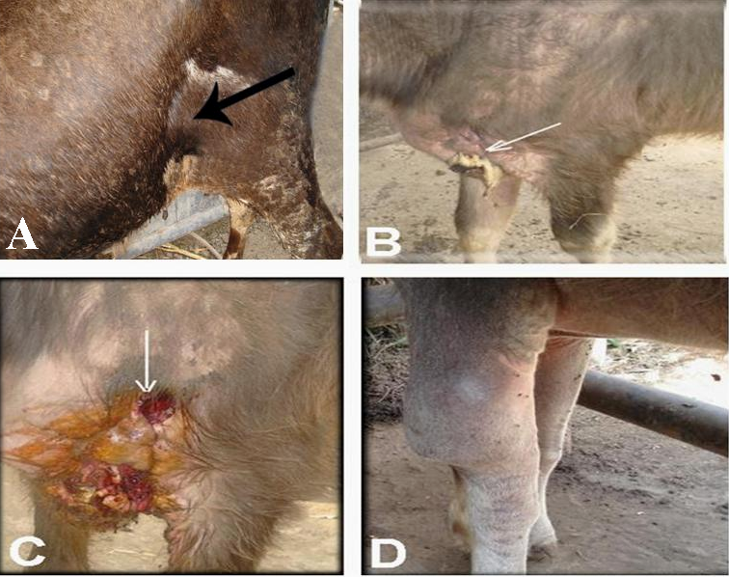
Figure 1: Different lesions of filariasis;
A, superficial lymph node enlargement.
B, spontaneously opened nodule.
C, surgical incision.
D, knee abcess and oedma.

Microscopic examination
Microscopic examination before treatment confirmed the presence of the adult and the microfilaria in the infected animal’s blood, the microscopic examination of the same animals after treatment confirmed the disappearance of the filarial parasites in the blood.
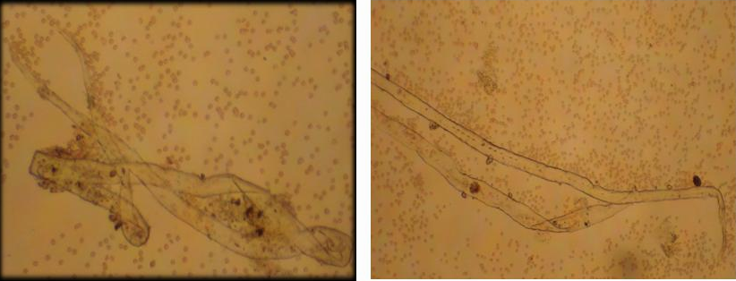
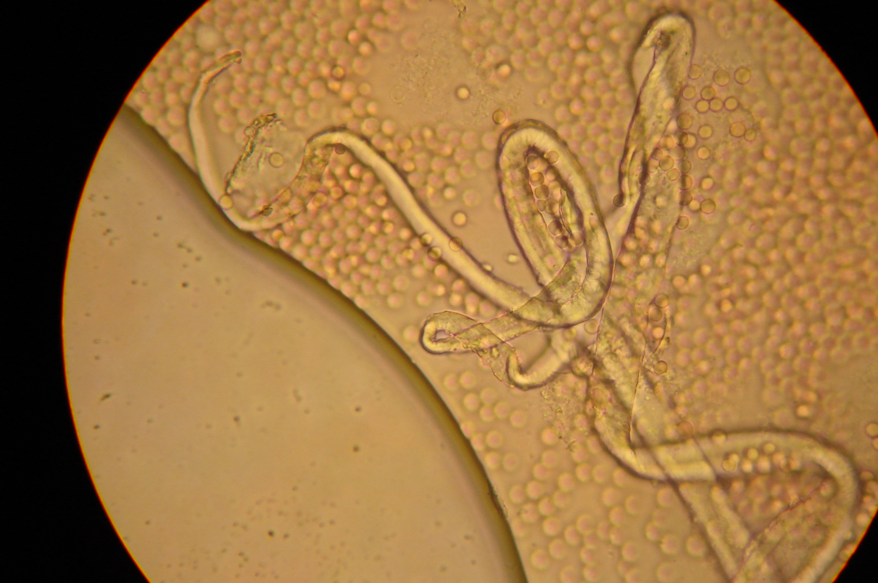

Figure 2: An impression smear of the filaria and the RBC in the capillaries

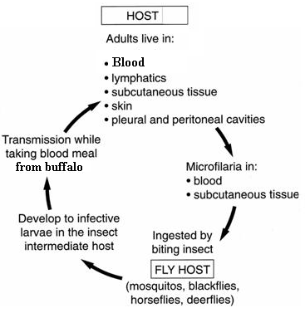
Figure 3: Basic life cycle of filarial

Biochemical Analysis
From gel electrophoresis ( Fig. 3) and from the statistical analysis examplified in table 1 , It is evidenced that, diseased buffaloes with filaria reported hypoproteinemia hypoalbuminemia , hypoglboblinemia (α,2a ; α,2b β1 and γ1,) and reduced A/G ratio was significantly increased as noticed after treatment.There was a significant drop in albumin value and consequently total protein.

Table (1 ): Total serum protein and its electrophoretic patterns concentrations (gm/dl) in control, diseased and treated buffaloes.
Parameter | Control | Diseased | Treated | LSD
T.P | 8.478±0.043 ª | 6.724±0.1745 ^{c} | 8.028±0.1026 ^{b} | 0.3683***
Albumin | 3.427±0.018^{b} | 2.439±0.039^{c} | 3.817±0.199ª | 0.363***
α₁ | 0.280±0.005^{b} | 0.250±0.016^{b} | 0.437±0.014ª | 0.0386***
α₂a | 0.413±0.004 ª | 0.282±0.007 ^{b} | 0.243±0.003 ^{c} | 0.01649***
α₂b | 1.076±0.014 ª | 0.496±0.058 ^{b} | 0.988±0.017 ª | 0.10917***
Total α | 1.769±0.017 ª | 1.028±0.080 ^{b} | 1.668±0.020 ª | 0.1507***
β₁ | 0.144±0.002 ª | 0.063±0.003 ^{c} | 0.084±0.002 ^{b} | 0.0066***
β₂ | 0.407±0.004 ª | 0.459±0.028 ª | 0.537±0.078 ª | 0.1476ns
Total β | 0.551±0.006 ª | 0.522±0.029 ª | 0.621±0.078 ª | 0.1471ns
γ₁ | 2.452±0.028 ª | 1.452±0.070 ^{b} | 1.213±0.094 ^{c} | 0.21407***
γ₂ | 0.279±0.007 ^{c} | 1.284±0.033 ª | 0.709±0.106 ^{b} | 0.1973***
Total γ | 2.731±0.034 ª | 2.735±0.053 ª | 1.922±0.143 ^{b} | 0.2776***
Total globulin | 5.051±0.040 ª | 4.285±0.153 ^{b} | 4.211±0.217 ^{b} | 0.476**
A/G | 0.679±0.006 ^{b} | 0.572±0.019 ^{b} | 0.925±0.098 ª | 0.176**
Each value represents mean ± S.E.; n = 5
*: Significant variation between groups by one ways ANOVA at P ≤ 0.05.

Total Protein was significantly decreased in diseased animals then partially restored in treated ones, albumin also significantly decreased in diseased buffalos where it was increased in treated animals.
α₁ significantly increased in treated buffalos, α2a significantly decreased in diseased and more decreased in treated. α ₂b significantly decreased in diseased animals where the total α significantly decreased in diseased buffalos.
In concern to β_{1,} it was significantly decreased in treated and more decreased in treated animals. It also noticed that total β and β₂ were non significantly changed in all groups.
γ₁ was significantly decreased in diseased and more decreased in treated
γ₂ significantly increased in diseased and more increased in treated, but total γ was significantly decreased in treated , concerning the A/G we can notice the significant increase in the treated animals .

Utilizing the MDA measurement in serum of diseased and treated animals, there was an elevated values of MDA in case of the infected animals, this value was declined after the treatment with ivermectin and levamisole

Fig (3 ) serum protein electrophoresis in different experimental buffalo groups: 1-2 control; 3-5 diseased; 6-8 treated

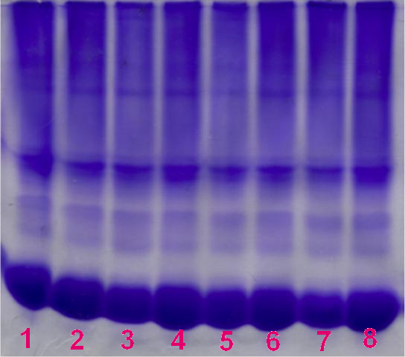

Table (2): Serum MDA (nmol/ml) in control, diseased and treated buffaloes.
Parameter | Control | Diseased | Treated | LSD
MDA | 0.058±0.0018 | 0.081±0.0034 | 0.0624±0.0065 | 0.0135**
Each value represents mean ± S.E.; n = 5
*: Significant variation between groups by one ways ANOVA at P ≤ 0.05.

Discussion
Screening for the filariasis has traditionally been difficult, requiring a microscopic examination of a blood sample. Often, this blood sample had to be collected in the middle of the night in order to correspond with the time of peak microfilariae abundance. Parasitic infections causes some biochemical alterations which could be recognized using some biochemical parameters investigations exemplified here by total serum protein and MDA with protein electrophoretic analysis.
It is evidenced from table (1) that diseased buffalo with filaria reported hypoproteinemia hypoalbuminemia, hypoglboblinemia (α2 ; β1 and γ1,) and reduced A/G ratio. The significant drop in albumin value and consequently total protein might be the result of inflammation caused by filarial disease, Taylor et al (2006). In inflammatory process, fluids and proteins move into the tissue fluids, resulting in edema and contributing to the decrease in albumin (Kaneko, 1989).
However, the significant alterations of globulins fraction table (1) may be attributed to immunosuppression effect of filarial host`s (Kamalu 1991) and the increase of prostaglandin E(2) which can affect the host s metabolism and immune response Brattig et al (2006). These results may reflect the decrease in α1-globulin due to decrease in alpha (1)-acid glycoprotein (Matsumoto et al, 2007). Also filaria can produce immune deficient in mice by development of lymphedema in the absence of T cells and opportunistic infection (Vincent, et al 1984).
Kuchbaev et al, 2001 showed that a significant increase of lysophosphatidylcholine and arachidonic acid as well as a decrease of docozagexaenic acid in PL of sheep infected with filaria have been recorded. That points out to structural and functional disorders of cellular membranes during the infection
Levamisol is a broad spectrum anthelmintic effective against the nematode infections including filaria. The combination of levamisole with ivermectin was neither macrofilaricidal nor more effective against the microfilariae and the adult worms Awadzi et al (2004). In this study, the alteration of serum t. protein and its fraction, induced by filarial infectious corrected by levamisole and ivermectin (anathematic treatment), treatment, which possibly protection against infection by enhance the immune system Kumari and Sahoo (2006). Also levamisole increase serum albumin level of Atessahin et al (2004) and consequently the level of total protein increase.
levamisol has consider an immune enhancer and reported to increase cell mediate, cellular and humeral immunities. Wang et al (2008).
Filarial mediated oxidative stress in the host which to produce reactive oxygen species (ROS), resulting from cellular metabolism of hosts ( Pal .et.al , 2006). Data revealed from this study shows a significant increased in lipid peroxidation in diseased group as compared with control. Thiobarbuturic acid reactive materials including MDA is the most popular and easiest method used as an indicator of liquid peroxidation and free radical activity in biological samples ( Romero et al., 1998). Filarial infection is displayed a significant increase of arachidonic acid. That points out to structural and functional disorders of cellular membranes during the infection. Kuchbaev and Bastarbekova (2001). The increase in arachidonic acid was accompanied by an increase in the quantity of thiobarbituric acid reactive substances (TBARS), Pompeia et al (2002) and Huang et al (2007).
As revealed from this study, levamisole and ivermectine co-administration with filarial infectious produced a significant reduction in serum malondialdehyde (MDA) level as compared with those treated with filaria alone( Table 2) These results are in agreement with those obtained by Kumar et al (1980) the author suggested that the inhibition of microsomal lipid peroxidation by levamisole is due to the generation of a sulfhydryl metabolite which had anti-oxidartant properties. Also Cam et al (2008) ivermectine ameliorated the increase in lipid peroxide
Treatment of filariasis involves two components: (1) getting rid of the microfilariae in animal's blood, so that the transmission cycle can be broken and (2) maintaining careful hygiene in infected animals to reduce the incidence and severity of secondary (e.g., bacterial) infections.
The operational efficiency of disease elimination programs in developing countries could be improved by integrating delivery of several interventions at local village and district areas endemic with filarial nematodes, the disease elimination strategy would be based on mass administration of a drug combination (WHO, 1998). Anti-filariasis medicines commonly used include Levamisole, which kills adult worms, and ivermectin, which kills the microfilariae produced by adult worms, El-Tahtawy et al., 2008.
ivermectin has a considerable direct macrofilaricidal action against female worms and that this lethal effect is supplemented by the drug's ability in some worms to increase the incidence, and the spread throughout the body of the worm, of the potentially fatal PN ovarian tumour. Duke BO, 2005 in his study confirmed that, in moribund and dead ivermectin-treated female worms that were heavily invaded by PN, it is probable that the neoplasm was chiefly responsible for their death, but the additional direct anthelminthic action of the drug, which by itself has been responsible for the death of many other female worms, cannot be excluded as having played a supplementary lethal rôle. Similar problems as to the exact means by which adult female worms are killed may arise now that ivermectin is used in Africa for the mass treatment of lymphatic filariasis; or if and when the macrofilaricidal actions on O. volvulus of other drugs, which are closely related to ivermectin, come to be investigated.
In this investigation, the treatment was carried out mass drugv administration
( multi dose combination therapy with ivermictin and levamisole) one targeting microfilariae and one targeting adult worms. Ivermectin is widely used for the control of filarial infections, particularly as a donated product for onchocerciasis and lymphatic filariasis (Edwards 2003). Ivermectin appears to work by paralyzing and then killing the offspring of adult worms, this may be a good drug administration strategy in the case of treatment of the microfilaria, it has long effective concentration time (2-4 week) after administration , this may be a good drug administration in the treatment of filarial , and serious adverse events ( SAE) rarely occur ( Brunton et al, 2006, especially that Levamisole has the capacity to enhance both the humoral and cellular immunity and kill the adult worms. Levamesole targeting on adult worms at low dose causing paralysis of the worms, it could be absorbed through the skin after dermal application and it will distribute through out the body , it also metabolize in liver, slow release and reach its peak concentration in blood after one hour from injection , so, levamesole efficiency depend on concentration not on the period contact. In this concern we utilized the administration of one mixed dose which was repeated after 14 days. Levamesole also has an immunomodulatory activity as its immunostimulant effect by restoring suppressed host immunity and enhancing the interferon activity ( Lullman et al., 2005 ).
It could be concluded that, different biochemical alterations in buffaloes serum proteins were influenced as a result of filarial infection and from the drug administration point of view, it is recommended that, co-administration of ivermectin and levamisole as filaricidal drugs was the administration of choice in the treatment of filarial in buffalo.

References
Atessahin A, Karahan I, and Pirincci I (2004):Effects of therapeutic and toxic doses of levamisole on thyroid hormones and some biochemical parameters in sheep. Cell Biochem Funct. 22(5):281-6.

Awadzi K, Edwards G, Opoku NO, Ardrey AE, Favager S, Addy ET, Attah SK, Yamuah LK, and Quartey BT(2004):The safety, tolerability and pharmacokinetics of levamisole alone, levamisole plus ivermectin, and levamisole plus albendazole, and their efficacy against Onchocerca volvulus. Ann Trop Med Parasitol.; 98(6):595-614.

Bal, B.K., Kulkarni, S., Bhandari, Y., Ganesh, B.B., Goswami,k., Reddy, M.V.R.Lymphatic Filariasis : Possible pathophysiological Nexus with oxidative stress. Tramsactions of Royal society of tropical medicine and hygiene , 2006, vol.100, No.7, pp . 650-655.

Börkü , M . Atalay , O . Kibar , M . Çam , Y . Atasever, A .( 2003): Ivermectin is an effective treatment for bovine cutaneous papillomatosis. J. Veterinary Science , Volume 83 , Issue 3 , Pages 360 – 363.

Brattig NW, Schwohl A, Rickert R, and Büttner DW. (2006): The filarial parasite Onchocerca volvulus generates the lipid mediator prostaglandin E(2). Microbes Infect.;8(3):873-9.

Cam Y, Atasever A, Eraslan G, Kibar M, Atalay O, Beyaz L, Inci A, and Liman BC. (2008):Eimeria stiedae: experimental infection in rabbits and the effect of treatment with toltrazuril and ivermectin. xp Parasitol.;119(1):164-72
Davis, B. (1964): Disk electrophoresis. II Method and application to human serum protein. Ann. N.Y. Acad. Sci., 121: 404-427.

Duke BO (2005): Evidence for macrofilaricidal activity of ivermectin against female Onchocerca volvulus: further analysis of a clinical trial in the Republic of Cameroon indicating two distinct killing mechanisms.J.Paracitology, 130(Pt 4):447-53

EL Setouhy,M.; REDA M. R.; EHAB S. A.; AMR M. K.; OMAR H. ; HODA A. F.; HANAN H. and GARY J. W.(2004): A randomized clinical trial comparing single- and multi-dose combination therapy with Diethyl carbamazine and albendazole for treatment of Bankroftian Filariasis. Am. J. Trop. Med. Hyg., 70(2): 191-196.
El-Tahtawy, A; Glue,P; Andrews, E. N.; Mardekian, J; Guy W. Amsden, and Knirsch, C.A.(2008): The Effect of Azithromycin on Ivermectin Pharmacokinetics—A Population Pharmacokinetic Model Analysis. J. PLoS Negl Trop Dis.2(5): e236.

WHO. Global Disease Elimination and Eradication as Public Health Strategies. Bull World Health Org. 1998;76(Suppl 2):162.

Geoffrey Edwards (2003): vermectin: does P-glycoprotein play a role in neurotoxicity?.J. Filaria, 2(Suppl 1):S8

Huang H, Chen Y, and Ye J. (2007): Inhibition of hepatitis C virus replication by peroxidation of arachidonate and restoration by vitamin E. Proc Natl Acad Sci U S A. 20;104(47):18666-70.

Kamalu BP, (1991) Canine filariasis caused by Dirofilaria repens in southern Nigeria. Vet Parasitol 40: 335–338.
Kaneko, JJ. (1989): Clinical Biochemistry of Domestic Animal. 4th Ed., Academic press, Inc. New York. P365-391.
Klotz U, Ogbuokir J, and Okonkwo P, (1990): Ivermectin bindings avidly to plasma proteins. Eur J Clin Pharmacol 39: 607–608.
Kuchbaev AE, and Bastarbekova GM (2001):[Phospholipid and fatty acid content of the blood of sheep infected with the nematode Dictyocaulus filaria] Parazitologiia. 2001 Sep-Oct;35(5):449-53

Kumar KS, Dobbs CR, Weiss JF, and Chirigos MA (1980): Levamisole inhibition of microsomal lipid peroxidation as related to its sulfhydryl metabolite dl-2-oxo-3-(2-mercaptoethyl)-5-phenylimadazolidine. Immunopharmacol. 1980;2(1):73-83.

Kumari J, and Sahoo PK (2006): Dietary immunostimulants influence specific immune response and resistance of healthy and immunocompromised Asian catfish Clarias batrachus to Aeromonas hydrophila infection. Dis Aquat Organ. 12;70(1-2):63-70.
Lullman, H.; Mohr, K.; Hein, L. and Bieger, D. (2005): Color atlas of pharmacology, 3ed Ed.

Mak J.W. . (2004): Antifilarial compounds in the treatment and control of lymphatic filariasis. J. Trop Biomed. 21(2):27-38.
Matsumoto K, Nishi K, Kikuchi M, Kadowaki D, Tokutomi Y, Tokutomi N, Nishi K, Suenaga A, Otagiri M (2007): Alpha1-acid glycoprotein suppresses rat acute inflammatory paw edema through the inhibition of neutrophils activation and prostaglandin E2 generation. Biol Pharm Bull. 30(7):1226-30.

Muthian , G. pradeep, C.G., Kuttappan sqrgapradeep, Raghavan Kaleysaraj, Bright, J.J: Setaria digitata secreted filarial Lipid modulate IL- 12 signaling through JAK- Stat Path way Leading to development of Th ₁ response. Experimental parasitology, 2006 , vol.114,No.3.pp . 193-203.
Okhawa H, Ohishi N, and Yagi N (1979): Assay for Lipid peroxides in animal tissues by thiobarbituric acid reaction. Ann Biochem,; 5: 351–58
Okonkwo P, Ogbuokiri J, Ofoegbu E, and Klotz U, (1993): Protein binding and ivermectin estimations in patients with onchocerciasis. Clin Pharmacol Ther 53: 426–430.
Ornstein, LC. (1964); Disk electrophoresis. 1-Background and theory. Ann.N.Y. Acd. Sci., 212:221.

Pillai, S.; Kalinna B.; Liebau, E.; Hartmann, S.; Theuring, F. and Lucius,R. (2005): Studies on Acanthocheilonema viteae cystatin: Genomic organization, promoter studies and expression in Caenorhabditis elegans. Filaria Journal vol 5, 4-9

Pompeia C, Freitas JJ, Kim JS, Zyngier SB, and Curi R.(2002): Arachidonic acid cytotoxicity in leukocytes: implications of oxidative stress and eicosanoid synthesis. Biol Cell. 94(4-5):251-65.

Romero, F.J.; Bosch-Morell, F.; Romera, M.J.; Martin, N.M. and Romera, J. ( 1998) : Lipid peroxidation products and antioxidant in human decrease. Environ. Health. Perspect, 106 (5): 1129-1234.
Sonnenwirth, A. and Jaret, L. (1980): " Garduals Clinical Laboratory Methods and Diagnosis." Vol.1,8th Ed., Mosby.

Sousby E.J.L.(1968): Six Th Edition Helminths, Ar thropods and protozoay Domesticated animals.

Taylor MJ, Cross HF, and Bilo K (2006): Inflammatory responses induced by the filarial nematode Brugia malayi are mediated by lipopolysaccharide-like activity from endosymbiotic Wolbachia bacteria. J Exp Med. 17; 191(8):1429-36.

Vincent, A.L., Vickery, A.C., Lotz, M.J., and Desai, U. 1984. The lymphatic pathology of Brugia pahangi in nude (athymic) and thymic mice C3H/HeN. J. Parasitol 70:48-56]

Wang X, Jin H, Du X, Cai C, Yu Y, Zhao G, Su B, Huang S, Hu Y, Luo D, She R, Luo X, Zeng X, Yi X, Wang B. (2008):The protective efficacy against Schistosoma japonicum infection by immunization with DNA vaccine and levamisole as adjuvant in mice. Vaccine. 28;26(15):1832-45.
Yie Liu, M.; Chiang, J. P.; Hsu, D. and Deng, J. (2003): Abamectin attenuates gastric mucosal damage induced by ethanol through activation of vagus nerve in rats. Alcohol.Vol 30, Issue 1, P 61-65.

10/13/2008

