Biodiversity Conservation and Sustainable Rural Development in the Garhwal Himalaya

Sumeet Gairola*, C.M. Sharma, S.K. Ghildiyal, Sarvesh Suyal, C.S. Rana and D.S. Butola

Department of Botany, HNB Garhwal University, Srinagar Garhwal-246 174, Uttarakhand India.
sumeetgairola@gmail.com, sharmacmin@gmail.com

Abstract: In the present paper we have reviewed the link between socio-economic conditions of the villagers in the Garhwal Himalaya with forest resources. Well being of Local people and forest are intricately linked with each other. Increased resource dependency on surrounding forests and unplanned extraction is negatively affecting the biodiversity of the region. Lack of employment opportunities is the major cause of dependency of rural people on forest for livelihood, which is causing degradation of forest and forcing people to migrate to cities in search of jobs. Proper planning and management by Government in association with local people in tapping forest resources like medicinal plants and NTFP’s will certainly improve socio-economic conditions of the people and reduce unnecessary pressure on the forest resources. [Report and Opinion. 2009;1(4):6-12]. (ISSN: 1553-9873).

Keywords: Traditional knowledge, Non-timber forest products, Biodiversity, Socio-economic conditions.

1. Introduction
The Indian Himalayan region occupies a special place in the mountain ecosystems of the world. These geodynamically young mountains are not only important from the stand point of climate and as a provider of life, giving water to a large part of the Indian subcontinent, but they also harbor a rich variety of flora, fauna, human communities and cultural diversity (Singh, 2006). The Himalayan mountain system covers only 18% of the geographical area of India, but accounts for more than 50% of India’s forest cover and for 40% of the species endemic to the Indian subcontinent. Himalayan resources and ecosystem services are critical, not only for the sustainable livelihood of 115 million mountain people but also for a much larger population inhabiting the adjoining Indo-Gangetic plains (Rao et al., 2003). The Uttarakhand State of India is located between 28° 30'- 31° 30' N latitudes and 77°-81° E longitudes, which covers and area of 55,491 Km², of which 90 % (about 50,000 Km²) lies in the Central Himalayan region (Nag, 2001). About 64% of total geographical area of Uttarakhand is covered with forest (FSI, 2003). The state is undergoing an economic transition phase, and due to population growth and increase in demands of various products, the natural resource exploitation has reached an unprecedented level.

2. Socio-economic Conditions
Dispersed small settlements and terraced agricultural fields carved out of the hill slopes for raising crops, with numerous multipurpose tree species growing particularly on the boundaries of rain fed terraces are typical features in the temperate area of Garhwal Himalaya. Agriculture is the main occupation of about 80% people of western and central Himalaya (Sharma et al., 1999). It is also essential for accelerating the process of rural development as it plays a critical role in providing food and employment to the people and raw materials to the industries. Most of the farmers (above 70%) have small land holdings (less than 1ha). Average cultivated land per farmer in the central Himalaya is 0.5ha, but its production is supplemented from the adjacent forest ecosystem (Tewari et al., 2003). Traditionally the agricultural activities are concentrated between 1000-2000m elevations, often called as the agricultural or populated zone (Tewari et al., 2003). The farming systems in Garhwal Himalaya are basically of three types viz., (i) Livestock farming representing nomadism, (ii) mix livestock-crop farming (semi-nomadism) and (iii) mix crop-livestock farming (settled agriculture). The agricultural lands, which in fact represent an extensive form of an agri-silvi-horticultural system, accounts for about 7,000 Km² or nearly 15% of the total geographical area (Pant and Singh, 1987). Crop cultivation, animal husbandry, wild biodiversity and rural economy are subsystems of the integrated traditional resource management system (Figure 1). Numerous people in this region still live in far-flung remote and almost isolated areas where they maintain their own economy and science. They are almost completely dependent on nature for their needs like food, cloth, medicine or articles for religious rites. Maximum agricultural works is carried out by women folks, as male migrates to plains in search of jobs.

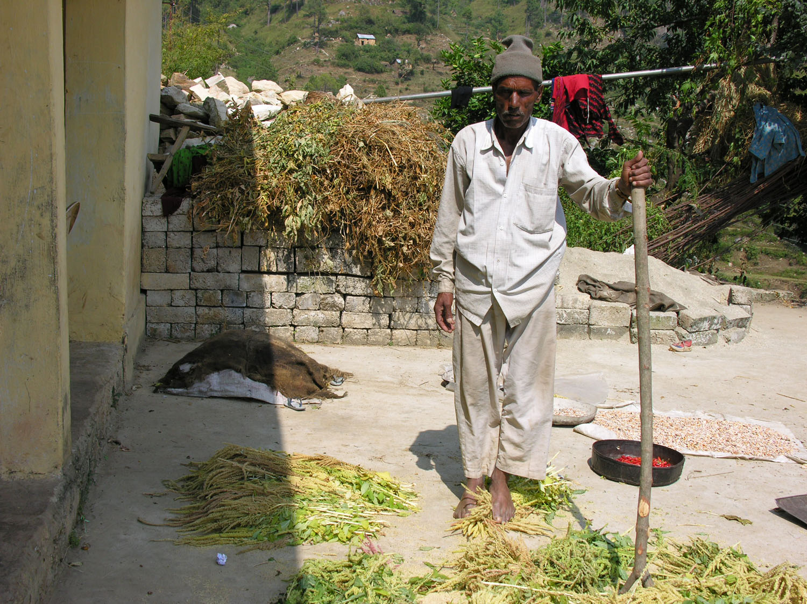
Figure 1. Agriculture is main occupation of people living in Garhwal region.

3. Biodiversity and people conflict
Biodiversity is essential for human survival and economic well being and for the ecosystem function and stability (Singh, 2002). The current biological diversity is a product of millions of years of evolution (Wilson, 1992). Over the past few decades, the Himalaya has experienced unprecedented land use changes, driven by rapid human population growth and intensified human activities, such as intense agriculture practice and expanding human settlements. Forest areas in the proximity of the population centres/villages are reported to be shrinking and degrading faster due to collection of fuel wood, fodder (Figure 2) and cattle/sheep grazing (Figure 3), etc, as compared to forests situated away from the population centres and located in inaccessible areas (FSI, 2000). The forest resources have also become unsustainable due to conventional management practices, which have resulted in to alienation of local population from forest and consequently in overall degradation of forests (Ghildiyal et al., 1998; Khanduri et al., 2002). These Himalayan mid-elevational anthropogenic landscapes now function as complex agro-ecosystems, and therefore management and conservation practices should be aimed in such a way so that conservation of biodiversity and sustainable use of the natural resources could be ascertained for future users (Maren and Vetaas, 2007).

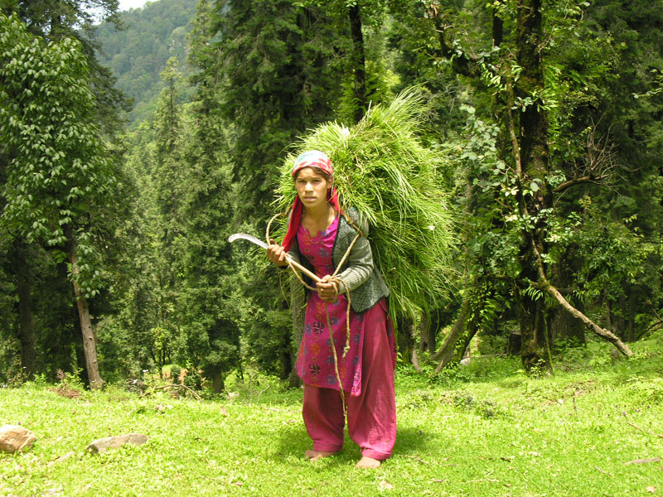
Figure 2. Girl extracting fodder from the forest.

Singh et al. (1984) reported that in Central Himalayan farming systems, each unit of agricultural crop energy produced entails an input of about seven units of energy from the adjacent forests in terms of fodder, fuel wood and litter (for manure). The link between forest management and the well-being of communities in forested areas has traditionally been defined by forest sector employment opportunities (Sharma and Gairola, 2007). The dependency of the continually growing population on finite resources, lack of viable technologies to mitigate the mountain specificities and enhanced production to meet the demands are depleting the resources along with increasing marginality of farmers, ultimately promoting poverty (Samal et al., 2003). Depletion of forest cover, biodiversity and terrestrial carbon stock, declining farm productivity, increasing hydrological imbalance and soil erosion are interconnected problems and therefore are the root-causes for the poor economy of the hill people (Chipika and Kowero, 2000). Because of the limited employment opportunities in the rural areas of the Garhwal Himalaya, people either migrate to plains in search of jobs or solely depend on forests and small scale agriculture for their livelihood. Human activity and unsustainable harvesting in the wild have been identified as one of the biggest causes of reported phenomenal loss of species (Wilson, 1988).
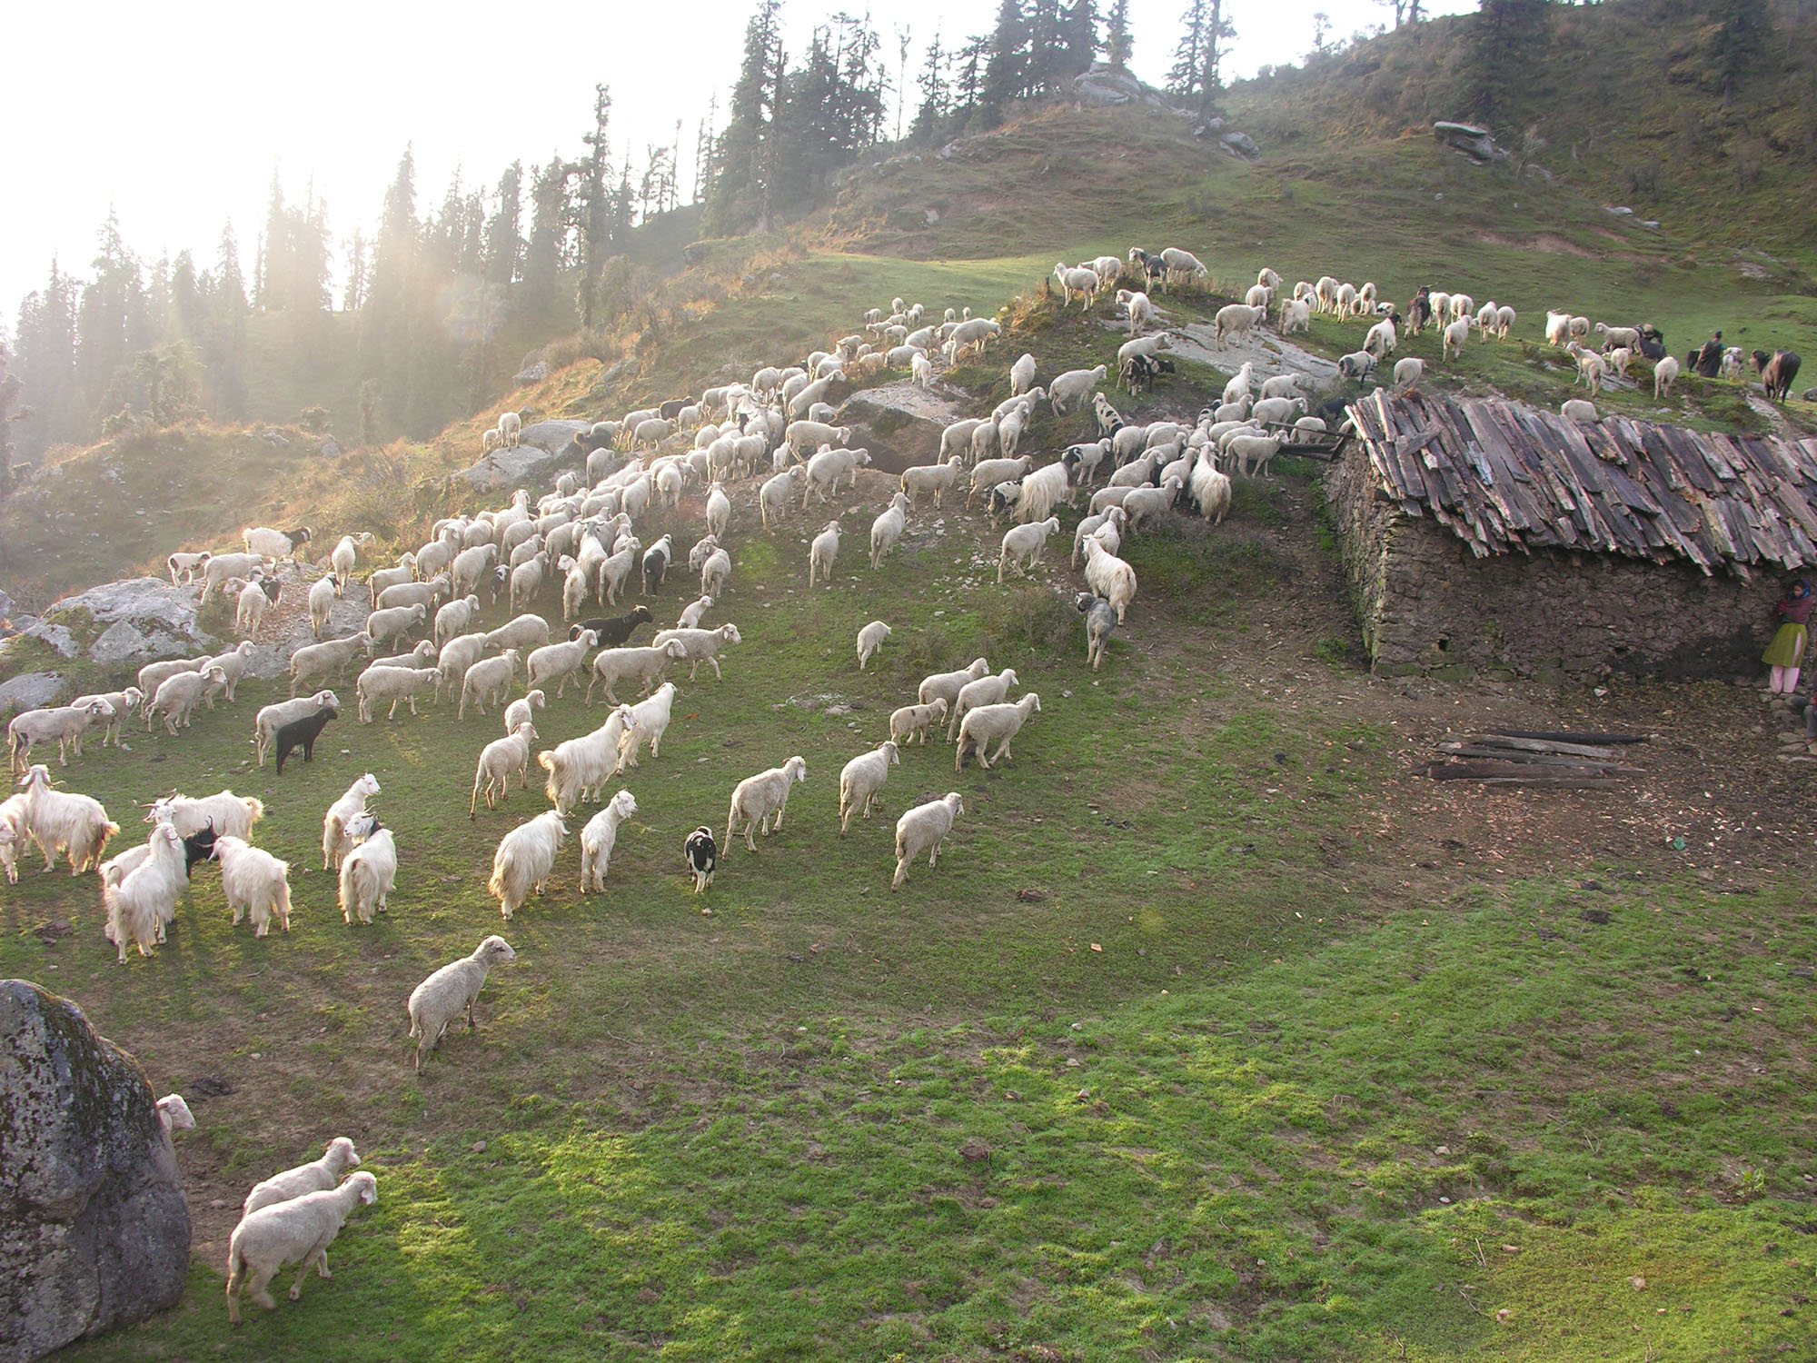
Figure 3. Grazing by sheep is common phenomenon in Alpine pastures of Garhwal Himalaya.

4. Medicinal Plants
Herbal medicine system has an important role in all the societies throughout the world. The use of folk medicines still occurs among different communities and the maintenance of their health even now is based on traditional system by the utilization of plant species. This folk knowledge provides an idea of conservation and search for new resources. One of the major sectors of natural resources in region is ‘medicinal plants’ (Adhikari et al., 2003). Medicinal plants have attracted considerable global interests in recent years. In the USA alone traditional drugs and preparation worth several hundred million dollars are imported from other countries especially India and China (Singh et al., 2005). India has a rich heritage of herbal medicines and an ethno-pharmocological tradition which has developed into an established scientific faculty dealing in plant-based Medicare, called Ayurveda (Mahapatra and Panda, 2002). The description of Himalayan medicinal plants can be seen in ancient as well as modern literature including those dealing with Ayurveda, Yunani, Tibetan, Chinese and Western system of medicine. It is believed that out of over 1600 species of medicinal plants traditionally used in India (Uniyal et al., 2002), more than 50% species come from the Himalayan region. About 2,500 wild plant species are reported in use for medicinal purposes in Indian sub-continent, of which, possibly about 300 taxa are used in 8,000 licensed pharmaceuticals in India (Ahmad, 1993).
Indigenous people have a vast knowledge of, and capacity for, developing innovative practices and products from their environment. Indigenous knowledge grows from close interdependence between knowledge, land, environment and other aspects of culture in indigenous societies, and the oral transmission of knowledge in accordance with well understood cultural principles and rules regarding secrecy and sacredness that govern the management of knowledge (Tripathi et al., 2000). Ethnobotanical studies typically focus on recording the knowledge of traditional societies in remote places (Hodges and Bennett, 2006). Studies by Jin et al. (1999) and Luoga et al. (2000) have showed that documenting indigenous knowledge through ethnobotanical studies is important for the conservation of biological and cultural diversities as well as sustainable utilization of resources. Maintaining traditional knowledge in the face of sweeping modern medicine and diminishing folklore is imperative (Abbas et al., 1992) as such wisdom in the past has proved to be the key for inventing wonder drugs for diseases once considered incurable. Identification of key habitats for conservation (Campbell, 1994) and integrating the ethanobotanical knowledge of forest users into conservation initiatives (Martin, 1995) can assist successful implementation of biodiversity plans and programmes. It is important to make strategies for the conservation of biological resources and to document the folk knowledge for the benefit of mankind. Such studies are beneficial in reducing the exploitation of product through the discoveries of new resources and will provide scope for the economic prosperity of the region.

5. Traditional Knowledge
Traditional botanical knowledge of indigenous communities relating to the uses and management of wild plant resources is extensive (Cotton, 1997). Turner et al. (2000) review showed that traditional ecological knowledge of indigenous people has fundamental importance in the management of local resources, in the husbandry of the world’s biodiversity, and in providing locally valid models fro sustainable life. This conservation and sustainable resource use will not be successful without the full participation of indigenous people and the application of their ethnobotanical and ecological knowledge. Rural people not only depend on wild plants as sources of food, medicine, fodder and fuel, but also developed methods of resource management, which may be fundamental to the conservation of some of the world’s important habitats (Cotton, 1997). Indigenous knowledge of these local communities includes a system of self-management that governs resource use (Laird and Neejovich, 2002).

6. Non-timber Forest Products
Medicinal and aromatic plants, as part of forest products other than fuelwood, fodder and timber, have been usually referred to as non-timber forest products (NTFPs) (Figure 4). The economic contribution of timber products, specifically in temperate forests and developed world, is fairly well understood, quantified, and recorded. Hence, normally, policy makers often assume that forests are of no economic value unless they are harvested (Greene et al., 2000). However, non-timber forest products (NTFPs), that include all biological products other than timber, are a traditional source of household income in rural areas around the world. NTFPs have always been and continue to be an important element of the forest resources in India; however, they have not received due attention. Extraction of non-timber forest products (NTFP) has assumed considerable significance in global efforts to conserve biodiversity (Godoy and Bawa, 1993). Judicious harvest of plant parts can be more sustainable than the harvest of whole adults, as is often the case when timber is harvested. The extraction of a wide variety of products can also result in greater economic diversification than the extraction of a single or a few products (Hegde et al., 1996).

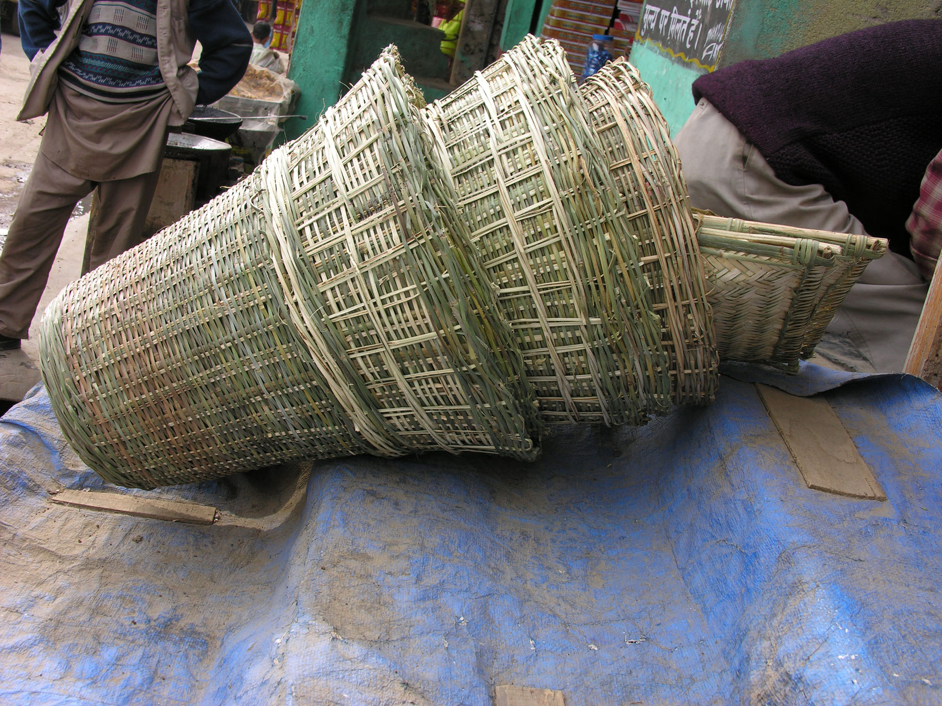
Figure 4. Hand woven basket made from bamboos extracted from forest.
NTFP provide a wide range of goods for domestic use and for the market, which includes fruit, nuts, medicinal herbs, forage and thatch and are available in open-access or semi-open access circumstances, particularly for the resource poor people (Singh et al., 2005). From a positive perspective, NTFPs can be viewed as a safety net because these serve as a source of emergency sustenance in times of hardship when crops fail, when economic crises hit, in times of conflict or war, or when floods was away homes (FAO, 2001). The value of NTFPs exceeds that of timber and economic systems and needs to be considered in full valuation of forest products (Jansen et al., 1991).

7. Conclusion
It is generally assumed that the sustained extraction and processing of non-timber forest products by local people can enhance their cash income and provide an alternative to tropical deforestation (Hegde et al., 1996). Sustainable extraction of NTFPs depends upon harvesting a small fraction of the total productivity. Over-exploitation can lead to a loss of biodiversity, but a low level of extraction, without value addition at the point of origin, is usually no economically feasible for extractors (Shankar et al., 1996). Levels of extraction resulting in resource depletion are not uncommon for many NTFPs in the tropics (Homma, 1992). Sustainable harvest of renewable natural capital like NTFPs can contribute to the economic well being of the forest people and involve them in conservation of biodiversity (Shankar et al., 1996). Sustainable harvest is defined here as the level of harvest that does not impair the ability of the harvested population to replace itself (Hall and Bawa, 1993). There is strong need to conserve over exploited species due to large scale collection form natural habitats. Conservation strategy has to build on by involving local people and all stakeholders for achieving a long lasting solution. The NTFPs have a huge potential that could lead to generate huge employment and revenue. In hilly areas, where the traditional agriculture could not match with the per unit area production with the plain areas, cultivation of medicinal plants could bring substantial benefit to local communities (Sundriyal, 2005). If the development interests of local people are marginalized for a long period of time, they might adopt actions detrimental to the goal of conservation. Capitalizing on the positive dimensions of traditional knowledge and overcoming its negative dimensions through conventional science-based inputs could ease the difficult process of securing people’s participation in environmental conservation together with the socio-economic development of local communities (Rao et al., 2003). Finally to avert negative outcomes of excessive species use integrated efforts that involve local people in the sustainable use of their resources should be made. Experienced and knowledgeable members of the community should participate in this process. Indigenous knowledge of local people on use and management of their plant resources is a valuable source of information for conservation and sustainable utilization of the plant biodiversity and, hence, conservation based on indigenous knowledge is recommended.

Acknowledgement:
We thankfully acknowledge the financial support provided by the Department of Science and Technology, Government of India, New Delhi, vide its Project No. SP/SO/PS-52/2004.

Correspondence to:
Sumeet Gairola
Department of Botany, HNB Garhwal University,
Post Box # 51, Srinagar Garhwal 2461 74,
Uttarakhand, India.
Telephone: 91-1346-250806
Cellular phone: 91-9411386123
Email: sumeetgairola@gmail.com

References
- Singh JS. Sustainable development of the Indian Himalayan region: Linking ecological and economic concerns. Current Science 2006;90(6):784-788.
- Rao KS, Semwal RL, Maikhuri RK, Nautiyal S, Sen KK, Singh K, Chandrasekhar K, Saxena KG. Indigenous ecological knowledge, biodiversity and sustainable development in the central Himalayas. 2003;44(1):93-111.
- Nag P. The Atlas of Uttaranchal. National Atlas and Thematic Mapping Organization, Department of Science and Technology, Govt. of India, New Delhi. 2001.
- FSI (Forest Survey of India). The State of Forest Report, Dehradun, FSI, Ministry of Environment and Forests, Government of India. 2003:134.
- Sharma CM, Baduni NP, Nautiyal DP. Socio-economic strategies for Environmental conservation in rural Garhwal Himalaya. Ecology, Environment and Conservation 1999;5(3):227-231.
- Tewari JC, Tripathi D, Pratap N, Singh SP. A study of the structure, energy fluxes and emerging trends in traditional Central Himalayan Agroforestry systems. Forest, Trees and Livelihoods 2003;13:17-38.
- Pant SS, Singh SP. Energy Use Pattern and Environmental Conservation: The Central Himalayan Case. Report, ICIMOD Project on rural Planning in the Indian Himalaya, TERI, New Delhi. 1987.
- Singh JS. The biodiversity crisis: a multifaceted review. Current Science 2002;82:638-647.
- Wilson EO. The diversity of life. WW Norton & Co., New York, USA. 1992.
- FSI (Forest Survey of India). The State of Forest Report 1999. Dehradun: FSI, Ministry of Environment and Forests, Government of India. 2000.
- Ghildiyal SK, Baduni NP, Khanduri VP, Sharma CM. Community structure and composition of Oak forests along altitudinal gradients in Garhwal Himalaya. Indian Journal of Forestry 1998;21(3):242-247.
- Khanduri VP, Sharma CM, Ghildiyal SK, Puspwan KS. Forest composition in relation to socio-economic status of people at three high altitudinal villages of a part of Garhwal Himalayas. Indian Forester 2002;128(12):1335-1345.
- Maren IE, Vetaas OR. Does regulated land use allow regeneration of keystone forest species in the Annapurna conservation area, central Himalaya? Mountain Research and Development 2007;24(4):345-351.
- Singh JS, Pandey U, Tiwari AK. Man and the forest: A central Himalayan case. Ambio 1984;12(2):80-87.
- Sharma CM, Gairola Sumeet. Prospects of Carbon Management in Uttarakhand: An Overview. Samaj Vigyan Shodh Patrika, Special Issue (Uttarakhand-1) 2007:23-34.
- Samal PK, Palni LMS, Agrawal DK. Ecology, ecological poverty and sustainable development in Central Himalaya region of India. International Journal of Sustainable Development and World Ecology 2003;10:157-168.
- Chipika JT, Kowero G. Deforestation of wood-lands in communal areas of Zimbabwe: is it due to agricultural policies. Agriculture, Ecosystems and Environment 2000;79:175-185.
- Wilson EO. The current state of biological diversity. In: Wilson EO, ed., Biodiversity Washington, DC: National Academy Press. 1988:3-18.
- Adhikari BS, Babu MM, Saklani PL, Rawat GS. Medicinal trees of Uttaranchal state: Distribution, use pattern and prospects for conservation. Indian forester 2003;129:243-267.
- Singh D, Srivastava RK, Khanduri VP. Marketing strategies and trade of medicinal plants in Uttaranchal: Present and future prospects. Indian Forester 2005;131(3):330-340.
- Mahapatra AK, Panda PK. Ethno-pharmacological knowledge of Juang and Munda tribes of eastern India, International Journal of Sustainable Development and World Ecology 2002;9:151-158.
- Uniyal SK, Awasthi A, Rawat GS. Current status and distribution of commercially exploited medicinal and aromatic plants in upper Gori valley, Kumaun Himalaya, Uttaranchal. Current Science 2002;82(10):1246-1252
- Ahmad RU. Medicinal plants used in ISM- their procurement, cultivation, regeneration and import/ export aspects- a report. In: Govil JN, Singh VK, Shamima H, eds., Glimpses in Plant Research. Vol X. Medicinal Plants: New Vistas of Research. Part-I. Today’s & Tomorrow’s Printers and Publishers, Delhi. 1993:221-258.
- Tripathi S, Varma S, Goldey P. Using plants for health: indigenous knowledge in health care in a tribal region of Bihar, India. International Journal of Sustainable Development and World Ecology 2000;7:321-332.
- Hodges S, Bennett BC. The ethnobotany of Pluchea carolinesis (Jacq.) G. Don (Asteraceae) in the Botanicas of Miami, Florida. Economic Botany 2006;60(1): 75-84.
- Jin C, Yin-Chun S, Gui-Qin C, Wen-Dun W. Ethnobotanical studies on wild edible fruits in southern Yunnan: Folk names, nutritional value and uses. Economic Botany 1999;53(1):2-14.
- Luoga EJ, Witkowski TF, Balkwil K. Differential utilization and Ethnobotany of trees in Kitulanghalo forest reserve and surrounding communal lands, eastern Tanzania. Economic Botany 2000;54(3):328-343.
- Abbas JL, El-Oqlah AA, Mahasneh AM. Economic Botany 1992;46(2):158-163.
- Campbell DG. Scale and patterns of community structure in Amazonian forest. In: Edwards PJ, Mayand RM, Webb NR eds., Large scale ecology and conservation biology, Blackwell Scientific Publications, London. 1994:179-199.
- Martin G. Ethnobotany. A people and plants conservation manual. Chapman and Hall, London. 1995.
- Cotton CM. Ethnobotany, Principles and applications. John Wiley & Sons, Chichester, UK. 1997.
- Turner NJ, Ignace MB, Ignace R. Traditional ecological knowledge and wisdom of aboriginal peoples in British Columbia. Ecological Applications 2000;10:1275-1287.
- Laird SA, Noejovich F. Building equitable research relationships with indigenous peoples and local communities: Prior informed consent and research agreements. In: Laird SA, ed., Biodiversity and traditional knowledge. Equitable partnerships in practice. World Wildlife Fund (WWF),UK and USA. 2002:179-220.
- Greene SM, Hammett AL, Kant S. Non-Timber Forest Products Marketing Systems and Market Players in Southwest Virginia: Crafts, Medicinal and Herbal, and Specialty Wood Products. Journal of Sustainable Forestry. 2000;11(3):19-39.
- Godoy R, Bawa KS. The economic value and sustainable harvest of plants and animals from the tropical rain forest: Assumptions, hypotheses, and methods. Economic Botany 1993;47: 215-219.
- Hegde R, Suryaprakash S, Achoth L, Bawa KS. Extraction of Non-Timber Forest Products in the Forests of Biligiri Rangan Hills, India. Economic Botany 1996;50(3):243-251.
- FAO (Food and Agriculture Organization). Global Forest Resources Assessment 2000. FAO Forestry Paper 140. Food and Agriculture Organization. Rome. http:// www.fao.org/forestry/fo/fra. 2001.
- Jansen PCM, Lemmens RHMJ, Oyen LPA, Siemonsma JS, Stabast FM, van Valkenburg JLCH. Basic list of Species and Commodity Grouping (Plant Resources of Southeast Asia). Wageningen, the Netherlands. 1991.
- Shankar U, Murali KS, Shaanker RU, Ganeshaiah KN, Bawa KS. Extraction of Non-timber forest products in the forests of Biligiri Rangan Hills, India. 3. Productivity, Extraction and Prospects of Sustainable harvest of Amla Phyllanthus Emblica, (Euphorbiaceae). Economic Botany. 1996;50(3):270-279.
- Homma AKO. The dynamics of extraction in Amazonia: a historical perspective. Pages 23-31 In: Nepstad DC, Schwartzman S eds., Non-timber products from tropical forests: evaluation of a conservation and development strategy. Advances

in Economic Botany 9. The New York Botanical Garden, Bronx, NY. 1992.
- Hall P, Bawa KS. Methods to assess the impact of extraction of non-timer forest products on plant populations. Economic Botany. 1993;47:234-247.
- Sundriyal RC. Medicinal plant cultivation and conservation in the Himalaya: An agenda for action. Indian Forester 2005;131(3):410-424).

5/20/2009

