Proximate Analysis and Mineral Composition of Edible Mushrooms in Parts of South Eastern Nigeria

¹Ezeibekwe, I.O, ²Ogbonnaya, C.I, ¹Unamba, C.I.N and ¹Osuala, O.M

¹Department of Plant Science and Biotechnology, Imo State University, Owerri.
²Department of Plant Science and Biotechnology, Abia State University, Uturu.
innocent_ezeibekwe@yahoo.co.in

Abstract: Proximate and mineral analysis of three species of mushroom, Plerotus tuber-regium, Plerotus squariosulus and Auricularia auricula were examined in this work to determine their nutritional value. These mushrooms were found to contain on the average 4.54-6.54% of crude fiber; 5.84-7.25% of ash; 1.29-3.73% of fats and oil; 19.47-22.76% of protein; 11.25-12.88% of moisture and 31.31-36.25 cal of carbohydrate. The average mineral element content of the mushrooms were found to be 0.59-0.92% of potassium; 0.57-0.74% of sodium; 0.52-0.63% of calcium; 0.24-0.36% of magnesium; 0.28-0.37% of phosphorus and 3.115-3.635% of Nitrogen. These results show that these species of mushroom are highly nutritive. These findings were discussed in line with the importance and implications of the uses of edible mushrooms to man. [Report and Opinion. 2009;1(4):32-36]. (ISSN: 1553-9873).

Keywords: Proximate Analysis, Mineral Composition, Edible, Mushroom, South Eastern, Nigeria

1. INTRODUCTION
Mushroom is a fleshy, spore bearing fruiting body, a fungus, typically produced above ground on soil or on its food source. Mushroom is most often applied to fungi (Basidiomycota, Agaricomycetes, order Boletales and family Boletaceae) that have stem (stipe), a cap (Pileus) and gills (Lamellae) on the other side of the cap. Mushrooms can be found in the forest around the country (Zoberi, 1985). Mushrooms such as the Pleurotus species are known to be among the largest fungi or saprophytic eukaryotes composed of hyphae filament that thrives very well in damp or moist condition (Mirko, 1985). According to Mirko (1985), some mushrooms especially members of the genus Amanita (Amanita species) are extremely poisonous.
Mushroom cultivation serves as the most efficient and economically viable biotechnology for the conversion of liqnocellulus waste materials into high quality protein food (Sohi, 1990). Mushrooms are found in areas with range of temperatures 20-40^{O}C and grow well in agricultural wastes (Soberi, 1985). They require a moderate rainfall and PH range of 3-10 for growth (Chang and Feinandez, 1980). Plerotus tuber-regium is the most edible mushroom in Nigeria.
Clara (2001) reported that Plerotus tuber-regium is highly nutritive and very rich in protein and also eaten for its flavour and beneficial medicinal effect. The protein content of edible mushrooms is equal to that of corn, milk and legumes (Clara, 2001). Mushrooms have been food supplement in various cultures and they are cultivated and eaten for their edibility and delicacy considered as sources of proteins, vitamins, fats, carbohydrates, amino acids and minerals (Clara, 2001).
Mushrooms have been considered healthy food because they contain high quality protein which contains all the essential amino acids, vitamins B, B₂, C and D and minerals such as A, K, Zn, Na, Fe, Mg, P and low fat (Bano, 1993).
Despite the medicinal, nutritional and economic importance of mushrooms as indicated by various authors and researchers, the nutritional values of some tropical edible mushrooms that are indigenous to South Eastern Nigeria have not been determined. This situation infers that people eat edible mushrooms without knowing their nutritional values. This justification informs this study whose aim is to determine the proximate values and mineral composition of three species of edible mushroom in parts of South Eastern Nigeria to be able to make deductions for general consumption on their food and mineral element values as well as their species differences as food items.

2. MATERIALS AND METHOD
Thirty (30) healthy, fresh and succulent mushrooms from the three species Plerotus tuber-regium, Plerotus squariosulus and Auricularia auricular were collected from Owerri and Orlu markets of Imo State, ten from each species. The samples were preserved in the chemistry laboratory of Imo State University, Owerri.

Proximate Analysis
The three edible mushroom species were analyzed for food composition according to the Association of Official Analytical Chemists (AOAC, 1995). These include the determination of crude fiber, Ash, Crude Protein, Fat, Carbohydrate and Moisture content.
The moisture content was determined by gravimetric method and calculated as follows:
% moisture = W₂ –W₂ x 100
W₂ – W₁ 1

Where W₁ = Wt of empty moisture can
W₂ = Wt of can before drying
W₃ = Wt of can + sample after drying to a constant weight
The protein content was determined by Kjeldahl method. The total nitrogen was determined and multiplied with the factor 6.25 to obtain the protein as follows:
Equal wt of W₂ = 14
Let the titre blank value be x
1ml of 0.02N H₂SO4 -14 x 0.02MgN
1ml of 0.2N H₂SO4 = 14 x 0.28 MgN
This was contained in 10mls digest
50ml digest will contain 0.28 x 50 MgN
This was contained in 0.2g sample
% N = 0.28 x 50m x 1 x 100
10 103 0.2
N = 0.7 x
% crude protein = 0.7x X 6.25
The x will be determined
The crude fiber was determined by the Weende method and calculated gravimetrically as % crude fiber as follows:
Crude fiber = W₂ –W₃ x 100
Wt of Sample 1

Where W₂ = weight of crucible + sample after washing and drying in oven.

W₃ = Weight = Weight of crucible + sample as ash
The total ash was done using the furnace incineration gravimetric method (AOAC, 1995) and the weight of ash obtained in percentage as follows:
% Ash = W₂ –W₃ x 100
Wt of Sample 1
Where W₁ = wt of crucible
W₂ = wt of crucible + material
The fat content was determined by the continous solvent extraction method using a Soxhlet apparatus and calculated as
% Fat = W₂ –W₁ x 100
Wt of Sample 1
Where W₁ = wt of empty extraction flask
W₂ = wt of flask and oil extract
The carbohydrate content was calculated by difference as the Nitrogen Free Extractive (NFE) as
% NFE = 100% (a + b + c + d + e) where
a = Protein
b = Fat
c = Fiber
d = Ash
e = Moisture
The mineral elements were dwetermined by the Dry Ash Extraction method of AOAC (1995) at National Root Crop Research Institute, Umudike as follows:
- Pottasium and Sodium by flame photosynthetic method
- Nitrogen by Kjeldahl method
- Phosphurus by the Vanadomolybdate (yellow) spectrometry method
Phosphurus content was given by the formula g/100g = 100/WxAU/ASxUF/VA where W = wt. of sample analysed
AU = Absorbance of test sample
AS = Assorbance of standard solution
VF = Total volume of filtrate
VA = Volume of filtrate analyzed
Percentage calcium and magnesium was calculated as follows
100 x EW x W x VF T
W 100 VA
The nitrogen content was determined by Kjedahl method as follows
Molecular wt. of N₂ = 14
Let the titre blank value be x
1 ml of 1NH₂SO₄ = 14gN
Xml of 0.2N H₂SO₄ = 0.28 x MgN
This was contained in 0.2g sample
%N = 0.20 x 50 m x 1 x 100
10 10³ 0.2
%N = 0.7x. The X will be determined.

3. RESULTS
The results of the investigation are presented here according to the parameters investigated. The moisture content is highest in A. auricular (12.88%) followed by Plerotus squarrosulus (11.85%) and least in Plerotus tuber-regium (11.25%). Fig 1
The crude protein content is highest in A. auricular (6.54%) and lowest in P. tuber-regium (4.8%) fig 3. Ash content is highest in P. tuber-regium (7.25%) with least content in A. auricular, fig 4. Crude fibre is more in A. auricular and least in P. tuber-regium. Fig 3.
The highest fat content is found in P. tuber-regium (3.73%) and the least found in A. auricular (1.29%) fig 5. The highest carbohydrate content is found in P. tuber-regium (36.25%) and lowest in A. auricular (31.31%) fig 6.
The highest potassium content is found in P. tuber-regium (0.9%) and lowest in P. squarrosulus (0.59%) fig 7. P. squarrosulus has the highest sodium content (0.74%) while P. tuber regium has the least (0.57%) fig 8. Calcium was more in P. tuber regium (0.6%) and least in A. auricular (0.52%) fig 9. Magnesium content was highest in A. auricular (0.36%) and least in P. tuber regium (0.24%) fig 10. Phosphurus is highest in P. tuber regium (0.37%) and least in A. auricular (0.28%) fig 11. The nitrogen content is highest in P. tuber regium (3.65%) and lowest in P. squarrosulus (3.11%) fig 12.

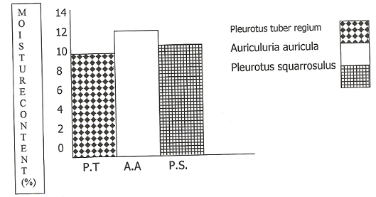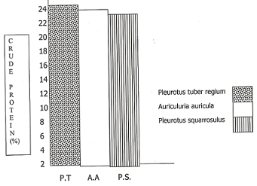
Fig 1: Moisture content of three mushroom species Fig 2: Crude protein content

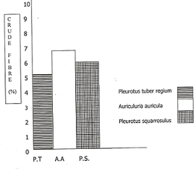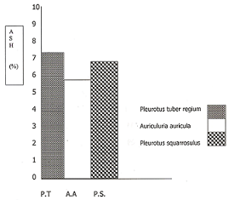
Fig 3: Crude fiber content Fig 4: Ash content

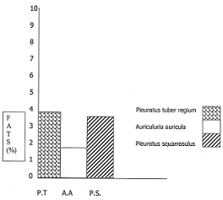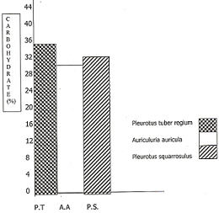
Fig 5: Fat content Fig 6: Carbohydrate content

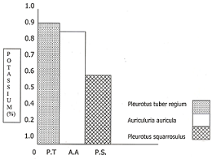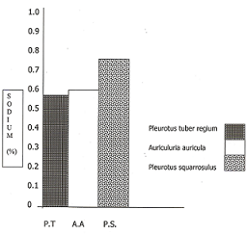
Fig 7: Pottasium content Fig 8: Sodium content

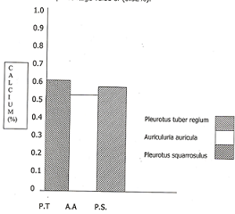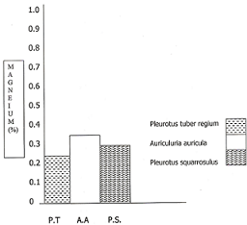
Fig 9: Calcium content Fig 10: Magnesium content

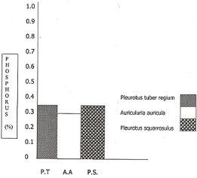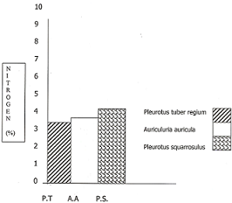
Fig 11: Phosphorus content Fig 12: Nitrogen content

4. DISCUSSION
The results of the proximate analysis of the three species of edible mushroom show that the mushroom are richly endowed with protein fibre, ash, moisture, fat, carbohydrates and mineral elements. This agrees with the finding of Moore and Chi (2005) that edible mushrooms have high nutritional attributes and potential applications in industries.
Plerotus tuber-regium has the highest protein content though low in crude fiber content of the three species. Plerotus tuber-regium also has the highest ash, fat and moisture content. This is in conformity with the findings of Bano (1993) who studied T. robustus and P. atroumbonata. Auricularia auricular and P. squarrosulus recorded low protein, ash, fat and carbohydrate contents when compared with P. tuber-regium. The relative high carbohydrate content as well as food energy values in these mushrooms suggests that they are food items (Chukwu, 2000). The high moisture content of protein especially in A. auricula suggests that great care must be taken in their handling and presentation as high moisture contents promote susceptibility to microbial growth and enzyme activity (Chukwu, 2000).
The results show that the three species of mushrooms were rich in Nitrogen and were found to contain reasonable levels of Pottasium, Sodium and calcium. This is in agreement with results of the study of some cultivated mushrooms(Agaricus bisporus and Pleurotus osterotus) (Edogo and Gomina 2000). They also reported that mushrooms are considered as sources of proteins, vitamins, fats, carbohydrates, amino acids and minerals. However, the three species of mushrooms studied here presented low levels of magnesium and phosphorus and these minerals are required for metabolic reactions.

5. Conclusion
The results of the proximate analysis of the three species showed that P. tuber regium had the highest levels of crude protein, ash, fat and carbohydrate. A. auricula recorded the highest moisture an fibre contents. It can be reasonably concluded following the results of this study that these edible mushrooms hold tremendous promise in complementing the protein and minerals supply deficiencies prevalent in developing countries like ours.
The results of the study showed appreciable levels of fibre which is known as anti-tumorigenic and hypochlestrolaemic agent. This implies that mushrooms hold special attraction and may be recommended for people with Cholesterol related ailment (Kadiri and Fasidi 1990). Due to high level of most mineral elements in the species, the three mushrooms can be essential for normal metabolic reaction, transmission of nerve impulse, regulation of water and salt balance and rigid bone formation.
The results suggest that the mushrooms hold great promise of alleviating the problem of protein supply deficit prevalent in this country since mushrooms are highly nutritional and can compare favourably with egg, meat and milk. However, for the nutritional potentioal of mushrooms to be realized, sustained efforts must be geared towards the husbandry (cultivation) and popularization of the more nutritious species like P. tuber regium, A. auricula and P. squarrosulus.

Correspondence to:
Dr. I.O. Ezeibekwe, Faculty of Science
Department of Plant Science & Biotechnology
Imo State University, Owerri
Email: innocent_ezeibekwe@yahoo.co.in

REFERENCES
AOAC (1995). Official Methods of Analysis. 13th
Edition. Association of Official Analytical Chemist, Washington, D.C.
Bano, Z (1993). Food value of mushrooms. Gram
Prandyogiki 3: 224-225.
Chang, S.T (1980) and Fernandex, F (1991). Studies on
the Padi Mushroom (Volvariella volvacea) 1 use of oil palm pericarp waste on alternative substrate. Mal. Agric. res. 2:15-22.
Chukwu, T (2000). Anti-nutritional factors in some
selected indigenous species. Unpublished project. Department of Biochemistry, ABSU, Uturu. Pp4-5.
Clara, F.M (2001). Culture of edible Mushroom in
Philippines. Journal of Agriculture 8(2):225-232.
Edeoga, H.O and Gomina, A (2000). Nutritional values
of some non-conventional leaf vegetables of Nigeria. Journal of Economic Botany 24:7-12.
Kadiri, M and Fasidi, I.C (1990b). Studies on enzyme
activities of Plerotus tuber regium Hein at various fruitbody stages. Nahrung, 34(8): 695-999.
Miriko, S (1985). Mushroom and fungi. Mycologia
48:10-12.
Moore, D and Chi, S.W (2005). Fungi products as food
(eds) pointing, S.B and Hyde, K.O. In Bio-Explotation of filamentous fungi. Fungi Diversity Research Lenis 6:223-251.
Sohi, H.S (1990). Studies on paddy straw mushrooms
(Volvariella spp) cultivated in India, present status and future prospects in beneficia fungi and their utilization. 2nd edition. Eds nair, M.C., Balakirishmans, N.N. scientific Publishers Jodhpur India. Pp 462-465.
Zoberi, M.H (1985). Some edible mushroom from
Nigeria. The Nigeria field 38; 81-89.

6/8/2009

