Comparative Effect of Poultry Manure and Urea on the Growth and Yield of Maize (Zea mays).

¹Ezeibekwe, I.O, ²Ogbonnaya, C.I and ¹Onuoha, C.I

¹Department of Plant Science and Biotechnology, Imo State University, Owerri.
²Department of Plant Science and Biotechnology, Abia State University, Uturu.
innocent_ezeibekwe@yahoo.co.in

Abstract: A comparative study on the effect of poultry manure and urea on the growth and yield of maize was carried out at Imo State University Botanical garden. The plant height, leaf area, stem diameter, number of leaves and fruit biomass (dry weight) parameters were measured. The results showed that poultry manure encouraged early flowering, fruiting and highest vegetative growth and fruit biomass/dry weight when compared with urea and control. The results also indicated that poultry manure is significantly different from control in all the parameters, but not significantly (P≤0.5) different from urea in number of leaf, with urea significantly different from control in stem diameter, leaf area and drey weight. Since maize is mainly grown for consumption and medicinal value, poultry manure is preferred for its production on the basis of this investigation. [Report and Opinion. 2009;1(4):37-40]. (ISSN: 1553-9873).

Key words: Effects, Poultry, Manure, Urea, Growth, Zea mays,

1. INTRODUCTION
Maize is an annual cereal crop which belongs to the family Poaceae. It grows up to 1-3m height producing a single upright stem with about ten to fourteen leaves inserted alternatively. Maize originated from central America and spread to the rest of the world following the discovery of America.
The crop has been in existence in Nigeria for more than 400 years, since its introduction by early explorers-the Portugueese. Although the cultivation of maize in Nigeria has assumed a wider proportion due to its high adaptability to this area, available information still indicates that majority of the crop production comes from the peasant farmers who have little or no knowledge of nutrient status present in a given soil prior to planting and the appropriate form required of the essential plant nutrient by plant. The essential plant nutrient supply especially that of Nitrogen can influence the growth and distribution of plant (Grigon and Rorison, 1972; Havill et al; 1974 and Richard, 2005).
Although plants take up Nitrogen in form of NO₃ and NH₄ under natural conditions, they can also take up N in form of Urea (Hayness and Goh, 1978). Urea is however converted to ammonia by urease in the soil; it can also be absorbed directly by plants (Mengel and Kirkby, 1979). Poultry farmers in the country tend to generate large amount of poultry manure which contains essential plant nutrients likely to be an asset to crop production. Poultry manure is a natural fertilizer which possess high nitrogen content and other essential plant nutrients, and serves as soil amendment by adding organic matter (Hussein, 1997).
Besides, due to the economic importance of this crop to the nation during this era of global food crisis and for the fact that majority of its production comes from peasant farmers who have little or no knowledge of the appropriate form required of essential plant nutrients (i.e. Nitrogen) by the crop, it is therefore necessary to assess the effect of poultry manure and urea on the growth and yield of maize. This paper also examined the economy of using poultry manure as an alternative to urea fertilizer for maize production and make recommendations to local farmers on how best to go about maize production.

2. MATERIALS AND METHODS

Experimental Location:
The experiment was conducted in the Botanical Garden of Imo State University, Owerri which is geographically located at latitude 5⁰N and Longitude 7⁰E in Imo State at South Eastern Nigeria.

Source of planting materials
The maize variety (Oba super-two) and urea used were obtained from imo Agricultural Development Programme (Imo ADP) Owerri, Imo State while the poultry manure was obtained from a local poultry farm at Orji in Owerri North L.G.A and analyzed to obtain its % Nitrogen content in the soil Science Laboratory of National root Crop Research Institute (NRCRI) Umudike. Besides, the experimental soil samples were taken from different locations at the experimental site and analyzed also at NRCRI Umudike for physical and chemical properties.

Table 1: Pre-Experimental Analysis of Soil
Parameters Values
Colour Dark
Texture Sandy loam
pH 5.20
% Sand 76.4
% Silk 9.4
% Clay 14.20
% Organic carbon 0.57
% Organic Matter 0.99
% P 55.64
% N 0.04
% Ca 3.20
% Mg 2.40
% K 0.03
% Na 0.096

Experimental design
The experiment was a Randomized Complete Block design (RCBD) with four plots. The experimental land was divided into four plots of 9.5 x 1.5m (14.25M²) each . The plots were further laid out into three blocks measuring 2.5 x 1.5m (3.7m²) each, thus giving a total of 12 blocks on which the treatments were randomly distributed. Both the plots and the blocks were separated one meter (1m) apart. The data obtained were subjected to analysis of variance (Anova) and Duncan New Multiple range Test was used to test for mean comparison.

Cultural Condition
After the blocks were properly ploughed into beds, 16 holes were made on each bed with a planting space of 75 x 30 cm² between the holes. The maize were planted three seeds per hole and ten days after germination, they were thinned down to one seedling per stand, thus giving a total of 16 maize seedlings per bed. The early rapid weed germination was controlled by weeding after which the treatments (urea and poultry manure) were applied at the third week after planting. The dried poultry manure was applied by broadcasting method while the urea was applied in granulated solid form in about 2cm deep circular trenches made away from the seedlings to avoid contact with them and covered with thin mantle of soil to avoid evaporation and leaching.

Table 2: Different Nitrogen Source and the level of application (i) g.N/block (ii) g. compound N fertilizer/block

Nitrogen Source % N content Level applied
Urea – N- 46.00 (i) 4.69
(ii) 10.2

Poultry manure 0.33 (i) 4.69
(ii) 14.21

Parameters Measured
The parameters measured during the experiment include- number of leaves per plant, total plant height, stem diameter and leaf area which were measured at weekly interval starting from 4th week after planting to 7th week after planting and fruit biomass (dry weight) which is measured after three weeks of air drying the harvested maize cobs. Number of leaves is measured by counting, stem diameter with venier caliper while plant height and leaf diameter were measured with tape.

3. RESULTS
The results of this investigation are reported here in accordance with the number of parameters investigated.

Total Height Growth (cm)
Table 3 shows the effect of poultry manure and urea on the total height growth of maize plants on sandy loam. The result showed no significance difference in urea and control but in poultry manure at 5% level of significance. Fig 1.

Table 3: Mean value of Total Height Growth (cm)
Treatments Mean/Value
Poultry manure 1.32ª
Urea 0.85^{b}
Control 0.74^{b}
(Mean with same letters are not significantly different)
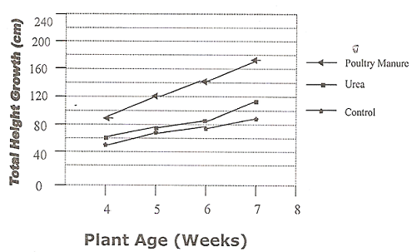
Fig 1: Effect of Poultry manure and Urea on Total Height growth of maize
Stem Diameter
The Analysis of Variance of Variance of the effect on stem diameter showed significant difference (P≤0.050 among the treatments. This is shown in table 4, Fig 2.
Table 4: Mean value of Stem Diameter (cm)
Treatments Mean/Value
Poultry manure 9.13ª
Urea 6.93^{b}
Control 5.8^{c}
(Mean with same letters are not significantly different)

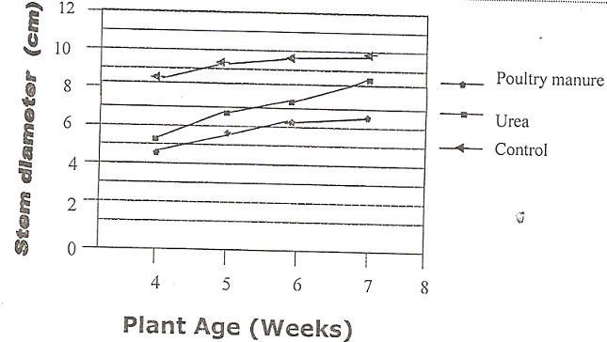
Fig 2: Effect of Poultry manure and Urea on Stem Diameter growth of maize

Number of Leaves
Table 5 shows the effect of poultry manure and urea on number of leaves produced by the plants. The highest number of leaves was recorded in poultry manure while control recorded the least. Analysis of variance showed that poultry manure is significant from control but urea is neither significant from poultry manure nor from control, Fig 3
Table 5: Mean value of Number of Leaves
Treatments Mean/Value
Poultry manure 12.11ª
Urea 9.73^{ab}
Control 8.73^{b}
(Mean with same letters are not significantly different)
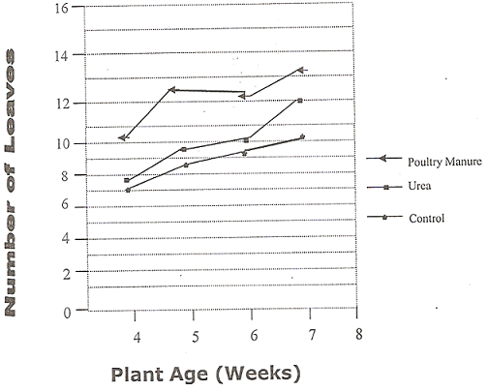
Fig 1: Effect of Poultry manure and Urea on Number of Leaves of maize
Leaf Area
Table 6 show the effect of poultry manure and urea on leaf of the investigated maize plant. Analysis of Variance showed significant differences among the treatments with poultry manure recording the highest mean while control recorded the least. Fig 4

Table 6: Mean value of Leaf Area (cm)
Treatments Mean/Value
Poultry manure 7.41ª
Urea 6.18^{b}
Control 5.23^{c}
(Mean with same letters are not significantly different)
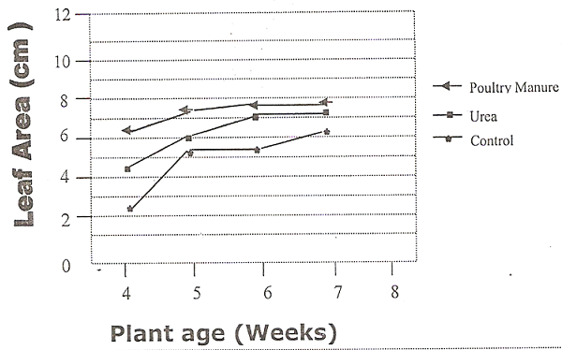

Fig 4: Effect of Poultry manure and Urea on Leaf Area of the maize plants

Dry Weight
Table 7 shows the effect of poultry manure and urea on dry weight of the maize cobs (fruits). The Analysis of variance showed significant difference (P≤0.05) in the treatments used. Fig 5
Table 7: Mean value of Dry weight
Treatments Mean/Value
Poultry manure 121.88ª
Urea 75^{b}
Control 35.5^{c}
(Mean with same letters are not significantly different).
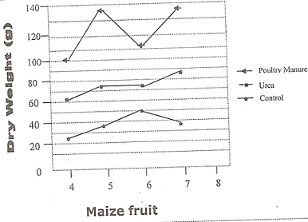
Fig 5: Effect of Poultry manure and Urea on Dry Weight of the maize fruits
4. DISCUSSION
The result of this investigation showed clearly that there was a significant difference among the treatments in stem diameter and leaf area while there was no significant difference among urea and control but in poultry manure at 5% level of significvance for total height growth of maize plants.
Also in number of leaves, poultry manure was significantly differenct from control while urea was non-significant (p≤0.05) to both poultry manure and control. The highest number of leaves was produced by plants treated with poultry manure (12.10) followed by those with urea (9.73) and the least is control (8.73). This was stressed by John et al (1992) that in addition to macro and micronutrients, organic manure improves soil physical condition and stimulates beneficial microorganisms. Thus improving the pore-space relationship on heavier soil that urea cannot do.
Plants treated with poultry manure started flowering in 6th week whereas those treated with urea and no treatment at all started in 7th and 8th week respectively. This is probably because poultry manure contains phosphorus which is responsible for early maturity (Sylvia, 1985).
However, the results obtained in this research work indicated that poultry manure did not only produce vegetative growth more than the control and urea but equally encouraged early fruiting of maize plants on the sandy loam soil. This is because poultry manure contains essential elements necessary for growth like nitrogen, phosphorus, calcium, magnesium and potassium unlike urea that is a single fertilizer containing only nitrogen as the essential element. This agrees with the report by Obi and Ebo (1995) that poultry manure as organic matter improves the chemical and biological qualities of the soil which increases crop productivity than chemical fertilizers.
Poultry manure recorded the highest dry weight/biomass of the cobs followed by urea with control having the lowest. The better performances associated with the poultry manure over other manures has been shown by many agronomic plants (Cooke, 1982 and Hussein, 1997). Poultry manure is well known organic matter which prevents acidification and helps in checking soil erosion by improving the soil structure (Bounchee et al, 1993). The enhancing of growth and yield by this fertilizer could by due to the neutralizing effect on sandy loam with the resultant release of other nutrients particularly phosphorus (Djokoto and Stephen, 1961).

Correspondence to:
Dr. I. O. Ezeibekwe
Department of Plant Science & Biotechnology;
Faculty of Science,
Imo State University
P.M.B. 2000, Owerri
E-mail: innocent_ezeibekwe@yahoo.co.in

REFERENCES

Djokoto, R.K and Stephens, D (1961). Thirsty
long-term fertility trials under continuous cropping in Ghana and crop yield responses to fertilizers and manure. Emperor Journal of Experimental Agriculture 29:181-190.

Grigon, A and Rorison, I.H (1972). Responses of some
ecological distinct plant species to NO₃-N and NH₄-N. Journal of Ecology 60:93-102.

Havil, D.C., Lee, J.A and Stewart, G.R. (1974). Nitrate
utilization by species from acid and calcareous soil. New phytologist 73;1221-1231.

Hayness, R.J and Goh, K.M 91978). Ammonium and
Nitrate nutrition of plants. Biological Revision 53:465-510.

Hussein, T.O (1997). Effect of poultry manure on
growth of tomato proceeding of 15th annual conference. HORTSON Apr. 8-11, 1997. NIHORT, Ibadan, Nigeria. Pp 43-45.

Mengel, K and Kirkby, E.A (1979). Principle of Plant
Nutrition. 2nd edition, International Potash Institute Berns, Switerland. Pp 30-35.

Obi, M.E and Ebo, P.O. (1995). The effect of organic
and inorganic amendments on soil physical properties and maize production in a severely degraded sand loamy soil in Southern Nigeria. Resource technology 51:117-123.

Richard, C (2005). Introduction to sustainable
Agriculture. National Sustainable Agric. Info. ATIRA. P2-4

6/19/2009

