sNew York Science Journal. 2009;1(4), Goshie, S. N., Comparative Study

Comparative Study Of Some Macrofauna In Sugarcane‘Fadama’ And Savanna Upland Soils

Goshie, Samuel Ndagi

Department Of Biology, College Of Education,P.M.B. 39, Minna, Nigaer State, Nigeria.

ndagijob@yahoo.com, +2348032884293

Abstract: Soil Macro fauna were extracted from Cultivated Sugarcane ‘fadama’ Soils, Using the Tullgren Funnel Method. Soil characteristics, such as Ph, Particle size and moisture content were determined. The Macro fauna of the two sites were dominated by two ant species, Camponotus acvapimensis and Phiedole species, although these species were generally fewer in Sugar cane ‘fadama’ soils. Finally the effects of the P^{H}, Particle sizes and moisture content on these organisms, as well as the roles they play in the soil were discussed.

[New York Science Journal. 2009;1(4):XX-XX](ISSN:1553-9873).

Key Words: Comparative, Macrofauna, Fadama, Savanna, Soils.

1. Introduction
Over the last decades there has been an increased interest in Soil Zoology, particularly in Europe and more recently in U.S.S.R, but little work has been done in soils of tropical regions Junk (1975).This interest has also to be sustained in Africa, particularly in the area of boosting the soil for agricultural production, a key to achieving the millennium development goals.
Soil in its widest sense is defined as the materials in which plants grow, (Madge&Sharma, 1969), and consists of both top and subsoils.The top soil is formed as a result of physiological, biochemical and biological processes .While the subsoil is formed as a result of the disintegration of parent rock into separate mineral particles, which are irregular in size and fit loosely together. These soils are also inhabited soil organisms and according to Wallwork (1970), and Okwakol (1980) the most widely used criterion in their classification is body size. He asserted that different soil organisms could either be classified as:
-Soil Microbiota: Those with body size less than 20um, e.g. soil protozoa, actinomagates, soil fungi and algae.
-Soil Mesobiota: Those with body size greater than 2oum, but less than
1cm e.g. nematodes, acari e.t.c.
-Soil Macroboita: Those with body size greater than 1 cm, e.g. Annelids, Mollusca, Athropods e.t.c.
This research is a contribution to the study of
macro fauna found in sugarcane “fadama” soils and

savanna upland soils with a view of establishing the roles they play in these soils.
2. Materials and Methods
Field Sampling:
Samples were obtained from cultivated sugar cane “fadama” soil located behind ICSA hall and savanna upland soil located at the botanical garden all within the confines of Ahmadu Bello University Zaria, Kaduna State, Nigeria. The soil samples were collected in the months of February, April and May. The samples were collected from the two sites by using a garden trowel to a depth of 10cm. Thereafter the samples were then placed in clean labeled polytene bags and transferred to the laboratory for the extraction of the macro fauna, and soil analysis

Extraction:
The macro fauna were isolated using Tullgren funnel method. The funnel consists of a glass funnel fixed to a retort stand and a sieve placed into it. 100gms of the soil sample was then transferred into the sieve. A collecting tube partially filled with 70% alcohol, was then fitted to the lower end of the funnel and stuck with a stopper. A 100 watt electric bulb was then fixed about 25cm above the sample. This concentrates heat and light on the sample. The set up was left undisturbed for 24hrs, after which the light was switched off and the tube underneath removed. The contents of the tube were then washed into a Petri dish containing 70% alcohol. The soil macro fauna obtained were examined and identified under a binocular microscope.

http://www.sciencepub.net/report reportopinion@gmail.com

New York Science Journal. 2009;1(4), Goshie, S. N., Comparative Study

Determination of Soil Characteristics

- Determination of soil P^{H}:
5ogms of each soil obtained from the two different sites, were put into two separate 250ml beakers. Thereafter 100ml of deionized water was then added to each of the soils in the beakers. The contents were stirred with glass rods intermittently every five to thirty minutes. The soil solutions were then left to settle for about thirty minutes after which the supernatants were decanted into two separate beakers. The ^{pH} was then read using a _{P}H scale.

- Determination of soil moisture:
20gm each of soils of the two different sites were transferred into two separate glass crucibles. The crucibles and their contents were then placed in an oven at 90 ºc for twenty four hours. At the expiration of this period the crucible and their contents were removed and cooled in a dessicator, until there was no more change in weight.

The moisture content was calculated by using the following formula:

A= (a-b)*100
b-c
Where:
A= Air dried content in percentage of dry soil weight.
a=Weight of the crucible with air dry soil.
b= Weight of the crucible with oven dried soil.
C= weight of the crucible

- Determination of particle size:
Soils of the two sites used for the determination of particle size were first loosened. After which 50gm of each of the soil samples were passed through sieves of different mesh sizes. The proportion of weight retained on each sieve was calculated.

Results:

During the course of this study, two species of ants were identified, these were, Camponotus acvapimensis (major) and Pheidole species (minor).

http://www.sciencepub.net/report reportopinion@gmail.com

New York Science Journal. 2009;1(4), Goshie, S. N., Comparative Study

Table 1: Number and Macro fauna Obtained from the two different sites

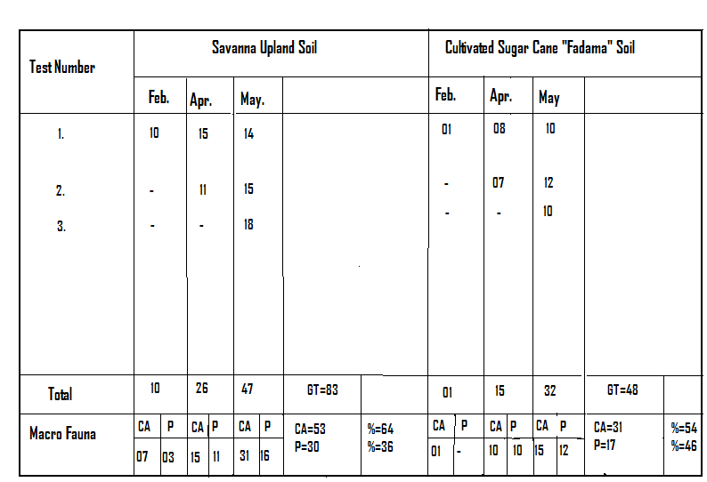
Key: CA = Camponotus acvapimensis
P = pheidole spp
GT = Grand Total

Table 1, above shows that savanna upland soil had the highest number Of macro fauna (83), as against cultivated sugar cane “fadama” soil with (48). It also showed that Camponotus acvapimensis was higher in Number in the two different, sites 64% and 54%, respective

Table 2: Mean comparison of macro fauna obtained from the two
different sites.

Test Month | Savanna Upland Soil | Cultivated Sugar Cane “Fadama” Soil
Feb.  Apr.  May. | 10  26  47 | 01  16  32
Total | 83 | 49
Mean | 28 | 17

Table 2 above showed that throughout the period of sampling Savanna upland soil had mean number of macro fauna of (28), while Cultivated sugarcane “fadama” had (17).

http://www.sciencepub.net/report reportopinion@gmail.com

New York Science Journal. 2009;1(4), Goshie, S. N., Comparative Study

Table 3: Showing the soil type of the two different sites.

Mesh Size (mm) | Cultivated Savanna Upland Soil  Weight in (grams) | Sugar Cane “Fadama” Soil  Weight in (grams)
1.700  0.710  0.600  0.500  0.212  <0.212 | 35.9  7.95  0.75  0.69  1.60  3.11 | 16.30  7.59  1.1  1.1  4.1  19.73

According to the international system of soil classification.
Coarse sand: 2.0-0.2mm
Fine sand : 0.2-0.2mm
Silt : 0.02-0.002mm
Clay : less than 0.002mm

Table 3, above has distinctly placed savanna upland soils as Sandy and Cultivated sugarcane “fadama” soils as clay soil.

Table 4: P^{H}
Soil Type | P^{H}
Savanna Upland Soil | 5.55
Cultivated Sugar Cane “Fadama” Soil | 5.25

Table 4, above shows that both soils as being slightly alkaline.

Table 5: Moisture content.
Soil Type | Moisture Content  % Dry Weight
Savanna Upland Soil | 1.3
Cultivated Sugar Cane “Fadama” Soil | 4.6

Table 5, above shows that cultivated sugarcane “fadama” soil having more % dry weight of moisture
than savanna upland soils.

Discussion:
In the course of this study, two ant species were identified from the two sites, i.e. cultivated sugar cane “fadama” and savanna upland soils. These are Camponotus acvapimensis, and pheidole species. Ants are very common and wide spread species organisms and occur particularly wherever there is terrestrial habitat. They form a large family of insects called formicidae, and order: Hymenoptera (Borror, 1976 and Levienx, 1980). Camponotus acvapimensis, belongs
to the family camponitae, while pheidole
specie, and belongs to the family myrinicinae.
http://www.sciencepub.net/report
Both species i.e. Camponotus acvapimensis and Pheidole species, obtained from savanna upland soil were more in number than those obtained from sugar cane “fadama” soil (see table 2), and this agrees with(Edwards & Loffty,1969),who noted that these ants dislike living in dry and friable soils, which was the case with savanna upland
soil which was slightly sandy soil( see table3). These ant species apart from
being more numerically in terms of species, were also more in number in savanna upland soil than in cultivated sugar cane “fadama” soil (see table 3),which shows that it is a distinctly sandy
reportopinion@gmail.com

New York Science Journal. 2009;1(4), Goshie, S. N., Comparative Study

soil. This is so because according to Wheeler (1960) and Kayani et al., (1979), this species of ants prefer to nest in soils devoid of stones and are best developed in sandy soils.

Cursory glance at (table 1) shows that for savanna soil, there was a rise in the number of these ant species in the months of April and May, with the coming of the rains and this shows
the importance of moisture in their development (Flogates & Blandin, 1985), while in the cultivated sugar cane “fadama” for the same months there was a slight decline. This could be attributed to the slightly sticky nature of the soil, clayey making the ants stick to the soil there by reducing their chances of emerging to the soil surface (see table 5).
Although there are certain soil macro fauna that have deleterious effects on the soil, these species of ants are important in the soil according to (Wheeler, 1960) in three different ways. Firstly their importance lies in their ability to hasten the decomposition of organic matter. Secondly they also act as predators by destroying certain pest and lastly their activities most especially Pheidole species to excavate the soil has a very useful effect, because large quantities of subsoil which is spread over the surface for plant use.
Finally the distribution of these macro fauna was not only affected by soil type, moisture content but also the time of sampling had a significant effect on the number and type of macro fauna obtained from the two areas of study as agreed with the assertion of (Brand,1979)

Recommendations:
- Efforts by researchers should be intensified in the studies of both micro and macro fauna of soil of different region of the world and not only my country Nigeria, determining roles they play in soils and fertility as a key to achieving millennium development goals in agriculture and food sufficiency.

http:www.sciencepub.net/report

- These macro fauna identified can

- be cultured and introduced into soils where the rate of
decomposition of organic matter that is very useful for plant growth is slow.

- They can also be introduced into soils which have poor aeration, to improve it by their excavating activities and ability to bring to the surface subsoil, which is rich in plant nutrients.

References:

Borror D. J. (1976): Introduction to the Study of Insects. Holt Binehart and Winston. 676-677.
Brand R.H. (1979): Effect of Sampling time in the estimation Estimation of arthropod population. Rouve d ecologie Et de Biologie du sol.16 (4), 499-504

Edwards C. A. And Loffty J. R. (1969): The Influence of Agricultural Practice on Soil Micro Arthropod Populations, In the Soil Ecosystematic Association. J. Gsheals.237-241.
Flogates E. and Blandin P. (1979): The Effect of Soil Sampling on Soil Macro Arthropods. Acta Ecologica Applicata 6(2). 129-141
Junk B.W. (1975): Progress in Soil Zoology. Proceedings of The 5th International Colloquium on Soil Zoology Held in Prague.425-427.
Kayani, S. A., Sheik, K. H. and Ahmad, M. (1979). The Altitudinal Distribution of Termites in Relation to Vegetation and Soil Condition. Pakistan Journal of Ecology II(1)123-131. Madge and Sharma (1969): Soil Zoology.Ibadan University Press.7-9, 13-17.
Levienx, J. (1980). Feeding Strategies of Ants in Different West

reportopinion@gmail.com

New York Science Journal. 2009;1(4), Goshie, S. N., Comparative Study

African Savannas. Lab. Ecol. Anim. University of Orleans Press. 165-166.
Okwakol M. J. N. (1980). Estimation of Soil Organic Matter Consumption by Termites. African Journal of Ecology. 1(18), 127-131
Wallwork J. A (1970): Ecology of Soil Animals. McGraw Hill London.38-40.
Wheeler W.M. (1960): Ants, Columbia university press.1-6

http://www.sciencepub.net/report reportopinion@gmail.com

