Toxicity of solvents exposure on the neuroendocrine system in rats: Role of amino acids supplementation

Hanaa H. Ahmed ¹, Fateheya M. Metwally ², Hend M. Rashad ²

1. Hormones Department, National Research Centre, Dokki, Cairo, Egypt.
2. Enviromental &Occupatioal Medicine, National Research Centre, Dokki, Cairo, Egypt.
,hanaaomr@yahoo.com, fathyamm@yahoo.com, hendrashad@yahoo.com

Abstract: The goal of this study was to elucidate the neurotoxic effects of repeated exposure to gasoline, perchloroethylene or toluene on male rats, in addition to evaluate the interventive role of certain nutraceuticals against the neurodegenerative insult produced by inhalants abuse. The experimental groups were assigned as follows: Gp(1) control; Gp (2) exposed to gasoline vapors (3200 ppm) for quarter an hour/day; Gp(3) exposed to vapors of gasoline and treated orally with tyrosine (400 mg/kg b.wt.) with subsequent intraperitoneal injection with tryptophan (400 mg/Kg b.wt.); Gp(4) exposed to perchloroethylene vapors (800 ppm) for quarter an hour/day; Gp(5) exposed to vapors of perchloroethylene and treated with tyrosine and tryptophan; Gp(6) exposed to toluene vapors (1000 ppm) for quater an hour/day; Gp(7) exposed to vapors of toluene and treated with tyrosine and tryptophan. The experiment was extended for 45 days. Brain lipid peroxidation, reduced glutathione, serotonin, dopamine and GABA were determined, plasma testosterone, DHEA-S, T₃ and T₄ were determined. In addition to the histopathological investigations which were carried out. The results demonstrated that inhalation of gasoline, perchloroethylene or toluene caused elevation of brain lipid peroxidation, GABA and plasma DHEA-S levels. However, these inhalants induced depletion of brain glutathione, serotonin, dopamine as well as plasma testosterone, total triiodothyronine (T₃) and total thyroxin (T₄) levels. Histopathological alterations in the brain of the rats exposed to inhalants were also observed. On the other hand, marked improvement was detected on the treatment of exposed rats with tyrosine and tryptophan. Tyrosine and tryptophan supplementation exerted a modulatory effect on the most of biochemical parameters. Histopathological investigation of the brain revealed that the treatment of rats with tyrosine and tryptophan produced pronounced modulatory effect as indicated by the appearance of healthy neurons. In conclusion, the current study clearly indicated the serious effect of inhalants on the central nervous system of rats and the neuroprotective effect of tyrosine and tryptophan against inhalant neurotoxicity. [Report and Opinion. 2009;1(4):66-83]. (ISSN: 1553-9873).

Keywords: Gasoline, Perchloroethylene, Toluene, Inhalation, Tyrosine, Tryptophan and Neurodegeneration.

1.Introduction
Inhalants are substances that generally fall into one of several chemical families including aliphatic hydrocarbons, alkyl halides, aromatic hydrocarbons and nitrates (Linden,1990) Inhalant abuse is the deliberate inhalation of vapor of the inhalants (volatile substance of abuse) with the intention to alter one's consciousness. The abuse of inhalants continues to be a significant problem among our country's children and youth. Inhalant abuse can result in serious organ system dysfunction and central nervous system (CNS) disorder or even sudden death (Kurtzman et al,2001).
Gasoline is an aliphatic hydrocarbon commercial product (Mckee et al,2000) It has been reported that the inhalation of gasoline is a major route for exposure for human and animals (Hong et al,1997). Ritchie,et al (2001) reported that the exposure to hydrocarbon fuel produces neurotoxicity and neurobehavioral concequences.
With the exception of a reduction in psychotic symptoms, the effects of sniffing unleaded petrol are similar to the effect of sniffing leaded petrol (Tenenbein,1997).The specific components included in gasoline (gasoline ethers) are methyl tertiary butyl ether, ethyl tertiary butyl ether, tertiary amyl methyl ether, butadiene, benzene, xylene, toluene, methyl alcohol and ethyl alcohol. All of these components are neurotoxic (Burbacher TM.,1993). Neuroimaging and neuropatho-logical studies in individuals with gasoline sniffing have identified abnormalities in the cerebral cortex, cerebellum, hippocampus, basal ganglia and brain stem )Roger et al,1990 ( . Also, significant CNS damage may occur in individuals who abuse gasoline before they become encephalopathic. Thus, the chronic exposure of individuals to gasoline causes cognitive deficit that includes apathy, poor concentration, memory loss, visual spatial dysfunction and decreased speed of processing complex linguistic material )Maruff,et al,1998).
Perchloroethylene (PCE) is a colorless, volatile organic liquid with an ether-like odour. It is widely used in dry cleaning, metal degreasing and printing industry as fat solvent. It is a solvent in adhesives, textile manufacturing and paint stripping (Ebrahim,1996). The symptoms associated with the exposure to PCE include depression of the central nervous system, damage to the liver and kidneys, impairment of memory, confusion, dizziness, headache, drowness and eye, nose as well as throat irritation (NIOSH,2000).Ebrahim and Sakthisekaran,1997 demonstrated the defective antioxidant defense system in PCE exposed rats. Beliles,(2000) stated that PCE affects dopamine metabolism in a plausible mode of action for some types of neurotoxicity. Also, PCE potentiates the function of inhibitory receptors of γ-aminobutyric acid type A (GABA_{A}) and glycine receptors (Beckstead,2000). Toluene (methyl benzene) is a volatile organic solvent commonly found in a variety of commercial, industrial and household products such as adhesive varnish, glue and paint thinners (Arlien-Spborg et al,1992). Toluene is a neurotoxic chemical that has been shown to have neurobehavioral and electrophysiological effects (Gotohda,2000).Exposure to toluene is known to result principally in central nervous system dysfunctin (Ogata et al,1999). These neurological changes were detected at prefrontal cortex, cerebellum and hippocampus which showed varying degrees of neuronal degeneration to necrosis ⁽Saavedra,1996). Acute toluene inhalation in adults includes harmful effects on GABAergic, glutaminergic, serotonergic and dopaminergic systems (Filley et al,2004). In animals, exposure to toluene disrupts neurotransmitter systems in the brain stem and cerebellum specifically it alters dopamine (Riegel and French,1999), γ-amino butyric acid (GABA) and glutamate levels (Stengard and O’cconnor,1994). Toluene has an anti-gonadotropic effect and may cause long-term endocrine disturbances in males (Yilmaz et al,2001).
Tyrosine is a nonessential amino acid that is synthesized in the body from phenylalanine. Tyrosine is needed to make epinephrine, norepinephrine, serotonin and dopamine. Because tyrosine binds unstable molecules (free radicals) that can potentially cause damage to the cells and tissues, it is considered as a mild antioxidant. Tyrosine and tryptophan are precursors to neurotransmitters and are transported from plasma into the brain (Voog and Eriksson,1984). A combination of 5-hydroxytryptophan (5-HTP), serotonin precursor, and tyrosine, dopamine precursor, in the treatment of CNS depression has been reported (Van praag,1984).

2.Aim of the work
The objectives of the current study were to elucidate the neurotoxic effects of repeated exposure to the inhalants; gasoline, perchloroethylene or toluene on male rats. These inhalants are the most common substances abused by children and adolescent in our population. The study was extended to evaluate the potential role of tyrosine and tryptophan as neuroprotective agents against the neurodegenerative impact produced by chronic exposure to the inhalants.

3.Materials and Methods
(1)Chemicals:
1- Gasoline (C₈ H₁₈), Perchloroethylene (C₂Cl₄) and Toluene (C₆H₅CH₃) were purchased from Fluka Chemica Co., GmbH (Germany) and the purity was above 99 %.
2- L-Tyrosine (C₉ H₁₁ O₃), L-tryptophan (C₁₁ H₁₂ N₂ O₂) were purchased from Aldrich Chemica Co., GmbH (Germany).
(2)Experimental animals
Seventy male Sprague Dawley rats weighing 100-120 g were obtained from the Animal House Colony of the National Research Centre, Cairo, Egypt. The animals were maintained on standard laboratory diet and water ad libitum. After an acclimation period of one week, the animals were distributed into ten groups (10 rats/group) and housed in stainless steel cages in a temperature controlled (23 ± 1ºC) and artificially illuminated (12 h dark/light cycle) room free from any source of chemical contamination. All animals received human care and use according to the guide lines for Animal Experiments which were approved by the Ethical Committee of Medical Research, National Research Centre, Egypt.The seven experimental groups were assigned as follows: group (1) Control group treated with 1ml/rat corn oil; group (2) The rats in this group were exposed to vapors of gasoline (3200 ppm) for quarter an hour/day (Poon et al,1995) for 45 days; group (3) The rats in this group were exposed to vapors of gasoline and treated orally with tyrosine (400 mg/kg b.wt.) with subsequent intraperitoneal injection with tryptophan (400 mg/Kg b.wt.) (Ng and Anderson,1992) for 45 days; group (4) The rats in this group were exposed to vapors of perchloroethylene (800 ppm) for quarter an hour/day (Mattsson et al ,1998) for 45 days; group (5) The rats in this group were exposed to vapors of perchloroethylene and treated orally with tyrosine with subsequent intraperitoneal injection with tryptophan for 45 days; group (6) The rats in this group were exposed to vapors of toluene (1000 ppm) for quater an hour/day (Bjornaes et al 1988) for 45 days; group (7) The rats in this group were exposed to vapors of perchloroethylene and treated orally with tyrosine with subsequent intraperitoneal injection with tryptophan for 45 days.
(3)Inhalation protocol
All rats had access to food and water in their home cages but not for the brief periods in the inhalation chambers. For each daily inhalation, the rats were transported from the vivarium to the lab, in their home cages and placed into an inhalation chamber. Inhalation of gasoline, toluene and perchloroethylene were conducted once a day for 15 min to mimic the high-dose “binge” inhalation seen in human abusers. Vapors inhalation was given in sealed 36-l cylindrical glass jars with acrylic lids (similar to description in Bowen and Balster) (1998). The lids were equipped with injection ports, a fan and a stainless steel mesh box holding filter paper. During gasoline, toluene and perchloroethylene inhalation, one dam was placed onto a grid floor 20 cm from the bottom and 30 cm from the filter paper in the lid of the chamber. The lid was replaced and a calculated amount of solvent was injected onto filter paper from which the fan volatilized the solvent. At the end of the inhalation period, the rats were removed immediately and returned to their home cages to a wait the next inhalation period, with the same procedure repeated daily for forty five days (Bowen et al,2005). The inhalation dose of gasoline, toluene and perchloroethylene were calculated as follows:
ppm = (mg solute / 10⁶ mg water) = (mg solute / liter solution)
Volume ml = (weight of solute / density of solution)
At the end of the experimental period, the animals were kept fasting for 12 hours and the blood samples were collected from the retro-orbital venous plexus under diethyl ether anesthesia. Blood sample of each animal was received in EDTA-containing tubes and plasma was separated after centrifugation at 3000 rpm for 15 min. at 4˚C. Plasma was used for determination of total testosterone, DHEA-S, T₃ and T₄.
After blood collection, the rats were killed and the whole brain of each animal was rapidly dissected, thoroughly washed with isotonic saline dried and then weighed. Each brain was homogenized immediately to give 10% (w/v) homogenate in ice-cold medium containing 50 mM Tris-Hcl (pH 7.4) and 300 mM sucrose (Tsakiris et al,2004). The homogenate was centrifuged at 3000 rpm for 10 min. at 4 ºC. The supernatant (10%) was used for the determination of Brain lipid peroxidation, reduced glutathione, serotonin, dopamine and GABA.
A colormetric method for quantitative determination of total protein in brain homogenate using Folin phenol reagent [Folin-Ciocalteu (Lowry)] was carried out according to Lowry et al (1951). Quantitative determination of lipid peroxidation in brain homogenate was performed according to the method described by Esterbauer and Cheeseman (1990). Reduced glutathione in brain homogenate was determined colorimetrically as described by Beutler et al (1963). Enzyme Immunsorbentassay (ELISA) technique was used for quantitative determination of serotonin in brain homogenate as described by Harenberg et al (2000). A fluorometric method was applied for quantitative determination of dopamine level in brain homogenate according to Ciarlone (1978) method. HPLC method was applied for quantitative determination of GABA in brain homogenate according to the method described by Seiler (1970). Quantitative determination of total testosterone in plasma was done using ELISA method as described by Joshi et al (1979). ELISA method for quantitative determination of dehydroepiandrosterone-sulphate (DHEA-S) in plasma was applied according to the method described by Tietz (1968). Quantitative determination of plasma T₃ was done using ELISA method as described by Wisdom (1976).

(3)Statistical analysis
All values are expressed as mean ± standard error (SE). Statistical differences were determined by using student t-test for the data according to the method of Snedecor and Cochran (1967). A probability value P < 0.05 was considered to be statistically significant while that corresponding to P < 0.01 was considered to be highly significant and that P > 0.05 was considered to be non significant.

4.Results
Table (1) illustrated the results of the effect of treatment with tyrosine and tryptophan against gasoline, perchloroethylene and toluene inhalation-induced disturbance in brain lipid peroxidation and reduced glutathione levels. Inhalation of 3200 ppm gasoline for quarter an hour/day for 45 days produced significant increase (P < 0.01) in brain lipid peroxidation level whereas, it produced significant decrease (P < 0.01) in brain glutathione level as compared to control group. Treatment of rats exposed to gasoline and received tyrosine and tryptophan showed modulatory positive action on lipid peroxidation and glutathione levels as indicated by Significant decrease (P < 0.01) in brain lipid peroxidation level and Significant increase (P < 0.05) in brain glutathione as compared to rats exposed to gasoline.
The results in Table (1) revealed significant increase (P < 0.01) in brain lipid peroxidation level in rats exposed to perchloroethylene in a dose of 800 ppm for quarter an hour / day for 45 days as compared to control group. In contrast, significant decrease (P < 0.01) in brain glutathione level was detected in the same group compared to control group as compared to control group. Supplementation with tyrosine and tryptophan to rats exposed to perchloroethylene caused significant depletion (P < 0.01) in brain lipid peroxidation level and nonsignificant increase (P > 0.05) in brain glutathione level as compared to group of rats exposed to perchloroethylene.
Inhalation of 1000 ppm toluene, for quarter an hour/ day for 45 days produced significant increase (P < 0.01) in brain lipid peroxidation level with concomitant significant reduction (P < 0.01) in brain glutathione levels as compared to control group. Supplementation with tyrosine and tryptophan combination to rats exposed to toluene caused significant reduction (P < 0.01) in brain lipid peroxidation level and nonsignificant elevation (P > 0.05) in brain glutathione level as compared to rats exposed to toluene (Table 1).
The data in Table (2) revealed inhibition in brain serotonin and dopamine levels (P < 0.01) in animals exposed to gasoline compared to control group. Treatment of rats exposed to gasoline with tyrosine and tryptophan resulted in significant increase (P < 0.01) in brain serotonin level and nonsignificant increase (P > 0.05) in brain dopamine level as compared to the group of those exposed to gasoline.
Concerning the group of animals exposed to perchloroethylene, significant decrease in brain serotonin and dopamine levels (P < 0.01) was detected as compared to control group (Table 2). However, significant elevation in brain serotonin and dopamine levels (P < 0.01) was demonstrated in rats exposed to perchloroethylene and supplemented with either tyrosine and tryptophan as compared to those exposed to perchloroethylene.
Toluene inhalation produces significant decrease in each of brain serotonin and dopamine levels (P < 0.01) as compared to control group (Table 2). supplementation with tyrosine and tryptophan to rats exposed to toluene caused nonsignificant increase (P > 0.05) in brain serotonin and significant decrease (P < 0.01) in brain dopamine level as compared to rats exposed to toluene.
The results in Table (3) show significant decrease in plasma total testosterone level (P < 0.01) and significant increase in plasma DHEA-S level (P < 0.05) in animals exposed to gasoline as compared to control group. Nonsignificant increase (P > 0.05) in plasma total testosterone level was detected in rats exposed to gasoline and treated with tyrosine and tryptophan as compared to those exposed to gasoline. In contrast, significant decrease (P < 0.01) in plasma DHEA-S level was detected in case of treatment of gasoline exposed rats with tyrosine and tryptophan as compared to rats exposed to gasoline.
Perchloroethylene inhalation induces significant decrease in plasma total testosterone and significant increase in plasma DHEA-S levels (P < 0.01) as compared to control group. Significant increase (P < 0.05) in plasma total testosterone level accompanied with Significant decrease (P < 0.01) in plasma DHEA-S level was detected in rats administered with tyrosine and tryptophan when exposed to perchloroethylene as compared to those exposed to perchoroethylene. (Table 3).
Inhalation of toluene produces significant decrease in plasma total testosterone and significant increase in plasma DHEA-S levels (P < 0.01) as compared to control group (Table 3). Treatment of animals exposed to toluene with tyrosine and tryptophan showed significant increase (P < 0.01) in plasma total testosterone level in concomitant with significant decrease (P < 0.01) in plasma DHEA-S level as compared those exposed to toluene.
The effect of gasoline, perchloroethylene or toluene inhalation with or without melatonin, tyrosine and tryptophan or a combination of folic acid and vitamin B₁₂ treatment on plasma triiodothyronine (T₃) and thyroxin (T₄) levels is shown in Table (4). The data revealed that gasoline inhalation produced significant decrease (P < 0.01) in plasma T₃ and T₄ levels as compared to the control group. Administration of tyrosine and tryptophan together with gasoline inhalation resulted in significant elevation in plasma T₃ (P < 0.05) and T₄ (P < 0.01) levels as compared to gasoline exposed group.
Significant depletion in plasma T₃ and T₄ levels (P < 0.01) was detected in rats exposed to perchloroethylene as compared to the control group. Treatment of perchloroethylene exposed rats with tyrosine and tryptophan resulted in significant increase in plasma T₃ and T₄ (P < 0.01) levels as compared to perchloroethylene exposed rats.
Toluene inhalation induced significant decrease (P < 0.01) in plasma T₃ and _{T4} levels as compared to control group. However, significant increase (P < 0.01) in plasma T₃ level accompanied with nonsignificant increase (P > 0.05) in plasma T₄ level was demonstrated in rats exposed to toluene and treated with tyrosine and tryptophan as compared toluene exposed rats (Table 4).
Data presented in Figure (1) show the effect of gasoline, perchloroethylene and toluene inhalation as well as treatment with tyrosine and tryprophan on brain GABA concentration. The results revealed that the inhalation of either of gasoline, perchloroethylene or toluene increases brain GABA concentration as compared to control group. Treatment with tyrosine and tryptophan caused pronounced increase in brain GABA concentration as compared to the groups exposed to the selected inhalants.
Among groups that exposed to gasoline, a slight increase in brain GABA concentration was demonstrated in the group exposed to gasoline and treated with tyrosine and tryptophan compared to that exposed to gasoline (Figure 1a).
Among groups that exposed to perchloroethylene, the treatment with tyrosine and tryptophan caused marked increase in brain GABA concentration as compared to that exposed to perchloroethylene (Figure 1b).
Among groups exposed to toluene, treatment with tyrosine and tryptophan caused considerable increase in brain GABA concentration as compared to group exposed to toluene (Figure 1c).

5.Histopathological Investigation
Microscopic examination of brain section of control rat shows the neuron with huge nuclei in comparison with those of surrounding supporting cells. These nuclei show dispersed chromatin and prominent nucleoli. The cytoplasm is basophilic. Oligodendrocytes and astrocytes have been found (Figure 2).
Gasoline inhalation in a dose equivalent to 3200 ppm, quarter an hour/day for 45 days produces earlier phase of coagulative necrosis in the brain. In some neurons, the nuclei show pale staining. Congested blood vessel surrounded by a clear Virchow-Robin space has been found (Figure 3).
Microscopic investigation of brain section of rat after inhalation of gasoline and treatment with tyrosine (400 mg/kg b.wt.) and tryptophan (400 mg /kg b.wt.) showed some dead neurons and the other neurons revealed pink-staining. The surrounding cells showed pyknosis (Figure 4).
Perchloroethylene inhalation in a dose equivalent to 800 ppm, quarter an hour/day for 45 days causes complete degeneration of the neurons. Some of the neurons show partial degeneration associated with pyknotic nuclei (Figure 5).
Examination of brain sections of rat after inhalation of perchloroethylene and treatment with tyrosine and tryptophan revealed the appearance of neurons in a healthy form. Few of them showed pyknosis (Figure 6).
In case of the inhalation of toluene at a dose equivalent to 1000 ppm, quarter an hour/day for 45 days, the brain section of rat shows severe coagulative necrosis and the nuclei of the neurons show a degree of pyknosis. Congested blood vessel has been also found (Figure 7).
The brain section of rat that exposed to toluene and treated with tyrosine and tryptophan showed normal neurons as well as the surrounding cells. Binuclear form appeared in many of the neurons (Figure 8).

Table 1. Effect of repeated gasoline, perchloroethylene or toluene inhlalation with or without tyrosine& tryptophan on brain oxidant/antioxidant status of male rats.
parameter  Groups | Malondoaldehyde  (nmol / mg protein) | Reduced glutathione  (mg / g brain tissue)
Control | 60.441 ± 1.24 | 3.60 ± 0.24
Gasoline inhalation | 89.36 ± 2.5^{a**} | 2.20 ± 0.15^{a**}
Gasoline inhalation+Tyrosine &tryptophan | 72.50 ± 2.9 ^{b**} | 2.70 ± 0.11^{b*}
Perchloroethylene inhalation | 80.7 ± 1.27^{a**} | 1.26 ± 0.13^{a**}
Perchloroethylene inhalation+ Tyrosine &tryptophan | 68.6 ± 2.6^{c**} | 1.33 ± 0.06^{NS}
Toluene inhalation | 80.2 ± 3.6^{a**} | 1.82 ± 0.35^{a**}
Toluene inhalation + Tyrosine &tryptophan | 60.6 ± 2.04^{d**} | 1.93 ± 0.3^{NS}
Data are expressed as means ± standard error SE for 8 animals/group.
*: Significant change at P < 0.05
** : Significant change at P < 0.01
NS : Non significant change at P ≥ 0.05
a : Differences as compared to control
b : Differences as compared to gasoline exposed group
c: Differences as compared to perchloroethylene exposed group
d : Differences as compared to toluene exposed group.

Table 2. Effect of repeated gasoline, perchloroethylene or toluene inhlalation with or without tyrosine& tryptophan on brain neurotransmitters levels of male rats.
Parameter  Groups | Serotonin  (ng / g brain tissue) | Dopamine  (μg / g brain tissue)
Control | 2941 ± 91.1 | 278 ± 11.50
Gasoline inhalation | 2166 ± 139.6^{a**} | 215.8 ± 7.50^{a**}
Gasoline inhalation + Tyrosine &tryptophan | 2732 ± 57.4^{b**} | 239.9±8.50^{NS}
Perchloroethylene inhalation | 1552 ± 96.8^{a**} | 228.4 ± 5.80^{a**}
Perchloroethylene inhalation+ Tyrosine &tryptophan | 2917±194.9^{c**} | 276.2±6.30^{c**}
Toluene inhalation | 2524 ± 13.9^{a**} | 204.6 ± 10.70^{a**}
Toluene inhalation + Tyrosine &tryptophan | 2716±223.3^{NS} | 255.6±12.19^{d**}
Data are expressed as means ± standard error SE for 8 animals/group.
* : Significant change at P < 0.05
** : Significant change at P < 0.01
NS : Non significant change at P ≥ 0.05
a : Differences as compared to control
b : Differences as compared to gasoline exposed group
c : Differences as compared to perchloroethylene exposed group
d : Differences as compared to toluene exposed group.

Table 3.Effect of repeated gasoline, perchloroethylene or toluene inhlalation with or without tyrosine& tryptophan on plasma steroid hormones level of male rats.
Parameters  Groups | Total testosterone  (ng / ml) | DHEA-S  (μg / ml)
Control | 9.3 ± 0.53 | 1.81 ± 0.01
Gasoline inhalation | 6.1 ± 0.26^{a**} | 1.86 ± 0.02^{a*}
Gasoline inhalation + Tyrosine &tryptophan | 7.3 ± 0.64^{NS} | 1.42 ± 0.05^{b**}
Perchloroethylene inhalation | 6.3 ± 0.35^{a**} | 1.92 ± 0.02^{a**}
Perchloroethylene inhalation+ Tyrosine &tryptophan | 7.8 ± 0.48^{c*} | 1.60 ± 0.10^{c**}
Toluene inhalation | 5.05 ± 0.46^{a**} | 1.87 ± 0.02^{a**}
Toluene inhalation + Tyrosine &tryptophan | 7.2 ± 0.56^{d*} | 1.53 ± 0.12^{d**}
Data are expressed as means ± standard error (SE) for 8 animals / group.
* : Significant change at P < 0.05
** : Significant change at P < 0.01
NS : Non significant change at P ≥ 0.05
a : Differences as compared to control
b : Differences as compared to gasoline exposed group
c : Differences as compared to perchloroethylene exposed group
d : Differences as compared to toluene exposed group.

Table 4. Effect of repeated inhlalation of gasoline, perchloroethylene or toluene with or without tyrosine & tryptophan on plasma thyroid hormones level of male rats.
parameter  Groups | T₃  (ng /ml) | T₄  (μg / dl)
Control | 2.10 ± 0.23 | 7.4 ± 0.3
Gasoline inhalation | 0.86 ± 0.05^{a**} | 4.9 ± 0.28^{a**}
Gasoline inhalation+Tyrosine &tryptophan | 1.00 ± 0.02^{b*} | 6.3 ± 0.30^{b**}
Perchloroethylene inhalation | 0.81 ± 0.05^{a**} | 4.9 ± 0.30^{a**}
Perchloroethylene inhalation+ Tyrosine &tryptophan | 1.80 ± 0.10^{c**} | 7.3 ± 0.60^{c**}
Toluene inhalation | 0.88 ± 0.06^{a**} | 6.0 ± 0.05^{a**}
Toluene inhalation + Tyrosine &tryptophan | 2.00 ± 0.09^{d**} | 7.2 ± 0.30^{NS}

Figure (1a)
Figure (1b)
Figure (1c)
Figure 1: 1a) Effect of repeated gasoline inhalation with or without tyrosine& tryptophan on brain γ-amino butyric acid (GABA) of male rats. 1b) Effect of repeated perchloroethylene inhalation with or without tyrosine& tryptophan on brain GABA of male rats. 1c) Effect of repeated toluene inhalation with or without tyrosine& tryptophan on brain GABA of male rats.

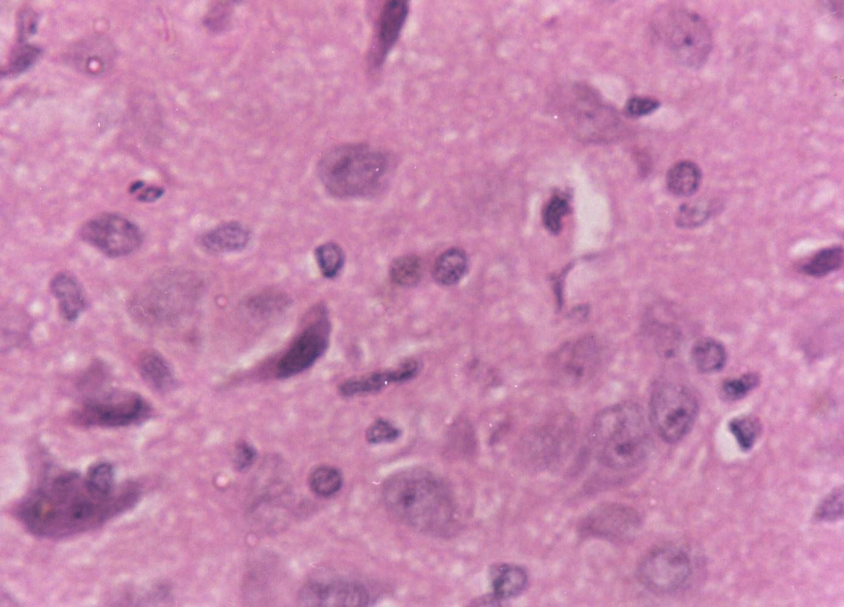
2
Figure (2): Photomicrograph of brain of control rat shows the neuron with huge nuclei. These nuclei show dispersed chromatin and prominent nucleoli. The cytoplasm is basophilic. Oligodendrocytes and astrocytes can be seen (H& E X 400).

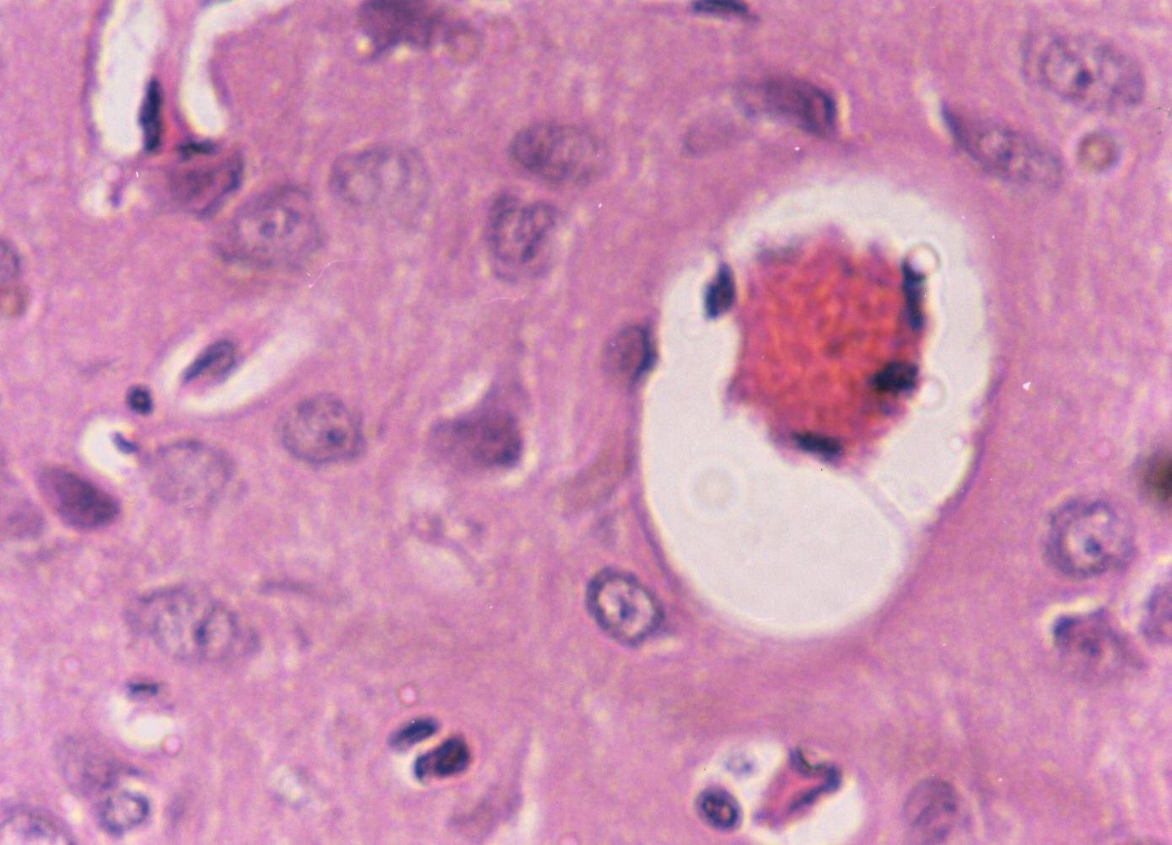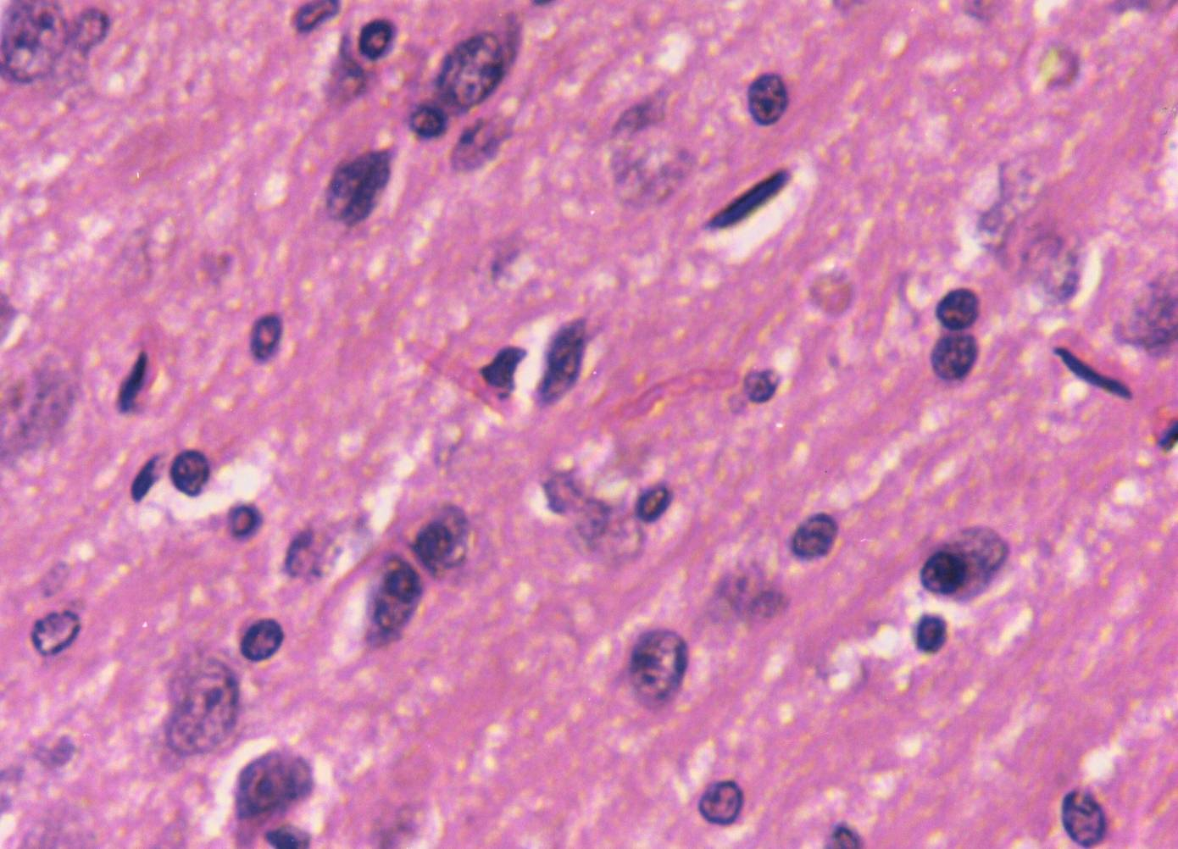
- 4

Figure (3): Photomicrograph of rat brain after gasoline inhalation shows earlier phase of coagulative necrosis. In some neurons, the nuclei show pale staining. Congested blood vessel surrounded by a clear Virchow-Robin space has been appeared (H & E X 400)
Figure (4): Photomicrograph of rat brain after inhalation of gasoline and treatment with tyrosine and tryptophan shows some dead neurons and another revealed pink-staining cell depress. The surrounded cells show pyknosis. (H & E X 400).

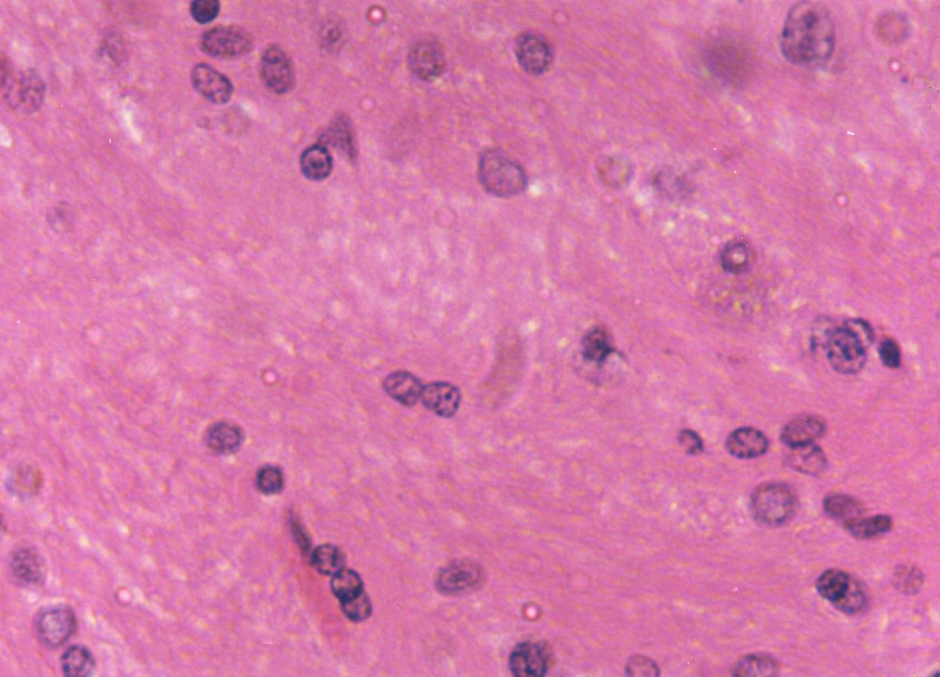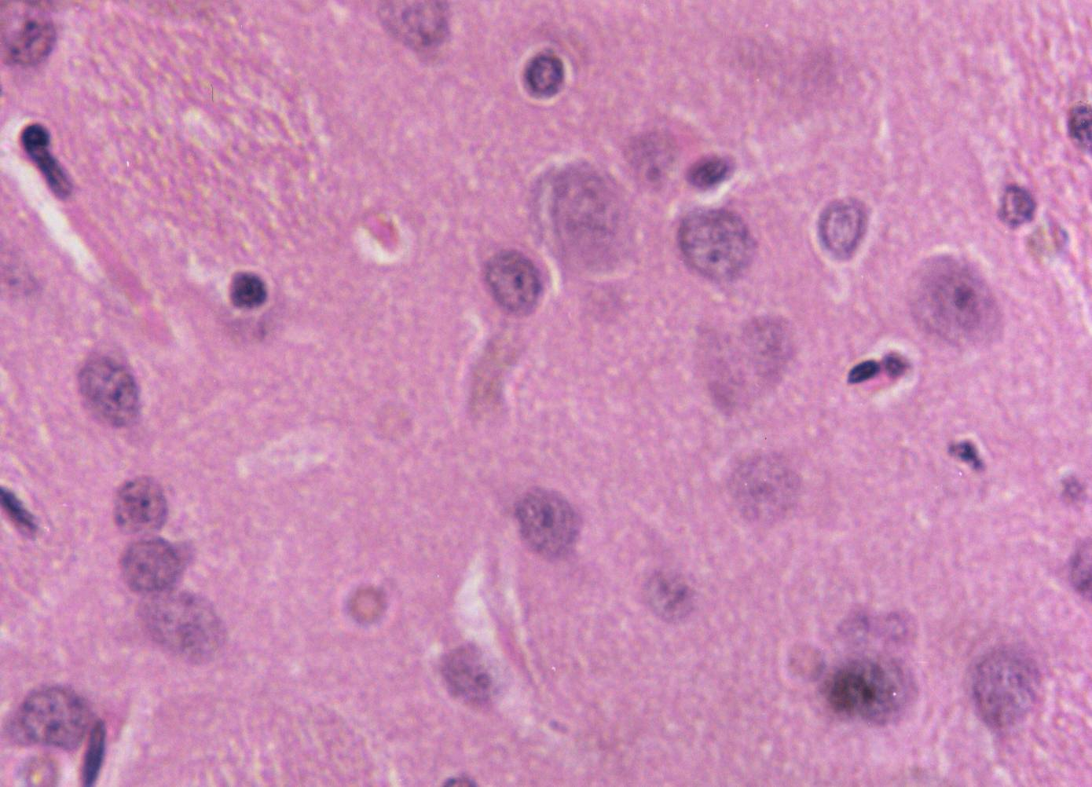
5 6

Figure (5): Photomicrograph of rat brain after inhalation of perchloroethylene shows complete degeneration of the neurons. Some of the neurons show partial degeneration associated with pyknotic nuclei (H & E X 400).
Figure (6): Photomicrograph of rat brain after inhalation of perchloroethylene and treated with tyrosine and tryptophan shows the neurons that revealed a healthy form. Few of them show pyknosis (H& E X400).

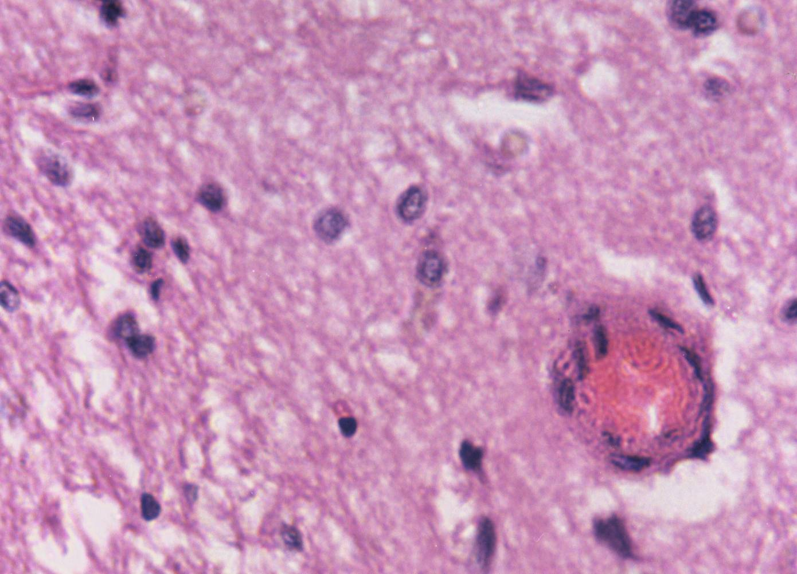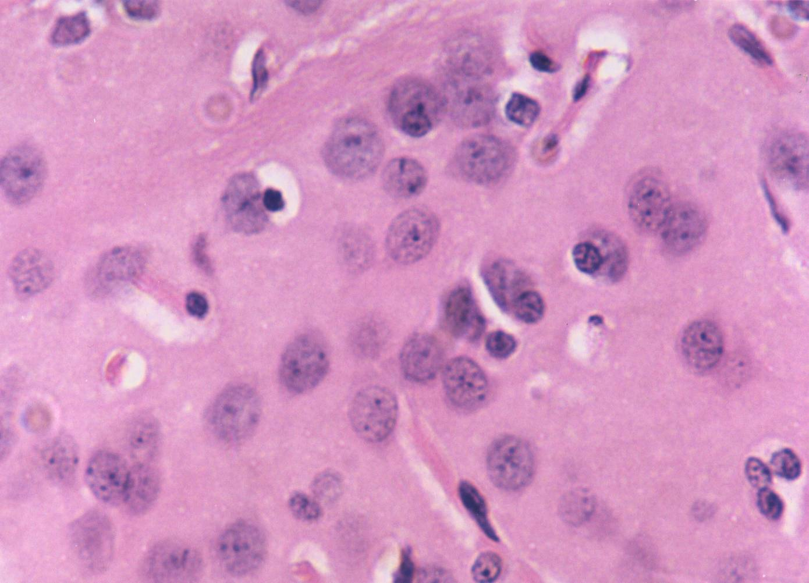
7 8
Figure (7): Photomicrograph of rat brain after inhalation of toluene shows severe coagulative necrosis. The nuclei of the neuron show a degree of pyknosis. Congested blood vessel is seen (H & E X 400).
Figure (8): Photomicrograph of rat brain after inhalation of toluene and treatment with tyrosine and tryptophan shows normal neurons as well as the surrounding cells. Binuclear form appears in many of them (H &E X 400).

6.Discussion
Inhalation results in serious organ system dysfunction. Airborne chemicals and volatile molecules enter the nose and can interact with chemoreceptors in the nasal cavity, especially trigeminal and olfactory receptors (Gobba,2003). Most solvents are easily absorbed from the blood into lipid-rich tissues and can cause widespread damage. The current results reveal that gasoline inhalation for 45 days causes significant increase in brain lipid peroxidation. This finding is in agreement with Ulakoğlu et al (1998) who demonstrated an increase in brain lipid peroxidation after inhalation of gasoline and/or its additives. Moreover, Lolin (1998) stated that the inhalation of gasoline additive which is called methyl tertiary-butyl ether (MTBE) induces an elevation in brain lipid peroxidation level in experimental animals. The increment in lipid peroxidation could be attributed to that gasoline expresses its toxicity via the production of reactive oxygen species (ROS) which causes cell damage (Ulakoğlu et al,1998).
The present study reveals that perchloroethylene significantly increases brain lipid peroxidation. Perchloroethylene (PCE) is oxidized by cytochrome P₄₅₀ (CYP₄₅₀) to produce trichloroacetyle chloride, trichloroethanol and trichloroacetic acid (TCA) (Birner et al 1994).
In both human and experimental animals (Volk et al,1998), TCA induces lipid peroxidation and oxidative DNA damage (Austin et al,1996). The toxicity of PCE to mammalian tissue depends mainly on cytochrome P₄₅₀-mediated oxidation as well as glutathione (GSH) conjugation (Lash et al,1998). Thus, PCE vapor produces dose-dependent increase in cellular H₂O₂ resulting in lipid peroxidation (Chen et al ,2002). Furthermore, PCE exposure leads to glutathione depletion and accumulation of hydrogen peroxide as well as its distal reaction products that can induce lipid peroxidation and cellular toxicity (Salahudeen,1995).
The present data indicate that toluene inhalation induces significant increase in brain lipid peroxidation. Toluene inhalation stimulates reactive oxygen species formation (Burmistrov et al,2001). This is the most important pathway of toluene neurotoxicity by which it induces oxidative damage to lipids, proteins and nucleic acids (Mattia et al,1993). Keeping on our results, Halifeoglu et al (2000) reported that toluene elevates the level of malondialdehyde in the brain. Also, toluene exposure causes significant elevation in the level of lipid breakdown products in several brain regions in rats due to the generation of reactive oxygen species, which causes neurodegeneration, and cognitive deficits (Baydas et al,2005).
Brain glutathione (GSH) shows significant decrease in the animals exposed to gasoline. This result is supported by the previous study of Raza et al (1995) who found a decrease in brain GSH with concomitant increase in brain lipid peroxidation levels after gasoline exposure in rats.
The present study reveals that perchloroethylene significantly decreases brain glutathione. Ebrahim and Sakthisekaran (1997)found a defect in the antioxidant defense system after PCE inhalation in rats. This was evidenced by low level of enzymatic antioxidants: superoxid dismutase (SOD) and catalase and non enzymatic antioxidants including glutathione, ascorbic acid and vitamin E with simultaneous increase in lipid peroxidation level.
The current data indicate that toluene inhalation induces significant decrease in brain glutathione level. As opposed to increasing lipid peroxidation level, a decrease in superoxide dismutase activity and glutathione level were developed (Ulakoğlu et al,1998).
Herein, the lowering glutathione level as a result of toluene inhalation is attributed to the oxidative stress induced by toluene (Fechter et al,2007).
The present study demonstrated that the treatment of rats exposed to gasoline, perchloroethylene or toluene with tyrosine and tryptophan combination causes significant depletion in brain lipid peroxidation level. Cadenas et al., (1989) and Moosmann and Behl (2000) reported that Long-chain acylated tyrosine and tryptophan or short-chain acylated derivatives are potent inhibitors of lipid peroxidation and oxidative cell death. The antioxidant properties of tyrosine and tryptophan provide a specific explanation for their protective action on neuronal membranes against oxidative stress. Recent study has been shown that serotonin and its precursor (tryptophan) have powerful antioxidant properties and the recovery of neurotransmitter concentration in brain is related to the reduction of lipid peroxide generation and improves antioxidant status of the brain (Munoz-castaneda et al,2009).
Treatment of rats exposed to gasoline, perchloroethylene or toluene with tyrosine and tryptophan induced remarkable increase in brain glutathione level. Casarejos et al. (2005) demonstrated an elevation in brain glutathione level in case of treatment with tyrosine metabolite. They explained this phenomenon as a compensatory mechanism of tyrosine metabolite to protect dopamine neurons from neural death.
In the current study gasoline inhalation reduces brain serotonin (5-HT) and dopamine (DA) levels significantly as shown in Table (2). Gasoline inhalation is associated with neurocognitive deficits including memory loss and poor concentration ( Maruff,et al,1998) which reflect the imbalance between the neuromodulatory effects of monoamines and acetylcholine. Memory impairment is linked to low serotonin level in the neocortex which is related to the focal hippocampal dysfunction (Vakalopoulos,2007). This interpretation supports the previous report of Yamazaki et al (1989) who stated that the central serotonergic dysfunction leads to learning retardation. Moser et al (1995) stated that exposure to gasoline and /or its additives shows some markers of neurotoxicity which represented by brain dopamine depletion in concomitant with elevation of brain GABA level.
Perchloroethylene inhalation significantly decreases each of brain serotonin and dopamine levels. A growing body of evidence demonstrated that the exposure to chlorinated hydrocarbon compounds including perchloro-ethylene produces various degrees of central nervous system depression (Cummings et al,2000). This property of perchloroethylene results in a depletion in serotonin level in brain stem (Nilsson,1986). Moreover, Seegal et al (1986) supported this fact as they stated that this type of chlorinated hydrocarbons could reduce serotonin concentration in frontal cortex and hippocampus. Additionally, the ratio of serotonin metabolite (5-hydroxyindolacetic acid) to serotonin was elevated in most brain areas following exposure of rats to chlorinated hydrocarbons. This means that the exposure to chlorinated hydrocarbons such as perchloroethylene affects each of serotonin concentration and metabolism (Seegal et al.1986). The reduction in brain dopamine level in animals exposed to perchloroethylene is greatly supported by the study of Goodwill et al (2007). They demonstrated that the exposure to chlorinated hydrocarbons results in peripheral inflammatory response associated with striatal terminal degeneration which in turn leads to dopaminergic loss in the striatum. In fact, chlorinated hydrocarbons could significantly reduce striatal dopamine, tyrosine hydroxylase, dopamine transporter and synaptophysin concentrations (Goodwill et al,2007) in addition to their reducing effect on the number of dopamine neurons in the ventral mesencephalon (Lyng et al,2007).
Toluene produces significant reduction in each of brain serotonin and dopamine level (Table 2). Toluene has high lipid solubility and no protein binding capability, so that it distributes according to lipid contents of the brain (Kiriu et al,1990). Repeated toluene inhalation has been shown to induce permenant changes in brain which correlated with neural dysfunction (Hass et al,1996). This is indicated by DA and 5-HT turnover in the caudate-putamen, nucleus accumbens, hippocampus, prefrontal cortex and cerebellum (Moser et al,1995). Subchronic exposure to toluene significantly results in sensitization to toluene-induced necrosis and alteration in DA and 5-HT transmissions. These events demonstrate that subchronic toluene exposure may lead to adverse effects on neurobehavioral and neurochemical functioning (Moser et al,1995). Moreover, a reduction in catecholaminergic neurons was previously detected in the brain stem of rats after toluene exposure (Bjornaes et al 1988). Furthermore, there is an evidence showed that the repeated toluene exposure results in alteration in dopaminergic transmission (Yamazaki et al,1989). The inhalation of toluene caused a decrease in noradrenaline (NA) level in the dorsal part of rat pons, rich in locus coeruleus and dopamine level in the hypothalamus and ventral part of the rat midbrain, rich in substantia nigra (Kiriu et al,1990).
Our results revealed that treatment of rats exposed to gasoline, perchloroethylene or toluene with tyrosine and tryptophan results in general increase in brain serotonin level. These results are in agreement with Denoyer et al. (1989); Arai et al. (1995) and Kitahama et al. (2002) who demonstrated that treatment with tryptophan and / or its derivatives can raise serotonin level in CNS. L-tryptophan administration can enhance serotonin release (Young,1996. Tryptophan is converted into serotonin in serotonergic neurons by the enzyme called aromatic amino acid decarboxylase (AADC) (Zhu and Juorio, 1995; Growdon et al,1982). Similarly, treatment of rats exposed to the different inhalants with tyrosine and tryptophan produces considerable increase in brain dopamine level. Dietary L-tyrosine administration can enhance dopamine synthesis in human as it does in rats (Thurmond, and Brown,1984; Narahashi et al,1989). AADC is also present in catecholaminergic neurons, where it normally converts tyrosine into dopamine (Arai et al,1995).General anesthetics enhance central inhibitory neurotransmission-mediated by GABA_{A} receptor-channel complex (Narahashi,1998). These CNS depressants are known to produce their effects in part by modulating GABA_{A} receptor function (Mihic et al,1997). Gasoline inhalation causes marked increase in brain GABA level. This finding coincides with that of Moser et al (1995). Such result indicates the potential role of GABA and its receptor (A) in the neurotoxic effects of gasoline and / or its additives (Martin et al,2004). Martin et al (2002)demonstrated that the oxygenated gasoline additives and their metabolites reduce the density of the convulsant binding site on GABA_{A} receptor in rat brain.
Perchloroethylene inhalation moderately increases brain GABA level in rats. It has been demonstrated that perchloroethylene inhibits the function of excitatory receptors N-methyl-D-aspartate (NMDA) (Cruz et al,2000), nicotinic acetylcholine receptor (nAchR) (Vakalopoulos,2007) and potentiates the function of inhibitory receptors γ-aminobutyric acid type A (GABA_{A}) as well as glycine receptors(Beckstead,2000). The activation of GABAergic neurons in the forebrain of rats due to exposure to perchloroethylene (Chen et al ,2002) may be contributed in the increased brain GABA level in the present study.
Toluene inhalation produces non appreciable increase in rat brain GABA level. This result is in agreement with Stengard and O’connor (1994) who stated that toluene exposure causes moderate increase in striatal GABA level. Toluene enhances GABA_{A} receptor function (Beckstead,2000).
Devaud et al (1997) and Charlton et al (1997) reported that GABA_{A} α-1 subunit may be an important target for the neurobehavioral and cellular actions of toluene.
Treatment of the group of animals exposed to gasoline, perchloroethylene or toluene with tyrosine and tryptophan caused significant increase in brain GABA level. It has been reported that tyrosine and tryptophan increase the potency of GABA (Schofield and Harrison, 2005). Soghomonian et al. (1996) suggested that tryptophan could increase GABAergic activity in the brain.
In the present study, gasoline induces significant decrease in plasma testosterone level. In general, organic solvents have negative influence on male reproductive functions through their action at the hypothalamo-hypophyseal level (Yilmaz et al,2001).
Moreover, gasoline and its additives, methyl tert-butyl ether (MTBE), could reduce plasma testosterone level in male rats due to their ability to accelerate the metabolism of endogenous testosterone and hence its clearance. This could be done via stimulation of some enzymes (cytochrome P₄₅₀ and testosterone hydroxylase) that involved in testosterone metabolism (Williams and Borghoff ,2000). Histological study of el Feki et al (2000) revealed an atrophy of the testicle, seminal vesicle and epididym in concomitant with a decrease in plasma testosterone level in male rats exposed to gasoline.
Gasoline inhalation causes significant increase in plasma DHEA-S level. It has been reported that unleaded petrol and related volatile organic compounds activates rat hypothalamo-pituitary-thyroid-adrenal system (Karuri et al,1998). Seitz et al (1985) and Vyskocil et al (1986) found that the exposure to organic volatile compounds leads to significant increase in plasma dehydroepiandrosterone (DHEA) which follows the elevation of plasma corticosterone level. This is because of DHEA is closely followed the secretory profile of corticosterone (Vyskocil et al,1986). This may explain the elevation in plasma DHEA-S level of rats exposed to gasoline in the current study.
Perchloroethylene inhalation significantly decreases plasma testosterone level. Perchloroethylene is well known as a reproductive toxicant which affects the hypothalamic pituitary gonadal axis (Reader et al,1991).
More recent study revealed that perchloroethylene has a direct inhibitory action on testicular testosterone biosynthesis (Klaunig et al,2003).
Plasma DHEA-S shows significant increase due to perchloroethylene inhalation. This finding agrees with that of Chia et al (1997) who detected an increase in plasma DHEA-S level as a result of perchloroethylene exposure. This could be attributed to that perchloroethylene may disrupt peripheral endocrine function, perhaps through its peroxisome proliferator potential activity. Perchloroethylene and related hydrocarbons constitute an important class of environmental pollutants whose adverse effects on liver, kidney and other tissues may be mediated by peroxisome proliferator-activated receptors (PPARs) and ligand-activated transcription factors belonging to the steroid receptor superfamily. In addition, it is conceivable that trichloroethylene, one of perchloroethylene metabolites may compete with DHEA-S for binding to PPAR and this ultimately leads to the elevation of plasma DHEA-S as a compensatory response (Zhou and Waxman.,1998).
Significant decrease in plasma testosterone level due to toluene inhalation is demonstrated in the current study. On line with this finding, Yilmaz et al (2006) reported that toluene inhalation affects testosterone synthesis and secretion in male rats via a direct action on the Leydig cells. Moreover, toluene causes a reduction in leutinizing hormone (LH) secretion from the anterior pituitary which in turn inhibits testosterone production (Yamada,1993). Another report suggested that toluene inhibits testosterone secretion through its action on the gonadotropin releasing hormone (GnRH) neurons or through its inhibitory effect on pituitary responsiveness to GnRH. It has been suggested that toluene has an anti-gonadotropic effect and it may cause long-term endocrine disturbances in male rats (Yilmaz et al,2001).
The present data reveal that toluene inhalation produces an increase in plasma DHEA-S level. Gotohda et al (2005) demonstrated significant increase in the weight of adrenal gland, hypertrophy of the adrenal cortex and expansion of the corticosterone-positive area in rats exposed to toluene. Also, toluene inhalation causes an increase in serum corticosterone level. This is due to the indirect effect of toluene on microphage/ lymphocyte activity via stress induction and hence a secretion of ACTH and corticosterone (Palermo et al,2001). Since DHEA is closely followed the secretory profile of corticosterone (Vyskocil et al,1986), the observed increase in plasma level of DHEA-S due to toluene inhalation is a consequence of corticosterone elevation.
Treatment of the group of animals exposed to gasoline, perchloroethylene or toluene with tyrosine and tryptophan resulted in marked increase in plasma testosterone level. Shishkina and Dygal (2000) reported that the administration of tryptophan and / or its derivatives increases plasma testosterone level in male rats. The suggesting mechanism of this action was reported by Pinilla et al. (1997) who stated that administration of serotonin precursor stimulates gonadotropins (FSH and LH) secretion.
Significant decrease in plasma DHEA-S level was detected in the present study in gasoline, perchloroethylene or toluene exposed rats treated with tyrosine and tryptophan. The suppressing effect of dopamine, a tyrosine product, on serum DHEA-S level was previously reported by Van den Berghe et al. (1995). The lowering effect of dopamine on DHEA-S level could be linked to the suppression of circulationg prolactin level.
In the current study gasoline inhalation caused significant depletion in each of plasma triiodothyronine (T₃) and thyroxine (T₄) levels. These results are in agreement with Singh et al. (2000) who reported that petrol exposure enhances the pituitary release of TSH and reduces serum T₃ and T₄ levels. This means that gasoline inhalation affects pituitary thyroid axis and inhibits response of thyroid to thyroid stimulating hormone (TSH). Moreover, it has been stated that gasoline and /or its additives cause changes in thyroid, liver and bone marrow (Poon et al,2005). Moreover, 1,6-dimethoxyhexane (gasoline additive) has been shown to reduce colloidal density and accelerate papillary proliferation of the follicular epithelium, which indicates of a mild degree of thyroid hyperplasia. Additionally, thyroid follicular-cell adenomas was detected in rats exposed to tertiary-butyl ether (other gasoline additive) (McGregor,2006), which indicates the alteration in T₃ and T₄ synthesis in rats exposed to gasoline.
Our study revealed significant decrease in plasma T₃ and T₄ levels in the group of animals exposed to perchloroethylene. These results agree well with the National Toxicology Program (2006) which revealed that the exposure to halogenated hydrocarbons causes significant decrease in serum total thyroxin (T₄), free T₄ and T₃. Halogenated hydrocarbons have a direct effect on the releasing efficacy of thyroid gland.
Toluene inhalation caused significant decrease in each of plasma T₃ and T₄ in the present study. This result consides with that of Chen et al (National Toxicology Program,2003) who stated that the exposure to glue solvent reveals significant depletion in serum T₄, T₃ and free T₄ levels. Low serum T₃ and T₄ levels that associated with glue sniffing were compatible with central hypothyroidism. Furthermore, toluene has been shown to affect dopaminergic and adrenergic turnover within various parts of the brain. This neurotransmitter affection leads to abnormal secretion of pituitary hormones resulting in transient central hypothyroidism (National Toxicology Program,2003).
The current study demonstrated that the treatment of rats exposed to gasoline, perchloroethylene or toluene with tyrosine and tryptophan results in marked increase in each of plasma T₃ and T₄ level. Morley et al. (1980) suggested that repeated dose loading of tryptophan or 5-hydroxytryptophan (5-HTP) increases plasma serotonin and T₃ levels and decreases plasma TSH level. Serotonin affects thyroid gland to produce T3 (Morley et al,1980). Moreover, Tahara et al (1988) reported that supplementation with tyrosine results in rapid increase in serum T₄, T₃ and free T₄ levels. These results could be explained by the action of dopaminergic system on both thyrotropin releasing hormone (TRH) and thyroid releasing hormone (TSH) release (Morley et al,1981).
Gasoline inhalation produces histopathological changes in the brain of rats. These are mainly represented in coagulative necrosis. These findings are, at least in part, in agreement with Salehi et al (2001) who found significant neural cell loss in globus pallidus and caudate putamen as well as in the frontal cortex in the brain of rats exposed to gasoline and/or its additives.
Perchloroethylene inhalation causes general degeneration of the neurons. This finding agrees with that of Wang et al (1993) who indicated that the exposure to perchloroethylene greatly reduces the number of brain cells, possibly glial cells.
The histopathological alterations associated with toluene inhalation include severe coagulative necrosis. Several pathological effects of toluene on the central nervous system have been previously described. These effects include neurovascular complications such as microvascular ischemic changes or ischemic stroke. Other neurological complication includes central atrophy (Borne et al,2005.
The histopathological investigation of the brain of rats exposed to gasoline and treated with tyrosine and tryptophan revealed the death of some neurons but many neurons still survive and reveal pink-staining. Tyrosine and tryptophan administration to rats exposed to perchloroethylene or toluene resulted in the appearance of neurons in a healthy manner. Strazielle et al. (1996) stated that the activation of serotonergic system by tryptophan modulates brain cell structure. Moreover, Ikemoto (2000) reported that dopamine protects brain neurons
against degeneration.

Conclusion
In conclusion the repeated exposure to inhalants (gasoline, perchloroethylene or toluene) induced many deleterious effects on the central nervous system of male rats. Treatment with either tyrosine and tryptophan revealed significant ameliorative effect against inhalant neurotoxicity.

Correspondence to:
Hend Rashad Goma
Environmental and Occupational Medicine Department,
National Research Center
Tahrir Street, 12622 Dokki. Giza,Egypt
Tel: +202-33377164
Fax: +202-33370931 & +202-37601877
Mobile: 0124471780
Emails: hendrashad@yahoo.com

References

- Linden CH. Volatile substances of abuse. Emerg Med Clin North Am. 1990; 8: 559-578.
- Kurtzman TL, Otsuka KN, Wahl RA. Inhalant abuse by adolescents. Science Direct-Journal of adolescent Health 2001; 28(3): 170-180.
- Mckee RH, Trimmer GW, Whitman FT, Nessel CS, Mackerer CR, Hagemann R, Priston RA, Rileg AJ, Gruzan G, Simpson BJ, Urbanus JH. Assessment in rats of reproductive toxicity of gasoline from agasoline vapor recovery unit. Report Toxicol. 2000; 14(4): 337-353.
- Hong JY, Wang YY, Bondoc FY, Yang CS, Lee M, Huang WQ. Rat olfactory mucosa displays a high activity in metabolizing methyl tert-butyl ether and other gasoline ethers. Fundam Appl Toxicol. 1997; 40(2): 205-210.
- Ritchie GD, Still KR, Alexander WK, Nordholm AF, Wilson CL, Rossi J 3rd Dr. A review of the neurotoxicity risk of selected by hydrocarbon Fuels. J. Toxicol Environ health B crit Rev. 2001; 4(3): 223- 312.
- Tenenbein M. Leaded gasoline abuse: the role of tetraethyl lead (Review). Hum. Exp. Toxicol. 1997, 16: 217-222.
- Burbacher TM. Neurotoxic effect of gasoline and gasoline constituents. Environ Health Perspect. 1993; 101(6): 133-141.
- Roger SD, Crimmins D, Yiannikas C, Harris DC. Lead intoxication in an anuric patient: management by intra peritoneal EDTA. Aust. Nz. J. Med. 1990; 20: 814-817.
- Maruff P, Burns CB, Tyler P, Currie BJ, Currie J Neurological and cognitive abnormalities associated with chronic petrol sniffing. Brain 1998; 121: 1903- 1917.
- Ebrahim A.S, Babekrishnan K, Sallthisekaran D. Perchloroethylene-induced alteration in glucose metabolism and their prevention by 2-deoxy-D-glucose and Vitamin E in mice. J. Apple. Toxicol. 1996; 16(4): 339- 348.
- The National Institute for Occupational safety and helath (NIOSH). Hazard Control: Control of exposure to perchloroethylene in commercial Dry cleaning (Machine Deisgn). Applied occupational and Environmental Hygeine. 2000; 15(1): 11-12.
- Ebrahim AS, Sakthisekaran DC. Effect of vitamin E and Taurine treatment on lipid peroxidation and antioxidant defense in perchlorethyllene – induced cytotoxicity in mice. J. Nutri. Biochem. 1997; 8(5): 270-274.
- Beliles RP. Concordance across species in the reproductive and development toxicity of perchloroethylene toxicol Ind. Health. 2002; 18 (2): 91-106.
- Beckstead MJ, Weiner JL, Eger EI, Gong DH, Mihic SJ. Glycine and gamma – ominobutyric acid (A) receptor function is enhanced by inhaled drugs of abuse. Mol. Pharmacol. 2000; 57: 1199-1205.
- Arlien-Spborg P, Hansen L, Ladefoged O, Simonsen L. Report on a confererce on organic solvents and the nervous system. Neurotoxcol Teratol. 1992; 14: 81-82.
- Gotohda T, Tokunaga I, Kubo S, Morita K, Kitamura O, Eguchi A. Effect of toluene in halation on astrocytes and neurotrophic factor in rat brain. Forensic Sci. Int. 2000; 113(1-3): 233-238.
- Ogata M, Michistsiyi H, Fujiki Y. Estimation amounts of toluene inhaled by workers with protective mask using biological indictors of toluene. Toxicol. Lett. 1999; 108: 233-239.
- Saavedra H, De marinis A, Palestini M. Neuronal changes induced by chronic toluene exposure in the cat. Arch Ital. Biol . 1996; 134 (3): 217-225.
- Filley CM, Halliday W, Chmidt-DeMasters BK. The effects of toluene on the central nerovous systems. J. Neuropathol. Exp Neurol. 2004; 63 (1): 1-12.
- Riegel AC, French ED. An electrophysiological analysis of rat ventral tegmental dopamine neuronal activity during acute toluene exposure. Pharmacol Toxicol. 1999; 85(1): 37-43.
- Stengard K, O’cconnor WT. Acute toluene exposure decreases extracellular gamma-aminobutyric acid in the globus pallidus but not in striatum –amicrodialysis study in a wake, freely moving rats. Eur. J. Pharmacol-Environ Toxicol Pharmacol Sect. 1994; 292: 43-46.
- Yilmaz B, Kutlu S, Canpolat S, Sandal S, Ayar A, Mogulkoc R, Kelestimur H. Effects of paint thinner exposure on serum LH, FSH and testosterone levels and hypothalamic catecholamine contents in the male rat. Biol Pharm Bull. 2001; 24(2): 163-166.]
- Voog, L. and Eriksson, T. Toluene-induced decrease in rat plasma concentrations of Tyrosine and Tryptophan. Acta pharmacol. Toxical (copenh), 1984; 54(2): 151-153. ]
- Van praag, H.M. In search of the mode of action of antidepressant: 5-HTP/Tyrosine mixtures in depression. Adv. Biochem psychopharmacol, 1984; 37: 301-314.
- Poon R, Chu I, Bjarnason S, Vincent R, Potvin M, Miller R, Valli BE. Short- term inhalation toxicity of methanol, gasoline and methanol / gasoline in the rat. Toxicol Ind. Health. 1995; 11(3): 343-336.

Ng, L.T. and Anderson, G.H. Route of administration of trypto phane and tyrosine affects short tearm food intake and plasma and brain amino acid concentrations in rate .J. Ntr., 1992; 122(2): 283-293.
- Mattsson JL, Albee RR, Yano BL, Bradley G, Spencer PJ. Neurotoxicologic examination of rats exposed to 1,1,2,2-perchloroethylene perchloroethylene) vapor for 13 weeks.Neurotoxicol Teratol. 1998; 20(1): 83-98.
- Bjornaes S, Naalsund LU. Biochemical changes In different brain areas after Toluene in inhalantion. Toxicology. 1988; (2-3): 367-374.
- Bowen SE, Balster RL. A direct comparison of inhalant effects on locomotor activity and schedule-controlled behavior in mice, Exp. Clin. Psychopharmacol. 1998; 6: 235–247.
- Bowen SE, Batis JC, Mohammadi MH, Hannigan JH. Abuse pattern of gestational toluene exposure and early postnatal development in rats.: Neurotoxicol Teratol. 2005; 27(1): 105-116.
- Tsakiris S, Schulpis KH, Marinou K, Behrakis P. Protective effect of l-cysteine and glutathione on the modulated suckling rat brain Na⁺, K⁺ –ATPase and Mg²⁺-ATPase activities induced by the in –vitro galactosaemia.Pharmacol Res. 2004; 49(5): 475-479.
- Lowry OH, Rosebrough NJ, Farr AL, Randall RJ. Protein measurement with the folin phenol reagent. J Biol. 1951; 193: 265-275.
- Esterbauer H, Cheeseman KH. Determination of aldehydic lipid peroxidation products: malondialdehyde and 4-hydroxynonenal. Methods Enzymol. 1990; 186: 407-421.
- Beutler E, Duron O, Kelly MB. Improved method for determination of blood glutathione. J. Lab Clin. Med. 1963; 61: 882-888.
- Harenberg J, Huhle G, Giese Ch, Wang L, Feuring M, Song X, Hofmann U. Determination of serotonin release from platelets by enzyme immunoassay in the diagnosis of heparin-induced thrombocytopenia. British Journal of Hematology, 2000; 109: 182-186.
- Ciarlone AE. Determination of catecholamines spectrophotofluro-metrically. Am.J. Physiol. 1978; 125:731-737.
- Seiler N. In methods of Biochemical analysis (Glick, D., ed), 1970; 18: 259-337.
- Joshi UM, Shah HP, Sudhama SP. A sensitive and specific enzyme immunoassay for serum testosterone. Steroids, 1979; 34(1): 35-46.
- Tietz NW. Textbook of clinical chemistry. sauders. 1968.
- Wisdom, G.B. Enzyme-Immunosorbentassay.Clin chem., 1976;22: 1243.
- Snedecor GW. Cohran WG. In statistical methods. The lowa state university press 6th ed. Ames Iwa USA. 1967; P.104.
- Gobba F. Occupational exposure to chemicals and sensory organs: a neglected research field. Neurotoxicology, 2003; 24: 675-691.
- Ulakoğlu EZ, Saygi A, Gümüştaş MK, Zor E, Oztek I, Kökoğlu E. Alterations in superoxide dismutase activities, lipid peroxidation and glutathione levels in thinner inhaled rat lungs: relationship between histopathological properties. Pharmacol.Res.1998; 38(3): 209-214.
- Lolin Y. Chronic neurological toxicity associated with exposure to volatile substances. Hum toxicol. 1989; 8: 293-300.
- Birner G, Richling C, Henschler D, Anders MW, Dekant W. Metabolism of tetrachloroethylene in rats: identification of N^{e} ( dichloro acetyl)- L- lysine and N^{e} ( trichloro acetyl)- L- lysine as protein adults, chem. Res. Toxicol. 1994; 7: 724-732.
- Volk W, Friedewald M, Lederer E, Pahler A, Parkers J, Dekant W.Biotransformation of perchloro ethylene: dose dependent excretion of trichloro acetic acid, dichloro acetic acid , and N- acetyle- S- (Trinchlor vinyl)- L – cysteine in rats and humans after inhalation. Toxicol Appl. Pharmacol. 1998; 153: 20-27.
- Austin EW, Parrish JM, Kinder DH, Bull RJ. lipid peroxidation and formation of 8- hydroxydeoxyguansine guanosine from acute doses of halogenated acetic acids, fundam. Appl. Toxicol. 1996; 31: 7782.
- Lash LH, Qien W, Putt DA, Desai K, Elfarra AA, Sicuri AR, Panker JC. Glutathione conjugation of perchloroethylene in rats and mice in vitro: sex – species – and tissue dpendent differences. Toxicol. Appl. Pharmacol. 1998; 150: 49-57.
- Chen SJ, Wang JL, Chen JH, Huang RN. Possible involvement of glutathione and p53 in tichloroethyene and perchloroethylene and perchlorethylene – induced lipid peroxidation and apoptosis in human lung cancer cells. Free Radical Biology &Medicine. 2002; 33 (4): 464-472.
- Salahudeen AK. Role of lipid peroxidation in H2o2- Induced renal epithelial (LLC- Pk1) cell injury. Am J Physiol. 1995; 268 Renal fluid Electrolyte , 37 F30 – F 38.
- Burmistrov SO, Arutyunyan AV, Stepanov MG, Oparina TI, Prokopenko VM. Effect of chronic inhalation of toluene and dioxane on activity of free radical processes in rat ovaries and brain. Bull Exp Biol Med. 2001;132(3): 832-836.
- Mattia CJ, Ali SF, Bondy SC. Toluene – induced oxidative stress in several brain regions and other organs. Mol. Chem. Neuropathol. 1993; 3: 313-328.
- Halifeoglu I, Canatan H, Ustundag B, Ilhan N, Inanc F. Effect of thinner inhalation on lipid peroxidation and some antioxidant enzymes of people working with paint thinner, Cell Biochem. Funct. 2000; 18: 263–267
- Baydas G, Ozveren F, Akdemir I, Tuzcu M, Yasar A. Learning and memory deficits in rats induced by chronic thinner exposure are reversed by melatonin. J pineal Res. 2005; 39(1): 50-56.
- Raza H, Qureshi MM, Montague W. Alteration of glutathione, glutathione S-transferase and lipid peroxidation in mouse skin and extracutaneous tissues after topical application of gasoline. Int J Biochem Cell Biol. 1995; 27(3): 271-277.
- Fechter LD, Gearhart C, Fulton S, Campbell J, Fisher J, Na K, Cocker D, Nelson-Miller A, Moon P, Pouyatos B. Promotion of noise-induced cochlear injury by toluene and ethylbenzene in the rat. Toxicol Sci. 2007; 98(2): 542-551
- Cadenas, E.; Simic, M.G. And Sies, H. Antioxidant activity of 5-hydroxytryptophan, 5-hydroxyindole, and DOPA against microsomal lipid peroxidation and its dependence on vitamin E. Free Radic Res Commun.1989; 6(1): 11-17.
- Moosmann, B. and Behl, C. Cytoprotective antioxidant function of tyrosine and tryptophan residues in transmembrane proteins. Eur J Biochem.2000; 267(18): 5687-5692.
- Munoz-castaneda, J.R.; Montilla, P.; Padillo, F.J.; Bujalance, I.; Munoz, M.C.; Muntane, J. and Tunez, I. Role of serotonin in cerebral oxidative stress in rats. Acta Neurobiol Exp (Wars).2006; 66(1): 1-6.
- Casarejos, M.J.; Solano, R.M.; Menéndez, J.; Rodríguez-Navarro, J.A.; Correa, C.; García de Yébenes, J. And Mena, M.A. . Differential effects of l-DOPA on monoamine metabolism, cell survival and glutathione production in midbrain neuronal-enriched cultures from parkin knockout and wild-type mice. J Neurochem. 2005;94(4):1005-14.
[61] Vakalopoulos C. Neurocognitive deficits in major depression and a new theory of ADHD: a model of impaired antagonism of cholinergic-mediated prepotent behaviours in monoamine depleted individuals.
Med Hypotheses. 2007; 68(1): 210-221.
- Yamazaki N, Nomura M, Nagaoka A, Nagawa Y. Idebenone improves learning and memory impairment induced by cholinergic or serotonergic dysfunction in rats.Arch Gerontol Geriatr. 1989; 8(3): 225-239.
- Moser VC, Cheek BM, Macphail RC. Amulti disciplinary approach to toxicological screening: III. Neurobehavioral toxicity . J. Toxicol Environ Health. 1995; 45(2): 173 – 210.
- Cummings BS, Zangar RC, Novak RF, LasH LH. Cytotoxiaty of trichloroethylene and S- (1, 2- dichlorovinyl) - L- cysteine in primary cultures of rat renal proximal tubular and distal tubular cell. Toxicology. 2000; 150: 83-98.
- Nilsson KB. Actions of 1,1,1-trichloroethane on the cAMP metabolism in mouse brain. Acta Pharmacol Toxicol (Copenh). 1986; 59(5): 362-369.
- Seegal RF, Brosch KO, Bush B. Regional alterations in serotonin metabolism induced by oral exposure of rats to polychlorinated biphenyls. Neurotoxicology. 1986; 7(1): 155-165.
- Goodwill MH, Lawrence DA, Seegal RF. Polychlorinated biphenyls induces proinflammatory cytokine release and dopaminergic dysfunction: protection in interleukin-6 knockout mice.J Neuroimmunol. 2007; 183(1-2): 125-132.
- Lyng GD, Snyder-Keller A, Seegal RF. Polychlorinated biphenyl-induced neurotoxicity in organotypic cocultures of developing rat ventral mesencephalon and striatum. Toxicol Sci. 2007; 97(1): 128-139.
- Kiriu T, Ameno K, Fuke C, Ameno S, Ijiri I. [The distribution of toluene in the brain and its effects on the brain catecholamines in acute toluene poisoning]: Nihon Hoigaku Zasshi. 1990; 44(1): 25-33.
- Hass U, Lund SP, Hougaard KS, Simonsen L. Developmental neurotoxicity after toluene inhalation exposure in rats. Neurotoxicol. Teratol. 1999; 21 (4): 349-357.
- Denoyer, M.; Kitahama, K.;Sallanon, M.; Touret, M. and Jouvet, M. . 5-hydroxytryptophan uptake and decarboxylating neurons in the cat hypothalamus. Neuroscience.1989; 31: 203-211.
- Arai, R.; Karasawa, N.; Nagatsu, T. and Nagatsu, I.. Exogenous L-5-hydroxytryptophan is decarboxylated in neurons of the substantia nigra par compacta and locus coeruleus of the rat .Brain Res..1995; 669: 145-149.
- Kitahama, K.; Jouvet, A.; Fujimiya, M.; Nagatsu, I. and Arai, R. . 5-hydroxytryptophan (5-HTP)uptake and decaboxylation in the kitten brain. J Neural Transm.,2002; 109: 683-689.
- Young, S.N. Behavioral effects of diatry neurotransmitter precursors: basic and clinical aspects. Neurosci. Biobehav.Rev.1996; 20: 313-323.
- Boadle-Biber, M.C.. Biosynthesis of serotonin. In: Osborne, N.N (Ed.), Biology of serotonin transmission. Wiley, Chichester pp.1982;63-94.
- Zhu, M.Y. and Juorio, A.V. . Aromatic L-amino acid decarboxyla: biological characterization and functional role. Gen Pharmacol.1995;, 26: 681-696.
- Growdon, J.H.; Melamed, E. and Logue, M.. Effects of oral L-tyrosine administration on CSF tyrosine and homovanilic acid levels in patients with –parkinson's disease. Life Sci..1982; 30: 827-832.
- Thurmond, J.B. And Brown, J.W. . Effect of brain monoamine precursors on stress-induced behavioral and neurochemical changes in aged mice. Brain Res.1984;296(1): 93-102.
- Narahashi T, Aistrup GL, Lindstorm JM, Marszale W, Nagata K, Wang F, Yeh JZ. Ion channel modulation as the basis for general anesthesia. Toxicol. Lett. 1998; 100: 185-191.
- Mihic SJ, Ye Q, Wwick MJ, Koltchine VV, Kraswski MD, Finn SE, Mascia MP, Harrison NL. Sites of alcohol and volatile anaesthetic action of GABA _{(A)} and glycine receptors. Nature. 1997; 389: 385-389.
- Martin JV, Iyer SV, McIlroy PJ, Iba MM. Influence of oxygenated fuel additives and their metabolites on gamma-aminobutyric acidA (GABAA) receptor function in rat brain synaptoneurosomes.Toxicol Lett. 2004; 147(3): 209-217.
- Martin JV, Bilgin NM, Iba MM. Influence of oxygenated fuel additives and their metabolites on the binding of a convulsant ligand of the gamma-aminobutyric acid (A) (GABA (A)) receptor in rat brain membrane preparations.Toxicol Lett. 2002; 129(3): 219-226.
- Cruz SL, Balster RL, Woodward JJ. Effects of volatile solvents on recombinant N-methyl-D-aspartate receptors expressed in Xenopus oocytes. Br J Pharmacol. 2000; 131(7): 1303-1308.
- Devaud L.L., Fritschy J.M., Sieghart W.and Morrow A.L., Bidirectional alterations of GABA (A) receptor subunit peptide levels in rat cortex during chronic ethanol consumption and withdrawal, J. Neurochem. 1997; 69: 126–130.
- Charlton M.E., Sweetnam, P.M. Fitzgerald, L.W. Terwilliger, R.Z. Nestler E.J. and Duman, R.S. Chronic ethanol administration regulates the expression of GABA_{A} receptor alpha 1 and alpha 5 subunits in the ventral tegmental area and hippocampus, J. Neurochem. 1997; 68: 121–127.
- Schofield, C.M. And Harrison, N.L. . Transmembrane residues define the action of isoflurane at the GABA_{A} receptor alpha-3 subunit. Brain Res.2005;1032(1-2): 30-35.
- Soghomonian JJ, Pedneault S, Blanchet PJ, Goulet M, Di Paolo T, Bédard PJ. L-DOPA regulates glutamate decarboxylases mRNA levels in MPTP-treated monkeys. Brain Res Mol Brain Res.1996; 39(1-2): 237-240.
- Williams TM, Borghoff SJ. Induction of testosterone biotransformation enzymes following oral administration of methyl tert-butyl ether to male Sprague-Dawley rats. : Toxicol Sci. 2000; 57(1): 147-55.
- el Feki A, Ghorbel F, Smaoui M, Makni-Ayadi F, Kammoun A. [Effects of automobile lead on the general growth and sexual activity of the rat] Gynecol Obstet Fertil. 2000; 28(1): 51-59.
- Karuri AR, Engelking LR, Kumar MS. Effects of halothane and methoxyflurane on the hypothalamic-pituitary-adrenal axis in rat.Brain Res Bull. 1998; 47(3): 205-209.
- Seitz W, Lubbe N, Bechstein W, Fritz K, Kirchner E. [Behavioral of the hypophyseal- adrenal cortex system in inhalation and conduction anesthesia. A review with comparative study.Anasth Intensivther Notfallmed. 1985; 20(3): 119-124.
- Vyskocil A, Tusl M, Zaydlar K. The effect of carbon monoxide on hormone levels and organ weights in rats.J Appl Toxicol. 1986; 6(6): 443-446.

- Reader SCJ, Shingles C, Sionard MD. Acute testicular toxicity of 1,3- dinitrobenzene and ethylene glycol monomethyle ether in the rat: evaluation of biochemical effect markers and hormonal responses. Fundam Appl Toxicol. 1991; 16: 61-70.
- Klaunig JE, Babich MA, Baetcke KP, Cook JC, Corton JC, David RM, Deluca JG, Lai DY, McKee RH, Peter JM, Roberts RA, Fenner-Crisp PA. PPARalpha agonist-induced rodent tumors: modes of action and human relevance. Crit Rev Toxicol. 2003; 33(6): 655-780.

- Chia SE, Goh VH, Ong CN. Endocrine profiles of male workers with exposure to trichloroethylene. Am J Ind Med. 1997; 32: 217-222.
- Zhou YC, Waxman DJ. Activation of peroxisome proliferator-activated receptors by chlorinated hydrocarbons and endogenous steroids. Environ Health Perspect. 1998; 106 (suppl 4): 983-988.
- Yilmaz B, Canpolat S, Sandal S, Akpolat N, Kutlu S, Ilhan N, Kelestimur H. Paint thinner exposure inhibits testosterone synthesis and secretion in a reversible manner in the rat: Reprod Toxicol. 2006; 22(4): 791-796.
- Yamada K. Influence of lacquer thinner and some organic solvents on reproductive and accessory reproductive organs in the male rat. Biol. Pharm. Bull. 1993; 16(4): 425-427.
- Gotohda T, Tokunaga I, Kubo S. Toluene inhalation-induced adrenocortical hypertrophy and endocrinological changes in rat.Life Sci. 2005; 76(17): 1929-1937.

Palermo-Neto J, Santos FA, Guerra JL, Santos GO, Pinheiro SR. Glue solvent inhalation impairs host resistance to Mycobacterium bovis-induced infection in hamsters.
: Vet Hum Toxicol. 2001; 43(1): 1-5.
- Shishkina, G.T. and Dygalo, N.N. Role of the serotoninergic system in the acceleration of sexual maturation in wild Norway rats selected for reduced aggressiveness toward humans. Comp Biochem Physiol C Toxicol Pharmacol.2000; 125(1): 45-51.
- Pinilla L, Tena-Sempere M, Aguilar E. Role of serotoninergic receptors in gonadotropin secretion in male rats. J Endocrinol Invest.1997;20(7): 410-416.
- Van den Berghe G, de Zegher F, Wouters P, Schetz M, Verwaest C, Ferdinande P, Lauwers P. (1995). Dehydroepiandrosterone sulphate in critical illness: effect of dopamine. Clin Endocrinol (Oxf)., 43(4): 457-463.
- Singh B, Chandran V, Bandhu HK, Mittal BR, Bhattacharya A, Jindal SK, Varma S. Impact of lead exposure on pituitary-thyroid axis in humans. Biometals.2000;13(2): 187-192.
- Poon, R.; Wade, M.; Valli, V.E. and Chu, I. Short-term oral toxicity of butyl ether, ethyl hexyl ether, methyl heptyl ether and 1,6-dimethoxyhexane in male rats and the role of 2-methoxyacetic acid. Toxicology.2005;214(1-2): 99-112.
- McGregor, D. Methyl tertiary-butyl ether : studies for potential human health hazards. Crit Rev Toxicol.2006; 36(4): 319-358.
- National Toxicology Program. NTP Toxicology and Carcinogenesis Studies of 2,3,4,7,8-Pentachlorodibenzofuran (PeCDF) (CAS No. 57117-31-4) in Female Harlan Sprague-Dawley Rats (Gavage Studies). Natl Toxicol Program Tech Rep Ser.2006; 525: 1-198.
- Chen, H.F.; Chen, S.W.; Chen, P.; Su, M.C.; See, T.T. and Lee, H.Y. Chronic glue sniffing with transient central hypothyroidism and hypergonadotropism. J Chin Med Assoc.2003; 66(12): 747-751.
- Morley, J.E.; Raleigh, M.J.; Brammer, G.L.; Yuwiler, A.; Geller, E.; Flannery, J. and Hershman, J.M. serotonergic and catecholaminergic influence on thyroid function in the vervet monkey. Eur J Pharmacol.1980; 67(2-3): 283-288.
- Tahara, Y.; Hirota, M.; Shima, K.; Kozu, S.; Ikegami, H.; Tanaka, A.; Kumahara, Y.; Amino, N.; Hayashizaki, S. and Miyai, K. Primary hypothyroidism in an adult patient with protein-calorie malnutrition: a study of its mechanism and the effect of amino acid deficiency. Metabolism.1988; 37(1): 9-14.
- Morley, J.E.; Brammer, G.L.; Sharp, B.; Yamada, T.; Yuwiler, A. and Hershman, J.M. Neurotransmitter control of hypothalamic-pituitary-thyroid function in rats.: Eur J Pharmacol.1981; 70(3): 263-271.
- Salehi F, Carrier G, Normandin L, Kennedy G, Butterworth RF, Hazell A, Therrien G, Mergler D, Philippe S, Zayed J. Assessment of bioaccumulation and neurotoxicity in rats with portacaval anastomosis and exposed to manganese phosphate: a pilot study.Inhal Toxicol. 2001; 13(12): 1151-1163.
- Wang S, Karlsson JE, Kyrklud T, Haglid K. Perchlorethylene-induced reduction in glial and neuronal cell marker proteins in rat brain. Pharmacol Toxicol. 1993; 72 (4-5): 273-278.
- Borne J, Riascos R, Cuellar H, Vargas D, Rojas R Neuroimaging in drug and substance abuse part II: opioids and solvents.Top Magn Reson Imaging. 2005; 16(3): 239-245.
- Strazielle, C.; Lalonde, R.; Riopel, L.; Botez, M.I. and Reader, T.A. Regional distribution of the 5-HT innervation in the brain of normal and lurcher mice as revealed by [3H] citalopram quantitative autoradiography. J Chem Neuroanat.1996; 10(2): 157-171.
- Ikemoto K. [Localization of non-monoaminergic aromatic L-amino acid decarboxylase neurons (D-neurons) in the human striatum and their functional significance]. Kaibogaku Zasshi.2002; 77(4): 71-75.

