A Note on Micro Tuber Seed Production of Potato: Necessitate Step for Uttarakhand Hills

Anoop Badoni* and J. S. Chauhan

Seed Biotechnology Laboratory
Department of Seed Science and Technology, H. N. B. Garhwal University, Chauras Campus,
Srinagar- 246 174, Uttarakhand, India
*For Correspondence: e-mail- annabadoni@yahoo.co.in
_____________________________________________________________________________________________________

Abstract: This article gives a note on micro tuber seed production of potato. [Report and Opinion. 2009;1(5):9-11). (ISSN: 1553-9873].

Keywords: micro tuber; seed production; potato

Traditional agriculture is not economical for the hill areas of the India because not only the yields low but the crop also takes longer time to mature. It has been observed that there is a drastic improvement and change in the socio-economic status of the hill people particularly in those areas where the pockets and valleys have bean exploited. Production and consumption of vegetables is directly related to the improvement of the socio-economic status of the hill people. Potatoes have better food value and their role in the daily diet of human beings as a protective food is well recognized. Most of the farmers, food processors and scientists prefer to concentrate on production nature than on planning for crop. The same story is repeated with potato cultivation, too. The countrywide efforts have been on to dawn a revolution. This has emerged as one of the major agricultural venture in the nineties. Since good quality seed supply is rationale with the production and demand of the same and the seed production is covered under seed act etc. which does cover planting material initially supplied by the breeder’s and followed by on site nursery certification as per technical standard fixed.
Since antiquities the traditional farmers of Uttarakhand were growing variety of vegetables in kitchen garden based farming system or backyard farming system. The main crops taken during past were comprising of Kachalu, Arbi, Turai, Lauki, Pumpkins, Karelas, Kakodas, Ishkush, Snake Gourds, Kakri and Kheera, Petha, Lady Finger, Brinjal during rainy seasons and Carrots, Radish, Pindalu, Methy, Palak, Chaulai, Rai, Onion in winters. Though some spices and condiments like Chilies, Dhania, Garlic, Ginger, Turmeric, Large cardamoms, Saunf, Tulasi, etc. were also in cultivation. If controversial debate to trace the actual date of potato cultivation in Uttarakhand is put to be immaterial, potato is being grown here for the last 500 years, when tribes were cooking it raw in dung cake fires during their religious fasts along with yams (though the introduction of crop is believed in the country after year 1830 by Sulavan and after 1832 Captain Tichmond in Uttarakhand. Britishers believed that England potato is much superior to that of local (Indian) varieties.
The potato is one of the most important food crops both in developed as well as developing countries. Due to its diversified uses in developed countries as food, feed raw material for producing starch. The potato was generally regarded to be a crop suited for western world. Potato is next only to rice, wheat and maize in cultivation in India. Next to cereals potato is the only crop, which could supplement the need of the food of the country. It is potentially a crop, which can be harvested, and the tuber can be consumed any time after sixty days of planting. As a source of energy it surpasses cereals like wheat and rice (Das; 1999).
In India potato is grown in almost all the states. Nearly 80% of the crop is grown in Indo-Gangetic plains comprising Punjab, Haryana, Uttar Pradesh, Bihar and West Bengal. Its world average yield is 16.1 tonnes/ha and per caput availability is 50.5 kg/year (Prasad; 2004). In all potato growing regions the availability of high quality clean seed tuber has been the most limiting owing to the conventional clonal propagation that favors disease build-up (Plate:1-a and b) that drastically reduces yield.

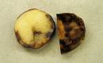a 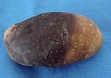b

Plate 1: (a) and (b) - Late Blight disease

However, the recent advancement in tissue culture and the flexibility of organ development in potato allows for alternative methods of propagation through in vitro techniques. Potato seed production programmes in many countries have been boosted by using these techniques. In recent years the first multiplication steps in seed production programmes are speeded up by using in vitro plantlets, Microtubers or mini tubers (Hussey and Stacey 1981).
Potato can supplements the food needs of the country in a substantial way. It produces dry matter food, well-balanced protein and more calories from unit area of land and times then other major food crops. It contains practically all the essential dietary constituents like cereals, carbohydrates that are the major constituents of potato. Besides it contains essential nutrients as proteins and minerals like calcium, phosphorus, iron and vitamins: B1, B2, B6 and C, (Thamburaj and Singh; 2001).

Successful cultivation of seed potato depends upon the availability of disease free seed, soil, moisture, plant protection measures, low temperature, short days conditions during tuberization phase, resulting rapid bulking rate. Potato plant is very sensitive to ecological factor such as temperature, rainfall and photoperiod. (Singh; 2002) Conventional propagation of potato is done vegetatively using seed tubers and ensures uniformity of the crop in terms of growth and yield, but results in degeneration of the crop due to virus infection, the rate of degeneration 398 varying from place to place and from cropping season to cropping season. The viruses are transmitted through different ways including through planting infected tubers. If the seed stock is not maintained well or frequently replaced with fresh ones, the virus infiltration can reach up to 100% in 3 - 4 successive crop seasons resulting in almost half or one third yields. This is the major problem faced by seed producers.
Almost half a century has passed since in vitro tubers (microtubers) were first described in potato, but their adoption as a seed propagule has been uneven globally. Consensus is lacking regarding optimal production practices for microtubers and their relative productivity in relation to other propagules for minituber production. There is significant uncertainty regarding the utility of microtubers for evaluation of agronomic characters. However, the application of microtubers in germplasm conservation is widely accepted. Microtubers are produced in vitro in a plethora of different growing systems with varying environment, media constituents, and storage intervals (Plate: 2- a and b). Many of the interactions between growth parameters in vitro and subsequent productivity appear to be genotype-specific. Accordingly, microtubers come in different sizes, have different dormancy requirements, and differ widely in relative growth potential and productivity. Despite these differences, there is evidence for strong analogies in growth responses between field-grown tubers and microtubers (Badoni and Chauhan, 2009).

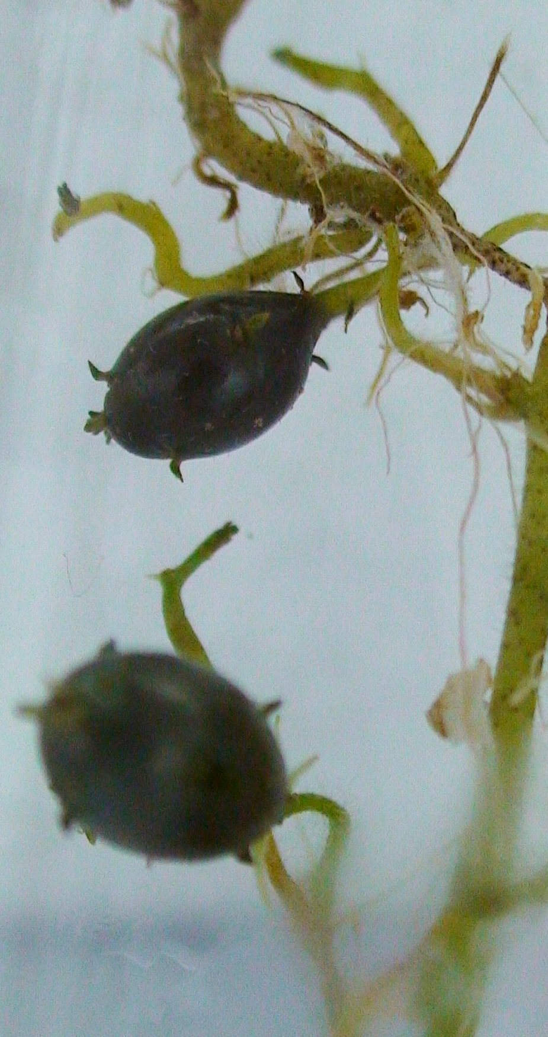a 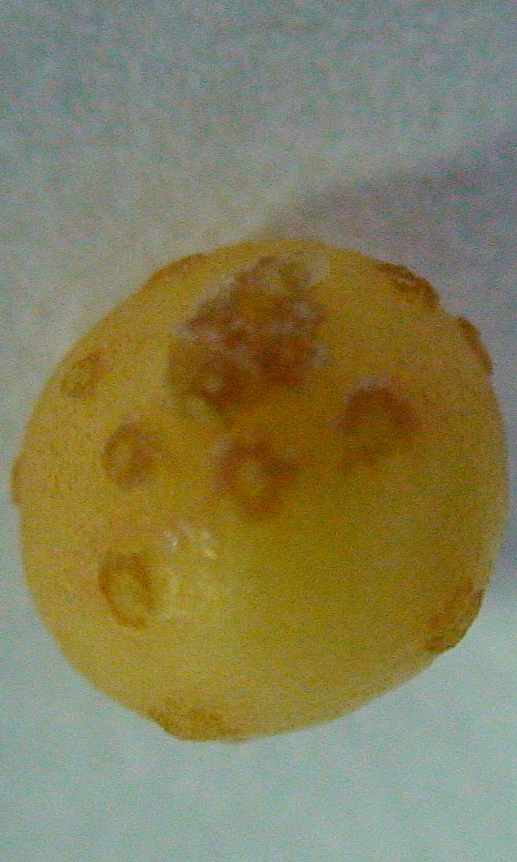b

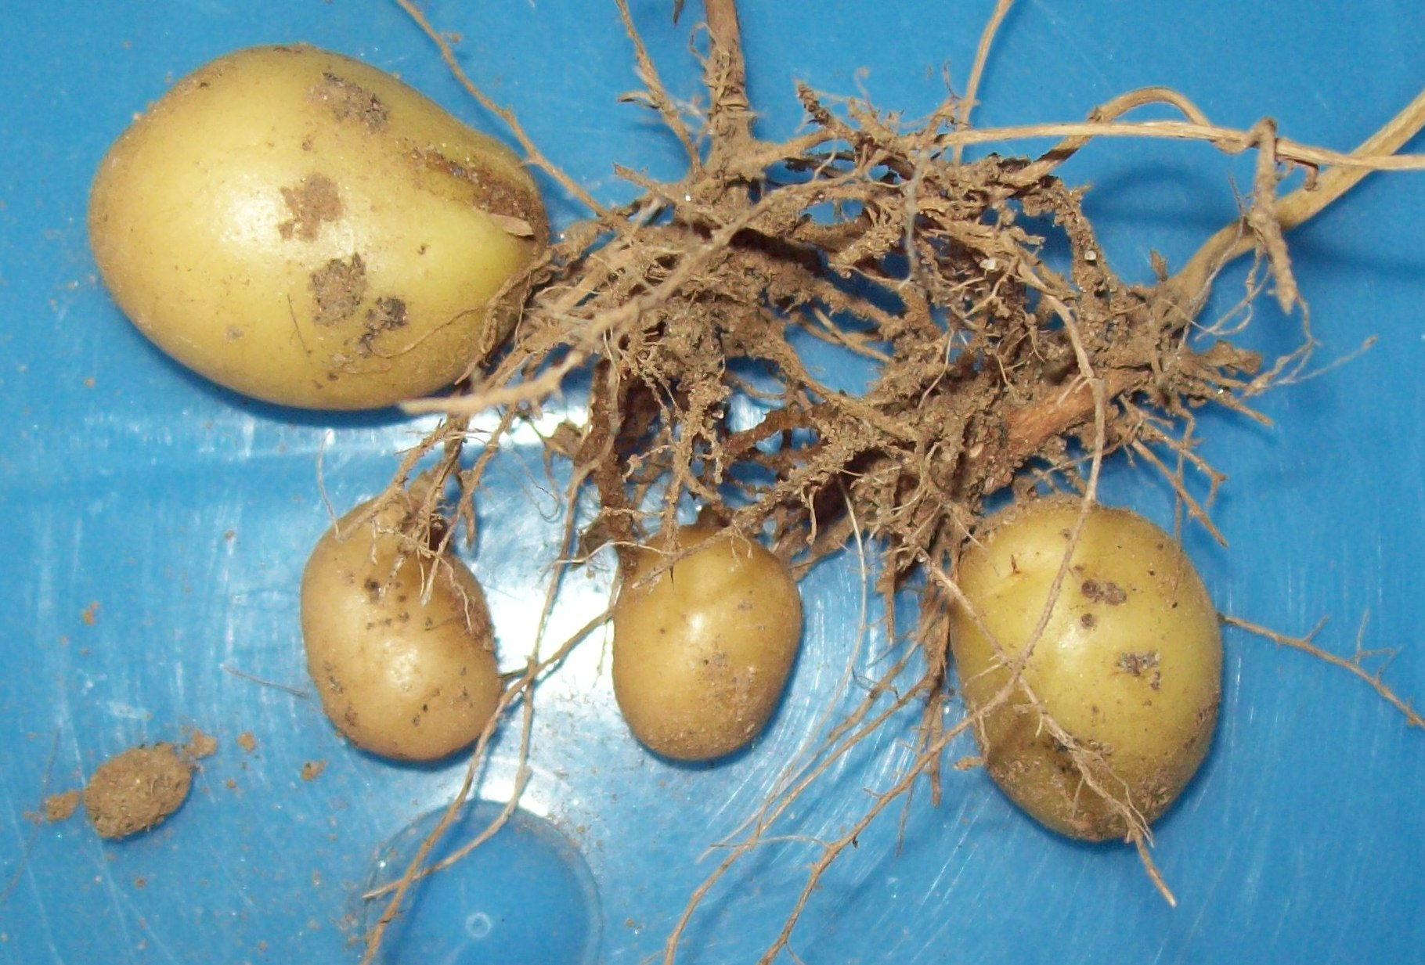c

Plate-2: (a) and (b) Microtubers and
(c) minitubers

The use of microtuber technology in seed tuber production, breeding programs, germplasm conservation, and research appears to have enormous potential. Microtubers are utilized for minituber (small tubers produced from in-vitro-produced propagules; Plate: 2- c) production in greenhouses or screenhouses and, less commonly, are directly field-planted. Wherever microtuber and minituber production technologies have been implemented, they have halved the field time necessary to supply commercial growers (3 or 4 years compared with 7 or more years), and greatly improved seed tuber quality (fewer viral, bacterial, fungal problems) (Donnelly, Danielle J, Coleman, Warren K, Coleman, Shirlyn E, 2003).
To large production of clonal material i.e., to produce the uniform, identical seed material of potato, micro propagation is the better alternative over to conventional propagation of potato. The in vitro propagation method is most suitable alternative to produce Microtuber seed material of potato. By using the technique, which involves low cost components, the large scale clonal material can be achieved in short time duration.

References

Badoni Anoop and Chauhan, J. S. (2009), Microtuber: A Source of Germplasm Conservation, Report and Opinion, 1(3): 69-71
Das, P.C. (1999), Potato in India; Kalyani publishers, Ludhiana
Donnelly, Danielle J, Coleman, Warren K, Coleman, Shirlyn E, (2003), Potato microtuber production and performance: A review, American Journal of Potato Research.
Hussey, G. and Stacey N. J. (1981). In vitro propagation of potato (Solanum tuberosum L.). Ann. Bot. 48(6): 787-796
Prasad, Rajendra (2004), Textbook of Field Crop Production; Indian Council of Agriculture Research, New Delhi.
Singh, I. P. (2002), Seed Production of Vegetable Crops; Aman publication House, Meerut, India.
Thamburaj, S. and Singh (2001) Text book of vegetables, tuber crops and spices, Indian Council of Agriculture Research, New Delhi.

Correspongence to:
Anoop Badoni
annabadoni@yahoo.co.in

7/5/2009

