Importance and Problems in Natural Regeneration of Spondias pinnata

Anoop Badoni^{1*} and Chetna Bisht²

¹Department of Seed Science and Technology
²High Altitude Plant Physiology Research Center
H. N. B. Garhwal University, Srinagar- 246 174, Uttarakhand, India
*For Correspondence: annabadoni@yahoo.co.in

Abstract: This article describes importance and problems in natural regeneration of Spondias pinnata. [Report and Opinion. 2009;1(5):12-13). (ISSN: 1553-9873].

Keywords: Importance and Problems; Natural Regeneration; Spondias pinnata
_____________________________________________________________________________________________________

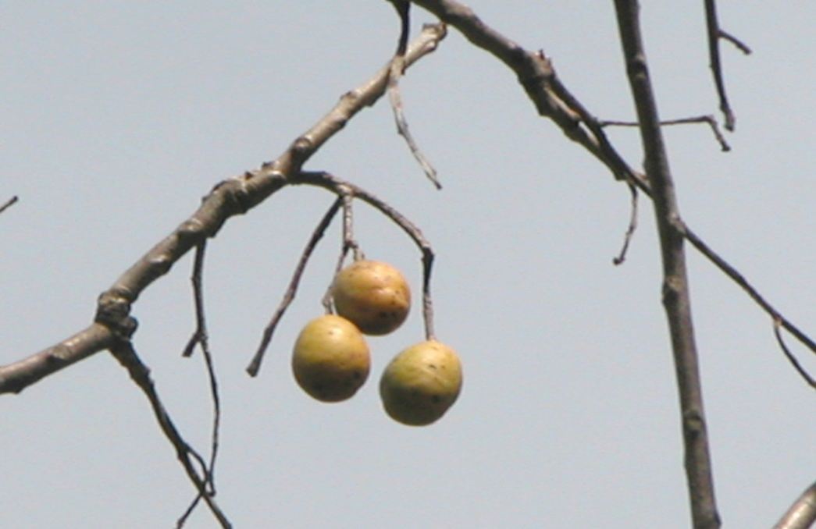
Spondias pinnata

Common name: Wild mango, Hog-plum, Amara
Altitude: 1500 m.
Distribution: Indian Himalayas, Andaman Island,
Srilanka, Myanmar Thailand,
Malaysia and china
Description Deciduous in nature and accomplish,
a height of 9 m to 18 m. Bark thick
aromatic

Importance of Spondias Pinnata

- Its wood is employed for packing cases, tea chests and match – splints.

- The fruits are eaten as a vegetable when green and as a fruit when ripe. Fruits are very nutritious and rich in vitamin A, minerals and iron content.

- The bark is useful in dysentery and diarrhea, and is also given to prevent vomiting.
- The root is considered useful in regulating menstruation.

- The plant is reported to have anti-tubercular properties.

- The leaves are aromatic, acidic and astringent. They are used for flavoring.

- The flowers are sour and used in curry as a flavoring and also eaten raw.

- Through value addition of this wild edible fruit tree plant the local people make chutney, jam and pickle. By production and marketing of these products, the local people may increase their socio-economic status.

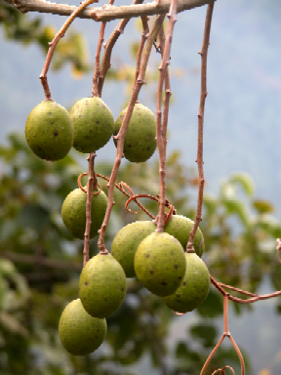
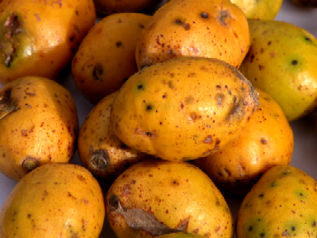

(a) Immature Fruits (b) Mature Fruits

Value Addition

- Wild fruits of many plant species have played a prominent role in the diet and medicine of human beings, particularly in the tribal and rural areas of the country, for thousands of years.
- If educated/uneducated and unemployed youth of this region engage themselves fully in the preparation of quality food and other related products from wild edible fruits like species as a source of income, the threat of unemployment could certainly be minimized.
- There is a great scope for enhancing the acceptability of wild edibles as income generating resources for the hill communities and initiating the potential plant resources for human consumption.

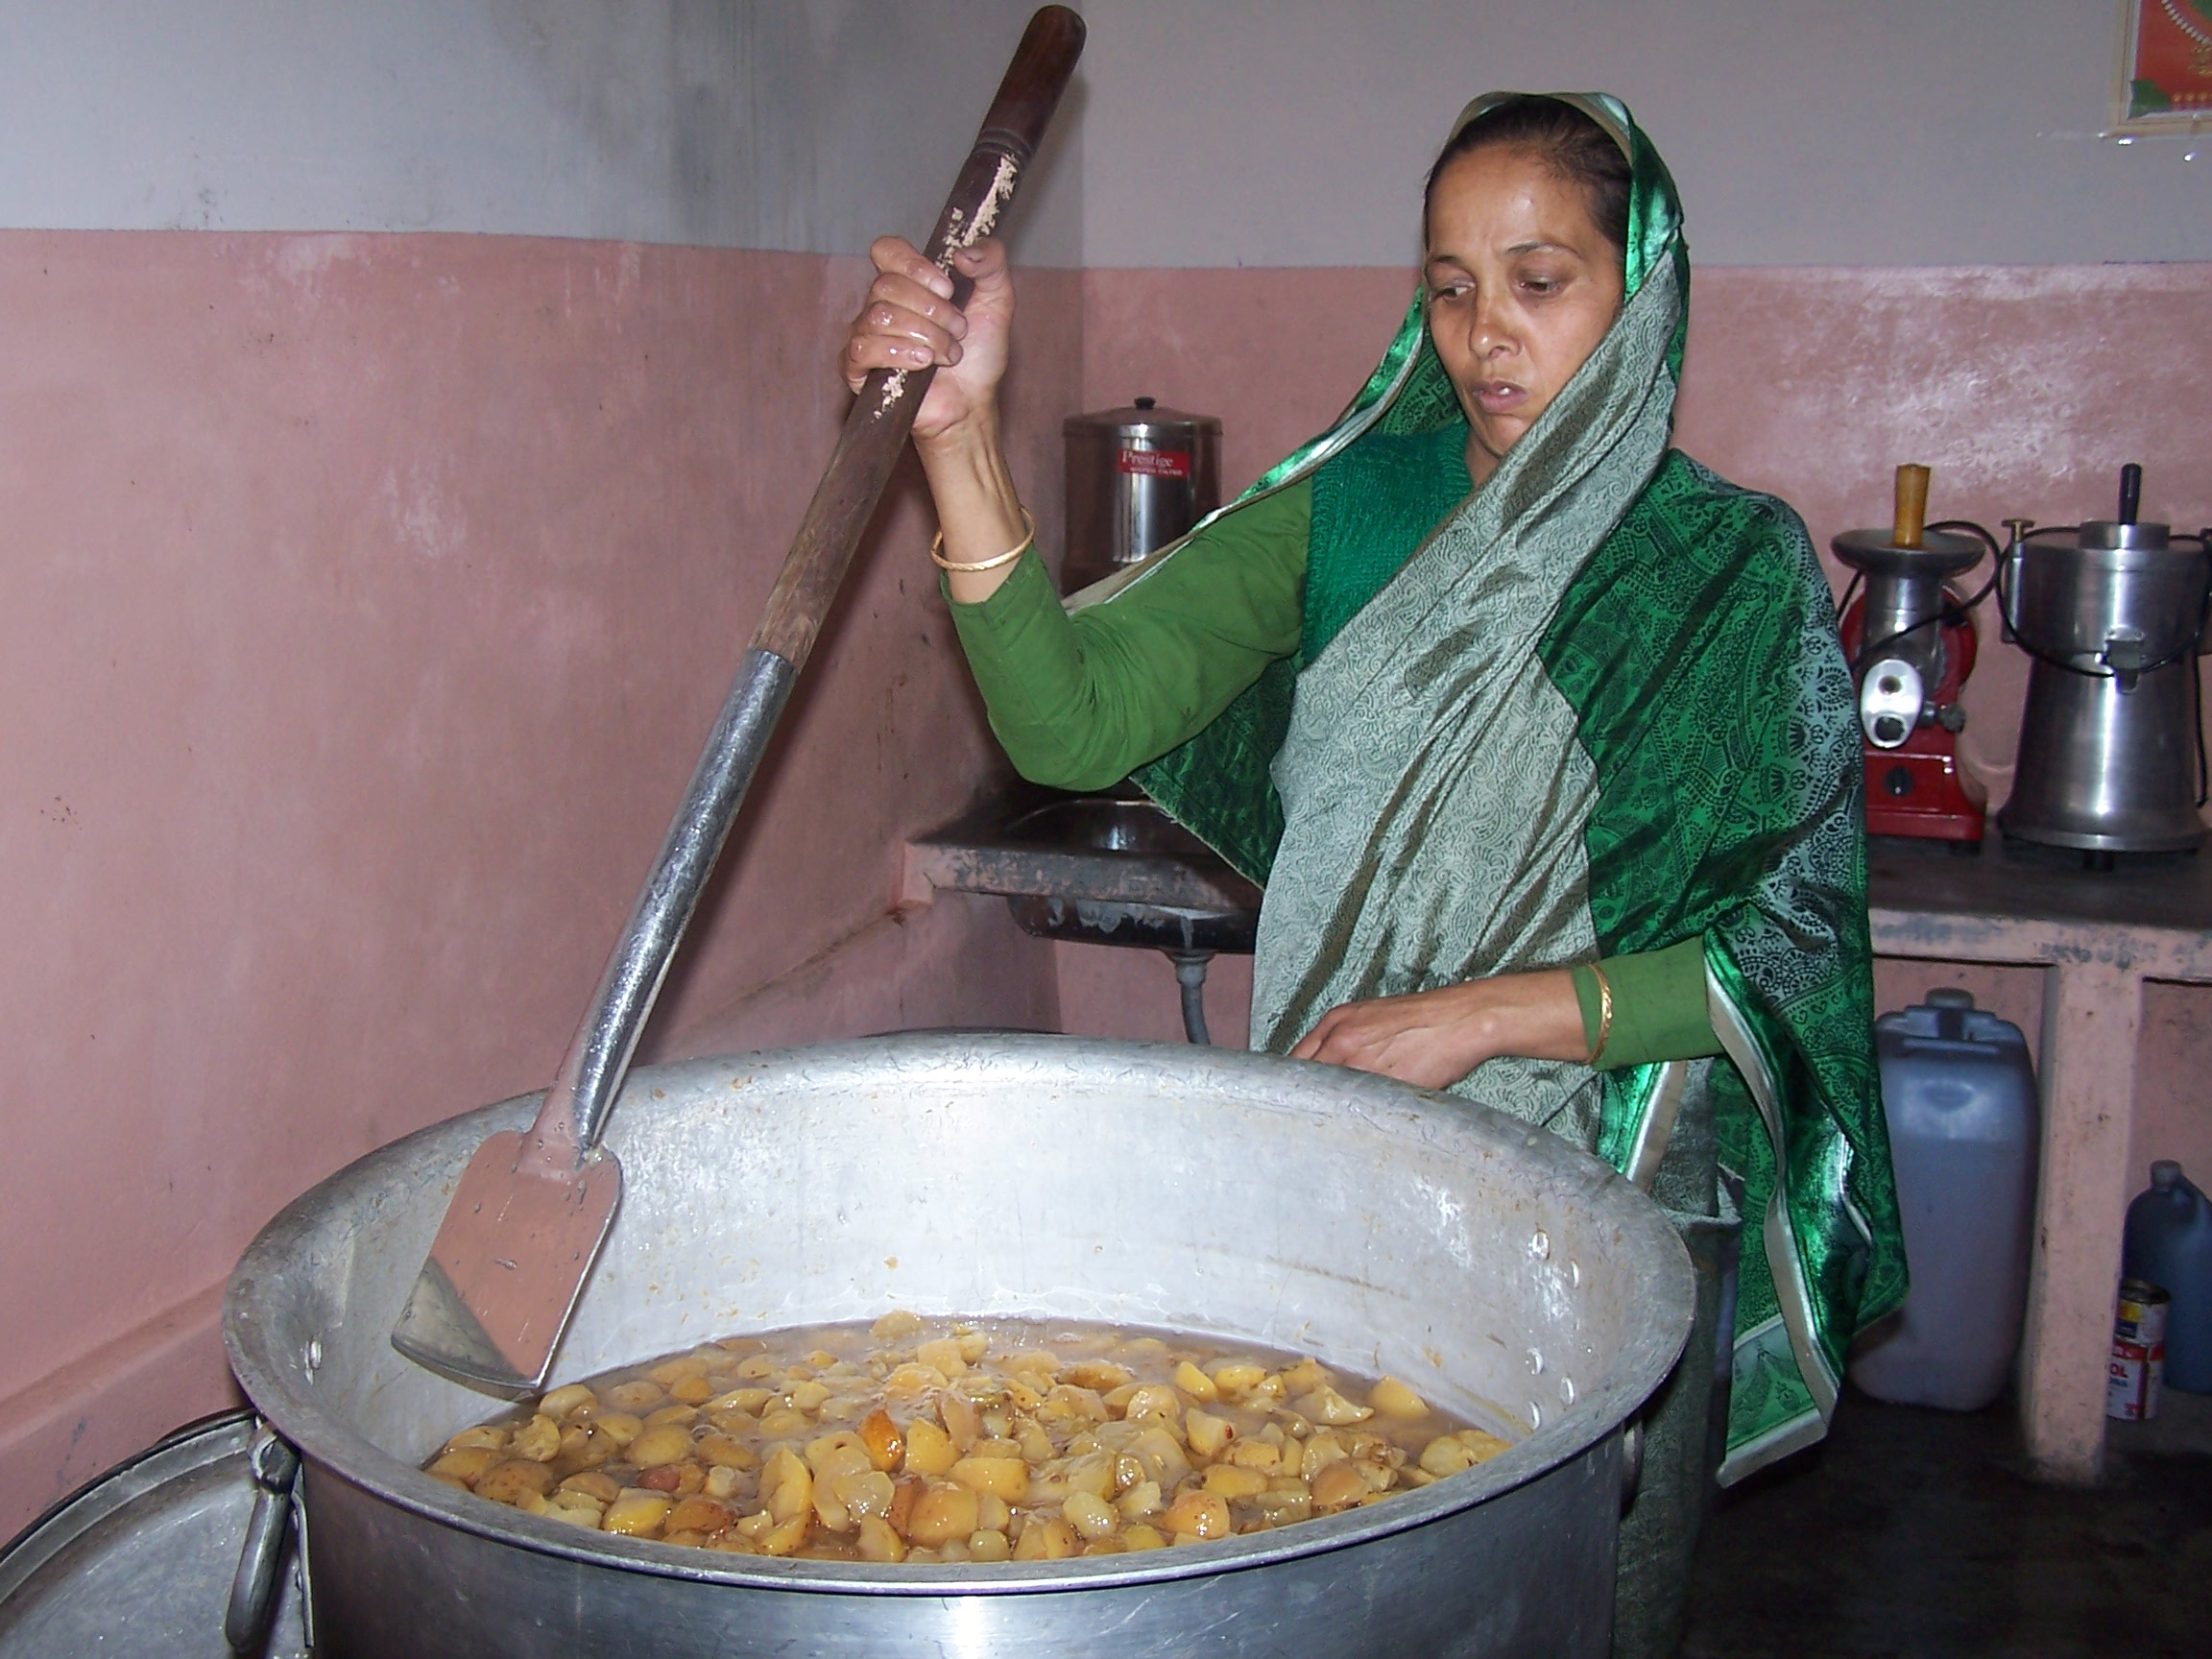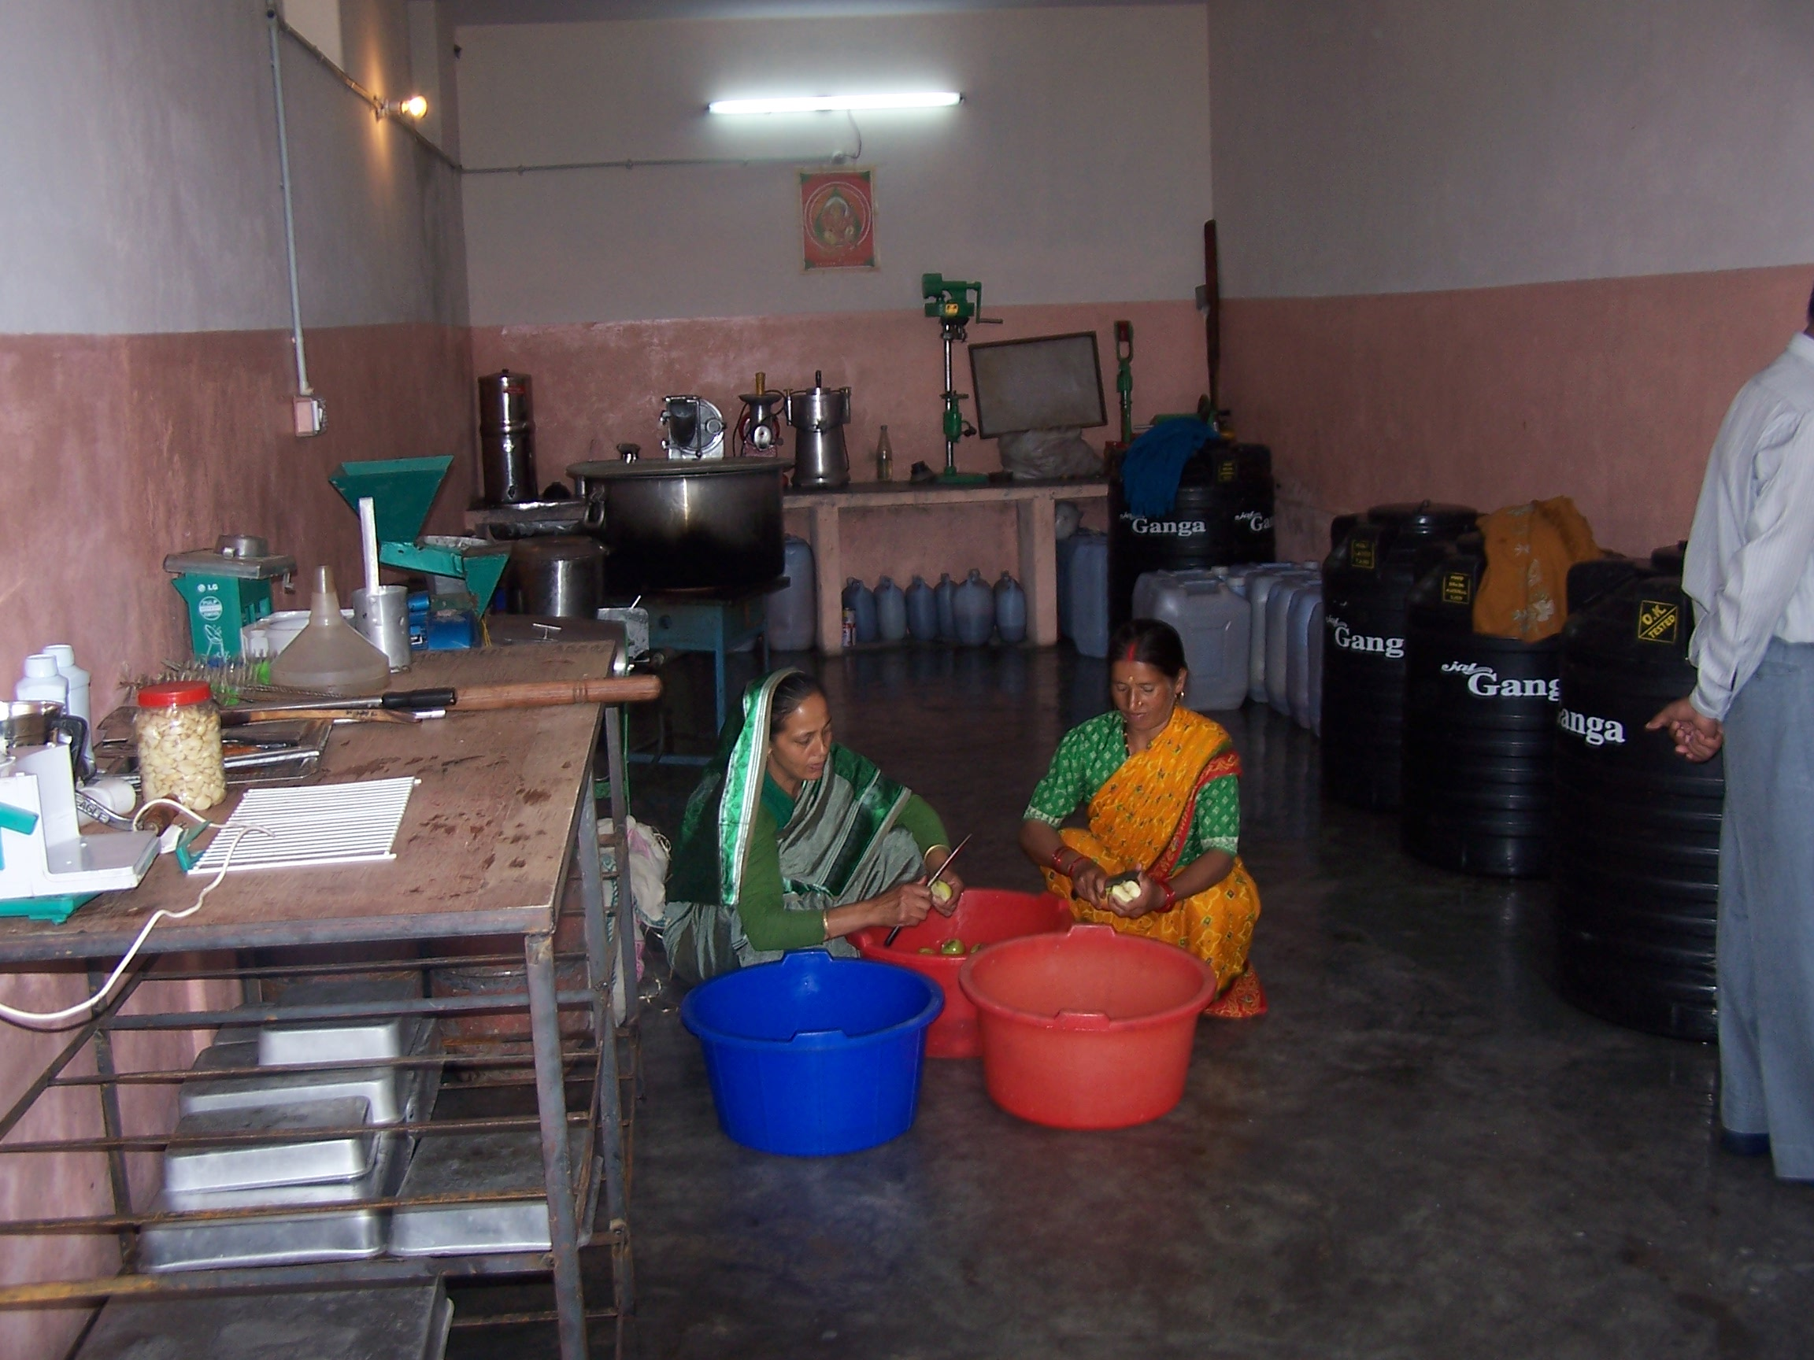

Problems in Natural Regeneration

- Hard seed coat, which creates a problem in seed germination.

- Commercial exploitation of the species because of the fruit and for other medicinal purposes by the locals.

- Lack of traditional knowledge know-how about the importance of the species and various uses.

- Seeds are damage because of the consumption of fruit by birds, monkey and other animals.
- Seeds are prone to attack by various pests, pathogen and insects in nature.

- Lantana might be creating inhibitory effect on both, the soil and species.

- The radicle is apt to dry, if not covered, or may be eaten by birds and insects.

There are many problems in the natural regeneration i.e. the hard seed coat create a problem in natural regeneration. Commercial exploitation and lack of traditional knowledge is also a very important problem. Spondias pinnata bear maximum pressure in natural habitat due to their higher demand for domestic consumption by locals. Attempts will be made to utilize this species as a source of income, particularly for poor rural inhabitants and unemployed youth of the regions by making a variety of values added edible products, such as juice, squash etc. Sustainable utilization and conservation of this plant as gained considerably importance, since it is also the key element of biodiversity.

7/6/2009

