Clinicopathological and Biochemical Studies on Tilipia Zilli Exposed to Climate change and Cadmium Chloride (0.25p.p.m.)
¹Mona Saad Zaki, ² Ahmed Hassan Osman, ³Olfat Mohamed Fawzi ³Suzan Omar Mostafa ⁴Nagwa Said Ata
¹Department of Aquaculture, vet. devission National Research Centre, Giza, Egypt.
dr_mona_zaki@yahoo.co.uk

²Department of Pathology, Faculty of Vet. Med, Cairo University, Egypt.
³Department of Biochemistry, National Research Centre, Giza, Egypt.
⁴Department of Microbiology, Vet. Division National Research Centre, Giza, Egypt.
Abstract
Heavy metals are recognized as cumulative toxic substances causing serious health hazards to man depending on their concentration.
Fourty fish (Tilipia Zilli) were collected from Abbassa Sharkia government and fed commercial fish diet. Thirty fish were exposed to cadmium chloride )0.25p.p.m.) and high temperature for 21 days. Ten fish were kept without treatment (control). Haematological analysis of the exposed group demonstrated a marked elevation in serum glutamic oxaloacetic transaminase, serum glutamic pyruvic transaminase, serum glucose, urea, creatinine, sodium, potassium and phosphorus, while serum calcium, haemoglobin and PCV were reduced. Histopathological examination of the fish exposed to cadmium chloride revealed necrobiotic changes of hepatocytes and epithelial lining of renal tubules spleen showed depletion of melanomacrophage centre. Necrosis of the gill filaments was also noticed. It could be concluded that cadmium chloride at 0.25 p.p.m induced deleterious effects in fish such as damage of liver, Kidney, spleen and gills, Which were reflected on the biochemical and hematological parameters. Heavy metals induced cumulative effect; therefore equivalent lesions of fish may occurr in humans. Moreover, immune suppression could play an important role in predisposing for further infections conditions.

Key words: Pollution – cadmium , fish, immunity.

INTRODUCTION
Heavy metals are persistent contaminants in the environment that come to the forefront of dangerous substances such as cadmium, lead, mercury, copper and zinc causing serious health hazard in humans and animals(Abbas et al. 2002, Abbas 2006, Abdel-Baky 2001, Abernthy & Cutnbie 1999, Abou El-Gheit et al. 2001, Abou El-Naga et al. 2005, Ahmed et al. 1998, Authman 2008, Authman et al. 2008, Bahnasawy 2001). The agricultural and industrial wastes, partially treated or without treatment are being discharged into surface water (Burger et al. 2007, Drabkin 1964, Forstner & Wittmann 2007, Frolin et al. 1986 , Fuda et al. 1991, Gad & Weil 1986). Such metals are absorbed from polluted water through gills, skin and digestive tract of fish by bio-concentration and bio-magnification. Chronic cadmium toxicity or "itai-itai" disease was recorded (Matsubara et al. 1985, Nomiyama 1988, O'Neill 1981).
Cadmium toxicity was interfered with calcium/phosphorus ratio (Stephen 2004, Stostiof 1993). Suppression of cell mediated and humoral response of mammals exposed to sublethal dose of cadmium has been reported (Trinder 1960, Vinodhini & Narayanan 2008, Vosyliene & Jankaite 2006, Zaki & Osman 2003, Fr).
Histophathological examination of fish exposed to cadmium showed edema of secondary gill lamellae, degeneration of hepatocytes and epitheliallining of renal tubules. Degeneration and necrosis in the gill lamellae of fish xposed to cadmium were noticed (Forstner & Wittmann 2007, Frolin et al. 1986 , Fuda et al. 1991, Gad & Weil 1986, Matsubara et al. 1985, Nomiyama 1988, O'Neill 1981).
Heavy metals are recognized as cumulative toxic substances causing serious health hazards to man depending on their concentration.

MATERIALS AND METHODS
Experimental design: Total of fourty fish 100-200 gm body weight of each were acclimatized A tized to laboratory conditions for two weeks before use. They were divided into control group (10 fish) and experimental group (30 fish) that was exposed to cadmium chloride at a concentration of 0.25 p.p.m. for 21 days and high temp (30C⁰ ).
Blood samples were collected from the caudal vein after 7 and 21 days of exposure. Serum for biochemical analysis and heparinized blood for hematological investigations were obtained from each sample.
Biochemical analysis: Test kits of Bio Merieux (France) were used for evaluation of serum glutamic pyruvic transminase and glutamic oxaloacetic transaminase (Reitman, 1957). Serum glucose was assessed according to Trinder (1960). Serum urea and creatinine were determined using kits of Bio Merieux (France). The concentration of cadmium, sodium, potassium and calcium were detected by using atomic spectrophotometry according to Forstner (2007).
Hematological examination: Blood hemoglobin (Rb) was assessed by Drabkin (1964). Hematocrit value was carried out by using microhaematocrit capillary tubes, centrifuged at 1200 r.p.m. for 5 min.
Bacteriological examination: Bacterial isolation was done from skin, liver and kidney of fish on blood tryptose agar, MacConcky agar and tryptic soy agar plates. The plates were incubated aerobically and anaerobically. The bacterial isolates were identified morphologically and biochemically, according to Nomiyama (1988).
The serum IgM was measured according to Fuda et. al. (1991). Antisera for fish were prepared by immunizing rabbits as previously described by Fuda et.al (1991). The procedure for labeling antibody fragment with enzyme was performed.
Elisa assay procedure: Assay was carried out in 96-well polystyrene ELISA microtiter plates (Titertex, Horsham, P A). The microtiter plates were coated with rabbit antigrey mullet IgM and was fractionated by DE-52 at a concentration of 40 $μ$g/ml in 0.01 MPBS. A volume of 150$μ$l was dispensed into each well and incubated for 4 hrs at 4°C.
Blocking was achieved after one washing with 200 $μ$l of 0.01 MPBS + 0.1 % 20 $μ$l per well and two washings with 200 $μ$l of PBS +1% PBS. 0.01% thiomerosol was added to each well and incubated for 2 hrs at room temperature.
Incubation of samples and standards after washing was carried out as described above. 100 $μ$l of sample and standard were placed into the appropriate wells in the microtiter plates and incubated at room temperature.
Incubation with peroxidase labeled antibody after washing was done as described above, each well received 150 $μ$l of peroxidase labeled antibody 1:1600 in PBSBSA, followed by incubation for 12 hrs at room temperature.
Histopathological examination:
Specimens from gills, liver, Kidney and spleen were collected from both control and exposed groups at the end of experiment. The samples were fixed in 10% neutral buffered formalin. Five-micron thick paraffin sections were prepared and stained with H&E for microscopic examination (Carleton, 1979).
Statistical analysis : The obtained data were subjected to the student T test.

RESULTS
Serum biochemical analysis: Fish exposed to cadmium chloride (0.25 p.p.m) and high temp (30C⁰ ) showed a significant increase of SGPT and SGOT activity with pronounced elevation of urea and creatinine by 1st, 2nd, 3rd week of exposure. High level of sodium and potassium in serum of exposure fish was noticed (Table 1). Hyperglycaemia and hypocalcemia were noticed along the experimental period with- marked elevation of serum cadmium (Table 2).
Haematological profile: Reduction of Hb concentration and P.C.V value were observed (Table 2).
Bacteriological examination: Pure culture of Streptococcus spp., Staphylococcus spp. Agrobacterium spp., Flavobacterium spp. and Lactobacillus spp. were isolated from the internal and external organs of exposed fish (Table 3).
Determination of fish IgM: There was a significant decrease in total protein and IgM level from the first week of exposure until the end of last week (Table 4).

Pathological findings
Macroscopical lesions of exposed fish revealed congestion in all internal organs after 21 days. Liver appeared friable and dark red. Peticheal haemorrhages around the operculum, and abdominal cavity were observed. Congestion and edema of gill lamellae were seen (Fig.1).
Histopathological examination revealed necrobiotic changes in hepatocytes and disorganization of hepatic cord (Fig.2). Kidney showed shrinkage of glomerular tufts and degeneration of proximal tubular epithelium (Fig.3). The anterior Kidney showed depletion of melanomacrophage center (Fig. 4). Sloughing of epithelial lining of secondary gill lamellae with lymphocytes, oesinophils, polymoph infiltration were observed (Fig. 5). Necrosis of both primary and secondary gill lamellae was sometimes seen (Fig. 6). Hyperplasia of primary and secondary lamellar epithelium associated with shortening and fusion of gill lamellae with obliteration of interlamellar space were noticed (Fig. 7). Rupture of pillar cells and capillaries associated with lamellar telangiectasis were also observed (Fig. 8).

Table 1. Effect of cadmium chloride .25p.p.m. on kidney and liver function of Tilipia Zilli.

Exposure  time | SGOT  U/L | SGPT U/L | Urea mg/dl | Creatinine  mg/dl | Sodium  Meg | Potassium  Meg
1st week (control) | 90.0$±$0.17 | 20.7$±$1.75 | 3.29$±$0.27 | 0.76$±$0.72 | 124$±$0.57 | 4.19$±$0.07
1st week of exposure | 91.00$±$2.40 | 25.5$±$0.73 | 3.90$±$0.34 | 0.81$±$0.01 | 131$±$0.76 | 4.60$±$0.02
2nd^{st} week control) | 90.00$±$0.10 | 22.1$±$1.48 | 3.30$±$0.28 | 0.75$±$30 | 120.3$±$4.8* | 4.33$±$0.58
2nd ^{st} week of exposure | 125$±$0.45* | 29$±$2.1* | 3.91$±$0.13** | 0.90$±$0.19** | 138$±$0.70** | 5.9$±$0.08
3rd week (control) | 90$±$2.2 | 20.00$±$0.05 | 3.20$±$0.27 | 0.72$±$0.27 | 126$±$4.2 | 4.1$±$0.09
3rd week of exposure | 136$±$2.46* | 35$±$1.56* | 4.6$±$24* | 0.99$±$0.18** | 148$±$7.6 | 6.25$±$0.13
* Segnificant P< 0.05 ** highly significant P < 0.01

Table2. Some hematological and biochemical changes in Tilipia Zilli exposed to cadmium chloride.
Exposure  time | P.C.V  % | Hemoglobin gm/dl | Glucose mg% | Cadmium p.p.m | Calcium mg/dl | Phosphonis mg/dl
1st week (control) | 21.00$±$0.06 | 8.7$±$0.3 | 62$±$1.20 | 0.05$±$0.01 | 5.6$±$0.32 | 4.2$±$0.07
1st week of exposure | 17.9$±$0.05 | 8.1$±$0.01 | 68$±$0.46 | 0.08$±$0.016 | 4.00$±$0.87 | 6.1$±$0.21
2nd^{st} week control) | 22$±$0.29 | 8.1$±$0.36 | 60$±$0.05 | 0.054$±$0.068 | 5.4$±$0.91 | 4.1$±$0.66
2nd week of exposure | 17$±$1.97 | 7.00$±$0.98** | 70$±$1.93** | 0.12$±$1.03* | 4.2$±$0.73* | 6.4$±$0.12*
3rd week (control) | 20.0$±$1.32 | 8.1$±$0.07 | 62.2$±$0.70 | 0.04$±$0.01* | 4.4$±$0.73 | 3.9$±$0.1
3rd week of exposure | 16.9$±$0.8 | 6.91$±$0.23* | 84$±$0.02* | 0.16$±$082* | 3.5$±$0.88* | 6.1$±$0.6*
* Segnificant P< 0.01 ** highly significant P < 0.05

Table 3. Bacteriological recovered in Tilipia Zilli exposed to cadmium chioride (0.25 p.p. m).
Bacterial strain | External surface | Internal organs | Internal organs liver | Gills
Agrobacterium spp. | 4.1x10⁷ | 3.8x10⁶ | 3x10⁴ | 5x10⁷
FlavobacterIum spp. | 7x10⁷ | 6.2x 10⁶ | 6X10³ | 7.3X10⁸
Staphylococcus spp. | 6x10⁵ | 5x10⁴ | 6.2x10³ | 4.2x10⁶
Streeptococcus SPP. | 5x10⁷ | 9x10⁵ | 7x10⁶ | 3x10⁷
Lactobacillus spp. | 3.3x10³ | 4.4x10⁶ | 2x10³ | 2x10⁶

Table 4. Influence of cadmium chloride 0.25 p.p.m on 1gM and protein level.
Exposure period | 1gM/old | Total protein/neg/dl
Control | 0.98$±$ 0.13 | 7.84$±$0.23
1st week of exposure | 0.80$±$ 0.23** | 7.00 $±$ 0.69*
2st week of exposure | 0.74$±$ 0.84* | 6.42$±$0.29*
3st week of exposure | 0.68$±$0.44 * | 6.2$±$0.48*
* Segnificant P< 0.01 ** highly significant P < 0.05 $±$ Standard errors

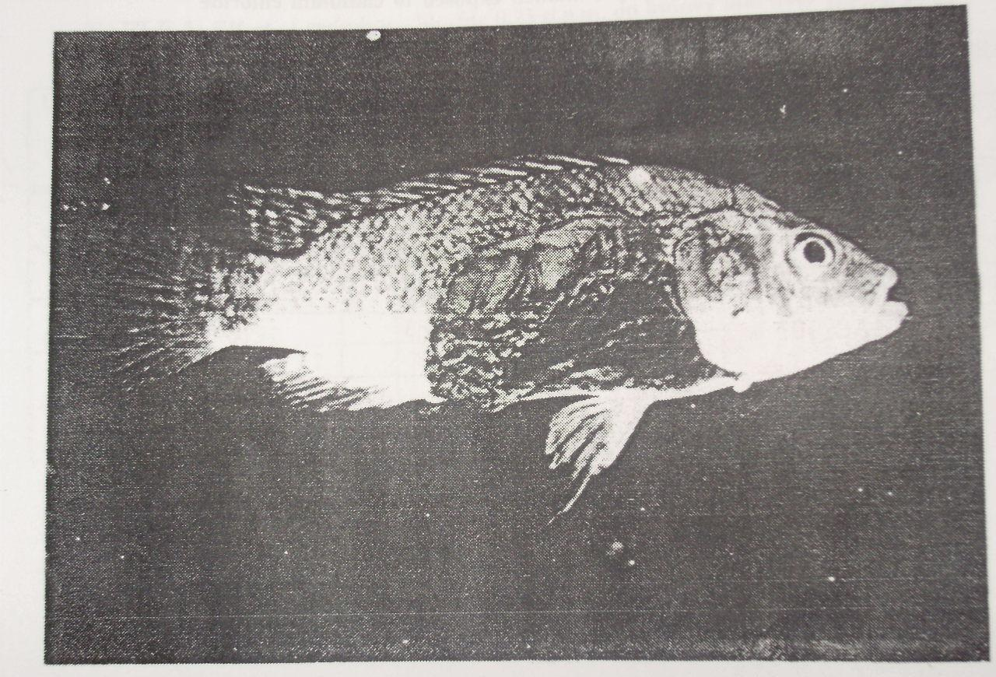"Figure 1. Congestion of all internal organs of exposed fish "

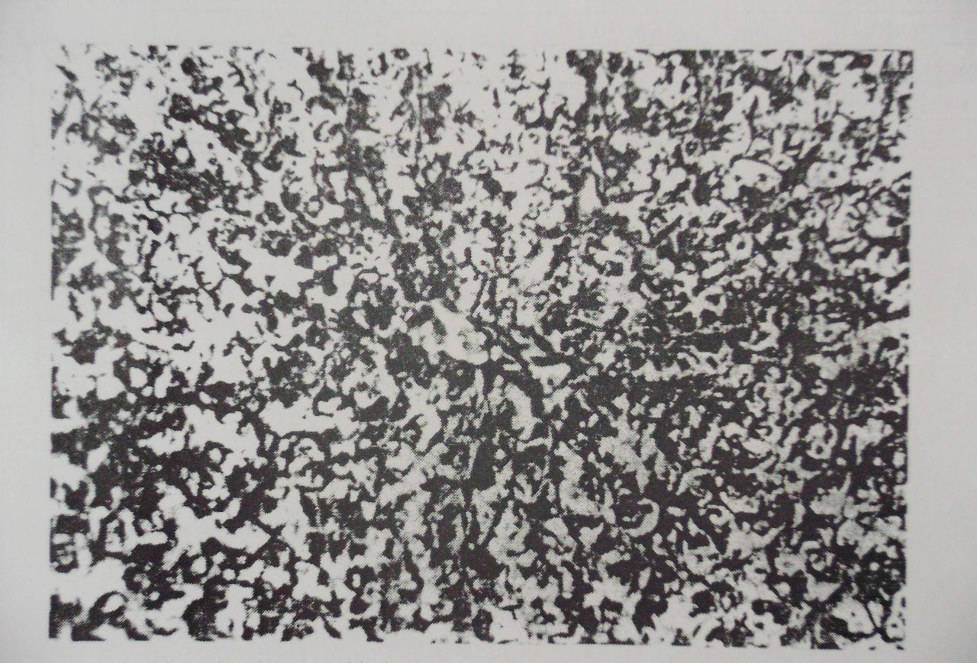"Figure 2. Liver showing necrobiotic changes of hepatocytes(H&E X 400)"

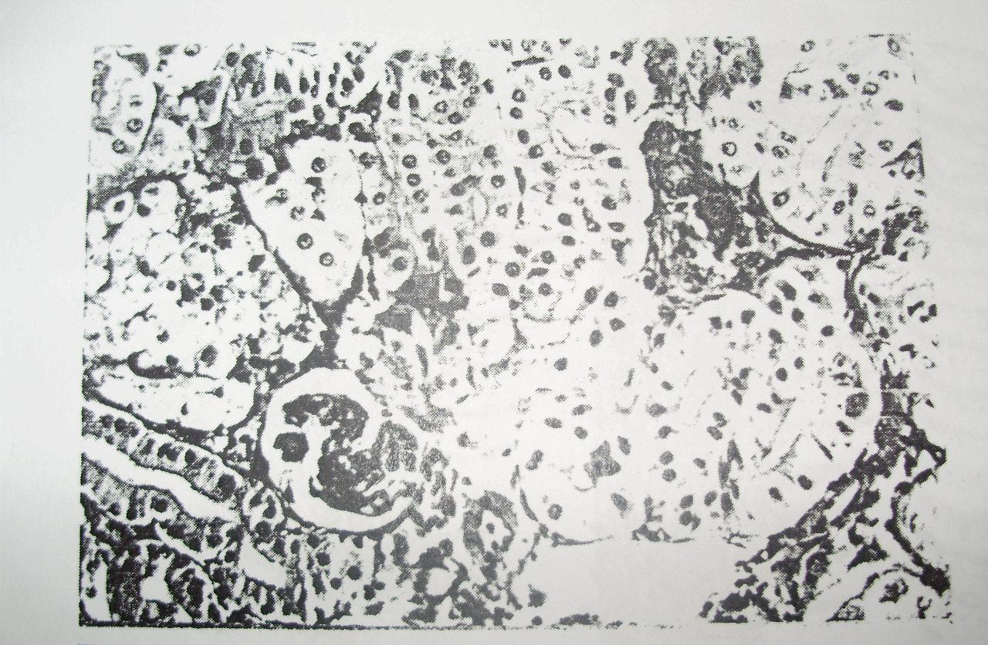"Figure 3. Kidney showing shrinkage of glomerular trufts and degeneration of tubular epithelium (H&P X 400)"

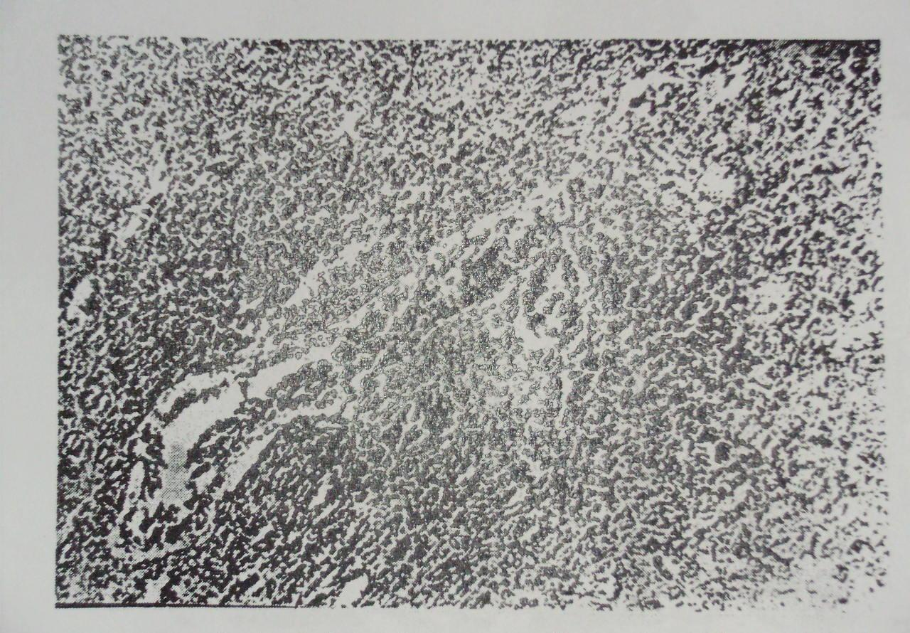
"Figure 4. Spleen showing depletion of melanomecrophage center and haemopoietic elements (H&E X 100)"

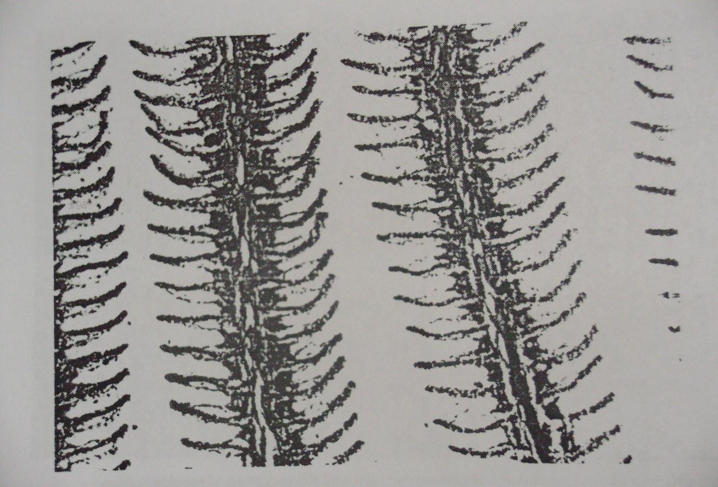
"Figure 5. Sloughing of epithelial lining of secondary gill lamellae (H&E X 100)"

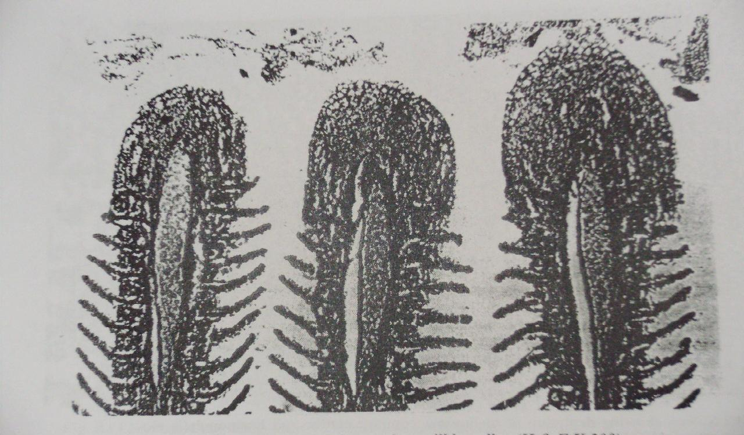
"Figure 6. Hyperplasia and fusion of secondary gill lamellae (H&E X 200)"
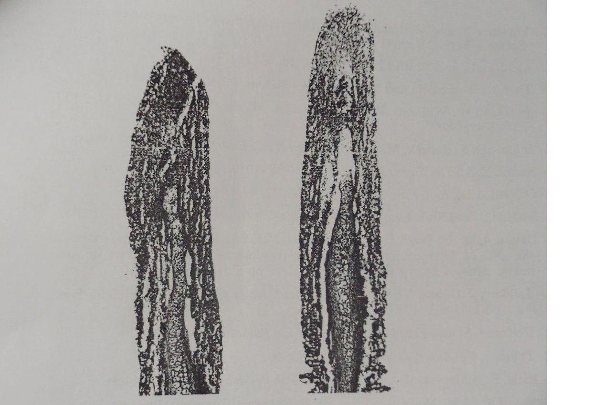
"Figure 7. Necrosis of both primary and secondary gill lamellae (H&E X 200)"

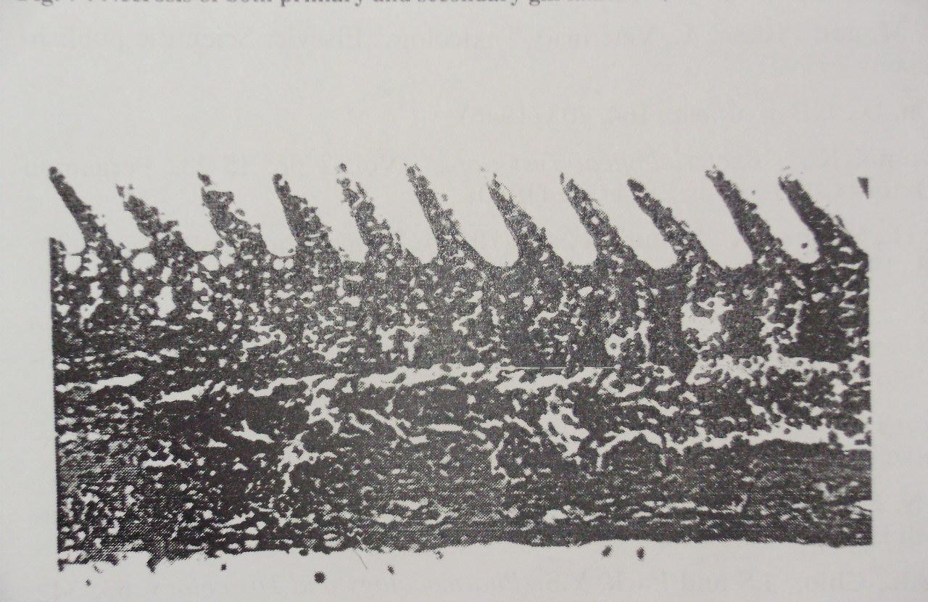
"Figure 8. Gill lamellae showing telangiectasis (H&E X 400)"

DISCUSSION
Aforementioned data of exposed fish to cadmium chloride (0.25 p.p.m) for 3 weeks revealed a elevation of serum GPT, GOT, urea and creatinine.
These findings are in agreement with previous results. Elevation of urea and creatinine beside liver enzymes in cadmium-exposed fish may be attributed to liver and kidney injury. Reduction of calcium level in serum may have resulted from its increased excertion in urine through inhibition of calcium ATPase enzyme. On the other hand, increase of the phosphorus level in serum of exposed fish was noticed. Cadmium chloride toxicity leads to disturbance in blood electrolytes followed by skeletal changes (Trinder 1960, Vinodhini & Narayanan 2008, Vosyliene & Jankaite 2006) Hyperglycemia was observed in the present work which coincides with that obtained in Rainbow traut and salmogaidneri (Vosyliene & Jankaite 2006). The blood glucose level was affected by the rate of carbohydrate metabolism under hypoxia and stress conditions. Hyperglycemia is attribute to stress stimuli followed by rapid secretion of both glucocorticoids and $α$-techolarnines from the adrenal tissue (Abbas, 2006). Regarding to hematological profile exposed fish, hemoglobin and P.C.V. values were decreased. These results are in agreement with previous findings (Matsubara et al. 1985, Nomiyama 1988). The erythropenia resulted from reduction of Hb concentration and P.C.V. value in Kwait Mullet due to disturbance of osmoregulatory mechanism accompanied with destruction of gill membrane and failure of gas exchange (O'Neill, 1981). Cadmium interfered with sulpha-hydride groups of essentials enzymes (Abernthy & Cutnbie 1999,Vosyliene & Jankaite 2006). Heavy metals are recognized as cumulative substances leading to serious health hazards to man and animals (Abou El-Naga et al. 2005, Ahmed et al. 1998, Authman 2008, Authman et al. 2008).
In the present study, a significant decrease of IgM and total protein during the experimental period were observed. Reduction of IgM level indicated that the cadmium chloride toxicity leads to suppression of immune system of exposed fish which become susceptible to any infective agents (Fuda et al. 1991,Reitman & Frankel 1957). There is a significant decrease in IgM level in fish exposed to cadmium chloride if compared with control which may have resulted from high cortisol secretion that was indicated by hyperglycemia in exposed fish.
Macroscopical examination of fish exposed to cadmium chloride for 21 days revealed a congestion of all internal organs and friable bloody liver. These findings are in agreement with those mentioned by other author (Abbas et al. 2002, Abbas 2006, Abdel-Baky 2001, Abernthy & Cutnbie 1999, Abou El-Gheit et al. 2001, Abou El-Naga et al. 2005, Ahmed et al. 1998, Authman 2008, Authman et al. 2008).
Degeneration and necrosis of hepatocytes may be attributed to the cumulative effect of cadmium and to the increase of its concentration in the hepatic tissue during experimental period. These results agreed with Frolin et al. (1986), who stated that liver has an important detoxical role of exogenous waste products as well as externally derived toxins such as heavy metals.
Necrobiotic changes of epithelial lining of renal tubules were observed especially the proximal convoluted tubules that were reflected on electrolytes reabsorption such as calcium, phosphorus, potassium and sodium. These findings come parallel to those previously reported.
It could be concluded that cadmium chloride at 0.25 p.p.m induced deleterious effect in fish such as damage of liver, kidney, spleen and gills, which were reflected on the biochemical and hematological parameters. Heavy metals induced cumulative effect, therefore equivalent lesions of fish may occur in humans. Moreover, immune suppression could play an important role in predisposing for further infections conditions.
Gills showed sloughing of epithelial lining and necrosis of some lamellae. Hyperplasia, shortening and fusion of the secondary gill lamellae that may lead to a great disturbance of gas exchange and ionic regulation were noticed (Balah et al. 1993) . Lamellar telangictasis resulted from rupture of pillar cells and capillaries under effect of chronic irritation of cadmium chloride and leads to an accu- mulation of erythrocytes in the distal portion of the secondary lamellae (Randi et al. 1996). The subepithelial space of the secondary gill lamellae was infiltrated with inflammatory cells. This finding is in agreement with that previously ment- ioned (Randi et al. 1996, Pascoe & Woodworth 1986). Mucinous metaplasia of lamellar epithelial lining is considered as adaptive mechanism against heavy metal toxicity. These alteration are in agreement with those previously mentioned (Stostiof, 1993).

It could be concluded that cadmium chloride at 0.25 p.p.m induced delet- erious effects in fish such as damage of liver, Kidney, spleen and gills, wh- ich were reflected on the biochemical and hematological parameters. Heavy metals induced cumulative effect, therefore equivalent lesions of fish may occurr in humans. Moreover, immune suppression could play an important role in predisposing for further infections conditions.

REFERENCES
- Abbas H.H, Zaghloul K.H, Mousa M.A. Effect of some heavy metal pollutants on some biochemical and histopathological changes in Blue tilapia, Oreochromis aureus. Egypt. J. Agric. Res. 2002; 80:1395-1411.
- Abbas W.T. Fish as an indicator for pollutants in aquatic environment. Ph. D. Thesis, Zoology Department, Faculty of Science, Cairo University, Egypt.2006: 144.
- Abdel-Baky T.E. Heavy metals concentrations in the catfish, Clarias gariepinus (Burchell, 1822) from River Nile, El-Salam Canal and Lake Manzala and their impacts on cortisol and thyroid hormones. Egypt. J. Aquat. Biol. & Fish.2001; 5:79-98.
- Abernthy A. R, Cutnbie P.M. Bull Environ. Contoam. Toxicol. 1999: 17: 595.
- Abou El-Gheit E.N, Zaki M.S. Abo El-Ezz A.A. El-Cherei H.A. Vertebral column curvature syndrome in common carp Cyprinus Carpio L. fish. J. Egypt. Vet. Med. Ass. 2001; 61:57-69.
- Abou El-Naga E. H , El-MoselhyK. M, Hamed M. A. Toxicity of cadmium and copper and their effect on some biochemical parameters of marine fish Mugil seheli. Egypt. J. Aquat, Res. 2005; 31:60-71.
- Ahmed Y.F, Mohamed M.M., El-Nemer I.Z, El-Desoky K.I, Ibrahim, S.S. Some pathological studies on the effect of cadmium and mercuric chlorides on the gonads of catfish (Clarias lazera). Egypt. J. Comp. Pathol. Clin. Pathol. 1998;11:72-81.
- Authman M.M.N. Oreochromis niloticus as a biomonitor of heavy metal pollution with emphasis on potential risk and relation to some biological aspects. Global Veterenaria. 2008: 104 -109.
- Authman M.M.N., Bayoumy E.M. Kenawy, A.M. (2008): Heavy metal concentrations and liver histopathology of Oreochromis niloticus in relation to aquatic pollution. Global Veterenaria . 2008;2:110-116.
- Bahnasawy M.H. Levels of heavy metals in catfish, Clarias gariepinus from different habitats and their effects on some biochemical parameters. Egypt. J. Aquat. Biol. & Fish. 2001; 5:99– 125.
- Balah A.M., El-Bouhy Z.M. ,Easa M.E.I.S. Histopathlogical studies in the gills of Tilipia nilotica "Oreochromis niloticus" under the effect of some heavy metals. Zagazig Vet. J.1993; 21(3): 351-364.
- Burger J., Gochfeld M, Jeitner C, Burke S., Stamm, T. Metal levels in flathead sole (Hippoglossoides elassodon) and great sculpin (Myoxocephalus polyacanthocephalus) from Adak Island, Alaska: Potential risk to predators and fishermen. Environmental Research. 2007; 103: 62–69.
- Carleton H. "Carleton's; Histopathological Technique" 4th Ed. London, Oxford University, Press, New York, Toronto.1979.
- Drabkin, D. Bio Chem. J.1964; 164: 703.
- Forstner N. , Wittmann, G.T.W. Metal pollution in the aquatic environment. Springer-Verlag, Belin .2007.
- Frolin L, Haux C, Karkson-Norgren L, Runn P , Larsson A. Aquatic Toxicol.J.1986; 8:51.
- Fuda H., Sayano K., Yamaji F, Haraj . Comp Brioche, Physiol, 1991;99 :637-643.
- Gad S.C. , Weil C.S. Statistics for Toxicologists. In Hayes. A. W. 2nd .1986.
- Matsubara A., MiharaS. , Kusuda R. Bull Japan Sac, Sic. Fish.1985; 51: 921.
- Nomiyama K. "Bacteriological Test Book ". 1988: 15-23.
- O'Neill J.G. Bull. Env. Contam. Toxico!.,1981; 27: 42-48.
- Pascoe D., Evans S. A, Woodworth, J. Arch. Env. Contam. Toxicol.1986; 15:481.
- Randi A.S., Monserrat J. M., Rodrigue E. M ,Romano L. A. J. of fish diseases.1996; 19: 311.
- Stephen W.I. Zinc, cadmium, mercury and lead. Stephen, W.I. Ed.; Blackwell Scientific Publications.2004.
- Stostiof, M.K. "Fish Medicine" W.B. Saunders Company, Philadelphia, London, Toronto, Montreal, Sydney, Tokyo.1993.
- Trinder P. (1960): Ann. CUn Brioche. 1960; 6:24.
- Vinodhini R. , Narayanan M. Bioaccumulation of heavy metals in organs of fresh water fish Cyprinus carpio (Common Carp). Int. J. Environ. Sci. Tech.2008; 5:179-182.
- Vosyliene M. Z. , Jankaite A. Effect of heavy metal model mixture on rainbow trout biological parameters. Ekologija.2006; 4:12-17.
- Zaki M.S., Osman A.H. Clinicopathological and pathological studies on Tilapia nilotica exposed to cadmium chloride (0.25 ppm) Bull. NRC, Egypt. 2003; 28: 87-100.

Beidou Xi ^{1, *}, Zimin Wei ^{1, 2}, Hongliang Liu ¹

- Chinese Research Academy of Environmental Sciences, Beijing 100012, China
- Northeast Agriculture University, Harbin, Heilongjiang 150030, China
xibeidou@263.net, weizm691120@163.com

Abstract: Modeling composting processes is the prerequisite to realize the process control of composting. In this paper, a simulation model for domestic solid waste composting processes was developed based on microbial process kinetics, mass conservation equation, energy conservation equation and water balance. Differential equations describing microbial, substrate, oxygen concentrations, moisture content and temperature profiles were derived. Considering that several factors (temperature, oxygen, moisture and FAS) in the process interacted to composting processes, microbial biomass growth kinetics was described. In order to verify the model, a series of aerobic composting experiments on domestic solid wastes were conducted. Temperature, moisture, microbial biomass growth, oxygen consumption rate and the concentrations of organic components were monitored in the composting processes and also simulated with the developed model. The simulation results were well consistent with the experimental results. It also could be seen from the model that the efficiency of composting processes could be raised and aeration requirements could be reduced by controlling the oxygen concentration in the exhaust air within a proper range. When the range is 8% to 12%, the aeration requirements reduced 79.61%. This result was verified by the composting experiment. When initial moisture content was higher than 66% or lower than 33%, it would significantly reduce the rate of substrate degradation. It indicated the effect of initial moisture content on the composting processes was significant. A simple sensitivity analysis demonstrated that two key parameters in composting modeling to determine were maximum specific growth rate ($μ_{\text{max}}$) and yield coefficient (Y_{Y/S}). Therefore, the composting processes could be optimized by the application of the developed simulation model. [Report and Opinion. 2009;1(4):xx-xx]. (ISSN: 1553-9873).

Key words: dynamic simulation; model; composting; domestic solid waste

1. Introduction
The biochemical and physical characteristics of solid wastes (e.g., constituents, pH, and moisture) and operating conditions of solid waste composting (e. g., carbon to nitrogen ratio, aeration rate, reaction temperature and pressure) impose significant effects on an ecological succession of microorganisms (Vallini, 1993; Huang, 2000). Although relationships between these factors have been stressed, it is often difficult to synthesize such a large volume of materials. Generally, the factors that affect composting processes, such as temperature and oxygen availability, are controlled to maintain a relatively better growth environment for microorganisms during the process of composting. Analytical and numerical modeling of the composting process could be used as a tool to analyze composting system performance under different operating scenarios.
Modeling composting processes is the prerequisite to realize the process control of composting. Over past years, there have been many approaches (Miller, 1996) which have been used to investigate composting processes: (Hammelers, 1993; Stombaugh, 1996; Agamuthu, 1999) considered growth rates of microorganisms and used the Monod equation to simulate the composting processes (Keener, 1993; Haug, 1993) made emphasis on the thermodynamic and kinetic changes taking place during composting processes. Mohee and White (1998) developed a dynamic simulation model to present biodegradation processes in composting based on the knowledge of the physical and chemical changes occurring in the processes. Hamoda et al. (1998). Wang and Li (2000) also conducted a number of works on the modeling for composting processes. Bari et al. (2000) studied a kinetics analysis of forced aeration composting processes operated under different aeration modes.
However, at the present, most of the existing composting systems are static control systems and the underlying biological portion of the process has been neglected. At the same time, the states of solid waste are various in different periods due to the dynamic features and the living environment of microorganisms is also incessantly changing due to the increase of metabolizing production and consumption of biochemical reaction. These inherent complicated processes are insurmountable for design of cost-effective composting system. So, the present models exist some limitation for real composting processes to determine optimal operation conditions. Thus, it is necessary to integrate the intrinsic rate equations with fundamental microbial kinetics to produce a dynamic model of the process. The dynamic simulation model would be more robust than current empirical models. It should consider more complete complexities process of composting and supply interactive relationship of temperature, oxygen, FAS, moisture and microbial biomass growth to instruct the design of composting system and determine the optimal operation conditions for the process.
The primary objective of this study is to develop an integrated simulation model, which can be used for engineering analysis and design. The dynamic kinetics of the whole composting processes and all key factors, which limit the kinetics, will be considered. The model describes substrate degradation, microbial growth, moisture change, oxygen concentration and aeration on-off situation as a function of substrate and oxygen concentration in the exhaust air, compost temperature and moisture content. Realistic economic aeration will be included to evaluate and optimize a rotation vessel composting process with the numerical simulation results. At the same time optimal composting conditions will be identified.

2. Development of dynamic composting of processes simulation model
Most modern municipal solid waste composting operations emphasize the enhancement of decomposition rate of the organic matter as well as the economic operating cost. This can be achieved once the composting process kinetics is well understood. Based on microbial process kinetics, mass conservation equation, energy conservation equation and water balance, differential equations describing microbial, substrate, oxygen concentrations, moisture content and temperature profiles are derived. Then a simulation model for domestic solid waste composting processes is developed. The process is shown in Figure 1.

Model development
(Process kinetics analysis)
Input variables
Output variables
Coefficient
parameter

Mass conservation
Monod kinetics
water balance
energy conservation
Temperature, air flow organic and inorganic matter content, moisture content, microbial mass, air flow and

Optimization simulation model
Simulation MSW composting processes
Case study and modeling validation

Figure 1. The process of developing simulation model for MSW composting

2.1 Kinetics of composting processes
The complex and dynamic interactions within bioconversion are a fundamental component for developing a proper composting process. Thermal/physical/chemical interactions must be considered completely in biological and physical composting processes in the simulation modeling. The Monod equation is the most popular kinetic expression applied to modeling biodegradation. The Monod equation expresses the microbial growth rate as a function of nutrient that limits growth. The expression is of the same form as the Michaelis-Menton equation for enzyme kinetics is derived empirically. The limiting nutrient can be a substrate, electron acceptor, or any other nutrient such as nitrogen or phosphorous that prevents the cells from growing at their maximum rate. The nutrient limitation is expressed in the form of a Monod term multiplying the maximum growth rate. The Monod equation (藤田賢二, 1993) is:
$\frac{\text{dX}}{\text{dt}}=μ=μ_{\text{max}}\left(\frac{\text{SX}}{\text{KcX}+S}\right)$ (1)
where:
$μ$= specific growth rate (1/h)
$X$= biomass concentration (m/l³)
$S$= substrate concentration (m/l³)
$μ_{\text{max}}$ = maximum specific growth rate (1/h)
$\text{Kc}$= half saturation constant (value of S at which $μ$ is ½ m/l³)
In this model, X represents total microbial biomass concentration including mesophlic and thermophilic bacteria, fungi and actinomycetes, etc.
Endogenous decay consists of internal cellular reactions that consume cell substance. The endogenous decay term is also sometimes conceived of as a cell death rate or maintenance energy rate and represents cells in the death period of the microbial growth cycle. Endogenous decay is described by adding a decay term to the Monod expression:
$\frac{\text{dX}}{\text{dt}}=μ=μ_{\text{max}}\left(\frac{\text{SX}}{\text{KcX}+S}\right)−\text{bX}$ (2)
where b is the endogenous decay rate constant (1/h).
The substrate ($S$) is assumed to be the substrate utilization which is determined by dividing the Monod expression by a yield coefficient, $Y_{x/s}$, the yield coefficient must also be determined experimentally. Substitution of the yield coefficient into the Monod expression for microbial growth results in the following expression for substrate utilization:
$\frac{\text{dS}}{\text{dt}}=−\frac{μ}{Y_{x/s}}=−\frac{μ_{\text{max}}X}{Y_{x/s}}\left(\frac{\text{SX}}{\text{KcX}+S}\right)+\frac{b}{Y_{x/s}}X$ (3)
The constant quotientis often called $k$, the maximum specific substrate utilization rate. and is called , so that the Monod equation for substrate utilization becomes:
$\frac{\text{dS}}{\text{dt}}=−k^{'}X\left(\frac{\text{SX}}{\text{KcX}+S}\right)+k_{d}X$ (4)
Following Haug (1993), the composite degradation constant is represented by multiplicative factors for temperature, oxygen, free air space and moisture content as:
$k^{'}=k⋅k_{T}⋅k_{\text{moisture}}⋅k_{\text{FAS}}⋅k_{O_{2}}$ (5)
where$k_{T}$ is the temperature correction, $k$
is the moisture content correction, $k_{\text{FAS}}$is the free airspace correction andis the oxygen concentration correction. The effects of them are concerned as follows:

(1) The temperature correction$k_{T}$
According (藤田賢二, 1993), the relationship between microbial specific growth rate $μ$ and temperature of compost bulk is presented by equation 6 (when$T≤T_{M},T_{M}=\text{60}$℃), equation 7 (when $T_{M}≤T≤T_{L},T_{L}=\text{80}$℃), when $T≥T_{L},μ=0,k_{T}=0\text{.}$
$k_{T}=\frac{μ}{μ_{s}}=\text{exp}\left\{−\frac{E_{A}}{R_{A}}(\frac{1}{T+\text{273}}−\frac{1}{T_{S}+\text{273}})\right\}$ (6)
$k_{T}=\frac{μ}{μ_{M}}=\frac{T_{L}−T}{T_{L}−T_{M}}$ (7)
where: $μ_{S}$=microbial specific growth rate at preference temperature $T_{\text{AS}}$(1/h)
$T$= temperature of compost bulk (ºC)
$E_{A}$= activate energy of compost bulk (J/mol)
$R$= universal gas constant (J/(model·K))

(2) The moisture content correction
Through experiments, the relationship between microbial maximum specific growth rate and water content in compost bulk is identified as follows.
When water content $w$ is lower than the critical value $w_{a}$, which is essential for microbial growth, $μ=0,k_{\text{moisture}}=0$. When $w$ is greater than $w_{a}$, $k_{\text{moisture}}=\frac{μ}{μ_{\text{max}}}=\frac{w−w_{a}}{K_{a}+w}$. When $w$ is greater than 60%, $k_{\text{moisture}}=\frac{μ}{μ_{\text{max}}}=\frac{w−w_{a}}{K_{a}+w}\frac{w_{2}−w}{w_{2}−w_{1}}$.
Here
w₁ is the optimum moisture and w₂ is the highest moisture above which composting can’t carry out.

(3) The free airspace correction
Free air space (FAS) is important in composting processes, because it is correlated with oxygen transfer. The FAS correction is given as (Hang, 1993).

$k_{\text{FAS}}=\frac{1}{1+e^{[−\text{23}\text{.}\text{675}∗\text{FAS}+3\text{.}\text{4945}]}}$ (8)
Because composting particles constantly consolidate, FAS in reality decreases with time. However, FAS is left constant because the interaction of particles and moisture which affects FAS through the composting processes on beyond the scope of this study.

(4) The oxygen concentration correction$k_{O_{2}}$
Oxygen concentration could be limited by diffusion the particle matrix of solid waste. Because the effect of particle size is difficult to model, a more simplified approach was adopted. Haug (1993) assumed that particle sizes are sufficiently small to avoid oxygen transport limitations and got a Monod-type expression shown as follows to model oxygen limitation.
$k_{O_{2}}=\left(\frac{\text{Vol}{\%O}_{2}}{K_{o}+\text{Vol}{\%O}_{2}}\right)$ (9)
The $\text{Vol}{\%O}_{2}$ is the percentage of oxygen in the incoming air. Because the substrates are well mixed, oxygen levels in the FAS between composting particles should be in the same range. So, it is assumed that the oxygen concentration in the FAS in the vessel is the same as the residual oxygen concentration in the exhaust gas. The half velocity coefficient is calculated through the relationship between the velocity and the oxygen concentration in the exhaust gas and get a value of 2.0%. In reality, oxygen concentration will be considerably above 6% to keep the reactor from becoming facultative or anaerobic. But when particle thickness on the order of 1.0 cm would appear to present large diffusion resistances that would tend to dominate the process kinetics. So the particle correction should be concerned. Then the experiential equation is given as follows.
$k_{O_{2}}=\left(\frac{\text{Vol}{\%O}_{2}}{K_{o}+\text{Vol}{\%O}_{2}}\right)k_{\text{particle}}$ (10)
Whereis an experiential coefficient (the range is 0 to 1). The value ofwill be adjusted according the composting particle size.

2.2 Conservation equation
2.2.1Mass conservation equation
Figure 2 shows the conceptual diagram of mass balance of composting processes from time $t−1$ to time $t$ during an operation process. Microorganisms ($X$) take organic substance ($S$) in solid waste as nutrients for growth. Microbial activities also result in the change of moisture (water content $W$) in solid waste. The mass balances are expressed as
$\frac{\text{dS}}{\text{dt}}=S_{t−1}−S_{t}$ $\frac{\text{dX}}{\text{dt}}=X_{t−1}−X_{t}$ $\frac{\text{dW}}{\text{dt}}=W_{t−1}−W_{t}$
where
$S$= the mass of organic substance (m)
$X$= the mass of microorganisms (m)
$W$= the mass of water in the reactor (m)
$t$= the time period (h)

Figure 2. Conceptual diagram of mass balance of composting processes.

2.2.2 Water balance and moisture content correction
There are positive relationships between water evaporation rate, water content and rate of air supply. The conservation equations of water in the reactor of solid waste compost are as follows:
$\frac{\text{dW}}{\text{dt}}=−λ\text{jq}\frac{W}{M}$ (11)
$j=\frac{\text{18}}{\text{22}\text{.}4}\frac{p_{s}}{p_{0}−p_{s}}$ (12)
where: $q$= flow rate of air supply (l³/h)
$λ$= saturation ratio of vapour
$M$=mass of compost bulk, equals $S+X+W+U$, $U$is the humus content (m)
$j$= saturate water vapour content (kg/Nm³)
$p_{s}$= saturation vapour pressure (Pa)
$p_{0}$= air pressure (Pa)
The relationship between saturation vapour pressure and air pressure can be described by the following equation (13):
$\frac{p_{s}}{p_{0}}=\text{exp}(A−\frac{B}{T+D})$ (13)
where $A,B$and$D$ are experiential constants. Based on Xi Beidou (2002), A = 11.961, B = 3993.7 and D = 233.9.

2.2.3 Energy conservation
Assuming the energy conservation is expressed by thermal balance during solid waste composting

processes, energy conservation equation is presented by equation (14) as follows:
$C_{c}M\frac{\text{dT}}{\text{dt}}+h_{1}(\frac{\text{dS}}{\text{dt}}+\frac{\text{dX}}{\text{dt}})=h_{2}\frac{\text{dW}}{\text{dt}}+(T_{a}−T)\left\lfloor {\text{qC}}_{a}+\text{KF}−C_{w}\frac{\text{dW}}{\text{dt}}−C_{s}(\frac{\text{dS}}{\text{dt}}+\frac{\text{dX}}{\text{dt}})\right\rfloor$ (14)
where:
$C_{c}$= heat capacity of compost bulk (kJ/ (kg·℃))
$h_{1}$= heat quantity generated by unit dry organic (kJ/kg)
$h_{2}$= potential heat of water evaporation (kJ/kg)
$T$= temperature of compost bulk (℃)
$T_{a}$= temperature of inflow air (℃)
$q$= rate of air supply (m³/h)
$C_{w}$= heat capacity of water (kJ/ (kg·℃))
$C_{a}$= heat capacity of air (kJ/ (kg·℃))
$C_{s}$= heat capacity of volatile organic
$K$= the thermal conductivity coefficient of compost facilities (kJ/（m²·h·℃）)
$F$= total thermal dispersion area of compost facility (m³)
On the left hand side of equation (14), $C_{c}M\frac{\text{dT}}{\text{dt}}$ is the heat quantity change due to temperature change of compost bulk and $h_{1}(\frac{\text{dS}}{\text{dt}}+\frac{\text{dX}}{\text{dt}})$ is the energy variation from microbial growth and organic biodegradation process. On the right hand side, $h_{2}\frac{\text{dW}}{\text{dt}}$ is the energy transported by water evaporating and $(T_{a}−T)\left\lfloor {\text{qC}}_{a}+\text{KF}−C_{w}\frac{\text{dW}}{\text{dt}}−C_{s}(\frac{\text{dS}}{\text{dt}}+\frac{\text{dX}}{\text{dt}})\right\rfloor$ is the energy variation due to temperature change of air, water, and volatile organic and system heat loss. The thermal conductivity coefficient of compost facility is calculated as follows:
$K=\frac{1}{F}\sum{\frac{F_{n}}{\frac{1}{γ_{1}}+\frac{L}{δ}+\frac{1}{γ_{2}}}}$ (15)
where:
$F_{n}$= total surface area of compost reactor
$γ_{1}$= the thermal conductivity coefficient between outside wall of reactor and ambient surroundings (kJ/ (kg·℃))
$γ_{2}$=the thermal conductivity coefficient between inside wall of reactor and compost bulk (kJ/ (kg·℃))
$δ$= the thermal conductivity coefficient of reactor wall
$L$= thickness of reactor wall

Figure 3. Schematic diagram of experimental reactor. 1. main body; 2. axis; 3. gas flow meter; 4. electromotor; 5. control system; 6. air feedsystem; 7. temperature equipment; 8. gas analyzer.

3. Result Analysis
3.1 Pilot-scale experiment
A schematic diagram of the pilot-scale rotation reactor is showed in Figure 3. The reactor was designed to accelerate the composting process by optimizing temperature and air flow, to verify the results of simulation model. The modes of aeration studied were up flow through PVC tubing filled gas chamber below a fine mesh screen near the bottom of the reactor. Solid wastes temperature sensors were used for temperature measurements. The leachate of the system would be captured and recycled through the chamber rotation. This not only prevents the composts from drying out, but also prevents the removal of any bacteria, microorganisms that are essential to the process. Outlet vent installed an O₂-H₂S measuring apparatus: MD-520E instrument and CO₂ analyzer: LX-710.
The initial moisture content of the compost mixtures was around 60.0% (g H₂O/g wet solids). The organic substrate of raw materials was 35.0%. Each pilot-scale composting tests was performed according to the conditions of simulation model. At the first time, the air flow was constant at 0.02 m³/（h·kg）. At the optimum condition, air flow was controlled and outlet oxygen concentration remains between 10 to 18%. This air flow served an additional service in keeping the reactor constantly aerated.
The solid wastes around 150 g were sampled to measure substrate concentration, moisture content, volatile solids at three points in the reactor. Moisture content was measured by oven drying at 101℃ for 24 h until a constant weight was obtained. Volatile solids content was determined by combusting samples at 550℃ for at least 6 h in a muffle furnace. Total nitrogen content was determined using the kjeldahl method while Carbon was determined using TOC analyzer.
Composite samples are processed for microbial count. The dilution plate is used to estimate the number of actinomycetes, bacteria and fungi in the samples. Mesophilic and thermophilic microbial strains are obtained by plating samples taken during composting progress in cultivating the plates at 30 and 60℃, respectively. Mesophiles and thermophiles are isolated and maintained on trytone soy agar (TSA) and peptone agar (PA), respectively. Isolates are obtained by streaking out all the colonies of a spread plate within a sector containing 40 colonies. All isolates are tested for a number of properties on identical media, at 30 and 60℃.
A basal agar (BA) contained 0.1% peptone (Difco), 0.1% yeast extract (Difco) and 1.5% agar. Test substrates were added to BA as follows: starch (0.5%), gelatine (1%), carboxymethyl cellulose (CMC, 1%), Chitin (swollen precipitated substrate, 30 ml/liter, and Tween 80 (1%) with CaCl₂·2HO₂ (0.01).

3.2 Validations of Parameters
Coefficient and parameter values were estimated from experimental data and the literature (Hang, 1993). For example, For hydrocarbon compounds, heat quantity generated by unit organic in compost bulk, $h_{1}$ is 17.4 MJ/kg. For protein, $h_{1}$ is 23.4 MJ/kg. And for fat, $h_{1}$ is 39.3 MJ/kg. According to the composition of solid waste used in pilot scale model, $h_{1}$ for organic substance in this study is selected as 17.6 MJ/kg. Potention thermal of water evaporation is 2.44 MJ/kg. Heat capacity of water, compost bulk and air, , and , are 4.2, 2.1 and 2.1 kJ/(kg·℃), respectively.
Under the condition of 55% water content, 60℃, 0.02 m³/（h·kg）air flow rate, microbial maximum specific grow rate is 0.18 (1/h);=0.066; is among the range of 0.02 to 0.07, in this study,$K_{a}$ =0.04. For the pilot scale model, temperature of compost bulk, $T_{A}$, is 60℃ and activate engery of compost bulk, $E_{A}$, is 29 kJ/mol.

3.3 Validation Simulation model
Three scenarous are investigated with the simulation model. The first simulation investigated the interactions between substrate concentration, microbial biomass growth, oxygen concentration temperature and moisture content within the composter using a constant aeration rate. The second set of simulations using the roatation composter set-up, the aeration rate was controlled by the oxygen concentration in outlet exhust gas.

3.3.1 Predicted composter performance for a constant aeration rate
With developed dynamic simulation model, variations of compost indexes, such as compost bulk, organic components in compost bulk, mass of microorganisms, water content and temperature in the reactor and oxygen concentration in out air flow, are listed in Table 1 . The data of Table1 showed that most of compost indexes were decreased during the composting processeses except for temperature and mass of microorganisms. Temperature of compost bulk increased rapidly at the early stage, then kept stable. In the later stage of composting processeses, temperature declined gradually and the oxygen concentration in air outflow kept stable. It showed that function of air supply in this period was mainly cooling compost bulk. The mass of microorganisms kept increasing during composting processeses. The simulation results were consistent with the real experimental results (Table 1 and Figures 4 to 7) except that the error of temperature simulation was a little bit high. Reduction rates of solid waste were 60.36% and 50.08% through numerical model simulation and pilot scale experiments. Simulation result of organic substance degradation was 27.1%, while experimental result was 39.7%. Water content decrease of simulation was 37.13% and experimental result was 30.5%. The retention time of temperature above 55℃ was 156 hours for simulation result, however, it was 72 hours for experimental result. The reason of high temperature simulation error is perhaps the heat loss due to incomplete insulative reactor.

Table 1. Simulation results with developed model
Time (h) | Total weight of compost bulk (kg) | Substrate (%) | Microbial (%) | Water content (%) | T (ºC) | O₂ concentration in out flow (%)
0 | 100.00 | 35.00 | 1.00 | 55.00 | 22.0 | 20.90
24 | 97.65 | 33.94 | 1.97 | 54.87 | 53.88 | 17.79
48 | 88.73 | 33.34 | 4.18 | 52.34 | 67.54 | 14.77
72 | 79.64 | 33.10 | 6.68 | 48.92 | 67.57 | 15.08
96 | 71.28 | 32.74 | 9.58 | 45.05 | 67.15 | 15.53
120 | 63.85 | 32.23 | 12.86 | 40.81 | 66.45 | 16.04
144 | 57.44 | 31.53 | 16.44 | 36.36 | 65.47 | 16.59
168 | 52.09 | 30.60 | 20.22 | 31.90 | 64.12 | 17.15
192 | 47.76 | 29.47 | 24.00 | 27.69 | 62.25 | 17.72
216 | 44.40 | 28.18 | 27.57 | 23.97 | 59.35 | 18.37
240 | 42.36 | 27.21 | 30.07 | 21.47 | 47.53 | 19.64
264 | 41.39 | 26.62 | 31.39 | 20.25 | 37.23 | 20.19
288 | 40.80 | 26.23 | 32.23 | 19.48 | 31.85 | 20.40
312 | 40.35 | 25.93 | 22.89 | 18.88 | 29.08 | 20.51
336 | 39.97 | 25.69 | 33.44 | 18.35 | 27.37 | 20.58
360 | 39.64 | 25.51 | 33.91 | 17.87 | 26.11 | 20.64

Figure 4. Comparison of simulation and experimental Figure 5. Comparison of simulation and experimental
results of water content results of substrate concentration
Figure 6. Comparison of simulation and experimental Figure 7. Comparison of simulation and experimental
results of temperature results of oxygen concentration

3.3.2 The aeration rate was controlled by the oxygen concentration in exhust gas
The simulation result of variations of compost indexes, are listed in Table 2. With developed dynamic simulation model, Air flow was adjusted so that outlet oxygen concentration in the exhaust gas remained a proper range to optimize the aeration costly. When the oxygen concentration was controlled the range from 10% to 18%, At the same conditions, the experimental results are shown in Figure 8.

Table 2. Simulation results under designed operation condition
Time (h) | Total weight of compost bulk (kg) | Substrate (%) | Microbial (%) | Air supply time (h) | Oxygen concentration (%)
0 | 105 | 33.33 | 0.95 | 0 | 20.90
24 | 102.67 | 32.34 | 1.85 | 12.90 | 14.67
48 | 93.30 | 31.65 | 4.0 | 36.90 | 14.94
72 | 83.44 | 31.43 | 6.45 | 60.90 | 15.22
96 | 74.35 | 31.11 | 9.33 | 84.90 | 15.64
120 | 66.25 | 30.63 | 12.61 | 108.90 | 16.13
144 | 59.24 | 29.95 | 16.25 | 132.90 | 16.65
168 | 53.37 | 19.03 | 20.15 | 156.90 | 17.19
192 | 48.62 | 27.87 | 24.12 | 180.90 | 17.73
216 | 44.91 | 26.53 | 27.93 | 195.90 | 7.36
240 | 42.60 | 25.46 | 30.70 | 200.90 | 15.80
264 | 41.51 | 24.79 | 32.18 | 203.70 | 15.84
288 | 40.84 | 24.33 | 33.14 | 205.51 | 10.38
312 | 40.33 | 23.97 | 33.88 | 207.00 | 28.65
336 | 39.91 | 26.69 | 34.52 | 208.10 | 10.90
360 | 39.53 | 23.45 | 35.07 | 209.20 | 12.92

Figure 8. Experimental results under designed operation
Comparison among simulation and experimental results showed that the developed model could well simulate solid waste composting processes. Therefore, it could be used to instruct the design of optimal operation. The developed model may be used to simulate the efficiency and cost of compost processes under different operation conditions. In this study, the air supply approach was adjusted and the developed model was then used to simulate the compost efficiency. It was identified, when composting processes was on the way of intermittent operation, starting air supply when oxygen concentration in air outflow lower than 10% and stopping air supply when oxygen concentration higher than 18%, composting processes was very cost-effective. With this condition, running pilot scale experiment results in consistent reduction rate of organic substance (Figure 8). At the same time, oxygen supply was reduced 40% so that the cost of system operation was saved greatly. Thus, it is necessary to optimize the aeration mode to enhance the degradation rate of composting process and reduce air flow.

3.4 Sensitivity analysis
A simple sensitivity analysis was performed to evaluate the relative importance of selected model parameters. The parameter values examined were maximum specific growth rate $K_{C}$μ$μ_{\text{max}}$_{max}, half velocity constants for both degradable substrate () and oxygen (), yield coefficient ($Y$), initial biomass concentration ($X_{O}$X₀), initial moisture content (W0) and temperature (Temp0). These parameters were run in the simulation program and all other parameters were set at their default values. Then each parameter was decreased to 60%, 40% and 25% of its default value and then increased by 20%, 40% and 60% of its default value over a 10-day simulation period. As each parameter was varied, all other parameters were maintained at their default values. All parameter values used are shown in Table 3. Results from this analysis are shown graphically in Figures 10 and Figures 11.

Table 3. Parameter values used in sensitivity analysis
Parameter | Unit | Percentage  -60 | Change in Parameter analysis
Parameter | Unit | Percentage  -60 | -40 -20 Default 20 40 60
S0 | % | 140 | 210 | 280 | 350 | 420 | 490 | 560
W0 | % | 220 | 330 | 440 | 550 | 660 | 770 | 880
Temp0 | ℃ | 8.8 | 13.2 | 17.6 | 22 | 26.4 | 30.8 | 35.2
X0 | g/kg | 4 | 6 | 8 | 10 | 12 | 14 | 16
 | h⁻¹ | 0.072 | 0.108 | 0.144 | 0.18 | 0.216 | 0.252 | 0.288
Kc | g/kg | 9.6 | 14.4 | 19.2 | 24 | 28.8 | 33.6 | 38.4
K_{O} | kg/m³ | 0.017 | 0.0264 | 0.0528 | 0.066 | 0.0792 | 0.0924 | 0.1484
Y_{x/s} | kgx/kgs | 0.2 | 0.3 | 0.4 | 0.5 | 0.6 | 0.75 | 0.9

The output values examined were the total material reduction (kg), the total percent reduction in readily degradable substrate (ΔS, %) during the 10-day simulation, the maximum biomass concentration at any time (X_{max}). The maximum compost temperature (T_{max},℃) at any time, air flow quantity and moisture content during the 10 day simulation. In Figure 10 and Figure 11 the effects of changes in each parameter value on these four outputs are shown. For instance as varied from 0.072 to 0.288h⁻¹, X_{max} increased from 6.721 to10.141 (kg/m³).
The sensitivity analysis demonstrated that several factors in the process (oxygen, biomass concentration, temperature, and moisture) interacted to control the rates of reactions. So, the interpretation of the results was not always straight forward because of these multiple interactions. For example, as Y_{X/S} increased, fairly large increases in X_{max} corresponding decrease in T_{max}, (Figures 10c and 10d). As $μ_{\text{max}}$ increased and K_{C} decreased, T_{max} (Figure 10 d) increased; however, X_{max} (Figure 10 c) and dS/dt (Figure 10b) have little changed. The slightly higher rates of substrate degradation at the increased μ_{max} values were terminated much earlier due to low moisture levels. The decreased sensitivity of these outputs was due to limits placed on the growth process by the oxygen concentration, FAS, moisture and temperatures. Even more pronounced interactions were observed in the effect of increased μ_{max} or Y_{X/S} on the total reduction in substrate (Figure 10b). The maximum total substrate degradation (22.6%) occurred at the values of μ_{max} =0.18h⁻¹ and Y_{X/S}=0.6. As μ_{max} decreased from its default value by 60%, a decrease in X of only 50.2% occurred because growth was inhibited somewhat by reduced oxygen levels, higher temperature and reduction of moisture. Similarly, a decrease in the maximum rate of substrates gradation was observed, but it was decreased by only 6.75%. The higher temperature when μ_{max} was decreased 60% (68.2 vs. 60.1℃) caused more rapid drying.
Changes in Kc or Ko had very little effect on the Total materials reduction of composting (Figure 10a), total substrate reduction (Figure 10b), maximum biomass (Figure 10c) and maximum compost temperatures (Figure 10d). Again, the air flow quantity and 10-day moisture content were regulated by changes in substrate and temperature levels. Higher values of Kc and Ko or lower values in slightly effect composting processes.
Changes in the initial biomass concentrations (Xo) and initial temperature had extremely small effects (Figures 10a through 11f) on the magnitudes of the output values examined (less than 2%); however, to different values of Xo, the times at which the maximum values were achieved shifted. For example, the maximum compost temperature occurred at 108 h for Xo=0.004 kg/m³ and at 60 h for Xo=0.01 kg/m³.
Changing the initial moisture content (W0) from 22% to 71.5 resulted in major changes in all output variables except maximum temperature which only decreased from 69.2℃ to 65.8℃ (Figure 110 d). However, the maximum temperature occurs in 240 h. The effect of initial moisture content on the composting processes is shown in more detail in Figures 10f. Slighter high moisture content than default provided more optimal conditions (Figures 11f) during the time periods when rapid composting was occurring, but when it comes over 66%, the rate of substrate degradation decrease. Particularly, when moisture content is more than 71.5%, the composting processes are impossible. As W0 decreased from its default value by 60%, the total substrate use and the X_{max} are 2.123% and 0.0365 kg/m³, respectively. This moisture depletion caused the durations of these higher rates to be shorter and the total substrate degradation was lower.

a b
c d
e f

Figure 10. Sensitivity analysis showing predicted model outputs as the indicated parameters ($μ_{\text{max}}$, $K_{C}$, $K_{O}$, $Y_{X/S}$) altered from –60% to +60% of its default value. (a) Total materials reduction. (b) Total substrate use. (c) Maximum biomass concentration. (d) Maximum temperature. (e) Air flow accumulative quantity. (f) Moisture content profile.

a b
c d
e f

Figure 11. Sensitivity analysis showing predicted model outputs as the indicated parameters(W0, Temp0, X0) altered from –60% to +60% of its default value. (a) Total materials reduction. (b) Total substrate use. (c) Maximum biomass concentration. (d) Maximum temperature. (e) Air flow accumulative quantity. (f) Moisture content profile.

4. Conclusions
In this study, a dynamic model was developed to simulate composting processes of solid waste based on the thermodynamics and kinetics of microbial growth. The model provided an excellent vehicle for explaining and demonstrating the complex interactions which occur in the composting processes. Variations of compost indexes, such as substrate degradation, temperature fluctuations, moisture exchanges, and oxygen concentration were simulated for a readily composted input mixture. The model could be used to optimize operational parameters. For example, it was used to develop different aeration regimes through controlling the oxygen concentration in exhaust air to optimize the composting processes and reduce the air flow. Another component should be controlled is the initial moisture content, the effect of initial moisture content on the composting processes was significant. If the initial moisture content was too high or too low, it would reduce the rate of substrate degradation. Particularly, when moisture content was more than 71.5% or lower than 33% the composting processes was impossible. The simulation result was consistent with results of pilot scale experiment. It was found that function of air supply in the later stage was mainly cooling compost bulk. Developed numerical model could be used to help identifying more cost-effective operation condition for composting processes. Adjusting operation conditions through changing key factors, optimal operation condition could be determined through comparing the results of numerical simulation. In this study, the optimal way of air supply was designed with the help of numerical model. Real experimental results showed that it could reduce 79.61% of oxygen supply with the same compost efficiency. Therefore, developed numerical model is of great significance to instruct the operation of real composting processes and reduce the operation cost.

Acknowledgement:
Foundation item: The National “973” of China (No.: 2002C410800-07) and The National “973” of China (No.: 2002CB412302).

Correspondence to:
Beidou Xi, Zimin Wei
Chinese Research Academy of Environmental Sciences
Beijing 100012, China
Telephone: 01186-10-8491-3946
Cellular phone: 01186-130-3103-8107;
01186-131-4100-9271
Emails: Xibeidou@263.net; Weizm691120@163.com

References
[1] Vallini G, Pera A, Valdrighi M, Cecchi F. Process constraints in source-collected vegetable waste composting. Wat Sci Technol 1993;28(2):229-36.
[2] Huang JS, Wang CH, Jih CG. Empirical Model and Kinetic Behavior Thermophilic Composting of Vegetable Waste. Journal of Environmental Engineering 2000; 126(11):1019-25.
[3] Miller F. Composting of municipal solid waste and its components. Microbiology of Solid Waste. CRC Press: 1996:116-45.
[4] Hammelers H. A Theoretical Model of Composting Kinetics. Science and Engineering of Composting. The Ohio State University. 1993:37-58.
[5] Haug RT. Development of Simulation Models, In: The Practical Handbook of Compost Engineering, Lewis Publishers 1993:385-436.
[6] Hamoda MF, Abu HA, Newham J. Evaluation of municipal solid waste composting kinetics. Resources, Conservation and Recycling 1988; 23(1): 209-23.
[7] Mohee R, White RK. Simulation Model for Composting Cellulosic (Bagasse) Substrates. Compost Science & Utilization 1998; 6(2): 82-92.
[8] Agamuthu P. Kinetic Evaluation of Composting of Agricultural Wastes. Environmental Technology 2000; 21(1):185-92.
[9] Quazi H, Bari AK, Tao G. Kinetic analysis of forced aeration composting—Reaction rates and temperature. Waste manage Res 2000; 18:303-12.
[10] Stombaugh DP, Nokes SE. Development of a Biologically Based Aerobic Composting Simulation Model. Transactions of ASAE 1996; 39(1):239-50.
[11] Keener H, Marugg C, Hansen RC, Hotink H. Optimizing the Efficiency of the Composting processes. Science and Engineering of Composting 1993; The Ohio State University: 59-94.
[12] Wang HT, Li YS. Simulation model of dynamic aerobic compost and the application. China Environmental Science 2001 (in Chinese);21(3): 240-4.
[13] 藤田賢二. コソポスト化技术. 技报堂出版, 1993:4.

