Heteroblastic Expression In Leaves Of Phyllanthus Urinaria Linn.

Avinash Mundhra* and Nanda Dulal Paria
Taxonomy & Biosystematics Laboratory, Department of Botany, University of Calcutta, 35, B.C. Road, Kolkata-700019, India.
e-mail: mundhra.avi@gmail.com

Abstract: Heteroblasty is a stair-case phenomenon in some plant life. The juvenile stage through heteroblastic development attains the adult stage. The present article deals with morphological changes observed in leaves of Phyllanthus urinaria Linn. from juvenile stage to adult stage. This is the first report of heteroblastic development in Phyllanthus urinaria as well as for the genus Phyllanthus. [Researcher. 2009;1(2):14-16]. (ISSN: 1553-9865).

Key words: Heteroblasty, morphology, eophylls, Phyllanthus urinaria.

Introduction
Phyllanthus urinaria Linn., commonly known as chamber-bitter or stone-breaker, belongs to the genus Phyllanthus of family Euphorbiaceae. This is a widely used medicinal herb in jaundice, liver and urinary disorders and is often confused with other herbaceous species of Phyllanthus.
In many plants, there is a gradual transition from juvenile traits, present soon after germination, to stable adult traits acquired by the time flowering commences, called heteroblastic development. Several experimental studies were made by Goebel (1889, 1928), Day (1998) regarding heteroblastic development. This phenomenon can be investigated from different view points, e.g. morphological, anatomical, genetical, physiological and environmental (Allsopp, 1965). The change in leaf morphology is one of the main components of this heteroblastic development. As such, the present study involves changes in morphological parameters of leaves of Phyllanthus urinaria Linn. The changes in leaf shape and size, appearance of trichomes and phyllotaxy or arrangemet of leaves of seedling and adult plants have been considered for study.

Materials and Methods
Seeds of Phyllanthus urinaria Linn. were collected from natural habitats of different parts of West Bengal, India and grown in the Nursery of the Experimental Botanic Garden of the Department of Botany, University of Calcutta. The developmental stages of seedlings were recorded and studied till 30th leaves stage. Moreover, the seedlings of the investigated taxon were also collected from the natural habitats in order to arrive at constancy of characters by comparing with the raised ones. The herbarium sheets were prepared and the voucher specimens were deposited in Calcutta University Herbarium (CUH), Kolkata.

Results and Discussion
The morphology of the leaves of angiosperms exhibits remarkable diversity. The changes in the morphology of the leaves are undoubtedly the most conspicuous feature of heteroblastic development in the vascular plants. In the simplest case (as is the case with most of the Phyllanthus species), there is merely increase in size of the leaves, without any change in form. However, in Phyllanthus urinaria, irrespective of any form changes, an increase in leaf size (both length and width) to a maximum (8th eophyll) is followed by a subsequent fall in the terminal portions (mature leaves) of the shoot. This change in leaf size is clearly illustrated in the fig. I.
Leaf shape is the most obvious trait that changes during heteroblastic development. In Phyllanthus urinaria, apart from size changes, there are progressive changes in leaf shape from node to node (fig. I). The cotyledons (regarded as paracotyledons due to foliar and photosynthetic nature) are oblong in shape with round apex and obtuse base. The cotyledons are followed by juvenile leaves termed as eophylls. These eophylls are developed up to 8th node and characterized by widely obovate leaves with faintly mucronate to rounded apex and acute, asymmetric base. First lateral branch emerges from the seventh node and bears narrow obovate leaves. The subsequent branches bear mature leaves characterized by oblong shape. These mature leaves have distinctly mucronate tip and obtuse, asymmetric oblique base.
In addition to changes in leaf shape, the ontogeny of a plant frequently involves changes in the phyllotaxy. In P. urinaria, the first two leaves are subopposite and at right angle to paracotyledons. Third Leaf is shifted laterally somewhat, thus initiating a spiral system which continues till 7-8th juvenile leaves (eophylls). After this lateral branch develops with emergence of leaves in alternate distichous manner. This change in phyllotaxy of leaves on lateral branch may be associated with onset of flowering. The first two leaves, after the cotyledons, have a decussate arrangement was also shown by Van Iterson (1907) in many dicotyledons with whorled leaves. This change from decussate to spiral pattern provide support to Goebel’s idea (1928) that the spiral arrangement is always derived from the decussate in dicotyledons.
The appearance of trichomes is also evident in Phyllanthus urinaria. The leaves on branches bear multicellular hairs intramarginally but the seedling leaves (paracotyledons and eophylls) are devoid of hairs. The study of impact of such type of heteroblastic development on the genotype may reveal interesting result.
This is the first report of heteroblastic development in Phyllanthus urinaria as well as for the genus Phyllanthus. This heteroblastic development of leaves serves as marker character and will help in identification of this taxon, from other closely related species of genus Phyllanthus, at juvenile stage i.e. much before flowering and fruiting stages which, in turn, can also be utilized in conservation of this medicinally important plants. Further, the knowledge of heteroblastic development in Phyllanthus urinaria can be of importance in morphological and physiological studies, and, it may provide a relatively simple interpretation of a wide range of experimental data for which varied and often somewhat strained explanations have been put forward.

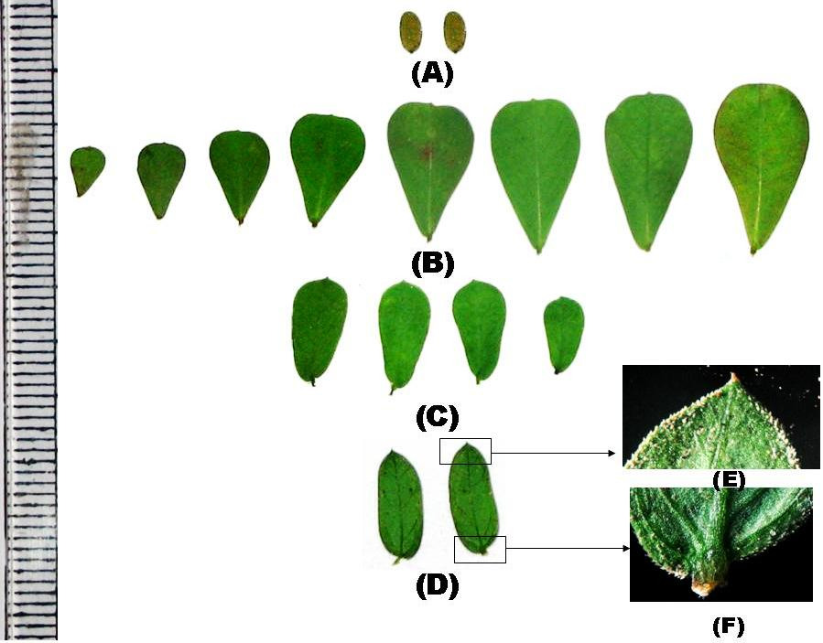

Fig. I: Heteroblasty in leaves of Phyllanthus urinaria Linn.
(A- Cotyledons, B – first eight juvenile leaves (eophylls), C – leaves on lateral branches, D – mature leaves, E – apex and margin of mature leaf, F – base of mature leaf)

Acknowledgement: We are grateful to the Department of Biotechnology, Govt. of India for Financial support for carrying out the investigation. We are thankful to the Head of the Department of Botany, University of Calcutta for providing necessary facilities.

Corresponding author:
Avinash Mundhra
Taxonomy & Biosystematics Laboratory,
Department of Botany,
University of Calcutta,
35, B.C. Road, Kolkata-700019, India.
Email: mundhra.avi@gmail.com

References
Allsopp, A. 1965. Heteroblastic development in Cormophytes. In Handbuch der Pflanzenphysiologie, vol. XV, eds. W. Ruhland, pp. 1173-1221. Springer-Verlag, Berlin, Germany.
Day, J. S. 1998. Light conditions and evolution of heteroblasty (and the divaricate forms) in New Zealand. New Zealand J. Ecol. 22(1): 43-54.
Goebel, K. 1889. Uber die Zugendjustande der Pflanzen. Flora (Jena). 72:1-44.
Goebel, K. 1928. Organographie der Pflanzen, Pt.1: Allgemeine Organographei. Jena, Gustav Fischer, 2nd edition.
Van Iterson, J. 1907. Mathematische und Mikroskopisch-Anatomische studien über Battstellungen nebst Btrashtungen üer den Shalenbau der Mliolinen. Jena, Gustav Fischer.

1/9/2009

