Researcher

ISSN 1553-9865

Volume 1 - Issue 2 (Cumulated No. 2), April 1, 2009

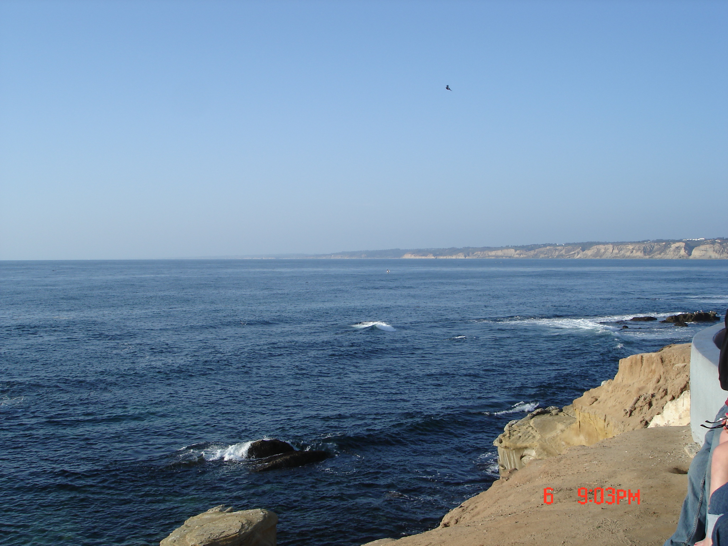

Marsland Press, New York, the United States

Researcher

ISSN 1553-9865

Marsland Press
525 Rockaway PKWY, #B44
Brooklyn, New York 11212, the United States
Telephone: 718-404-5362
sciencepub@gmail.com
http://www.sciencepub.org
http://www.sciencepub.net

ISSN 1553-9865


