Achieving the Millennium Development Goals: An Assessment of Water and Sanitation Intervention of the Ikaram-Ibaram Millennium Village Project.

Anthony Chovwen; Olabisi Orebiyi and Taye Afere

nuelnice@yahoo.com

Abstract: This article describes an assessment of water and sanitation intervention of the Ikaram-Ibaram Millennium village project as the achieving the Millennium development goals. [Researcher. 2009;1(2):6-13]. (ISSN: 1553-9865).

Keywords: Millennium; water; sanitation

Introduction
The millennium development goals are series of eight time-bound development goals that seek to address issues of poverty, education, equality, health and the environment, to be achieved by the year 2015. They were agreed by the International community at the United Nations Millennium Summit, held in New York in September 2000. To address these challenges, all member countries of the United Nations signed the Millennium Declaration in September 2000, which laid out quantified, targeted goals-the Millennium Development Goals (MDGs) – to halve extreme poverty in its many forms by 2015. In January 2005, the UN Millennium Project, commissioned by the UN Secretary General, recommended an action plan detailing what needs to be done and how to achieve the MDGs. The report identified practical strategies to eradicate poverty by scaling up investments in infrastructure and human capital while promoting gender equality and environmental sustainability. Sub-saharan Africa is the region most off-track on the MDGs; the Millennium Project estimates that a typical country in sub-Saharan Africa will need to significantly increase public investments to approximately $75-$80 per capita by 2006, rising to $125-$160 by 2015, in order to meet the goals. In typical rural community, the required investments average US$110 per capita/year over 5-10 year period.
Between 1990 and 2001, the number of people in sub Saharan Africa living on less than $1 a day rose from 227 million to 313 million with one-third of the population below the minimum level of nourishment and many countries including Nigeria crippled by disease, drought and poor infrastructure. Thus the millennium village project (MVP) was inaugurated in 2004 as a direct response to this growing crisis. The Ikaram-Ibaram Millennium Village Project is been executed with support from the Earth Institute –Columbia University, The Millennium Promise New York, UNDP Nigeria and Ondo State Government of Nigeria.
The importance of safe water in poverty alleviation and socio-economic development cannot be overemphasized. Access to safe drinking water and adequate sanitation are part of the Millennium Development Goals of reducing poverty by the year 2015. Safe water has been described as water that meets the National Standard for Drinking Water Quality for Nigeria (FMWR, 2004). However, abnormally low levels of access to clean water by a large proportion of humanity have been reported. Worldwide, about 2 billion people struggle daily for access to clean and sufficient water (Smith and Marin, 2005). Africa is the region that suffers most from inadequate access to water supply. Yahaya (2004) reported that in Africa, only 62 percent of the populations have access to potable water supply (compared with 82 percent Worldwide, 81 percent in Asia and 85 percent in Latin America). Furthermore, of 55 countries in the world whose domestic water use is below 50 litres per capita per day, 35 are in Africa. In Nigeria, 52 percent of the population does not have access to safe drinking water (UNDP 2006; UNICEF 2007). Improved access to safe drinking water is a prerequisite to poverty reduction. Access to safe drinking water prevents the spread of water-borne and sanitation-related diseases. Lack of access to safe water and adequate sanitation services especially in developing countries often result in about two million infant death annually.(Cosgrove and Rijsberman, 2003; Gomez and Nakat, 2002; The World Bank, 2001).
This paper therefore seeks to discuss efforts at achieving the water and sanitation MDGs in Ikaram, Nigeria.

Scope of the MVP Concept
The Millennium Villages Initiative aims to establish a rigorous proof of concept for implementing the practical interventions needed to achieve the MDGs in rural Africa Over five year time frame. It seeks to scientifically demonstrate and document low cost, and integrated community based intervention geared towards empowering rural areas in order to enable them achieve the MDGs. Figure 1. Shows location of the Millennium Villages in Africa.
The scope of the MVP covers the eight MDG goals through nine objectives as stated below.
To eliminate hunger and malnutrition in the villages by increasing production, access and utilization of nutritious foods, with a special focus on improving nutritional status of pregnant women, nursing mothers and infants under two (MDG 1).
To improve livelihoods of women and men and increase their incomes for both on and off-farm activities beyond extreme poverty (MDG 2).
To ensure full attendance to primary schools for both boys and girls and eliminate gender disparity in schools (MDG 2) and 3).
To improve access to medical services, especially focused on improving women’s health and drastically reducing child and maternal mortality (MDG 4 and 5).
To decrease rate of infection of HIV/AIDS, malaria, tuberculosis and other major diseases; and increase access to essential medicines such as antiretroviral medication (MDG 6).
To integrate the principles of sustainable development into village programs to reverse the loss of environmental resources and enhance ecosystem services (MDG 7).
To increase access to energy, clean air, water and sanitation for households, schools and medical services (MDG 7).
To eliminate the digital divide by making available the benefits of communication technologies, especially access to the internet and mobile telephone services (MDG 8)
To record with scientific rigor and accuracy the inputs, costs and results of the investments and interventions implemented in each Millennium Village and examine opportunities for scaling up lessons learned.
For the purpose of this paper, focus will be limited to the water and sanitation aspect of the MDG goals.
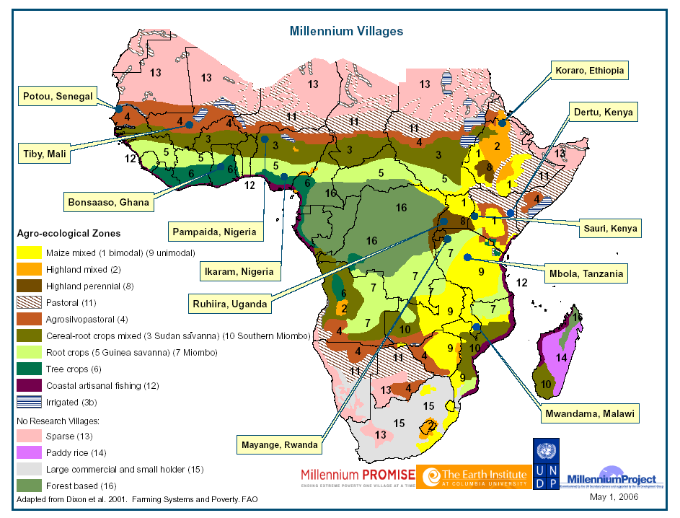

Fig. 1: Locations of Millennium Villages in Africa

Description of the Ikaram-Ibaram Millennium Villages
The Ikaram –Ibaram Millennium Villages is located in Akoko North West Local Government Area of Ondo State Southwest Nigeria (Figure 2). It is located approximately 400km from Lagos, 9km north of Oke-Agbe, and 100km from Akure, the Ondo State capital. The Ikaram-Ibaram Millennium Village in Nigeria was established in May 2006 with generous support from the Japanese Government to UNDP and a gift from Sara Miller McCune. The Ikaram community is the primary research site in the Ondo State project with an estimated population of 4,417 people. However, Ikaram is one of several contiguous and densely packed communities that make up the larger Millennium Cluster Village. Combined, these communities – Ikaram, Ibaram, Iyani, Ase, Erusu, Gegegede and Ajowa – have a population of more than 17,742 people. The cluster village is referred to as Ikaram-Ibaram to simplify matters and because the communities are all located in the same local government area. Because the MVP seeks to use an integrated and holistic approach and because of the contiguous nature of the overlapping Ikaram-Ibaram communities, interventions targeted for Ikaram have also played a crucial role in supporting ‘cluster-wide’ initiatives, being leveraged for positive effect on the overall population.

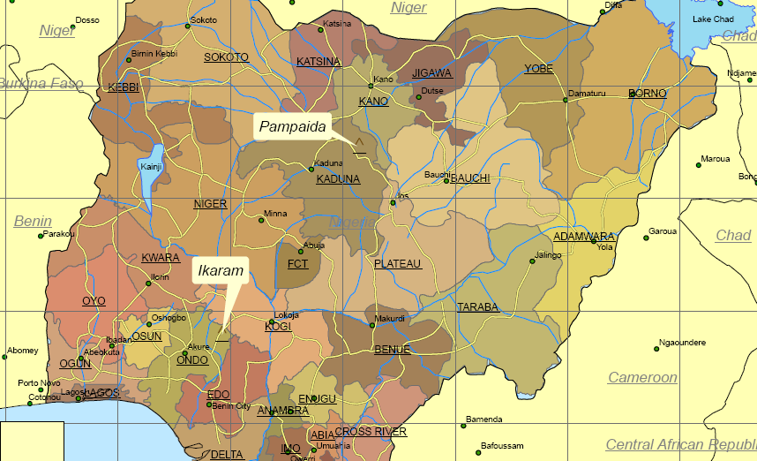

Fig. 2. Map of Nigeria Showing Location of Ikaram Millennium Village.

Project Methodology
The project adopts a participatory and demand driven approach to problem identification, solution planning and project implementation and management.

Needs Assessment and Participatory Appraisal:

Needs assessments of local community facilities and infrastructure to identify areas of critical need and opportunities for quick-impact initiatives was conducted. Important baseline data which included a detailed demographic survey of the entire cluster, water and sanitation baseline study and a socio-economic survey were obtained. Data entry and analysis covering all these studies was done to facilitate comprehensive development strategies and intervention plans.
In order to optimize the level of community involvement, the village baseline assessment was conducted in close consultation with local leaders and community groups. As a result, the community quickly committed to improve their capacity for action by establishing democratically elected committees which liaises with the MV team to advise and consult on development priorities for the village.

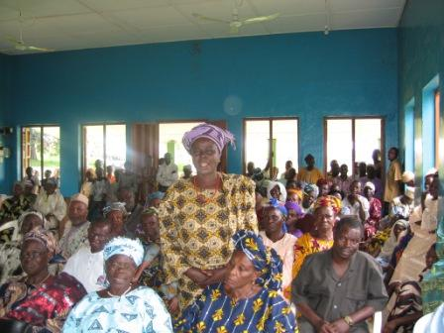

Fig. 3: Cross section of community members during a participatory meeting.
Several participatory meetings were held in order to establish Water and sanitation committees (WASHCOMs) which will focus on the water and sanitation infrastructures, technology options, operation, management and record keeping. Participation was all inclusive to ensure involvement and participation of women, men and youth (Fig. 3). In addition, two members from the committee were appointed to act as representatives of the sector in the MVP Central Committee. This committee will be a key decision making organ in planning, implementing and monitoring project activities within the cluster.
Access to potable water is severely compromised with too few boreholes and pumps to serve the community, especially during the dry season when the boreholes do not function. Even during the rainy season, when the boreholes are operational, the water is frequently not clean enough to drink. This results in villagers having to travel long distances to collect water. An immediate goal therefore is to provide the village cluster with a viable water supply. A first step to reaching this goal is the implementation of a comprehensive study followed by detailed analysis to determine suitable locations for the establishment of safe, reliable boreholes. To this end, baseline survey was carried out on existing water points and sanitation facilities to assess: number and type of existing water points in the Cluster; in terms of viability, quality and accessibility. The baseline survey brought clearer picture of water situation in the cluster. It reveals that the critical areas of water needs are in the health centres and schools where water does not exist.

Table 1: Analysis of pre intervention water Survey of Ikaram-Ibaram MVP
S/N | SUB VILLAGE & POPULATION | WATER POINT | TOTAL No. | OWNERSHIP |  |  | TOTAL NO FUNCTIONAL/PERRENIAL (IN THE CASE OF WELLS)
 |  |  |  | INSTITUTION | COMMUNITY | PRIVATE
1 | ITA BALOGUN | MPBH | 0
1 |  | SLPBH | 0
1 | 310 | MBH | 0
1 |  | WELL | 19 |  |  | 19
2 | AYETEJU | MPBH | 2 |  | 2
2 |  | SLPBH | 1 |  | 1 |  | 1
2 | 127616 | MBH | 1 |  |  | 1 | 1
2 |  | WELL | 54 |  |  | 54 | 0
3 | IYOTU | MPBH | 3 |  | 3 |  | 15
3 |  | SLPBH | 2 |  | 2 |  | 1
3 | 1557 | MBH | 1 |  |  | 1 | 1
3 |  | WELL | 38 |  |  | 38 | 0
4 | OYAGI | MPBH | 1 |  | 1 |  | 17
4 |  | SLPBH | 1 |  | 1 |  | 0
4 | 306 | MBH | 1 |  |  | 1 | 1
4 |  | WELL | 12 |  |  | 12 | 1
5 | IYOKE | MPBH | 2 |  | 2 |  | 10
5 |  | SLPBH | 0 |  |  |  | 1
5 | 968 | MBH | 0
5 |  | WELL | 62 |  |  | 62
6 | ASE | MPBH | 1 |  | 1 |  | 20
6 |  | SLPBH | 0 |  |  |  | 1
6 | 72 | MBH | 1 |  | 1
6 |  | WELL | 1 |  |  | 1 | 0
7 | IBARAM | MPBH | 4 | 1 | 3 |  | 1
7 |  | SLPBH | 2 |  | 2 |  | 1
7 | 61324 | MBH | 2 | 1 |  | 1 | 1
7 |  | WELL | 19 |  |  | 19 | 3
8 | IYANI | MPBH | 1 |  | 1 |  | 1
8 |  | SLPBH | 1 |  | 1 |  | 0
8 | 514 | MBH | 3 | 1 |  | 2 | 2
8 |  | WELL | 15 |  |  | 15 | 9
9 | GEDEGEDE | MPBH | 4 |  | 3 | 1 | 3
9 |  | SLPBH | 1 |  | 1 |  | 1
9 | 995 | MBH | 0
9 |  | WELL | 15 |  |  | 15 | 1
10 | ERUSU | MPBH | 6 |  | 6 |  | 2
10 |  | SLPBH | 2 |  | 2 |  | 1
10 | 3,067 | MBH | 10 |  | 2 | 8 | 6
10 |  | WELL | 126 |  |  | 126 | 52
11 | AJOWA | MPBH | 10 |  | 10 |  | 7
11 |  | SLPBH | 3 |  | 3 |  | 0
11 | 8,064 | MBH | 9 |  | 1 | 8 | 6
11 |  | WELL | 377 |  |  | 377 | 187
The following results were obtained from the survey
A ratio of 257 people per functional drinking water point was established. The failure rate of existing water points is very high. 25% for Solar powered boreholes with gravity tanks and standpipes and 38% for hand pump fitted boreholes
A large number of people make use of unsafe water points – 738 Numbers of unprotected hand dug wells of which only 331 (44.9%) are perennial.
There also exist 3 unprotected springs in the cluster.
For sanitation, only 398 toilet facilities were available for use by the 17, 742 inhabitants of the cluster village. These comprise of 206 flush toilets, 19 VIP toilets and 173 pit latrines.

Moving Forward

Focusing on schools and health centers, the MVP has supported the cluster villages with provision of hand pump fitted boreholes in 13 schools, and 4 motorized boreholes in health centers across the cluster and 1 motorized borehole for use at the proposed office of the MVP. This support is to improve the water supply situation of the cluster villages. This was achieved through
- An in depth geophysical survey conducted to determine viable VES points for drilling of borehole.
- Contract awarded for the borehole construction
- Monitoring of drilling and construction activities for quality assurance.
- Installation of hand pumps in schools and submersible pumps in health centers to make boreholes operational.
- Establishment of environmental Health Clubs in Schools was also carried out to ensure hygiene and education education through child to child methodology.

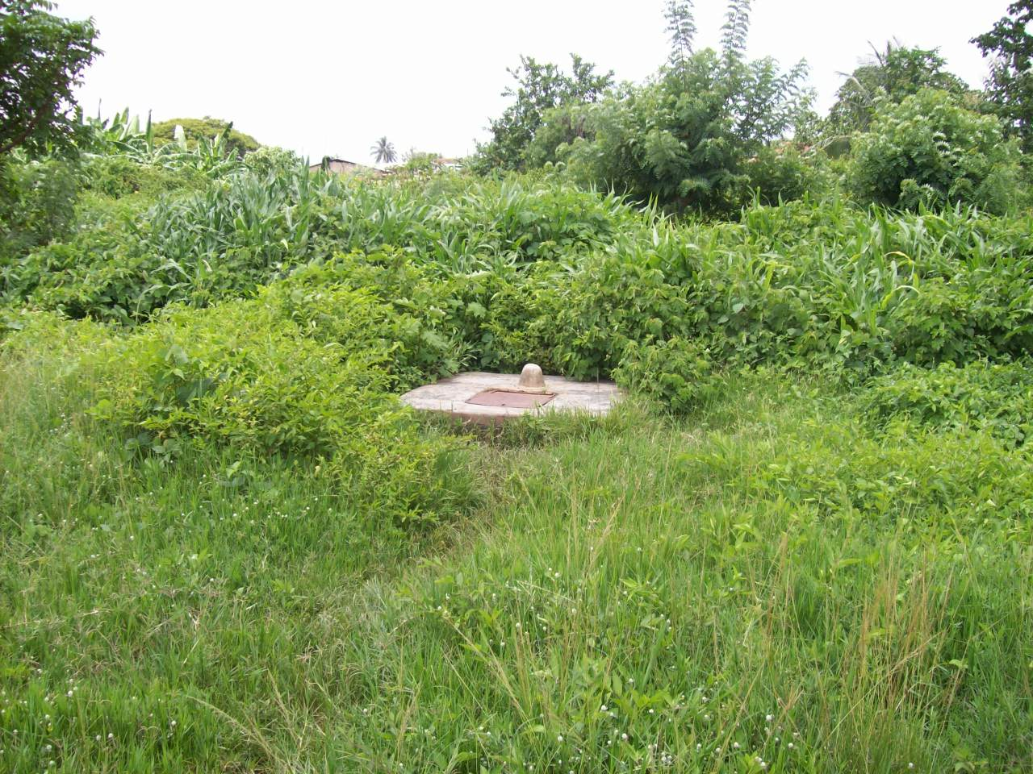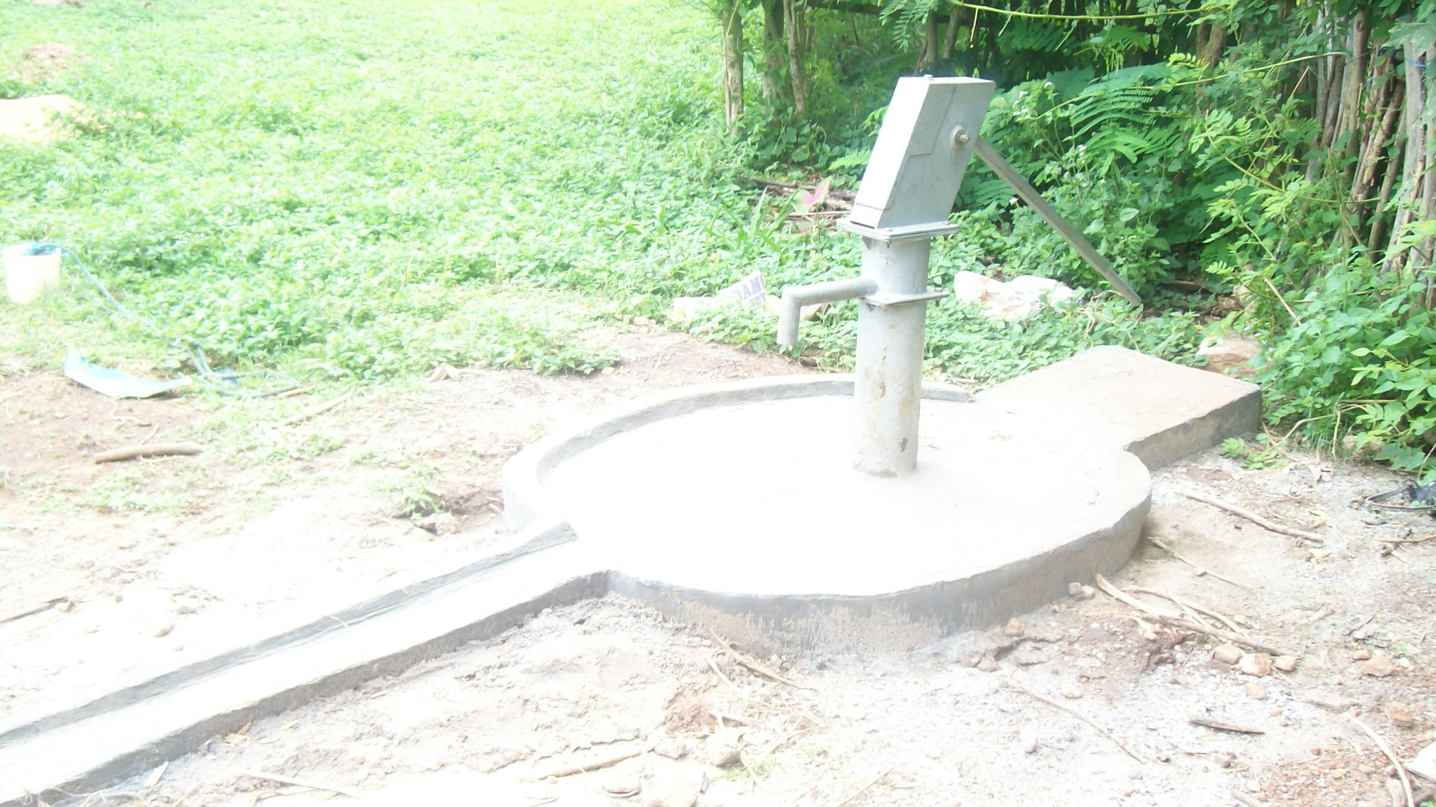
Fig 4(a) Fig 4 (b)

Fig. 4: Water supply source to L.A. Primary School, Ajowa (a)before and (b)after intervention

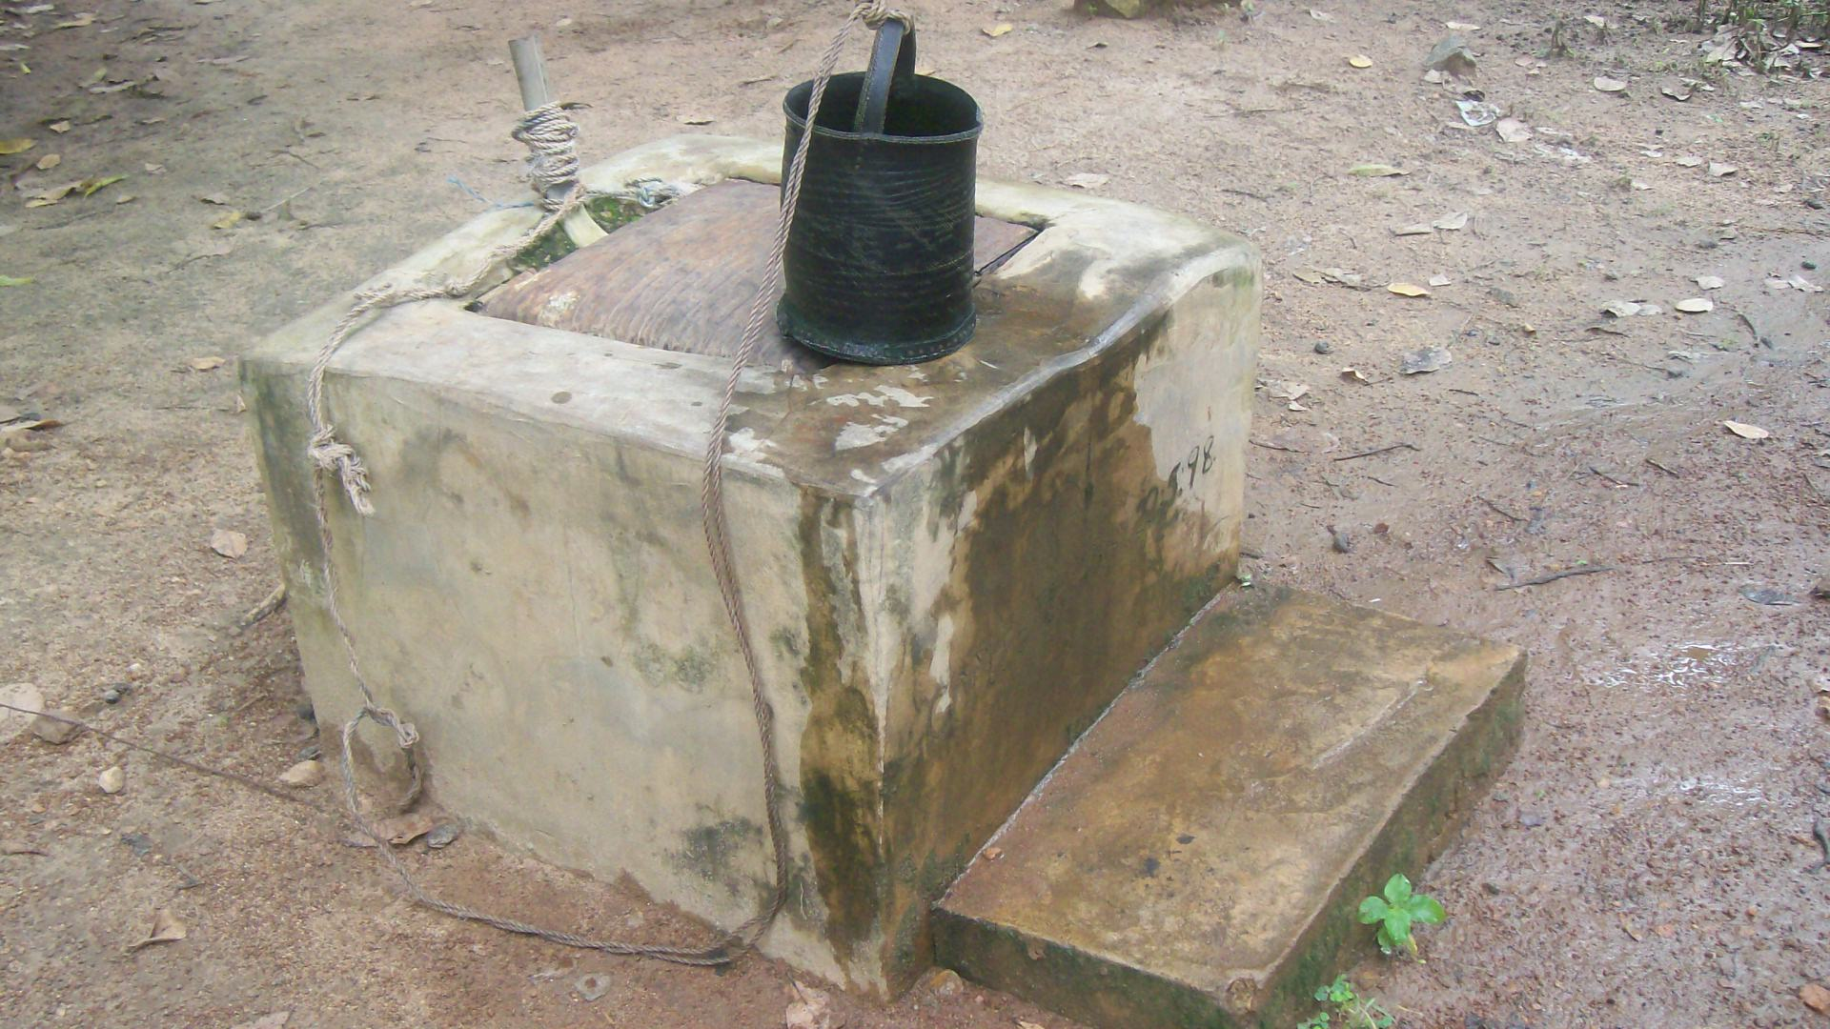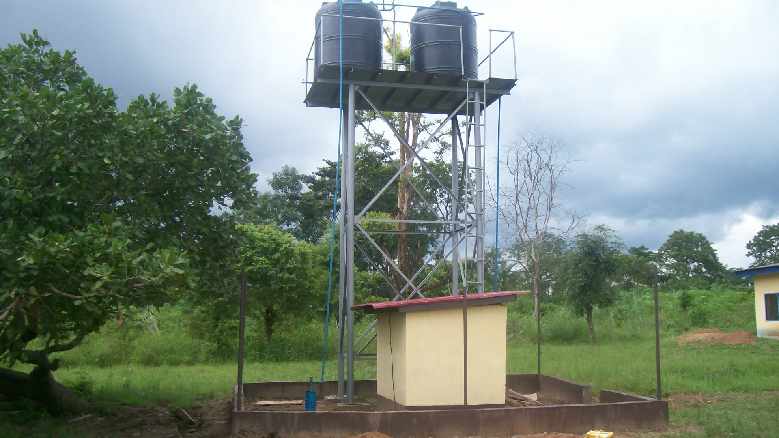 Fig. 5 (a) Fig. 5 (b)

Fig. 5: Water supply source to Ikaram Basic Health Centre (a) before and (b) after intervention.

The transformation of the village and the confidence of villagers in their ability to take charge of a brighter future become more tangible as each week pass and more are accomplished. It is projected that the output in the next few years will improve greatly and the overall infrastructural capacity of the village is improving steadily – particularly in the areas water and sanitation.

Proposed Water and Sanitation Intervention
The following have been proposed in order to support the Ikaram cluster villages to achieve the water and sanitation MDG goals.
- Construction of Ventilate Improve Pit (VIP) latrines in all 16 Primary schools.
- Rehabilitation of non functional boreholes in the cluster.
- Training of Community members on construction of Sanitation Platforms (SANPLAT) and basic environmental sanitation and hygiene.
- Capacity building for local government water and sanitation technicians for effective water and sanitation management in the cluster
- Construction of hand dug wells in cluster Fulani communities
- Establishment of Environmental Health clubs in all 16 primary schools
- Training of primary school, health institution and the community on the operation and maintenance techniques for water and sanitation infrastructure
- Hand wash campaign to promote hygiene and hand washing at critical periods.
- Quarterly monitoring of water quality and treatment in the cluster.
- Development of 2 springs at Ikaram and Ajowa.

Conclusion
Our generation has the unprecedented opportunity to end extreme poverty throughout the world by 2025. Achieving the Millennium development goals by 2015 will be a crucial step along the way. However this requires a holistic approach through demand responsiveness and participatory planning. Our support towards these laudable and achievable targets will solve our quest for a more peaceful and prosperous world. It will be a worthwhile legacy for our children to inherit a poverty free world where there is adequate provision of water and sustainable sanitation.

Acknowledgement
The authors sincerely acknowledge the efforts and contributions of all members of the Ikaram-Ibaram MVP team towards this peace of work.

References
Cosgrove, W.J. and Rijsberman F.R.(2000) World water Vision: Making
water everybody’s Business. London, U.K. World water Council.
Earthscan Publications Limited.
Gomez, J.D and Nakat, A.C (2002) Community Participation in water and
Sanitation. Water International Vol. 27, No.3 Pp343-353

Ikaram-Ibaram, Nigeria Millennium Village Annual Report (Feb 2006-May 2007)

Smith S.E. and Marin L.E.(2005). Water and the rural poor in Latin America:
The case study of TIamacazapa, Guerrero, Mexico.Hydrogeology Journal
13:346-349.
The World Bank (2001) UNDP Water and sanitation Report: 1999-2000. The World
Bank Water Supply and Sanitation Division, Washingtons DC.
UNICEF (2005). National Rural water supply and Sanitation Investment Programme
Final draft Pp1.
United Nations development Programme, Project document with annual workplan.

1/9/2009

