Somatic Embryogenesis And In Vitro Regeneration Of An Endangered Medicinal Plant Sarpgandha (Rauvolfia serpentina. L)

Prabhat Singh, Anand Singh, Arvind K. Shukla, Lalit Singh, Veena Pande and Tapan K. Nailwal*
Department of Biotechnology, Kumaun University
Nainital,Uttarakhand- 263001,India
Email: tapannailwal@gmail.com

ABSTRACT
An efficient protocol for in vitro regeneration of endangered medicinal plant Rauvolfia serpentina has been developed. The juvenile leaf explants were transferred to MS medium containing different combinations of PGRs. Among the various combinations of BAP (1.0-3.0) and IAA (0.1-0.5) the intensity of callus induction was highest in BAP (2.5) + IAA (2.0) mg/l and BAP (1.0) + IAA (0.5) mg/l. The frequency of callus induction was highest 77.77% in BAP (1.0) + IAA (0.5) mg/l. During organogenic callus formation, different types of calli with variation in colour and texture were noticed and among them, the light green, fragile calli responded well for the induction of shoots. Among the various combinations of BAP and IAA used the frequency of shoot regeneration was highest 75% in BAP (2.5) +IAA (0.4) mg/l. For elongation of shoot 1ppm GA₃ was also used, this provides a better result. The shoot was transferred to M.S. Media for root regeneration containing PGRs BAP (2.5) + IAA (0.3-0.5) + NAA (0.3-0.5) mg/l. The frequency of root regeneration was 100% in MS Medium containing BAP (2.5) + IAA (0.5) + NAA (0.5) mg/l. After rooting on shoots the plantlets were shifted to sterile soil field pots for acclimatization. The survival percentage of plants after hardening was 67%. The protocol was optimized by manipulations of different PGRs for enhanced multiplication. Protocol explained in this research paper provides a rapid plant regeneration system which could be used for the somaclonal variation; shoot induction and producing transgenic plants in Rauvolfia through Agrobacterium and biolistic methods. [Researcher. 2009;1(3):46-53]. (ISSN: 1553-9865).

INTRODUCTION
Medicinal plants have been the subjects of man’s curiosity since time immemorial (Constable, 1990). Almost every civilization has a history of medicinal plant use (Ensminger et al., 1983). Approximately 80% of the people in the world’s developing countries rely on traditional medicine for their primary health care needs, and about 85% of traditional medicine involves the use of plant extracts (Vieira and Skorupa, 1993). In vitro cell and tissue culture methodology is envisaged as a mean for germplasm conservation to ensure the survival of endangered plant species, rapid mass propagation for large-scale revegetation, and for genetic manipulation studies. Combinations of in vitro propagation techniques (Fay, 1992) and cryopreservation may help in conservation of biodiversity of locally used medicinal plants.
Rauvolfia serpentina. L commonly known as sarphgandha is an important medicinal shrub of family Apocynaceae (Nathan Kline, 1954). The snake-weed genus includes about 50 species, this has fairly wide area of distribution, including the tropical part of the Himalayas, the Indian peninsula, Sri Lanka, Burma, and Indonesia. The plant is indigenous to India, Bangladesh and other regions of Asia and found to grow in the wild in many places around the country (Ghani, 1998). Its roots contain 0.15% resperine-rescinnamine group of alkaloids (Anonymous, 1969). It also contains a number of bioactive chemicals, including ajmaline, deserpidine, rescinnamine and yohimbine (Lewis, W.H., 2003). This herbal plant is used as medicine for high blood pressure, insomnia, anxiety and other disorders of the central epilepsy (Ghani, 1998).
Rauvolfia is threatened in India due to indiscriminate collection and over exploitation of natural resources for commercial purposes to meet the requirements of pharmaceutical industry, coupled with limited cultivation (Nayar and Sastry, 1987; Gupta, 1989). IUCN has kept this plant under endangered status. The chemical resperine is an alkaloid first isolated from roots of Rauvolfia serpentina and is used to treat hypertension (Ford, R.V. et al., 1953; Vida, F., 1953). Although, for centuries they have been used empirically in India for a variety of conditions that they were effective in relief of hypertension was first commented on by Bhatia in 1942. Subsequently, other clinical investigators working in India confirmed the effectiveness of Rauvolfia serpentina for that purposes (Chakraverti, N.K. et al., 1951; Gupta, J.C., 1942). In a short term study, a significant decrease in systolic as wall as diastolic blood pressure of patients to whom the drug was given was observed (Vakil, 1949). Insanity, Snakebite and Cholera can also be treated by use of this alkaloid (Wild, R., 1994). The pectic polysaccharide named rauvolfian RS was obtained from the dried callus of Rauvolfia serpentina L. by extraction with 0.7 % aqueous ammonium oxalate and it was found to posses some anti-inflammatory effect (Popov, S.V. et al., 2007).
In approximately 60% of medicinal plants used in traditional medicines, roots are the principal source of drug preparation (Kamboj, 1988). The development of fast growing culture system can offer an opportunity for producing drugs from the roots in the laboratory with out having to depend solely on field cultivation (Sudha and Seeni, 2003).
In vitro regeneration of sarphgandha has been done from several genotypes. Micropropagation has been achieved from explant of Rauvolfia micrantha Hook F cultures (Sudha and Seeni, 1996). Micropropagation can be considered as an important tool for the production of higher quality plant based medicines (Debnath, M., 2006). In view of this, there is an urgent need to apply in vitro culture methods for the micropropagation and conservation of this valuable endangered plant. Here efforts have been made to define efficient protocol for the recovery of plants through organogenesis of Rauvolfia serpentina. In vitro regeneration of Rauvolfia has been reported by many authors (Butenka, 1964;
Mitra and Kaul, 1964; Vollosovich and Butenka, 1970; Kukreja et. al. 1989 and Roy et. al. 1994). The present study was undertaken to develop a more efficient protocol for rapid in vitro multiplication of Rauvolfia serpentina using leaf explant as an initial plant material.

MATERIALS AND METHODS :
Plant material
Plantlets of Rauvolfia serpentina were obtained from Corbett jadibuti Udhyan Kaladhungi, Nainital, Uttarakhand and grown in sterile vermiculite at 25-30 ⁰C in light. All the explants were taken from these donor plants for present investigation. Leaf explants from 2 month old donor plant was kept for 2 hrs in systemic fungicide Bavistin (VIMCO pesticides, Gujarat) and Tween-80 an antimicrobial agent, prior to surface sterilization. For surface sterilization, chemicals such as HgCl₂ (0.1%), NaOCl (1%), H₂O₂ (1%) and ethanol (70%) was used. Juvenile leaves were washed thoroughly in running tap water for 30 min. and then with distilled water three times. Leaves were treated with bavistin solution for 4-5 min., and then rinsed thoroughly with sterile distilled water. The leaves were subjected to 0.1% HgCl₂ for 30 sec., washed with distilled water and then placed in 70% ethanol for 1 min. and again washed with distilled water, followed by addition of three drops of antibiotic solution (Cefotaxime) in laminar airflow cabinet. In the antibiotic solution, all leaves were dissected into small pieces and treamed so that maximum part can be exposed to media. All the chemicals used were purchased from Hi-media unless stated otherwise.

Culture media and growth condition
The medium comprised of macro and micro elements according to Murashige and Skoog (1962) with Mesoinosotol (100 mg/l), Thiamine-HCL (0.5mg/l), pyridoxine-HCL (1mg/l), Nicotinic acid (0.5mg/l) and sucrose (30g/l), solidified with (0.6%) agar. The Plant growth regulators used were 6- Benzyl-aminopurine (BAP), α- naphthalene acetic acid (NAA) and indole acetic acid (IAA). All experiments were carried out in culture tubes (150 × 25 mm) containing 30 ml of culture medium. The pH of media were adjusted to 5.8 prior to autoclaving at 121⁰C at 15 lbs pressure for 20 min. Culture were incubated under 16 h /8h light/ dark cycles (artificial light , 80 µM per m²/s).

Callus induction and shoot regeneration:
For callus induction juvenile leaf section (3-5 mm in length) with cut end surface in contact with culture medium were placed on MS medium supplemented with various concentrations of PGRs BAP and IAA. After 20 days of culture, the leaves cultured on MS basal medium supplemented with 3% (w/v) sucrose, BAP (1.0 ppm) and IAA (0.5ppm) were found to give profuse callusing and when callusing was observed in entire explant, the callus was cut into small pieces transferred to MS media having BAP and IAA in same concentration as for callus induction. Subculturing was done after every 1-2 week. After 3-4 weeks of subculturing first shooting is observed in callus.

Regeneration of roots and development of complete plantlets:
For initiation of roots the 6-8 weeks old shoots (2.5-4.0 cm. in length) were cultured on half strength MS basal medium supplemented with 2% (w/v) sucrose and different concentration of PGR were tested BAP(2.5ppm) : IAA(0.3ppm): NAA(0.3ppm),BAP(2.5ppm) : IAA(0.4ppm) : NAA(0.4ppm), BAP (2.5ppm) :IAA(0.5ppm) : NAA(0.5ppm), for 2-3weeks. The shoots were also tested on hormone free full and half strength MS basal medium with 3% sucrose ((w/v) for root initiation.
The complete rooted plantlets (6-10 weeks old) were washed free of agar and dipped in 0.2% bavistin fungicide for 5-10 min., and potted in small plastic pots containing sterilized soilrite. The plantlets were covered with polythene bags to maintain high humidity. These were acclimatized at 25±3⁰C under 16h photoperiod and watered regularly. After 3-4weeks, the polythene bags were removed and established plantlets were transplanted to earthen pots in a greenhouse.

RESULTS AND DISCUSSION
The smaller size of explants were chosen due to fact that smaller size of explants provide less chance of contamination, as well as longer leaves showed total loss of morphogenic potential. (Mujib, A., 2003). Initiation of calluses from leaf explants did not pose a major problem. During initiation the explants did not show any leaching or browning of tissues. MS basal medium was the most effective for callusing of leaf explants. The explant cultured on MS basal medium supplemented with different combinations of BAP and IAA show varied response for callusing (Table1). Leaf explants culture on MS basal medium without any PGR supplementation show only swelling of explants that were not significant for callusing. This was possibly due to significant role of PGR over callusing. In the media supplemented with BAP and IAA, the leaf segments remain green for long period with very slow process of callus induction (Fig .1). Further transfer into media containing BAP and IAA rapidly shows callus induction because the excretion of phenolic compounds from explants to the medium was strictly avoided by regular sub-culturing of callus. (Fig. 2)
Callus is an unorganized mass of plant cells and its formation is controlled by growth regulating substances present in the medium (auxins and cytokinins) (Shah et. al., 2003). The specific concentration of plant regulators needed to induce callus, varies from species to species and even depends on the source of explant (Charriere et. al., 1999). It has been demonstrated in many cases that 2,4-D is usually the choice of auxin for callus induction and subculture of grasses (Bhaskaran and Smith, 1990; Chaudhury and Qu, 2000). Lately more and more experimental results indicate that the addition of a low concentration of cytokinin in callus culture medium often enhances callus regeneration (Alpeter and Posselty, 2000; Chaudhury and Qu, 2000; Cho et. al., 2000; Bai and Qu, 2001; Bradely et. al., 2001). Minimal cytokinins and auxins in culture media would avoid somaclonal variation and efficiently produce true to type plantlets (Edson et. al., 1996).
The success of micropropagation largely relies on the selection of suitable plant part, which is to be used as the starting material for the experiment. In the present experiment leaf explants was best fit for purposes. The best callusing was observed in media having BAP: IAA in concentration ratio of (1.0: 0.5ppm). In the media supplemented with only BAP and IAA the callus induction was very significant (Fig. 2). This remains in accordance with previous reported work of (Mathur et.al., 1987). Different types of calli with variation in colour and texture were noticed (Table 1) and among them, the light green, fragile calli responded well for the induction of shoots.
This study further demonstrates that shoot regeneration from callus was very earlier in media supplemented with BAP and IAA in concentration ratio of (2.5: 0.4 ppm), in comparison to 2.5:0.3, 1.0:0.5 or 2.0:0.5 (Table 2; Fig. 3). Thus, the PGR concentrations have significant impact on shoot regeneration. This is basically due to endogenous level of growth regulators. For elongation of shoot 1ppm GA₃ was also used, this provides a better result (Fig. 4).
No root could be induced in either basal medium of full or half strength MS media. However, when 2.5-4.0 cm. elongated shoots were placed on half strength MS basal medium supplemented with BAP ,IAA and NAA in concentration ratio of (2.5: 0.5: 0.5 ppm)roots were induced in nearly 100% of shoots within 2 weeks. (Fig. 5,6,7) Other concentration BAP, IAA and NAA (2.5:0.4:0.4 and 2.5:0.3:0.3) induce rooting in slightly lower percentage (Table 3). Basal media supplemented with NAA was found to be better for root regeneration this was in accordance with previous reported work of Kumar, et al., 1993.
Taking care of root regeneration data it can be concluded that the standard protocol developed for regeneration of Rauvolfia was nearly 100% efficient but in accordance with hardening data (Table 4) there is a need for further standardization and work to increase the efficiency, during hardening so that this medicinally important plant could be propagate at larger scale and its medicinal importance properties could be utilized for well being of human population. This further become important due to advancement in commercialization of plant tissue cultured plantlets by commercial sectors have led to continued exponential growth within the industry in terms of numbers of new units as well as numbers of plants produced by the units (Govil, S. and Gupta, S.C., 1997). The development of a reliable in vitro protocol are of great importance for producing plant material and for conservation of rare plant species, and offset the pressure on the natural populations as well as plant medicinal purposes.
The present study describes a well documented and reliable protocol of R. serpentina from leaf explants with much higher rate of multiplication. This protocol can be used as a basic tool for commercial cultivation of sarphgandha plant.

Table 1. Effect of different concentrations of PGR added to MS medium on induction of callus from leaf in R. serpentina. Observation after 27 Days:

PGR( mg/l)  IAA BAP | Intensity of callus induction | Nature of callus
0.1 -  0.1 1.0  0.1 1.5  0.2 0.0  0.2 1.0  0.2 1.5  - 2.0  - 2.5  - 3.0  0.1 2.0  0.1 2.5  0.1 3.0  0.2 2.0  0.2 2.5  0.2 3.0  0.3 -  0.3 1.0  0.3 1.5  0.3 2.0  0.3 2.5  0.3 3.0  0.4 -  0.4 1.0  0.4 1.5  0.4 2.0  0.4 2.5  0.4 3.0  0.5 -  0.5 1.0  0.5 1.5  0.5 2.0  0.5 2.5  0.5 3.0  - - | -  ++  +  -  ++  +  -  -  -  +  -  -  -  +++  -  -  ++  +  -  ++  -  -  ++  +  -  ++  -  -  +++  +  ++  -  -  - | No callus formation  White coloured, fragile  Green coloured ,fragile  No callus formation  Light green coloured ,fragile  Light green coloured ,fragile  No callus formation  No callus formation  No callus formation  White coloured, fragile  No callus formation  No callus formation  No callus formation  White coloured, fragile  No callus formation  No callus formation  Green coloured ,fragile  Light green coloured ,fragile  No callus formation  Light green coloured ,fragile  No callus formation  No callus formation  Light green coloured ,fragile  Light green coloured ,fragile  No callus formation  Light green coloured ,fragile  No callus formation  No callus formation  Light green coloured ,fragile  Green coloured ,fragile  Light green coloured ,fragile  No callus formation  No callus formation  Swelling of the explant observed.

Table. 2: Effect of different concentration of PGRs added to MS medium on induction of callus and regeneration of shoots from leaf of R. serpentina.

PGR (mg/l)  BAP IAA | Days for  Callus  formation | Days of shoot  Regeneration  after callusing | Frequency of  Callusing | Frequency of Shoot Regeneration (%)
2.5 0.4 | 24 | 18 | 72.00 | 75
2.5 0.3 | 24 | 36 | 40.00 | 45.03
1.0 0.5 | 24 | 37 | 77.77 | 52
2.0 0.5 | 24 | 38 | 70.00 | 39.45

Table. 3. Effect of different concentration of PGR added to MS medium for root regeneration from shooted callus of R. serpentina.

PGR (mg/l)  BAP IAA NAA | Days of Rooting | Frequency of  Rooting  (%)
2.5 0.3 0.3 | 12 | 85
2.5 0.4 0.4 | 15 | 96
2.5 0.5 0.5 | 10 | 100

Table. 4. Estimated survival of plants after hardening.

Number of pots containing Plants | Number of plants survived | Percentage of survival  (%)
5 | 3 | 60
3 | 2 | 67
4 | 2 | 50

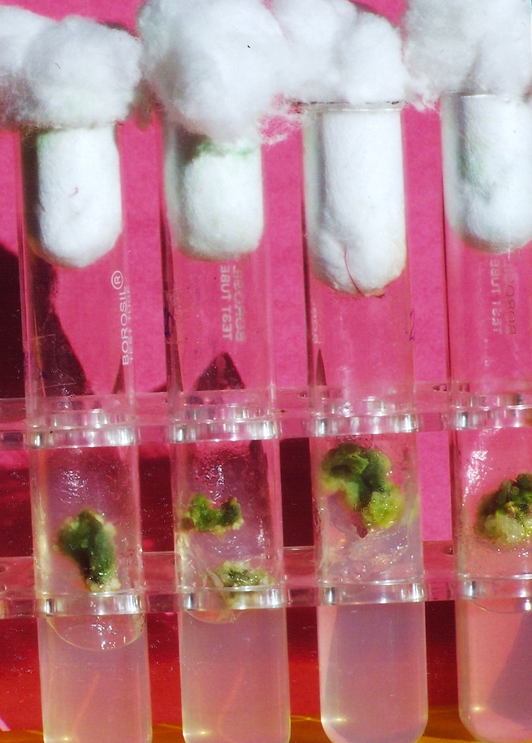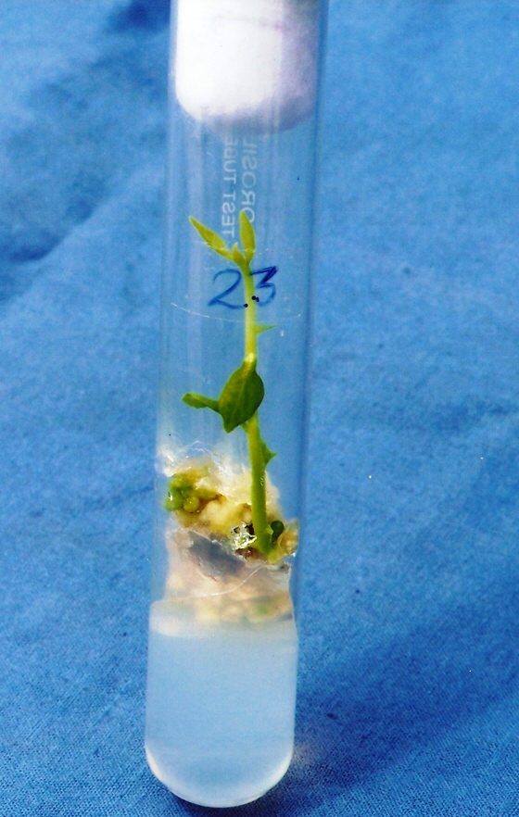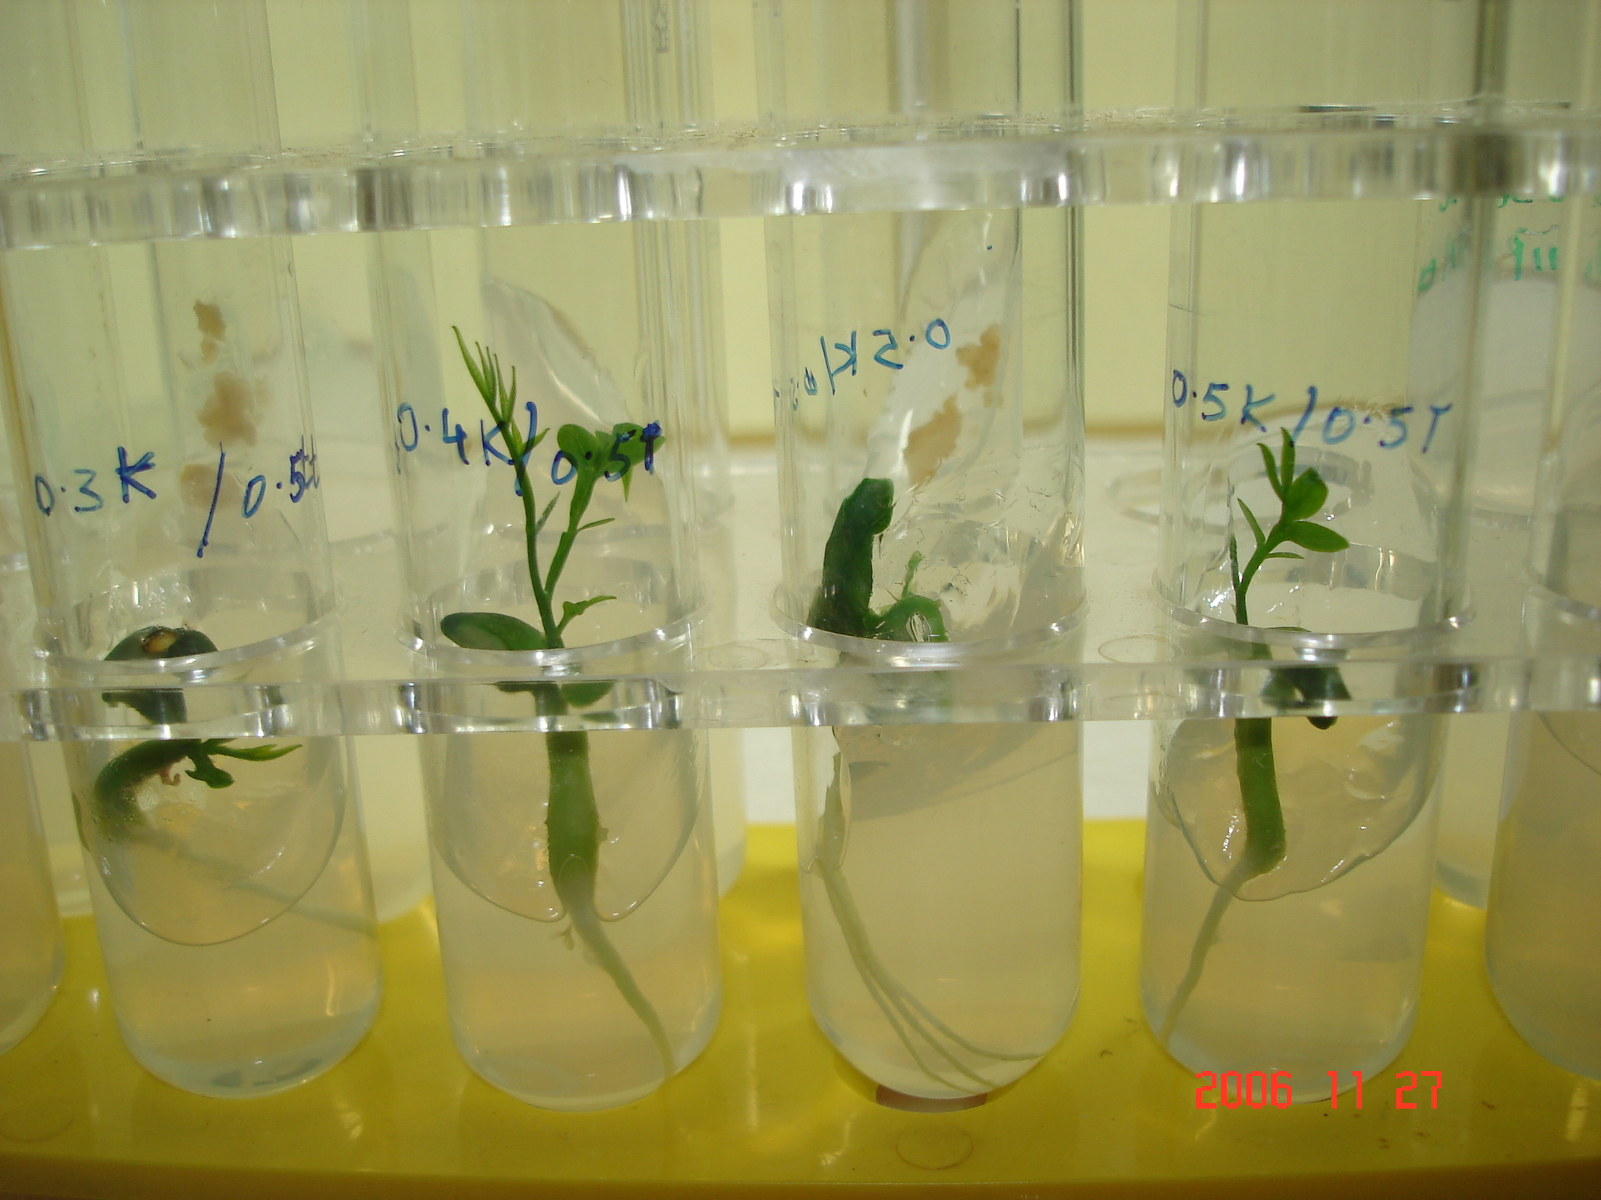

Fig.1. Callus induction in R. sepentina from leaf explants in MS media containing BAP(1.0) and IAA(0.5)mg/l Fig .2. Shoot regeneration from callus on BAP (2.5) + IAA (0.4) mg/l MS media. Fig.3. Rooting regeneration on BAP (2.5) + IAA (0.5) + NAA (0.5) mg/l MS media.

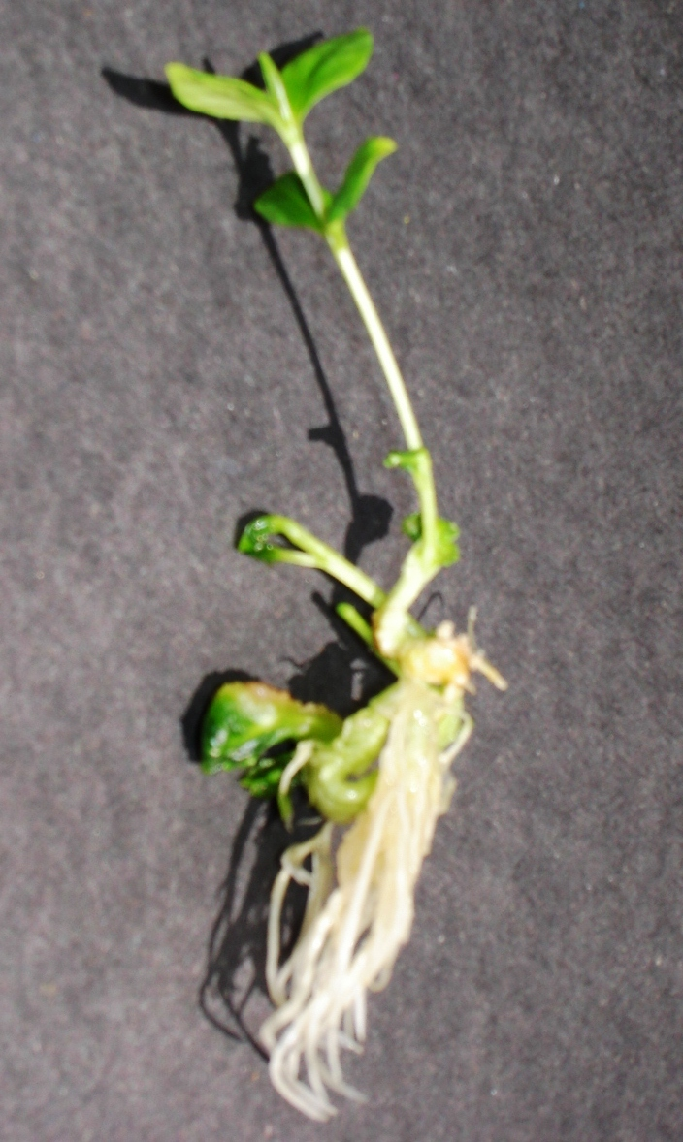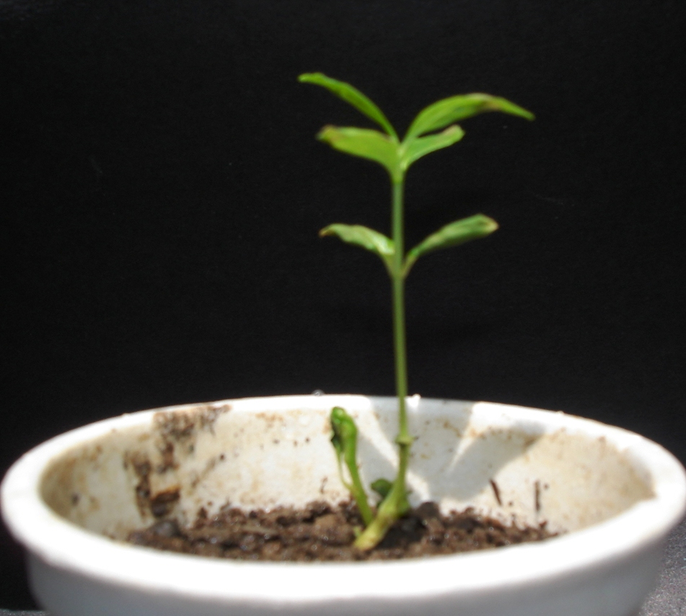

Fig.4. In vitro regeneration of complete plantlets of R. serpentina from leaf explant. Fig.5. Hardening of plantlet to mixture of sterile soil, sand and vermicompost.

Corresponding Author:
Dr. Tapan k. Nailwal
Department of Biotechnology,
Kumaun University Nainital-263001
E mail: tapannailwal@gmail.com

References:
Anonymous (1969). In: the wealth of India , Raw materials, Vol. III, Publication and information Directorate, CSIR, New Delhi, India.

Alpeter, F.and Posselt, U.K. (2000). Improved regeneration from cell suspensions of commercial cultivars, breeding and in bred lines of perennial ryegrass (Lolium perenne L.). J. Plant Physiol. 156:790-796.

Bai, Y. and Qu, R. (2001). Factors influencing tissue culture responces of mature seeds and immature embryos in turf-type tall fescue (Festuca arundinacea schreb.)Plant Breeding. 120: 239-242.

Bhaskaran, S. and Smith R.H. (1990). Regeneration in cereal tissue culture : A review . Crop Sci. 30: 1328-1336.

Bhatia, B.B. (1942). On the use of Rauvolfia serpentina in high blood pressure, J.Ind. Med.Assn. 11:262.

Butenka, R.G. (1964) Isolated tissue culture and physiology of plant morphogenesis. Nauka, Moscow.

Bradley, D.E., Bruneau, A.H. and Qu, R.. (2001). Effect of cultivar, explant treatment and medium supplements on callus induction and plantlet regeneration in perennial ryegrass. Int. Turfgrass Soc. Res. J. 9: 152-156.

Chakraverti, N.K., Rai Chudjuri, M.N. and Chaudjuri, R.N. (1951)). Rauvolfia serpentina in essential hypertension. Ind. Med. Gazette. 86:348.

Chaudhury, A. and Qu, R. (2000). Somatic embryogenesis and plant regeneration of truf-type bermudagrass:effect of 6-Benzaldehyde in callus induction medium. Plant cell tiss. Org.Cult.. 60:113-120.

Charriere, F., Sotta, B., Miginiac, E. and Hahne, G. (1999). Induction of adventitious shoots or somatic embryos on invitro culture.Plant Physiol.Biochem. 37(10):752-757.

Constable, F. (1990). Medicinal plant biotechnology. Planta Med. 56: 421-425.

Edson, J.L., Leege-Brusven, A.D., Everett, R.L. and . Wenny, D.L. (1996). Minimizing growth regulators in shoot culture of an endangered plant, Hackelia ventusa (Boraginaceae).In vitro cell Dev.Biol.Plant. 32 :267-271

Ensminger, A.H., Ensminger, M.E., Konlande, J E. and Robson, J.R.K. (1983). Food & Nutrition Encyclopedia. Pegus Press, Clovis, California, U.S.A. 2:1427-1441.

Fay, M.F. (1992). Conservation of rare and endangered plants using in vitro methods. In Vitro Cell. Dev. Biol.-Plant. 28: 1-4.

Ford, R.V. and Moyer, J.H. (1953). Extract of Rauvolfia serpentina in hypertension. Genl. Practice. 8:51.

Ghani, A. (1998).Medicinal plants of Bangladesh. Chemical constituents and uses. Asiatic Society of Bangladesh, Ed. 2nd pp. 36.

Govil, S. and Gupta, S.C. (1997). Commercialization of Plant tissue culture in India. Plant cell ,Tissue and Organ Culture. 51:65-73.

Gupta, J.C. (1942). Alkaloids of Rauvolfia serpentina. Rep. Adv. School Bd., Ind. Res.Fund Assn.:70.

Gupta, R. (1989). Indian J Plant Genet Resources 1:98-102.

Kukreja, A.K. Mathur, A.K. Ahuja, P.S. and Thakur R.S. ( 1989) Tissue Culture and Biotechnology of Medicinal and Aromatic Plants. ICSIR, Lucknow, India.

Kumar, K.P., Soniya, E.V., Lawrence, B., Nair, G.M. (1993). Micropropagation of Clitoria terntea L. (Paplionaceae) through callus regeneration and shoot tip multiplication. Journal of species and aromatic crops. 2:41- 46.

Mitra, G.C. and Kaul, K.N. (1964) In vitro culture of root and stem callus of Rauwolfia serpentina Benth. for reserpine. Indian J. Exp Biol 2: 49-51.

Mujib, A., Das, S. and Dey, S. (1997). Free cell culture, organization and plant regeneration in Santalum album L.. Plant tissue culture .7:63-69.

Murashige, T. and Skoogs, F. (1962). Physiol Plant. 15:473- 479.

Popov, S.V., Vinter, V.G., Patova, O.A., Markov, P.A., Nikitina, I.R., Ovodova, R.G., Popova, G.Y., Shashkov, A.S., Ovodov, Y.S. (2007). Chemical characterization and anti-inflammatory effect of rauvolfin, a pectic polysaccharide of Rauvolfia callus. Biochemistry (Mosc). 72(7): 778-784

Roy, S.K. Hossain, M.Z. and Islam, M.S. (1994) Mass Propagation of Rauvolfia serpentina by in vitro Shoot Tip Culture. Plant Tissue Cult. 4 (2): 69-75

Shah, M.I., Jabeen, M. and llahi, l.(2003). In vitro callus induction, its proliferation and regeneration in seed explants of Wheat (Triticum aestivum L.) var. Lu-26S. Pak. J. Bot. 35(2):209-217

Vakil, R.J. (1949). A clinical trial of Rauvolfia serpentina in essential hypertension. Brit. Heart J. 11:350.

Vida, F. (1953). Behandlung der Hypertonie mit der indischen Rauvolfia serpentina. Die Med. 37:1157.

Vieira, R.F. and. Skorupa, L.A (1993). Brazilian medicinal plants gene bank. Acta Hort. 330: 51-58.

Vollosovich, A.G. and Butenka, R.G. (1970) Tissue culture of Rauwolfia serpentina as a resource of alkaloids. In: Culture of isolated organs, tissues and cells of plant. 253-257. Butenka, R.G. (Ed) Nauka, Moscow.

3/7/2009

