Taxonomic studies on the family Pteridiaceae Ching and Pterdaceae Ching (Pteridophyta) in Uttarakhand

Mamta Rani, Y.P.S. Pangtey, Lalit M. Tewari, Sanjay Kumar, Jeevan Singh Jalal, Anita Martolia, Kanchan Upreti and Tapan Nailwal*
Department of Botany, *Department of Biotechnology, D.S.B. Campus, Kumaun University, Nainital – 263002, India
l_tewari@rediffmail.com; jeewansinghjalal@rediffmail.com; y_pangtey@yahoo.com; sonu_monu28@rediffmail.com; tapannailwal@gmail.com

ABSTRACT: The present work, 2 families, 2 genera and 15 species i.e. Pteridium (1 species) and Pteris (14 species) including 1 subspecies have been studied. Some of the taxa of ferns reported earlier from Uttarakhand by previous workers based on wrong identification have been placed under the heading excluded/doubtful species giving only botanical name and the reasons of their being excluded/doubtful species are based on Khullar (1994, 2000, 2001). [Researcher. 2009;1(4):15-41]. (ISSN: 1553-9865).

Key words: Pteridaceae, Uttarakhand, Pteridium

Introduction
The eastern part of the west Himalaya is occupied by the Uttarakhand state and lies between the latitudes 28° 44' and 31° 32' North and longitudes 77° 38' and 81° l' East. The newly created state of Uttarakhand is situated at the trijunction of Nepal, Tibet and India. In the north, a natural water divide separates it from the Tibet, Kali river defines it's eastern border with the kingdom of Nepal, Yamuna-Tons rivers separates it from the state of Himachal Pradesh in the west and southern limit of tarai belt almost demarcates it's southern boundary and corresponds almost exactly with the southern limit of the tarai-belts separating it from Saharanpur, Bijnor, Moradabad, Bareilly, Rampur and Pilibhit districts of Uttar Pradesh state. Thus it constitutes a distinct geographical entity of great strategic significance.
The publication of very comprehensive account of plant collections from Kumaun and adjacent parts of Garhwal by Sir Richard Strachey and J.E. Winterbottom between the years 1846-1849 followed the classical works. The original catalogue was published in 1852 in Atkinson's Gazetteer of Himalayan Provinces and Oudh. This original catalogue of Strachey and Winterbottom was later revised and supplemented by J.F.Duthie (1906), which is known as Catalogue of the Plants of Kumaun and of the adjacent portions of Garhwal and Tibet based on the collections made by Strachey and Winterbottom during the years 1846-1849 and on the catalogue originally prepared by Sir Richard Strachey in 1852, by adding the results of previous and subsequent botanical explorations. This catalogue still functions as a milestone for the floristic works including pteridophytes in the part of Himalaya. From this vast area, covering an area of 18,400 km², a total of 30 genera of ferns and 4 genera of fern-allies belonging to 185 species of ferns and 13 species of fern-allies were recorded. However, the nomenclature used is outdated and unsuitable for modern researches and present day needs. Besides, it completely lacks keys, descriptions, figures and ecological notes etc. of the species of pteridophytes listed.
Herbarium specimens of plants drawn are deposited in the Herbarium, Department of Botany, D.S.B. Campus, Kumaun University, Nainital except Pteris multifida, Pteris pellcida and Pteris vittata subsp. Vermae, which are included on the basis of published reports only. The figures of the whole plant or frond or part of it are natural size, while for the detailed drawings the following magnifications have been used; dermal appendages (x 17.5), magnified portion (x 10), spores (x 450), part of lamina to show venation and arrangement of sori (x 150), indusia (x 17.5) following Khullar (1994).

KEY TO FAMILIES
A. Lamina 1-2-pinnate, glabrous; veins free oranastomosing;
indusia formed by incurved lamina margin………………………2. Pteridaceae
A. Lamina 2-3-pinnate, hairy throughout; veins free or
Forked; indusia double; inner one obsolete………………………1. Pteridiaceae

1. Family: PTERIDIACEAE Ching, Acta Phytotax. Sin. 13: 96 (1975).
Rhizome long-creeping, profuselybranched, polystelic, densely hairy; hairs light brown, long, weak, straight, broad scales absent. Lamina large, 2-3-pinnate-quadripinnatifid, hairy throughout, hairs pale brown. Sori continuous, marginal, linear; indusia double, one consisting of thin reflexed edge of the lamina, the order thinner, attached just below the receptacle.
Type: Pteridium Gled. ex Scop., Fl. Carniolica : 169 (1760), nom. cons.

PTERIDIUM
Pteridium Gled. ex Scop., Fl. Carniolica : 169 (1760), nom. cons.
Circinalis Gled., Syst. Pl. : 290 (1764).
Eupteris Newm., Phytologist 2: 278 (1845).

Ornithopteris (J. Agardh) J. Smith, Hist. Fil : 297 (1875), nom Bernh.
Type : Pteridium aquilinum (L.) Kuhn, Deck. Reis. 3 Bot.:11 (1879).
Rhizome long-creeping, hypogeal, clothed with rather few pale brown hairs, solenostelic. Stipes long. Fronds large. Lamina 2-3-pinnate or quadripinnatifid, continuing apical growth for a considerable period; costules, costa and rachises grooved on the upper surfaces, ultimate pinnules or lobes rather small and narrow; texture firm to subcoriaceous, more or less densely hairy all over; veins free except for a marginal strand. Sori submarginal, linear, borne on the connecting veins, indusiate; indusium double, outer false formed by reflexed margin, the inner true well developed or obsolete. Sporangia with the annulus passing just on one side of the stald. Spores globose, tetrahedral, trilete, pale brown, nonperinate, exine smooth.

Pteridium revolutum (Bl.) Nakai, Bot. Mag. 39: 109 (1925); Brownsey, Aust.Syst. Bot. 2: 120 (1989); Fraser-Jenkins, New Sp. Syndrome Indian Pterid. & Ferns Nepal: 217 (1997); Chandra, Ferns India : 109 (2000).
Pteris rovouta Bl., Enum. Pl. Jav.: 214 (1820).

Pteridium aquilinum (L.) Kuhn var. wightianum sensu auct. Ind.; Stewart. 150th Ann. Vol. Royal Bot. Calcutta 2: 168 (1942); Loyal & Verma, J. Bombay nat. Hist. Soc. 57: 484 (1960); Pande, Indian For. 99: 50 (1973Chandra, J. Bombay nat. Hist. Soc. 74: 643 (1979); Awasthi & Sharma, Proc. Indian Acad. Sci. (Pl. Sci.) 89: 310 (1980); Dhir & Sood, Biblioth. Pterid. 2: 36 (1981); Goel & Bhattacharyya, Indian Fern J. 4: 33 (1981); Pangtey et al., Him. Res. & Dev. 1:160 (1982); Bir et al., Pterid. Fl. Garhwal Him.: 32 (1983); Dixit, Census Indian Pterid.: 98 (1984); Pande & Kandpal, Acta Botanica Indica 14 (Suppl.): 118 (1986); Singh et al., Indian J. For. 9: 14 (1986); Khullar et al. in Western Him. 1: 396 (1987); Pande & Pande, Acta Botanica Indica 15: 102 (1987); Pande & Dashila, Indian Fern J. 5: 81 (1988); Pande, Geobios new Reports 8: 106 (1989); Indian Fern J. 7: 165 (1990); Khullar et al., Ferns Nainital 86 (1991); Pangtey et al., New Botanist 18: 221 (1991); I11. Fern Fl. West Him. 1: 254. t. 91 (1994); Chandra, Ferns India: 108 (2000).
Pteris wightianum Wall., Nurmer. List no.: 2178 (1829), nom. nud.
Pteridium aquilinum sensu Mehra, Ferns Muss.: 11 (1939); Chandra, Ferns India: 108 (2000).
Pteris aquiline sensu Clarke, Trans. Linn. Soc. Lond. II (Bot.) 1: 468 (1880); Bedd., Handb. Ferns Brit. India : 115 (1883); Duthie, Cat. Pl. Kumaun: 224 (1906); Marten, J. Bombay nat. Hist. Soc. 19: 179 (1909).

Rhizome long-creeping, shout, hairs pale brown, uniseriate, 7-13-celled, acicular, straight. Stipes 40 cm or more, stout, stramineous, stout, hairy but extreme base densely woolly, hairs brown. Stipe becoming sparsely hairy to almost glabrous higher up; rachis sparsely hairy becoming glabrous. Fronds rather distant. Lamina 2-3-pinnate, large, 30-60 (-150) x 30-60 cm; subdeltate, texture subcoriaceous to coriaceous, hairy, hairs white; pinnae 10-15 pairs, alternate, distal pinnae opposite, lower pinnae the largest, 30 x 10 cm; pinnules lanceolate, margin lobed to the costules into numerous short lobes, which are ovate, more of less falcate, apex obtuse, margin entire or lobed in the middle pinnae; pinnules about 6 x 1 cm, margin lobed almost to the costule, about the middle few pairs of pinnae lanceolate, densely lobed to the costa, lobes short, triangular or linear, terminal few pairs of pinnae simple; veins free, simple or forked, hairy, costules and costae grooved on the upper surface densely hairy. Sori marginal, continuous linear, indusiate; indusia double, inner one obsolete, membranaceous. Spores brown, 21.5 – 31.5 x 24.0 – 35.0 µm, exine almost smooth.

HABITAT: Grows on forest floor or as a weed in orchards. It forms thickets resulting in a characteristic ground vegetation of oak forest.
DISTRIBUTION: Quite common to abundant and usually covering a large area often gregarious from 1800-2700 m altitude.
UTTARAKHAND: DEHRADUN: Deoban, Mussoorie, Jabarkhet forest, Lal Tibba. TEHRI GARHWAL: Nag Tibba, Dhanolti, Govana, UTTARKASHI: Barkot, Yamunotri, Hanumanchatti, Gangotri, Lanka, Jangalchatti. PAURI GARHWAL: Candollea. CHAMOLI GARHWAL: Gopeshwar to Chopta, Gobindghat to Ghangaria, Pandukeshwar to Vinayakchatti. RUDRAPRAYAG: Guptakashi, Gaurikund to Kedarnath, Kalimath, Ukhimath to Duggalbitta. NAINITAL: Naini peak, Kilbury, Snow view, Lariakanta, Tiffin top, Khurpatal, Jeolikote, Bhimtal area, way to Ratighat. ALMORA: Ranikhet, Jhuni, Kausani, Dhaulchhina, Jageshwar, Binsar. BAGESHWAR: Laharkhet to Dhakuri, Khat, Jhuni. PITHORAGARH: Kanalichhina, Didihat, Berinag, Chakori, Gangolihat, Munsiari, Namik, throughout the district (common). CHAMPAWAT: Champawat, Lohaghat.
INDIA: Jammu & Kashmir; Himachal Pradesh: Sikkim; Darjeeling; Arunachal Pradesh; Manipur; south India.
GENERAL DISTRIBUTION: Pakistan; Nepal; Bhutan; China; Taiwan; Vietnam; Thailand; Philippines; Borneo; Sumatra; Java; Sri Lanka; New Guinea.

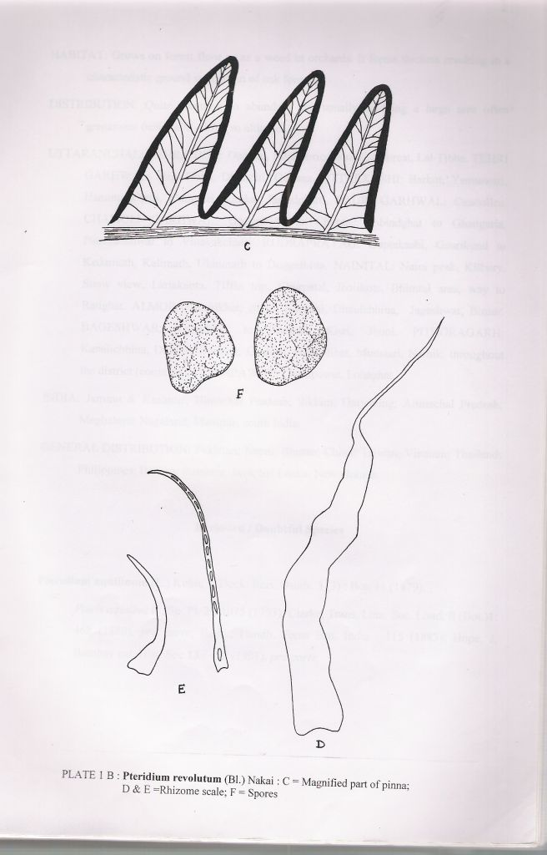
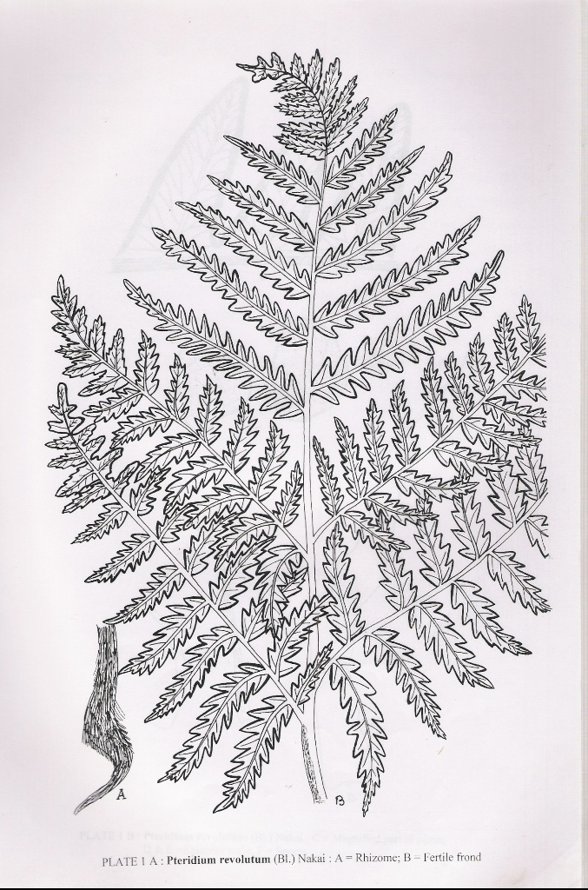

Excluded / Doubtful Species
Pteridium aquilium (L.) Kuhn, v. Deck. Reis. Ostafr. 3(3) : Bot. 11 (1879).
Pteris aquiline L., Sp. Pl. 2 : 1075 (1753); Clarke, Trans, Linn. Soc. Lond. II (Bot.)1: 468 (1880), pro parte; Bedd., Handb. Ferns Brit. India : 115 (1883); Hope, J. Bombay nat. Hist. Soc.13 : 455 (1901), pro parte.

2. Family: PTERIDACEAE Ching, Webbia 35(2): 239 (1982).
Rhizome short, erect or short-creeping, dictyostelic, densely scaly; scales lanceolate, septate hairs absent. Fronds mostly clustered or close together. Lamina 1-2-pinnate, labrous; veins free or anastomosing; costae with small appendages, setae on upper surface. Sori continuous, marginal; indusia formed by incurved lamina, which never reach the costae. Spores mostly tetrahedral, trilete, rarely bilateral, monolete.

PTREIS
Pteris Sp. Pl.. 2 : 1073 (1753); Gen. Pl.ed.5 : (1754).
Campteris Presl, Tent. Pterid. : 146 (1836).
Type: Pteris longifolia L., Sp. Pl. 2: 1074 (1753).
Rhizome short, erect or creeping, scaly, scales generally towards rhizsome apex, linear-lanceolte, margin entire or variously lobed or fimbriate. Stipes base generally scaly; rachis grooved on the upper side. Fronds dimorphic or isomorphic. Lamina 1-2-(-3)-pinnate, never finely dissected, herbaceous to coriaceous, glabrous, lowest pair of pinnae often forked near the base on basiscopic side resulting in a long pinnule with its lobes similar to other pinnae, terminal pinna similar to lateral ones; veins free or anastomosing to form a series of narrow areolae along the costar or costules; areolae without included veinlets; costae and costules usually with short setae on the upper surface. Sori actually submarginal but as the margin curls back to form the indusium it becomes marginal, linear; indusia formed by reflexed pinna margin. Spores brown, tetrahedral, trilete, rarely bilateral, monolete, nonperinate, exine smooth, tuberculate or verrucose, the two surfaces have different types of ornamentation, a prominent collar-like ridge girdles the spores.

KEY TO SPECIES
A. Lamina pinnate…………………………………………….B
- Lamina 2-pinnatifid or 2-pinnate………………………….G
- Lowest pinnae never forked……………………………….C
- Lowest pinnae forked at least once………………………..E
- Pinnae generally 3 (-7), lower never reduced;
fronds dimorphic…………………………………………..10. P. stenophylla
C. Pinnae numerous, lower gradually reduced,
distant and sterile…………………………………………..D
D. Plants tetraploid sexual……………………………………12. P. vittata
D. Plants diploid sexual………………………………………13. P. vittata subsp. Vermae
E. Terminal pinna and the pair of pinnae below it
decurrenton rachis…………………………………………7. P. multifida
E. Terminal pinnae and the pair of pinnae below it
not decurrent on rachis…………………………………….F
F. Fronds on a rhizome few; pinnae many
(3-10 pairs), broad 0.5-1.0 cm fertile, 1-2 cm sterile………4. P. cretica
F. Fronds on a rhizome many; pinnae usually 3,
rarely up to 7 narrow (0.3 cm broad)………………………5. P. dactylina
G. Rhizome short-creeping; lowest pair of
pinnae usually nor forked; ultimate lobes
long, facate; sori extend from almost the
base of the sinus to the apex of the pinna lobe…………….6. P. excelsa
G. Rhizome erect; lowest pair of pinnae always
forked at least once; ultimate lobes linear,
oblong, short; sori never reaching the sinus
but restricted to the middle of the pinna lobes……………..H
H. Pinnae few, a large central terminal pinna with usually one, rarely two pairs of pinnae……………………………………………………..11. P. subquinata
- Pinnae many, an apical pinna with 4-15
pairs of lateral ones…………………………………………I
- Lamina pinnately compound……………………………….J
I. Lamina pedately compound………………………………14. P. wallichiana
- Stipes cataneous throughout……………………………….K
- Stipes castaneous to deeply pinkish………………………..L
K. Lateral pinnae up to 5 pairs………………………………..2. P. asperula
- Lateral pinnae 5-15 pairs…………………………………..1. P. aspericaulis
- Lateral pinnae 2-5 pairs……………………………………9. P. puberula
L. Lateral pinnae not as above………………………………...M
- Lateral pinnae deeply lobed………………………………...3. P. biaurita
M. Lateral pinnae unlobed……………………………………...8. P. pellucida

  - PTERIS ASPERICAULIS
Pteris aspericaulis Wall. Ex Agardh, Recens. So. Gen. Pterid. : 22 (1839); Pande, Indian For. 99: 50 (1973); Chandra, J. Bombay nat. Hist. Soc. 74: 643 (1979); Dixit, Census Indian Pterid.: 68 (1984); Chandra, Ferns India :33 (2000).
Pteris quadriaurita Retz. Ver. Aspericaulis (Wall. Ex Agardh) Bedd., Dandb. Ferns Brit. India : 111 (1883).
Pteris pseudoquadriaurita Khullar, Ill. Fern. Fl. West Him. 1: 272. t. 98 (1994).

Rhizome short, erect, scaly; scales dark-brown. concolorous, linear-lanceolate, margin irregularly dentate- crenate, apex acute. Stipes 25-45 cm long, stramineous or pink or upper surface stramineous, lower pink or almost violet, asperous or glabrous; rachis variable in colour like stipe, glabrous. Lanceolate or ovate-lanceolate; texture subcoriaceous, glabrous; pinnae 4-15 pairs. 10-20 x 1.5-3.0 cm, alternate, lower pinnae shortly stalked, upper sessile, margin deeply lobed to the costa; pinnules many, 0.5-2.0 x 0.3-0.4 cm, linear or oblong-obtuse, size and shape variable, distant or close, apex apiculate to acuminate, infertile apex of fertile lobes almost entire, lowest pair of pinnae always the largest and forked at least once, rarely twice or three times, the next one or two pairs of pinnae may also be forked; veins free, forked or simple, the lowest from either side of costa reaching the sinus but never fusing. Sori indusiate, extent of fertility variable, generally the sorus is present a little above the sinus and not reaching the lobe apex. Spoers dark-brown, 31.5-42.0 x 38.5-45.5 µm, exine tuberculate.
HABITAT: Grows on moist shaded localities forming large clumps along the road-sides, way sides or in humus rich forest floor.

DISTRIBUTION: An extremely common fern throughout the region from 1800-2400 m altitude.
UTTARAKHAND: DEHRA DUN: Deoban, Chakrata, Mussoorie (all over), Camel’s back, Jabarkhet, Lal Tibba, Company garden, en route Kemty falls etc. TEHRI GARHWAL: Magra, Dhanolti, Deolsari. UTTARKASHI: Hanumanchatti, Brahmkhal, Barkot. PAURI GARHWAL: Pauri. CHAMOLI GARWAL: Gobindghat. RUDRAPRAYAG: Gaurikund, Vinayakchatti, NAINITAL: (all over), Snow view, land’s end, Cheena peak range, Kilbury, lariakanta, Dhobighat etc. ALMORA: Almora, Lodhia, Binsar, Jageshwar, Ranikhet. BAGESHWAR: Jalat, Phurkia, Dhakuri, Sikhar, Bageshwar. PITHORAGARH: Above Maghar, Deochula, Dhaj, Thalkedar, Didihat, Berinag, Munsiari etc. (common). CHAMPAWAT: Lohaghat, Champawat.
INDIA: Jammu & Kashmir (rare); Himachal Pradesh; Sikkim; Darheeling; Karnataka; Takil Nadu; Kerala.
GENERAL DISTRIBUTION: Nepal; Tibet; China (Yunnan); Thailand; N Myanmar.
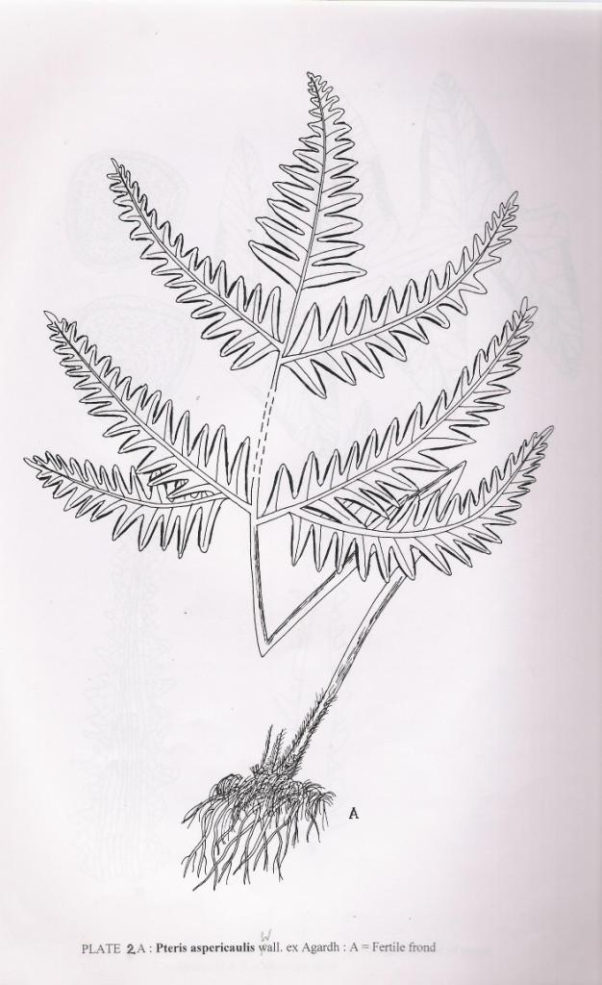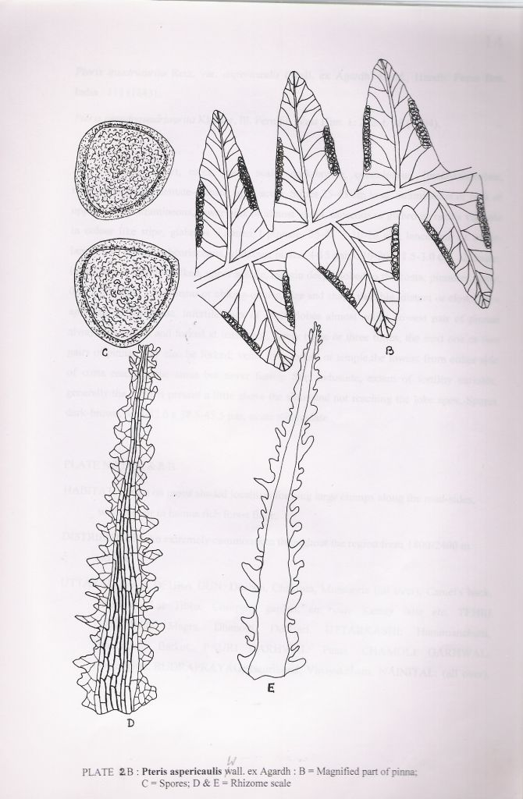

  - PTERIS ASPERULA
Pteris asperula J. Smith ex Hieron., Hedwigia 55 : 361 (1941); Dixit, Census Indian Pterid. : 69 (1984); Pande, Indian Fern J. 7: 157 (1990); Chandra, Ferns India : 33 (2000).
Pteris quadriaurita Retz. Var. setigera Hook. in Bedd. Handb. Ferns Brit. India : 11 (1883).
Pteris quadriaurita Retz. Var. hamulosa Wall. Ex Bedd., Handb. Ferns Brit. India Suppl.: 23 (1892).
Pteris quadriaurita Retz. Var. asperula (J. Smith ex Hieron.) Bedd., Handb. Ferns Brit. India Suppl.: 24 (1892).
Rhizome suberect, 3-7 cm thick, unbranched. Stipe 15-45 cm long, pale reddish brown when dry, with median groove shallow and broad, glabrous upwards at maturity. Fronds ± spreading. Lamina 20-30 x 15-25 (-30) cm, bipinnate, with the rachis glabrous and bearing 5-10 pairs of subopposite lateral obliquely placed pinnae and a similar terminal one, basal lateral pinna more spaced and short pitiolate but others subsessile to sessile, basal one or two pairs larger than others, 20 x 2-3 (-4) cm, bearing with basiscopic basal half pinnae like lobes which are similar to and as large as lateral pinnae; pinnules ablong, with almost truncate base but acroscopic base slightly narrowed and the apical region narrow and acuminate, 2-3 cm long, margin of pinnule lobed almost to the midrib into narrowly oblong lobes, 12-18 x 3-4 mm and with nearly parallel sides, a pellucid smooth edge and rounded, apex, lamina thin, coriaceous, glabrous on bnoth surfaces, midrib bearing an obliquely erect, 1.0-1.5 mm long seta at the base of main lateral veins, lateral veins 12-15 pairs in each lobe, forked once near the base with branches merging with the cartilaginous margin of the lobes, the basal basiscopic veins arising from the costa; fertile fronds similar to sterile ones. Sori indusiate, restricted to the margin of the lobes, usually 4-5 mm long, leaving a major part of the margin at the base and apex sterile. Spores 35 x 50 µm, dark brown, verrucose, tetrahedral, trilete, sometimes bilateral, monolete.
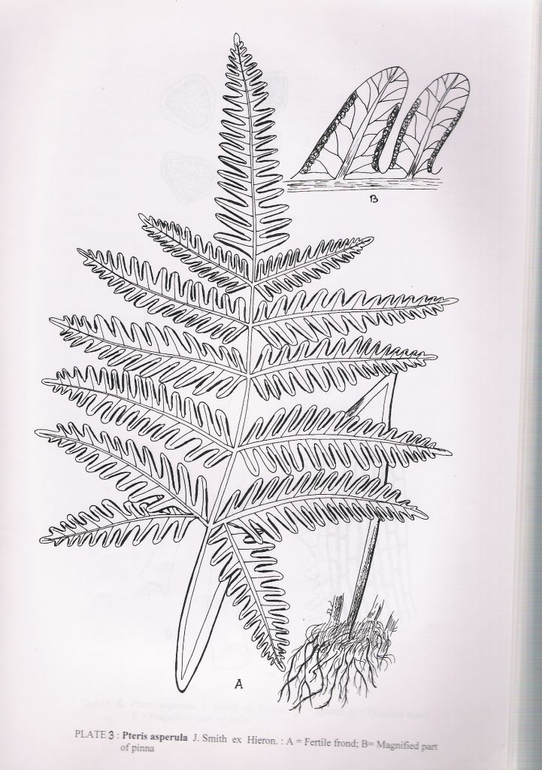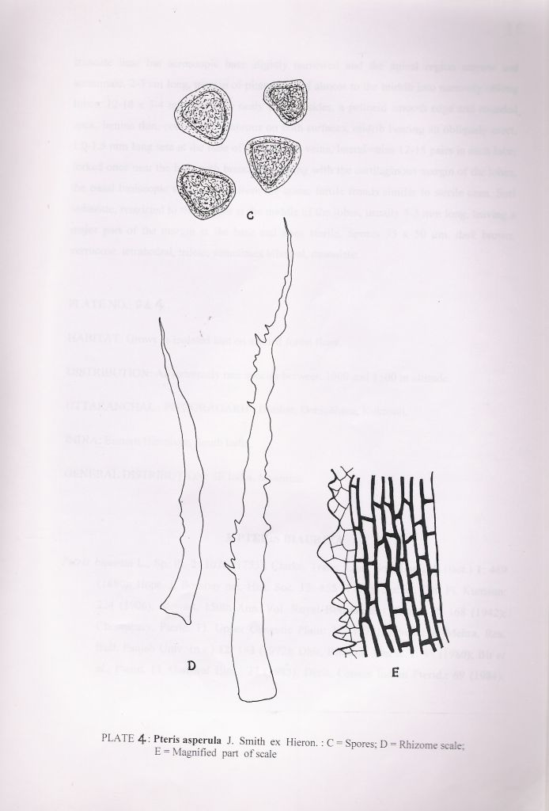

HABITAT: Grows as isolated land on shaded forest floor.
DISTRIBUTION: An extremely rare species between 1000 and 1500 m altitude.
UTTARAKHAND : PITHORAGARH : Didihat, Debichhina, Kukrouli.
INDIA: Eastern Himalaya, South India.
GENERAL DISTRIBUTION: SE India, Myanmar.

  - PTERIS BIAURITA
Pteris biaurita L., Sp. Pl. 2: 1076 (1753); Clarke, Trans. Linn. Soc. Lond. II (Bot.) 1: 469 (1880); Hope, J. Bombay nat. Hist. Soc. 13: 455 (1901); Duthie, Cat. Pl. Kumaun: 224 (1906); Stewart, 150th Ann. Vol. Royal Bot. Gard. Calcutta 2: 168 (1942); Chowdhury, Pterid. Fl. Upper Gangetic Plain: 32 (1973); Dhir, Biblioth. Pterid. 1: 49 (1980); Bir et al., Pterid. Fl. Garhwal Him.: 27 (1983); Dixit, Census Indian Pterid.: 69 (1984); Pande & Kandpal, Acta Botanica Indica 14 (Suppl.): 117 (1986); Khullar et al. in Western Him. 1: 363 (1987); Pangtey in Western Him. 1: 396 (1987); Pande & Dashila, Indian Fern J. 5: 80 (1988); Pande, Geobios new Reports 8: 105 (1989); Indian Fern J. 7: 157 (1990); Khullar et al., Ferns Nainital: 77 (1991); Ill. Fern Fl. West Him. 1: 260. t. 92 (1994); Chandra, Ferns India: 34 (2000).
Pteris nemoralis Willd., Enum. Pl. Berol.: 1073 (1809); Caroli, Sp. Pl. 5: 386 (1810); Alston & Bonner, Candollea 15: 202 (1956).
Pteris pectinata D. Don, Prodr. Fl. Nepal.: 15 (1825).
Campteria biaurita (L.) Hook., Gen. Fil.: t. 65 A (1841); Bedd., Ferns South. India: t. 44 (1863); Handb. Ferns Brit. India: 116 (1883)
Rhizome short. Erect, apex scaly; scales brown, bicolorous, margins irregularly fimbriate with a few long projections. Stipes 30-45 (-60) cm long, stramineous but extreme base brown, thick; rachis glabrous. Lamina pinnate, 30-45 (-60) x 25-30 cm; texture herbaceous, glabrous; pinnae 5-10 pairs, 15-25 x 3-5 cm, alternate, short petiolate, lanceolate, margin deeply lobed almost to the costa; lobes 20 pairs, lobes 20 pairs, oblong, apex rounded, margin entire, sinus narrower in sterile, broad in fertile, acroscopic lobes smaller than the basiscopic ones, the lowest pair of pinnae always forked on the basiscopic side opposite the second acroscopic lobe; veins the basiscopic basal veins from each costule anastomosing with the acroscopic basal veins of the next costule to form a more or less curved continuous arch along the costa, many veins arise from arch and go towards the base of the sinus, the remaining veins in the inner lobe free, forked; costae the costules with small setae on the upper surface at their junction. Sori indusiate, margins continuous from the base of sinus and reaching almost to the apex with a very little infertile apex left; indusia continuous curls back at maturity. Spores dark brown, 45.5-49.0 x 49.0-61.5 µm, densely regulose on the distal surface, verrucose on the proximal one.
HABITAT: Generally grows along the banks of streamlets or in wet places in forested areas.
DISTRIBUTION: Quite common in the region between 600 and 1300 m altitude.
UTTARAKHAND: DEHRA DUN: Dehra Dun. CHAMOLI GARHWAL: between pandukeshwar to Vinayakchatti. NAINITAL: Bhujiaghat, Dogaon; Sattal, Gola valley. BAGESHWAR: Loharkhet. PITHROGARH: Didihat, Gangolihat, Pithoragarh, Thal, Thalkedar, Pamtori, Malghar, Suklari, Munsiari. CHAMPAWAT: Champawat, Lohaghat, Sukhidak.
INDIA: Sikkim; Darjeeling; Arunanchal Pradesh; Meghalaya; Nagaland; Tripura; central and south India.
GENERAL DISTRIBUTION: Nepal; Bhutal; China; Philippines; Malaysia; Java; Borneo; Myanmar; Sri Lanka; Australia: S. Africa; Brazil; West Indies.

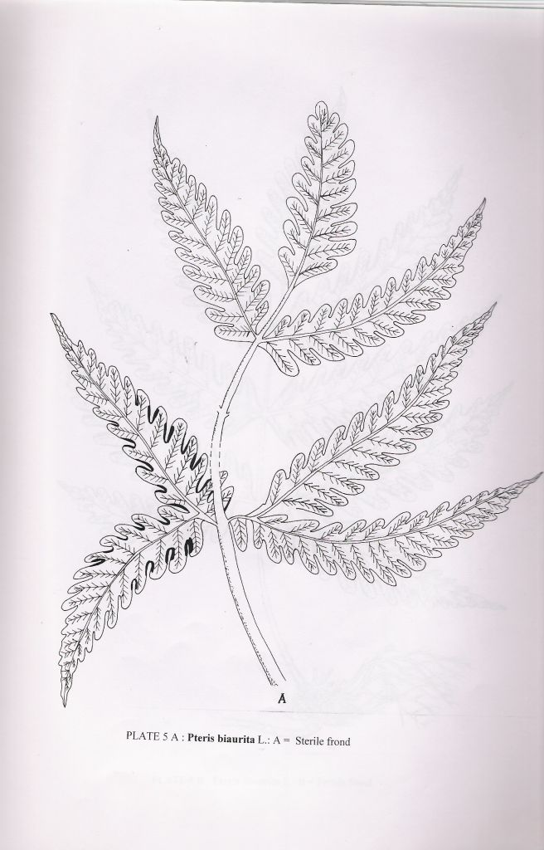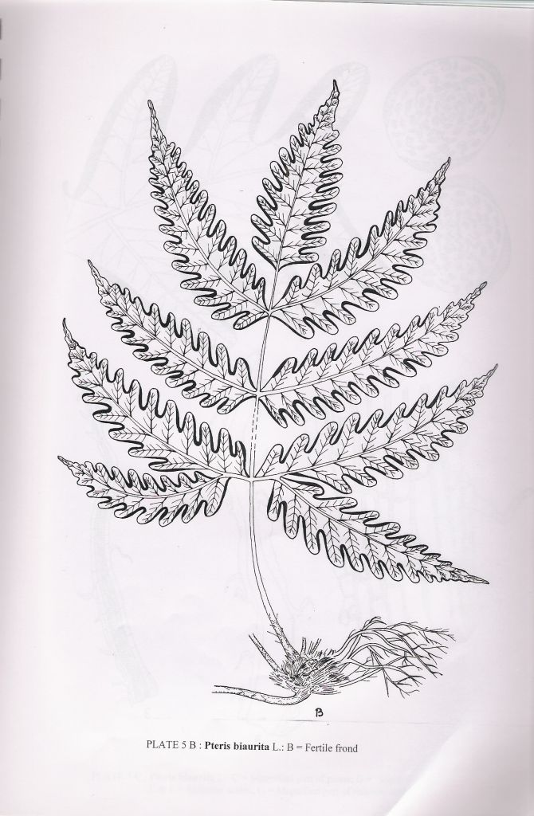
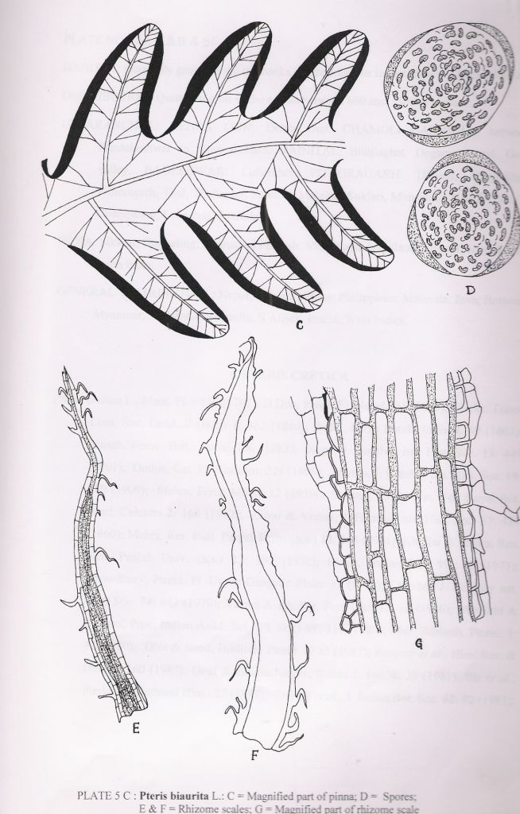

4. PTERIS CRETICA
Pteris cretica L., Mant. Pl. : 130 (1767); D. Don, Prodr. Fl. Nepal.: 15 (1825); Clarke, Trans. Linn. Soc. Lond. II (Bot.) 1: 462 (1880); Handb. Ferns Brit. India: 106 (1883); Hope, J. Bombay nat. Hist. Soc. 13: 449 (1901); Duthie, Cat. Pl. Kumaun: 224 (1906); Khullar & Mehra, Res. Bull. Panjab Univ. (n.s.) 23: 193 (1972); Pande, Indian For. 99: 50 (1973); Chandra, J. Bombay nat. Hist. Soc. 74: 643 (1979); Verma & Khullar, Fern Gaz. 12: 85 (1980); Dhir, Biblioth, Pterid. 1: 47 (1980); Dhir & Sood, Biblioth, Pterid. 2: 33 (1981); Pangtey et al., Him. Res. & Dev. 1: 160 (1982); Bir et al., Pterid. Fl. Garhwal Him.: 27 (1983); Dixit, Census Indian Pterid.: 69 (1984); Pande & Kandpal, Acta Botanica Indica 14 (Suppl.): 117 (1986); Khullar et al. in Western Him. 1: 363 (1987); Pangtey & Punetha in Western Him. 1: 393 (1987); Khullar et al., J. Cytol. & Genet. 23: 49 (1988); Pande, Geobios new Reports 8: 105 (1989); Indian Fern J. 7: 157 (1990); Pangtey et al., New Botanist 18: 221 (1991); Khullar et al., Ferns Nainital: 77 (1991); Chandra, Ferns India: 35 (2000).
Pteris nervosa Thunb., Fl. Jap.: 332 (1784); Ching & S.K. Wu in C.Y.Wu Fl. Xizangica 1: 68 (1983).
Pycnodoria cretica (L.) Small, Fl. Florida: 39 cum tab. (1932).
Rhizome short-creeping, thick, scaly; scales dark brown, concolorous, linear-lanceolate, margin entire, apex acuminate. Fronds dimorphic; sterile fronds usually smaller and bending backwards; fertile fronds erect with longer and stronger stipes. Stipes 10-45 cm long, stramineous, glabrous, dark brown towards base, thick, stipe base sparsely scaly; scales small, dark brown, linear-lanceolate, higher up stipe glabrous; rachis stramineous, glabrous. Lamina pinnate, imparipinnate, 30-50 x 10-30 cm; texture herbaceous to subcoriaceous; pinnae 3-5 pairs, 15-20 x 1-2 cm, opposite, petiolate but upper pinnae gradually sessile, lanceolate, margin spinulose serrate, lowest pair of pinnae usually forked at base, sometimes the next pair also be similarly forked. Fertile subcoriaceous; pinnae 8-10 pairs, more in number than sterile ones, opposite, petiolate, upper pinnae subsessile or sessile, lanceolate, margin entire, the infertile apex dentate-serrate, apex acuminate, lower pinnae slightly distant, usually forked once at base; veins free, simle or forked, costae and costules glabrous. Sori indusiate, marginal, entire, pinnae soriferous except for the infertile apex; indusia membranaceous, continuous. Spores 35.0-45.5 x 42.0-49.0 µm, exine levigate, undulate.

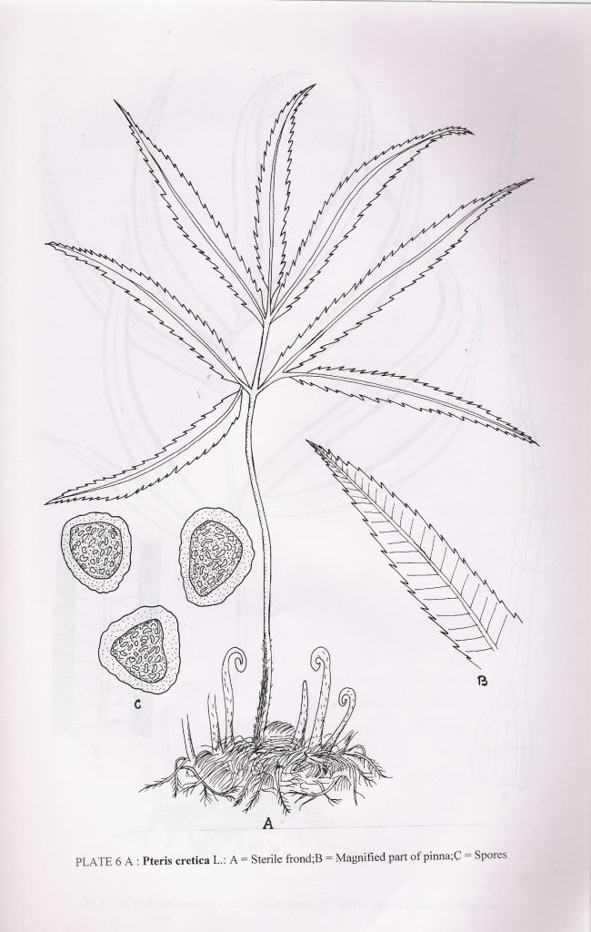
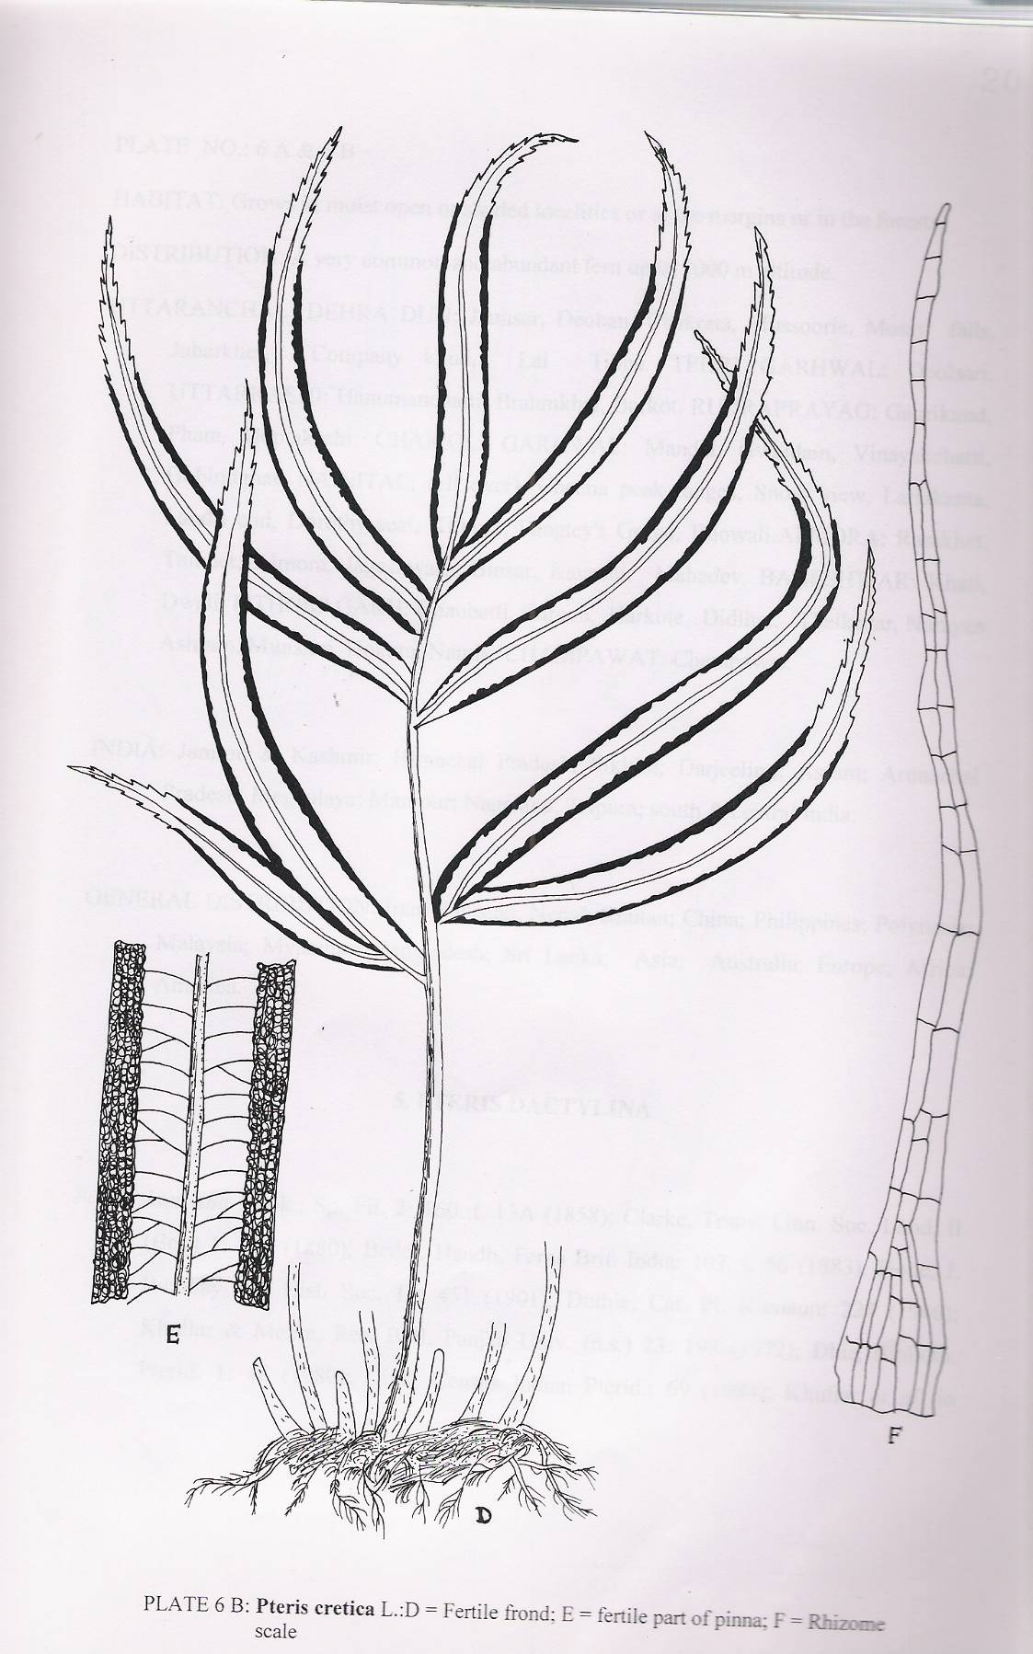

HABITAT: Grows in moist open or shaded localities or at the margins or in the forests.
DISTRIBUTION: A very common and abundant fern up to 3000 m altitude.
UTTARAKHAND: DEHRA DUN: Jaunsar, Deoban, Chakrata, Mussoorie, Mossy falls, Jabarkhet, Company khud, Lal Tibba. TEHRI GARHWAL: Deolsari. UTTARKASHI: Hanumanchatti, Brahmkhal, Barkot. RUDRAPRAYAG: Gaurikund, Phata, Guptakashi. CHAMOLI GARHWAL: Mandal, Gwaldam, Vinayakchatti, Gobindchat. NAINITAL: (all over), Cheena peak ranges, Snow view, lariakanta, Land’s end, Dorothy seat, Kilbury, Pangtey’s Gorge, Bhowali. ALMORA: Ranikhet, Taikhet, Almora, Jageshwar, Binsar, Kausani, Mahadev. BAGESHWAR: Khati, Dwali. PITHORAGARH: Chaubatti, Garaon, Harkote, Didihat, Thalkedar, Narayan Ashram, Munsiari, Hokara, Namik. CHAMPAWAT: Champawat.
INDIA: Jammu & Kashmir; Himanchal Pradesh; Sikkim; Darjeeling; Assam; Arunachal Prakesh; Meghalaya; Manipur; Nagaland; Tripura; south & central India.
GENERAL DISTRIBUTION: Iran; Pakistan; Nepal; Bhutan; China; Philippines; Polynesia; Malaysia; Myanmar; Bangladesh; Sri Lanka; Asia; Australia; Europe; Africa; America.

5. PTERIS DACTYLINA
Pteris dactylina Hook., Sp. Fil. 2: 160. t. 13A (1858); Clarke, Trans. Linn. Soc. Lond. II (Bot.) 1: 463 (1880); Bedd., Handb. Ferns Brit. India: 107. t. 56 (1883); Hope, J. Bombay nat. Hist. Soc. 13: 451 (1901); Duthie, Cat. Pl. Kumaun: 224 (1906) Khullar & Mehra, Res. Bull. Panjab Univ. (n.s.) 23: 193 (1972); Dhir, Biblioth. Pterid.1: 46 (1980); Dixit, Cunsus Indian Pterid.: 69 (1984); Khullar et al. in Western Him. 1: 363 (1987); Pande, Indian Fern J. 7: 157 (1990); Khullar et al., Ferns Nainital: 78 (1991); Him. Bot. Res.: 394 (1991); Ill. Fern Fl. West Him. 1: 265. t. 94 (1994); Chandra, Ferns India: 36 (2000).
Rhizome short-creeping, covered all over by roots and persistent stipes bases, scaly; scales dark brown, concolorous, lanceolate, margin entire, apex acuminate. Fronds dimorphic, only few fertile. Stipes 20 (-30) cm long, stramineous, thin, wiry, glabrous; rachis glabrous. Lamina pinnate; texture subcoriaceous, glabrous, 10-20 cm long; pinnae 1-7 (-9) but usually 3, mostly a central pinna at the apex and two lateral ones that are forked at base, all clustered together and apparently appearing as 5 pinnae all arising from the same point, up to 15.0 x 0.3 cm, shortly stalked, linear-lanceolate, margin crenate-serrate (in sterile pinnae); infertile apex of fertile pinnae sharply toothed, apex elongated; veins far apart, mostly simple, few forked, conspicuous Sori indusiat, marginal; indusia broad, continuous, margin entire, spores dark-brown, 35-49 x 42-64 µm, exine reticulate.

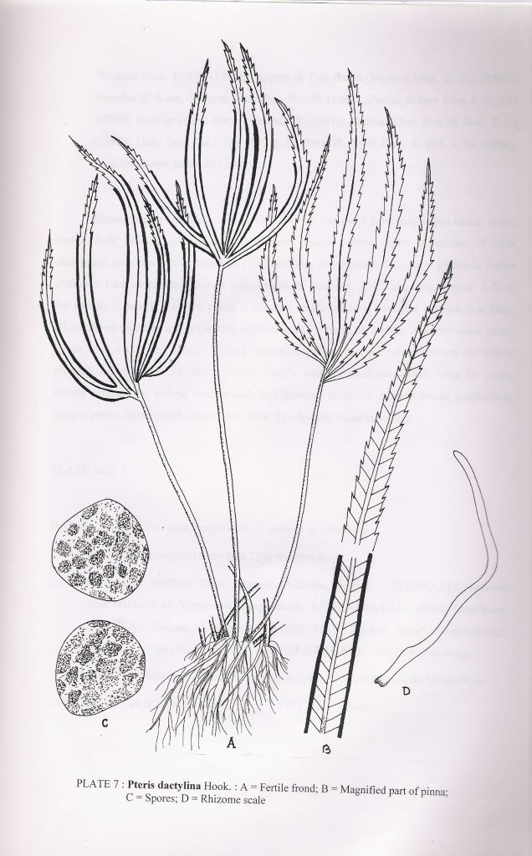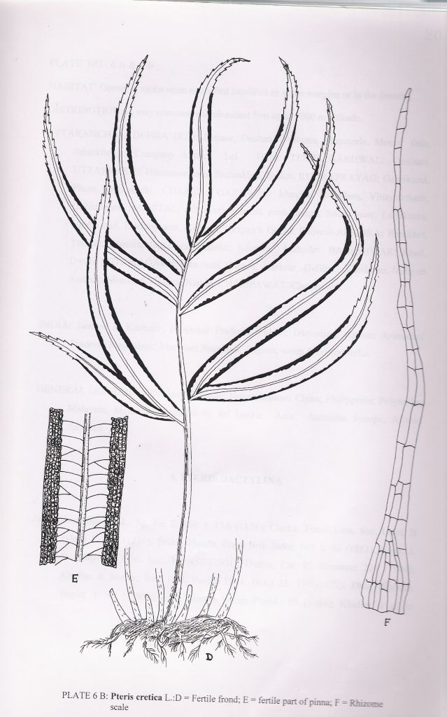

HABITAT: Grows on moist steep banks of streams or roadsides.
DISTRIBUTION: Infrequent from 800-2700 m altitude.
UTTARAKHAND: DEHRA DUN: Jaunsar, Chakrata, Deoban. UTTARKASHI: between Jankibaichatti to Yamunotri, Jangalchatti. RUDRAPRAYAG: above Gaurikund. NAINITAL: Nainital, Lariakanta. BAGESHWAR: Pindari, Dwali, Sundardhunga. BAGESHWAR: Dhaulchhina, Sikhar. PITHORAGARH: Bogdwar, Satsiling.
INDIA: Himanchal Pradesh; Sikkim; Darjeeling; Assam; Arunachal Pradesh; Meghalaya.
GENERAL DISTRIBUTION: Nepal; Bhutan; SW China; Taiwan.

6. PTERIS EXCELSA
Pteris excelsa Gaud., Freyc. Voy. Bot.: 388 (1827); Clarke, Trans. Linn. Soc. Lond. II (Bot.) 1: 467 (1880); Bedd., Handb. Ferns Brit. India: 114 (1883); Hope, J. Bombay nat. Hist. Soc. 13: 454 (1901); Duthie, Cat. Pl. Kumaun: 224 (1906); Stewart, 150th Ann. Vol. Royal Bot. Gard. Calcutta 2: 168 (1942); Khullar & Mehra, Res. Bull. Panjab Univ. (n.s.) 23: 193 (1972); Pangtey et al., Him. Res. & Dev. 1: 160 (1982); Bir et al., Pterid. Fl. Garhwal Him.: 27 (1983); Dixit, Census Indian Pterid.: 70 (1984); Pangtey & Punetha in Western Him. 1: 393 (1987); Pande & Dashila, Indian Fern J. 5: 80 (1988); Pande, Geobios new Reports 8: 105 (1989); Pande & Pande, Vegetos 3: 58 (1990); Khullar et al., Ferns Nainital: 79 (1991); Khullar, Him. Res. & Dev. 7: 62 (1988); Ill. Fern Fl. West Him. 1: 265. t. 95 (1994); Chandra, Ferns India: 36 (2000).
Pteris terminalis Wall., Numer. List. no.: 101 (1828), nom, nud.
Pteris excelsa Gaud. Var. rotunda (routundus) P. & H. Pande, Indian Fern J. 11: 99 (1994), nom. nud.

Rhizome short-creeping, thick, apex scaly; scales brown, concolorous, lanceolate, margin entire, apex acute or acuminate. Stipes 40-100 cm long, generally shorter or equal to lamina, dark-brown to violet, base very dark, thick, base scaly, scales brown, linear-lanceolate, margin entire, higher up stipe glabrous, grooved. Rachis light brown, glabrous, glossy. Lamina 1-2-pinnate, 50-100 x 20-30 cm, subdeltate, texture herbaceous, glabrous; pinnae 4-8 pairs or more, large, 15-30 x 1.5 cm, alternate, petiolate becoming subsessile to sessile in the distal part of lamina, deltate to lanceolate, margin deeply lobed to the base or the lobes becoming free in bipinnate fronds; pinnules (or lobes) many, 5.0-6.0 x 0.7-1.0 cm, linear-lanceolate, subfalcate, the lower base decurrent, margins of sterile lobes, finely crenate-serrate, basiscopic lobe generally longer than the acroscopic one; the lowest pinnae the largest, not forked; veins free forked, rarely a few veinlets anastomose; costae with a few short setae at the base of costule; veins slightly raised on the lower surface. Sori endusiate, marginal, continuous extend from the base to about the apex of the pinnule; indusia somewhat broad, membranaceous, olive-green of olive-brown. Spores brown, 28.5 –35.5 x 35.0-42.0 µm, exine smooth.

HABITAT: Grows in extremely moist places along the streamlets in densely shaded ravines in forests.
DISTRIBUTION: Frequent, but locally common fern from 2000-2400 m altitude.
UTTARAKHAND: DEHRA DUN: Mussoorie, Dhobighat. UTTARKASHI: between Jankibaichatti to Yamnotri, Jangalchatti. TEHRI GARHWAL. RUDRAPRAYAG: Gaurikund. NAINITAL: Dhobikhud, Kilbury, Pangtey’s Gorge. ALMORA: Jageshwar. BAGESHWAR: Turturia, Khati, Jhuni, Pindar gorge. PITHROGARH: Bogdwar, Thalkedar, Lilam, near Pangu, Goriganga valley, Dharamghar, Sandeo.

INDIA: Jammu & Kashmir; Himanchal Pradesh; Sikkim; Darjeeling; Arunanchal Pradesh.
GENERAL DISTRIBUTION: Pakistan; Nepal; Bhutan; China; Taiwan; Japan; Korea; Philippines; Polynesia; Malaysia; Hawaii.
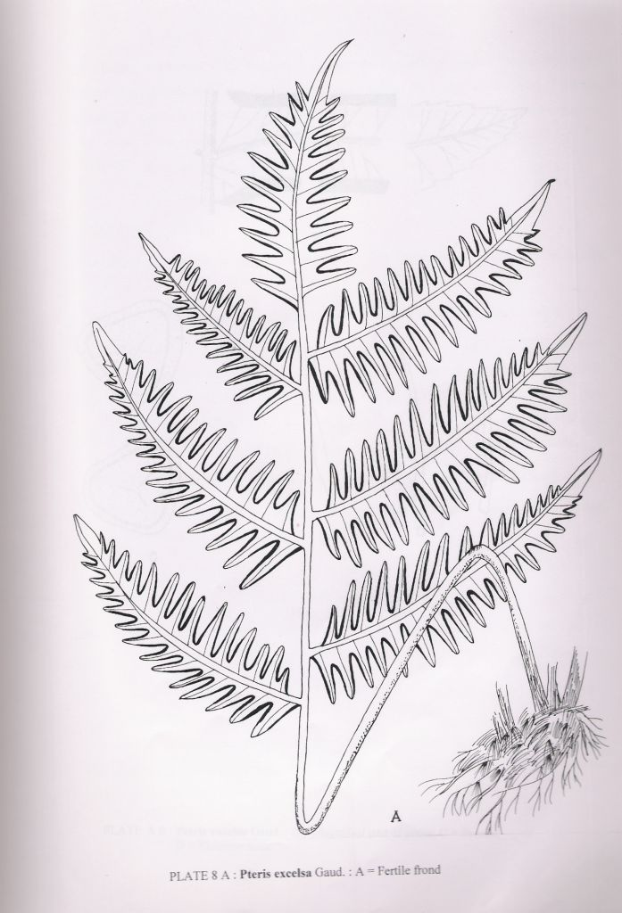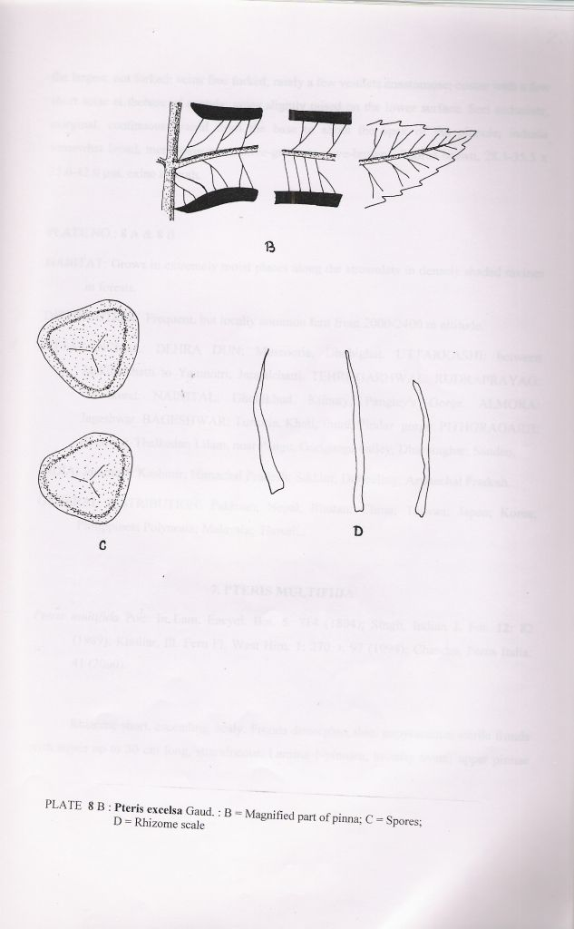

7. PTERIS MULTIFIDA
Pteris multifida Poir. in Lam. Encycl. Bot. 5: 714 (1804); Singh, Indian J. For. 12: 82 (1989); Khullar, Ill. Fern Fl. West Him. 1: 270. t. 97 (1994); Chandra, Ferns India: 41 (2000).
Rhizome short, ascending, scaly. Fronds dimorphic, thin, papyraceous; sterile fronds with stipes up to 30 cm long, stramineous. Lamina 1-pinnate, broadly ovate; upper pinnae decurrent resulting in a winged rachis on each side; pinnae sharply serrate; fertile pinnae much longer and narrower. Sori marginal, continuous along the margin.
HABITAT: Grows along the banks of canals or walls of old gardens.
DISTRIBUTION: Rather rare. Adventive plants, presumably an escape from cultivation.
UTTARAKHAND: DEHRA DUN: Dehra Dun, New Forest Campus.
INDIA: Uttar Pradesh; South India.
GENERAL DISTRIBUTION: Pakistan; China; S Korea; Japan; SE United States.
No specimens are seen and the description is given here as given by Singh (1989) and Khullar (1994).

8. PTERIS PELLUCIDA
Pteris pellucida Presl, Rel. Haenk, 1: 55 (1825); Clarke, Trans. Linn. Soc. Lond. II (Bot.) 1: 468 (1880); Bedd., Ferns South. India: t. 38 (1863); Handb. Ferns Brit. India: 106 (1883); Dixit, Census Indian Pterid.: 71 (1984); Chandra, Ferns India: 41 (2000).
Rhizome short or thick and creeping, densely scaly at the apex; scales lanceolate, pale brown at the periphery, dark at the center, gland tipped, margins with amny multicellular glandular, finger-like projections. Stipe length variable, up to 45 cm long, more or less uniformly chest-nut brown all ober except stramineous or yellowish-brown distal part, sometimes pale brown or stramineous all over, glossy and glabrous. Lamina simply pinnate with ternate apex, c 30 cm long or longer, coriaceous-membranaceous, bright-green; pinnae 3-11, generally 15.0-25.0 x 2.5-4.0 cm long, entire or slightly serrulate at the apex; lateral pinnae sessile, upper ones sometimes decurrent, generally all entire or the lowest pair bifid; veins simple or forked, close. Sori linear marginal except and the base or along the margin of the one third to half of the distal or median part of the pinna excluding the apex, up to 2 mm wide indusiate; indusium dark brown, entire, glabrous, narrow. Spores tetrahedral, trilete, 55 x 55 µm, perispore yellowish-brown, exine dark brown, coarsely verrucose.
HABITAT: Grows in well shaded dense forests on the banks of streamlets at lower elevation.
DISTRIBUTION: Extremely rare between 600 and 1800 m altitude.
UTTARAKHAND: PITHORAGARH: Didihat. CHAMPAWAT: Chalthi.
INDIA: South India.
GENERAL DISTRIBUTION: Nepal; Bhutan; Taiwan; Malaysia; Philippines; Malaysia; Myanmar.
This species is included here based on earlier reports only and the description is based on published literature.

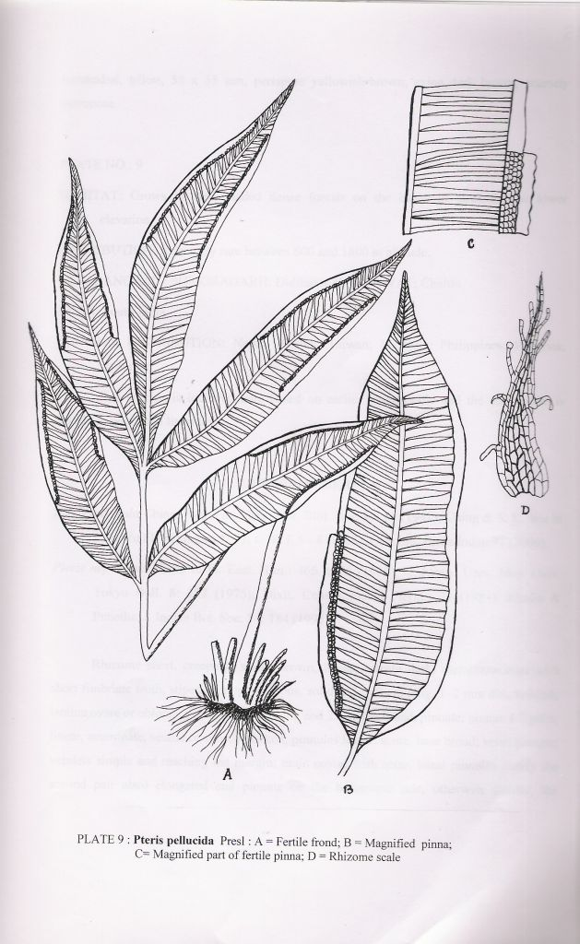

9. PTERIS PUBERULA
Pteris puberula Ching, Bull. Fan Mem. Inst. Biol. Bot. 11: 52 (1941); Ching & S.K. Wu in C. Y. Wu Fl. Xizangica 1: 71. t. 18. f. 5 – 8 (1983); Chandra, Ferns India: 41 (2000).
Pteris nepalensis H. Ito in Fl. East. Him.: 466. t. 26 (1966); K. Iwats., Univ. Mus. Univ. Tokyo Bull. 8: 177 (1975); Dixit, Census Indian Pterid.: 71 (1984); Kholia & Punetha, J. Indian Bot. Soc. 74: 184 (1995).
Rhizome short, creeping; scales brown, linear, margin dark, membranaceous with short fimbriate teeth; stipes shinning, glabrous, solid, c 35-40 cm long. 1-2 mm dia., reddish; lamina ovate or oblong-ovate, 40-50 cm long and 25-35 cm broad, pinnate; pinnae 4-7 pairs, linear, acuminate, sessile or shortly stalked; pinnules linear, acute, base broad; veins pinnate; veinlets simple and reaching the margin; main costae with setae, basal pinnules (rarely the second pair also) elongated and pinnate on the basiscopic side, otherwise similar, the terminal pinna at the lamina top similar to other pinnae; sori marginal; indusia membranaceous, pale brown, linear, margin entire 1-3 cm long and 0.6-0.8 mm broad; sporangia annular cells 18-20; spores tetrahedral, wings small.
HABITAT: Grows in humus rich forest floor.
DISTRIBUTION: Rather infrequent fern between 2300 and 2700 m altitude.
UTTARAKHAND: KUMAUN: BAGESHWAR: Dwali.
INDIA: Eastern Himalaya: Darjeeling.
GENERAL DISTRIBUTION: Nepal, S. W. China, N. Thailand.

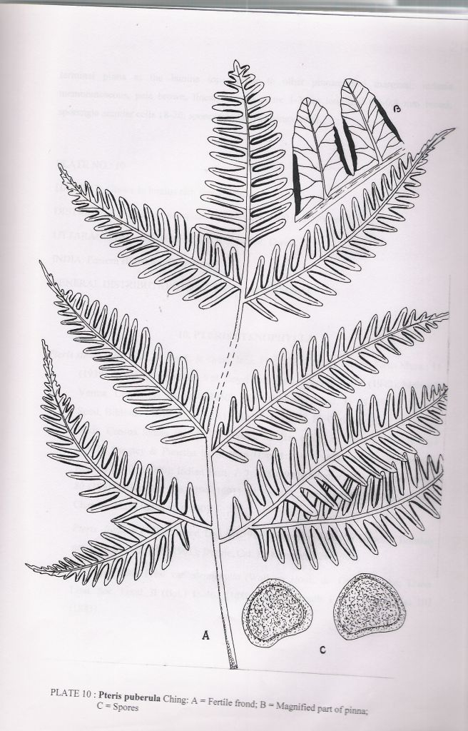

10. PTERIS STENOPHYLLA
Pteris stenophylla Wall. ex Hook. & Grev., Icon. Fil.: t. 130 (1829); Mehra, Ferns Muss.: 11 (1939); Stewart, 150th Ann. Vol. Royal Bot. Gard. Calcutta 2: 168 (1942); Mehra & Verma, Caryologia 13: 619 (1960); Dhir, Biblioth. Pterid. 1: 46 (1980); Dhir & Sood, Biblioth. Pterid. 2: 32 (1981); Bir et al., Pterid. Fl. Garhwal Him.: 28 (1983); Dixit, Census Indian Pterid.: 72 (1984); Khullar et al. in Western Him. 1: 364 (1987); Pangtey & Punetha in Western Him. 1: 394 (1987); Pande, Geobios new Reports 8: 105 (1989); Khullar et al., Ferns Nainital: 80 (1991); Him. Bot. Res.: 394 (1991); Ill. Fern Fl. West Him. 1: 275. t. 99 (1994); Chandra, Ferns India: 45 (2000).
Pteris digitata Wall., Numer. List. no.: 91 (1828), nom. nud.; ex Hope, J. Bombay nat. Hist. Soc. 13: 450 (1901); Duthie, Cat. Pl. Kumaun: 224 (1906).
Pteris pellucida Presl var. stenophylla (Wall. ex Hook. & Grev.) Clarke, Trans. Linn. Soc. Lond. II (Bot.) 1: 463 (1880); Bedd., Handb. Ferns Brit. India: 107 (1883).
Rhizome short-creeping, thick, scaly; scales dark brown, lanceolate, margin entire. Fronds dimorphic. Stipes 4-25 (-30) cm long, stramineous or brownish, thin, base scaly, rest glabrous, scales similar to rhizome scale but smaller ans narrower Lamina pinnate, 20-30 cm long; texture subcoriaceous, glabrous; pinnae 3-5, sometimes 3 or even one, 20.0-30.0 x 0.5-2.0 cm; sterile pinnae 1.5-2.0 cm, fertile pinnae narrower and longer than the sterile one, opposite, shortly stalked, usually clustered towards the stipe apex, lanceolate, margin slightly toothed, in fertile pinnae the infertile apex small, margin almost entire or coarsely dentateserrate; veins simple or toothed, glabrous. Sori indusiate, marginal; indusia almost continuous from pinnae base to apex. Spores brown, 35-42 x 42-49 µm, exine tuberculate or verrucose.
HABITAT: Grows in rather humid locations.
DISTRIBUTION: An infrequent fern from 1000 – 1600 m altitude.
UTTARAKHAND: DEHRA DUN: Chakrata, Mussoorie, Mossy falls, Kempty falls, Jhariapani. TEHRI GARHWAL: Dhanolti. UTTARKASHI: between Jankibaichatti and Yamunotri. CHAMOLI GARHWAL: Vinayakchatti.
RUDRAPRAYAG: Gaurikund, Gaundar to Madhyamaheshwar, Dungalbitta. BAGESHWAR: Bageshwar, Sarju valley, between Dhakuri to Khati. PITHROGARH: Munsiari.

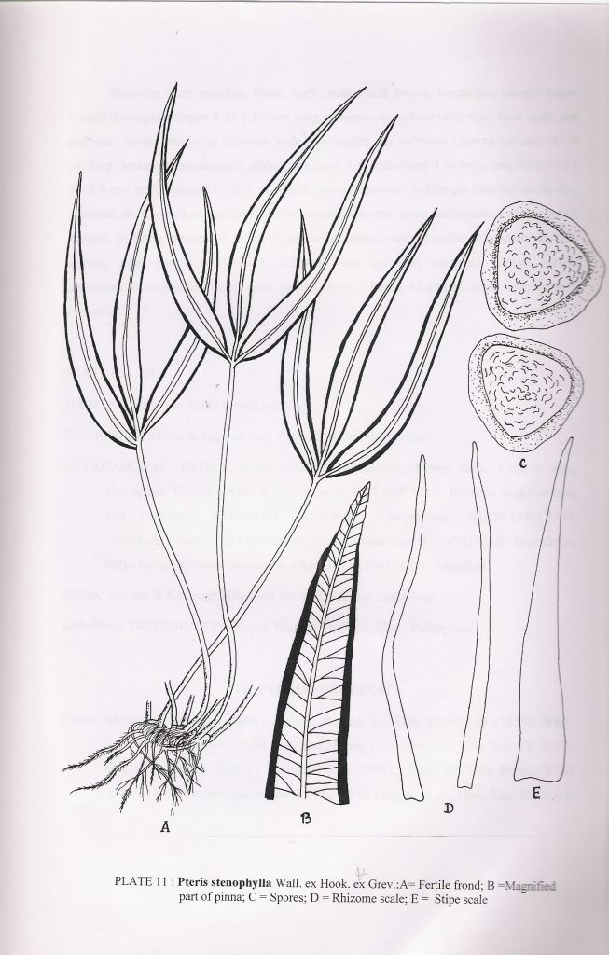

INDIA: Jammu & Kashmir; Himanchal Pradesh; Sikkim; Darjeeling.
GENERAL DISTRIBUTION: Nepal; Bhutan; Thailand; Laos; Philippines.

11. PTERIS SUBQUINATA

Pteris subquinata (Wall. ex Bedd.) Agardh, Recens. So. Gen. Pterid.: 21 (1839); Hope, J. Bombay nat. Hist. Soc. 13: 453. t. 17 (1901); Duthie, Cat. Pl. Kumaun: 224 (1906); Dhir, Biblioth. Pterid. 1: 47 (1980); Dixit, Census Indian Pterid: 72 (1984); Pangtey et al., Him. Res. & Dev. 1: 160 (1982); Khullar et al. in Western Him. 1: 364 (1987); Pangtey & Punetha in Western Him. 1: 394 (1987); Punetha & Kholia, New Botanist 16: 120 (1989); Indian Fern J. 7: 158 (1990); Khullar, him. Res. & Dev. 7:62 (1988); Ill. Fern Fl. West Him. 1: 277. t. 100 (1994); Chandra Fern India : 45 (2000).
Pteris quadriaurita Retz. var. subquinata Wall. ex Bedd., Handb. Ferns Brit. India Suppl.: 23 (1892).
Rhizome short, erect, apex scaly; scales brown, concolorous, lilnear-lanceolate, margin entire. Stopes 7-20 cm long, stramineous, glabrous. Lamina pinnate, c 15 x 10 cm, short deltate, texture herbaceous, glabrous; pinnae 3 (-5)-6, a terminal central pinna and either one (rarely 2-4) pairs of lateral ones, 7-10 x 3-5 cm, opposite, sessile, lanceolate, margin deeply lobed to costa, lobes many 1.5-3.0 x 0.4-0.5 cm, nearly wqually broad throughout, infertile apex of fertile lobe finely crenate-serrate, lowest basiscopic lobe of the lowest lateral pinnae generally enlarged (in young plants) or the pinnae forked at base (in older plants), terminal central pinna the largest; veins free, mostly forked, a few simple costae with small setae at junction with costules. Sori indusiate, marginal, stretching from base to almost the apex; indusia membraneous, brown. Spores brown, 35.0-38.5 x 39.5-52.5 µm, exine smooth.
HABITAT: Grow on slopes or on damp rocks in lime rich areas.
DISTRIBUTION: A rather infrequent fern between 1000 and 1400 m altitude.

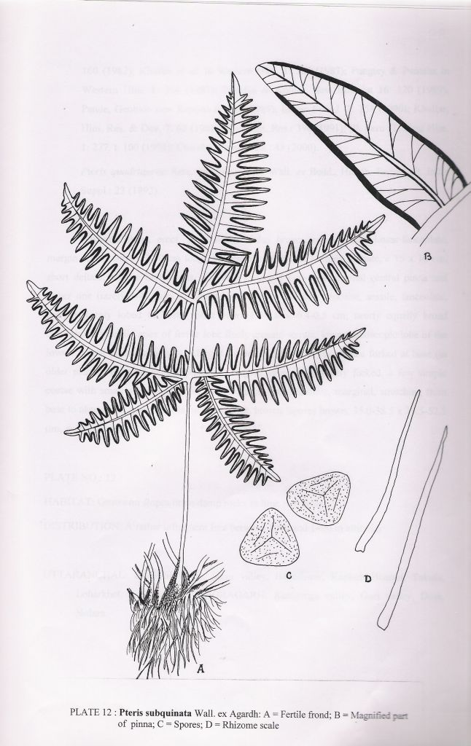
UTTARAKHAND: BAGESHWAR: Sarju valley, Bageshwar, Kapkote-Bharari, Takula, Loharkhet, Kharbaggar. PITHORAGARH: Ramaganga valley, Gori valley, Dore, Nolara.
INDIA: Sikkim; Darjeeling.
GENERAL DISTRIBUTION: Nepal; Thailand; Tonkin.

12. PTERIS VITTATA
Pteris vittata L., Sp. Pl. 2: 1074 (1753); Stewart, 150th Ann. Vol. Royal Bot. Gard. Calcutta 2: 168 (1942); Loyal & Veram, J. Bombay nat. Hist. Soc. 57: 484 (1960); Khullar & Mehra, Res. Bull. Punjab Univ. (n. s.) 23: 193 (1972); Awasti & Sharma, Proc. Indian Acad. Sci. (Pl. Sci.) 89: 310 (1980); Bir et al., Pterid. Fl. Garhwal Him.: 28 (1983); Dixit, Census Indain Pterid.: 73 (1984); Pande & Kandpal, Acta Botanica Indica 14 (Suppl.): 117 (1986); Pangtey & Punetha in Western Him. 1: 394 (1987); Khullar et al., J. Cytol. & Genet. 23: 49 (1988); Pande & Dashila, Indian Fern J. 5: 80 (1988); Pande, Geobios Naintal: 80 (1991); Khullar, Him. Res. & Dev. 7: 62 (1988); Him. Bot. Res.: 394 (1991); Ill. Fern Fl. West Him. 1: 279. t. 101 (1994); Chandra, Fern India: 46 (2000).
Pteris longifolia auct. quoad. Pl. Asia; D. Don, Prodr. Fl. Nepal.: 15 (1825); Bedd., Ferns South. India: t. 33 (1863); Handb. Ferns Brit. India: 106. t. 55 (1883); Clarke, Trans. Linn. Soc. Lond. II (Bot.) 1: 461 (1880); Hope, J. Bombay nat. Hist. Soc. 13: 148 (1901); Duthie, Cat. Pl. Kumaun: 224 (1906); Marten, J. Bombay nat. Hist. Soc. 19: 180 (1909); Mehra, Ferns Muss.: 11 (1939); Chowdhury, Pterid. Fl. Upper Gangetic Plain: 30 (1973).
Pycnodoria vittata (L.) Small, Ferns SE States: 102 cum tab. 468 (1938).

Rhizome creeping, thick, scaly; scales light-brown, concolorous, 0.3-0.5 long, narrow, linear-lancolate, margin entire, apex acuminate. Stipes length variable, (2-) 3.5-13.5 (-50) cm long, generally much shorter tan the lamina, stramineous or light-green or light-brown on drying, thick, scaly and fibrillose; scales abundant at base, light-brown, narrowly linear-lanceolate, margin entire, scales becoming narrower higher up on stipes, fibrils of the same colour as the stipes on stipe but narrower. Lamina pinnate, 6-100 x 1-27 cm, oblong-obovate; texture berbaceous to subcoriaceous, upper surface glabrous; pinnae 20-30 pairs, 0.5-8.0 (-15) x 0.3-0.5 cm, alternate, sessile, linear, base truncate or cordate or slightly auricled, margin of sterile pinnae and infertile apex of fertile pinnae finely dentate-serrate, lower 5-7 pairs of pinnae gradually reduced and distant one usually sterile, apical pinnae variable in size; veins free, simple or usually once forked or 3-4 times forkedl costules hairy on lower surface. Sori marginal, continuous from the base of pinnae, stopping at little short of the apex, indusiate; indusia whitish, membranaceous, margin irregularly serrulate. Spores light-brown, 38.5-45.5 x 42.0-54.0 µm, non-perinate, exine tuberculate to rugulose on the proximal surface, reticulate on distal surface.

HABITAT: Often grows on open roadsides, waysides or walls or on river banks and canals in the plains.
DISTRIBUTION: A family common and abundant fern from the plains up to 1500 m altitude.
UTTARAKHAND: DEHRA DUN: Dehra Dun, Sahasradhara, Mussoorie, Kempty fals, Mossy falls, Rajpur, Rishikesh. UTTARKASHI: Brahmkhal, Barkot. PAURI GARHWAL: Srinagar. CHAMOLI GARHWAL: Gobinghat, Ghangaria, Joshimath, Chamoli, Pandukeshwar, Vinayakchatti. RUDRAPRAYAG: Gaurikund, Guptkashi, Kalimath, Mastura. NAINITAL: Dogaon, Jeolikote, Bhimtal, Sattal, Bhujuyaghat, Kaladhungi. BAGESHWAR: Suring, Loharkhet. PITHORAGARH: Pithoragarh, Dharchula, Thal. CHAMPAWAT: Chalthi, Sukhidak, Lohaghat, Champawat.
INDIA: Jammu & Kashmir; Himachal Pradesh; Sikkim; Darjeeling; Assam; Arunachal Pradesh; Meghalaya; Nagaland; Manipur; Tripura; Orissa; North; Central, south, western India.
GENERAL DISTRIBUTION: Afghanistan; Pakistan; Nepal; China; Taiwan; Philippines; Australia; Africa; Mediteranean Europe.

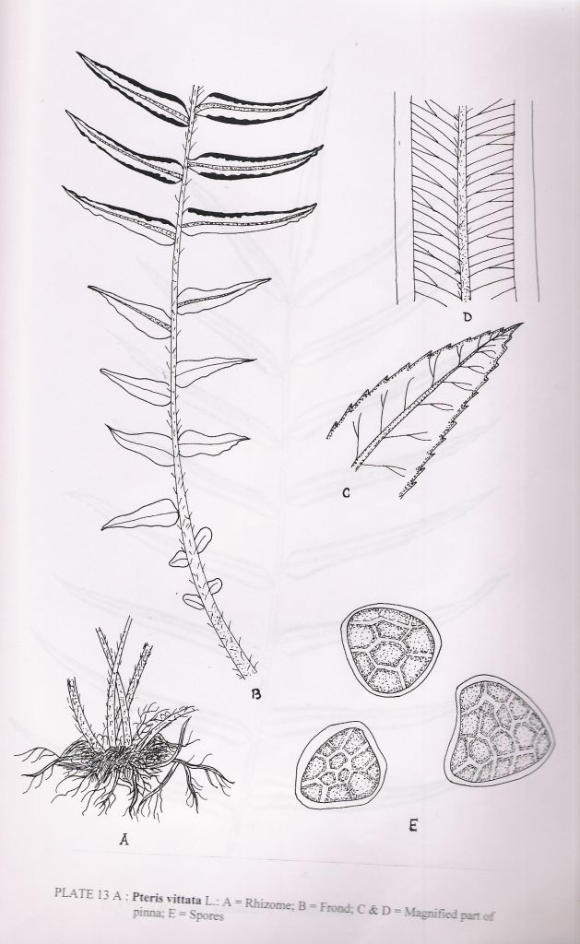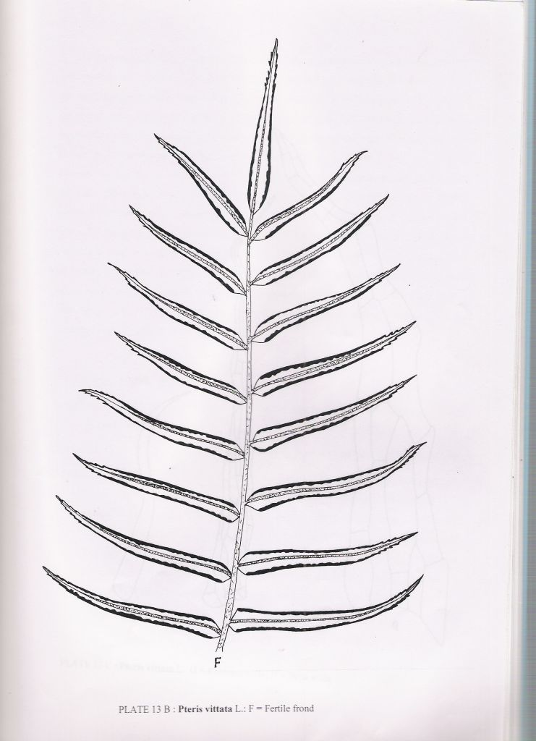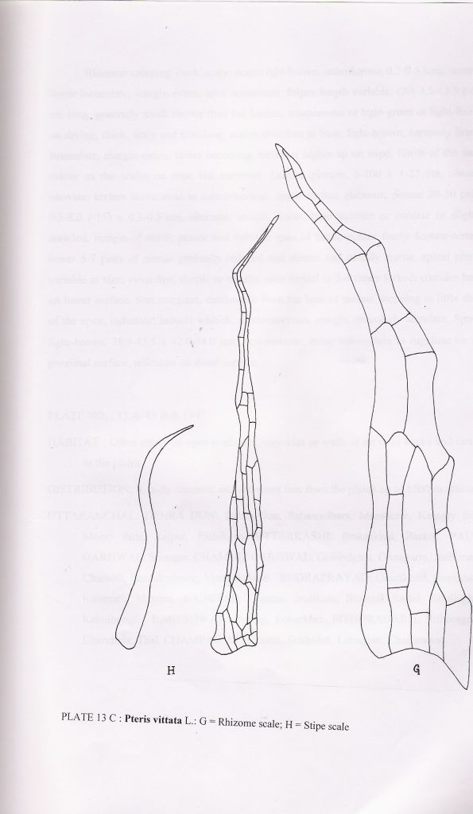

13. PTERIS VITTATA subsp. VERMAE
Pteris vittata L. subsp. vermae Fras.-Jenk., New Sp. Syndrome Indian Pterid. & Ferns Nepal.: 231 (1997); Chandra, Ferns India: 47 (2000).
Pteris vittata L. forma brevipinna Verma, nom. nud.; Khullar et al., Ferns Nainital : 81 (1991); Khullar, Ill. Fern Fl. West Him. 1: 282 (1994).
Differs from P. vittata in having somewhat darker coloured scales, cells of the scales larger and with thicker walls; pinnae narrower, base not widened but broadly and unequally cuneate; indusial flaps broader. Spores light-yellow, somewhat globose and with small papillae present on the exine.
HABITAT: Grows along the waysides and roadsides.
DISTRIBUTION: Collected only once from below Nainital around 600 maltitude.
UTT ARANCHAL: NAINIT AL: Bhujiaghat.
INDIA: Uttarakhand.
GENERAL DISTRIBUTION: China, Sichuan.

14. PTERIS WALLICHIANA
Pteris wallichiana Agardh, Recens. Sp. Gen. Pterid.:69 (1839); Clarke, Trans. Linn. Soc. Lond. II (Bot.) 1: 469 (1880); Hope, J. Bombay nat. Hist. Soc. 13: 456 (1901); Duthie, Cat. Pl. Kumaun: 224 (1906); Khullar & Mehra, Res. Bull. Panjab Univ. (n.s.) 23: 193 (1972); Dhir, Biblioth. Pterid. 1: 49 (1980); Dixit, Census Indian Pterid.: 73 (1984); Pangtey & Punetha in Western Him. 1: 394 (1987); Khullar et al., J. Cytol. & Genet. 23: 50 (1988); Pande & Pande, Acta Botanica Indica 15: 101 (1987); Pande, Geobios new Reports 8: 106 (1989); Indian Fern J. 7: 159 (1990); Khullar, Him. Res. & Dev. 7: 62 (1988); Him. Bot. Res.: 394 (1991); Ill. Fern Fl. West Him. 1: 282. t. 102 (1994); Chandra, Ferns India: 47 (2000).
Campteria wallichiana Moore, Index Fil.: 221 (1861); Bedd., Handb. Ferns Brit. India: 118 (1883).
Pteris raghavendrae (raghavendii) Chowdhary & Singh, Indian J. For. 12: 163 (1990).
Pteris x khullarii Pangtey, Samant & Verma, Fern Gaz. 13: 357 (1990); Khullar, Ill. Fern Fl. West Him. 1: 268. t. 96 (1994); Chandra, Ferns India: 39 (2000).

Rhizome erect, apex scaly; scales brown, concolorous. Stipes very long up to 2 m, castaneous, becoming paler higher up, thick, extreme base scaly, scales brown, concolorous, rest of stipe glabrous, glossy; rachis of the same colour as the stipe but paler glabrous, glossy. Lamina subpedate, generally 3 or 4-6-partite, two lateral and a central branch, each branch pinnate, large, thin, texture thin, herbaceous, glabrous; pinnae 30-60 x 15-30 cm, opposite, petiolate, lanceolate, each pinna pinnate, lowest pinnae forked at base, terminal pinna as large as the lateral ones; pinnules many, 10-20 pairs, 5-15 x 1-3 cm, alternate, petiolate, lanceolate, margin deeply lobed to the costa, lobes many, linear-Ianceolate, margin of sterile lobes .and the infertile apex of fertile lobe serrulate, apex acute or acuminate, the lower pair of acroscopic and basiscopic lobes may sometimes be free, basal pair of veins anastomosing to form a pair of areolae at base of costule, remaining veins free, forked. Sori indusiate, generally occupying only the lower half of the lobe; indusia brown, not opening out maturity. Spores brown, 24.5-35.0 x 35.0-38.0 µm, slightly verrucose.

HABITAT: This large-sized fern grows in the forest areas, forest margins, roadsides, waysides, in the beds of dry streamlets and on the edges of cultivated fields.
DISTRIBUTION: Fairly common and often gregarious or abundant in the central and inner ranges of Uttarakhand hills between 1800 and 2400 m altitude.
UTTARAKHAND: TEHRI GARHWAL: Ganges valley, Pinswar, Urmi. UTTARKASHI: Jankibaichatti, Sianichatti, below Hanumanchatti. PAURI GARHW AL: Pauri, Candollea. CHAMOLI GARHWAL: Gobindghat, Ghangaria, Pandukeshwar, forest between Gopeshwar to Chota, Vianyakchatti, MandaI. RUDRAPRAYAG: Mandakini valley, Gaurikund, Chopta, Madhyamaheshwar, Tungnath, way to Trijuginarayan. NAINITAL: Nainital (cultivated). ALMORA: Binsar. BAGESHW AR: Khati, way to Dhakuri, Gwaldam. PITHORAGARH: Bogdwar. Lilam, Munsiari, Dharchula, Tawaghat, Girgaon, Didihat, Deochula, Garaon, Suklari. CHAMPAWAT: Champawat, between Champawatand Sukhidak.
INDIA: Himachal Pradesh; Sikkim; Darjeeling; Assam; Arunachal Pradesh; Meghalaya; Nagaland; Manipur.

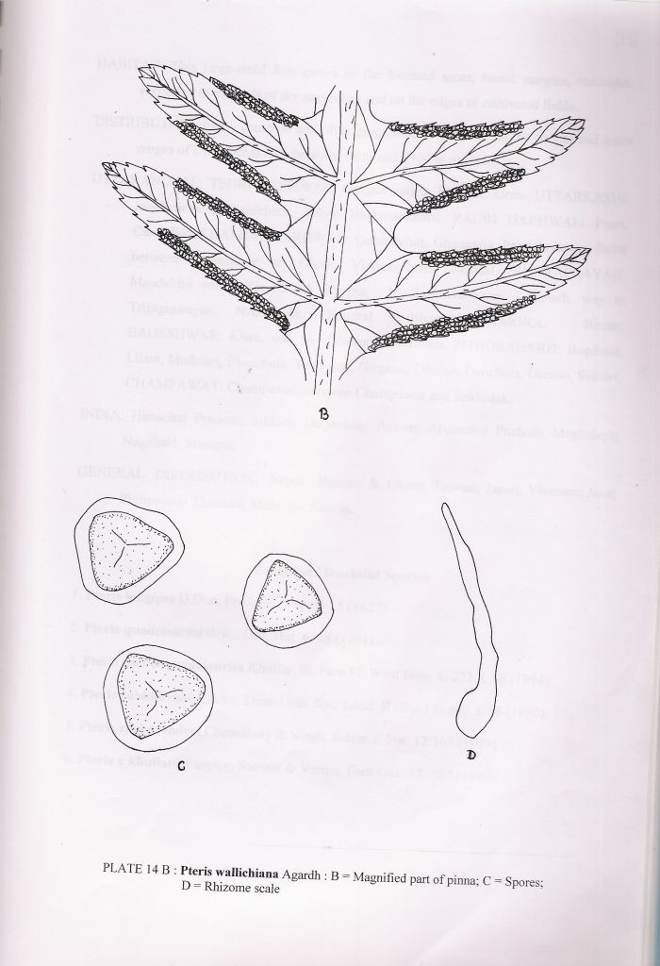

GENERAL DISTRIBUTION: Nepal; Bhutan; S. China; Taiwan; Japan; Vietnam; Java; Philippines; Thailand; Malaysia; Samoa.

Excluded / Doubtful Species
1. Pteris longipes D.Don, Prodr. Fl. Nepal.: 15 (1825)
2. Pteris quadriaurita Retz., Obs. Bot. 6: 38 (1791).
3. Pteris pseudoquadriaurita Khullar, Ill. Fern Fl. West Him. 1: 272. t. 98 (1994).
4. Pteris subindivisia Clarke, Trans Linn. Soc. Lond. II (Bot.) 1: 467. t. 56 (1880).
5. Pteris raghavendrei Chowdhury & Singh, Indian J. For. 12: 163 (1989).
6. Pteris x khullarii Pangtey, Samant & Verma, Fern Gaz. 13: 357 (1990).

Acknowledgement
The authors are thankful to Vice Chancellor, Kumaun University, Nainital for encouragement and also thankful to Head, Botany Department, D.S.B. Campus for providing facilities.

REFERENCES
Awasthi, D. K. & P. C Pande (1984). A note on the phytogeographical distribution of ferns and fern-allies of Almora (W.H.). J. Bombay nat. Hist. Soc. 8: 739-741.
Awasthi, D. K. & M. P. Sharma (1980). Ecological and phytogcographical observations on the ferns and fern-allies of Nagpur block (Chamoli Garhwal). Western Himalayas. Proc. Indian Acad. Sci. (Plant Sci.) 89: 307-313.
Beddome, R. H. (1863-1864). The Ferns of British India. Madras: Gantz Brothers (1863-1864). 1-38, t. 1-110 (1863); 3 -88. t. 111-271 (1864). 2nd edn. (1873). 1-88. t. 1-27. Reprint: Today & Tomorrow's Printers & Publishers. New Delhi (1970).
Beddome, R. H. (1865-1870). The Ferns of British India. Madras: Gantz Brothers. (1865 - 1870) 1: 1-120 (1865); 121-150 (1866); 2: 151-210 (1866); 211-255 (1867): 256-300 (1868); 301-330 (1869); 331-354 (1870); Reprint: Oxford and IBH Publication Co., New Delhi (1976).
Bir, S. S. (1962). Taxonomy of the Indian members of family Aspleniaceae. Bull. Bot. Surv India 4: 1-16.
Bir, S. S. (1964). Taxonomic notes on some Himalayan ferns. J. Indian Bot. Soc. 43: 556-572.
Chandra, P. (1979). Ferns of Kedarnath, Madhyamaheshwar and Tungnath. J. Bombay
Ching, R. C. (1940). On the natural classification of the family Polypodiaceae. Sunyatsenia. 5: 202-268.
Ching, R. C. (1978). The Chinese fern families and genera : systematic arrangement and historical origin. Acta Phytotax. Sin. 16(3): 1-19; 16(4): 16-37.
Chowdhery, H. J. & Surendra, Singh (1989). A new species of Pteris L. (Pteridaceae) : P. raghavendreii sp. nov. from India. Indian. J. For. 12: 163-164.
Chowdhury, N. P. (1973). The Pteridophytic Flora of the Upper Gangetic Plain. Navayug Traders, New Delhi.
Clarke, C. B. (1879). Ferns of north India. J. Linn. Soc. Lond. Bot. 17: 402-404.
Clarke, C. B. (1880). A. review of ferns of northern India. Trans. Linn. Soc. Lond. II. (Bot.) 1: 425-611.
Copeland, E. B. (1947). Genera Filicum. The Genera of Ferns. Chronica Botanica Co., Waltham. Mass. USA.
Dhir, K. K (1980). Ferns of North Western Himalayas. Bibliotheca Pteridologia 1: 1-158.
Dhir, K. K. & K. Rani (1978). The genus Athyrium Roth in Nainital hills. J. Bombay nat. Hist. Soc. 76: 49-58.
Dixit, R. D. (1981). The genus Vittaria Sm. in India. J. Econ. Tax. Bot. 2: 209-222.
Dixit, R. D. (1984). A Census of the Indian Pteridophytes. Botanical Survey of India, Howrah.
Dixit, R. D. & A. Das (1979). The genus Coniogramme Fee in India. Proc. Indian Acad. Sci (Plant Sci.) 88: 253-268.
Duthie, J. F. (1906). Catalogue of the Plants of Kumaon and of the Adjacent Portions of Garhwal and Tibet, based on the collections made by Strachey and Winterbottom during the years 1846 to 1849 and on the Catalogue originally prepared in 1852 by Sir Richard Strachey. Lovell Reeve & Co., Limited, London.
Fraser-Jenkins, C. R. (1978). Dryopteris stewartii a new fern from the West Himalaya Kalikasan Philip. J. Biol. 7: 269-274.
Fraser-Jenkins, C.R. (1984). An introduction to the fern genera of the Indian subcontinent Bull. Brit. Mus. Nat. Hist. (Bot. Ser.) 12: 37-76.
Fraser-Jenkins, C. R. (1986). A classification of the genus Dryopteris (Pteridophyta : Dryopteridaceae). Bull. Brit. Mus. Nat. Hist. (Bot. Ser.) 14: 183-218.
Gaur, R. D. & P. Painuli (1992). Some little known Pteridophytes from Garhwal Himalaya. J. Econ. Tax. Bot. 16: 345-347.
Gaur, R. D. & P. Painuli (1993). Some little known Pteridophytes from Garhwal Himalaya. Indian J. For. 16: 173-175.
Ghosh, S. R. & R. K. Ghosh (1986). Gymnopteris delavayi (Baker) Underw. : A new fern record for India. J. Bombay nat. Hist. Soc. 82: 243.
Goel, A. K. & U. C. Bhattacharyya (1981). Contribution to the Pteridophytic flora of Tehri district (Garhwal). Indian J. For. 4: 30-37.
Hajra, P. K. & R. D. Dixit (1984). Woodsia cycloloba Hand-Mazz. (Woodsiaceae)- A new fern from Nandadevi National Park, Chamoli district, Uttar Pradesh. Bull. Bot. Surv. India 26: 202.
Holttum, R. E. (1947). A revised classification of leptosporangiate ferns. J. Linn. Soc. (Bot.) 58: 123- 158.
Hope, C. W. (1899-1904). The ferns of North-Western India. J. Bombay nat. Hist. Soc. 12 (2): 315-325 (March 1899); 12 (3): 527-538 (July 1899); 12 (4): 621-633 (Nov.1899); 13 (1): 25-36 (April 1900); 13 (2): 236-251 (July 1900); 13 (3): 443-461 (Jan. 1901); 13 (4): 657-671 (May 1901); 14 (1): 118-127 (Jan. 1902); 14 (2): 252-266 (May 1902); 14 (3): 458-480 (Oct. 1902); 14 (4): 720-749 (Feb. 1903); 15 (1): 67-111 (June 1903); 15 (3): 415-429 (Feb.1904).
Kaur, S. & N. Punetha (1984). Arthromeris lungtauensis Ching: A new record for Western Himalaya (India). J. Bombay nat. Hist. Soc. 81: 737-738.
Kaur, S. & N. Punetha (1984). A new variety of Dicranopteris linearis (Burm. f.) Underw. from India. J. Indian Bot. Soc. 63: 34 -36.
Kaur, S. & N. Punetha (1985). Some new records of ferns from Kumaun Himalaya. New Botanist 12: 166-168.
Kaur, S. & S. Chandra (1985). Indian Thelypteroid ferns-their nomenclature, distribution and phytogeography. New Botanist. 12: 83-116.
Kholia, B. S. & N. Punetha (1993). An enumeration of Athyrium Roth species of the Pithoragarh district (West Himalayas). Highter Plants of Indian Subcontinent 4: 243251.
Kholia, B. S. & N. Punetha (1995). Notes on taxonomy and distribution of some pteridophytes in Kumaun (West Himalaya). J. Indian Bot. Soc. 74: 183-187.
Khullar, S. P. (1976). Some lesser known ferns from the W. Himalayas-I. Cheilanthes anceps var. brevifrons. Amer. Fern J. 66: 21-24.
Khullar, S. P. (1984). The ferns of Western Himalaya- A few additions, corrections and annotations. Indian Fern J. 1: 89-95.
Khullar, S. P. (1988). The ferns of West Himalaya: An enumeration as in The Illustrated Fern Flora of West Himalaya. Him. Res. & Dev. 7: 59-67.
Khullar, S. P. (1994). An Illustrated Fern Flora of West Himalaya. Vol. I. (Botrychiaceae to Aspleniaceae). International Book Distributors, Dehra Dun.
Khullar, S. P. (2000). An Illustrated Fern Flora of West Himalaya. Vol. II (Onocleaceae to Salviniaceae). International Book Distributors, Dehra Dun.
Khullar, S.P. (2001). Diversity of the fern wealth of the West Himalaya. In: Plant Diversity of the Himalaya. eds. P. C. Pande & S. S. Samant, Gyanodaya Prakashan. Nainital. 153-176.
Khullar, S. P. & S. C. Gupta (1979). On the occurrence of Polystichum aculeatum in the Himalaya. Recent Researches in Plant Sciences 1: 66-70.
Khullar, S. P. & S. C. Gupta (1980). Systematics of the genus Polystichum from the Himalayas. Nova Hedwigia 32: 415-444.
Kumar, S. & M. B. Raizada (1989). Survey and distribution of fern-allies and ferns of Chakrata Forest Division. Uttar Pradesh. Indian For. 115: 578-589.
Loyal, D. S. & S. C. Verma (1960). Ferns of Nainital. J. Bombay nat. Hist. Soc. 57: 479-490.
Marten. J. (1909). List of ferns in and around Mussoorie. J. Bombay nat. Hist. Soc. 19: 179-183.
Mehra, P. N. (1939). Ferns of Mussoorie. Punjab University Publication, Lahore.
Murti, S. K., D. K. Singh & S. Singh (2000). Plant diversity in Lower Gori valley Pithoragarh U.P. (Hydro-Electric Project Area). Higher Pl. Indian Subcont. 10:1-284.
Naithani. B. D. (1969). Plant collection with Kedarnath Parbat Expedition, 1967. Bull. Bot. Surv. India 11: 224-233.
Naithani, B. D. (1979). An interesting tree fern Cyathea spinulosa Wall. ex Hook. - A new record from Garhwal Himalaya. Bull. Bot. Surv. India 21: 186.
Nayar, B. K. & Others (1961-1964). Ferns of India I-XV. Bull. Nat. Bot. Gard. Nos. 52, 56, 58, 64, 67, 68, 75, 79, 81, 82, 88, 94, 100, 106, 117. Lucknow.
Nayar, B. K. & S. Kaur (1974). Companion to R. H. Beddome's Handbook to the Ferns of British India, Ceylon and Malay Peninsula. Chronica Botanica, New Delhi.
Pande, P. C. (1973). Pteridophytic flora of Ranikhet. Indian For. 99: 49-53.
Pande, P. C. (1985). Peranema cyatheoides D. Don from Kumaun Himalaya. J. Indian Bot. Soc. 64: 227.
Pande, P. C. (1989). Contribution to the fcrn flora of Almora district. Geobios new Reports 8: 103-110.
Pande, P. C. (1990). A census of Kumaun ferns (North - Western Himalaya). Indian Fern J. 7: 140-195.
Pande, P. C. & S. S. Bir (1985). Occurrence of Onychium fragile Verma & Khullar from Kumaun Himalaya. J. Bombay nat. Hist. Soc. 82: 441.
Pande, P. C. & P. S. Basera (1988). Pteridophytic flora of Berinag hills (Western Himalaya). Indian Fern J. 5: 150-161.
Pangtey, Y. P. S. (2001). Further additions to the fern flora of Nainital-II. Indian. J. Forestry 25: 106-107.
Pangtey, Y. P. S. & S. S. Samant (1987 c). Additions to the Pteridophytic flora of Nainital. J. Bombay nat. Hist. Soc. 83: 683-684.
Pangtey, Y. P. S. & S. S. Samant (1987 d). Additions to the Pteridophytic flora of Nainital-II. J. Econ. Tax. Bot. 11: 5-6.
Pangtey, Y. P. S. & S. S. Samant (1987 e). Additions to the Pteridophytic flora of Kumaun and Nainital (Western Himalaya). J. Bombay nat. Hist. Soc. 84: 486-487.
Panigrahi, G. & S. K. Basu (1980). Three species of Dryopteris Adans. (Aspidiaceae) reinterpreted. Indian. J. Forestry 3 : 266-271.
Panigrahi, G. & R. D. Dixit (1969). Studies in Indian Pteridophytes-II. The family Osmundaceae in India. J. Indian Bot. Soc. 48: 90-101.
Panigrahi, G. & R. D. Dixit (1969). Studies in Indian Pteridophytes-IV. The family Ophioglossaceae in India. Proc. nat. Inst. Sci. India 35 B: 230-266.
Pant, P. C. (1986). Flora of Corbett National Park. Botanical Survey of India, Howrah.
Pichi Sermolli, R. E. G. (1977). Tentamen Pteridophytorum genera in taxonomicum ordinem redigendi. Webbia 31: 313-512.
Price, M. G. (1990). Four new Asian Loxogramme. Amer. Fern J. 80: 4-8.
Punetha, N. (1985). Taxonomic observations on some species of Athyrioid ferns from Pithoragarh district of Kumaun Himalaya (western Himalaya). Indian Fern J. 2: 22-31.
Punetha, N. (1985). Taxonomic observations on some species of Pteris from Pithoragarh district of Kumaun (Western Himalaya). Indian Fern J. 2: 65-72.
Rao, T. A. (1959). Report on a botanical tour to Milam glacier. Bull. Bot. Surv. India 1: 97-120.
Rau, M. A. (1961). Flowering plants and ferns of north Garhwal, Uttar Pradesh. India (an account based on collections made during 195 -1959). Bull. Bot. Surv. India 3: 15-25.
Rawat, G. S. & B. S. Aswal (1984). On the occurrence of tree fern Cyathea spinulosa Wall. ex Hook. (Cyatheaceae) in Kumaun Himalaya. Him. Res. & Dev. 3: 44.
Samant, S. S. & Y. P. S. Pangtey (1990). New records of some ferns for Kumaun Himalaya (Western Himalaya). J. Bombay nat. Hist. Soc. 87: 173-174.
Samant, S. S. & Y. P. S. Pangtey (1990). Rediscovery of some ferns of Kumaun Himalaya (Western Himalaya). J. Bombay nat. Hist. Soc. 87: 333-334.
Satija, C. K. & S. S. Bir (1985). Polypodiaceous ferns of India. In: Aspects of Plant Sciences 8: 1-131.
Satija, C. K., S. S. Bir & D. K. Bhardwaj (1983). Taxonomic revision of the Polypodiaceous genera of India – 7. Pyrrosia Mirbel. Bull. Bot. Surv. India 25: 62-89.
Singh, Surendra (1989). Pteris multifida Poir. – A new record for India. Indian J. For. 12: 82.
Singh, S., U. Choudhery & R. R. Rao (1986). Ferns and fern – allies of Chamoli district. Indian J. Forestry 9: 1-15; 161-167.
Stewart, R. R. (1942). The ferns of Mussoorie and Dehra Dun. 150th Ann. Vol. Royal Bot. Garden, Calcutta 2: 159-172.
Tewari, L. M., R. S. Rawal & Y. P. S. Pangtey (1992). Ecology of Drynaria mollis Bedd. (Drynariaceae) in Kumaun (Western Himalaya). Geobios new Reports 11: 180-183.
Verma, S. C. & S. P. Khullar (1965). A new western Himalayan species of Onychium from O. contiguum complex : O. fragile. Nova Hedwigia 9: 83-88.
4/10/2009

