In vitro Rapid clonal propagation of Phyllanthus urinaria Linn. (Euphorbiaceae) – A Medicinal Plant

Kalidass C*, and Mohan V.R
Ethnopharmacology unit,
Research Department of Botany,
V.O.Chidambaram College, Tutuicorin-8.
*Corresponding author e-mail: vrmohan_2005@yahoo.com

Abstract: An efficient micropropagation protocol was developed for the medicinal plant Phyllanthus urinaria Linn. (Euphorbiaceae) using nodal segments for axillary shoot proliferation. Maximum multiplication rates was achieved on Ms Media supplemented with 1.0 µM BA. Rooting was achieved with 100% of the micro shoots in MS medium with 2.0 µM IBA. Regenerated plants were successfully acclimatized and about 80 – 90 % of plantlets survived under ex vitro conditions. [Researcher. 2009;1(4):56-61]. (ISSN: 1553-9865).

Key words: Phyllanthus urinaria Linn., Euphorbiaceae, Clonal propagation, acclimatization.

Introduction
The genus Phyllanthus Linn. (Euphorbiaceae) has between 550 to 750 species and several of them produce useful secondary metabolites which have been extracted from whole plants (Unander 1996). The stems, infusion of leaves and roots of Phyllanthus spp are used in folk medicine for treating intestinal infections, diabetes, the hepatitis B virus and disturbances of the kidney and urinary bladder (Calixto et al., 1998). Several compounds such as alkaloids, tannins, flavonoids, lignans, phenols and terpenes have been isolated and identified in various species of Phyllanthus and have shown antinociceptive action in mice and other therapeutic activities (Cechinel Filho et al., 1996). Antiviral effects against hepatitis B virus and possibly against the reverse transcriptase of retroviruses have also been reported (Venkateswaran et al., 1987, Thyagarajan et al., 1988, Shead et al., 1992). Pharmacological studies carried out with callus extracts of P. niruri, P. tenellus and P. urinaria have shown antinociceptive properties and the main compounds identified in the extracts were flavonoids, tannins and phenols (Santos et al., 1994). Additional studies on callus and root extracts of these different species have shown the presence of phyllemblin, a tannin which has antimicrobial activity, of possible hydrolyzable tannins which inhibited DNA polymerase and reverse transcriptase, of geraniin and its derivatives which showed high activity in the inhibitions of HIV reverse transcriptase and angiotensin-converting enzyme involved in diabetic complications (Ueno et al., 1988, Ogata et al., 1992, Unander 1996).
The gallotannin corilagin, the haemostatic ellagic acid, as well as seven ellagitannins, which have been shown to be active against Epstein–Barr virus DNA polymerase at the micro-molar level (Liu et al., 1999), have been isolated from Phyllanthus urinaria Linn. Two new phenolic compounds, namely methyl brevifolin carboxylate and trimethyl ester dihydrochebulic acid, have also been isolated from the same source (Yao and Zuo, 1993). Corilagin has been reported to show bioactivity in various different therapeutic areas such as cardiovascular disease anti-hypertensive (Lin et al., 1993; Cheng et al., 1995) and infectious disease antiviral (Yoon et al., 2000). Therefore, the aim of the current work was to establish consistent micropropagation, for P. urinaria Linn. for large scale multiplication of selected genotypes and to explore their potential for secondary metabolite studies.

Materials and Methods
Tender twigs were collected from field grown mature plants of P. urinaria L. defoliated and sectioned into 2 - 3 nodal segments. They were washed under continuous flashing of running tap water for 30 min and then treated with a solution of the Savlon (5% v/v) for 10 min and finally surface sterilized with HgCl₂ (0.1% w/v) for 5-10 min. Lastly, the material was washed 3 -5 times with autoclaved distilled water to remove any trace of HgCl₂.
The shoot tip and nodal segments were excised from the disinfected material and divided into 1.0 - 1.5 cm pieces with at least one node in each explants. The basal medium used for all the experiments was MS (Murashige and Skoog 1962) formulation containing 3% sucrose, 6 - 8 % agar and supplemented with BA and KN, either individually or in different combinations with auxins, IBA, NAA and IAA. The media were adjusted to pH 5.7 ± 0.2 and autoclaved at 1.1 kg/cm² for 20 min at 121°C.
Cultures were incubated at 25 ± 1°C with a photoperiod of 16 h at 2000 - 3000 lux of cool white fluorescent light. Cultures were initiated in 150 - 25 mm glass tube and subcultured regularly on fresh medium at four-week intervals in 100 ml flasks. The shoots that proliferated from primary explants were isolated and subcultured on fresh medium several times for bulking up shoot culture material. Shoots (3 - 4 cm) were excised from proliferating cultures and implanted on half strength MS supplemented with either of IBA, NAA and IAA (0.1 - 1.0 µM) for rooting. Rooted shoots were transferred to pots under ex vitro condition after proper hardening.

Results and Discussion
Axillary shoot induction, multiplication and rooting, the effects of cytokinins and auxins on morphogenesis of nodal segment explants are presented in Tables 1, and 2. The effects of cytokinins and auxins at various concentrations on axillary shoot induction from nodal explants are presented in Tables 1. Cytokinins did not promote intensive shoot multiplication and either had no effect or inhibited significantly the number of nodes, shoot length and culture fresh mass in comparison to the controls (Table 1). The proliferation efficiency of nodal explants from mature plants was significantly higher than that of shoot tip explants when evaluated twenty days after proliferation. As a supplement, 1.0 µM BA showed the best performance of proliferation that produced shoots in 100% of cultured explants. Explants produced the highest number of 2.85 ± 0.10 shoots per culture on the medium with 5.97 ± 0.13 cm average length of shoots per culture (Figs. B - D). When the explants were cultured on KN based medium, only 47 - 73% of them proliferated. In this treatment, the highest number of shoots per explants and average shoot lengths were 5.23 ± 0.24 and 4.60 ± 0.35 cm for nodal explants, respectively.
These are the first attempts to establish shoot cultures of this species and the results obtained show that the unusual promotive effects of IBA on shoot culture growth was not only due to the increase in axillary shoot proliferation but also in the number of axillary buds formed in the shoots which can be used as starting plant material for further multiplication. Similar results were obtained for Leptadenia reticulata shoot cultures, where IBA, NAA and IAA stimulated significantly the number of nodes per plantlet in comparison to cytokinins (Kalidass et al., 2008).However, for other Phyllanthus species, such as P. tenellus, P. niruri, P. caroliniensis, and P. fraternus (Catapan 1999, Saradhi and Islamia 1997) and for other Euphorbiaceae species, such as Excoecaria agallocha L. (Rao et al., 1998) cytokinins stimulated shoot proliferation.
Root formation was induced in in vitro regenerated shoots by culturing them on half strength of MS with 0.1 - 4.0 µM either of IBA, NAA, and IAA. Among the three types of auxin, IBA was found to be most effective at different concentrations tested for root production on cut margins of the shoot (Table 2). Among different concentrations, 2.0 µM IBA was found to be the best for proper rooting in which 100% shoots rooted within three weeks of culture (Fig. D). These findings are in agreement with those observed in other plant species Phyla nodfolia, Leptadenia reticulata (Bhatt et al., 2006) and Lins culinaris Medik (Omran et al., 2008). The in vitro derived plants acclimated better under ex vitro condition when they were transferred on specially made plastic trays containing coco-peat as potting mix and moistened uniformly at periodic intervals taking special care not to damage the roots. The rest of the procedure, followed from this stage up to their establishment in soil was as usual.
About 80 - 90% of the regenerated plantlets could tolerate and survive under ex vitro environment or field conditions. A number of plantlets were lost due to damping off and necrosis during acclimatization in ex vitro condition. Loss of regenerants due to such symptoms was also observed in Eucalyptus tereticornis (Gill et al., 1993), Solanum nigrum (Ara et al., 1993), Rauvolfia serpentina (Ilahi 1993) and Rosa damascena (Kumar et al., 1995). Through this study a protocol for regeneration of complete plantlets has been established. This is perhaps the first report on in vitro plant regeneration of Phyllanthus urinaria Linn. The results may be of some importance as a pioneering study on tissue culture of this medicinal plant.

Table 1. Effect of growth regulators on shoot proliferation and number of shoots per culture from nodal explants. Data (Mean ± S.D.) were recorded after four weeks.

Growth regulators (µM) | % of shoot formation | No. of node per shoots/culture | No. of usable shoots/culture | Av. Length of shoots/culture
BA 0.0 | 80 | 0.84 ± 0.13 | 1.10 ± 0.21 | 1. 79 ± 0.17
0.1 | 80 | 1.38 ± 0.08 | 2.41 ± 0.13 | 3. 24 ± 0.17
0.2 | 75 | 1.30 ± 0.37 | 1.73 ± 0.36 | 4.29 ± 0.08
0.5 | 82 | 2.47 ± 0.18 | 2.85 ± 0.06 | 4.90 ± 0.04
1.0 | 100 | 2.85 ± 0.10 | 3.38 ± 0.50 | 5.97 ± 0.13
2.0 | 76 | 2.37 ± 0.21 | 1.96 ± 0.11 | 3.70 ± 0.12
3.0 | 64 | 1.28 ± 0.05 | 1.76 ± 0.12 | 2.32 ± 0.21
5.0 | - | - | - | -
Kn 0.1 | 65 | 0.89 ± 0.12 | 1.25 ± 0.13 | 2.70 ± 0.18
0.2 | 47 | 1.10 ± 0.35 | 1.00 ± 0.18 | 4.26 ± 0.25
0.5 | 55 | 1.80 ± 0.42 | 1.62 ± 0.15 | 4.60 ± 0.35
1.0 | 73 | 2.12 ± 0.16 | 1.95 ± 0.14 | 5.23 ± 0.24
2.0 | 54 | 1.58 ± 0.13 | 1.96 ± 0.15 | 3.50 ± 0.12
3.0 | 48 | 0.90 ± 0.15 | 1.76 ± 0.31 | 2.10 ± 0.42
5.0 | - | - | - | -

Table 2. Effect of different concentration and combination of auxins on adventitious root formation from the in vitro grown micro-cutting cultured on ½ MS medium. Data (Mean ± S.D.) were recorded after four weeks.

Growth regulators (types auxin) (µM) | % of micro cutting rooted | No. of root/micro cutting | Av. Length of root/micro cutting
IBA 1.0 | 78 | 1.56 ± 0.09 | 1.49 ± 0.13
2.0 | 100 | 2.30 ± 0.16 | 1.34 ± 0.04
3.0 | 65 | 3.36 ± 0.21 | 1.97 ± 0.01
4.0 | - | - | -
IBA 1.0 + NAA 0.1 | 70 | 2.63 ± 0.24 | 1.79 ± 0.17
IBA 2.0 + NAA 1.0 | 65 | 1.67 ± 0.16 | 0.96 ± 0.04
IBA 3.0 + NAA 2.0 | 55 | 1.48 ± 0.04 | 1.98 ± 0.07
IBA 4.0 + NAA 3.0 | - | - | -
IBA 1.0 + IAA 0.5 | 55 | 2.30 ± 0.16 | 1.59 ± 0.12
IBA 1.0 + IAA 1.0 | 65 | 1.88 ± 0.09 | 1.81 ± 0.15

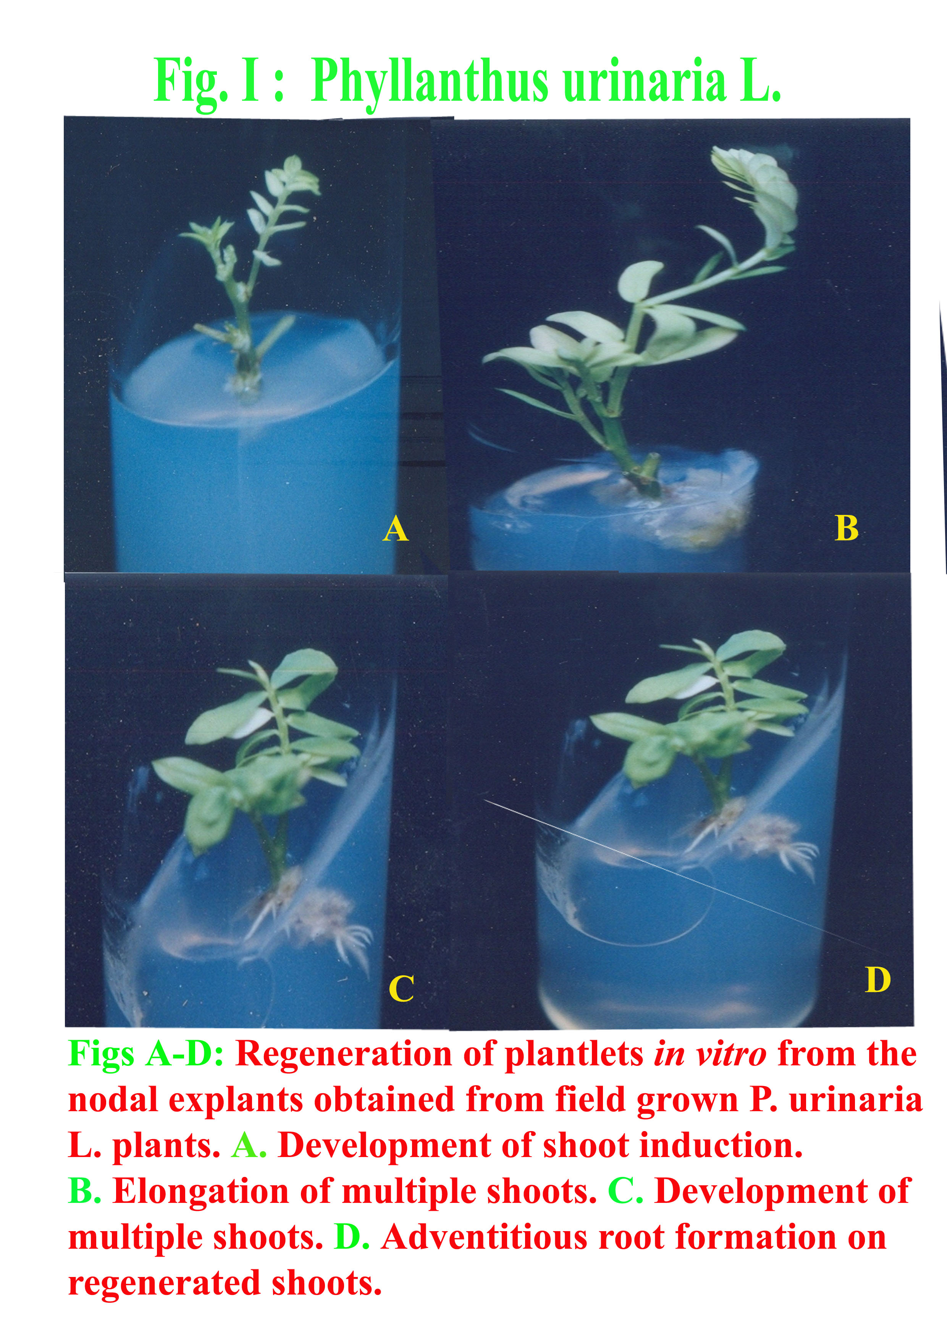

References
Ara, M. Jahan, A. and Hadiuzzaman, S. 1993 In vitro plant regeneration from leaf explant of Solanum sisymbrifolium Lamk in Bangladesh. Intl. Plant Tissue Cult. Conf. (Dhaka, 19 - 21 Dec.) p. 47.
Bhatt, T., Jain, V., Jeyathirtha, M.G, Banerjee, G. and Mishra, S.H. 2006. In vitro regeneration of roots of Phyla nodfolia and Leptadenia reticulata and comparison of roots from cultured and mature plants secondary metabolites. Indian J. EExp. Biol. 40: 1382 – 1386.
Calixto, J.B., Santos, A.R.S., Cechinel Filho, V. and Yunes, R.A. 1998. A review of the plants of the genus Phyllanthus: Their chemistry, pharmacology and therapeutic potential. Medical Research Review 4:225-258.
Catapan, E. 1999. Cultivo in vitro e analises fitoquimicas de especies de Phyllanthus. Tese de Mestrado, Universidade Federal de Santa Catarina, Florianopolis.
Cechinel Filho, V., Santos, A.R.S., Campos, R.O.P., Miguel, O.G., Yunes, R.A., Ferrari, F. , Messana, J. and Calixto, J.B. 1996. Chemical and pharmacological studies of Phyllanthus caroliniensis in mice. Journal of Pharmaceutical Pharmacology 48:1231-1236.
Cheng, J.T, Lin, T.C and Hsu, F.L. 1995. Anti-hypertensive effect of corilagin in rat. J. Physiol. Pharmac. 73: 1425 – 1429.
Gill, R.I.S, Gill S.S. and GOSAL, S.S. 1993. Vagetative propagation of Eucalyptus tereticornis Sm. through tissue culture. Intl. Plant Tissue Cult. Conf. (Dhaka, 19-21 Dec.), p. 44.
Ilahi, I 1993. Micropropagation and biosynthesis of alkaloid by Rauvolfia serpentina cell culture. Intl. Plant Tissue Cult. Conf. (Dhaka, 19-21 Dec.) p. 21.
Kalidass, C., Manickam, V.S., and Glory, M. 2008. In vitro studies on Leptadenia reticulata (Retz.) Wt. & Arn. (Asclepiadaceae). Indian Jor. of Multidis. Res. Vol. 4 (2): 221 -225.
Kumar, S. Choudhary, M.L. and Raghava, S.P.S. 1995. In vitro manipulation of Rosa damascena Mill for oil contents. 2nd Intl. Plant Tissue Cult. Conf. (Dhaka, 10-12 Dec.), p. 47.
Lin, T.C, Hsu, F.L and Cheng, J.T. 1993. Anti-hypertensive activity of corilagin and chebulinic acid, tannins from Lumnitzera racemosa . J. Nat. Prod. 56: 629 – 632.
Liu, K.C, Lin, M.T, Lee, S.S, Chiou, J.F, Ren, S, and Lien, E.J. 1999. Antiviral tannins from two Phyllanthus species. Planta Med. 65: 43 – 46.
Murashige, T. & Skoog, F. 1962. A revised medium for rapid growth and bioassays with tobacco tissue cultures. Physiologia Plantarum 15:473-497.
Ogata, T., Higuchi,H., Mochida, S., Matsumoto,H., Kato, A., Endo, T., Kaji, A. and Kaji, H. 1992. HIV-1 reverse transcriptase inhibitor from Phyllanthus niruri. AIDS Research Human Retroviruses 8:1937-1944.
Omran V.G., Bagheri A. and Moshtaghi N. 2008. Direct in vitro regeneration of Lentil (Lens culinaris Medik.), Pakistan Journal of Biological Science, 11 (18): 2237 – 2242.
Rao, C.S., Eganathan, P., Anand, A., Balacrishna, P. and Reddy, T.P. 1998. Protocol for in vitro propagation of Excoecaria agallocha L., a medicinally important mangrove species. Plant Cell Reports 17:861-865.
Santos, A.R.S., Cechinel Filho, V., Viana, A.M., Moreno, F.N., Campos, M.M., Yunes, R.A. and Calixto, J.B. 1994. Analgesic effects of callus culture extracts from selected species of Phyllanthus in mice. Journal of Pharmaceutical Pharmacology 46:755-759.
Saradhi, P.P. and Islamia, J. M. 1997. Phyllanthus fraternus - A plant with anti-hepatitis viral activity. Industrial Crop and Products 6:35-40.
Shead, A., Vickery, K., Pajkos, A., Medhurst, R., Freiman, J., Dixon, R. and Cossart, Y. 1992. Effects of Phyllanthus plant extracts on duck hepatitis B virus in vitro and in vivo. Antiviral Research 18:127-138.
Thyagarajan, S.P., Subramanian, S., Thirunalasudary, T., Venkastewaran, P.S. and Blumberg, B.S. 1988. Preliminary study: the effect of Phyllanthus amarus on chronic carriers of hepatitis B virus. Lancet 2:764-766.
Ueno, H., Horie, S., Nishi, Y., Shogawa, H., Kawasakim, M., Suzuki, S., Hayashi, T., Arisawa, M., Shimizu, M., Yoshizakim, M., Morita, N., Berganza, L.H., Ferro, E. and Basualdo, I. 1988. Chemical and pharmaceutical studies on medicinal plants in Paraguay. Geraniin, an angiotensin-converting enzyme inhibitor from “papaparaimi”, Phyllanthus niruri. Journal of Natural Products 51:357-359.
Unander, D.W. 1996. Phyllanthus species: in vitro culture and production of secondary metabolites. In Biotechnology in agriculture and forestry (Y.P.S. Bajaj, ed.), v.37 Springer-Verlag, Berlin, p.304-318.
Venkateswaran, P.S., Unander, D.W., Blumberg, B.S., Halbherr, T., Sharager, D., Dahl, L., Kraus, M., Rissinger, C. and Simmons, H.H. 1987. Potential antiviral agents for the treatment of hepatitis B virus and retroviruses. Scientia Reports 300-301.
Yao Q.Q and Zuo C.X. 1993. Chemical studies on the constituents of Phyllanthus urinaria. Acta Pharm. Sin. 28: 829 – 835.
Yoon S, Chung T.H and Chung C.C. 2000. Pharmaceutical composition for the treatment of Hepatitis B comprising corilagin or brevifolin. Patent WO0027413.

4/21/2009

