Effect of Azotobacter and Nitrogen on Seed Germination and
Early Seedling Growth in Tomato

P. Mahato, Anoop Badoni* and J. S. Chauhan

Seed Testing Laboratory
Department of Seed Science and Technology
H. N. B. Garhwal University, Srinagar- 246 174, Uttarakhand, India
*For correspondence: annabadoni@yahoo.co.in

Abstract:

The present study was carried out to evaluate the response of bio-fertilizer and inorganic fertilizer on germination and growth of tomato plant. Nitrogen (N) was used as inorganic fertilizer and Azotobacter was used as bio-fertilizer. Three treatments were used for investigation i.e. Control (T1- only soil), Soil + N (T2) and Soil + Azotobacter (T3). The germination was observed higher in T 3 treatment in contrast to other treatments. Generally plant height increased with the advancement of growth stages. The shoot length (35.5 ±0.8), number of leaves (5.6 ±0.6), length (7.8 ±0.8) and width (7.5 ±0.8) of leaves was reported higher in T 3 treatment followed by T 1 and T 2. The root length was measured after 30 days of sowing. T2 treatment showed higher root length (8.5 ±0.8) in comparison to all other treatments. The conclusion of the present study is that Azotobactor as bio-fertilizer reported better then inorganic fertilizer in relation to seed germination and all plant growth parameters described. [Researcher. 2009;1(4):62-66]. (ISSN: 1553-9865).

Introduction:

Tomato (Lycopersicon esculentum Mill.) is one of the most popular and widely grown vegetable crop in the world, covering an area of 2.85 million hectares with corresponding production of 77.24 million tones, whereas in India it covers an area of 0.31 million hectares with production of 4.6 million tones (FAO, 1995). Tomato is being cultivated as an important summer season vegetable crop in low and mid hills of Uttarakhand. The crop is quite remunerative and the farmers are getting rich dividends by its cultivation. The fruits are rich source of vitamin A, B and C and minerals like calcium, iron, and phosphorus besides they have been reported quite useful in controlling liver problems, indigestion, arthritis and urinary troubles (Chouhan, 1983).
In the management of tomato crop the application of fertilizers have a major role for germination and growth. Although these fertilizers contribute a lot in fulfilling the nutrient requirement of vegetable crops but there regular, excessive and unbalanced use may lead to health and ecological hazards, depletion of physiochemical properties of the soil and ultimately poor crop yields. The problems of nutrient drain from the soil are becoming so acute that it is beyond the capacity of any single fertilizer to accept the challenge of appropriate nutrient supply. Hence there is a need to think of alternate sources of safe fertilized which may enhance crop yields without having adverse effects on soil properties, the use of bio-fertilizers seen to be a hope in this direction.
Bio-fertilizers are the carrier-based preparations containing mainly effective strains of microorganisms in sufficient number, which are useful for nitrogen fixation. If they are used in association with macronutrients the expected yields per unit area may be much higher. Amongst these nutrients, nitrogen is the only nutrient, which play major role in synthesis of chlorophyll, amino acids and protein building blocks, which is ultimately responsible for higher source to sink ratio. Amongst bio-fertilizers azotobacter strains play a key role in harnessing the atmospheric nitrogen through its fixation in the roots. They have been also reported to improve fertility condition of the soil. Therefore, the present investigation was based on the objective, to find out the effect of azotobacter and nitrogen on germination and growth of tomato.

Material and Methods:

Present study was done using following material and method:

Treatments:

T-1: Control (only soil),
T-2: Soils + Urea (Inorganic fertilizer)
T-3: Soils + Azotobacter (Bio-fertilizer; Population density >2 X 10⁹ (c.f.u./gram),
Microbial adjuvant 2%, Microbial media residue inert
ingredient 95-97%)

Total number of germinated seeds were counted in all the treatments, at the interval period of five days after sowing and recorded as emergence count / poly bag. For growth study, height of ten randomly selected plants from each treatment was measured with a meter scale from the ground level to the tip of the spike, (shoot length) and mean height was calculated from each treatment. The total number of leaves from ten randomly selected plants from each treatment was counted after twenty days of germination. Length and width of leaves of ten randomly selected plants from each treatment were measured with a meter scale from the end of petiole to the apex of the leaf. Width of the leaves was measured by measuring leaf margins. Root lengths of selected plants from each treatment were measured with a meter scale.

Result:

Germination Counts: The germination percentage was influenced by different treatments (Table-1; Plate-1). Result showed that the maximum number of seedling emergence was reported in T3 treatment (90%), which contains bio-fertilizer (Azotobacter), in contrast to followed by T2 (80%) and T1 (60%).

Growth Study:

The shoot length (35.5 ±0.8), number of leaves (5.6 ±0.6), length (7.8 ±0.8) and width (7.5 ±0.8) of leaves was reported higher in T 3 treatment followed by T 1 and T 2. The root length was measured after 30 days of sowing. T2 treatment showed higher root length (8.5 ±0.8) in comparison to all other treatments (Table-1; Plate-2).

Discussion:

The experiment on the plant tomato (Lycopersicum esculentum Mill) is done in natural environmental condition to evaluate the advantage of bio-fertilizer upon the inorganic fertilizer. After getting the results of the experiments it is clear that the bio-fertilizer shows better results then the inorganic fertilizer. Since Green Revolution the inorganic fertilizers are used in large amount to increase the yield of the crops. In all the agriculture sectors of India the use of these fertilizers by farmers is increasing day by day to increase the yield and economy. Using inorganic fertilizers farmers can increase the yield of crops but the soil pollution is also increased with this day by day. The use of inorganic fertilizers is increased 6-8 times from the time of green revolution. These fertilizers not only affect the soil but also influence the characteristics and the product of the crop. Fertility of the soil increases due to the continuous use of the fertilizers but it also reduces the crop productivity. The main reason of reduction in crop productivity is due to soil pollution. Soil pollution is caused due to the use of inorganic fertilizers, pesticides, and other chemicals etc (Badoni, 2006).
Azotobacter has long been used in Russia to inoculate seeds or roots of crop plants and increase in yields have been reported from this practice (Mishustin and Naumova, 1962). Jackson et al. (1964) found accelerated growth of tomato stem with inoculation of Azotobacters. Mishutin (1966) demonstrated that bacterial fertilizers slightly improved yield of a wide range of crop plants, especially vegetable. The yield increases have been reported up to 28.56, 18.25, 19.33 and 55 per cent in case of tomato, potato, cabbage and cucumber respectively. Mehrotra and Lehri (1971) while working at kanpur observed that successful proliferation of Azotobacter can be achieved in association with synthetic fertilizers and yield increases up to 50 per cent in cabbage and 62 per cent in brinjal were obtained by the application of Azotobacter, however they observed that these increases extremely depend upon the fertility status of the soil and the type of strain used. Vanisht et al. (1979) from their experiment conducted t higher germination (69-70%) compared with 43 per cent in the control. El-Shanshoury et al. (1989) conducted experiment in Egypt on tomato in a sandy soil having low content of available nitrogen and phosphorus. The soil was inoculated with Azotobacter which resulted in better plants growth and higher nitrogen content in shoots as compared to uninoculated soil. Pandey and kumar (1989) concluded from their experiments at New Delhi that inoculation of Azotobacter to without application of nitrogen, phosphorus and potassium had increased the yield per unit area. Martinez et al. (1993) in this study carried out at La-Habana, Cuba, reported that soil inoculation with Azotobacter increased tomato seed germination by 33-46 per cent, shortened the period between sowing and transplanting by 5-7 days, increased the yield by 38-60 per cent.
Kuksal et al. (1977) from their studies on tomato in UP Hills concluded that plants height, fruit and sees yield increased with increasing levels of nitrogen from 60 to 120 kg N ha ⁻¹ . Similarly, Randhawa et al. (1977) from Ludhiana reported that maximum plant height of tomato was obtained optimum seed quality from tomato plants which received N @ 120 kg ha⁻¹ in Russia. On the other hand, Rastogi et al. (1978) reported from Solan that 60kg N ha⁻¹ gave the highest yield of tomato var. Solan Gola. Seth and Choudhry (1978) observed that 90 kg N ha⁻¹ gave the highest fruit and seed yield. In trails at Moldavian, Russia, Nesterova and Butkevich (1980) obtained highest tomato seed yields when N was applied @ 120 kgha⁻¹. Kooner and Randhawa (1983) reported from Ludhianaa that tomato plant growth. Fruit and seed yield increased with rising nitrogen rates and the maximum values were obtained at 200 kg N ha⁻¹. Vadivelu (1983) reported from coimbtore that highest seed yields in tomato were obtained with the application of nitrogen @ 100 kg ha⁻¹. Olasantan (1991) reported from Ila-Orangun, Nigeria that tomato fruit yield increased with every ascending level of nitrogen and the highest value was obtained at 60 kg N ha⁻¹. Eryuce et al. (1992) reported from their experiment conducted at Lisbon, Portugal that 1000 seed weight of field grown tomato cv. Rio Grande increased at highest nitrogen level, where as seed germination and seed vigour reduced at this level. Singh and singh (1992) from their studies carried out at Faizabad, concluded that plant height and number of branches per plant increased significantly and maximum values were obtained at 125 kg N ha⁻¹ in tomato cv. Pusa Ruby. They also reported tht fruits per plant and marketable fruit yield (q ha⁻¹) increased in linear fashion with increasing nitrogen levels. Arora et al. (1995) reported from Hisar that nitrogen application @ 120 kg N ha⁻¹ increased seed content of fruits and seed yield per plant and per hectare in tomato cv. Hisar Arun.
In the present study application of bio-fertilizer resulted increase of shoot length and more number of leaves per plant. Similar observations were observed by Martinez et al (1993) in case of tomato. Bio-fertilizer application significantly increased the nitrogen uptake in tomato at growth stage. This may be because of better nitrogen fixation as result of accelerated bacterial activity and better root system which might have resulted in more nitrogen accumulation in tomato shoots. Mohandas (1987) and EL-Shanshoury et al. (1989) while working with Azotobacter in tomato have also obtained similar results. From the results of the experiment it is clear that bio-fertilizer shows better results as compare to that of the inorganic fertilizers. The main advantage of bio-fertilizer is that it does not pollute the soil and also does not show any negative effect to environment and human health.

Table-1 Germination and Growth observation in Tomato plant using inorganic
and organic fertilizers:

Treatment Germination% Shoot height No. of leaves Length of Width of Root length

per plant leaves leaves

T1 60 20.4 ±0.5 3.4 ±0.7 4.0 ±0.7 4.2 ±0.5 7.2 ±0.7
T2 80 29.5 ±0.5 5.4 ±0.6 6.6 ±0.8 5.7 ±0.5 8.5 ±0.8
T3 90 35.5 ±0.8 5.6 ±0.6 7.8 ±0.8 7.5 ±0.8 8.2 ±0.8

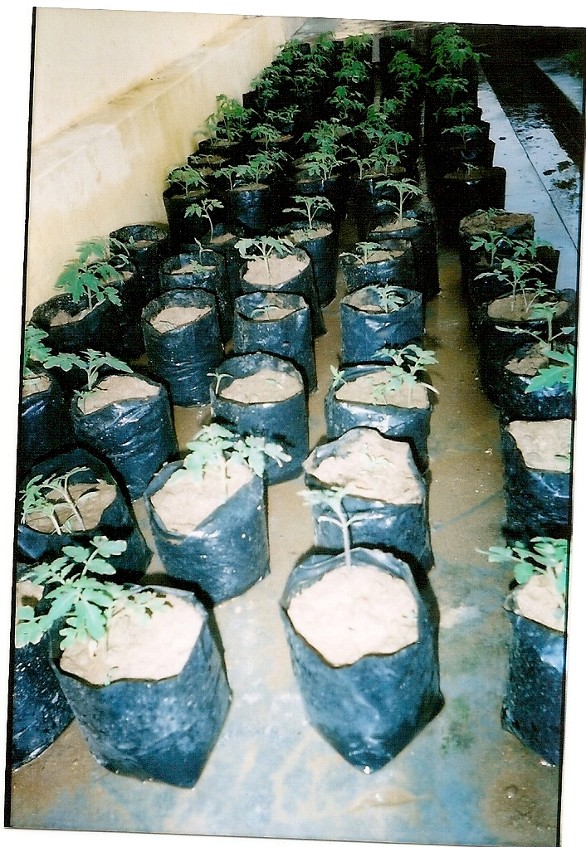
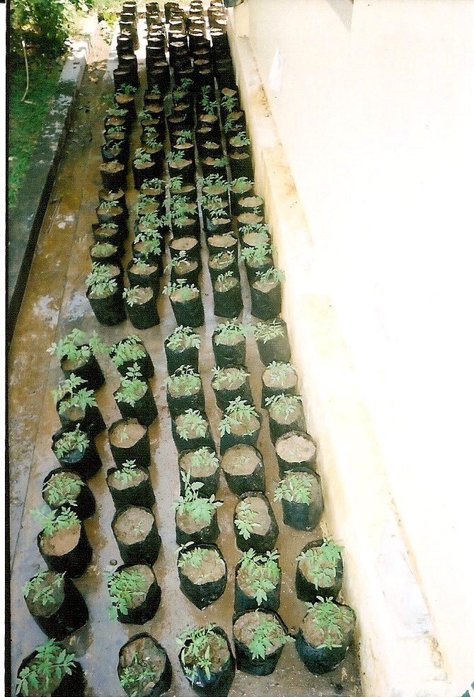

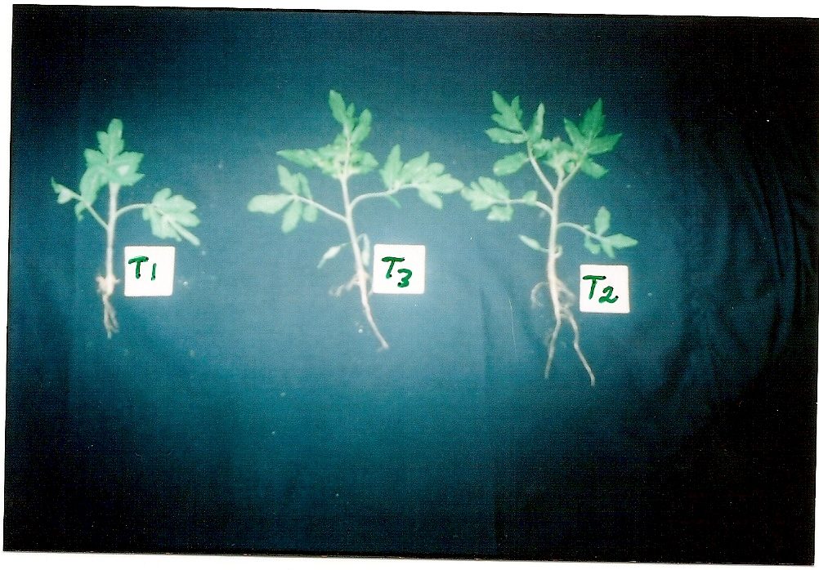
Plate-1 Plant growth after germination on field

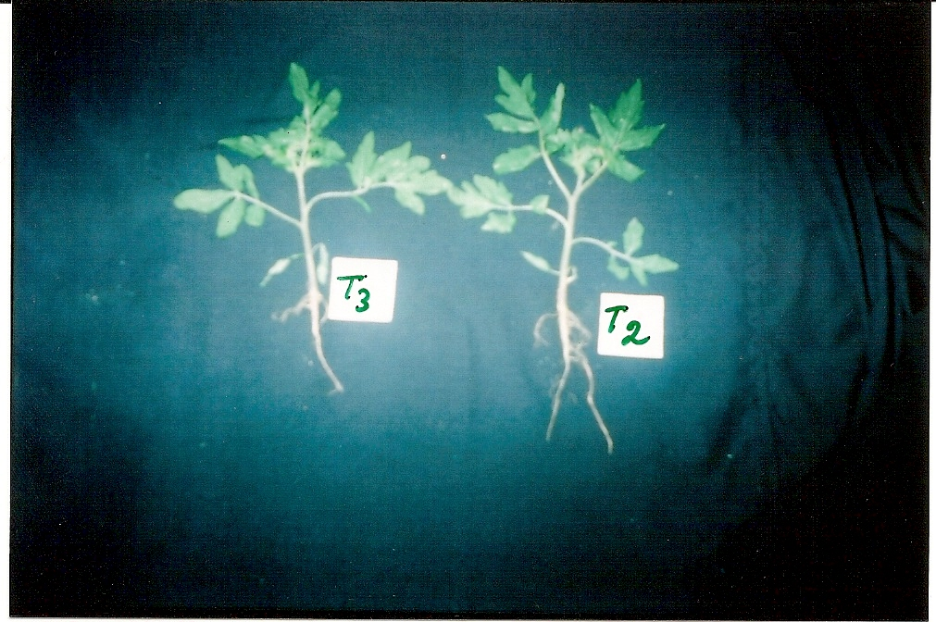

Plate-2 Comparison of root length between T1, T2 & T3 Treatments

References:

Arora, SK; Singh, I; Pandita, ML and Banerjee, NK. (1995). Response of tomato to nitrogen fertilization and plant geometry for seed yield. Haryana Journal of Horticultural Science. 24: 49-54.
Azcon, R and Barea, JM. (1975). Synthesis of auxins, gibberellins and cytokinins by Azotobacter beijerinckii related to effects produced on tomato plants. Plants and soil. 43: 609-619.
Badoni, Anoop (2006). Effect of inorganic fertilizers and organic manure on seed germination and seedling growth of Solanum melongena L. under environmental condition. M. Sc. Thesis, Department of Seed Science and Technology, H. N. B. Garhwal University, Srinagar.
El-Shanshoury, AR; Hassan, MA and Abdal Gaffar, BA. (1989). Synergistic effect of vesicular-arbusculr-mycrorrhizas and Azotobacter on the growth and the nutrient contents of tomato plants. Phyton Horn. 29: 203-212 (Hort. Abst. 61: 358).
Grigoryan, GA.(1978). Changes in tomato seed quality in relation to varietal characteristics and fertilization. Biologicheskii Zhurnal Armenii. 30: 21-25 (Hort. Abstr. 48: 9928).
Hedge, DM and Sriniwas, K. (1989). Studies on irrigation and nitrogen requirement of tomato. Indian journal of Agronomy. 34: 157-162.
Jackson, RM; Brown, ME and Burlinghum, SK. (1964). Similar effects on tomato Plants of Azotobacter inoculation and application of gibberellins. Nature. 192:575.
Kuksal, PP; Shyam , RD and Yadav, JP. (1977). Effect of different levels of nitrogen and phosphorus on fruit and seed yield of tomato variety Chaubattia Red. Progressive Horticulture. 9: 13-20.
Martinez, R.; Dibut B and Gonzalez , R. (1993). Stimulation of tomato development and yield by inoculation of red ferrallitic with Azotobacter chroococcum.
Mehrotra, CL and Lehri, LK. (1971). Effect of Azotobacter inoculation on crop yields. Jurnal of the Indian Society of Soil Science. 19: 243-248.
Mishustin, EN and Naumora, AN. (1962). Bacterial fertilizers their effectiveness and mechanism of action. Microbiologiya. 31: 543-555.
Mohandas, S. (1998). Field response of tomato (Lycopersicon esculentum Mill. ‘Pusa Ruby’) to inoculation with a VA mycorrhizal fungus Glomus fasciculatum and with Azotobacter vinelandii. Plant and soil. 98: 295-297.
Nesterova, RF and Butkevich, TB .(1980) . Yeild and quality of tomato seeds in relation to mineral nutrition. Semenovod ovoshuh. Kul’tur Kishinev Moldavian SSR: 43-48 (Hort. Abst. 51:6279).
Oampo, JA and Barea, JM. (1978) . Effects of microbial fertilizers on flowering of tomato in the absence of established inocula in the rhizosphere. Anales de Edafologia Y Agrobiologia. 37: 315-325 (Hort. Abst. 50: 1104).
Olasantan, FD. (1991). Response of tomato and okra to nitrogen fertilizers in sole cropping and inter cropping with cowpea. Journal of Horticultural Science. 66: 191-199.
Randhawa, KS; Nandpuri, KS and Singh, D. (1977). The effect of N, P and K fertilization on the growth and yield of tomato cultivar. Vegetable Science. 4: 61-65.
Seth, JN and Chaudhry, B. (1978). Effect of fertilizer and spacing on the fruit and seed yield in tomato. Progressive Horticulture. 2: 5-14.
Singh, AB and Singh, SS. (1992). Effect of various levels of nitrogen and spacing on groeth, yield and quality of tomato. Vegetable Science. 19: 1-6.

3/16/2009

