Reproductive behaviour of wild Asian Elephants Elephas maximus in the Rajaji National Park, North-West India

Ritesh Joshi¹*, Rambir Singh², Raju Pushola³, M. S. Negi⁴

¹Doon Institute of Engineering and Technology, Shyampur, Rishikesh,
Dehradun, 249 204, Uttarakhand, India
²Science and Engineering Research Council, Department of Science and Technology,
Government of India, Technology Bhavan, New Delhi, 110 016, India
³Summer House, Society Area, Clement Town, Dehradun - 248 002, Uttarakhand, India
⁴Chilla Forest Range, Rajaji National Park, Pauri Garhwal, Uttarakhand
*Corresponding author’s E-mail: ritesh_joshi2325@yahoo.com

Abstract: The breeding behaviour of Asian Elephant (Elephas maximus) in the Rajaji National Park was studied during 2000-2007. Despite, the status, movement pattern, habitat utilization, feeding behaviour and man-elephant conflict, extremely rare research work has been carried out on its reproductive behaviour in the wild. During the recent past most of the wildlife corridors in the Rajaji National Park area through which elephant performs their long-term migration between Rajaji to Corbett National Park has been shrinked, which has affected the breeding performances along with genetic exchange between the elephants of different protected areas. Direct observation method was followed for conducting this study and study findings have wider implications for developing predictive models of Asian elephant conservation. Mixing of the adult bulls, selection of prospective partner to mate, smelling of genital organ and discharge of urine were few of the major features of mating behaviour in elephants. Generally 15 – 20 days were required for completion of mating process but if the environmental conditions were unfavourable it was completed by a month. The duration of coitus was observed to be 3-4 minutes, which largely depends upon presence of group members and cooperation of the prospective cow. Breeding season in Rajaji National Park was noted to be extending maximum from May to November, which through embraces the hot, rainy and beginning of cold seasons but largely the warm period. Musth phenomenon in adult male elephants was mostly observed during February to July, which was dominated by dry period. High level of parental care was also observed in elephants and serious bullfights were the attempts of mating needs. Presently large scale developmental and anthropogenic activities are responsible for habitat deterioration in this area and hence, continued protection of the Asian elephant is of paramount importance for the global conservation of this endangered species [Researcher. 2009;1(5):76-84]. (ISSN: 1553-9865).
.
Keywords: elephant; Elephas maximus, reproductive behaviour; Rajaji National Park; musth; north-west India

1. Introduction
The behaviour of wild animals is presently a subject matter of great interest leading to understanding about the nature of various wild animals, which may be helpful in their management and conservation. Behaviour of Asian elephants (Elephas maximus) particularly in domesticated form provide lot of recreation to the human beings and easy to understand. However, the behaviour of wild elephants is a tough task to be observed and studied in wild especially in foothills dominant areas. The Shivalik foothills (lesser Himalayan zone) are one of the world’s most spectacular landscapes, encompassing the tall grasslands and the Shorea robusta (Sal) forests. India has between 21,000 and 25,000 Asian elephants (Elephas maximus) in the wild and among them Uttarakhand state harbours 1346 elephants distributed within 14 protected areas. India currently has the largest surviving population of the Asian elephant, approximately 50 % of the total world population of the species^{[1]}. A number of wildlife habitats have undergone or are being threatened with fragmentation due to various anthropogenic factors and this has adversely affected the large mammal populations residing in them^{[2]}. Recently, developmental activities and habitat destruction have caused major decline in the abundance of the terrestrial megafauna. As most of the wild animals are presently categorized under threatened category therefore, there is increasing concern that the area-wise decline of the elephant will have unexpected and grave consequences for the long-term viability of the terrestrial ecosystems.
The Rajaji National Park was established to enhance the long-term survival of the Asian elephant in a sub tropical moist deciduous forest in India. But during the recent past natural continuous forest ranges of India has been broken up into many parts due to agriculture, urbanization, increasing road traffic and development related activities as well as other anthropogenic activities. This situation creates many problems for various organisms living in forests especially for large size mammals like elephant. Genetic isolation, limitation of dispersal, migration and the decline of populations of animals requiring large territories are the most common problems connected with fragmentation of forests and other components of the environment.
Shivalik landscape (lesser Himalayan zone) is one of the last few places in the world where elephants exist and offers urgent need for conservation. From conservation point of view Rajaji National Park appears to be India’s one of the most successful national park and its management has helped to boost the population of Asian elephant in their natural habitat. Before the Gujjar rehabilitation programme elephants must scarify the feeding grounds in order to feed on the short grasses due to domestic buffaloes being grazed^{[3]}.
Several research studies on the breeding biology of African elephant (Loxodonta africana) were conducted during the recent past but only few studies has been carried out on the behavioural biology of wild Asian elephants. In recent years, due to dwindling of forest areas only few protected areas are available for wild elephants where they can be observed in their natural habitat performing their usual activities and different behaviours. The status of the elephant in the adjoining countries is equally poor. Nepal, which has the lowest country population, has lost over 80% of its elephant habitat on account of human settlement. Bangladesh, Myanmar, Cambodia, Vietnam, Laos and Sri Lanka are also losing rapidly the natural forest cover, specially the elephant habitats. In Thailand in spite of the elephant having been a protected species since the 18th century, over exploitation of the habitat and the pressure of human population has made the species highly vulnerable^{[1]}.
The major objective of the present study was to document the reproductive behaviours of wild elephants. The present study was a part of our long term study on the behaviour of Asian elephant in sub tropical moist deciduous forests of north-west India.

2. Methods

2.1 Study Area
Rajaji National Park [29⁰15' to 30⁰31' North Latitude, 77⁰52' to 78⁰22' East Longitude] is spread over an area of 820.42 Km² in and around the Shivalik foothills, which lies in the lesser Himalayas and the upper Gangetic plains (Figure 1). Rajaji National Park (RNP) was notified in 1983 by amalgamating three erstwhile wildlife sanctuaries namely, Rajaji, Chilla and Motichur. Spread across Hardwar, Dehradun and Pauri districts of Uttarakhand state, Rajaji National Park has been designated as a reserved area for the "Project Elephant" by the Ministry of Environment and Forests, Government of India with the sole aim of maintaining the viable population of Asian elephants in their natural habitat. The Shivalik foothills offer the most prominent geomorphic features of this tract. The river Ganges has cut across these hills at Hardwar. The Chilla forest area of the RNP lies in the east of the river Ganges and is attached by the Garhwal Forest Division. The study was conducted in Chilla (District-Pauri) forest range of the RNP. Besides, Laldhang forest range (Lansdowne forest division, LFD), Shyampur and Chiriapur forest ranges (Hardwar forest division, HFD) were also included in this study. The altitude lies between 302-1000 m asl.

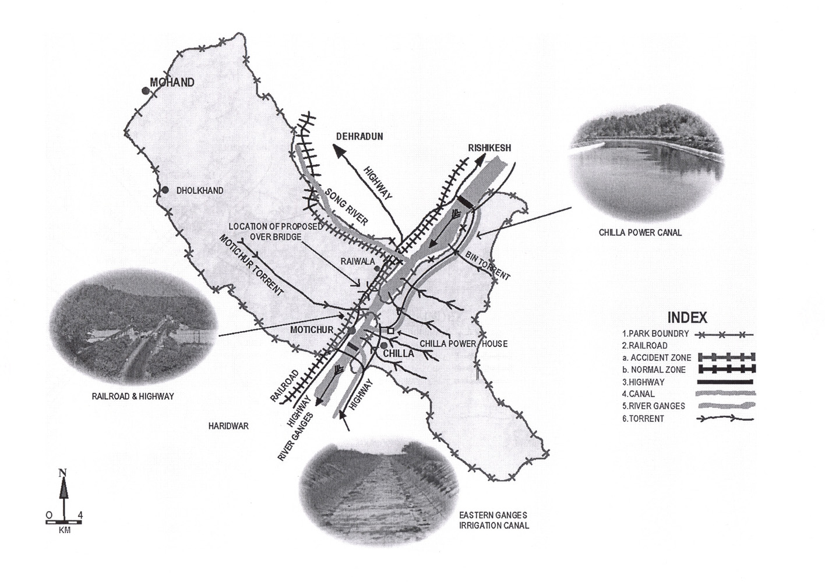
Fig. 1. Map of the study area

This protected area in India's lesser Himalayan region falls under sub tropical moist deciduous forest type with extensive stands of Shorea robusta (Sal), Mallotus phillipinensis (Rohini), Acacia catechu (Khair), Adina cordifolia (Haldu), Terminalia bellirica (Bahera), Ficus bengalensis (Bar) and Dalbergia sissoo (Shisham) in its premise besides many other important fodder plant species. This entire belt is natural home of Asian elephants (Elephas maximus) besides many other wild animals like Panthera tigris (tiger), Panthera pardus (leopard), Melursus ursinus (Sloth bear), Hyaena hyaena (Hyaena), Muntiacus muntjak (Barking deer), Axis axis (Spotted deer), Cervous unicolor (Sambhar), Sus scrofa (Wild boar) and Ophiophagus hannah (King cobra).

2.2 Data Collection
For assessing the reproductive behaviour of elephant’s four forest ranges (Chilla, Shyampur, Chiriapur and Laldhang) of the RNP, HFD and LFD were selected and in-depthly surveyed. All the field observations were made during 2000 to 2007. It was not possible to observe the elephants during monsoon as most of the areas are dominated with tall grasses and dry period was the best time to observe the elephants especially near to water sources. The study area was visited at weekly intervals during which observations on elephants were made along the motorable forest track, present in between different forest habitats. Few other connected rough routes, which link the grassland habitat with motorable road were also used during the course of study. As few forest beats of the study area does not comprises of any road, therefore, study was made on foot. Although some animals were observed up to a maximum distance of 100 meter, most of the observations fell within 50 meter. Besides, all the potential habitats (water dominant areas, cool shaded areas, fodder enriched areas and rough forest routes) were also investigated on foot during early morning, mid-day and evening hours. Cool shaded trees like Ficus bengalensis, Adina cordifolia and Ficus glomerata and dense forest of Mallotus phillipinensis and other favourite fodder species were examined mostly during mid day (March-June) hours as elephants generally take rest under these cover. Whereas all the water sources (perennial/annual) were investigated alternatively during evening hours.
As the elephants in RNP have been known to emerge from the forest predominantly during evenings, all sightings of elephants were made between 1500 hours and 1900 hours. Besides, observations were also done during early morning hours (0600 hours to 10 hours). Different forest blocks of concerned forest ranges were selected one after another sequentially and searched for elephants for about 10 – 12 hours (depending upon weather conditions) in a single day search. The observations started at early hours in the morning being the best time to search and observe the elephant in open areas and four hours in the afternoon i.e. before the sunset. The data collected was as part of the animal monitoring activities and the daily record was based on direct sighting of animals, indirect evidences like feeding sign, footprints impression time and fresh dung piles. The direct sighting were noted in duly prepared proforma, recording the Herd composition, age and sex, if observed in Herds and also the place of sighting, time and vegetation type. Besides, villagers of adjoining areas, Gujjars (where available), staff of forest department, the researchers from various scientific institutions and non-government organizations and other individuals working on this problem, were also interviewed. Field binocular was also used for observing their mating without disturbing the animal from an adequate and safe distance.
Identification of the elephants was important to verify their movement as in the same area there was a possibility that the same Herd was observed in the different forest beats. Therefore, distinctive features, with certain identification marks of individual elephants were noted like; shape of the ears, tusk size and shape, scars and tubercles on the body, tail length, total number of individuals (all ages separately), body mass and nature of herd or solitary bull.

3. Results
Elephant is a highly social animal with group instinct and generally one group consists of 5 to 15 individuals, which comprises of adult cows, sub adult cows, juveniles and calves (newly born). Adult bull elephants are rarely seen within any group, they were observed to join the groups for only breeding purposes. Adult bull elephants prefer solitary life and they utilize wide range of feeding grounds and move more as compared to groups. As RNP area falls under sub tropical moist deciduous forest type; therefore, feeding and breeding parameters are dependent on availability of natural food and water. Several studies have conducted on the breeding habits of elephants but still little is known about the actual breeding biology of Asian elephants in the wild.

3. 1 Mating behaviour
Like many other animals elephants also show the phenomenon of love play, which includes mixing of bull elephants in the groups, selecting prospective partner to mate, smelling of genital organs, sniffing the urine and dung, touching the trunk especially temporal gland and discharge of urine. The whole process was observed to happen within 15-20 days but sometimes it also took one month if environmental conditions are unfavourable (scarcity of fodder and water and high rate of movements). Sometime it was also observed that the adult cow within a group does not accept the bulls in their groups, at that time groups produce loud noise and reflects their weirdness. Long duration of love play and secretion of urine are important factors, which promotes the successful mating. The males are capable of making a second crossing after about 45 minutes and may do the copulation act 4 to 5 times a day^{[2]}.

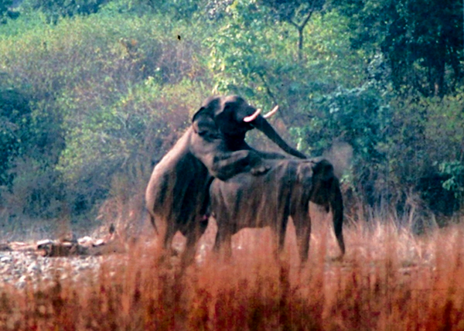
Fig. 2. Elephants during coitus at Chilla forest of the Rajaji National Park

The duration of coitus was observed to be 3-4 minutes depending upon presence of group members and cooperation of the cow elephant. The contact promoting was important factor, which includes separation from groups and mounting of bull elephant but several times false mating were also occurred, which expands the conception duration. The total time required for love play and actual act may take one or two hours. In younger bulls, which are afraid of grown up leaders, the whole act may be brisk and is completed in a short period^{[2]}. When cow comes under heat, exhibits her approval for the conception and at the same time both of them respond equally towards each other and the process of smelling of genital organ by male was observed to be quite frequent. As per the observations of the study it was not compulsory that the bulls, which are in musth condition only exhibits healthy sexual contacts, mating bulls are often observed to have no signs of musth phenomenon, besides the fact that the bulls those are in musth are quite aggressive then those who do not exhibits the phenomenon of musth and can dominate over other males.

Mating was observed mostly inside the dense forest zones especially in those areas, which are enriched with water (Fig 2). Whenever the mating process was completed (10 to 15 days) bull elephants leave the group and starts to live solitary life. Longer stay of bull elephants with a group was also observed during the study period but at the same time they also leaved the group for a short period of time to perform movement on a wide range as the group movement was always restricted to some extent (03 kilometers). Examinations of genital organ with trunk, hugging, touching of temporal region of males and sniffing the dung are important pre-contact promoting behaviours of male and female elephants^{[3]}.

3. 2 Breeding season
Most of the newborn calves were observed during January to May, which corresponds to the wet as well as dry season. The gestation period in Asian elephants varies from 18 to 23 months and if an average value of twenty months is taken as the gestation period, then the breeding season seems to be maximum to extend from May to November, which through embraces the hot, rainy and beginning of cold seasons, but can be taken up by and large as - warm period. On the basis of these observations, it would appear that there are some particular months of breeding. The important ultimate factors that influence the animal's reproductive cycle are probably the seasonal availability of food and water^{[4]}. Since, there is never any extreme shortage of food in RNP area therefore; the breeding season of elephant’s was never so pronounced and drastic. Numerous perennial and seasonal rivers and streams further ensure the yearlong availability of fresh water.
It was also observed during the study period that in few of the places, elephants utilize the same feeding grounds round the year (recognised groups). Elephants inter-change the forests of Rajaji and Corbett National Park as their part of traditional migration. But presently in few of the areas their traditional feeding grounds and corridors are denied to them, which have causes man–elephant conflict. The long-term effects will include genetic isolation, habitat fragmentation within the same forest and enhancement in the human-elephant conflict in adjoining areas. Genetic isolation of elephant populations may also increase the chances of replacement of interbreeding to intrabreeding, and thereby reduce the population persistence even for wide ranging wildlife species^{[5]}. Kotdwar – Lansdowne road runs parallel to the river Kho and crosses the Rajaji-Corbett corridor, the major movement track of northwestern elephant population between the Yamuna and river Sharda. This road serves as the major transport link between Pauri town and Kotdwar area. The presence of traffic on the road, construction of steep retaining walls and the presence of human population along the entire corridor area have almost restricted the migration of elephants^{[6]}.

3.3 Musth phenomenon
The subject of ‘musth’ in elephants has for many years been of much controversy among various elephant workers. The exact biological purposes of ‘musth’ are still unknown. The subject of sex in elephants is one, which evokes curiosity and surprise, since, for a long period there was very little accurate information^{[2]}. Male Asian elephants show periodically the phenomenon of musth, which is characterized by enlargement and discharge of the temporal glands (Fig 3). This gland is a paired organ found on either side of the head, located just beneath the skin in the subcutaneous fascia, above the zygomatic arch. During the musth period the gland gets enlarged and few of the silent morphological features could be seen frequently in adult males like discharge of the temporal gland secretion, excessive bulging out of the perennial part, frequent erection of penis as well as dribbling of urine. All healthy males will exhibit musth over 20-25 years and the duration ranges from 3 weeks to 3 months^{[7]}. Few of the adult bulls were recognized to be in musth during the study period in late winters and in peak summer. As per the field observation it seems that majority of such cases were met especially from February to July, which are predominance by dry period. At that time they are quite aggressive and destructive and frequently release loud noise and their trumpeting was quite frequent.

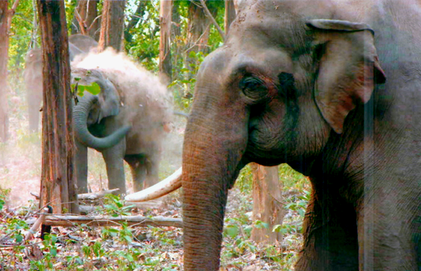
Fig. 3. A bull elephant in musth

3.4 Parental care
Elephants are highly social animals and show parental care behaviour. Newly born babies are kept under high care by their elder ones for about 10 to 15 years and the mother nurses and suckle the calf beyond 2 to 3 years (Fig 4). At the same time calf started to feed on smooth vegetation under the care of their elders. When the male elephant has attained the age of 16, they prefer solitary life and separates from the herd. All the members within a group exhibit an equal responsibility to care the newly born infants but adult cow elephants are more careful towards calves as compared to bull elephants. Once an elephant herd marched to the lake with a baby elephant, which was almost motionless, virtually lifted by the mother and another cow elephant. There are many incidents of such type, which were observed during the study period. It was also observed that any herd when feeding, spreads within 50-100 meters (depending on herd size) and at that time adult bull separates from herd but the calves move with their elder one (adult cows or sub-adult cows). Calves also sometimes show play behaviour, when they are in water, they splash mud and play by entangling their trunk with other. Similarly, When calves fed or bath and when they are crossing any water stream, their elder ones are too much careful of them.

3. 5 Bull fights
Serious fights, which are a rare occurrence, are conducted with tremendous vigor. These fights consist of a series of head rams where by the tusks clash and the trunks wrap around each other (Fig. 5). Several times these fights were observed during the course of study. Serious fights were accounted highest for Chilla (2002) followed by Shyampur (2004) and Barkot (2006) whereas two major fights, one in 1999 and another in 2007 were also observed during the field observations but both of these were result less.
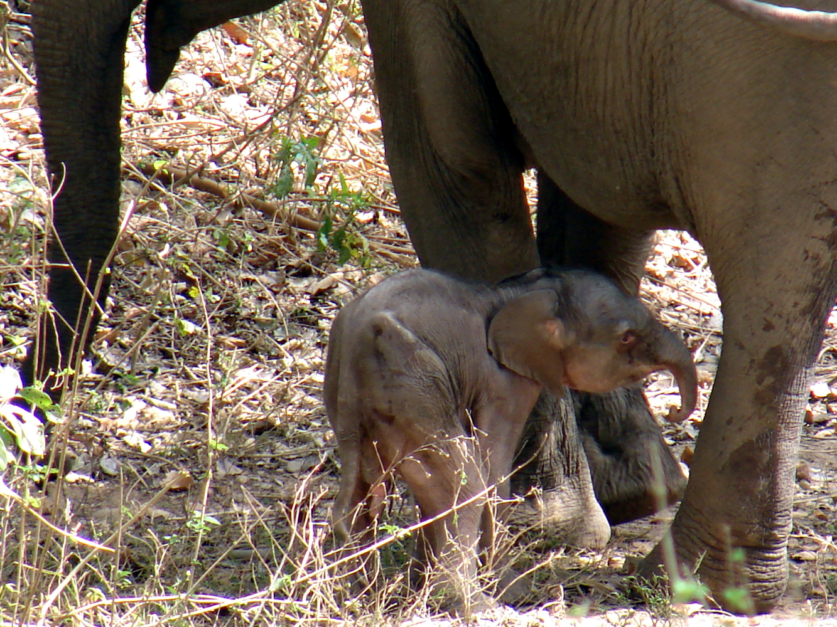
Fig. 4. A newly born (02 hours old) elephant calf at Rajaji National Park.

Tremendous trumpeting was observed during such incidences and sometimes tusks have played the major role in killing one of the combatants through penetrating the elephant. Elephants’ fight could be continues till death of anyone of them or until one of them ran away. Tusks are often broken during elephant fight, revealing how much energy was involved. Male-male aggression were also denoted by several workers and called them as "pseudo fights". The aggression is basically for the mating purpose, besides few other biological requirements like joining of group and feeding.

4. Discussion
During the recent past extensive work has been carried out on the movement pattern, habitat utilization and feeding biology of Asian elephants^{[1,5,8,9,10]} but the work on its behavioural biology has remained neglected. Therefore, less information is available in relation to behavioural pattern of elephants in the wild. The adult / sub-adult (excluding solitary sub-adult bulls) sex-ratio of the elephants in Hardwar, Chilla and Motichur forest ranges of the RNP was 100 females : 22.4 males, which was a good elephant population along with ratio 1 : 4.4 (male: female)^{[11]}. Apparently it shows a very good sexual ratio, however, under field conditions, it is impossible to represent the accurate sex ratio especially in sub tropical forests, which are having dense vegetation cover and continuous undulating foothills in its regime.
The age at which elephant’s attained sexual maturity was the matter of affair and depends often on the nutrition that is available to them. In many mammals the puberty and maintenance of fertility are influenced by growth rate and conditions^{[12]}. Among the elephants the ability to breed depends not only on the attainment of a minimum critical body weight but more importantly, on the size and their relative position in the social hierarchy. In the Asian elephant, the young male may reach sexual maturity as early as 7 or 8 years^{[13]}. The female cow reached of age for breeding when they are 12 to 14 years old and adult males get mature when they are 14 to 15 years old. Rare exceptions are also there in their mating processes^{[2]}.
Rainfall is another major factor, which influence the breeding behaviour in elephants and rainfall by stimulating the new growth of forest cover could influence the breeding performance by raising the plane of nutrition. There is a definite correlation between the rainfall and the timing in conception, which is more pronounced as one move away from the equator, and the rainy seasons become more pronounced^{[14]}. The courting is another long drawn-out process, which may last for days, weeks or months. During the contact promoting and pre-copulatory processes, besides mutual smelling of genital organs bull elephant also follow the prospective cow (within a group) for a short period. It was also observed during the present investigation that courtship might occur either within or away from the herd.

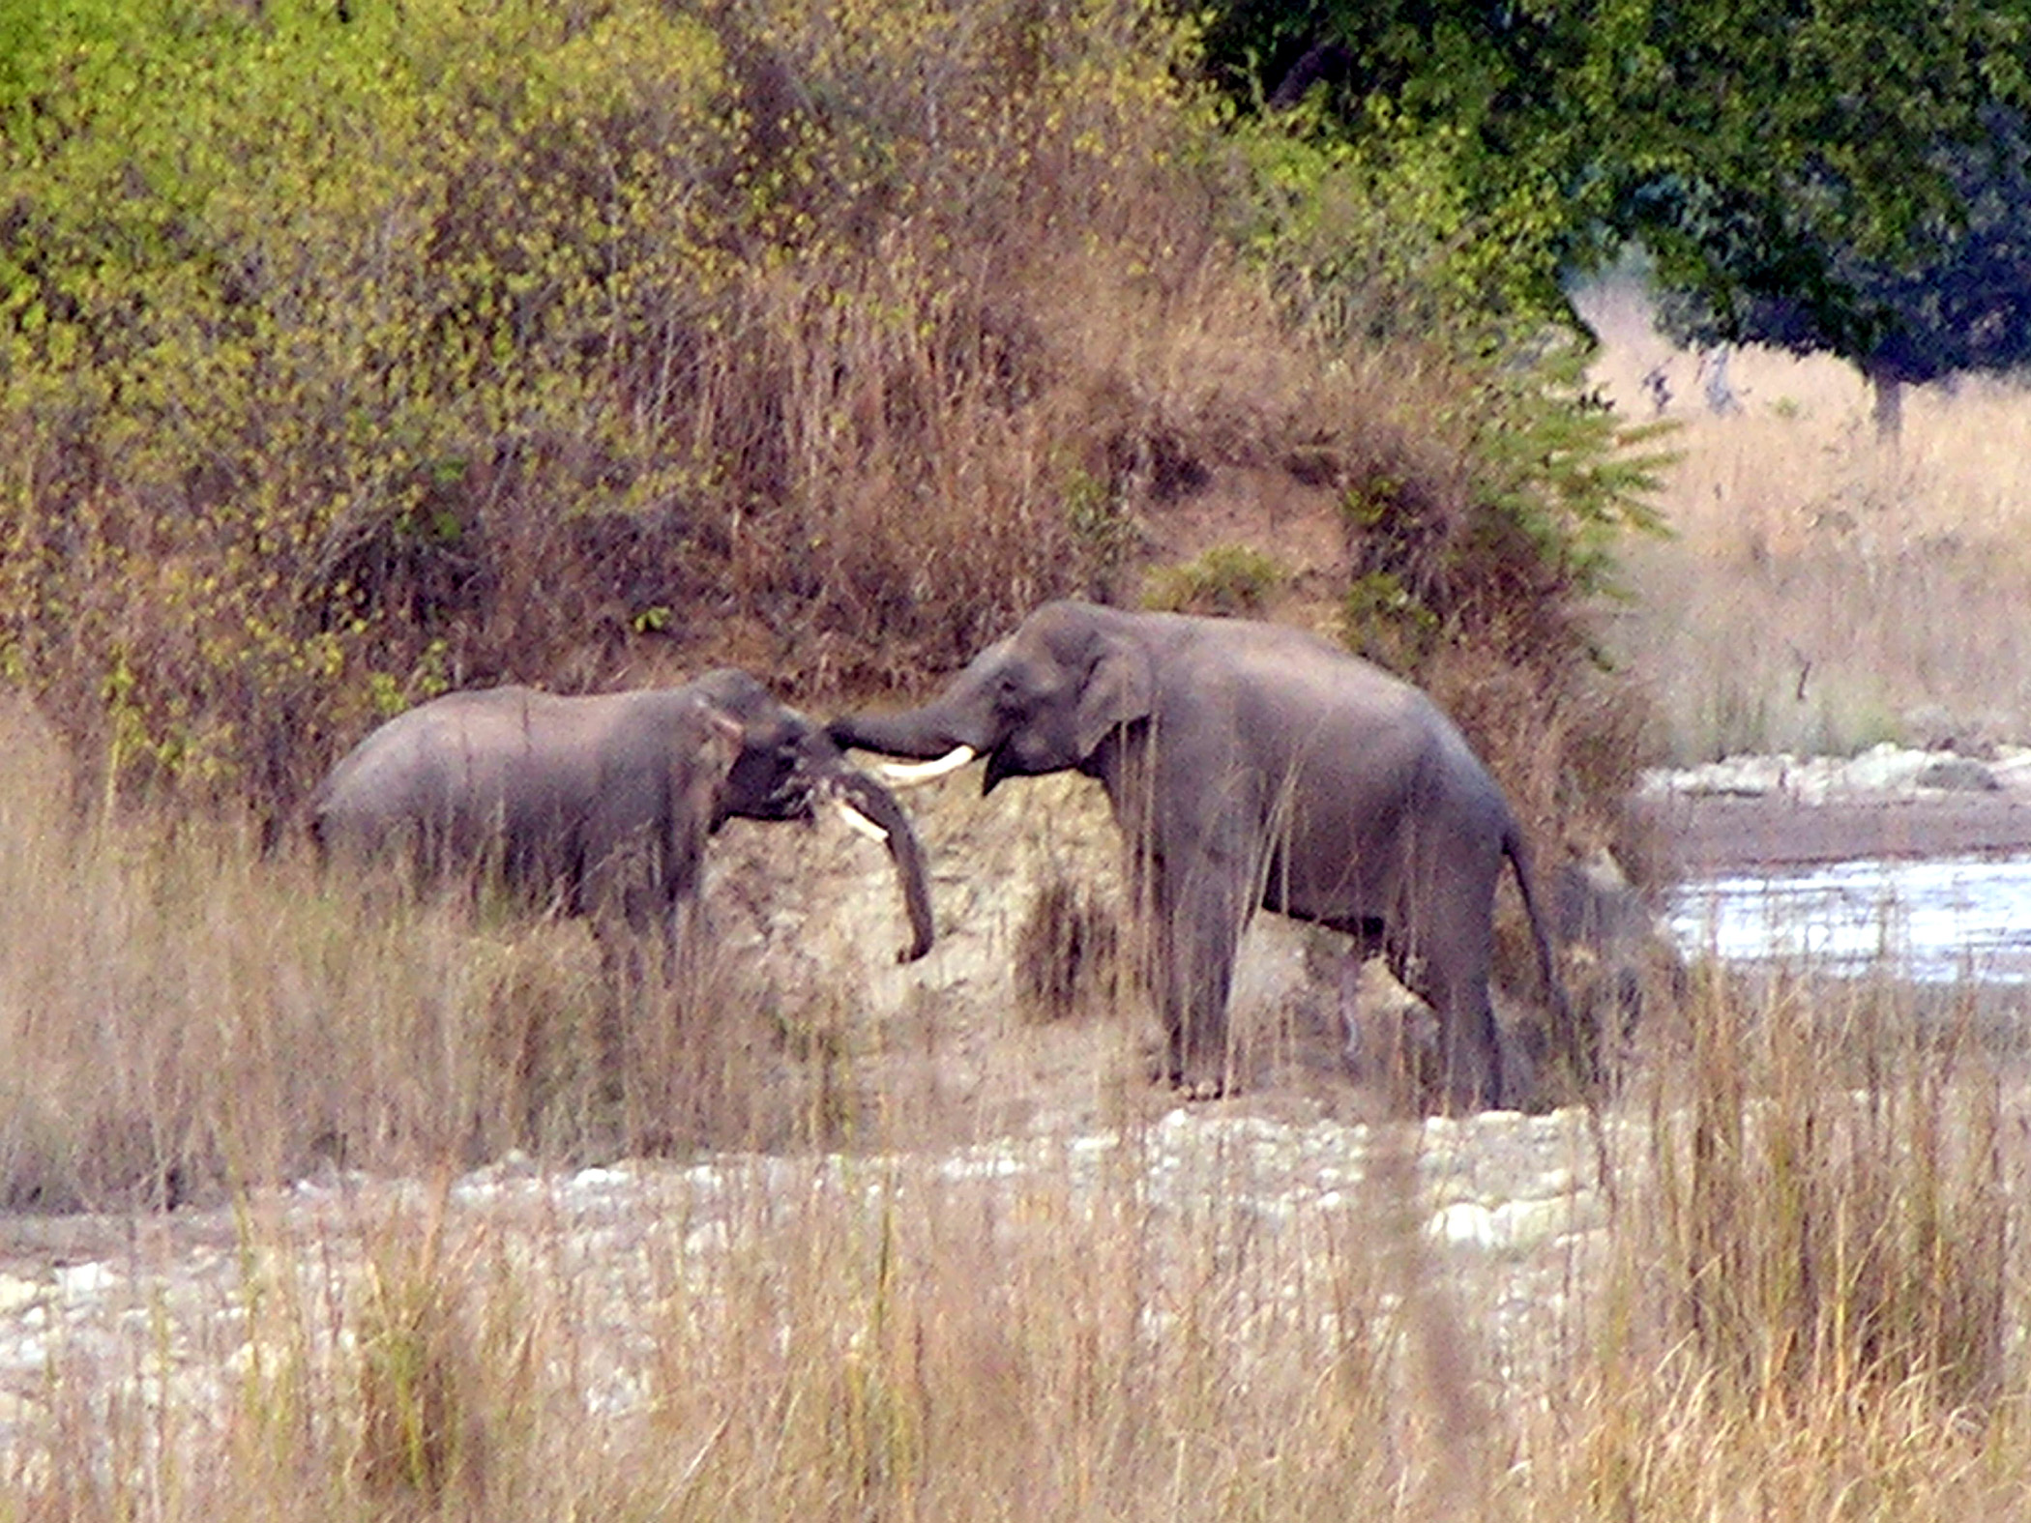
Fig. 5. Bull Fight at Mundal forest

As pregnancy advances, the females may be observed to remain slightly away from the herd and avoids climbing on high hills. Its movements become comparatively slower and urinate frequently. Such a female maintains a distance from the advances of other eligible males and demonstrates defensive behaviour keeping her ears low and tail tucked in between her hind legs^{[15]}. Such incident was also observed in Kharkhari forest beat of Hardwar forest range and Khara forest beat of the Chilla forest where the pregnant cow was observed often moving at some distance from the herd and also feeding separately on the rich nutritious fodder species, but occasionally the cow also made her to re-group the herd. When the time of delivery advances the cow elephant becomes very restless and shows signs of suffering from a motionless pain. Discharge from the veginal organ and slowly releasing milk from her tits (when cow attained final pregnancy stage) are common symptoms observed.
The breeding season from June to September, which corresponds to the dry season was observed in Way Kambas Game Reserve^{[8]}. Elephants do not have breeding season and cow elephants have an oestrus cycle of 20-27 days with a mean of 22 days, whereas gestation period is 18 to 22 months^{[7]}. In the present study breeding was observed to extend from May to November, which though embraces the hot, rainy and beginning of cold season. The breeding season was observed to be rainy season in Way Kambas Game Reserve, Sumatra^{[8]}, but it is just opposite in Ruhuna National Park in Sri Lanka where births were confined to the wet season, while breeding took place in the dry season^{[16]}. This may be due to the fact that Way Kambas Game Reserve and Ruhuna National Park are located on to the south and north of the equator, respectively and so changes in the reproductive pattern may be linked to their relative geographic positions. Reproductive performance was known to vary with age, season, locality, population density and plane of nutrition^{[14]}.
The gestation period might vary from 17 to 23 months on account of several reasons. Since in elephants males are carried longer and are heavier at birth than the female, therefore, number of births also depends upon sex^{[15]}. The hereditary factors also influence the length of gestation besides environmental factors probably also contributes to variation. However, this represents merely a stage in physiological maturity. The sociological maturity that refers to the animal's ability to compete with others for oestrus females may take much longer time – upto 17 or 18 years^{[3,13,17]}. Likewise, females may reach sexual maturity as early as 7 years of age under a high plane of nutrition, while sexual maturity could be delayed until 10 years or more if the animals are living in less productive marginal habitats. The reproductive performance of the females falls off sharply by the time they are about 50 years of age, whereas this is equivalent to the human menopause and the associated selection for survival of grand mothers, who help in the care of the young one and there by reduce infant mortality^{[18]}.
The birth-spot is normally selected closer to the water source and was generally nearer to the grassy patch. The size of the birth-spot was variable depending upon the size of the herd and constant paddling of the elephants makes this spot quite smooth. During the period of delivery the spot was well guarded by all the members of the herd, including the adult males. Normally, one calf was born at a time but twins are also known. The calf was able to stand on its legs within an hour, but the herd with the new born baby will continue to stay in the area for two to three days, probably the time required for the newborn calf for able movement. Trunk plays a major role in upliftment, touching and shifting of the new borne calf and the mother was extremely protective to her young one and during the first few weeks, keeps it quite near or directly under her belly as she walks about. The mother suckles the calf at an interval of every 15-20 minutes during the first fortnight^{[15]}.
Whenever the group was moving, the infants also tend to remain very close to their mothers and, if any disturbance was there, the adults form a group with the infants in the center. At such times, the infants are frequently restrained from straying by the adults, who will extend their trunks around an infant that was about to move away and pull it back. In a group containing infants, there are frequently more adult females than infants. In such instances, all females appear to share equally in the care of the young one. Whenever the group of females was feeding in a relatively stationary position, older infants frequently stray from them and indulge in fairly extensive play behaviour^{[19]}. Since the habitat of the elephants has been shrinking rapidly and also been fragmented, there was no mating between the elephants of different herds within different protected habitats.
Feeding and breeding are the most important ecological factors, which are directly linked with the survival of any species. The RNP represents one of the important sub-tropical moist deciduous protected area for elephants in north-west India. At present, observations from this study indicated that the elephant population is below the park carrying capacity since there are no obvious signs of any over utilization and habitat deterioration. The long-term survival of elephants and the viability of the park itself as a self sustaining eco-system would depend very much on wise management practices that incorporate both socio-economic as well as ecological considerations.

Acknowledgements
We are thankful to the Science and Engineering Research Council, Department of Science and Technology, Government of India for providing financial support and thanks are due to Late Dr. R. C. Srivastava, Scientist ‘G’ & Advisor – SAC (PM of India) and Dr. Jagdish Chander, Scientist ‘F’, DST, for their cooperation and valuable suggestions. Shri C. M. Dobhal, Director and Shri O. P. Bhatt, Chairman, Doon Institute of Engineering and Technology, Rishikesh are acknowledged for providing facilities, encouragement and suggestions. Thanks are due to Prof. B. D. Joshi, Department of Environmental Sciences, Gurukul Kangri University, Haridwar and Dr. S. P. Sinha, Coordinator – Swamp Deer Project, Wildlife Institute of India, Dehradun for providing suggestions during the study period. Shri Srikant Chandola, Additional Principal Chief Conservator of Forests (Wildlife), Government of Uttarakhand and Shri G. S. Pande, Former Director, Rajaji National Park are highly acknowledged for giving the permission to carry out the research work in the said area. Thanks are to various concerned forest officials and staff for providing help during the field investigations.

Correspondence to:
Ritesh Joshi
Doon Institute of Engineering and Technology,
9th Mile Stone, Shyampur, Rishikesh,
Dehradun, 249 204, Uttarakhand, India
Telephone: +91 135 2453203 (O)
E-mail: ritesh_joshi2325@yahoo.com

References
- Daniel JC. Conservation of Asian elephant. Gajah 1996; 16:9-16.
- Johnsingh AJT, Narendra P, Goyal SP. Conservation status of the Chilla-Motichur corridor for elephant movement in Rajaji-Corbett National Park area. Biological Conservation 1990; 52:125-138.
- Joshi R, Pande GS. Rehabilitation of Gujjar community from the Rajaji National Park: An approach for biological diversity conservation through restoration ecology. Nat. Acad. Sci. Lett. 2007;30 (9&10):263-267
- Iyppu AI. Sex in elephants. In: Karunakaran CK, ed. Ecology, behavior and management of elephants in Kerala, India. Kerala books and publications society, Kakkanad, Kochi, India.1990: 76-81.
- Nair PP. Problem of crop raiding by elephants in Kerela. In: Karunakaran CK, ed. Ecology, behavior and management of elephants in Kerala, India. Kerala books and publications society, Kakkanad, Kochi, India.1990: 208-212.
- Laws RM, Parker ISC, Johnstone RCB. Elephants and their habitats: the ecology of elephants in north Bunyoro Uganda. Clarendon Press, Oxford. 1975:1-376.
- Joshi R, Singh R. Asian elephant (Elephas maximus) and riparian wildlife corridors: A case study from lesser-Himalayan zone of Uttarakhand. J. Am. Sci. 2008; 4(1):63-75.
- Johnsingh AJT, Williams AC. Elephant corridors in India: lessons for other elephant range countries. Oryx 1999; 33(3):210-214.
- John MC, Subramanian R. The elephants. Zoo’s Print 1991; 6(2):1-4.
- Santiapillai C, Suprahman H. The ecology of the elephant (Elephas maximus Linn.) in the Way Kambas Game Reserve, Sumatra. Technical Report, WWF / IUCN Bogor. 1986:1-96.
- Sukumar R. The Asian elephant: ecology and management. Cambridge University press, Cambridge. 1989:1-251.
- Joshi R. Population dynamics and general behavioural pattern of Indian Elephant (Elephas maximus) in the Shivalik foothills of the Rajaji National Park, India. Ph.D. thesis, Gurukul Kangri University, Hardwar, India. 2002.
- Joshi R, Joshi BD, Singh R. Population composition of Asian elephant (Elephas maximus) in the Rajaji National Park, Uttarakhand, India. Him. J. Env. Zool. 2007; 21 (2):189-202.
- Mitchell B, Staines BW, Welch D. Ecology of Red Deer: a research review relevant to their management in Scotland. Institute of Terrestrial Ecology, Banchory, UK. 1977: 1-74.
- Eisenberg JF. The mammalian radiations: An analysis of trends in evolution, adaptation and behaviour. University of Chicago Press, Chicago.1981:1-610.
- Hanks J. A struggle for survival, the elephant problem. The Hamlyn publishing group Ltd., London. 1979:1-176.
- Ali SM. The Indian elephant: their distribution, ecology and reproduction. In: Majupuria TC, ed. Wildlife wealth of India. Bangkok, Thailand. 1986:1-12.
- Santiapillai C, Chambers MR, Ishwaran N. Aspects of the ecology of the Asian elephant (Elephas maximus Linn.) in the Ruhuna National Park, Sri Lanka. Biological Conservation 1984; 29:47-61.
- Croze H. The seronera bull problem. E. Afr. Wildl. J. 1974; 12:1-27.
- Laws RM. Experiences in the study of large mammals. In: Charles WF, Smith TD, eds. Dynamics of large mammal populations. Johnwiley & Sons., New York. 1981:1-45.
- Mckay GM. Behaviour and ecology of the Asiatic elephants in south-eastern Ceylon. Smithson. Contribution Zoology, Washington DC. 1973:1-112.

6/15/2009

