Cardiovascular Effects of Vernonia amygdalina in Rats and the Implications for Treatment of Hypertension in Diabetes.

Idowu Adewumi Taiwo¹*, Peter Godwin Chikwenye Odeigah¹, Smith Ishmael Jaja², Frank Babatunde Mojiminiyi³.

- Department of Cell Biology and Genetics, Faculty of Science, University of Lagos, Lagos 101017. Nigeria.
- Department of Physiology, College of Medicine, University of Lagos, Idi-Araba, Lagos 101017, Nigeria.
- Department of Physiology, College of Health Sciences, Danfodio University, Sokoto 840001, Nigeria.

tai_dex@yahoo.com podeigah2003@yahoo.com

Abstract: Cardiovascular effects of aqueous extract of Vernonia amygdalina was investigated in normotensive Sprague-Dawley rats weighing 200-250g. Intravenous (femoral vein) administration of the extract at doses of 5.0 and 10.0mg/kg caused a bi-phasic alteration of blood pressure: an initial transient rise in mean arterial pressure which later fell to a considerably lower level than the starting blood pressure. This pattern of response was most clearly noticeable with the dose of 10 mg/kg whereby the mean arterial pressure of 73.7+3.4 mmHg rose to 101.9+4.1 mmHg in the first phase (P<0.01) before it finally fell to 60.2±2.5 mmHg in the second and final phase. Although higher doses (50 and 100mg/kg) caused more significant reduction in mean arterial pressure than the lower doses, the initial temporary elevation in blood pressure was not observed. Cumulative addition of the plant extract to isolated rings of aorta precontracted with noradrenaline produced a dose-dependent relaxation of the aortic smooth muscle. Maximum relaxation of 31.3±3.1% was observed with extract concentration of 2.7 mg/ml. These findings suggest that V. amygdalina has antihypertensive effect, and this could be mediated through direct vaso-relaxant mechanism. The implication of these results for the treatment of hypertension associated with diabetes is discussed.

[Researcher. 2010;2(1):76-79].(ISSN: 1553-9865)

Key words: aortic rings; cardiovascular; hypertension; V. amygdalina; diabetes.

1. Introduction
There is considerable evidence that the incidence of hypertension and diabetes is rising in both the developed and the developing countries (Swalocki et al, 1989; Wokoma, 2002). This is particularly so in rural and developing communities where there are gradual changes in lifestyles to those of more developed and urban societies. Besides, hypertension has been observed to be highly prevalent in diabetic patients (Swales, 1990; Mbanya, 1993). The association is so close that it is often necessary to screen a newly diagnosed diabetic for hypertension and vice versa. Several explanations have been put forward to explain this association: the roles of obesity, insulin resistance, renal factors, and cardiovascular control systems have been discussed in considerable detail in other reports (Fournier et al, 1986; Swales, 1990; Mbanya 1993). Moreover, emerging evidence has indicated an increasing incidence of metabolic syndrome, a cluster of metabolic and cardiovascular disorders including insulin resistance, hypertension, and noninsulin-dependent diabetes ,mellitus (NIDDM).
According to Osuntokun (1992) and some others (Okesina et al, 1996; Wokoma, 2002), the frequency of diabetes complicated with hypertension in Africa, particularly in Nigeria, is 25-42 per cent. In our opinion, this figure does not represent the true prevalence rate because most of the studies were group-oriented and hospital based. These and other available data, though limited, suggest a high frequency of diabetes associated with hypertension in Nigeria. Epidemiological studies are required to ascertain the true prevalence rate of this problem in Nigeria and many other developing countries.
The management of diabetes has been a major problem in tropical Africa including Nigeria (Gill, 1990; Naidu, 1992). Complications with hypertension and other cardiovascular diseases constitute additional difficulties to the management problem. Fortunately, several countries in the world are endowed with plant biodiversity, and there is presently a growing awareness about the importance of native plant remedies in health care delivery system. In many parts of the world especially in the poor countries, efforts are now being directed towards investigating therapeutic efficacy of locally available medicinal herbal products because they are conceived to be safer and more readily available.
Vernonia amygdalina Del. (Astereaceae) is a widely distributed plant used for dietary and medicinal purposes in Nigeria. Its hypoglycaemic effect and possible use in diabetic therapy have been discussed in previous reports (Ogbuokiri et al, 1989). The present investigation was designed to examine the effect of V. amygdalina on blood pressure, heart rate, and smooth muscle contractile response in normal rats. The results are expected to stimulate further studies, interest and discussions as regards better understanding, treatment and control of hypertension associated with diabetes in developing countries.

2. Materials and Methods

2.1 Experimental Animals and Plant Extraction
Adult Sprague-Dawley (SPD) rats of both sexes weighing 200-250g were obtained from the Laboratory Animal Centre of the College of Medicine, University of Lagos. They were randomly divided into groups of 5-6 rats per cage for the experiments. Aqueous extract from the powdered dried leaves of Vernonia amygdalina was obtained using the Soxhlet extraction procedure.

2.2 Cardiovascular Measurements
The blood pressure and the heart rate were determined using standard procedure as described by previous workers (Obiefuna et al, 1991). In brief, the rats were anaesthetized with a combination of 25% urethane (Sigma) and 1% chloralose (Sigma) by intraperitoneal (i.p.) injection. The trachea was exposed by gentle dissection and immediately cannulated to improve ventilation. The femoral artery and vein were similarly exposed and cannulated. The cannulated artery was used for blood pressure and heart rate measurements while the vein was for administration of graded doses (5.0, 10.0, 50.0 and 100.0mg/kg) of the plant extract. Heparin (500 i.u./kg) was injected intravenously to prevent intravascular clotting. The arterial cannula was connected to a pressure transducer which was coupled to a polygraph for cardiovascular recordings. Heart rate was obtained from blood pressure pulses for 15 seconds and then converted to beats/minute.

2.3 Isolated Tissue Experiment
Contractile responses of aortic smooth muscle to V. amygdalina was determined through an in vitro study (Obiefuna et al (1991). Briefly, the rats were sacrificed by cervical dislocation after which their thoracic aorta were removed, freed of connective tissue, cut into 2 mm ring segments and placed in a petri dish containing physiological salt solution. The solution was continuously bubbled with 95% O₂. The aortic ring segments were then suspended from a stainless steel rod in a 20ml organ bath containing physiological salt solution containing 5% dissolved CO₂. Varying concentrations of plant extracts (0.1, 0.3, 0.9, and 2.7 mg/ml) were added cummulatively to the bath to determine its effect on the noradrenaline precontracted aortic rings.

2.4 Data Analysis
All results are presented as mean + SEM. Blood pressure was expressed as mean arterial pressure (MAP). The mean arterial pressure for each rat was calculated from the systolic and the diastolic arterial pressure (AP) using the formula below (Meyer, 1980):

MAP=Diastolic AP+1/3(Systolic AP–Diastolic AP)

Differences between means were compared using the student’s t test. When the comparison involved more than two groups, one-way analysis of variance (ANOVA) was used. P values less than 0.05 were considered significant in all cases.

3. Results

3.1 Effect of Intravenous Injection of V. amygdalina on Blood Pressure and Heart Rate
At lower doses (5.0 and 10.0 mg/kg), the extract of V. amygdalina caused a dose-dependent bi-phasic alteration of both the systolic and the diastolic blood pressure. This was most clearly observed with the dose of 10 mg/kg that caused a transient rise in mean arterial pressure from a starting level of 73.7+3.4 mmHg to a higher level of 101.9+4.1 mmHg (P<0.01) in the first phase (Figure 1). The mean arterial pressure then fell to a level (60.2+2.5 mmHg) that is significantly lower than the starting (P<0.05) and the first phase (P<0.01) values respectively. Intravenous injection of 10 ml/kg of normal saline (control) did not significantly affect the blood pressure. At higher doses (50 and 100mg/kg), the temporary hyperglycaemic phase was not noticeable; however, the mean arterial pressure fell significantly below the starting level (P<0.05).

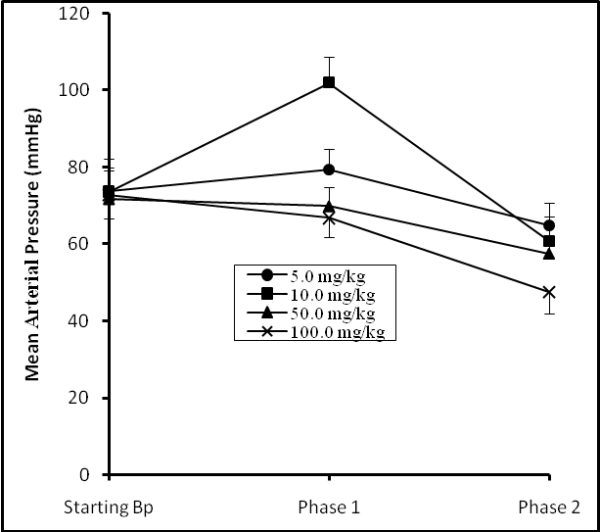

Figure 1. Biphasic Alteration of Mean arterial Pressure after Treating Albino Rats with V. amygdalina. Note: Vertical bars represent SEM.

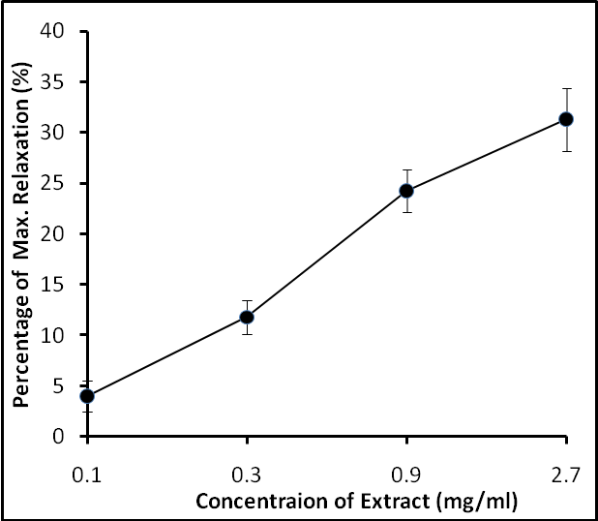

Figure 2: Relaxation Response of Isolated Aortic Smooth Muscle to V. amygdalin. Note: Vertical bars represent SEM.

3.2 Relaxation Response of the Aortic Rings to V. amygdalina.
Cumulative addition of V. amygdalina to noradrenaline precontracted rings of the aorta produced a positive dose-related relaxation of the rings (Figure 2). The extract achieved a maximum relaxation of 31.3+3.1% of the maximum tension developed to 10⁻⁷ noradrenaline at the concentration of 2.7mg/ml.

4. Discussion
The data from the present investigation showed that V. amygdalina, a plant commonly used for dietary and medicinal purposes, caused an overall blood pressure lowering effect in normotensive rats. The extracts caused bi-phasic alteration of blood pressure at lower doses (5.0 and 10.0mg/kg) but not at higher doses (50 and 100mg/kg). The reason for the difference in blood pressure alteration at lower and higher doses is not yet clear. The observation may imply the presence of a mixture of constituents that lower blood pressure and those that elevate it with the effect of the latter being suppressed at higher doses.
Blood pressure depends on several factors which include heart rate, stroke volume, and peripheral resistance. Agents that lower blood pressure do so via one or a combination of several blood pressure regulatory mechanisms. The results of in-vitro experiment on isolated rat aorta in this study suggested that aqueous extracts of V. amygdalina produced a dose-dependent decrease in arterial pressure through vascular relaxation mechanism. It is not possible at this stage to rule out other mechanisms that involve the autonomic nervous system such as sympathetic inhibition or/and parasympathetic stimulation. Experiments are currently in progress to clarify the issues raised above and also to see whether the blood pressure lowering effect of V. amygdalina is through acetylcholine or/and histamine mechanisms. Acetylcholine and histamine are known to affect the smooth muscle and cause vasodilatory effect in the body (Obiefuna et al, 1991).
The close association between hypertension and diabetes had long been well established (Naidu, 1992). Adequate control of blood pressure and blood glucose with drugs and other measures like dietary and life style regulations are necessary to retard the progression of cardiovascular complications associated with hypertension and diabetes (Swales, 1990, Mbanya, 1993). Unfortunately, there are compliance problems with recommended drug schedules. This is complicated by the fact that the drug regimes may not be appropriate in developing countries like Nigeria for various cultural and socio-economic reasons associated with poverty and illiteracy. Furthermore the majority of the populations in most of these countries especially those in the rural areas do not have access to conventional medical facilities, so they rely mainly on traditional medicine for their health care needs. The most widely used anti-hypertensive drugs have been criticized, particularly in diabetics, because of their various adverse effects (Mbanya, 1993).
In addition to previous reports that showed that V. amygdalina had hypoglycaemic effects in human and animal experimental subjects (Ogbuokiri et al,. 1989; Gyang et al, 2004; Taiwo et al, 2009), the results of this study further suggests that the plant may also be useful in the treatment of
hypertension because of its blood pressure lowering and vasorelaxant effects. The implication is that V. amygdalina may be especially useful in those increasing cases of hypertension complicated with diabetes. Recent data from toxicity studies had shown that V. amygdalina is safe when consumed in moderate quantities (Ojiako and Nwanjo, 2006).
Extensive phytochemical studies carried out on V. amygdalina by previous workers showed that it contains several bioactive compounds (Bohlman et al, 1982). This probably accounts for its widely reported pharmacodynamic nature and its use for the treatment of several diseases. Specific activity-guided phytochemical studies are presently being carried out in our laboratory to determine the active hypotensive and hypoglycaemic constituents of V. amygdalina for possible drug formulation and development.

Acknowledgement
We thank Professor O.A. Sofola, College of Medicine, University of Lagos, for allowing the use of the facilities in his laboratory. We also appreciate the technical support given by Mrs. Mojiminiyi (formerly of the College of Medicine, University of Lagos) and the secretarial assistance provided by Mrs. B.T. Taiwo.

Correspondence to:
Idowu Adewumi Taiwo
Department of Cell Biology and Genetics, university of Lagos, Akoka, Lagos 101017, Nigeria
Telephone:+234-01-5454891-3,+234-01-4972730-5; Ext. 2331.
Cellular phone: +234-803-326-6013.
E-mails: tai_dex@yahoo.com

References
[1] Swalocki AL, Hoffman BB, Reaven GM. Insulin resistance, glucose tolerance, and hyperinsulinemia in patients with hypertension. American Journal of hypertension 1989. 2: 419-423.
[2] Wokoma FS. Diabetes and Hypertension in Africa – an overview. Diabetes International 2002; 13: 36-40.
[3] Swales J D (1990) Hypertension in diabetes. Practical Diabetes Digest 1(3), 92-95.
[4] Mbanya JC. How to treat hypertension in diabetes. International Diabetes Digest1993; 4(4): 107-109.
[5] Fournier AM, Gadia MT, Kubrushy DB, Skyler JS, Sosenko JM. Blood pressure, insulin and Glycaemia in nondiabetic subjects. The American Journal of Medicine 1986; 80: 861-864.
[6] Osuntokun BO (1992) Hypertension in Nigerian diabetics: a study of 832 patients. African Journal of Medical Science 1992; 3: 257-265.
[7] Okesina AB, Omotoso ABO, Gadzama AA, Ogunrinola EO. Frequency of hypertension in diabetic patients: relationship with metabolic control, body mass index, age and sex. International Diabetes Digest 1996; 7(2): 39-45.
[8] Gill G. Practical management of diabetes in the tropics. Practical Diabetes Digest 1990; 1: 75-78.
[9] Naidu R. Dietary advice for diabetics in Africa. International Diabetes Digest 1992; 3(4): 114-118.
[10] Ogbuokiri JE, Ekpechi DL. Anti-hyperglycaemic activity of Vernonia amygdalina on healthy adult volunteers. Clinical Pharmacy and Herbal Medicine 1989; 5(3): 18-21.
[11] Obiefuna PCM, Egbeigbe AB, Sofola OA, Aloamaka PC. Altered responses of aortic smooth muscle from Sprague-Dawley rats with salt-induced hypertension. Clinical and Experimental Pharmacology and Physiology 1991; 18: 813-818.
[12] Gyang SS, Nyam DD, Sokomba EN. Hypoglycaemic Activity of Vernonia amygdalina (chloroform extract) in Normoglycaemic and Alloxan-Induced Hyperglycaemic Rats. Journal of Pharmacy and Bioresources 2004; 1(1): 61-66.
[13] Taiwo IA, Odeigah PGC, Ogunkanmi LA. The glycaemic effects of Vernonia amygdalina and V. tenoreana with tolbutamide in rats and the implications for the treatment of diabetes mellitus. Journal of Scientific Research and development 2009; 11: 122-130.
[14] Ojiako OA, Nwanjo HU. Is Vernonia amygdalina Hepatotoxic or Hepatoprotective? Response from Biochemical and Toxicity Studies in Rats. African journal of Biotechnology 2006; 5(18): 1648-1651.
[15] Bohlman F, Zdero C, King RM, Robinson HD. Hirsutinolides and other sesquiterpene lactones from Vernonia species. Phytochemistry 1982; 21(3): 695-699.

11/30/2009.

