Glycaemic Activity of Ficus exasperata in Fructose-Induced Glucose Intolerance in Rats

Idowu Adewumi Taiwo*, Olumide Adedapo Adebesin, Amdalat Funmilayo Shittu, Rukiat Ibironke Lawal, Peter Godwin Chikwenye Odeigah

Department of Cell Biology and Genetics, Faculty of Science, University of Lagos, Lagos 101017, Nigeria.
tai_dex@yahoo.com podeigah2003@yahoo.com

Abstract: Glycaemic effect of acute loading of aqueous extract of Ficus exasperata was investigated in fructose-induced glucose intolerance in Sprague-Dawley rats. Fructose ingestion as 10% drinking water (ad libitum) was given for 21 days while oral glucose tolerance test (OGTT) was carried out by administering a 30% glucose load through oro-gastric intubation to 18-hour fasted rats and monitoring the blood glucose changes for 2 hours thereafter. The fasting blood glucose concentration of rats maintained on ordinary tap water (normal control) was 5.6+ 0.4 mmol/l, a value that was comparable to those of the animals fed with fructose (fructose-fed) which was 5.0+ 0.3 mmol/l and those of the fructose-fed rats given plant extract for OGTT (fructose-extract) which was 5.9+ 0.6 mmol/l. After 30 minutes of OGTT, the blood glucose concentration reached a peak level of 8.0+0.3 mmol/l in the normal control group while the peak (7.9+0.3mmol/l) was attained 30 minutes later in the fructose-fed rats. At 120 minutes, the blood glucose level of the fructose-fed group dropped to 6.7+0.6 mmol/l; however, the corresponding value was lower (P<0.05) in the normal control (4.7+0.8 mmol/l). The blood glucose profile of the fructose-fed animals treated with the plant extract (fructose-extract) was similar to that of the normal control, but the 120-minute blood glucose was lower in the normal control. Thus, treating fructose-fed animals with extract of F. exasperata improved glucose tolerance as assessed by glucose tolerance index (GTI) which was 182.0+25.0 mmol.min/l when compared to the normal control (110.7+35.0 mmol.min/l) but significantly lower (P<0.05) when compared to the GTI of the fructose-fed group (262.5+50.0 mmol.min/l). It was concluded that F. exasperata ameliorated glucose intolerance induced by fructose feeding in rats. The implication for habitual consumption of fructose diets and the possible therapeutic significance of F. exasperata in the treatment of diabetes is discussed.

[Researcher. 2010;2(1):80-83].(ISSN: 1553-9865)

Key words: fructose; oral glucose tolerance; insulin resistance; metabolic syndrome; Ficus exasperata.

1. Introduction
Emerging evidence indicates that incidence of metabolic syndrome, a recently described syndrome, is increasing worldwide (Harati et al, 2003). The syndrome is a cluster of common metabolic and cardiovascular disorders including obesity, hypertension, dyslipidemia, and noninsulin-dependent diabetes mellitus (NIDDM). Insulin resistance, a common feature of the metabolic syndrome, has reached epidemic proportions worldwide with the changes in life styles to a more sedentary type and especially the adoption of more westernized diets in many parts of the world (Basciano et al, 2005). Available reports suggest that high dietary intake of fructose is an important causative factor in the development of insulin resistance and the associated metabolic syndrome.
Oral hypoglycaemic drug therapy for controlling insulin resistance and hyperglycaemia in NIDDM often fails, and glucose metabolism deteriorates progressively due to worsening insulin sensitivity and associated complications. Most patients may later require insulin therapy, but several side effects may accompany insulin use (Emillien et al, 1999). Thus agents that could control hyperglycaemia associated with metabolic syndrome and NIDDM may play beneficial therapeutic role. Nigeria and many other developing countries of Africa and Asia including China and India are rich in plant biodiversity, and attention is now being focused on native plant remedies for many diseases. Ficus exasperata Vahl (Moraceae) is an important medicinal plant with a wide geographical distribution in Africa particularly in Nigeria. Hallan (1979), Abbiw (1990) and more recently Ijeh and Agbor (2006) reported the use of F. exasperata for treating several problems like difficult child birth, bleeding and diarrhoea in traditional medicine.
The present paper is the report of a recently concluded study on the glycaemic effect of F. exasperata on glucose intolerance induced by fructose loading in rats. We hope that the result of this short term investigation will stimulate more discussions about the adverse effects of chronic ingestion of fructose diets especially in developing countries and the potential role of F. exasperata in controlling increased glycaemic response associated with insulin resistance in human.

2. Materials and Methods

2.1 Experimental Animals
Adult Sprague-Dawley (SPD) rats of both sexes weighing 180-200g were obtained from the Laboratory Animal Centre of the Nigerian Institute of Medical Research (NIMR), Yaba, Lagos, Nigeria. They were housed in the Laboratory Animal Care Unit of the Biological Garden, University of Lagos, Akoka, Yaba, for a 2-week acclimatization period before the actual experiments. The cages were thoroughly cleaned, and the rats were weighed daily. They were allowed free access to rat feed and tap water. On this regime, the animals remained healthy and active throughout the period of acclimatization and the experiments.

2.2 Collection of Plants and Extraction
The plants were collected from the wild around the Biological Garden of the University of Lagos, Akoka, Lagos, Nigeria. They were authenticated at the Forestry Research Institute of Nigeria (FRIN), Ibadan. For the extraction, the leaves were removed, washed free of sand and cut into pieces. The leaves were air-dried before being ground into powder. Fifty grams of the powder was extracted with 250 ml of distilled water using the Soxhlet method. The extract was slowly evaporated in vacuo to obtain a total yield of 3.0g. Weighed sample of the dried extract was used to prepare solution of extract for oral glucose tolerance test (OGTT). Freshly prepared leaf extract was always used for the experiments.

2.3 Experimental Design and Administration of Materials
The rats were randomly selected and assigned to 3 groups of 7 rats per cage. One group (normal control) was given the normal feed and ordinary tap water while each animal in the other 2 groups was given fructose for 21 days as 10% of drinking water. One of the fructose treated groups, designated as fructose-fed, was given only glucose for oral glucose tolerance test (OGTT) while the other group received glucose combined with extract (fructose-extract) as a single solution for the test. The procedure for OGTT was as described in earlier reports (Odeigah et al, 1994). Briefly, a glucose load of 3.0g/kg b.wt. was delivered into the stomach of 18-hour fasted animals by oro-gastric intubation as 30% glucose solution or as glucose-extract solution. The glucose-extract solution was constituted such that the dose of the extract was 250.0 mg/kg while the glucose load was 3.0 g/kg with an administration volume of 1.0ml/100g b.wt. Blood samples were then obtained from the tail for the determination of blood glucose concentration using an automated digital glucometer (Accu-Chek Advantage, Roche, USA) just before oral glucose infusion (0 minute) and at 30, 60, and 120 minutes of OGTT.

2.4 Data Analysis
Results of blood glucose determinations are given as mean+SEM. The glucose tolerance index (GTI) for each rat was taken as the incremental area under its glucose toleramce curve. It is calculated by summation of the areas of the trapezoids defined by individual points on the curve (Lebovitz and Feinglos, 1983). Statistical difference between means was determined by Student’s t-test and P<0.05 was considered significant. When comparison of means involved more than two groups, analysis of variance (ANOVA) was used.

3. Results
The glucose tolerance curves in Figure 1 shows the plasma glucose profiles of the three groups of rats after the administering the glucose load. It could be observed that the fasting blood glucose concentration of rats given ordinary tap water (normal control) was 5.6+ 0.4 mmol/l, a value that was comparable to that of the animals fed with fructose (fructose-fed) which was 5.0+ 0.3 mmol/l (P>0.05). After 30 minutes of OGTT, the blood glucose concentration reached a peak level of 8.0+0.3 mmol/l in the normal control group while the peak (7.9+0.3mmol/l) was attained 30 minutes later in the fructose-fed rats. At 120-minute time point, the blood glucose level of the fructose-fed group dropped to 6.7+0.6 mmol/l; however, the corresponding value was lower (P<0.05) in the normal control (4.7+0.8 mmol/l). The pattern of glycaemic response of the fructose-fed animals treated with the plant extract (fructose-extract) was similar to that of the group that did not receive fructose treatment (normal control), but the 120-minute blood glucose was lower in the normal control. Determination of glucose tolerance index (GTI) showed that treating fructose-fed animals with extract of F. exasperata (fructose-extract caused higher GTI which was 182.0+25.0 mmol.min/l when compared to the normal control group with mean GTI of 110.7+35.0 mmol.min/l but significantly lower (P<0.05) when compared to the GTI of the fructose-fed group (262.5+50.0 mmol.min/l).

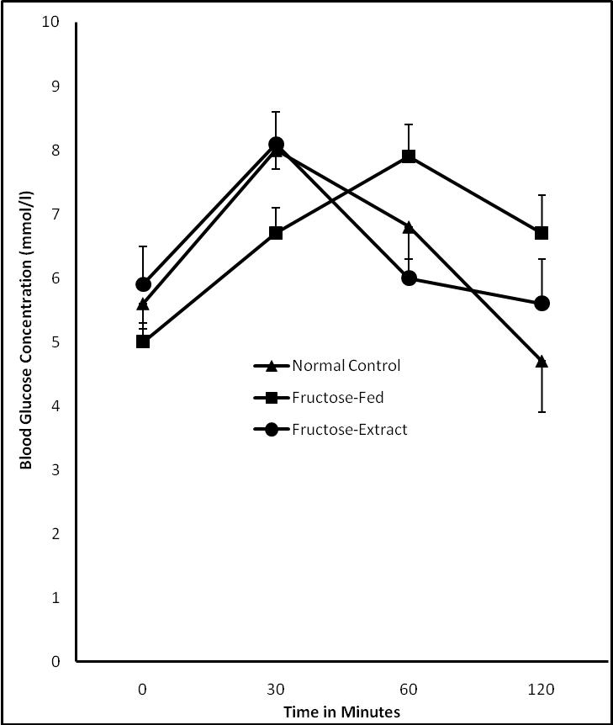

Figure 1. The blood glucose concentration of different groups of rats at different time points of oral glucose tolerance test. Note: Vertical bars represent SEM.

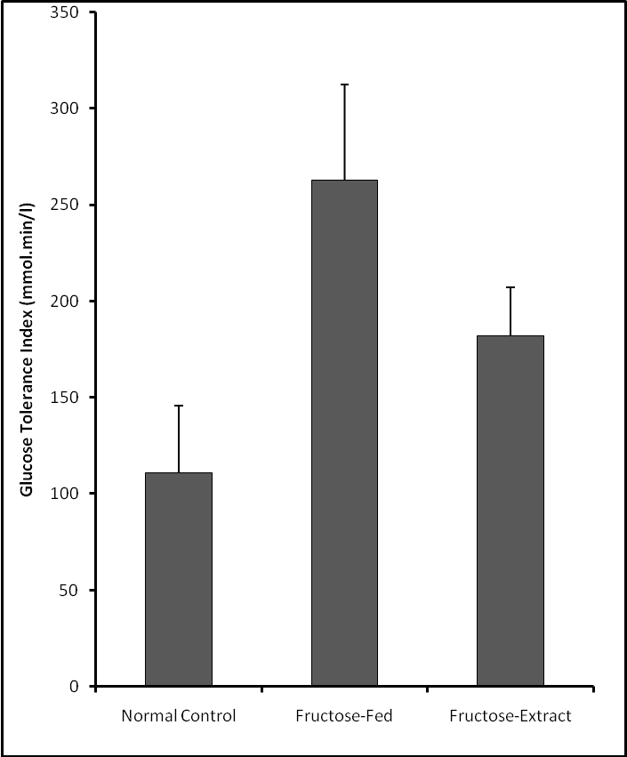

Figure 2. The glucose tolerance index (GTI) in different groups of rats. Note: Vertical bars represent SEM.

4. Discussion
It is now well established that fructose feeding causes insulin resistance in experimental animals. There is therefore little or no doubt that the glucose intolerance observed in this study is a consequence of insulin resistance induced by excess fructose feeding in the rats. However, Concomitant measurement of insulin by radioimmunoassay would have been more elucidating. Previous studies carried out in rats and other rodents indicated similar effect of excess fructose intake on carbohydrate metabolism (Bezerra et al, 2001; Harati et al, 2003). Thus an adverse effect of fructose on insulin sensitivity is now well established. Several mechanisms have been suggested for the phenomenon of fructose-induced insulin resistance. One proposed mechanism involves the hypertriglyceridemic effect of fructose (Lee, 1994). Fructose is readily metabolized to fat in the liver and can lead to nonalcoholic fatty liver disease and insulin resistance. A more recently proposed mechanism by Catena et al (2003) indicated that feeding rats with 66% fructose for two weeks caused a decrease in insulin receptor mRNA and subsequent insulin receptor numbers in skeletal muscle and liver. In another recent report, Litherland et al (2004) suggested a mechanism involving GLUT5, a fructose transporter that has high expression in young obese Zucker rats.
It is of interest that F. exasperata, a common medicinal plant, reduced glycaemic response to glucose challenge in fructose induced glucose intolerance in this study. This is more so considering the inadequacy of western medical facilities in many poor countries. When such facilities are available, several problems including treatment complications and compliance problems are usually associated with conventional drug and insulin therapy. The exact mechanism involved in the glycaermic action of F. exasperata is not yet clear; studies are in progress to clarify the effect of F. exasperata on carbohydrate metabolism. The extracts may stimulate insulin secretion by the pancreas or/and enhance insulin sensitivity in various organs especially the muscle and the liver in a manner similar to sulfonylureas. In this study, glucose and the plant extract were administered simultaneously into the rats to determine the pattern of oral glucose tolerance; it is therefore not possible to rule out the possibility that F. exasperata affects intestinal glucose absorption in the rats.
The active ingredient in F. exasperata that is responsible for the glycaemic effect observed in this study is not yet known. Phytochemical studies are needed to clarify this. Data from Iwu (1985) showed the presence of tannins, flavonoids and other compounds in Bridelia ferruginea, an important plant used in Nigeria for the treatment of diabetes. Ijeh and Ukweni (2007) recently showed that F. exasperata also contains tannins, flavonoids and other compounds including akaloids, saponins and glycosides. Thus the glycaemic effect of F. exasperata may be due, at least in part, to one or more of these constituents. Activity-guided phytochemical studies will, however, be elucidating.
The results of this study support the call urging the general population particularly the diabetics to reduce their fructose consumption. The general increase in the intake of refined carbohydrate and especially fructose correlates positively with an alarming increase in metabolic syndrome including insulin resistance. It is noteworthy that despite all the evidence implicating fructose in metabolic syndrome, there are claims that there is no link between fructose, being an ordinary sugar, and the syndrome. Such campaigns rely, partly, on nutritional researches that are funded by companies that have financial interest in the outcome of such studies. We should guide against another episode similar to that of tobacco when lobbyist consistently denied that tobacco causes lung cancer until they had to accept.

Acknowledgement
We thank the entire staff of the Department of Cell Biology and Genetics, University of Lagos, Lagos, Nigeria for their support. The secretarial assistance by Mrs. T. B. Taiwo.

Correspondence to:
Idowu Adewumi Taiwo
Department of Cell Biology and Genetics, university of Lagos, Akoka, Lagos 101017, Nigeria
Telephone:+234-01-5454891-3,+234-01-4972730-5; Ext. 2331
Cellular phone: +234-803-326-6013.
E-mails: tai_dex@yahoo.com

References
[1] Harati M, Ani M, Messipour M. Effect of vanadyl sulfate on fructose-induced insulin resistant rats. Iranian Biomedical Journal 2003; 7(4): 179-182.
[2] Basciano H, Federico L, Adeli K. Fructose, insulin resistance and metabolic dyslipidemia. Nutrition and Metabolism 2005; 2: 5-28.
[3] Emilien G, Maloteaux JM, Ponchon M. Pharmacological management of diabetes: recent progress and future perspective in daily drug treatment. Pharmacology and Theapeutics. 1999; 8(1): 37-51.
[4] Hallan, P. Population dynamics of Fig wasps from Ficus exasperata Vahl. Proc. Kon, ned. Akad-we ser. C. 1999:87:365-375.
[5] Abbiw, T., Study of tropical shrubs and plants. Journal of Biogeography 1990; 23:591-602.

[6] Ijeh I.I.,and Agbor, C. Body and organ weight changes following administration of aqeous extracts of Ficus exasperata Vahl on white albino rats. Journal of animal and veterinary advances 2006;5(4):277-279.
[7] Odeigah, PGC, Taiwo IA, Onokpite GO. Effect of salt and chilli pepper on oral glucose tolerance in normal and alloxan-diabetic rats. International Diabetic Digest 1994;5: 70-73.
[8] Lebovitz, HE, Feinglos, MN. Mechanism of action of the second-generation sulfonylurea glipizide. In: The American Journal of Medicine (Proceeding of a Symposium). 1983: 46-54.
[9] Bezerra RM, Veno M, Silva MS, travares DQ, Carvallo CR, Saad MJ. A high fructose diet induces insulin resistance but not blood pressure in normotensive rats. Brazilian Journal of Medical and Biological Research 2001; 35(9): 1155-1160.
[10] Lee MK, Miles PDG, Khoursheed M, Gao KM, Moosa, AR, Olefsky JM. Metabolic effects of troglitazone on fructose-induced insulin resistance in rats. Diabetes 1994; 43: 1435-1439.
[11] Catena C, Glacchetti G, Novello M, Collussi G, Cavarape A, Sechi LA. Cellular mechanisms of insulin resistance in rats with fructose-induced hypertension. America Journal of Hypertension 2003; 16: 973-978.
[12] Litherland GI, Hajduch E, Gould GW, Hundal HS. Fructose transport and metabolism in adipose tissue of Zucker rats: diminished GLUT5 activity during obesity and insulin resistance. Molecular and Cellular Biochemistry 2004; 261:23-33.
[13] Iwu MM. The hypoglycaemic effect of Bridelia ferruginea. Fitoterapia 1983; 54(6):243-248.
[14] Ijeh II, Ukweni AI. Acute effect of administration of ethanols extracts of Ficus exasperata vahl on kidney function in albino rats. Journal of medicinal plant research. 2007; 1(2):027-029.

11/30/2009

