Prevalence of Rabies Virus Antigens in Apparently Healthy
Dogs in Yola, Nigeria
Aliyu, T. B¹. , *De, N¹. , Yenda, E.N² And Lynn, .M¹
- Department of Microbiology, School of Pure and Applied Sciences, Federal University of Technology, P. M. B.2076, Yola, Nigeria. Phone: +2348050890271,
2. Health Services Management Board, P.M.B. 1082, Jalingo, Taraba State, Nigeria
e-mail: nanditamicrobio@yahoo.com
*To whom all correspondence should be addressed
Abstract: Fifty dog heads were collected from apparently healthy dogs slaughtered in Jambutu, Army Barracks, Borronji and Mbamba wards of Adamawa State, Nigeria. These were subjected to Microscopic examination of Negri bodies (M.E.N.) and Fluorescent Antibody Test (F.A.T) for the examination of rabies virus antigens. Investigations were done on the following parameters: age, type of tissues, sex, location and nature of management to see the relationship with rabies antigen presence in apparently healthy dogs slaughtered in the different locations. Out of 50 samples, 22 (44%) of them using F.A.T and 13 (26%) of them using M.E.N were found to be positive for rabies antigens. The findings for this work revealed that there is no significant statistical difference in age, sex, nature of management, types of tissues and locations in respect to the positivity or presence of rabies virus antigen at p0.05. The results of this work has now provided a basis for the reassessment of dog bite cases for the institution of proper prophylactic cover for human and dog populations. [Researcher. 2010;2(2):1-14]. (ISSN: 1553-9865).
Keywords: Prevalence; Rabies Virus; Antigens

Introduction
Rabies is one of the most feared of all diseases because its terrifying symptoms almost invariably end with death. Rabies remains incurable and survivors are extremely rare (Alvarez et al., 1996). The rabies virus is the type species of the Lyssavirus genus, which encompasses other similar viruses. The rabies virus travels to the brain by following the peripheral nerves. The incubation period of the disease depends on how far the virus must travel to reach the central nervous system, usually taking a few months.
The cause of rabies is the rabies virus, a member of the Rhabdovirus family ((Nadin-Davis et al., 2008). Rabies is found in most countries of the world except for few areas such as Australia, New Zealand, Japan, Taiwan, Hawaii various pacific Island that are rabies free (Kaplan, 1977,Kureishi , 1992, Ogboegbulem, 1994, Kwasari and Baba, 2000). In Africa, rabies is endemic and widespread. Cases of animal and human rabies are recorded each year from all the ecological zones and sub-regions in the continent. In unvaccinated humans, rabies is almost always fatal after neurological symptoms have developed, but prompt post-exposure vaccination may prevent the virus from progressing. Rabies kills around 55,000 people a year, mostly in Asia and Africa. There are only six known cases of a person surviving symptomatic rabies, and only three known cases of survival in which the patient received no rabies-specific treatment either before or after illness onset( Jordan., 2008)
Like other viral diseases, it begins with fever, head and muscle aches, soar throat, fatigue and nausea. The characteristic symptoms that strongly suggests rabies is a tingling sensation at the site of viral entry, usually an animal bite. These early symptoms generally begin 1 to 2 months after viral entry and progress rapidly to symptoms of encephalitis, agitation, confusion, hallucinations, seizures, and increased sensitivity to light, sound and touch (Haig, 1976, Moran, et al., 2008).
Two of the dogs, inoculated with a rabies virus strain from Ethiopia recovered from clinical rabies (Fekadu and Baer, 1980). This implies that virus carrying and virus excreting healthy dogs are assumed to exist. The implication of healthy carriers, in-apparent infection and recovery from clinical rabies is that they compound human exposure to unrecognized carriers (Ogboegbulem 1994 and Ajayi et al., 2006). Between 1980 to 1998 there were eleven children with rabies in Sokoto, Nigeria (6 males, 5 females, aged 3 to 13 years old) all had history of dog bites but in only 2 cases was post exposure anti-rabies vaccination commenced (Ahmed et al., 2000). The incubation period was between 1-3 months and mortality was 100%. Ogboegbulem (1994) cited 6 cases of fatal rabies in children bitten by apparently healthy dogs. Vereraghavan, 1964 stated that the biting dogs remained healthy even after the children developed clinical rabies in India. Similarly, in Vietnam, clinical rabies occurred in 2 out of 10 person bitten by the same apparently healthy puppy over a period of 26 days. In Ethiopia, some biting dogs were known to have survived their victims. One survey of apparently healthy dogs in Thailand revealed that 4 percent were carriers of rabies virus (Kaplan, 1969).
The pattern of rabies in Nigeria still implicates dogs as the principal vector of the disease (Tomori, 1980). Dogs are listed as only moderately susceptible but are without any doubt the animals most likely to spread infection to human beings, while squirrels and other rodents are also susceptible ((Nadin-Davis et al., 2008).
In Nigeria, particularly in Maiduguri, a survey of the apparently healthy dogs revealed that 32 percent were carriers of the rabies virus (Baba, 2006) and in another studies carried out in the Northwestern states of Nigeria the results revealed that 23.1 percent were positive for rabies (Garba, 2005; Garba, 2007).
In the USA, Canada, and Western Europe, where canine rabies has been controlled, dogs are responsible for very few cases. Rather, human rabies develops from bites of wild animals (especially bats, squirrels, rats, raccoons, skunks and foxes) or occurs in travelers bitten by dogs else where in the world. (Dato et al., 1995; Smith, 1996).
Human to human rabies infection is very rare. The only documented case involved rabies transmitted by cornea transplants; the corneas came from donors who died with undiagnosed central nervous system diseases, and the recipients died from rabies 50-80 days later (Clark et al.,1975). Raccoons are an important reservoir for rabies in the USA and account for over half of all reported cases of animal rabies. The raccoon rabies epizootic has spread and now covers the eastern USA into Canada, (Hemachuda, 1994). Bats present a special problem because they may carry virus while they appear to be healthy, excrete it in saliva and transmit it to other animals and to humans (Dato and Sorhage, 1993).
In a study using two groups of apparently healthy slaughtered dogs, the owned and the stray (ownerless) dogs were examined for the presence of rabies virus antigen in their tissues (brain and salivary gland). It was observed that the dogs under the different management systems were equally vulnerable to sub-clinical or non-fatal rabies virus infection.
Repeated isolation of rabies virus from healthy dogs for a period of more than seven years has been reported (Fekadu, 1975). In addition, reports from rabies endemic areas have consistently indicated that apparently healthy dogs could excrete rabies virus in their saliva for long period without showing sign and symptoms of the disease (Fekadu, 1975).In addition, reports from rabies endemic areas have consistently indicated that apparently healthy dogs could excrete rabies virus in their saliva for a long period without showing signs and symptoms of the disease (Fekadu, 1975). Furthermore, in a study carried out in Ethiopia, it was observed that dogs inoculated with rabies virus later recovered from clinical rabies indicating that the virus carrying and virus excreting healthy dogs could exist (Fekadu and Baer, 1980). In general, many reported cases in Africa and elsewhere show that clinical rabid dogs may not die but recover and continue to live as carriers (Arko et al., 1973,Fekadu, 1975; Bell, 1975).
The possibility of carrier state in rabies virus infection indicates that the virus antigen or infectivity may be demonstrated in salivary gland and not in the brain.
Consequently, in addition to brain samples, it has been recommended that samples of submaxillary gland should also be submitted for rabies diagnosis (Fekadu, 1975). The implication of healthy carriers in-apparent infection and recovery from clinical rabies is that they compound human exposures to unrecognized carriers.
F.A.T is now the most widely used method for diagnosing rabies infection in animals and humans. It is carried out as microscopic examination, under ultraviolet light, of impressions, smears or frozen sections of nervous tissues after treatment with antirabies serum or globulin conjugated with flourescein Isothiocyanate. The test is accurate and results can often be obtain within 30 minutes of reaction with specimen, although for routine purposes a period of 2 - 4 hours is desirable for the fixation in acetone.
Historically, microscopic examination of histological preparations was the primary means of identifying evidence of rabies infection in post mortem samples from animals and humans. Fresh brain smears or microtome-cut sections of formalin fixed paraffin-embedded tissue were stained with combinations of basic fuchsin and methylene blue or with hematoxylin and eosin (Tierkel and Atanasiu, 1996). Histopathologic evidence of encephalitis includes signs of inflammatory response, such as perivascular cuffing and cellular infiltrations. The presence of acidophilic intracytoplasmic inclusions, called Negri bodies, found prominently in the purkinje cells of the cerebellum and the pyramidal cells of the hippocampus, is virtually pathognomonic for the disease (Perl and Good, 1991)
The vaccination records of dogs in Adamawa State is grossly inadequate going by the Vaccination records from the ministry of Animal health and nomadic settlement in the State, it meant a lot of dog population remain unvaccinated and thus posing a lot of threat to human and other animal population.
The other statement of problem emanates from the facts that there are a lots of dog bites in the local Government Areas as being reported to the Ministry of Animal Health and Nomadic settlement by the Ministry of Health.
The above stated problems of rabies carriers and rabies excreting healthy dogs remain unexplored. The public health presumption is the constant risk of human exposures to dog bites and rabies from healthy carriers and in-apparent rabid dogs. It is these problems and especially the absence of research evidence, that this work was aimed at determining the prevalence of rabies antigens in apparently healthy dogs in Yola, Nigeria.

MATERIALS AND METHODS
3.1 Study area
The four specific study areas namely Jambutu slaughter area, slaughter point of Mammy Market in the Army Barrack of 232 battalion, slaughter area in Borronji and slaughter area in Mbamba were selected for this research work. All the areas are located in Yola, Adamawa State.
These areas are chosen because they are known to be the only existing dog slaughter points, as such make it easier and more assessable for such specimens to be collected or purchased.
Sample collection

A total of fifty(50) dog head samples were collected from the above mentioned four areas over a period of three months ( January – March, 2008). The labeled head samples were then placed in polythene bags and were transported on an ice pack to NVRI laboratory in Kofare, Yola Adamawa State, Nigeria. The head samples were later processed by extracting the cerebellum, salivary gland Hippocampus and Gasserian ganglion using the method specified by Kaplan and Koprowski , 1973).
3.4.1 Extraction of Hippocampus, cerebrum, cerebellum and gasserian ganglion
On arrival at Kofare laboratory, the heads were processed immediately. For opening the heads and collection of the brain, the heads were allowed to thaw and be held firmly in a vice fitted on the operation table with the roastral end of the head facing downward, while the dorsal surface of the head facing the operator.
A midline incision was made on the dorsal surface of the head using scalpel and blade. The skull was then exposed by dissecting away the skin, aponeurosis and temporal muscles and reflecting them laterally. The skull was sawed using hacksaw by making two latero-medial cut through the occipital bone, then the temporal bones and finally joining these two lateral cuts at a mid point just above the eyes.
The calvarium was lifted off by the aid of a strong thumb forceps, the meninges and the optic nerves were cut with the help of rat tooth forceps and a pointed scissors. The two parts of head were then untied from the vice and turn upside down and using a scalpel blade, the brain sample was then transferred onto a polythene bag and then placed on the table to remove the hippocampus, cerebrum, the cerebellum and the Gasserian ganglia in the brain.
Each of the hippocampus, cerebrum, cerebellum and gasserian ganglion was placed in a pre-labelled EDTA free bottle and the bottles with the samples were placed in a deep freezer at -20⁰C till when ready for use. The same procedures was carried out for all the other head other samples.
3.4.2 Extraction of the salivary gland
Generally, the submaxillary salivary glands are the ones removed and examined (Kaplan & Koprowski, 1980). The gland was dissected out from fibrous tissues and was placed in a sterile petridish. The extracted salivary gland was then stored in an EDTA free bottle at -20⁰C in the deep freezer until when needed.
  - Processing of the Brain (Hippocampii, cerebrum, cerebellum and gasserian ganglion) and salivary gland samples.
Each of stored brain & salivary gland samples were removed from the refrigerator and were allowed to thaw and then subjected to Fluorescent antibody test (F.A.T) and microscopic examination for Negri bodies (M.E.N). (Atanasiu, 1975).
3.5. Microscopic examination for Negri bodies using Seller’s staining procedure
Small transverse sections of the brain area were cut and placed on a wooden or clean white paper with the cut surface facing upwards. Then a clean grease-free microscopic slide was touched against the brain section and press gently downwards. The pressure exerted was just enough to create an impression of the cut surface of the brain tissue onto the slide as one or two impressions of the same cut surface were made on the same slide. At least two slides samples were made for each of the samples from the hippocampus, cerebrum, cerebellum, gasserian ganglia and salivary gland. (Ogboegbulem, 1994, Baba et al., 2006). The slide was then flooded with sellers working reagent and was allowed to stain for 5 seconds. The slide was washed quickly with buffered distilled water and was allowed to dry quickly without blotting. The slide was then examined under x 100 magnification for intracytoplasmic inclusion Negri bodies.
3.6.2 Fluorescent antibody Test (F.A.T)
Rabies direct fluorescent antibody assay DFA (monoclonal antibody FITC – conjugate) reagents from Fujirebio Diagnostic Inc Malvern, P.A 19355 was used and the working (reagent) dilution was prepared in accordance with the manufacturers recommendations (Flamand et al, 1980).
The FA test was carried out in accordance with the procedures described by Kissling (1975). A small fraction of the brain sample was smeared using wire loop on one part of a slide and then was air dried and fixed in acetone. Another smear was prepared on other part of the slide using the same method. The smears were then stained , one with conjugate mixed with equal parts of 20% rabies-infected mouse brain (RMB) in diluents, the other conjugate mixed with equal part 20% normal mouse-brain in diluents (NMB). Known rabies positive and rabies negative smears in each run should also be stained with both preparations of the conjugate.
Excess conjugate was removed from the slides by briefly rinsing with working PBS solution. It was then washed for 10 minutes with working PBS solution once during this time. It was briefly washed once with distilled water to remove salt and was allowed to air dry. The cover slips were mounted with buffered Glycerol Mounting medium and the slides were examined with a fluorescence microscope within 2 hours.
If brilliant apple-green fluorescence is exhibited in the first impression (adsorbed with normal mouse brain suspension), and diminished staining is exhibited in the second impression (adsorbed with rabies-infected mouse brain suspension), the test slide is positive. If no specific apple-green fluorescence is exhibited in either impression, the test slide is negative, If comparable fluorescence is presented on both the impression stained with NMB-adsorbed conjugate and the impression stained RMB-adsorbed conjugate, the reaction cannot be considered positive.
RESULTS
4.1 Distribution of slaughtered dogs by management
This Study revealed that out of the 50 dogs examined, 15 were owned dogs, and 35 stray dogs. Among the owned dogs, 5(33.33%) showed positive for F.A.T and 5(33.33%) showed positive for M.E.N . Among the 35 stray dogs slaughtered 17( 48.57%) showed positive for F.A.T and 8( 22.86%) showed positive for M.E.N.
Chi square analysis revealed that the value of X² calculated (0.403 for F.A.T and 0.178 for M.E.N) was less than X² tabulated (3.841) in both the cases, therefore there was no significant differences (at p0.05) between owned and stray dogs with respect to positivity or incidence of rabies antigen in the two groups of dogs. (Table 4.1).

Table 4.1: Nature of management of dogs in relation to rabies antigen presence using both F.A.T and M.E.N
Nature of dog  management | No slaughtered | No. (%)of dogs positive  For rabies  (F.A.T) M.E.N
Owned dogs  Stray dogs (ownerless)  Total | 15 (30%)  35(70)  50 | 5(33.33%) 5(33.33)  17(48.57) 8(22.86)  22 13

4.2 Distribution by sex of apparently healthy dogs.
Analysis of sexual distribution of slaughtered dogs revealed that more male dogs i.e. 30 males were slaughtered and only 20 female dogs were slaughtered. Out of the 30 males, 15 (50.00%) showed positive for F.A.T and 5( 33.33%) showed positive for M.E.N While among 20 female dogs slaughtered, 7( 35.00%) showed positive for F.A.T and 8( 22.86%) showed positive for M.E.N X² calculated ((0. 57 for F.A.T and 0.039 for M.E.N) was less than X² tabulated (3.841) in both the cases, therefore there was no significant differences (at p0.05) between male and female dogs with respect to positivity or incidence of rabies antigen in the two groups of dogs (Table 4.2).

Table 4.2 Sex distribution of dogs in relation to rabies antigen presence, using F.A.T and M.E.N
Sex | No slaughtered | No(%) of dogs positive for rabies  (FAT) (M.E.N)
Males | 30 | 15(50%) 5(33.33)
Females | 20 | 7(35%) 8(22.86)
Total | 50 | 22(44%) 13(26.00)

4.3 Age distribution among slaughtered dogs
The ages of dogs were classified into two (2) as adults and puppies and were investigated in relation to the presence of rabies virus antigen. Of the 50 brain and salivary gland samples from apparently healthy slaughtered dogs the results show that 4(8%) puppies were slaughtered with 1(5%) positive while 46(92%) were adult dogs with 21(95%) showing positive, as shown in Table 4.3
Since X² calculated ((0.075 for F.A.T and 0.299 for M.E.N) was less than X² tabulated (3.841) in both the cases, therefore there was no significant differences (at p0.05) between sex and positivity or incidence of rabies antigen in the two groups of dogs.

Table 4.3 Age distribution of apparently healthy dogs in relation to rabies positivity using F.A.T and M.E.N
Age | No slaughtered | No(%) of dogs positive for rabies  (FAT) (M.E.N)
Puppy | 4 | 1(25.00) 1(25.00)
Adult | 46 | 21(45.65) 12(26.09)
Total | 50 | 22(44.00) 13(26.00)

4.4 Distribution of samples according to the locations and the type of tests.
The results in table 4.4 showed the prevalence of rabies virus antigen among dogs in different locations. The prevalence of rabies virus antigen in Mbamba was 33.33% using F.A.T and 16.67% using M.E.N. while in Army Barracks the corresponding values were 10(50.00%) and 5(25.00%) for F.A.T and M.E.N respectively. The results obtained from Borronji indicated that 4 (50.00%) and 3(37.5%) dogs were tested positive for rabies virus antigen using F.A.T and M.E.N. The respective values for Jambutu area are 6(37.5%) using F.A.T and 4 (25.00%) using M.E.N.
Since X² calculated ((0.38 for F.A.T and 0.481 for M.E.N) was less than X² tabulated (3.841) in both the cases, therefore there is no significant differences (at p0.05) between location and positivity or presence of rabies antigen in the slaughtered dogs.

Table 4.4 The distribution of samples according to the locations and the type of tests (F.A.T or M.E.N).
Location | No slaughtered | No of dogs(%) positive for rabies using F.A.T M.E.N
Mbamba | 6 | 2(33.33) 1(16.67)
Army barracks | 20 | 10(50.00) 5(25.00)
Borronji | 8 | 4(50.00) 3(37.50)
Jambutu | 16 | 6(37.50) 4(25.00)
Total | 50(100) | 22(44.00) 13(26.00)

4.5 Tissue assay for positive samples
The results of tissue assay for positive rabies antigen presented in Table 4.5 revealed that out of 50 hippocampii sanples, 22(28.2%) were positive for rabies antigen, out of the 50 cerebrum samples 12(15.4%) were positive for rabies virus antigen, out of 50 cerebellum samples 13(16.7%) were positive for rabies antigen, while out of 50 samples of gasserian ganglia 14(17.9%) showed positive for rabies antigen and out of 50 salivary gland samples 17(34.00%) showed positivity for rabies antigen (Table 4.5).
Since X² calculated is less than X² critical in both the cases, therefore there is no significant differences (at p0.05) between type of tissue and positivity or incidence of rabies antigen in the slaughtered dogs.

Table 4.5: The results of test performed on different tissues from apparently healthy dogs.
Tissues | Total no of tissues tested | No of dogs(%) positive for rabies using F.A.T M.E.N
Hippocampus | 50 | 22(44.00) 13(26.00)
Cerebrum | 50 | 12(24.00) 11(22.00)
Cerebellum | 50 | 13(26.00) 10(20.00)
Gasserian ganglion | 50 | 14(28.00) 11(22.00)
Salivary gland | 50 | 17(34.00) 12(24.00)
Total | 250 | 78 57
X² calculated = 1.82 and X² tabulated = 9.488 at p 0.05 using M.E.N
X² calculated = 0.581 and X² tabulated= 9.488 at P0.05 using F.A.T

4.6 Kappa test for agreement between two tests, F.A.T and M.E.N

Table 4.6: Kappa test for agreement between two tests, F.A.T and M.E.N
F.A.T |  | Total
M.E.N  +  - | + -  13 0  9 28 | 13  37
Total | 22 28 | 50

Agreement between M.E.N. and F. A. T. for rabies diagnosis of the 50 test samples was performed using Kappa test.
The sensitivity and specificity were also determined as described by Noordhuizen et al., (1997).
The 13 samples that were positive for M.E.N, all were also positive for F.A.T
Those with high intensity and quantity of fluorescence by F.A.T were all positive by M.E.N. Comparing the agreement by the two test (M.E.N & F.A.T) when kappa = 0, there is no agreement and when Kappa is 0.4 to 0.6 there is moderately good agreement and when between 0.6 to 0.8 there is good agreement. In the present study there was a good agreement between M.E.N and F.A.T ie Kappa = 0.62
DISCUSSION
The presence of rabies antigen in apparently healthy dogs in this studies agreed with earlier works that apparently healthy dogs could excrete rabies virus in their saliva for a long period without showing signs and symptoms of the disease. Repeated isolation of rabies virus from healthy dogs for a period of more than seven years has been reported (Fekadu, 1975). Furthermore, in a study carried out in Ethiopia it was observed that dogs inoculated with rabies virus recovered from clinical rabies carrying and virus excreting healthy dogs could exist (Fekadu and Baer, 1980).In general, many reported cases in Africa and elsewhere showed that clinically rabid dogs may not die but recover and continue to live as carriers (Arko, et al.,1973; Fekadu, 1975; Bell, 1975). The results of this study have therefore suggested the possible carrier state of rabies among stray and owned dogs regardless of the age, sex, tissues (brain and salivary gland) and their location. The carrier state of rabies could pose serious public health problem in the endemic areas of Africa. However, the role of the “rabies virus strain” (Isolated from the carrier dogs) in the epidemiology of the disease deserves further investigation.
The possibility of carrier state in rabies virus infection indicates that virus antigen or infectivity may be demonstrated in salivary gland and not in the brain. In this study we compared the agreement, sensitivity and specificity of two different staining techniques (Sellers and immunoflourescence (F.A.T) procedures) for the demonstration of inclusion bodies and rabies virus antigen respectively in tissues from slaughtered dogs. The immuno-flourescence staining technique recorded the highest sensitivity when compared to the Microscopic Examination of Negri bodies (MEN) technique (Seller) method used. These agreed with the findings of Ajayi et al., 2006 and Garba, 2007
Also in this study the age, sex and location of the dogs in question were examined to investigate the relationship between these variables and the presence of the rabies antigen. It was shown from Table 4.2 that there are more male dogs positive for rabies virus antigen than female dogs. The possible reason could be that more male dogs were slaughtered than female dogs during the period of this study, possibly due to some population dynamics factors like breeding and sex i.e. many male dogs chase female dogs and in the process compete with other males resulting in a lot of cases of bites between the male dogs during fighting. The male dogs may be bitten by possibly infected dogs and thus propagate the spread in the males more than the females. This result agreed with the work Ajayi et al., 2006.
Adult dogs ( 95.00% positive) were more affected with rabies virus antigen than the puppies (5.0%). This may be due to the fact that adults are more prone and vulnerable due to their nature of movements and wider activities, than puppies which are mostly home - bound, This result agreed with that of Baba, 2006 which showed that more adult dogs tested positive for rabies virus antigen compared to the puppies.
The location distribution of slaughtered dogs and rabies antigen presence revealed that more number of rabies virus positive dogs were slaughtered in Army Barrack followed by Jambutu then followed by Borronji and lastly followed by Mbamba slaughter point. The probable reason for more positive samples in the Army Barrack might be due to more number of dogs slaughtered and probably this location has more cases of infection than the other locations in the study area.
There was a good agreement between the two tests i.e M.E.N and F.A.T, results with Kappa value of (0.62). This finding agreed with the report of Zelia et al., (2000) and Garba, (2007). Another important revealation was that, of the 22 specimens that tested positive for rabies antigen by F.A. technique 13 specimens were positive by M.E.N. indicating that F.A.T is more sensitive and specific than M.E.N.
The study has established a proportion of 44% of rabies antigen in apparently healthy dogs in Yola, Nigeria using Microscopic Examination of Negri bodies (M.E.N) and Fluorescent Antibody Test (F.A.T). The results of this study have provided strong evidence that apparently healthy dogs could be potential source of rabies virus for man and other animals in this environment. The immunoflourescent techniques has demonstrated high sensitivity and specificity as well as potentials for wide application and could therefore be useful for rabies diagnosis and investigation in endemic areas of Africa especially in the rural areas of Nigeria. Concerted efforts thus need to be made in order to control the owned and stray dog populations.
With 34.00% positivity for rabies antigen in the salivary gland, it is tempting to conclude that every normal dog bite should be considered necessary for anti-rabies post exposure treatment in this environment. These results may serve as a guide for adequate pre and post exposure rabies vaccination coverage especially when there is a bite from apparently healthy dogs.

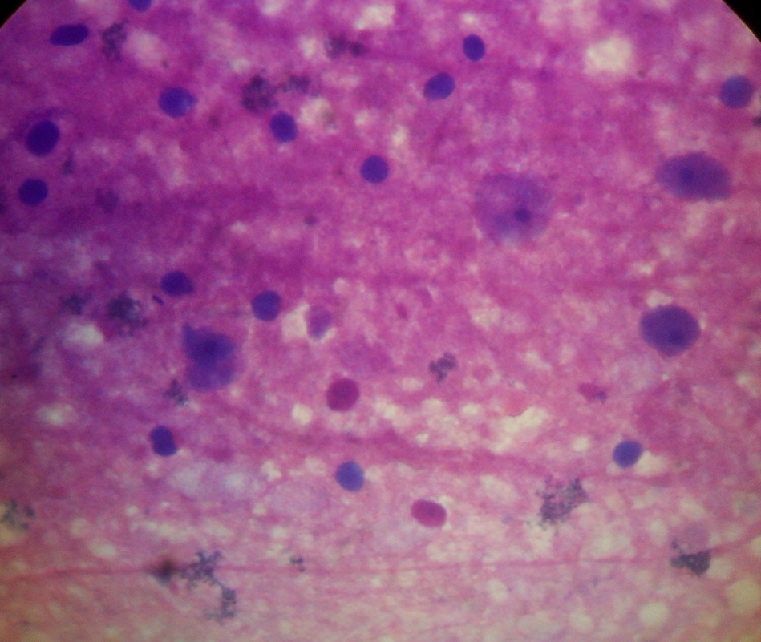
Plate 1. Positive stained slide with Negri bodies

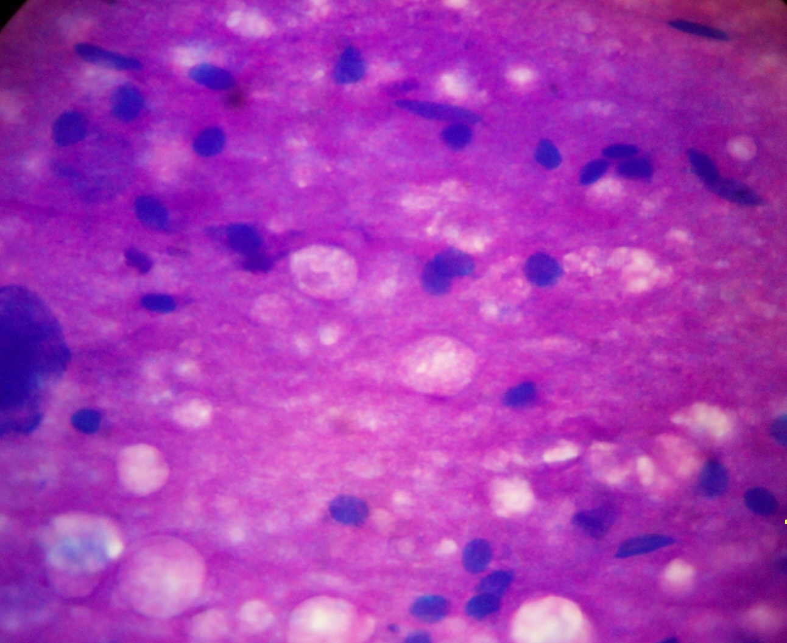
PLATE 2. Negative stained slide with no Negri bodies

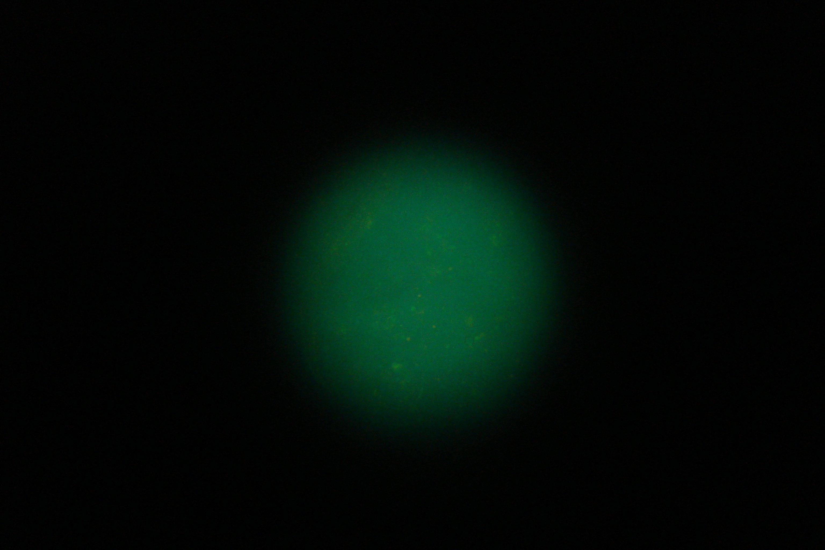
PLATE 3. Positive slide for rabies viral antigen showing apple green flourescence


PLATE 4. Negative slide for rabies viral antigen with no apple green flourescence

REFERENCES
Ahmed H; Chafe, U.M; Magaji, A. A.; and Abdulqadir A; (2000): Rabies and dog
bite: A decade of experience in Sokoto, Nigeria; Sokoto Journal of Veterinary
Science 2 1:Pp 2-10
Ajayi B. B; Rabo, J. S; and Baba, S. S. (2006): Rabies in apparently Healthy Dogs Histological and Immunochemical studies. Nigerian Postgraduate Medical Journal 13: 128-134
Arko, R. J; Schneider L. G; and Baer G. M; (1973) Non-fatal rabies. Amer J. Vet. Res. 34: Pp. 937-938
Alvarez, L.M, Cashat E.A Arellano and G.M Baer, 1996: A New Phenomenon in Rabies: Partial Recovery in Children treated promptly with potent Vaccine, P. 78 in Abstracts of the VII Annual International Meeting on Advances towards Rabies Control in the Americas, Atlanta, Ga.
Atanasiu P (1975) Animal Inoculation and the Negri Body In: The Natural History of Rabies. G.M Baer (ed) Acad Press Inc. New York Vol. 1: pp 373-400.
Baba, S. S. (2006): Detection of Rabies virus RNA and antigen in tissues from naturally infected Nigerian Dogs; Insitu hybridization and Immunohistochemical studies. Rev. Elev. Vet Pays Trop. 52: 85-91
Bell, J. F. (1975). Latency and Abortive Rabies in: the Natural History of Rabies. 1, by G. M. Baer (ed), Academic Press, Newyork, Pp. 331-354.
Clark F, T. Wiktor, and H. Koprowski (1975) Human Vaccines, Past
and Present in: The Natural History of Rabies 2nd ed by G.M Baer, Academic Press New York, PP 341-365.
Dato, V.M and F.E Sorhage (1993). Guide to Pre and Post Exposure
Rabies Treatment N.J Med. 90: 751-754.
Dato, V.M, F.E Sorhage, and K.C Spitany, (1995) Post Exposure
Rabies Prophylaxis. 1 Experienced with a Computerized Algorithm Am. J Public Health 86:1020-1021.
Fekadu, M; (1975). Asymptomatic non-fatal canine rabies. The lancet 1: 569
Fekadu, M., and Baer, G. M; (1980). Recovery from Clinical rabies of 2 dogs inoculated with a rabies virus strain from Ethiopia Amer J. Vet Res. 41 (10): 1632-1634.
Flamand, A., Wiktor, T. J., and Koprowski, H. (1980). Use of monoclonal antibodies in the detection of antigenic differences between rabies virus and rabies related virus proteins: The nucleocapsid protein. J. Gen. Virol. 48, 105-109
Garba, A. Oyetunde, I.L, Kumbish, P.R., Clement A.M Chiko, K.L., Ahmed, J.S., Lapang, H.B., Dashe Y; Tunde O., and Banyigyi, S.A (2005): A Retrospective Study of Biting Dogs and Rabies in Vom Plateau State Vom J. Vet Sci 1: 57 – 63.
Garba, A., (2007) Studies of rabies virus Antigen in the Brain of Apparently Healthy Slaughtered dogs in Sokoto and Katsina, Nigeria. A dissertation for M.Sc unpublished Pp 5-8
Haig, D.A (1976) Rabies in Animals. Rabies: The Facts. Colin Kaplan (Editor) Oxford University Press, London.
Hemachuda, T. (1994) Human Rabies: Clinical aspects. Pathogenesis and potential therapy. Curr. Trop Microbiol, immunol. 187: 121-143.
Jordan Lite (2008-10-08). "Medical Mystery: Only One Person Has Survived Rabies without Vaccine—But How?". Scientific American. pp. 4. http://www.sciam.com/article.cfm?id=jeanna-giese-rabies-survivor&sc=WR_20081014. Retrieved 2008-10-16.
Kaplan, M.M (1969) Epidemiology of rabies. Nature 221: 421-425
Kaplan, C. (1977) The World Problem, Rabies; The facts. Oxford University Press, London.10-21
Kaplan, M.M and Koprowski,H. (1980) Rabies Scientific America PP 103-114.
Kissling, R.E (1975). The Fluorescent Antibody Test in Rabies. In: The Natural History of Rabies by G.M Baer (ed) Vol. 1 Anto Press New York.
Koprowski, H. (1967) in: La rage. Techniques de Laboratoire Monogr. No 23 OMS Geneva P. 72.
Kureishi, A., Xu, L. Z., Wu, H., and Stiver, H. G. (1992). Rabies in China: Recommendations for control. Bull WHO: 70: 443-450
Kwasari A.R.S and Baba, S. S. (2000). The Status of Canine Rabies in Borno Museum Society Newsletter. 2000; 50: 99-122
Moran, G. J., Talan, D. A., Mower, W., Newdow, M. Ong, S., Nakase, J. Y., Pinner R. W., and Childs J. E. (2008). Appropriateness of rabies postexposure prophylaxis treatment for animal exposure JAMA 284; 1001-1007.
Nadin – Davis, S. A.,Casey, G.A., and Wandeler, A.I.(2008). A molecular epidemiological study of rabies virus in central Ontario and western Quebec. J. Gen. Virol. 75, 2575-2583.
Noordhuizen J. P. T. M; Frankena, K; Vander Hoofd, C.M. and Graat, E.A.M (1997). In: Application of Quantitative Methods in Veterinary Epidemiology. Wagen Pers, Netherlands PP 81-82.
Ogboegbulem, S.I. (1994). Rabies in man and Animals Fidelity Publishers. Enugu, Nigeria 1-10.
Perl D.P., and Good, P.F. (1991). The pathology of rabies in the central nervous system. In the Natural History of Rabies, G.M. Baer (ed.), pp 163-190. CRC Press, Boca, Raton, FL.
Smith J.S (1996). New Aspects of Rabies with Emphasis on Epidemiology, Diagnosis and Prevention of the Disease in the United States Clin. Microbiol. Rev. 9:166-176.
Tierkel E.S. and Atanasiu, P. (1996) Rapid Microscopic Examination for Negri bodies and preparation of specimens for biological tests. In Laboratory Techniques in Rabies, F. X. Meslin M.M., Kaplan, and H. Koprowski, (ed.), 4th ed., pp. 55-65. World Health Organization, Geneva.
Tomori, O., (1980) Wildlife rabies in Nigeria. Experimental infection and transmission studies with Shrew (Crocidura Sp.). Ann. Trop. Med. Parasit. 74: 151-156
Vereraghavan,S.K. (1964). Scientific Report “Pasteur Inst. Of Southern India, Coonoor Tamilnadu India.
Zelia,M.P.P; Elenice, M.S.C; Debora, R.V; Suzana, L.G; Ivanete, K. (2000). Rabies laboratory diagnosis peculiar features of samples from equine origin. Braz. J. Microbiol. Vol.31(1).pp1517-8382

1/5/2010

Researcher

Volume 2 - Issue 2 (Cumulated No. 8), 2010, ISSN 1553-9865

