Study of Physical-Chemical Variables and Primary Productivity in Bacanga River Estuary Dam, Sao Luis, Maranhao, Brazil
Ana Paula P. Carvalho^{1*}, Tang Zhonghua¹, Maria Marlucia F. Correia² & Jose Policarpo C. Neto²

¹ China University of Geosciences, 388 LuMo road, Wuhan, Hubei, P.R. China. Zip code 430074
²Federal University of Maranhao, Labohidro, Campus do Bacanga S/N, Sao Luis, Maranhao, Brazil.
*app_carvalho@yahoo.com.br

Abstract: The study of the biological variables and the physical-chemical characterization of the aquatic ecosystems it is an important tool as subsidy not only in the characterization of the environment, but also in the capacity of recharge and sustainable use of the livings resources. The present work approaches the study of the primary productivity related with the physical and chemical variables of the Bacanga river estuary dam (BRED). To study the variables in the water column, samples were taken from four depths according to the light penetration (Subsurface, 50%, 25% and 1%) at a single sampling station during the dry and rainy season. The following variable had been analyzed: pH, salinity, dissolved oxygen, water temperature, light attenuation coefficient, nitrate, nitrite, phosphate, silicate, ammonium, the phytoplankton community - qualitative and quantitative - chlorophyll and primary productivity. The GPP of phytoplankton ranged from 10.0mg.C.m⁻³.h⁻¹to 752.5mg.C.m^{-3.}h⁻¹. The consumption showed the highest value of 1556.7mg.O₂.m-³.h-¹ and lowest of 0.0mg.O₂.m⁻³.h⁻¹, while NPP ranged from -369.3mg.O₂.m^{-3.}h⁻¹ and 702.5mg.O₂.m-³.h⁻¹. A total of 41 taxa were found, being primarily distributed in 7 groups of microalgae: Bacillariophyta, Chlorophyta, Cryptophyta, Crysophyta, Cyanophyta, Euglenophyta and Pyrrophyta. The phytoplankton biomass of BRED ranged from 97.460cells/L (Oct/04 and May/05) to 43.359.370cells/L (Feb/05). The values for the diversity index ranged from 1.06bit.ind⁻¹ to 1.56bit.ind⁻¹, richness from 1.07 to 2.08 and equitability from 0.48 to 0.60. The highest value of diversity, richness and equitability was recorded in February/05, while May/05 and October/04 had the same value for the Diversity Index. For BRED was possible to infer that the contribution of nitrogen and phosphate compounds increased during the rainy season, which could be explained by the increase of water in the drainage system. The gotten results had been important to evaluate the quality of the water of BRED. [Researcher. 2010;2(2):15-24]. (ISSN: 1553-9865)

Keywords: Bacanga River; phytoplankton; primary productivity; physical-chemical variables.

1. Introduction
The estuaries, lagoons and bays are areas rich in fish, mollusks and crustaceans and have intensive human activities. By offering a diversity of resources, are responsible to support small river towns, mainly by the shell fishing activity, which is often considered as the main source of income and food of these populations (Lassere in: Day, 1998). These environments are also used as a route to ecological tourism and are considered recreational areas for sports fishermen and recreational achievements in general (Oliveira, 1999).
The estuaries present unique environmental characteristics that result in high biological productivity. These ecosystems play important ecological roles such as exporting of nutrients and organic substances for adjacent coastal waters, they are vital habitats for species of commercial importance and are rich in many animals from microscopical forms to great fish, birds, reptiles and mammals (Braga and others,. 2000, Pereira Filho and others, 2001; Azevedo and others, 2008).
The biological productivity in coastal areas is almost always related to the abundance of planktonic organisms that are part of the aquatic food chain. Phytoplankton is at the base of the food chain in aquatic environments and, overall, is among of the most important primary producers in these environments (Chiu and others, 1994). According to Tundisi (1976), primary productivity refers to the fixation of inorganic carbon and the gross or net production of organic matter by the photosynthesis process. The light intensity and nutrient availability are important factors to primary productivity in aquatic ecosystems, because they constitute a limiting factor of photosynthesis.
The assessment of primary production in aquatic ecosystems, especially in coastal areas, and the determination of the physical and chemical characteristics of water in this ecosystem are an important tool that aim not only the characterization of the environment, but also the recharge capacity and sustainable use of living resources, especially in environments that suffer extraction or natural and artificial eutrophication (Santos 2002).
Thus, he dynamic of organic and inorganic compounds has a key role in productivity in different ecosystems. Its residence and regeneration in coastal lagoons, estuaries and bays is related to local hydrograph, especially by the action of tides and the incidence of winds. However, the functioning of the ecosystem make other variables be considered, especially physical factors such as salinity and temperature.
In order to obtain the knowledge and analysis of support capacity of the ecosystem, according to the above mentioned author, the measure of primary productivity should be considered as a starting point in these studies because all the organic production of an ecosystem depends on the photosynthetic organisms. The physical and chemical processes of an ecosystem are important with regard to the confirmation of the information obtained from the analysis of primary productivity. According to Herrera-Silveira (1998), the analysis of primary production and environmental factors may provide knowledge about the functional structure of aquatic ecosystems, once that the dynamic of the phytoplankton community, such as species composition, biomass and primary productivity are controlled by physical, chemical and biological factors.
In Brazil, some studies were conducted to study the physical-chemical, biological variables, such as Kampel (2003), lecturing on the estimation of primary production and phytoplankton biomass through remote sensing, and Santos (2002), expounding on the hydrologic characterization and primary productivity of the Bay of Guarapuava-BA. In Maranhão some work has been done addressing the physical, chemical and biological environments, such as, Labohidro (1994, 1998 and 1999), Ramos (2002), Alcantara (2004) and Moreira (2003). For the area subject of this study we can quote Labohidro (1998) and (1994), which deals with environmental assessment of the river Bacanga, Melo (1998), lecturing on the biogeochemical behavior of nutrients in the estuary of the Bacanga river, and Lopes et al., (1994), on the study of plankton (phytoplankton and zooplankton) and physical-chemical factors in the estuary of the Anil and Bacanga rivers.
The present research aimed at studying the qualitative and quantitative composition of phytoplankton and primary productivity in the Bacanga River estuary dam and its relationship with physical and chemical parameters, seeking a greater knowledge about current conditions of the environment studied, and serving as basis for further work.

2. Material and Methods
The study area is located in the northwest quadrant of the island of Sao Luis, between latitudes 2 ° 32 '26 "2 ° 38' 7" S latitude and 44 º 16 '00 "to 44 º 19' 16" W longitude, inserted in the Bacanga river basin, forming an integral part of the Environmental Protection Area called State Park of Bacanga. (Refer to Map 01)
The Bacanga basin covers an area of approximately 11 hectares, being served by the Bacanga River, housing an Environmental Preservation Area and a State Park. The Bacanga River rises in the Maracana, with a distance of 22 km from the source to the mouth, and at this point, is blocked by a dam that connects the historic center of Sao Luis to the district of Anjo of Guarda (Labohidro, 1998 ).
To study the physical-chemical variables, samples were collected in October/2004(dry season), February and May/2005 (rainy season) at a fixed collection station with a Van Dorn bottle (5 L) and at four depths: subsurface (100%), 50%, 25% and 1% radiation. The following parameters were measured “in situ”: salinity, temperature and electrical conductivity (YSI - Model 33), radiation (radiometer Minipa, model ET - 2060). For the determination of total suspended solids, was applied the gravimetric technique described by Teixeira and others, (1965) and Tundisi (1969), and to dissolved oxygen (Winkler, 1888). To determine the hydrogen potential was used Potentiometer Hanna. Nutrient analyses was conduct in laboratory, according to the following methods: nitrite and nitrate (Golterman, 1978), ammonium (Koroleff, 1976), phosphates (Nanzel and Corvin; Gomes, 2001) and silicates (Strickland and Parsons, 1972).
To measure the primary productivity of phytoplankton water samples were collected using a van Dorn bottle. Later, placed in light and dark bottles and suspended in a vertical position in the sampling depth (subsurface, radiation of 100, 50, 25 and 1%). The incubation time was three hours. In the laboratory was used the method of dissolved oxygen (Winkler, 1888). Samples for qualitative and quantitative analyses were obtained using the network of phytoplankton with 65mm and 40 mm opening mesh and Van Dorn bottle, respectively, and fixed with formalin 4%.
3. Results and Discussion
The fact that the environment under study represent the portion of the Bacanga river estuary, located upstream of the dam that divides the estuary imposes, to this environment, characteristics much closer to a reservoir, since most of the time, it behaves like a lentic water body, whose salinity fluctuation depending on the management and behavior of the dam gate that regulates the outflow of freshwater and the inflow of saltwater.
The transparency of the environment is a measure that, under certain circumstances, can be used as an indicator of primary production. Faina (1979), found a close relationship between these two variables. In lakes, where most of the particles in the water column belong to the phytoplankton, the empirical estimation of the amount of phytoplankton can be obtained through the measure of transparency.
The water transparency during the period analyzed showed the lowest value of Secchi disk 0.80m in October/04 and February/05 and the highest 5.35m in May/05. The coefficient of relative transparency of the water, CTR, that express the relation between the Secchi depth and the local depth was 0.10 (October/04), 0.32 (February/05), and 0.33 (May/05).
The light extinction coefficient (k) varied from 0.76 to 2.12. The maximum value was observed in October/04 and February/05. The minimum was recorded for May/05. The time of less C.T.R. (October/04) can be explained by the highest concentration of chlorophyll that varied from 0.5µg/L to 96.35µg/L (Table1), and by the concentration of total suspended solids that ranged from 3.1mg.L⁻¹ to 47.8mg.L⁻¹(Figure1). For both analyses the lowest value was recorded in May/05 and the highest in October/04.
The salinity ranged from 8 to 22 UPS in the water column. The maximum value was recorded in October/04, the dry season, while the minimum was observed during February/05, rainy season. The salinity recorded in May/05 remained on average between the other months (October/04 and February/05), ranging from 11 and 21 UPS. The gradient of salinity increased from surface to the bottom, it was observed to all sampling months. (Figure2).
The maximum daily air temperature observed for the months of sampling were between 31ºC and 34ºC and minimum daily air temperature between 22ºC and 26ºC, being the mean temperature between 26ºC and 29°C. The highest value for the maximum temperatures of 34 º C was observed in all months sampled for study. While the minimum value of 22°C was recorded only for the month of May/05.
The vertical water thermal structure during the period studied showed the following values: a minimum of 29ºC was recorded in October/04, with the maximum of 32°C, in May/05. The greatest amplitude between the first depth (Subsurface) and the last (1% radiation) was 1ºC. As showing in the Figure3 that difference would characterize a thermocline in this environment, wich was observed to all the sampling periods.
The electrical conductivity of water is affected by the total concentration of ions and other factors such as the ability of ions to conduct electrical current. The amplitude of the electrical conductivity was 15.000μS.cm⁻¹ to 40,000μS.cm⁻¹ and its maximum was in October/04 and minimum in February/05. The values for May/05, as well as occurs with salinity, were intermediate between the values for October/04 and February/05. (Figure4).
The highest electrical conductivity of the environment occurred in October. This variation can be explained by a higher nutrient dynamics in the water column, considering mainly the change in the residence time of water resulting from the change in management of the dam gate. Considering the close interrelation of conductivity with salinity, the behavior displayed by these two variables were consistent, which is reinforced by the strong correlation coefficient (r = 0.71).
The radiation in the water column was between 86 cal.cm⁻².dia⁻¹ to 390cal.cm⁻².day⁻¹ on the water subsurface and 3 cal.cm⁻².dia⁻¹ to 9 cal.cm⁻².day⁻¹, in the depth of 1% radiation.

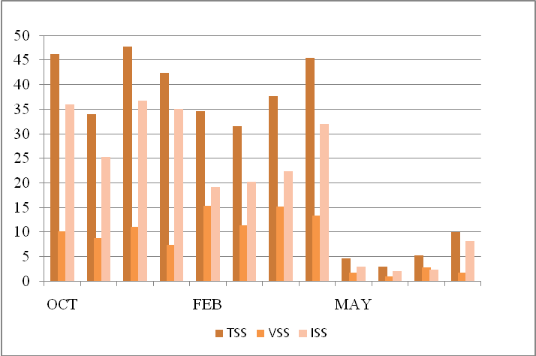
Figure 1. Total suspended in the water colunm during the period studied.

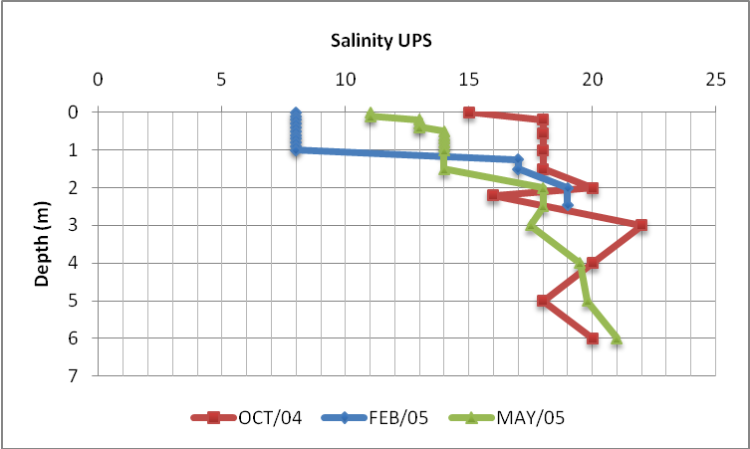
Figure 2. Salinity gradient in the water column during the period studied.

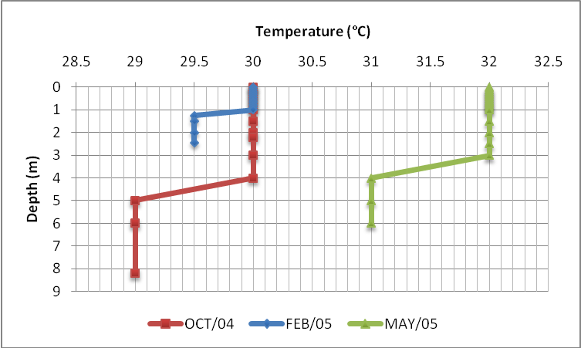
Figure 3. Water column temperature during the period studied.

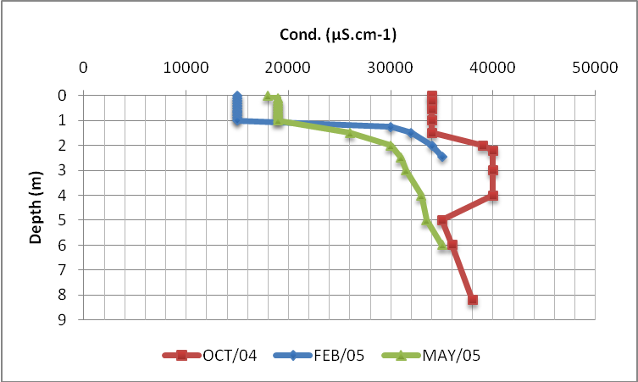
Figure 4. Electrical conductivity in the water colunm during the period studied

The highest surface value was recorded in May/05 and the lowest in February/05. The months of May/05 and October/04 obtained the lowest record of solar radiation at a depth of 1%, the highest value recorded for February/05. (Figure5).
The cumulative daily solar radiation ranged from 98.0cal/cm².dia to 614.2cal/cm².dia, and its maximum value was recorded in October/04 and the minimum, as occurred in the water column was obtained to February/05 (Figure6).

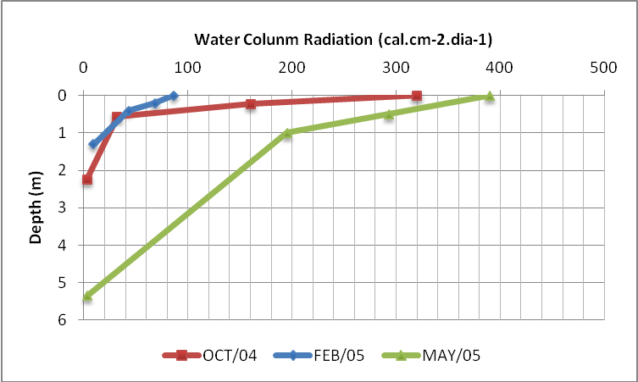
Figure 5. Water column radiation in the water colunm during the period studied.

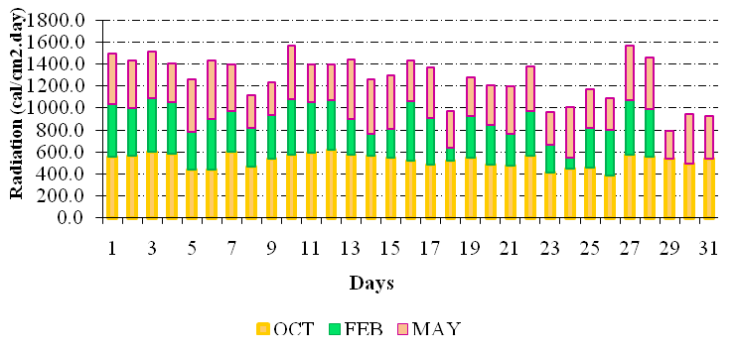
Figure 6. The daily solar radiation during the period analysed

Alkalinity is the ability of an aqueous system has to neutralize (buffer) acids. This ability depends on a few compounds, mainly bicarbonates, carbonates, hydroxides, and the latter anion is rare in most natural waters, usually occurring in water whose pH is greater than 10 (Esteves,1988). The saline and brackish waters typically have high alkalinity, due to high ion concentrations of carbonates and bicarbonates.
The pH ranged from 6.94 to 8.43, the more alkaline environment was in October/04 and slightly acid in February/05. The values closest to the neutral pH, between 7.08 and 7.56 were recorded during February/05 and May/05. (Figure7).
The alkalinity determined for the Bacanga river estuary dam during the presented work ranged from 80.0meq/L to 241.8meq/L. The increase in alkalinity was accompanied by an increase in pH, in almost all samplings, except in May, when the deeper stratum, the pH dropped to 7.51, and alkalinity increased to 101.5meq/L (Figure7). This result, however, can not be explained, because in this stratum, in this period, the primary productivity was relatively high, compared to the above strata. Also, the chlorophyll and the ammonium concentration were high. This increase, however, is of great importance for the presence of high concentrations of ammonium ions (Screckenbach and others, 1975, 1978; Barthelmes, 1976), especially if the balance of the food chain moves towards the primary producers, which is represented by the increase of DO and pH to extreme values. High pH simultaneously with high concentrations of ammonium leads to the production of NH3 in quantities that are harmful to fish.
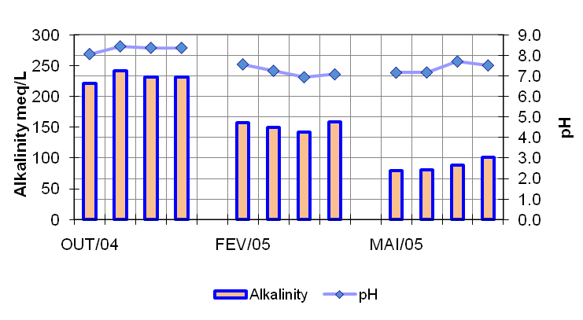
Figure 7. The relationship between pH and Alkalinity in water column during the period studied

The rainfall in the month of October/04 was almost nonexistent, was more evident in the months of February/05 and May/05, the cumulative monthly values to these months is showing in Figure8.
Dissolved Oxygen showed a variation from 1.76 mg.L⁻¹ in May/05 to 11.01 mg.L⁻¹ in October/04. (Table1). According to the results, during the three periods of sampling was recorded an anoxic environment. There was, however, strong hypoxia at a depth of 5.35m in May/05, which can be attributed to heavy rains of the previous day, because, as is natural in this basin, when it occurs, causes carrying of high loads of suspended solids to the river bed, especially to the estuary, its lower part. In Figure1, it is possible observe the concentration of TSS increasing in higher depth, although the largest fraction is made up of inorganic suspended solids. Furthermore, the depletion of oxygen in the hypolimnion, in eutrophic environments, has been described by several Limnologists and Oceanographers (Hino, 1985). The chlorophyll concentration in this layer, recorded 3.5µg/L, relatively low, was the highest value in that month at this time, but would not justify that hypoxia, which suggests that bacteria associated with the decomposition of sewage are the major causative agents of stress.
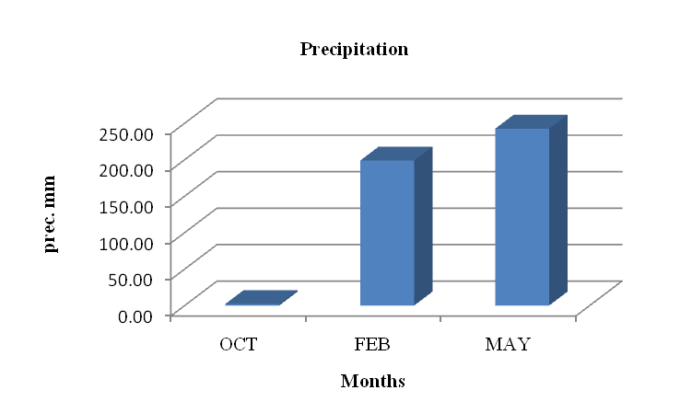
Figure 8. Cumulative rainfall during the period analysed.

The maximum daily wind was between 2m/s and 42.8 m/s, both recorded in May/05, and the daily mean of 2.7m/s and 9.4m/s, was recorded to May/05 and October/04, respectively. (Figure 9)
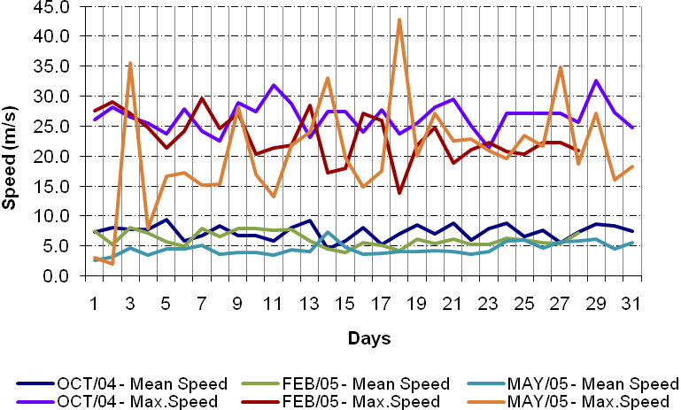
Figure 9. The daily wind speed observed during the period analysed.

In photosynthesis, phytoplankton consumes the CO₂ in the water during the day and increases the pH. Phytoplankton can continue to use small amounts of CO₂ available, at pH values above 8.34. At night respiration produces CO₂ in the water system and the pH decreases.
The pH ranged from 6.94 in February/05, to a maximum of 8.43 in of October/04, when the values of gross primary production were respectively 187.5mg.C.m⁻³.h⁻¹ and 247.5mg.C.m⁻³.h⁻¹. The dynamics of nutrients in the environment may have been influenced by the pulses of suspended solids, organic load represented by sewage and garbage, and the climatologic factors such as wind, rain and radiation.
The gross primary productivity of phytoplankton ranged from 10.0mg.C.m⁻³.h⁻¹, in recorded at a depth of 1m, in May/05, to a maximum of 752.5mg.C.m^{-3.}h⁻¹ in the subsurface and depth of 0.56m, in October/04. The consumption showed the highest value of 1556.7mg.O₂.m-³.h-¹ and lowest of 0.0mg.O₂.m⁻³.h⁻¹, in October/04 and May/05, respectively. The net primary productivity, it presented a range of -369.3mg.O₂.m^{-3.}h⁻¹ and 702.5mg.O₂.m-³.h⁻¹, which correspond to October/04. Showing negative values to October/04 and May/05, when the consumption was more expressive then the gross primary productivity (Figure10).
Values of ammonium, nitrite, nitrate, phosphates and silicate are shown in Table3. The highest values found for the concentration of total dissolved PO₄ occurred in February/05 at a depth of 0.2 m, and in October/04 at a depth of 2.24 m.

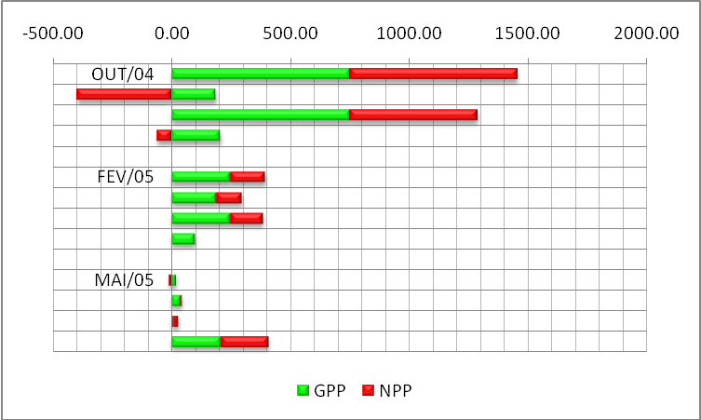
Figure10. Gross primary productivity and Net primary productivity in the water colunm during the period studied.

The concentration of ammonium ion (NH₄ ⁺) in the BRED, was usually quite high, ranging between 185.4µg.L⁻¹ and 780.7µg.L⁻¹. The lowest value found for the concentration of this ion was recorded in October/04 and the highest in the May/05.
The high values shown by the environment for nutrient concentrations can be explained by increased rainfall and the entry of saltwater, especially during February/05 to May/05, when the time of water renewing changed from 10 to 5 days, respectively.
In three periods, in almost all strata, the highest concentrations of nitrogen were in the order: ammonium > nitrite > nitrate. The exception occurred in May/05 at a depth of 1m, which order was: ammonium > nitrate > nitrite, which also had the lowest value of primary productivity and chlorophyll, and also the highest value of dissolved inorganic phosphorus.
The phytoplankton community, considering the whole period (October/04- May/05) had 41 taxa, being primarily distributed in 7 groups of microalgae: Bacillariophyta, Chlorophyta, Cryptophyta, Crysophyta, Cyanophyta, Euglenophyta and Pyrrophyta.
The group more representative in number of taxa was that of Bacillariophyta (54%), followed by Pyrrophyta (15%), Chlorophyta (12%), Cyanophyta and Euglenophyta (7%), Chryptophyta (3%) and Chrysophyta (2%) (Figure11).
We identified 22 taxa for the Bacillariophyta divided into: 2 classes, 12 orders, 12 families, 17 genera and 16 species. Within the group of diatoms that the class had the highest number of taxa was Coscinodiscophyceae (12taxa), followed by Fragillariophyceae (10taxa).
In Coscinodiscophyceae class, the most representative families were Chaetocerotaceae and Coscinodiscaceae with 4taxa. The division Pyrrophyta was the second most representative with 6taxa, distributed in 1class, 2 orders, 2families, 3genera and 2species. Chlorophyta with 5 taxa, distributed in 3 orders, 4 families, 5 genera and 1 specie. And, Cyanophyta with 3taxa, 1order, 3families, 3genera and 1specie.

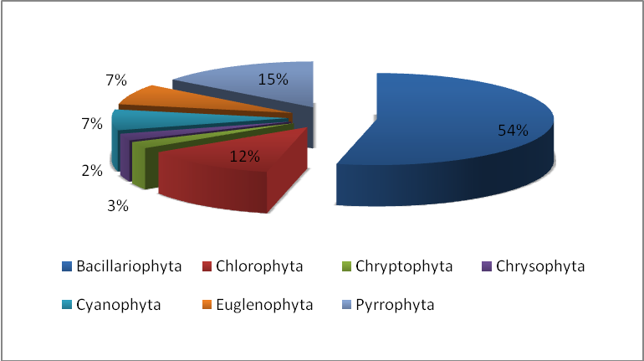
Figure 11. The distribution of the phytoplankton community during the period studied.

The phytoplankton biomass of BRED ranged from 97.460cells/L to 43.359.370cells/L. The highest value for the density was recorded in February/05 and the lowest value of 97.460cel/L, in October/04 and May/05. The values for the diversity index ranged from 1.06bit.ind⁻¹ to 1.56bit.ind⁻¹, richness from 1.07 to 2.08 and equitability from 0.48 to 0.60. The highest value of diversity, richness and equitability was recorded in February/05. The months of May/05 and October/04 had the same value for the Diversity Index.
Phytoplankton has been used as an indicator of environmental quality because it has a short life cycle reflecting the rapidly environment changing. Among the indicators of phytoplankton are the Cyanophyta, Chlorophyta, Bacillariophyta, Euglenophyta and Pirrophyta. Within the microalgae that occurred during the period studied in BRED, we can mention the euglenoids that were recorded in all months of sampling. This group of algae is very abundant in waters rich in organic matter.
The cyanobacteria are photosynthetic organisms that comprise the phytoplankton blooms in fresh, salt or brackish water. According to Branco (1986) they grow in environments where the pH ranges from 6.0 to 9.0 and temperature above 15 º C. During the sampling period, which occurred the cyanobacteria (February/05 and May/05), the pH was observed between 6.94 and 7.7 and temperatures above 30 °, what is according to the above mentioned author.
The results obtained in the qualitative analysis showed that diatoms were the group most representatives of microalgae for the period studied in BRED. Similar results were observed by Lavor-Fernandes (1988), in the Sao Marcos and the estuary of the Tibiri River, Almeida and others, (2004), the Bay of Turiacu and Moreira (2003) to the river Anil.
In the BRED, the genera that most stood out in number of species were Chaetoceros and Coscinodiscus. The result obtained agrees with the work of Almeida and others, (2004), in the Bay of Turiacu, Lavor-Fernandes (1988), in the Sao Marcos, and Lacerda (1994), in the estuary of the Paripe River.
The phytoplankton of BRED showed a wide density variation, from 97.460 to 136.718.750 cells/L. The values found agree with those of Sassi (1991), the estuary of the Parnaiba River, he found the minimum of 1.035.000 cells/L, values very close to the minimum found in the study area, and Moreira (2003), the estuary of the Anil River.
Phytoplankton densities tended to increase during the months of May/05 and February/05, which can be explained by the increase of nutrients in the environment, especially nitrogen and phosphorus. High concentrations of nutrients can lead to major blooms of phytoplankton. This intensive development takes place across the water surface and prevents light from reaching the water beneath it, reducing biological diversity.
Diversity, equitability and richness in the estuary of the river Bacanga had small variations during the study period. The highest values for these indices were 1.56bit.ind⁻¹, 2.08 and 0.60, respectively. The results for BRED during the study period, do not agree with the work carried out by Almeida and others, (2004), the Bay of Turiacu, and Moreira (2003), in the estuary of Anil, who showed higher values for the same indexes, suggesting that a low diversity recorded for the sampled point may be associated with organic matter in this environment.
The study showed a strong linear correlation between pH vs. Electrical Conductivity, Total Suspended Solids vs. Inorganic Suspended Solids, Total Suspended Solids vs. Organic Suspended Solids, Total Suspended Solids vs. Alkalinity, pH vs. Alkalinity, Inorganic Suspended Solids vs. Suspended Organic Solids, Organic Suspended Solids vs. Chlorophyll and Alkalinity vs. Inorganic Suspended Solids (Table4).

Table 1. The concentration of dissolved oxigen and chlorophyll-a during the period analised.

Table 2 . Diversity, Richness and Equitability Index during the period analised

5. Conclusion
The results obtained in this study allowed us to conclude that the BRED was relatively eutrophic during the study period, what can be evidenced not only by the microalgae biomass, which is related to the results obtained to the physical and chemical variables, but also by some groups of algae that is considered as indicator of polluted environments.
The use of meteorological, physical-chemical and biological variables, especially the monitoring of their dynamics is a powerful tool for water resource management being essential to guide any type research.
For BRED, the management of the gate and the discipline of sustainable use of its living resources should be based and guided by such studies with the understanding of the basin as a planning unit, which could prevent the disasters that have often resulted in fish mortality, as occurred during the period studied. It is, also possible to infer that there was an increase in the contribution of nitrogen and phosphate compounds during the rainy season, which can be explained by the increase of water in a drainage system. This is very relevant, because these compounds are abundant in domestic sewage. Further study may possibly detect the presence of these compounds in drainage networks that drain into the Bacanga River.
It is recommended a larger of studies about the Bacanga river, in accordance with the CONAMA Resolution 357 of 17 March 2005 (replacing Resolution No. 20, June 18, 1986), and the preparation of a Management Plan specific to the discipline of preservation and conservation of this environment.

Table 3 . The concentration of total phosphate, dissolved inorganic phosphate, Total dissoved phosphate, amonium, nitrate, nitrite, total nitrogen and silicate in the water colunm according to the measure radiation 100, 50, 25 and 1%, during the period analised.

Table 4. Table of the linear correlation of some variables measured during the study period.

Acknowledgements: We are thankful to LABOHIDRO/ UFMA and all the people that collaborate during the field work and laboratory analysis. We wish this paper can contribute to further research in Bacanga river estuary dam.

Correspondence to:
Ana Paula Pinto Carvalho
Master Student in Hydrology and Water Resources
China University of Geosciences, 388 LuMo road, Wuhan, China. Zip code 430074.
Email: app_carvalho@yahoo.com.br

References
- Almeida, I. C. S., Ferreira-Correia, M. M. and Dourado, E. C. S. Microalgae in Turiacu Bay, EPA of the Maranhense Reentrance’s – a qualitative view. Hydrobiology Laboratory Bulletin, 2004, 17:1-8. (in Portuguese)
- Azevedo, A. C. G., Feitosa, F. A. N. and Koening, M. L. Spatial and distribution of the phytoplankton biomass and environmental variables, Brazil. Acta bot. bras. 2008, 22(3): 870-877. (in Portuguese)
- Barthelmes, D. Zur steuerung von pH-Wert und Gehalt in Karpfenteichen. In: Komarkova, J. et al. Influence of the Watershed and Fishstock upon the Fish Pond Biocenoses. Szech. Acad. Sci., Limnology, 1976, v. 23, n. 1712, p. 334-354.
- Braga, E.S., Bonetti, C.V.D.H., Burone, L. and Bonetti Filho, J. Eutrophication and bacterial pollution caused by industrial and domestic wastes at the Baixada Santista estuarine system - Brazil. Marine Pollution Bulletin. 2000, 40: 165-173.
- Branco, S. M. Hydrology applicable to the sanitary engineering. 3ª ed. Sao Paulo. CETESB/ACATESB. 1986, 640p.
- Chiu, H. M. C., Hodgkiss, I.J., Chan, B. S. S. Ecological studies of phytoplankton in Tai Tam Bai, Hong Kong. Hydrolobiologia. 1994, n.273, p.81-94.
- Day Jr., J. W., Yanez-Arancibia, A. Coastal lagoons and estuaries, ecosystem approach. Ciência Interamericana, OAE Washington DC. 1998, vol. 22, n.1-2, p.11-26.
- Esteves, F.A. Limnology Fundaments. São Carlos, Ed. Interciência/FINEP. 1988. (in Portuguese)
- Faina, R. Contribution to the biology of feeding on common carp - In: Komarokova, J. et al. Influence of the Watershed and Fishstock upon the Fish Pond Biocenoses. Szech. Acad. Sci., Limnologica, 1979, v. 23, n. 17/2, p. 333-354.
- Golterman, H.L., Clymo, R.S., Ohnstad, R. Methods for Physical and Chemical Analysis of Freshwater. 1978, 2.ed. I.B.P. Handbook, 8. Blackwell Sci. Publ., Oxford.
- Gomes, L. V. Physical, chemical and microbiologiocal characterization of the water, fish and shrimp of the jansen lagoon impacted by domestic sewage, Sao Luis. Maranhao Federal university. 2001, p. 11-58.
- Herrera-Silveira, J. A. Nutrient-phytoplankton production relationships in a groundwater influenced tropical coastal lagoon. Aquatic Ecosystem Health and Management, 1998, n.1, p.373 – 385.
- Hino, K. Mixing Patterns and Productivity of Phytoplankton in a small artificial pond. Ciên. e Cult. 1985, v.37, n. 8, p. 1331-1340.
- Kampel, M. Primary production and phytoplankton biomass estimative using remote sensing of the ocean color and data in situ of the south-eastern brazilian coast. Thesis. 2003. 311p. (in Portuguese )
- Koroleff, F. Determination of nutrients. In: Grasshoff, K. (Ed.). Methods of seawater Analysis. New York: Verlag Chemie Weinhein.1976, p. 117-181.
- Labohidro. Phytoplnakton and physico-chemical study in the estuarine region of the Bacanga e Anil rivers, São Luís/MA. 1994. (in Portuguese)
- Labohidro. Environmental Diagnosis of the Bacanga river estuary, São Luís – MA: Chemical and biological characterization. Final Report. 1998, 122p. (in Portuguese)
- Labohidro. Environmental Diagnosis of the Caju Island. Environmental units sintese report. Maranhao Federal University. 1999, 94p. (in Portuguese)
- Lacerda, S. R. Diurnal and seazonal variation of the phytoplankton of the Paripe river estuary, Itamaraca Island, Pernambuco, Brasil. Thesis. 1994, 146p. Pernambuco Federal University. (in Portuguese)
- Lavor-Fernandes, G. Microphytoplankton in the Paciencia river estuary, Paco do Lumiar, Maranhao. Hydrob. Lab. Bul., Sao Luís, 1988 a, (8):23-44. (in Portuguese)
- Lavor-Fernandes,G. Microphytoplankton in the Sao Marcos Bay, Sao Luis, Maranhão, Brasil. Gayana, Chile, 1988b, 45 (1-4):265- 274. (in Portuguese)
- Melo, O. T. Nutrients Biogeochemical behavior in the Bacanbga river estuary, Sao Luis - MA. Para Federal University. 1998, 115p. (in Portuguese)
- Moreira, E. G. Phytoplankton community in the Anil river estuary, Sao Luis-MA. Graduation conclusion work. UFMA. 2003. (in Portuguese)
- Pereira Filho, J., Schettini, C.A.F., Rörig, L. and Siegle, E. Intratidal variation and net transport of dissolved inorganic nutrients, POC and chlorophyll a in the Camboriu river estuary, Brazil. Estuarine, Coastal and Shelf Science. 2001, 53: 249-257.
- Teixeira, C., Tundisi, J. G. and Kutner, M B. Plankton studies in a mangrove environment II. The standing stock and some ecological factors. B. Inst. Oceanography, 1965, 24: 23-41.
- Tundisi, J., Tundisi, T.M. Organic production in aquatic ecossystem. Sao Paulo Culture and Science, 1976, n.8, p. 861-887. (in Portuguese)
- Tundisi, J.G. Primary production "Standing-Stock" and phytoplancton fractionalization of the Cananeia lagunar region. Sao Paulo. Thesis. Sao Paulo University. 1969. (in Portuguese)
- Santos, F. P. Biologic characterization and primary production in Guarapua bay (Cairu-BA): a subsidy to the environment recharge capacity research. Bahia Federal university. 2002, 106p. (in Portuguese)
- Sassi, R. Phytoplankton and environmental factors in the Paraíba of the Norte river estuary, southeastern Brazil: composition, distribution and quantitative remarks. Oceanographic Istitute Bulletin, 1991, 39: 93-115.
- Schreckenbach, K. et al. (1975 and 1978). Die Ursache der Kiemennekrose. In Komarkova, J. et al. Influence of the Watershed and Fishstock upon the Fish Pond Biocenoses - Szech. Acad. Sci., Limnologica, v. 23, n. 17/2, p. 334-354.
- Strickland, J. D. H. and Parsons, T. R. A practical handbook of seawater analysis. 2nd. Ed. Fisheries Research borad of Canada, Ottawa, 1972, n.167, p1-211.
- Winkler, L. W. Die Bestimmung des im Wasser Gelösten Sauerstoffs. Ber. Dtsch Chemie Gestamenn. 1888, v21,p. 2843-2354.

Map Section
Map 01: Bacanga river satellite TM-LANDSAT image, showing the Maranhao State, Sao Luis Island and the sampling station where the samples were taken in the Bacanga river estuary. Source: INPE, 1984; Zee.ma, 2004
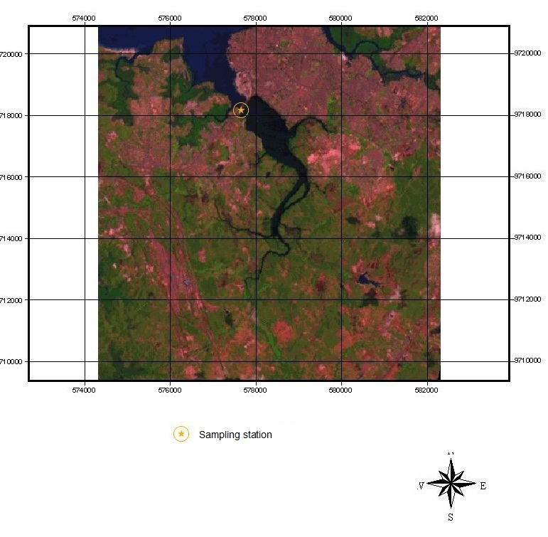
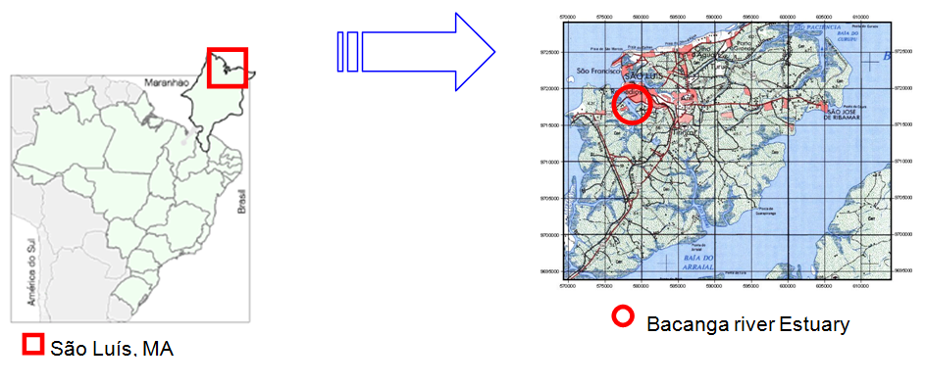
01/19/2010

