Application of GC/MS Quantitation in the Adsorption of Herbicide by Sorbents from two Abundant Nut Shells
Itodo A.U.¹, Abdulrahman F.W.², Hassan L.G³, Maigandi S.A.⁴, Itodo H.U⁵
¹Department of Applied Chemistry, Kebbi State University of Science and Technology, Aliero, Nigeria
²Department of Chemistry, University of Abuja, Nigeria
³Department of Pure and Applied Chemistry, Usmanu Danfodiyo University, Sokoto, Nigeria
⁴Faculty of Agriculture, Usmanu Danfodiyo University, Sokoto, Nigeria
⁵Department of Chemistry, Benue State University, Makurdi, Nigeria
itodoson2002@yahoo.com
Abstract: Economically viable remediation technique based on adsorption by locally made Groundnut shells (GS) and Sheanut shells (SS) biosorbents was proposed to improve the ecological system. Samples were employed to investigate the removal of organochlorine herbicide (atrazine) from waste water as it was evidently proven. GC/MS quantitation experiment based on external standard method was performed and demonstrated over 95% atrazine removal. The equilibrium study showed that SS/A/25 adsorbed up to 66.324% Atrazine. The entire filters however shows a good competitive adsorption (18.736-22.977gdm⁻³) but lower than the commercially available M&B reference carbon, with uptake of 23.731 out of 25.00gdm⁻³ . Adsorption of herbicide at different level by the different sorbent was linked to their activating agent and physicochemical parameters such as density (0.125-0.496) and porosity (0.833-0.975) which were determined based on swellings. Other parameter investigated include sorption capacities (q_{e}).The major results support the conclusion that the sorted Agro-wastes has the potential to serve as extractants adsorbents in remediation process. [Researcher. 2010;2(2):64-73]. (ISSN: 1553-9865).

Keywords: GCMS, herbicide, activated carbon, adsorption.nut shells

- INTRODUCTION
Past studies was built on a strong case that atrazine is hazardous and unsafe to both human and ecosystem. Some of these studies found that the pesticide or herbicide, atrazine disrupt the production and functionality of human hormones and a higher incidence was reported for cases of cancer in humans and laboratory animals (Zhongren et al., 2006). The use of active carbon was prescribed by USEPA as the best available technology for the removal of atrazine from water. Many studies have revealed adsorption of atrazine using conventional activated carbon granules and fibres (USEPA,2002).
Due to pore blockage by natural organic matter (NOM), a deleterious effect on atrazine removal was reported. It was therefore proposed that mesopores development could alleviate pore blockage with a resultant fast adsorption rate. A chemical activation using activating agents is a new generation of adsorption fibre development sorbents obtained with this method provides higher yield, high surface area, high mesopores volumes and some unusual pore surface chemistries (Zhongren et al.,2006; Hertrick et al., 2000).The sorption of herbicide from aqueous phase by activated carbon has been reported (Agdi et al.,2000; USEPA,2002; Zhongren et al., 2006; Hertrick et al., 2000 ). This present study reports atrazine sorption, not in a micro quantity but within range that could account for both the topical and systemic poisoning reportedly associated with atrazine (Raymond, 2003).
  - Herbicide Loss in the Environment
Herbicides degrade or move within the environment via numerous physical, chemical and biological mechanisms including adsorption, leaching, volatilization, chemical transformations and biological degradation process (Coker, 2000). The largest quantity of is used for crop dusting and spraying. Some of these chemicals reach the intended crops but most of them are deposited on the soil. On either the crop or the soil they may be washed by subsequent rainfall or irrigation into the nearest water course, or they may percolate through the soil into the ground water table (Schwartz, 1996). Other pathways of herbicide loss into the environment are through removal in the harvested plant and by vaporization into the atmosphere. (Schwartz, 1996).
Several attempts had been made in the past to minimize the level of Chemicals present in the environment. Some of the pesticides and herbicides are biodegradable and are naturally broken down by microorganisms . It has been observed that organic herbicide are found in nearly all living matter that has been analyzed . Micro- organisms can only metabolize pesticides if they are bioavailable and if they have chemical structure compatible with the organisms’ enzymes that catalyze the biodegradation (Coker, 2000). Mechanisms of degradation include mineralization, partial degradation to secondary compounds, adsorption, humification and volatilization (Coker, 2000).
1.2.Gas chromatography (Choice of equipment)
The sample herbicide (containing atrazine) is a multicomponent mixture containing atrazine (test sample) and other organochlorine moieties, which are very similar to atrazine. Secondly, the GC column has a very high efficiency which was claimed to be in excess of 400,000 theoretical plates. The column is about 100m long, a very dispersive type of stationary phase retaining the solute approximately in order of increasing boiling point. Helium carrier gas was selected since it can realize high efficiencies with reasonable analysis time (Raymond, 2003).The gas chromatographic technique is at best a mediocre tool for qualitative analysis. It is best used with other technique to answer the question of what is present in a sample. Besides the simplicity of the instrument, ease of operation, GC also provides the answer to how much? It is an excellent quantitative analytical tool in quantifying micrograms in a litre or one volume in millions of volumes (Robert and Eugene, 2004). This present research is in line with the nation’s economic objectives of self reliance in motivating local industries to embark on production of activated carbon and in effect, help to conserve foreign exchange used for importing the materials hitherto. The work is also needful due to the diverse application of activated carbon as the most versatile adsorbent (Odebunmi and Okeola,2001). Contribution by this work was also hoped for its scholarly knowledge .

- Materials and methods
2-chloro-4-ethylamino-6-isopropyl amino-1,3,5-trazine with 50% atrazine specification was procured from a retailer’s stand of the Agro-chemical wing of Sokoto central market, Nigeria. Stock standard solution (25g/L) was prepared and from which ranges of working standard were prepared in chloroform and stored in the dark. This was employed as adsorbate, used in this analysis. Zinc Chloride (98+ %) and Ortho Phosphoric acid obtained from prolabo chemicals were used as chemical activants while Chloroform was used as solvent. Hydrochloric acid (0.1M) and distilled water were used as washing agents. The substrates were; Groundnut shell (GS) and Shea nut shell (SS) collected freely from waste depots of local oil mill at Sokoto and Rikoto- Zuru in Kebbi state of Nigeria. The raw materials were pretreated as earlier described (Zahangir et al.,2008;Itodo et al .,2009a&b). By washing several times using tap water and finally with distilled water. The samples dried at 105°C for 24 hour in oven to remove excess water content until constant weight. Then, the dried sample was grinded to aperture size of < 2.0mm and stored at room temperature for further use.
  - Activation
For thermo chemical (heat/chemical) activation, 3g each of the initially 500ºc-carbonized, washed and dried samples were first interacted with 3cm³ of each 1M activants (ZnCl₂ and H₃PO₄) and immediately placed in crucible and heated in a furnace at 900ºc and at different dwell times according to the design of experiment for its optimization (Itodo et al., 200a and 2009b;Turoti et al.,2007).Then, the samples (activated carbon produced) were crushed and sieved using <2mm aperture size sieve. Two variables such as nature of activating agents and activation time were chosen for its optimization for maximum removal of herbicide. A total of 20 experiments by GC/MS were carried out for sorption studies.

2.2. Preparation of standard for sorption efficiency studies
5g of substrate was diluted to the mark of 100cm³ volumetric flask. This concentration of 50g/L herbicide is equivalent to 25g/L or 25,000ppm atrazine stock. 10cm³ of the atrazine solution was interacted with 0.1g of each sorbent and allowed to stand for 12hours. The mixture was filtered and the filtrate was analyzed with a gas chromatography (coupled with a mass spectrophotometer detector) for atrazine equilibrium phase concentration (Methods,1998;Min and Yun,2008).

2.3. Physicochemical parameters
The characterization experiment via porosity and density of the GAC was investigated. Some of these entailed the preparation and standardization of certain solutions.Adopted methods were those by Aziza et al., (2008) and Igwe and Abia, (2003).
2.4. GC/MS Conditioning/calibration
A gas chromatography equipped with a mass spectrophotometer detector (with a model GCMS QP2010 plus Shimadzu, Japan) was used in this analysis. The column was held at 60ºC in injection volume of 1µL and then programmed to 250ºC. it was set at a start m/z of 40 and end m/z of 420.The detector (mass spectrophotometer) was held at 250ºC above the maximum column temperature. The sample size was 1µL, which was split 100⁻¹ onto the column and so the total charge on the column was about 1. Helium was used as the carrier gas at a linear velocity of 46.3Cm/sec and pressure of 100.2kPa. Ionization mode is electron ionization (EI) at a voltage of 70eV. In this analysis, Amplification and resolution for test herbicide was achieved by adjusting the threshold to 6000. Thus, worse interference and solvent peaks were screened out leaving majorly the deflection of target compound (atrazine) as it was made pronounced on the chromatogram. Baseline disturbance was linked to either hydrocarbon impurities. Impure carrier gas can also cause baseline instability (Robert and Eugene, 2004).It can be corrected by changing the purifier when pressure drops reaches 10 – 15 pSi (0.7 – 1.1 bar) routinely monitoring the pressure. Sorption efficiency of an adsorption process is defined based on the fractions of extracted and unextracted solutes (Robert and Eugene, 2004).
2.5.External standardization
Techniques of external standardization entails the preparation of standards at the same levels of concentration as the unknown in the same matrix with the known. These standards are then run chromatographically under ideal conditions as the sample. A direct relationship between the peak size and composition of the target component is established and the unknown is either extrapolated graphically or mathematically (Robert and Eugene, 2004).This technique allows the analysis of only one component in the same sample. Peak size is plotted against absolute amount of each component or its concentration in the matrix. Two important facts from the shape of the calibration curve i.e. the straight line which passes through the origin obtained under the condition of analysis and over the concentration range covered is that;
3.Results and Discussion
3.1.Physicochemical parameters
Table 1: represent the porosity and density of sorbent based on swollen state. These approximations revealed that porosity measurement of sample in solution is substantially different from those measured in dry state (Aziza et al., 2008; Igwe and Abia, 2003).

Table 1 : Porosity and density estimation for generated Biosorbents based on swollen state.
Biosorbents | V_{W1}(cm³) | V_{T}(cm³) | V_{F}(cm³)= V_{T}-V_{W1} | V_{W2}(cm³) ₌V_{T}- m | Porosity(α)= V_{W1}/V_{T} | Density (g/Cm³)
Comm. | 20 | 23.00 | 3.00 | 10.70 | 0.870 | 0.165
GS/A/15 | 20 | 23.00 | 3.00 | 10.80 | 0.870 | 0.165
GS/Z/15 | 20 | 21.10 | 1.50 | 10.70 | 0.930 | 0.137
SS/A/15 | 20 | 21.00 | 1.00 | 10.70 | 0.952 | 0.496
SS/Z/15 | 20 | 24.00 | 4.00 | 10.60 | 0.833 | 0.125
Comm- Commercial Activated Carbon. SS/A/15 -Sheanut shells, treated with H₃PO₄,activated for 15 minute dwell time,
GS/A/15 – Groundnut shells, treated with H₃PO₄(Acid), ,activated for 15 minute dwell time.

Values presented by the sorbents follows the trend SS/A/15(0.952) > GS/Z/15(0.930) > GS/A/15(0.870) in sorbent. These sorbents gave higher porosity than the commercially available sorbent; Comm. (0.870) whose porosity is only slightly higher than the Shea nut shell sorbent, SS/Z/15(0.833). It is evidence that the porosity value (on wet basis) for the sorbent agrees well with that of commercial carbon and they all falls within the range of 0.833-0.952. It is also obvious that the commercial PAC has higher surface area than the generated sorbent due to its finer grain size than the <2mm aperture size of the generated sorbents. There is an assumption that all pores are accessible to all contaminants. However, for larger molecules, steric hindrance leads to decrease in the maximum adsorption capacity (Itodo et al.,2009a). On the basis of the wet carbon, it was observed that sorbent GS/A/15 and SS/Z/15 gave pore volume values of 0.870 and 0.833 respectively. These values are in good agreement to that obtained for the commercial activated carbon, 0.870. This is an indication that plant based sorbents gave porosity of good similarity. However, the type of activating agent plays significant role. Besides the Shea nut shell carbon, all other sorbent gave higher pore size with ZnCl₂ catalysis. The values include; 0.930 for GS/Z/15.This values is higher than those of their corresponding acid modified sorbents; 0.870, GS/A/15.The porosity range for all the adsorbents tends to similarity with the same activation temperature and dwell time. These parameters are also critical for pore size development. The porosity values obtained in this research is close to those of activated sawdust (0.939-0.990) by Aziza et al.,(2008).
3.2. Bulk density (Prior to Adsorption)
Generally, Bulk density was estimated by placing a known weight of PAC in a graduated cylinder and tapping until the PAC occupies a minimum volume and thus calculated as; Density = m / v. The result of bulk density measured on swollen or wet weight basis was also presented (Table 1). Calculation was based on porosity. It is evidence that there is a linear relationship between porosity and bulk density prior to adsorption. More porous carbon was reportedly more denser. This could be linked to the extra mass gained from the occupation of more sorbate (water) into the pore sizes. It should be noted that the density measurement on dry weight bases is substantially different from when it is in swollen state. Low value (0.165g/cm³) was obtained for the commercial activated carbon. Similar to this are those of GS/A/15 (0.165), GS/A/15(0.137) and SS/Z/15(0.125).The relationship between porosity (on wet basis) and density (also on swollen basis) is given in the equation 1 (Aziza et al., 2008).
Density = (Ma/Vw) α / (1-α) - - - ( 1)
Where α = porosity = Vw/V_{T};Ma = mass of sorbent (g), Vw = initial volume of water (cm³) ;V_{T} = final volume of water + dispersed sorbent (cm³).This density measurement on wet basis is different from those involving dry sorbents, (Aziza et al., 2008).

3.3.GC-MS quantitation of Equilibrium phase Atrazine
Calibration curve: A three point calibration curve was made from 1.0, 5.0 and 10.0g/L atrazine solution. These standards were run chromatographically under ideal conditions. A direct relationship between the peak height or size and concentration of target is established (Figure 1). The unknown is extrapolated graphically (Robert and Eugene, 2004).

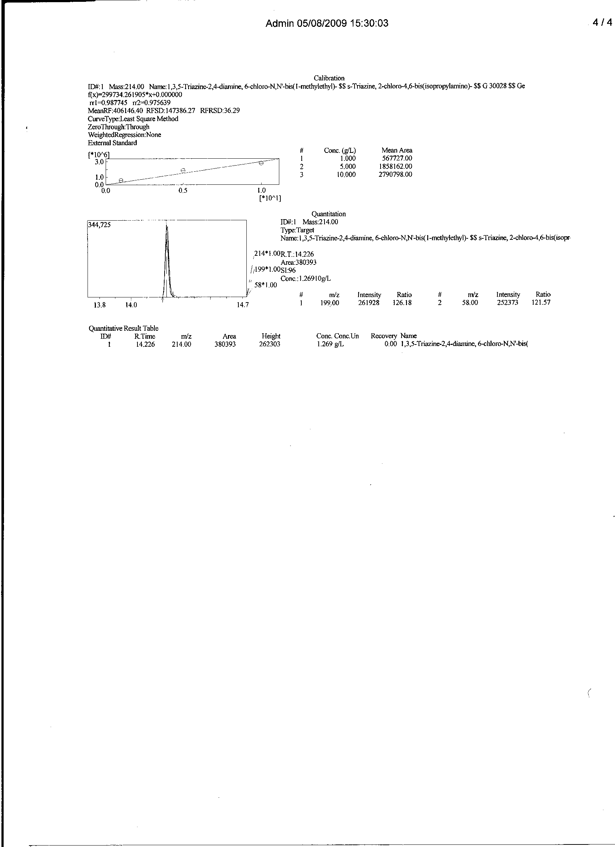
Figure 1: GC/MS external standard calibration curve for 1.0-10.0 g/L concentration range of atrazine

3.4. Determination of sorption efficiency
The equilibrium phase analyte (atrazine) remaining in the test solution was collected and analyzed using a Gas chromatography (GC) equipped with a Mass spectrophotometer (MS) as detector and a data processor.The amount of dye at equilibrium, q_{e} was calculated from the mass balance equation given in equation 2 (Hameed et al., 2006).
q_{e} = (C_{O} –C_{e}) V/W ………..(2)
where C_{o} and C_{e} are the initial and final dye concentrations (mg/L) respectively. V is the volume of dye solution and M is the mass of the acid catalyzed poultry waste sorbent (g). The percent dye removal (R %) was calculated for each equilibration by the expression as equation (3)
RE(%) = (C₀ ₋ C_{e} )/C_{o}x 100 …… (3)
Where RE (%) is the percent of dye adsorbed or removed. The % removal and adsorption capacities were used to optimize the activation condition (Maryam et al., 2008). The tests were done at a constant temperature of 27±2⁰C.(Rozada et al, 2002).

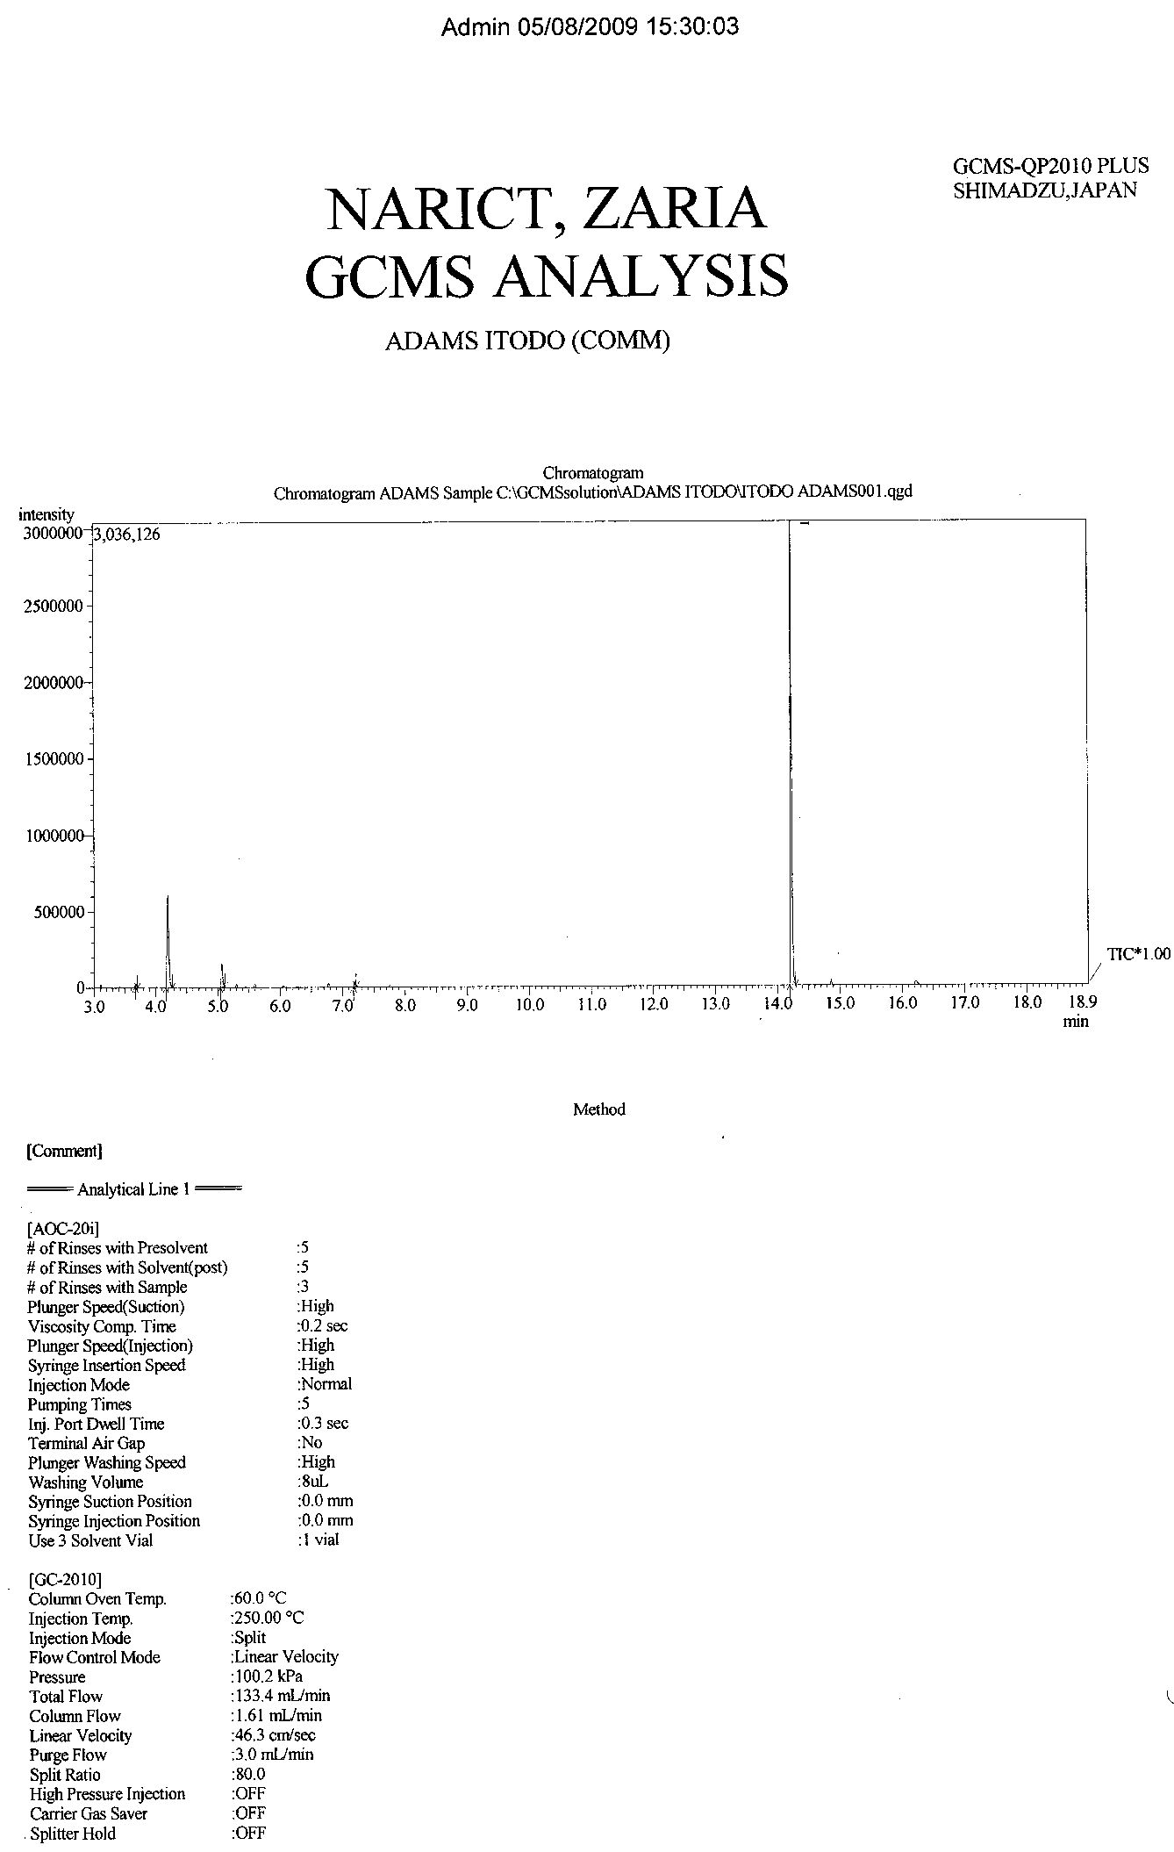
Figure 2: GC/MS chromatogram of equilibrium concentration atrazine after adsorption onto commercial reference sorbent (Carrier gas-Helium 100.2kpa,Column temperature –60ºc,Injection temperature-250ºc,Injection volume—1µL,Flow rate-1.61mL/min, Injection method- split, Linear velocity- 43.6cm/sec.)

The above chromatogram is free from baseline instability, a disturbance, usually caused by either hydrocarbon impurities or impure carrier gas (Robert & Eugene,2004)
Table 2 represents the percentage atrazine removal by nut shells acid and salt catalyzed biosorbents. Values obtained compete well with that of the commercial (M α B Charcoal, MD Ltd Dadedham) carbon. Results indicated over 80% atrazine removal, being a sorption of between 20.050 – 23.731g/L out of the initial 25g/L atrazine concentration.

Table 2: GC/MS estimation of sorption efficiency (%RE) of atrazine uptake onto plant based chemically modified biosorbent.
Sorbents | C_{o}(g/dm³) | C_{e}(g/dm³) | C_{a}(g/dm³)  (g/dm³) | %RE | Ads.m(10⁻³mg) | q_{e}(mg/g x10⁻³) | % q_{e}
Comm. | 25 | 1.269 | 23.731 | 94.924 | 0.237 | 2.370 | 94.80
GS/A/15 | 25 | 4.950 | 20.050 | 80.200 | 0.201 | 2.010 | 80.40
GS/Z/15 | 25 | 3.750 | 21.500 | 86.000 | 0.215 | 2.150 | 86.00
SS/A/15 | 25 | 2.696 | 22.304 | 89.216 | 0.223 | 2.230 | 99.22
SS/Z/15 | 25 | 3.112 | 21.888 | 87.552 | 0.219 | 2.190 | 87.55

Comm- Commercial Activated Carbon. SS/A/15 -Sheanut shells, treated with H₃PO₄,activated for 15 minute dwell time,
GS/A/15 – Groundnut shells, treated with H₃PO₄(Acid), ,activated for 15 minute dwell time.

3.5.Nature of biomass
The entire biosorbents were screened based on their level of herbicide uptake. For the acid and base plant waste catalyzed sorbents, adsorption by Shea nut sorbent gave values (87.552 – 89.216%) that are more closer to the commercial carbon (94.924%). The trend of removal efficiency follows the order SS/A/15(89.216%) > SS/Z/15(87.552%) > GS/Z/15(86.00%) > GS/A/15(80.20%). It is evidence that Shea nut shell (SS) sorbent actively adsorb atrazine than does the groundnut shell (GS) sorbent. Figure 3 to 6 presents the GC/MS quantitative chromatogram for the equilibrium phase concentration of atrazine after interaction with SS and GS adsorbents.

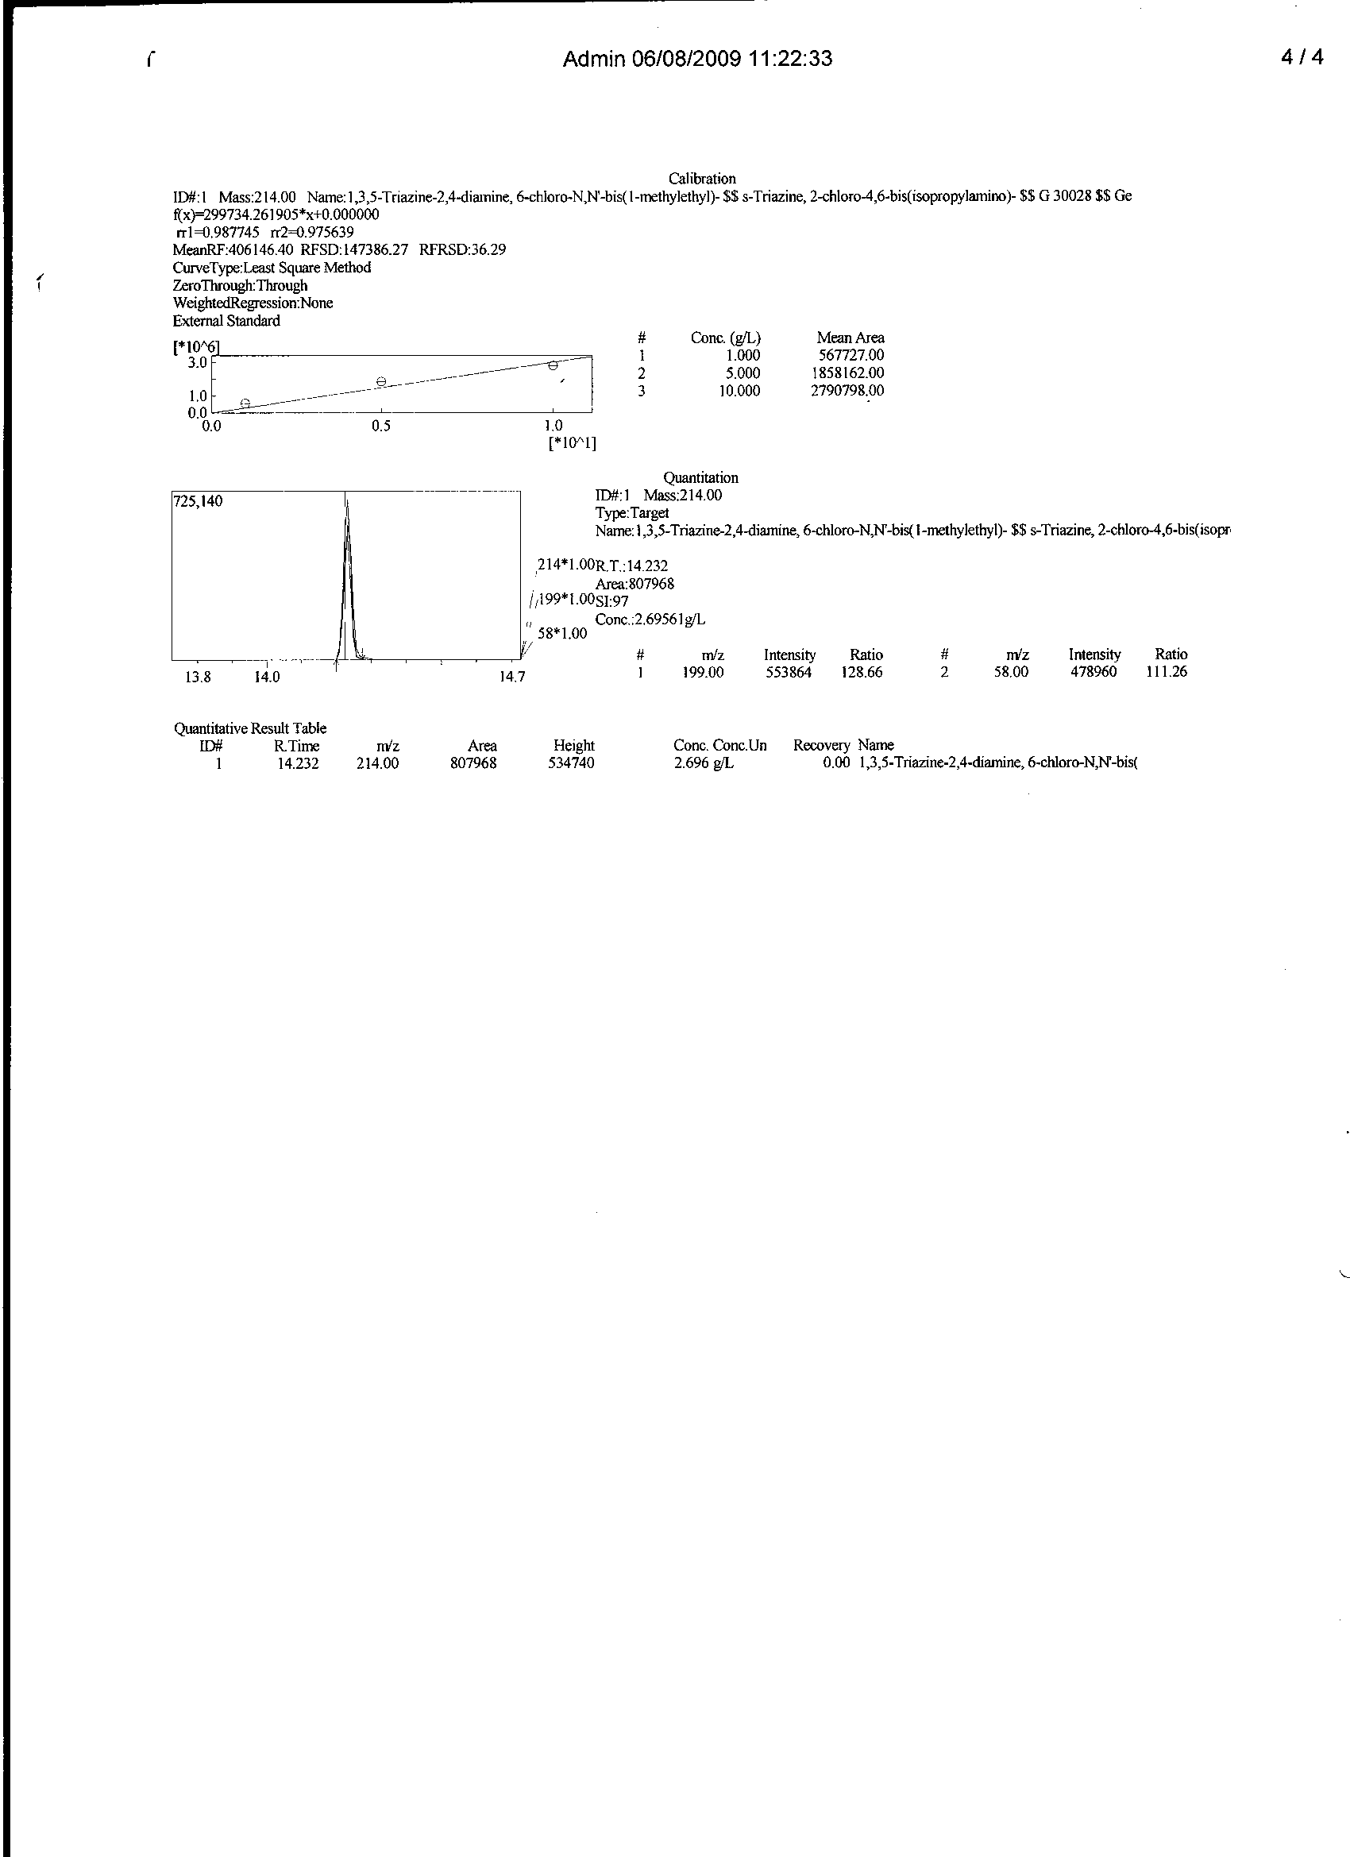
Figure 3: GC/MS chromatogram, quantitative measurement and spectral information of equilibrium phase atrazine after adsorption onto SS/A sorbent

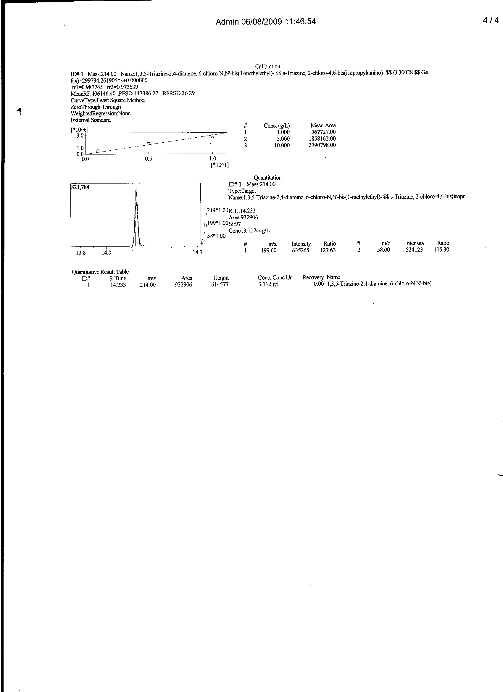
Figure 4: GC/MS chromatogram, quantitative measurement and spectral information of equilibrium phase atrazine after adsorption onto SS/Z sorbent

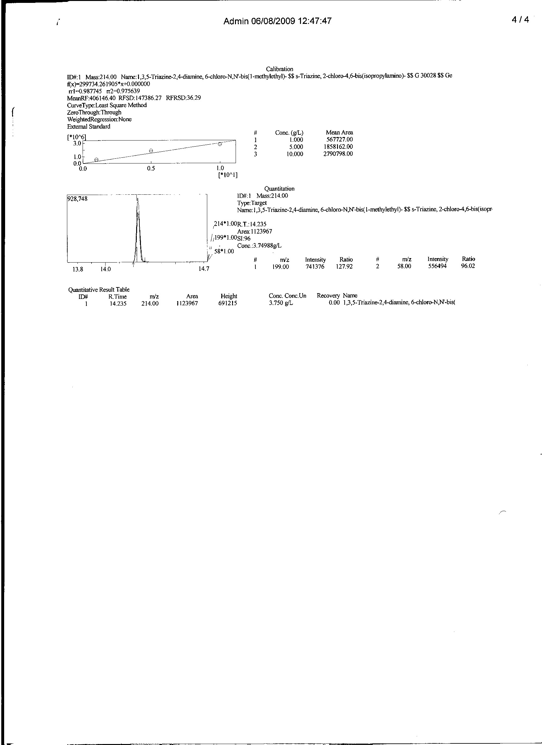
Figure 5: GC/MS chromatogram, quantitative measurement and spectral information of equilibrium phase atrazine after adsorption onto GS/Z sorbent

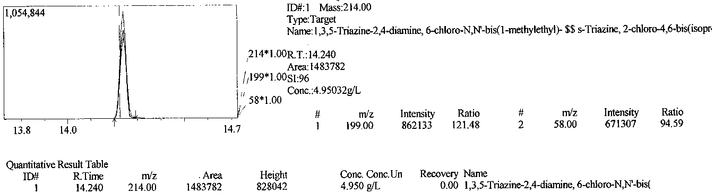
Figure 6: GC/MS chromatogram, quantitative measurement and spectral information of equilibrium phase atrazine after adsorption onto GS/A sorbent

3.6.Comparative study
A control or reference activated carbon (M α B Charcoal), manufactured by M α B Ltd Dadedham was subjected to the same interaction condition as the generated sorbent. A fairly higher percentage removal was evidence. 94.924% was reported to have a total uptake of 23.731 out of the 25g/L initial sorbate concentration by a 0.1g sorbent dose per 10cm³ sorbate solution.
The general trend follows the sequence of Comm. (94.924%) > SS/A/15(89.216%) > SS/Z/15(87.552%) > GS/Z/15(86.00%) > GS/A/15(80.20%). Adsorption by M α B charcoal charcoal is 1.184 times higher than that of the GS/A/15 with least atrazine sorption. Apart from GS/A/15, it follows that acid catalyzed sheanut shell adsorbents (SS/A/15) gave better sorption. Chromatogram on Figure7 presents unadsorbed quantity (1.269) by reference activated carbon.

Figure 7: GC/MS chromatogram, quantitative measurement and spectral information of equilibrium phase atrazine after adsorption onto commercial reference sorbent

3.7.Nature of activating agent
The effect of the nature activants on the general analysis is not pronounced. It could however be observed that the efficacy of a given activating agent as revealed by this analysis could be a function of the nature of biomass since both activating agents favors pore size development to a less distinct level. Figure 8 showed that acid catalyzed Shea nut shell (SS) gave higher removal efficiency (89.216%) than the ZnCl₂ sorbent (87.552%). On the contrary, acid catalyzed activated groundnut shell (GS) carbon presented lower value (80.20%) than does its corresponding ZnCl₂ sorbent (86.00%).

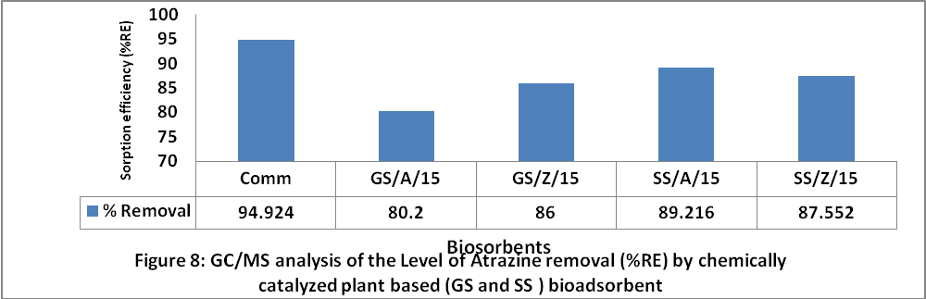

It can thus be deduced that H₃PO₄ proves a potentially favorable activating agent for Shea nut shell (SS) sorbents than ZnCl₂ which majorly groundnut shell (SS) sorbents.Generally, activating agent such as ZnCl₂ dehydrate the cellulose material resulting in the weakening of the precursor structure and creation of pore. The space occupied b y the activating agent added to pore size formation after intense washing (Malik et al., 2006).
3.8.Adsorption Capacity
The amount of sorbate attracted by unit mass of sorbent was estimated as q_{e} (in mg/g x 10⁻³). Table 2 also indicates that 1g of GS and SS sorbents was able to adsorbed between 2.01 – 2.15mg and 2.189 – 2.230mg of the adsorbate respectively. It thus implies that Shea nut shell (SS) activated carbon has a higher adsorption capacity than the groundnut shell (GS) sorbent for atrazine uptake
3.9.Peak information and quantitation
Peak is the portion of chromatogram recording the detector response or eluate concentration while peak area is the band area of the peak on the chromatogram. Commercial reference carbon presented value for peak area as 380393 with a corresponding mass peak of M – 62 as revealed (NIST,2005) on Table 3. The mass peak of the various eluate revealed that the sample GS/A/15 with higher mass peak (M - 92) presented a corresponding higher peak intensity (8533008) and peak height (828042). Such samples (Table not shown) presented least percentage recovery i.e. high percentage adsorption. Intensity is a measure of detector response (Robert and Eugene, 2004).

Table 3: Mass to charge ratio and peaks data of atrazine uptake onto chemically catalyzed plant based biosorbents
Spectral data |  |  |  | Peak information
Sorbents | M/Z | Rt | Scan # | Area | Intensity | Height | Mass | Base
Comm. | 214.00 | 14.226 | 1,348 | 380,393 | 3,036,126 | 262,303 | M- 62 | 199.30
GS/A/15 | 214.00 | 14.242 | 1,350 | 1,483,782 | 8,533,008 | 828,042 | M- 92 | 199.40
GS/Z/15 | 214.00 | 14.235 | 1,349 | 1,123,967 | 7,115,290 | 691,215 | M- 90 | 199.40
SS/A/15 | 214.00 | 14.232 | 1,349 | 807,968 | 6,055,907 | 534,740 | M- 82 | 199.40
SS/Z/15 | 214.00 | 14.233 | 1,349 | 932,906 | 6,657,282 | 614,577 | M- 87 | 199.40
Comm- Commercial Activated Carbon. SS/A/15 -Sheanut shells, treated with H₃PO₄,activated for 15 minute dwell time,
GS/A/15 – Groundnut shells, treated with H₃PO₄(Acid), ,activated for 15 minute dwell time.

It is evidence in the analysis that sorbents with least peak area gave a corresponding low mass peak and low equilibrium phase concentration, hence high percentage adsorption.
Conclusion
We have demonstrated that chemically modified agro-wastes of plant origin has the potential for adsorbing herbicides from chloroform. These results suggest that herbicide sorption depends on the surface chemistry of substrate and the characteristics of atrazine. However, it is also likely that the extent of herbicide sorption was influenced by the type of activating agent, which in turn determines the total surface area of the sorption bed that is available for interaction with the atrazine. Pore size development of Sheanut shell biomass upon acid (H₃PO₄) treatment and their use for the adsorption of organochlorine herbicide (atrazine) gave more appreciable results, based on higher sorption efficiencies within the series.
Acknowledgements:
Authors are grateful to Mrs. Happiness U. Itodo for her immeasurable support toward this work and to NARICT, Zaria for GCMS Analysis.

Corresponding Author:
Dr. Itodo Udoji Adams
Department of Applied Chemistry,
Kebbi state University of Science and Technology,
P.M.B 1144, Aliero, Kebbi state
Nigeria
E-mail: itodoson2002@yahoo.com
TEL: +2348073812726, +2348039503463

REFERENCES
[1] Abdul A, Aberuagba F. Comparative study of the Adsorption of Phosphate by Activated Carbon from Corncobs, Groundnut shell and Rice-husk. A.U.J.T. 2005; 9 (1): 59 – 63
[2] Abia AA, Igwe JC. Sorption kinetics & intraparticulate diffusivities of Cd, Pb and Zn ions on maize cob. African Journal of Biotechnology 2005; 4 (6):509-512, Available online at http://www.academicjournals.org/AJB
[3] Agdi K, Bouaid A, Martin E, Fernandez H, Azmani A, Camara C. Removal of atrazine from environmental water by diatomaceous earth remediation method. Journal of Environmental monitor 2000; 2: 420-423.
[4] Aziza A, Odiakosa A, Nwajei G, Orodu V. Modification and characterization of activated carbon derived from Bumper sawdust and disk sawdust to remove lead(II) and cadmium(II) effluent water. CSN Conference proceeding. Chemical Society of Nigeria. Deltachem 2008: 235-243.
[5] Coker C. Mechanism of Pesticides in Compost 2006. Accessed on 09/01/07 from http://www.carolinascompostingcouncil.org
[6] Hetric J, Parker R, Pisigan J, Thurman N. Progress report on estimating pesticide concentration in drinking water. 2000. Retrived on 10/07/009 from http://www.epa.gov/sapoly/sap/meetings/2000 /september/sepoo_sap_dw_0907.pdf
[7] Igwe JC, Abia AA. Maize cob and husk as adsorbent for removal Cd, Pb and Zn ions from waste water. The physical science 2003; 2: 83-94.
[8] Itodo AU, Abdulrahman FW, Hassan LG, Abubakar MN, Dogonyaro AI, Sirajo M. Spectral characteristics of atrazine sorption onto derived H₃PO₄ and ZnCl₂ catalyzed poultry wastes 2009a.Conference paper presented at the 32nd international Chemical Society of Nigera (CSN) conference on 5th-9th /10/2009 at Bauchi, Nigeria.
[9] Itodo AU, Abdulrahman FW, Hassan LG, Maigandi, S A, Happiness UO. Diffusion mechanism and kinetics of Biosorption of textile dye by H₃PO₄ and ZnCl2 impregnated poultry wastes sorbents. International journal of Natural and Applied sciences 2009b;5(1)7-12
[10] Jensen S, Renberg L, Reutergardth L. Residue Analysis of Sediment and Sewage Sludge for Organochlorines . Anal. Chem. 1977; 49: 316-318
[11] Maggs F. Activated charcoal (Active carbon). Chemical Defence Establishment, Porton Down,Salisbury, Wiltshire, U.K, 1980. Accessed on 10/01/07from http://www.web.dss.go.th/information/fultex/3.6pdf
[12] Methods. Organochlorine pesticides by gas chromatography.CD ROM .Revision 2 methods 1998; 8081B:6-8
[13] Min C, Yun Z. Rapid method for analysis of organophosphorus pesticide in water:Bulletin application note. Agilent Technology, USA 2008;19-21.
[14] NIST..National Institute for standard techniques: A database MS library in Shidmadju QP2010plus GC/MS. Japan, 2005.
[15] Odebunmi E, Okeola F. Preparation and characterization of activated carbon from waste material. Jnal.Chemical society of Nigeria 2001; 26 (2): 49-155.
[16] Rao PS, Hornsby AG. Behavior of Pesticides in soils and water. Fact Sheet 2001; SL40. Accessed on 06/03/07 from http://www.edis.ifas.uf/edu
[17] Raymond, P.W. Principle and practice of chromatography. First edition. Chrom. Edn. Bookseries, 2003;19 – 26. Retrieved from http://www.library4science.com/enla.html.
[18] Reuben N.O, Miebaka J.A. Chromium (VI) adsorption rate in the treatment of liquid phase oil based drill cuttings. Africa journal of Environmental Sci and Tech. 2008;2 (4): 68 - 74.
[19] Robert, L. and Eugene, F. Modern practice of chromatography. 4th Edn. Wiley interscience. John Wiley and sons Inc. New Jersey, 2004; 425
[20] Schwartz HG. Studies on Adsorption and Microbial Degradation of the Pesticides isopropyl N–(3–chlorophenyl) carbamate and 2,4 – diisochlorophenoxy acetic acid in aqueoussolutions .Ph.D Thesis, California institute of Technology, Pasadena, California, 1966.
[21] Turoti M, Gimba C, Ocholi O, Nok A. Effect of different Activation Methods on the Adsorption Characteristics of Activated Carbon from Khaya Senegalensis Fruits and Delonix Regia pods. Chemclass Journal 2007; 4 : 107 – 112.
[22] USEPA. Revised Preliminary Human Health Risks Assessment for Atrazine. Office of Pesticide Programs, Washington D.C, 2002; 28.
[23] WHO. International Agency for Research for Cancer. Monograph on evaluation of carcinogenic risks to human: Atrazine. WHO, Geneva.1999; 73: 59.
[24] Yoshiyuki S, Yutaka K. Pyrolysis of plant, animal and human waste: Physical and chemical characterization of the pyrolytic product. Bioresource Technology 2003;90 (3): 241-247.
[25] Zahangir, A; suleyman A., Noraini, K. (2008) ,production of activated carbon from oil palm empty fruit Bunch for Zn removal, Bul.conference proceedings 12th int.water Tech conf. IWTC12 Egypt :373-383
[26] Zhongren, Y;James, E; Kishore, R;Gary, B; Marv, P; Ding, L and Benito, M. (2006). Chemically Activated Carbon on a Fibre glass Substrate for removal of trace atrazine from water. Journal of Material Chemistry. 16: 3375-3380.

2/8/2010

