Intraparticle Diffusion and Intraparticulate Diffusivities of
Herbicide on Derived Activated Carbon
Itodo A.U.¹, Abdulrahman F.W.², Hassan L.G³, Maigandi S.A.⁴, Itodo H.U⁵
¹Department of Applied Chemistry, Kebbi State University of Science and Technology, Aliero, Nigeria
²Department of Chemistry, University of Abuja, Nigeria
³Department of Pure and Applied Chemistry, Usmanu Danfodiyo University, Sokoto, Nigeria
⁴Faculty of Agriculture, Usmanu Danfodiyo University, Sokoto, Nigeria
⁵Department of Chemistry, Benue State University, Makurdi, Nigeria
itodoson2002@yahoo.com
Abstract: Three fundamental relationships were applied to study the mode of transport of Atrazine sorption onto derived Poultry based sorbent. Intraparticle diffusion rate constant via percentage uptake method ( k_{id} = 61.094 mgg⁻¹ min ^{-1(1/2)} ) is closely related to that which was based on q_{t} and t^{1/2} (72.41 (mgg⁻¹ min ^{-1(1/2)}). This supports an enhanced rate of adsorption which is linked to improved bonding. Deviation from validity test for sorption mechanism is an indication that intraparticle transport is not the only rate limiting step .For particulate diffusivity study, Fractional attainment of equilibrium (α_{e}) was utilized to investigate if sorption equilibrium is either film-diffusion controlled or particle-diffusion controlled. At equilibrium, the fraction of sorbate (Atrazine) on the adsorbent include; 0.9335, 0.9740, 0.9819, 0.9922 and 1.00 at 60,120,180,240 and 300 minutes respectively. It thus implies that equilibrium time for this analysis is 300 minutes. The sorption is particle diffusion controlled (transport of the sorbate through the sorbent-sample interphase onto the pores of the sorbent) with rate coefficient for particle diffusion controlled process (k_{p} ) of 0.011.Hence, the diffusivity of Atrazine onto the adsorbent surface is independent of the extent of sorption. [Researcher. 2010;2(2):74-86]. (ISSN: 1553-9865).

Key words: GCMS, Intraparticulate Diffusivities, Herbicide, Activated Carbon, Atrazine

- Introduction:
Organochlorine herbicides (Triazines) and organophosphorus pesticides are considered as priority pollutants since they are harmful to organism even µgL⁻¹ levels. These pesticides or herbicides constitute a diverse group of chemical structures exhibiting a wide range of physiochemical properties (Agdi et al., 2000). Atrazine (2-chloro-4-, amino-6-isopropylamino-s-triazine) and related substituted chlorotriazine compound,2-chloro-4,6-bis(ethylamino)-s-triazine) finds extensive use as herbicides (Shimabukoro,1967).They are widely used for the control of broadleaf and grassy weeds. Contrary to expectations, these compounds reduce the rate of CO₂ fixation in plants and act as inhibitors of hill reaction during photosynthesis. Unfortunately too, it is also widely detected in water supplies (Itodo et al., 2009a).
Conventional methods for removal of sorbates include oxidation, reduction, ion exchange, precipitation, filtration, electrochemical treatment, membrane technologies, solvent extraction etc. However the use of these technologies can be expensive prohibitive for developing economies and most times do not work well for low concentration of the pollutants (Okoronkwo and Anwasi,2008). Therefore it becomes imperative to search for alternatives. Biosorbents lately have become of considerable interest and present an attractive alternative to traditional physicochemical means of removing adsorbate from water . Bacteria, Fungi, Algae and higher plants have been tested for their ability to remove particles from aqueous solutions . Inactivated biological materials contain numerous potential binding sites and functional groups through which sorbate complexation can occur. Groups such as carboxyl, hydroxyl, carbonyl, phenolic, and phosphates had been identified. (Okoronkwo and Anwasi,2008).Non conventional methods, studied for sorbate uptake include the use of wood, fullers earth, fired clay, fly ash, biogas waste slurry, waste orange peels, chitin, silica etc (Maria and Virginia, 2009).

Adsorption is the adhesion of a chemical substance (adsorbate) onto the surface of a solid (adsorbent). The most widely used adsorbent is activated carbon (Itodo et al.,2009a).
Activated carbon can be prepared either by physical or chemical means, using a variety of starting material such as coconut shells, shell hull palm tree, apricot stones, almond shells etc with the most popular being wood charcoal or coal (Yoshiyuki and Yukata,2003).
Biomass is currently a major economic and ecological issue, and the conversion of these Agro products to adsorbent, such as activated carbon represents a possible outlet . This measure, to some extent, agrees with the concept of zero emission” as proposed to be an idea of reducing environmental impact produced by discarded waste products and increase the effective and repeated utilization of resources (Yoshiyuki and Yukata, 2003). In the United States, a predicted 8.6 billion broilers will be produced in 2004 ,generating approximately 9 million metric tons of manure. Broiler management involves their confinement in concentrated animal facilities which usually results in excessive localized land application of this manure due to over production. This situation may pose a threat to public health and the environment because of potential contamination of air, ground and surface water sources via run-off and odor releases. Other manure uses, beside land application, such as burning for fuel recovery or land filling, produce low-value alternatives (Isabel et al.,2005).
To access adequately the feasibility of activated carbon for normal removal of contaminant, and to design the most effective manner in which it can be used ,it will be necessary to qualitatively and quantitatively predict the expected adsorption performance, using adsorption isotherms.(Dinesh et al.,2007). Knowledge of adsorption kinetics (i.e. the rate of solute uptake, which dictates the residence times of sorbed solute at the solid-liquid interface) is important in carbon adsorption process.
The relationship between the amount of adsorbate adsorbed onto the adsorbent surface and the equilibrium concentration of the adsorbate in solvent at equilibrium at a constant temperature may be estimated by various adsorption isotherm models. The amount of Dye at equilibrium, q_{e} was calculated from the mass balance equation given in equation 1 by Hameed et al.,(2006).
q_{e} = (C_{O} –C_{e}) V/W ………..(1)
where C_{o} and C_{e} are the initial and final Dye concentrations (mg/L) respectively. V is the volume of dye solution and M is the mass of the acid catalyzed Poultry waste sorbent (g). while t is the equilibrium contact time, when q_{e} = qt, equation 1 will be expressed as equation 2 below:
q_{t} = (C_{o} - C_{t})v/w ………….(2)
where q_{e} = q_{t} and C_{t} is the concentration at time t. The percent dye removal (RE %) was calculated for each equilibration by the expression presented as equation 3
R E(%) = (C₀ ₋ C_{e} )/Co x 100 …… (3)
Where R (%) is the percent of dye adsorbed or removed. The % removal and adsorption capacities were used to optimize the activation condition.(Maryam et al., 2008). The test were done at a constant temperature of 25±2⁰C.(Rozada et al.,2002).
1.1.Transport mechanism (Batch kinetic studies) In terms of kinetics numerous models have been investigated among which we have the intraparticulate diffusivity model. Kinetics of adsorption is one of the important characteristics defining the efficiency of adsorption .According to Demirbas et al., (2004), the study of adsorption dynamics describes the solute uptake rate and evidently the rate control the resident time of adsorbate uptake at the solid-solution interface. The adsorption rate constant can be used to compare the performance of activated carbons (Demirbas et al.,2004).
Various adsorption kinetic models have been adopted to describe the behaviour of batch biosorption processes under different experimental conditions.(Okoronkwo and Anwasi,2008). Sorption kinetics are however controlled by different steps including solute transfer to the sorbent particle surface, transfer from the sorbent particle surface to the intra particle active sites and retention on these sites via sorption, complexation and intraparticle precipitation phenomena. Contribution of intra particle diffusion mechanism, can be tested by applying the Weber and Morris equation (Okoronkwo and Anwasi,2008).According to one of the intraparticle diffusion equation,for intra particle diffusion mechanism, the plot of qt versus t0.5 should be linear. If the plots are not totally linear, and moreso do not pass through the origin, then intraparticle diffusion could not be the only mechanism involved.(Okoronkwo and Anwasi,2008)
1.2.Standardization for GC/MS
Quantitative analysis in gas chromatography is to convert the size of the peak into some measure of quantity of the particular material of interest. This involves chromatographing known amount of the material to be analyzed and measuring their peak sizes. Then, the composition of the unknown is determined by relating the unknown peaks to the known amounts through peak size. Standards are made from a matrix to be close to the unknown sample as possible not only in the amount of material to be analyzed, but also in the matrix of the sample itself. This standard was prepared, used and discarded within a short period of time owing to evaporation of most of the solvent and stability of standard (Robert and Eugene,2004).
1.3.External standardization for GC/MS Techniques of external standardization entails the preparation of standards at the same levels of concentration as the unknown in the same matrix with the known. These standards are then run chromatographically under ideal conditions as the sample. A direct relationship between the peak size and composition of the target component is established and the unknown was extrapolated graphically.This technique allows the analysis of only one component in the same sample. Peak size is plotted against absolute amount of each component or its concentration in the matrix (Robert and Eugene, 2004).
2. Materials and methods
Brand name herbicide (atrazine® presumably 2-chloro-4-ethylamino-6-isopropyl amino-1,3,5-trazine) with assay of 50% atrazine was procured from a retailer’s stand of the Agro-chemical wing of Sokoto central market, Nigeria. Stock standard solution (25g/L) was prepared and from which ranges of working standard were prepared in chloroform and stored in the dark. This was employed as adsorbate, used in this analysis. Zinc Chloride (98+ %) and Ortho Phosphoric acid obtained from prolabo chemicals were used as chemical activants while Chloroform was used as solvent. Hydrochloric acid (0.1M) and distilled water were used as washing agents.
2.1.Sample Collection and Preparations
Poultry droppings, PD (as the raw material for the production of activated carbon) were collected from Labana farms, Aliero in Kebbi state. The raw materials were pretreated as earlier described elsewhere (Zahangir et al.,2008;Itodo et al .,2009a and b). For thermo chemical (heat/chemical) activation, methods by Itodo et al., 200a and 2009b;Turoti et al.,2007 were used after slight modifications. The samples (activated carbon produced) were crushed and sieved using <2mm aperture size sieve.
2.2.Preparation of Atrazine standard
5g of substrate was diluted to the mark of 100cm³ volumetric flask. This concentration of 50g/L herbicide is equivalent to 25g/L or 25,000ppm atrazine stock.
2.3.Batch equilibrium kinetic studies
Accurately weighed 0.1g of home based activated carbon was mixed with 10cm³ of the 25g/L atrazine solution. The residual concentration of atrazine in solution (C_{e} in g/L) was measured after different stirring and interaction times (60, 120, 180, 240, and 300mins). The equilibrium phase herbicide was analyzed using a GC/MS. External standard method was used to calibrate the machine beforehand (Min and Yun,2008;Agdi et al.,2000).
2.4.GC/MS Conditioning
A gas chromatography equipped with a mass spectrophotometer detector (with a model GCMS QP2010 plus Shimadzu, Japan) was used in this analysis. The column was held at 60ºC in injection volume of 1µL and then programmed to 250ºC. it was set at a start m/z of 40 and end m/z of 420.The detector (mass spectrophotometer) was held at 250ºC above the maximum column temperature. The sample size was 1µL, which was split 100⁻¹ onto the column and so the total charge on the column was about 1. Helium was used as the carrier gas at a linear velocity of 46.3cm/sec and pressure of 100.2kPa. Ionization mode is electron ionization (EI) at a voltage of 70eV. In this analysis, Amplification and resolution for test herbicide was achieved by adjusting the threshold to 6000. Thus, worse interference and solvent peaks were screened out leaving majorly the deflection of target compound (atrazine) as it was made pronounced on the chromatogram. Baseline disturbance was linked to either hydrocarbon impurities. Impure carrier gas can also cause baseline instability (Robert and Eugene, 2004).It can be corrected by changing the purifier when pressure drops reaches 10 – 15 pSi routinely monitoring the pressure. Sorption efficiency of an adsorption process was defined based on the fractions of extracted and unextracted sorbates (Robert and Eugene, 2004).
2.5.Calibration curve for GC/MS analysis
A three point calibration curve was made from 1.0, 5.0 and 10.0g/L atrazine solution. These standards were run chromatographically under ideal conditions. A direct relationship between the peak height or size and concentration of target was established. The unknown was extrapolated graphically (Robert and Eugene, 2004).
This work was aimed at evaluating Poultry Droppings as a substrate for removing atrazine (herbicide) from solutions. Specific objectives include; Generation of activated carbon thereby adding values to the wastes. Testing the experimental data with 3 different kinetic models viz; (i) First order kinetics ,(ii) Second order kinetics and (iii) Apparent first order kinetics. Beside adding value to the waste and arriving at a more ecofriendly environment, contribution by this work was also hoped for its scholarly knowledge in areas like prediction of kinetic models, transport models, sorption energies and their evaluations. We also investigate the mode of transport, sorption rate and fractional attainment at equilibrium following interpretations from three fundamental models.

3.Results
Table 1: Adsorption experimental data of atrazine uptake by fixed mass of PD-Sorbents at different contact time, using GC/MS.
Biosorbent | Co(g/dm³) | Ct (g/dm³) | Ca (g/dm³) | % RE | Ads mass (mgx10⁻³) | q_{t} (mg/g) | Kc= Ca/Ct | F = q_{t}/q_{e}
PD/A/60 | 25 | 6.925 | 18.008 | 72.032 | 0.1801 | 1.801 | 2.600 | 0.9385
PD/A/120 | 25 | 6.205 | 10.795 | 75.180 | 0.1879 | 1.879 | 3.029 | 0.9740
PD/A/180 | 25 | 6.065 | 18.935 | 75.740 | 0.1894 | 1.894 | 3.122 | 0.9819
PD/A/240 | 25 | 5.865 | 19.135 | 76.540 | 0.1914 | 1.914 | 3.263 | 0.9922
PD/A/300 | 25 | 5.707 | 19.293 | 77.172 | 0.1929 | 1.929 | 3.381 | 1.000
PD/A/60 – Poultry droppings, treated with, H₃PO₄interacted with Atrazine solution for 60 minute. PD/A/300 – Poultry droppings, treated with, H₃PO₄interacted with Atrazine solution for 300 minute.

Chromatograms presented as Figures 1 to 5 were typical of charts obtained for the equilibrium phase concentration analyzed using GC/MS. Analysis was carried out after filtration at the 60,120,180,240 and 300th minutes contact time. As interaction time increases, equilibrium concentration reduces. This implies an increase in adsorbed sorbate concentration with time.

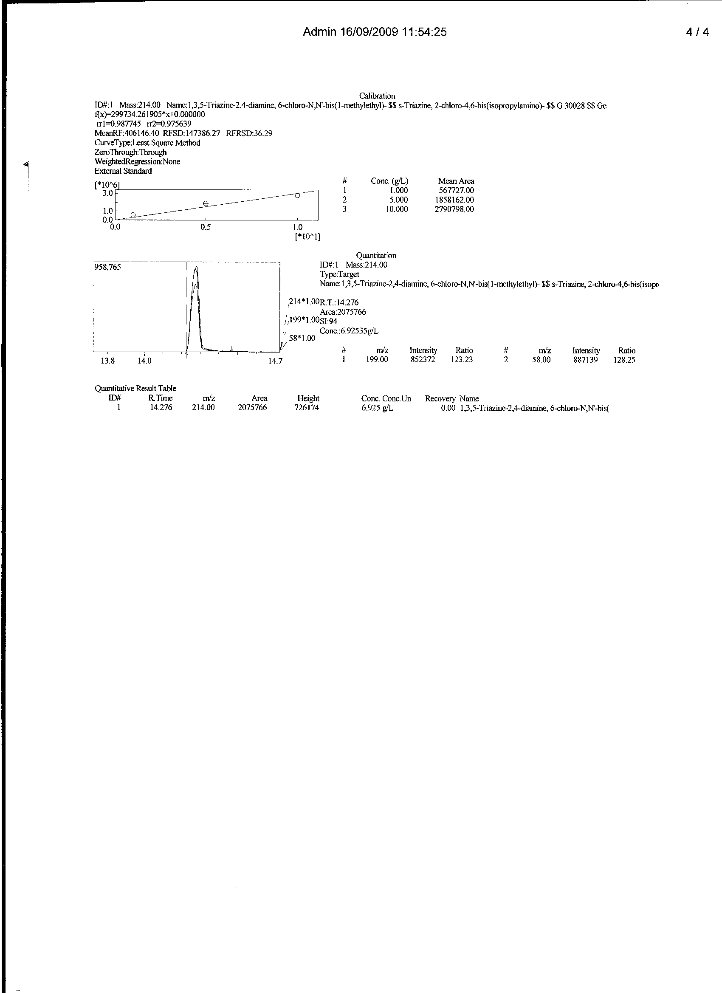
Figure 1: GC/MS chromatogram, quantitative measurement and spectral information of equilibrium phase atrazine after adsorption onto PD/A/60min sorbent
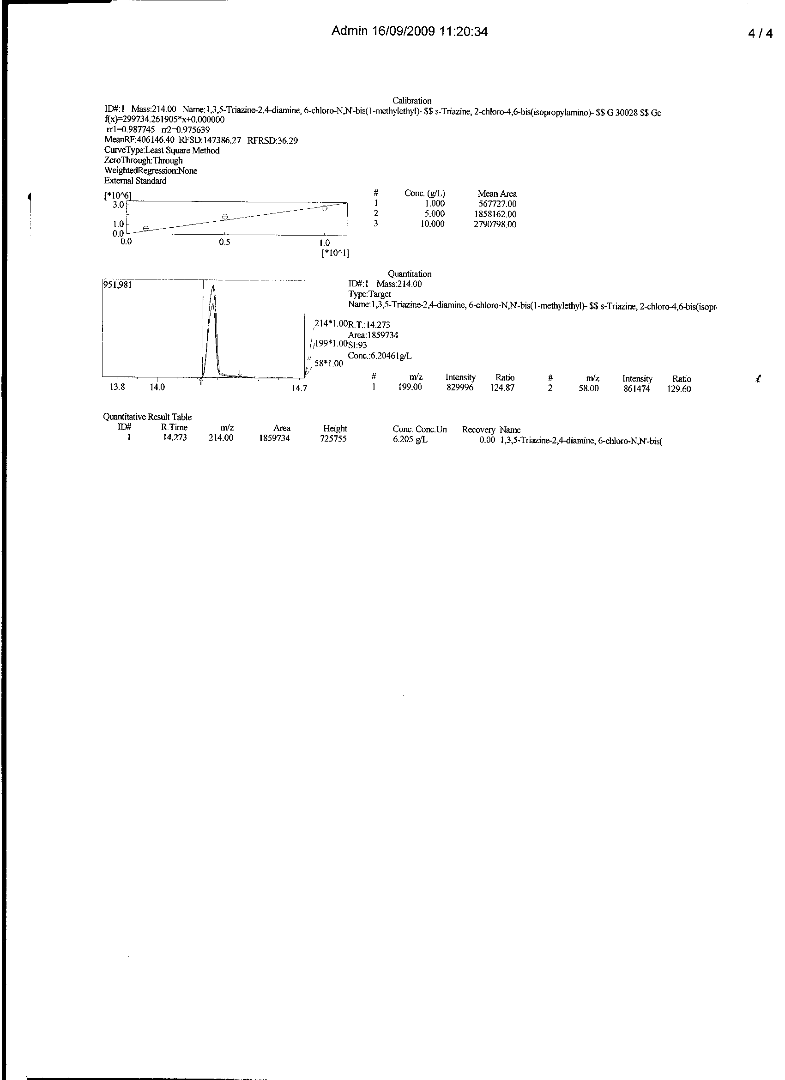
Figure 2: GC/MS chromatogram, quantitative measurement and spectral information of equilibrium phase atrazine after adsorption onto PD/A/120min sorbent
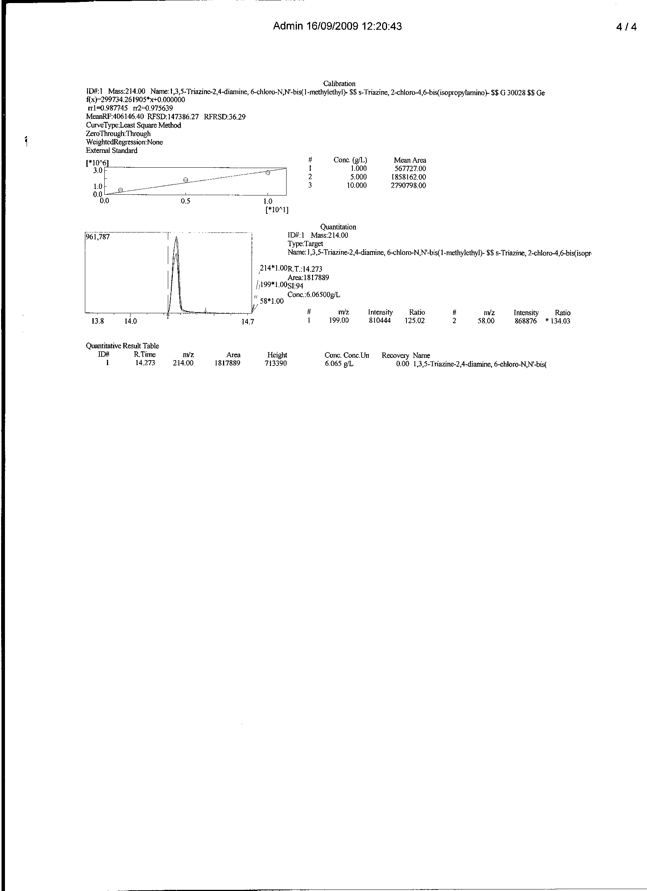
Figure 3: GC/MS chromatogram, quantitative measurement and spectral information of equilibrium phase atrazine after adsorption onto PD/A/180min sorbent
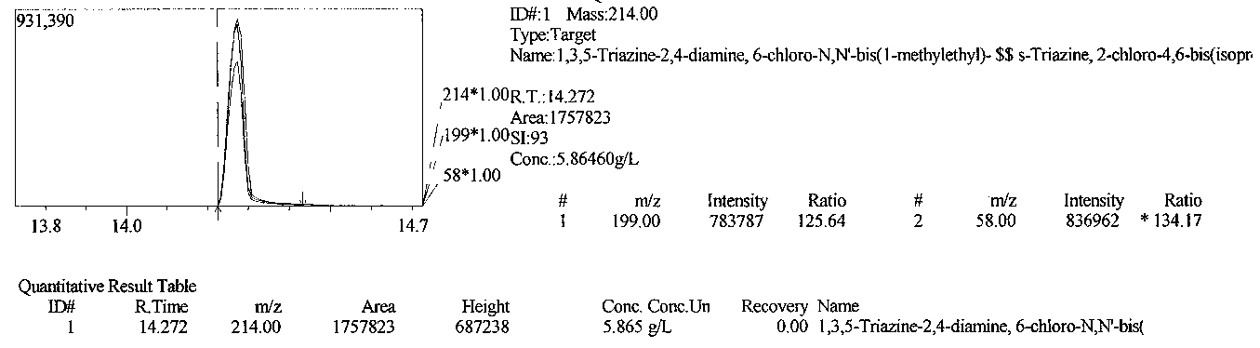
Figure 4: GC/MS chromatogram, quantitative measurement and spectral information of equilibrium phase atrazine after adsorption onto PD/A/240min sorbent

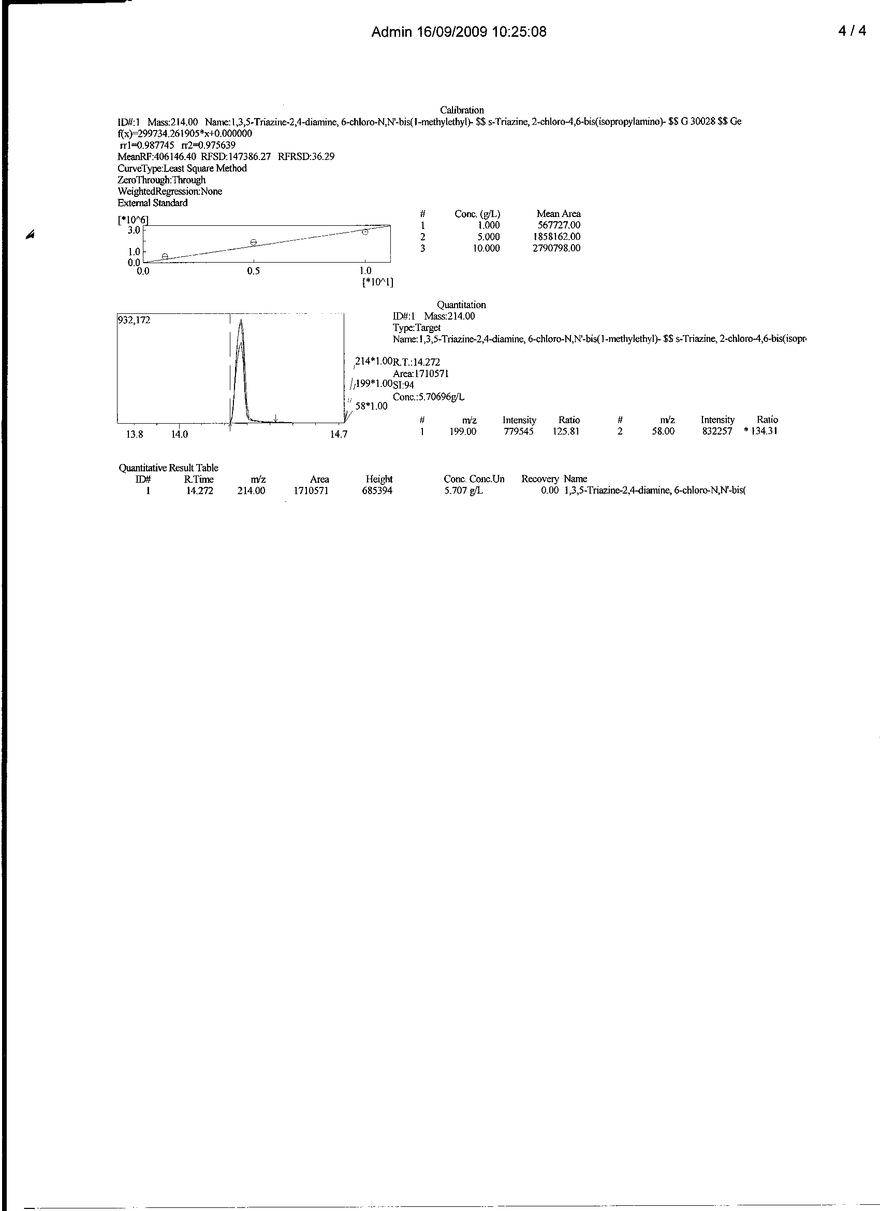
Figure 5: GC/MS chromatogram, quantitative measurement and spectral information of equilibrium phase atrazine after adsorption onto PD/A/300min sorbent
4.Discussion.

The extent at which contact time affect adsorption is non monotonical in multiplicity. At such, a 300 min sorbate – sorbent interaction gave 19.293 adsorption (being a 77.172% adsorption). This is only 5.140, 1.992, 1.432 and 0.632% higher than the 60, 120, 180 and 240 mins interaction with 72.032, 75.180, 75.740 and 76.540% atrazine removal respectively. Summarily, over 72% of atrazine removal was attained within the selected 60 – 300mins timing.
4.1.Application of intraparticle diffusion models The structure of the solid and its interaction with the diffusion substance influences the rate of transport. Adsorbent may be in the form of porous barriers and solute movement by diffusion from one fluid body to the other by virtue of concentration gradient (Shrihari et al., 2005).Intraparticle diffusion is a transport process involving movement of species from the bulk of the solution to the solid phase. In a well stirred batch adsorption system, the intraparticle diffusion model has been used to describe the adsorption process occurring on a porous adsorbent .A plot of the amount of sorbate adsorbed, q_{t} (mgg⁻¹) and the square root of the time, gives the rate constant (slope of the plot). It is calculated by using the intraparticle diffusion model given as equation 4 (Itodo et al., 2009a; Shrihari et al., 2005)
q_{t} = k_{id} t(^{1/2)} + C_{i}. - - (4)
k_{id} (mgg⁻¹ min ^{-1(1/2)}) is a measure of diffusion coefficient.
C_{i} = intraparticle diffusion constant i.e. intercept of the line (mgg⁻¹). It is directly proportional to the boundary layer thickness.

Table 2: Intraparticle diffusion model experimental constants of atrazine uptake onto PD/A-sorbent by fixed mass of PD-Sorbents at different contact time, using GC/MS
Kinetic model | Relationship(y = ) | R² | Constants | Values
Intraparticle diffusion  q_{t} = k_{id}t^{1/2} + C_{i} | 72.41x – 123.4 | 0.916 | k_{id}(mgg⁻¹ min ^{-1(1/2)})  C_{i}(mg/g) | 72.41  -123.4
Intraparticle diffusion  logR = logk_{id} + a log(t)  Intraparticulate diffusivities. In(1-α_{e}) = -k_{p}t | 0.041x + 1.786  -0.011x-2.109 | 0.965  0.975 | k_{id}(mgg⁻¹ min ^{-1(1/2)})  a  k_{p} | 61.094  0.041  0.011

4.2.Deduction from the shape of the intraparticle diffusion plot
A non regression coefficient plot by fitting experimental data to equation 4 gave the 3 phased plot of type in figure 6 .Explanation of these phases was based on reports earlier presented by Biyan et al.,(2009).

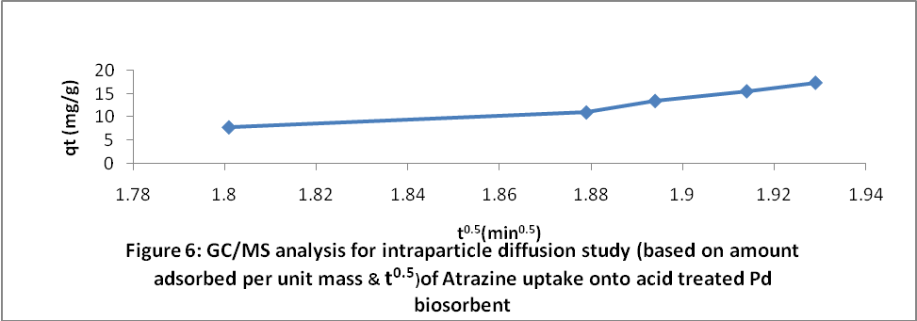

The plot in this analysis revealed a linear step, corresponding to fast uptake of sorbate. The line in the initial stage does not pass through the origin. This makes it noteworthy that uptake is dominated by film diffusion than it does for the intraparticle diffusion process. In the second stage, sorbate adsorption speeds up reflecting non consecutive diffusion of sorbate molecules into the micropores with wider pore width within the sorbent (Biyan et al., 2009).In the third phase, diffusion remains fairly constant when the pore volume is exhausted. Generally, adsorption controlled by the intraparticle model is due to the preferential adsorption of sorbate in the micropores (Biyan et al., 2009)
4.3.Deduction from linear relationship
The same data were fitted into the equation 4 above and investigated for their correlation coefficient and linear relationship by plotting the amount of adsorbed specie against a function of retention time (Badmus et al., 2007). A constant of coefficient (K_{id}) of 72.41 (mgg⁻¹ min ^{-1(1/2)}) was reported.
Disregarding the linearity (high R² value) of the intraparticle diffusion plot, the sorption mechanism assumes intraparticle diffusion if the following conditions are met:
(i) High R² values to ascertain applicability
(ii) Straight line which passes through the origin for the plot area qt vs. t^{1/2}.
(iii) Intercept C_{i} < 0. A validity test which deviates from (ii) and (iii) above shows that the mode of transport is affected by more than one process (Hameed, 2009).

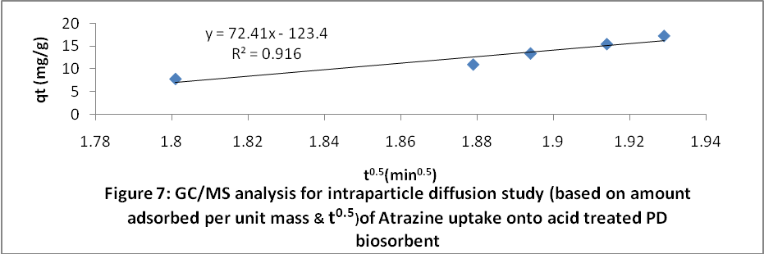

The deviation of the line from the origin further shows that intraparticle transport is not the only rate limiting step. Probably the transport of the sorbate through the particle-sample interphase onto the pores of the particles, as well as adsorption on the available surface of the adsorbent, is responsible for the adsorption. This is in line with the finding of Badmus et al., (2007).

4.4.Deduction of k_{id} in terms of % Sorption
Erhan et al., (2004) described intraparticle diffusion as (Weber and Morris, 1963; Shrivastava et al., 1989) and presented as equations 5.
R = k_{id} (t)ª - - - (5)
Linearized form of the equation is given as 6
Log R = log k_{id} + a log (t) - - (6)
Where R = percent of sorbate adsorbed, t = contact time (minutes),a = gradient of linear plot.The value of ‘a’ depicts the adsorption mechanism. k_{id} is the intraparticle rate constant (time⁻¹). It is taken as rate factor i.e. percent of sorbate adsorbed per unit time(mgg⁻¹min^{-1(1/2)}).

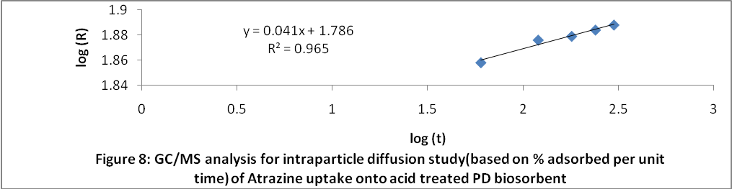

Higher value of k_{id} illustrate an enhancement rate of adsorption, whereas, larger k_{id} values illustrate better adsorption which is related to improved bonding between sorbate and sorbent particles (Erhan et al., 2004).Application of this model to experimental data in this analysis gave a good fit plot with a correlation coefficient of R² = 0.965 and a value of “a” which is less than unity (0.041) and the intraparticle diffusion rate constant, k_{id} is as high as 61.094. This supports an enhanced rate of adsorption which is in turn, linked to improved bonding. (Erhan et al., 2004).The k_{id} value with estimation based on percentage uptake (61.094%) is closely related to that which was based on q_{t} and t^{1/2} (72.41).
4.4 Intraparticulate diffusivities of sorbates on sorbents.
The fractional attainment at equilibrium is the ratio of the amounts of sorbate removed from solution after a certain time to that removed when sorption equilibrium is attained. It would definitely be expected that factors such as the number of reactive sites on the substrate and the bulkiness of the substrate would affect the rate of sorption of atrazine. However, a great deal of information is gotten from the fractional attainment of equilibrium. The rate of attainment of equilibrium may be either film-diffusion controlled or particle-diffusion controlled, even though this two different mechanism cannot be sharply demarcated (Okieimen, 1991)
The fractional attainment at equilibrium α was calculated from the relationship in 7:
α_{e} = q_{t} /q_{e} - - - - (7)
Where q_{t} is the amount of sorbate at any time t and q_{e} is the amount at infinity (i.e. equilibrium) with units in mg/g.

Table 3:Intraparticulate diffusivities experimental data of atrazine uptake by PD sorbent
t (min) | C_{i} (g/dm³) | C_{t} (g/dm³) | q_{t}(x10⁻³mg/g) | α_{e} = q_{t} /q_{e} | In (1-α_{e})
60 | 25 | 6.925 | 1.801 | 0.9336 | -2.711
120 | 25 | 6.205 | 1.879 | 0.9740 | -3.650
180 | 25 | 6.065 | 1.894 | 0.9819 | -4.012
240 | 25 | 5.865 | 1.914 | 0.9922 | -4.854
300 | 25 | 5.707 | 1.929 | 1.000 | ---

The plot of α_{e} against time is shown on Figure 9. From this figure, it is observed that the value of α_{e} with change in time increases from about 0.9335 to 1.00 at 300 min. It can be seen that values of α_{e} converge to one at 300 min. This value of α_{e} at 300 minutes showed that the sorbate was adsorbed most, followed by at 240min and least at 60 minutes. That also means that the rate of adsorption at 300min was faster.

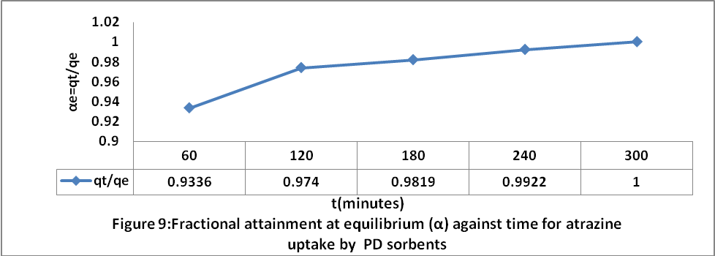

The linear driving force concept was used to develop the relationship for particle-diffusion controlled sorption processes (Okieimen, 1991; Abia and Igwe, 2005) as equation 8
In(1-α_{e}) = -k_{p}t - - - (8)
α_{e} is the fractional attainment of equilibrium, At equilibrium, the fraction of sorbate (atrazine) on the adsorbent include; 0.9335, 0.9740, 0.9819, 0.9922 and 1.00 at 60,120,180,240 and 300 minutes respectively. It thus implies that equilibrium time for this analysis is 300minutes. k_{p} is the rate coefficient for particle diffusion controlled process corresponding to particle size of the sorbent. k_{p} value of 0.011 was estimated as the rate of diffusion. t is time and In(1- α_{e}) is a measure of then intraparticulate diffusivity with negative values as shown on Table 3. If a plot of ln(1 - α_{e}) versus time results in a linear relationship, then the sorption process is particle-diffusion controlled and the diffusivity of atrazine onto the adsorbent surface is independent of the extent of sorption. In this analysis, a linear plot with correlation coefficient value of R²=0.975 was obtained (Figure 10).It thus follows that the sorption process is particle- diffusion controlled.

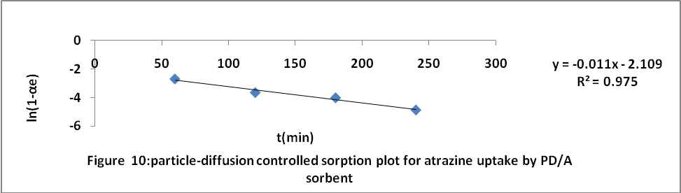

Conclusion
This study has shown that Poultry droppings are good material for fast and efficient sorption of Atrazine. Adsorption of these sorbate was found to be dependent on contact time. The work supports an enhanced rate of adsorption which is linked to improved bonding. Deviation from validity test for transport mechanism is an indication that intraparticle transport is not the only rate limiting step. Estimations based on Fractional attainment of equilibrium (α_{e}) revealed that sorption is more of particle diffusion controlled (transport of the sorbate through the sorbent-sample interphase onto the pores of the sorbent)
Acknowledgements:
Authors are grateful to Mrs. Happiness U. Itodo for her immeasurable support towards the success of this work and to NARICT, Zaria for GCMS Analysis.
Corresponding Author:
Dr. Itodo Udoji Adams
Department of Applied Chemistry,
Kebbi state University of Science and Technology,
P.M.B 1144, Aliero, Kebbi state
Nigeria
E-mail: itodoson2002@yahoo.com
TEL: +2348073812726, +2348039503463
REFERENCES
[1] Abia AA, Igwe JC. Sorption kinetics & intraparticulate diffusivities of Cd, Pb and Zn ions on maize cob. African Journal of Biotechnology 2005; 4 (6):509-512, Available online at http://www.academicjournals.org/AJB
[2] Agdi K, Bouaid A, Martin E, Fernandez H, Azmani A, Camara C. Removal of atrazine from environmental water by diatomaceous earth remediation method. Journal of Environmental monitor 2000; 2: 420-423.
[3] Badmus MA, Audu TO, Anyata BU. Removal of Pb (++) ion from industrial waste water. Turkish J. Eng. Env. Sc. 2007; 31 (1):43-47
[4] Biyan J, Fei S, Hu G, Zheng S, Zhang Q, and Xu Z. Adsorption of methyl tert-butyl ether (MTBE) from aqueous solution by porous polymeric adsorbent. Journal, Hazard material. 2009; 161 (1): 81-87.
[5] Dermibas, E; Kobya, M; Senturk, E. and Ozkan, T. (2004). Adsorption kinetics for the removal of Cr (vi) from aqueous solutions on the activated carbon prepared from agricultural wastes. Journal of water. 30 (4): 533-539.
[6] Dinesh M, Charles U, and Pittman T. Arsenic removal from waste water using adsorbent;A critical review.2007 Elsevier B.V, 2007:16-42
[7] Erhan D, Kobya M, Ehf S, Ozkan T. Adsorption kinetics for Cr (Vi) removal from aqueous solution on activated carbon prepared from Agro wastes. J. water 2004; 30 (4) :533-541.
[8] Hameed BH. Evaluation of papaya seed as a non conventional low cost adsorbent for removal of MB. Hazardous materials 2009 ;162:939-944..
[9] Hameed BH, Din AM, Ahmad AL. Adsorption of methylene blue onto Bamboo based activated carbon: kinetics and equilibrium studies. Hazardous materials. 2006;137(3):695- 699
[10] Isabel M, Wayne, M. The ultimate trash to treasure: poultry waste into toxin – grabbing char. Agricultural research . 2005; 306 (1): 127-43.
[11] Itodo AU, Abdulrahman FW, Hassan LG, Maigandi, S A, Happiness UO. Diffusion mechanism and kinetics of Biosorption of textile dye by H₃PO₄ and ZnCl2 impregnated poultry wastes sorbents. International journal of Natural and Applied sciences 2009b;5(1)7-12
[12] Itodo AU, Abdulrahman FW, Hassan LG, Maigandi SA, Happiness UO. Thermodynamic equilibrium, kinetics and adsorption mechanism of industrial dye removal by chemically modified poultry droppings activated carbon.Nigerian Journal of Basic and Applied Science 2009b;17(1):38-43.
[13] Maria p, Virginia M. Guava seed as adsorbent for adsorption of dye. Bioresource technology 2009; 100 (2): 2111-2117.
[14] Maryam k, mehdi A, Shabnam T, Majdeh M, Hamed k. Removal of Pb, Cd Zn and Cu from industrial waste water by carbon developed from Walnut, Hazelnut, Almond and Apricot Stones. Harzadous material .2008;150:322-327.
[15] Min C, Yun Z. Rapid method for analysis of organophosphorus pesticide in water:Bulletin application note. Agilent Technology, USA 2008;19-21.
[16] Okiemen FE, Ojokoh FI, Okiemen CO, Wuana, RA. Preparation and evaluation of activated carbon from rice husk and rubber seed shell. Chemelass Journal 2004;191-196.
[17] Okoronkwo AE, Anwasi S. Biosorption modeling of copper and zinc adsorption from aqueous Solution by tithonia diversifolia. CSN Conference proceeding. Chemical Society of Nigeria. Deltachem 2008;92-102.
[18] Robert, L. and Eugene, F. Modern practice of chromatography. 4th Edn. Wiley interscience. John Wiley and sons Inc. New Jersey, 2004; 425
[19] Rozada F, Calvo F, Garcia A., Martin V, Otaro M. Dye adsorption by sewage sludge based activated carbon in batch and fixed bed system. Bioresource technology 2003; 87 (3): 221 – 230.
[20] Shimabukoro R.H. Atrazine metabolism and herbicidal selectivity. plant physiol. 1967;42:1269-1276.
[21] Shrihari V, Madhan S, Das A. kinetics of phenol sorption by Raw Agrowastes. Applied Sciences. 2005;6 (1): 47-50.
[22] Turoti M, Gimba C, Ocholi O, Nok A. Effect of different Activation Methods on the Adsorption Characteristics of Activated Carbon from Khaya Senegalensis Fruits and Delonix Regia pods. Chemclass Journal 2007; 4 : 107 – 112.
[23] Yoshiyuki S, Yutaka K. Pyrolysis of plant, animal and human waste: Physical and chemical characterization of the pyrolytic product. Bioresource Technology 2003;90 (3): 241-247.
8/02/2010

