In vitro clonal propagation of Acacia nilotica (L.) - A nitrogen fixing tree

Dhabhai K ,Sharma M M and Batra A
Department of Botany, University of Rajasthan, Jaipur, Rajasthan 302055, India
kshipramicrobiology@gmail.com, drmadansharma@gmail.com, amlabatra@gmail.com

Abstract: An efficient regeneration protocol was developed for in vitro propagation of Acacia nilotica (L.), a nitrogen fixing tree, through direct regeneration. In vitro nodal segments cultured on Murashige and Skoog (MS) medium supplemented with NAA (0.6 mg/l) and Kn (1.0 mg/l) for shoot proliferation. NAA was found to be more effective than Kn for shoot multiplication. The highest number of shoots (4.6±0.7) were achieved on MS medium augmented with NAA (0.6 mg/l). However, excised shoots (2-3cm) were rooted on half strength MS medium supplemented with IBA (0.5 mg/l) after 15-20 days of culture. The micropropagated plantlets were hardened and acclimatized. They were successfully transferred to natural conditions with 75% survival rate. [Researcher. 2010; 2(3):7-11].(ISSN: 1553-9865).

Keywords: Cytokinin, Auxin, in vitro regeneration

1. Introduction
Acacia nilotica (L.) wild ex Del belongs to the family Leguminosae commonly known as Babool or Kikar, is a multipurpose legume tree. It act as a biological control agent for herbivores ( Dhileepan et al, 2009).It is found in the central belt of Indian sub-continent and Australia. This plant has been used as a source of pulpwood , timber, fodder and gum. The whole parts of the plant used for medicinal purposes like barks act as astringent which found to be useful in the treatment of dysentery, diarrhoea, leprosy and smallpox (Pande et al, 1982; Orwa, 2009 ).This plant also shows antioxidant activity (Singh et al, 2009).

The leguminous trees are one of the most significant component of forest vegetation due to their economic and ecological importance . However, the regeneration rate of this plant in natural surroundings is quite low (Dewan et al, 1992). In general, the woody plants are difficult to regenerate under in vitro conditions but some success was achieved in a few leguminous tree species except Acacia nilotica. In vitro regeneration protocols have been standardized earlier in some other species of Acacia like A.. mearnsii De Wild (Beck et al, 2000 ), A. catechu Willd ( Kaur and Kant, 2000), A. sinuate ( Vengadasan et al, 2003), A. chundra (Roxb.).DC (Rout et al, 2008), A. Senegal ( halafalla et al, 2008) except A. nilotica(L.). However, a large number of publications are available regarding its antimicrobial activity (Satish et al, 2010), antioxidant activity (Singh et al, 2009). This paper describes a successful protocol on in vitro propagation of A. nilotica from nodal explants of in vitro grown plants.

2. Materials and Methods

2.1 Seed germination and procurement of explants

Seeds of Acacia nilotica L. were collected from Sirsi (Haatoj) District, Jaipur, Rajasthan. Prior to surface sterilization, seeds were soaked in distilled water for about 48 hrs. Then they kept under running tap water for about 10-15 mins. followed by washing with 1% (v/v) Teepol for 2 min. and rinsed with double distilled water for three times. Prior to inoculation, sterilized seeds were then sterilized with 0.1% (w/v) aqueous HgCl₂ for about 2 mins. followed by 2-3 rinsing with double distilled water in Laminar Air flow cabinet. These sterilized seeds were inoculated on half and full strength MS salts medium, filter paper bridges, filter paper disk and on non-absorbent cotton in the Petri plates. After 7-10 days of inoculation, seed germinated and gave rise seedlings. (Table 1and Figure A). These in vitro seedlings were used as source of explant. Nodal segments (1.5cm) were taken from the seedlings which did not required sterilization and inoculated on the MS medium congealed with various concentrations (1.0-2.0 mg/l) of Kn and (0.2-1.2mg/l) of NAA for the morphogenic responses.

2.2 Culture Media and Growth Condition

The Murashige and Skoog (1962) (MS) medium was prepared by adding 3 % sucrose as a carbon source and 0.8% (w/v) agar as a solidifying agent , supplemented with different concentrations of Kn (0, 1.0,1.2,1.4,1.6,1.8,2.0 mg/l), NAA( 0,0.2, 0.4, 0.6, 0.8,1.0,1.2 mg/l) alone. The pH of medium was adjusted to 5.8 ± 0.2 before autoclaving at 121⁰C for 15 minutes at 15 lb/in². 20 ml of molten agar medium was poured into a culture bottle and plugged with nonabsorbent cotton. All cultures were incubated in 16 h /8 h photoperiod under light intensity of 50 µE/ m²/s provided by cool, white and fluorescent light at 25 ± 2°C with 55% relative humidity. Each treatment performed using eight replicates and the experiment was repeated at least thrice. The effect of different growth regulators were quantified as the mean number of multiple shoots per explant. The data were statistically analyzed (Harter, 1960).

2.3 Multiple shoot induction and in vitro rooting

Multiple shoots raised on MS medium alongwith growth hormones by inoculating in vitro nodal segment. In vitro regenerated shoots measuring about 3.5-4 cm grown in multiplication medium were excised and cultured on half-strength MS basal medium as control and supplemented with IBA (0.1,0.3,0.5,0.7 mg/l) and NAA (0.2,0.4,0.6,0.8,1.0 mg/l) alone for induction of rooting. In addition to different concentrations of NAA and IBA alone, control medium was also tried for the root induction. The cultures were examined every day and the morphological changes were recorded on the basis of visual observations. The effects of different treatments were quantified as the mean percentage of rooting.

2.4 Hardening and Acclimatization

The plantlets were taken out from culture tube without damaging the delicate root system and rinsed with distilled water to remove adhering agar and then transferred to polycups containing vermicompost and autoclaved soil (1:3). Polycups were covered with inverted glass beakers to maintain high humidity and kept in culture chamber. They were gradually exposed from artificial environmental conditions to natural acclimatization.

3. Results and Discussion

Various tests were performed to germinate seeds in vitro conditions (Table 1).Out of all the tests performed, seeds, germinated on filter paper bridges with 90% response after 5 days of inoculation. These in vitro germinated seedlings were the regular source of nodal segments in further experiments. The present investigation was carried out to explore the morphogenic potential of A. nilotica by using different combinations of growth regulators. The nodal explants resumed new bud growth by proliferating the axillary shoot within 1–2 weeks of culture (Figure B). Nodal segments inoculated on MS medium fortified with Kn (0, 1.0,1.2,1.4,1.6,1.8,2.0 mg/l ) and NAA (0, 0.2 0.4, 0.6, 0.8,1.0,1.2 mg/l) separately for the proliferation of axillary bud. Proliferation of axillary bud was observed on MS medium having Kn (1mg/l) but these proliferated axillary buds remained undifferentiated till one month. However, axillary buds proliferated on NAA (0.6 mg/l) underwent multiplication of shoots (Figure C). Some of these shoots were rooted on the same medium. Due to remained undifferentiating of tissues in Kn (1mg/l), these tissues were subcultured on the medium having NAA at concentrations (0.6 mg/l). Within 4 weeks of inoculation, axillary meristems elongated up to 3.5-4 cm in height. Similar results were reported in other legume trees A .mearnsii and Albizia odoratissima (Beck et al, 2000; Rajeshwari and Paliwal, 2008) respectively. NAA proved to be the most effective treatment for promoting shoot multiplication (3–5 shoots/explant, each shoot having 3 to 4 nodes) within four weeks of subculture (Table.1,Figure C). Similar observations were made in A. mangium and Tylophora inidica (Bhaskar et al, 1994; Nanda et al, 2004; Faisal et al, 2007). In contrary to the present results, modified MS medium alongwith BAP (1.5 mg/l) and BAP (1mg/l) in MS medium also stimulated the multiplication of shoots in A. nilotica and A. Senegal (Dewan et al,1992; Khalafalla and Daffalla, 2008) respectively.

Elongated shoots derived from nodal explants were separated and cultured on half strength MS basal medium supplemented with IBA (0.5 mg/l) and NAA (0.6 mg/l) alone for induction of rooting. Out of the auxins tested, IBA induced rooting at the basal end of shoots. (Table 2). The optimum concentration was 0.5 mg/l of IBA and it resulted in 80% of root initiation within 8–10 days of culture (Figure D). At higher concentrations (1.0–1.5 mg/l) of IBA, the percentage of rooting was reduced and callus formation was obtained at the basal cut end. Similar results were observed in A. mangium, Withania somnifera, A. Senegal and Prosopis ceneria for root induction (Nanda et al, 2004; Sharma and Batra, 2006; Khalafalla and Daffalla, 2008; Kumar and Singh, 2009) respectively. In contrary to the present results, MS medium alongwith IAA (2 mg/l and 3 mg/l) respectively in A. nilotica, A .catechu, Ormacarpum sennoides and Withania somnifera for root induction (Dewan et al, 1992; Kulneet and Kant, 2004; Shanti, 2008; Shekhawat et al, 2009 ) respectively.
Now, efforts are being made to gradually transfer plant to the field. After 35-45 days of culturing the shoots on rooting medium, the plantlets were removed from the cultured tube and hardening and acclimatization was done by the method described in “Materials and Methods” (Figure E).

Table 1: Seed Germination in vitro Methods:
S. No. | Experiment for seed germination | Days taken for seed germination | % Seed germination
1. | Filter paper bridge method | 5 | 90%
2. | Filter paper disk method | 7 | 75%
3. | Cotton disk method | 10 | 68%
4. | Half strength MS medium | 15 | 55%
5. | MS medium | 25 | 20%

Table 2: Effect of Cytokinins & Auxins on shoot multiplication from nodal explants of Acacia nilotica after four weeks of culture
Plant Growth Regulators % response Average Number of multiple shoots Average length of shoots
(mg/l) (*Mean ± t _{0.05} S.E.) (*Mean ±t _{0.05}S.E.)
NAA Kn
0 0 0 0 0
0.2 40 2.38 ± 0.4 2.7 ± 0.8
0.4 50 2.45 ± 0.6 3.7 ± 0.3
0.6 90 4.61 ± 0.7 4.0 ± 0.6
0.8 70 2.86 ± 0.7 3.0 ± 0.3
1.0 60 2.62 ± 0.6 3.5 ± 0.5
1.2 50 2.45 ± 0.6 3.7 ± 0.4
1.0 70 2.70 ± 0.4 2.7 ± 0.6
1.2 60 2.38 ± 0.8 2.3 ± 0.4
1.4 50 2.82 ± 0.7 2.4 ± 0.7
1.6 30 2.62 ± 0.6 1.5 ± 0.2
1.8 40 2.38 ± 0.4 1.7 ± 0.6
2.0 30 2.62 ± 0.6 1.5 ± 0.4

*Values are 95% confidence limits for Mean and mean values within the column followed by the same letter are not significantly different by the Tukey’s test at 0.05% probability level

Table 3: Effect of Auxins on rooting of Acacia nilotica after two weeks of culture

Plant Growth Regulators % response % of rooting (mg/l) (*Mean ± t _{0.05} S.E.)
NAA IBA
0 0 0 0
0.2 10 1.4 ± 0.6
0.4 50 2.5 ± 0.6
0.6 80 3.5 ± 0.7
0.8 60 3.2 ± 0.8
1.0 20 1.6 ± 0.4
0.1 20 1.6 ± 0.4
0.3 40 2.4 ± 0.6
0.5 90 3.6 ± 0.6
0.7 30 2.1 ± 0.4
0.9 60 3.2 ± 0.8
*Values are 95% confidence limits for Mean and mean values within the column followed by the same letter are not significantly different by the Tukey’s test at 0.05% probability level

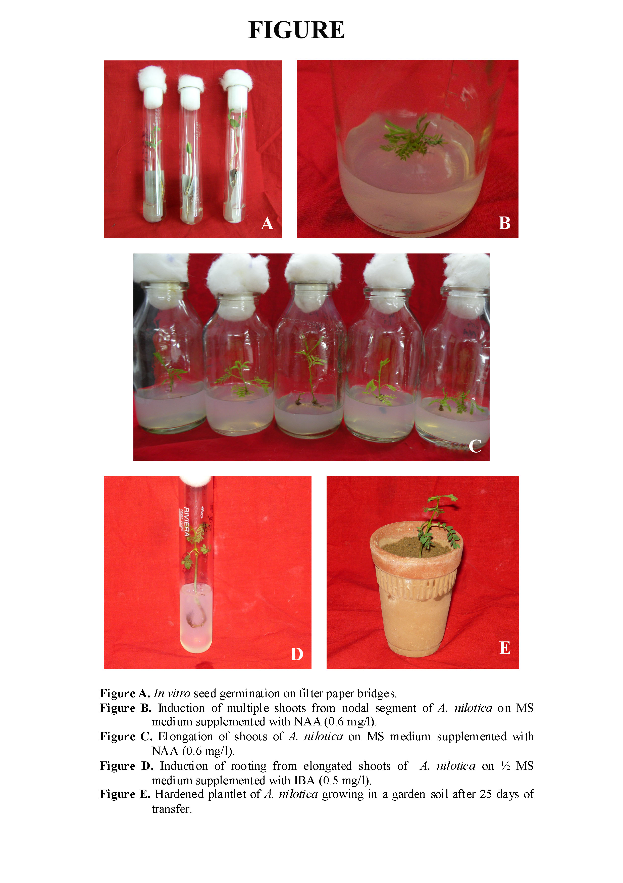

4. Conlusion
The present paper presents for a quick, reliable and reproducible protocol for in vitro clonal propagation large scale clonal production of A. nilotica without any seasonal influences. However, few reports are also available on regeneration of this plant species, but they are not much efficient and taking more time as compared to the present protocol.

Correspondence to:
Kshipra Dhabhai
Lab.No.5, Department of Botany
University of Rajasthan, Jaipur (Raj.), India
kshipramicrobiolgy@gmail.com; +91-98280805

References:
- Beck SL, Dunlop R, Staden JV. Meristem culture of Acacia mearnsii. Plant Growth Regulation 2000; 3: 49-58.
- Bhaskar P and Subhash K. Micropropagation of Acacia mangium Willd. through nodal bud culture. Indian Journal of Experimental Biology 1996; 34: 590–591.
- Dewan A, Nanda K, Gupta SC In vitro micropropagation of Acacia nilotica subsp, Indica Brenan via cotyledonary nodes. Plant Cell Report 1992; 12:18–21.
- Dhileepan, Lockett, Robinson, Pukallus. Prioritising potential guilds of specialist herbivores as biological control agents for prickly Acacia through simulated herbivory. Annuals of Applied Biology 2009;154(1):97–105.
- Faisal M, Ahmad N, Anis M. An efficient micropropagation system for Tylophora indica: An endangered, medicinally important plant. Plant Biotechnology Reports 2007;1(3):155-161.
- Harter HL. Critical values for Duncan’s multiple range test. Biometric 1960; 16: 671–685.
- Kaur K and Kant U. Clonal propagation of Acacia catechu Willd. by shoot tip culture. Plant Growth Regulation 2004; 31(3): 143-145.
- Khalafalla, MM and Daffalla, HM. In vitro Micropropagation and Micrografting of Gum Arabic Tree, Acacia Senegal (L.) Wild. International Journal of Sustainable Crop Production 2008; 3(1): 19-27.
- Kumar S and Singh N. Micropropagation of Prosopis ceneria (L.) Druce- A multiple desert tree. Researcher 2009; 1 (3): 28-32.
- Nanda RM, Das P and Rout GR. In vitro clonal propagation of Acacia mangium Willd. and its evaluation of genetic stability through RAPD marker. Annuals of forest Science 2004;61:381-396.
- Orwa. Agroforestry Database 2009; 4.
- Pande MB, Talpada PM, Patel ZN, Purohit LP and Shukla PC. Note on processed babul feeding to mature Kankrej bullocks. Indian Journal of Animal Science 1982; 52: 798-799.
- Rajeshwari V and Paliwal K. In vitro adventitious shoot organogenesis and plant regeneration from seedling explants of Albizia odoratissima L.f. (Benth.) In vitro cellular and Developmental Biology 2008; 44 (2): 78-83.
- Ranga Rao, GV and Prasad, MNV. Plantlet regeneration from the hypocotyl callus of Acacia auriculiformis –multipurpose tree legume. Journal of Plant Physiology 1991; 37: 625–627.
- Rout GR, Senapati SK and Aparajeta S. Micropropagation of Acacia chundra ( Roxb.)DC. Horticulture Science 2008; 35: 22-26.
- Satish S, Raghavendra MP and Raveesha KA. Screening of plants for antibacterial activity against Shigella species. International Journal of Integrative Biology 2010;9:16.
- Shanti P. In vitro propagation of Ormocarpum sennoides (Willd) DC. Prodr. from shoot tip explant. Indian Journal of Plant Physiology 2008; 13:1.
- Sharma MM and Batra A. High frequency Plant Regeneration in Indian Ginsing : Withania somnifera L.(Dunal ) in physiology and Molecular Biology of plants. International Journal of Functional Plant Biology 2006; 12 (4): 289-293.
- Shekhawat SG, Mathur S and Batra A. Role of phytohormones and nitrogen in somatic embryogenesis induction in cell culture derived from leaflets of Azadirachta indica. Biological Plantarum 2009; 53(4): 707-710.
- Singh R, Singh B, Singh S, Kumar N, Kumar S and Arora S. Investigation of Ethyl Acetate Extract/ Fractions of Acacia nilotica Willd. Ex del as Potent Antioxidant. Records of Natural Products 2009; 3(3): 131-138.
- Skolman NRG and Mapes OM. Acacia koa Gray plantlets from somatic callus tissue. Journal of Heredity 1986; 67: 114–115.
- Vengadesan G, Ganapathi A, Anand P and Selvraj N. In vitro propagation if Acacia sinuata (Lour.) Merr. from nodal segments of a 10-year-old tree. In vitro Cellular and Developmental Biology 2003; 39: 409-414.

Date of Submission: 16.02.2010

