Land use change in Siby, Mali, 1986-1999and 2002: A Remote Sensing Analysis
Lansine Kalifa Keitaª* Liqin Zhang^{b}
Department of Land Resources Management, China University of Geosciences, Wuhan, Hubei 430074, China. lansinekeita73@yahoo.fr
Abstract: In this paper，it gave a detailed introduction about the classification process of land use in Siby in Mali Using remote sensing and GIS software’s such as ENVI.4.3 and ArcGIS 9.3 three Landsat TM images (1986- 1999 and 2002) of Siby were used for the study. After being geometric corrected subset and enhanced, the images were classified into 5 classes: urban area, Farmland, Water, Forest, and Grassland, using the supervised maximum likelihood classifier. As expected, urban area increased throughout the study period 1986, 1999 and 2002 (1%) (15%) (16 %) respectively. The main objective of this paper is to identify the spatial changes of land uses in the Siby commune using multi-temporal satellite images. The implication of this unprecedented growth in urban land is the resulting environmental and ecological problems associated with unplanned urban growth and development such as loose of grassland, deforestation and increased of farmland. The unsustainable agricultural practices along with many other physical, socio-economic and political factors have been the driving forces to a series of land degradation problems. The main objective of this paper is to identify the spatial changes of land uses in the Siby commune using multi-temporal satellite images. Statistical analysis bivariate correlation is used to establish the correlation between land use type populations, income .Human use of land has altered the structure and functioning of ecosystems. Human activities override natural changes of ecosystems caused by climate variations of the past few thousand years. Agriculture, forestry, and other land-management practices have modified entire landscapes and altered plant and animal communities of many ecosystems throughout the world .The most spatially and economically important human uses of land globally include cultivation in various forms, livestock grazing, settlement and construction, reserves and protected lands, and timber extraction .The pattern of land use can give us insight in the factors that have caused the land cover to change. A better understanding of the determining factors of land-use change is of crucial importance to the study of global environmental change. [Researcher. 2010; 2(3):12-21].(ISSN: 1553-9865).

Key Words: Remote Sensing, classification, Land use change

Introduction
LC/LU classification on the basis of satellite images with appropriate specifications serves as an essential database for planning and making decisions at different administrative levels (Diabaté, D., 19860). The integration of such remote sensing data into a GIS offers a wide variety of new perspectives and possibilities for the analysis, evaluation and interpretation of such data, in combination with auxiliary digital information such as digitized maps. Land use practices generally develop over a long period under different environmental, political, demographic, and social conditions. These conditions often vary and have a direct impact on land use and land cover .The interaction of nature and society and their implications on land use and land cover is a very complex phenomenon that encompasses a wide range of social and natural processes. ‘‘Land-use planning is the systematic assessment of land and water potential, alternatives for land-use and economic and social conditions in order to select and adapt the best land-use options’’ This definition embraces the systematic approach of possibilities for different land-uses in the future, and also the felt need for changes and the willingness to execute the plan. All present land-use planning is caught up between two seemingly contradictory dimensions: ecological conservation and economic existence (Hurni, 1990). Both dimensions are, in some way or another, related to sustainability. The first dimension refers, at present, strongly to conservation: This work concerns land use change in Siby, a rural community in The Republic of Mali, using three satellite images (1986, 1999 and 2002) .The main aim is to show how, urban land area, farmland, Grassland, water, and forest in Siby have changed between the time periods 1986, 1999 and 2002.The combination of population growth, limited expansion of arable land, and the growing need for land for non-agricultural purposes, increases the pressure on grassland competition for the available space. Land derives its interest from the vegetation and crops that can be grown on it. Land cover and land use are, however, dynamic, and are affected both by natural phenomena, such as climatic events and natural disasters, and by human activities, although the impact of the latter has mainly been felt in recent centuries. We must understand the term ‘resources’ and classify them before we can discuss the various problems arising from potential scarcity and evaluate the threats they pose. Natural resources are those products or properties of the physical environment which human beings are technically capable of utilizing and which provide desired goods and services. Both these criteria must be satisfied before a particular part of the physical world can acquire a value as a resource (FAO, 2000), Technological innovation and improved knowledge only create the opportunities for utilization. Whether these opportunities are taken up depends upon economic, social and political demands. Resources are, therefore, defined by human desires, needs and capacity. They are phenomena which depend greatly on the prevailing culture. This helps to explain the many disagreements over which particular elements in the environment are resources.

MATERIALS AND METHODS
Software Used
Basically, five software’s were used for this project:
A) ArcGIS 9.3 – This was also used to compliment the display and processing of the data; map of Siby.
B) ENVI 4.3 – This was used for the development of land use land cover classes and subsequently for change detection analysis of the study area.
D) SPSS 16.0 This was used for the interpretation of data.
E) Microsoft word – was used basically for the presentation of the research.
F) Microsoft Excel was used in producing the bar graph.

Study area
This research was conducted in Siby (Fig.1) Siby is a rural municipality in Mali. It is located in the Circle of Kati in the Koulikoro Region, 50 km from Mali's capital, Bamako It lies on Latitude:.12°23’N, and along longitude: 8°20 ‘W. Its Elevation is 1226ft.above sea level. The municipality of Siby has a population of 20,287 inhabitants (2004) (Table: 2).It covers a surface of 1001.25km² . The village of Siby is sub-divided into five quarters, all located on the plain at the side of the Mandingoes Mountains. The climate is characterized by its sudano-sahelian type, with a long dry season (September-May), divided into a cool period from November to February and warm period from March to June. The rainy season extends from June to September or mid October. As a tropical climate, it is characterized by a dry season characterized by warm and tropical air masses known as the harmattan, and by a rainy season controlled by continental tropical air masses monsoon at times of low sun .In this study, three Landsat TM images (December 14, 1986, October 25, 1999 and May 03, 2002) of Siby (wrs path 199, row 52) are used for analysis. The quality of images is good. Remote Sensing is the main research method while GIS is the auxiliary method (Kanté Salif (2001).The figure below shows the main processes involved in image processing and analysis of results. Land-use planning has been described in many ways. A simple and short description is that it consists activities that: (1) determine future land-uses; (2.) improve the area properties and (3). Organize the management of the new situation. (A) ‘Physical planning’ is related to place and where. In this sense it distributes the often scarce space between several potential users, with the optimization of the land-uses as a main objective. Many developed and developing countries have policies and projects resulting in this type of land-use planning. (B) ‘Land redevelopment’ refers to the actual changing of the land-uses and the improvement of the physical conditions for the planned land-uses. In most cases, this type of land-use planning follows physical planning. It is responsible to carry through the planned land-uses as determined in physical planning and often to improve the physical conditions for the planned land-uses. (C).
‘Land management’ refers to new methods of how to manage lands by mankind. For the rural countryside it mainly focuses on farm practices, forest management and nature management. The intensity of the use, especially in farming and to a certain degree also in forestry, has a tremendous long-term effect on the abiotic (soil, water, air. as) well as on the biotic factors.

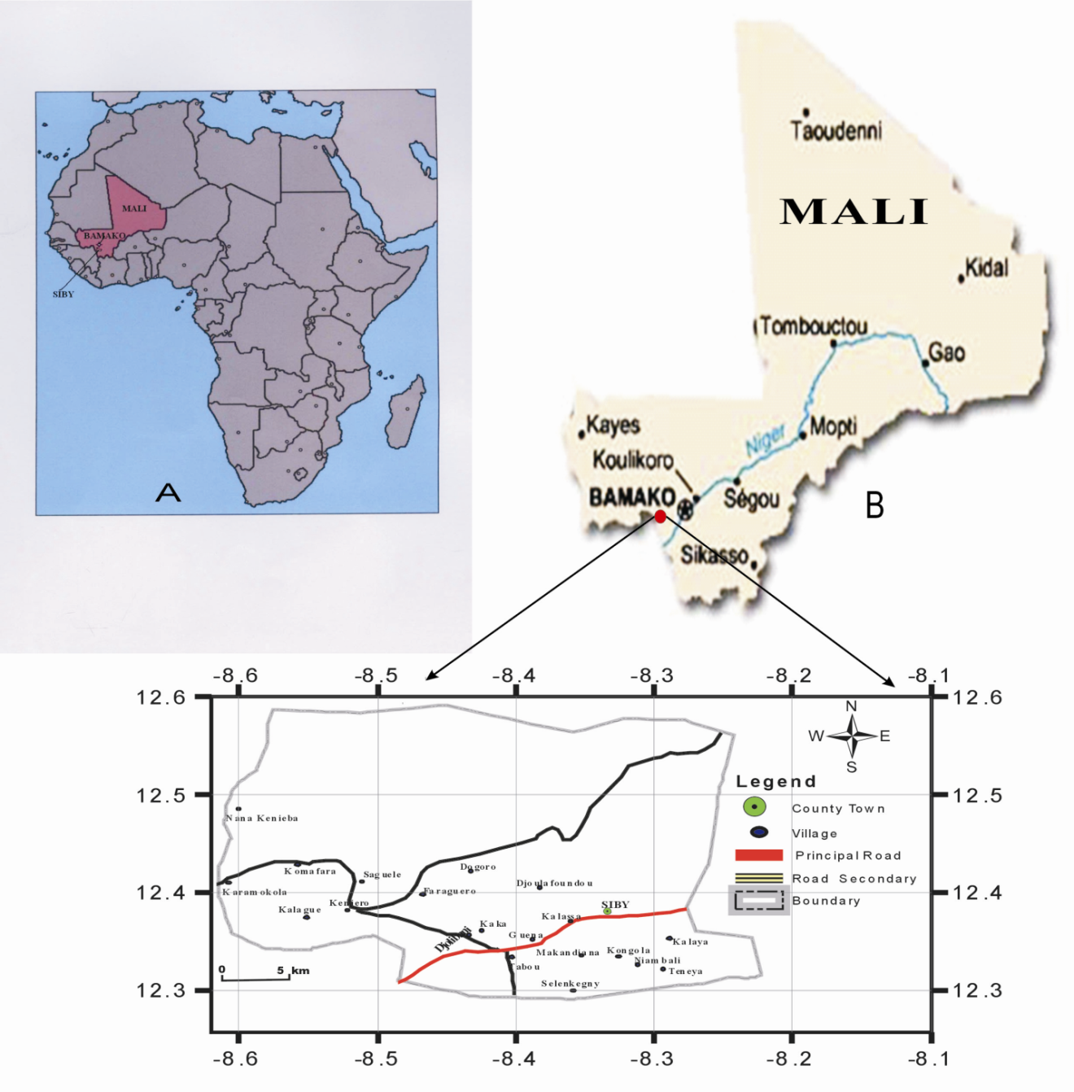

Figure1. Location of the study area

Figure 2. Schematic presentation of the study
OBJECTIVES OF LAND USE/LAND COVER
DATA ACQUISITION
CENSUS and REPORTS
DATA ENHANCEMENT, PROCESSING AND INTEGRATION

INITIAL LAND USE /LAND COVER CLASSIFICATION

DEVELOPMENT OF A CLASSIFICATION SCHEME
GROUND TRUTHING
EDITING OF INITIAL LAND USE/LAND COVER MAPS
FINAL PRODUCTION OF LAND USE/LAND COVER MAPS
CHANGE DETECTION ANALYSIS BASED ON LAND USE/LAND COVER MAP FOR EACH YEAR
Analysis of the (%) change

Analysis of rate (%) change

Bivariate analysis with SPSS

Macleod and Congation (1998) list four aspects of change detection which are important when monitoring natural resources:
- Detecting the changes that have occurred
- Identifying the nature of the change
- Measuring the area extent of the change
- Assessing the spatial pattern of the change.
A wide variety of digital change detection techniques have been developed over the last two decades. Singh (1989) and Coppin & Bauer (1996) summarize eleven different change detection algorithms that were found to be documented in the literature by 1995(Figure 4). These include
1 Mono-temporal change delineation.
2 Delta or post classification comparisons.
3. Multidimensional temporal feature space analysis.
4. Composite analysis.
5. Image differencing.
6. Multitemporal linear data transformation.
7. Change vector analysis.
8. Image regression.
9. Multitemporal biomass index
10. Background subtraction.
11. Image rationing sensed images obtained from various Landsat.

4.1 Satellite image processing
Precisely defined, land cover is the (bio-) physical ground cover of the land surface and immediate subsurface .Land use, on the other hand, describes human employments of that land. In that sense, farming would be an example of land use while scrub could be the corresponding cover. As remote sensing can quickly provide data covering a large area, it has become an indispensable tool for monitoring changes in land use/cover. However, in literature the two are often used synonymously .In this study, land “cover” will be referred to denote the categories of the dependent variables and land “use” when interpreting the results of the analysis. Changes in land cover were measured using time series of remotely sensed satellite data. Remote sensing relies on the measurement of electromagnetic energy .Most passive remote sensing sensors measure the wavelength of the sunlight reflected from the earth’s surface. A time series of three high resolution Landsat images acquired for the years 1986 , 1999 and 2002 Landsat TM ( Table 6.) were used for land cover analysis.
The image processing system ENVI imagine was used in processing and classifying the acquired images. Geo-referencing of images was executed on the basis of ground control points, derived from 1:10,000 topographic maps scale topographical maps. A sub-pixel accuracy of control points was obtained for all satellite images by georeferencing
A supervised classification of images was carried out using the maximum likelihood method. This decision rule is based on the probability that a pixel belongs to a particular class with the highest probability among several possibilities. The algorithm is more computation intensive and therefore slower than most of the other classification algorithms; but the accuracy of classification is usually higher, especially in cultural, small-area heterogeneous landscapes (Tilman, D., et al, 2001). LANDSAT TM bands 5, 4, 3 are used in the image classification. The supervised (Maximum Livelihood) classification algorithm was followed and the probability threshold of 0.9 was set for the class. Post-classification was accordingly deployed with and of better classes and classifying evaluation using Confusion Matrix method, which compares reference pixels with classified pixels. The result was also re-calibrated by comparing the geographical data derived from ground truthing to remove uncorrelated pixels.
Change detection: The biophysical data of Siby map with villages were obtained through the change detection analysis of remote sensing imagery. We have worked on the followings data: Data type, landsat TM Datum: WGS84 coordinate system Type UTM zone 29 N, Number of bands: 3, Number of lines 1296 respectively for (1986, 1999 and 2002. This was because some of the land use types observed during field work was a result of change. Therefore, areas that did not change throughout the study period were identified on the images and used for accuracy assessment. Google Earth (especially the parts of the Siby commune that are overlaid with large-scale aerial photos images) was employed as reference data for the assessment of the classification and accuracy. Supervised classifications using Maximum Likelihood method was performed on the images. Five land use change classes were used. These include urban area,
Farmland, Water, Forest and Grassland, points of all classes are higher than 1000 (Fig.4). Since there are some influential factors, such as mixed pixel and phenomenon of same spectrum on different targets, some small spots were produced .Rejection of the small spot was done by the RS and GIS software. The mapping was done using GIS tools in ArcGIS 9.3 .In addition correction was also done by visual interpretation. The accuracy of the two classified images was testified with a stratified random sampling method, and the overall accuracy reached. Sometime it is important to calculate changes of variable values over time (Table 2). Changes can be expressed as an absolute change or a percent change, as an average annual absolute change, or as an average annual absolute change, or as an average annual percent change. Let us use (x_{t}) to represent the value in beginning year and (t_{t+n}) for the ending year. The period between the beginning and ending year is n year. Also, let us use G_{a} for the absolute change, G_{p} for the percent change,g_{a} for the average annual absolute change. The formulas to calculate the three changes are expressed as:
Ga= x_{t+n} - x_{t} (1)
Gp=G_{a} / x_{t} = (x_{t+n} - x_{t}) / x_{t} (2)
g_{a}= G_{a} / n = (xt_{+n}- x_{t}) / n (3)

Statistical analyses:
The measurement scales used should be at least interval scales, but other correlation coefficients are available to handle other types of data. Correlation coefficients can range from -1.00 to +1.00. The value of -1.00 represents a perfect negative correlation while a value of +1.00 represents a perfect positive correlation. A value of 0.00 represents a lack of correlation. We have chosen some parameters such as population, income, grassland, farmland, Forest to see the correlation between these different elements.
The analysis of relationships involves more than one variable. Regression is used to determine how independent variable(s) affects a dependent variable. The outcome of a correlation analysis is to calculate the strength and the direction of the linear relationship between two variables. A common correlation analysis is to calculate the linear correlation coefficient for ordered pairs of continuous numerical variables. Types of Bivariate Correlations, Pearson’s product moment correlation coefficient represented by(r) are the most common type of correction. It is often referred to as:
-Pearson’s r or correlation coefficient,
-Pearson’s r evaluates the possibility that two interval- or ratio-level variables are related in a linear way,
- Pearson’s r measures the strength of the relationship between two variables. It varies from -1 (a perfect negative relationship) to +1 (a perfect positive relationship) .It is a bound measure that falls between -1 and 1.
r > 1 indicates positive association
r < 1 indicates negative association
The formulas for calculating Pearson’s r is:
(4)
Where N is the sample size
ΣX is the sum of the X values
ΣY is the sum of the Y values
ΣXY is the sum of the X values multiplied by the Y Values
ΣX² is the sum of the X values squared
ΣY² is the sum of the Y values squared.
N=Number of individuals considered in the sample.

RESULTS AND DISCUSSIONS
According to the currently available figures on human population and land size, population density for the study area was about 20.26 persons/km² .The following section illustrates how to compute the population change rates. Total absolute change growth (TACG), Average annual absolute change (AAAC), Total percent change growth (TPCG) (Formula 1-2 and 3). The result shows that Siby area’s population grew by 41,654 people from 1987 to 2004.The observed population increase 15,150 inhabitant to 18,846 respectively 1998-1999 (Table 1) a positive G_{a} value represents an increase and while a negative value. It indicates a decline in the variable values according to formula (1-2 and 3). A percent change reflects the magnitude of the absolute change in reference to the variable value at the beginning year. There was an increase in population at Siby during the study period. We are also concerned by the average rate of change each year in this study; we calculated the average annual absolute change (AAAC) (formula 2). Hence, in the case of this analysis, the major driving force to changes in LULC is increased population change. This implies that population pressure is believed to be one of the major driving forces for the changes in the study area.

Land Use and Land Cover change analysis in Siby:
Land use has changed greatly over the period from 1986-1999 and 2002 in Siby. From 1986 to 1999, and 2002 grassland, water, and forested land decreased (Table.2) .To a large extent, land-use change from 1986 -1999 and 2002 was characterized by replacement of forest with farmland, urban area and rural settlements, and construction land (Mbodj FB, 2005). In addition to LULC change, we also analyzed changes rate in fragmentation of land in Siby between 1986 -1999 and 2002 (Map.1,2 and 3).
The study area has been defined to have five land cover categories, which were: Urban area, Farmland, water body, forestland, and grasslands .The description of these land cover categories was presented previously in (Table 4). The land covers analysis for 1986-1999 and 2002 from remote sensing (Map 1-2 and 3). The results for land use changes for all area in Siby .As expected, urban area increased throughout the study period. It increased by 1,001.25ha (1%) between 1986 and 1999, from 15,018.75 ha (15%) to 16,020 ha (16 %) respectively. It increased by 2002.5 ha (2 %) between 1999 and 2002, from 16,020 ha (16 %) to 18,022.5 (18%) respectively. One thing is apparent, that the annual change of urban area during the 1999 -2002 period about 6,007.5ha over 3years is somewhat high compared to that for 1986-1999 period - 0.0769 ha over 13 years. This can be attributed to the agricultural land expansion and population size in Siby. The size of Farmland, increased by 33081.3ha (33.04 %) in 1999 compared to the sizes in 1986, 28,936.12 ha (28.9 %) (Table 2).It further decline by a large margin of 8,010ha (8 %) respectively, from 7,759.68 ha (7.75 %) to - 250.32ha (- 0.75 %) during 1999-2002 period (Map.2) Water saw a relatively large decline of -1752.18ha (5.22%) over 1999-2002 compared to - 2,50.32 ha (- 0.75%) over the 1986-1999 period, respectively. The annual change is - 19.25 ha (-0.583%) (Table .3) Forest lost -1251.57ha (-1.25%) during 1986-1999 period which was almost completely reversed by the present forest in Kaka (581 ha), Kongani (2297ha, Keniéro (1226 ha), Kalagué (548 ha), Karamokola (805ha), Saguelé (438ha), Dogoro (2037ha) (Dembele et al., 2006). Annual change in 1986-2002 was - 96.27ha (1.25 %). (Turner II et al., 1993; Turner II et al., 1995)
The increase in forest area reflects the policy of reforestation launched by the Malian government in early 1992s. In addition, most of the forest around Siby area occurs on hills protected forest parks of which cannot be converted into agricultural land (Map.3). For the approximately 1001, 25 km² of area classified in the 1986–1999 and 2002 periods, grassland cover decreased from 34142.62ha (34.10%) from 33541.87 (33.5%) and 3204ha (32%) a annual change of - 46.21ha to (0.5%). 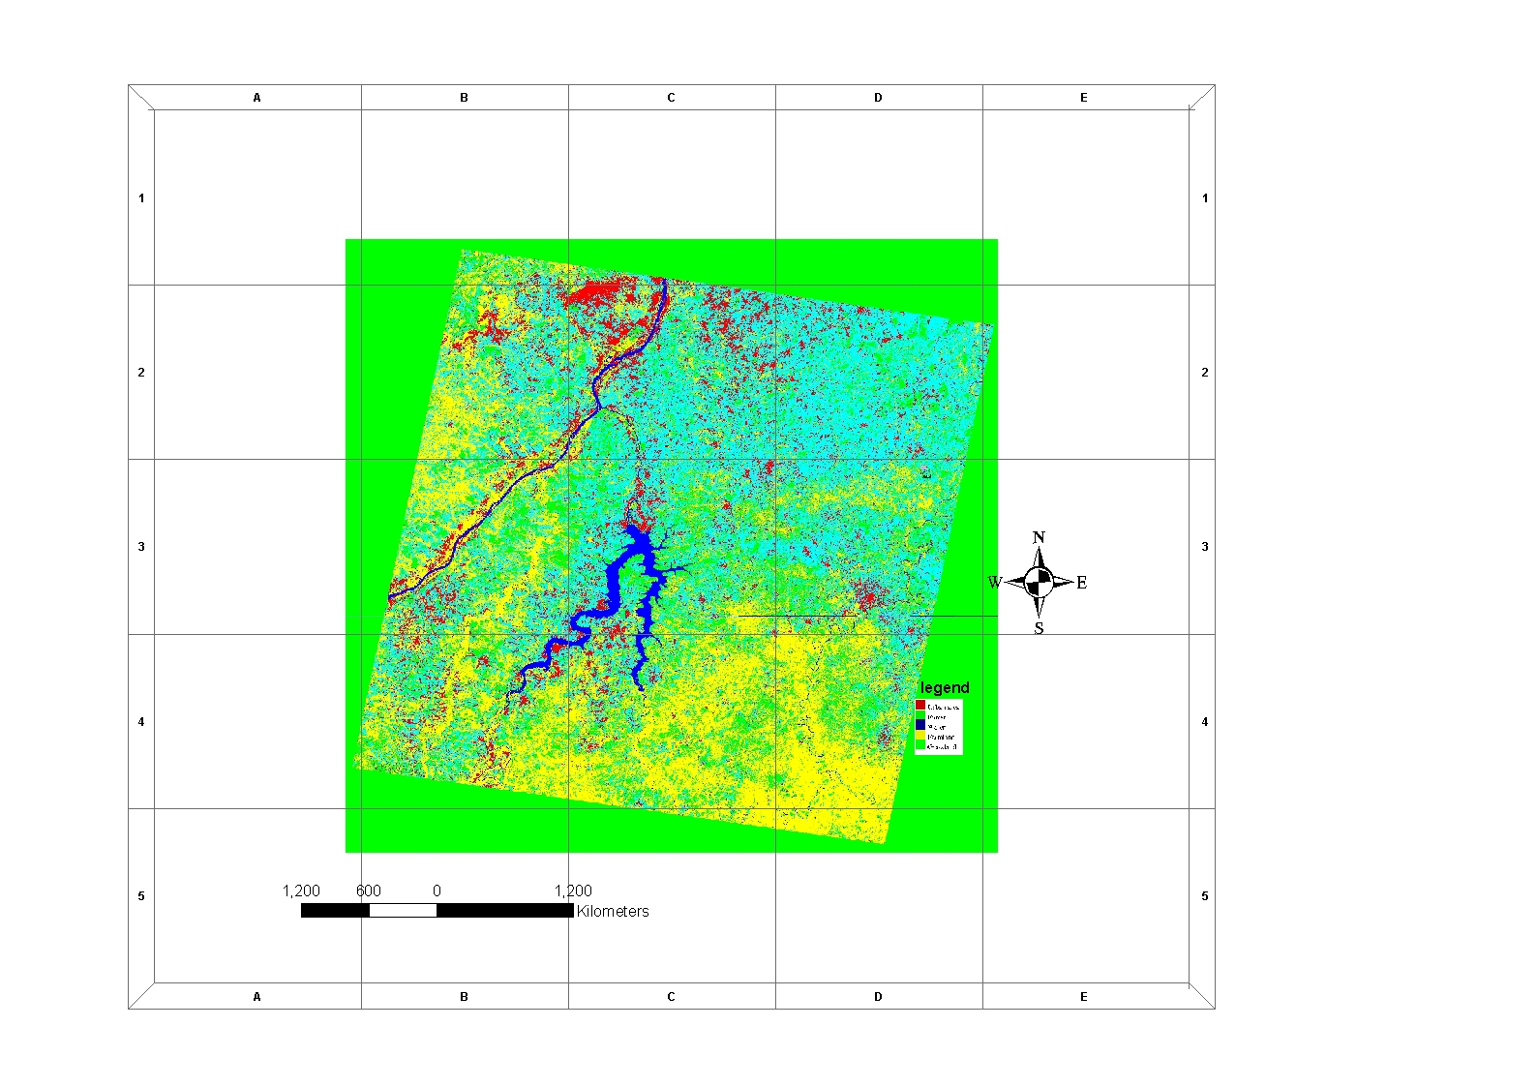
(Map 1). The classification of TM 1986 in Siby

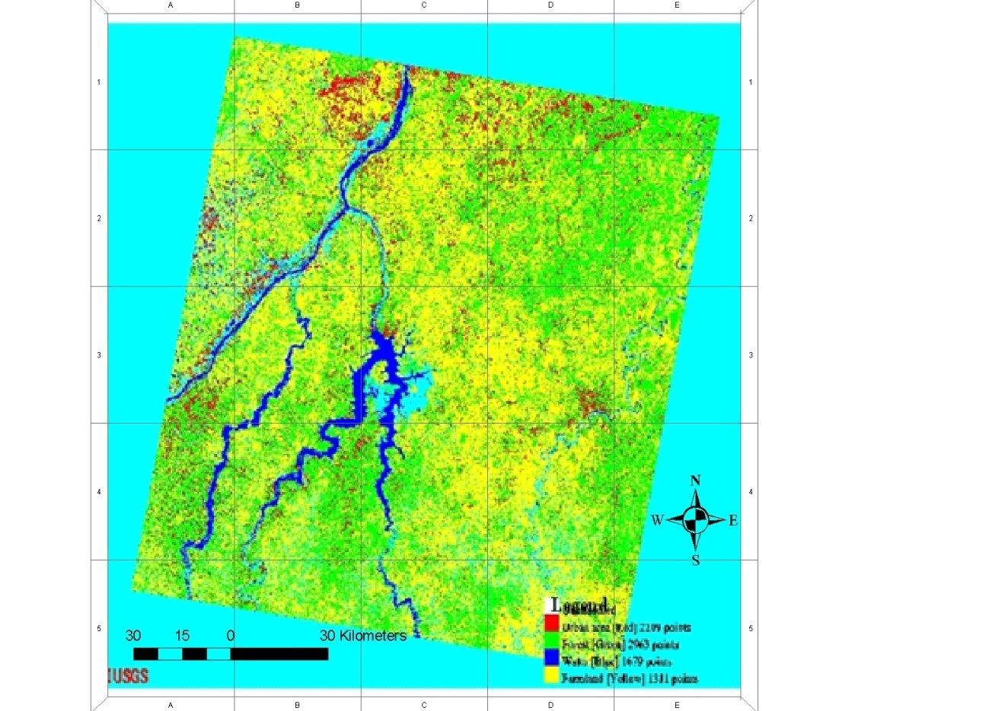
(Map .2). The classification of TM 1999 with points in Siby

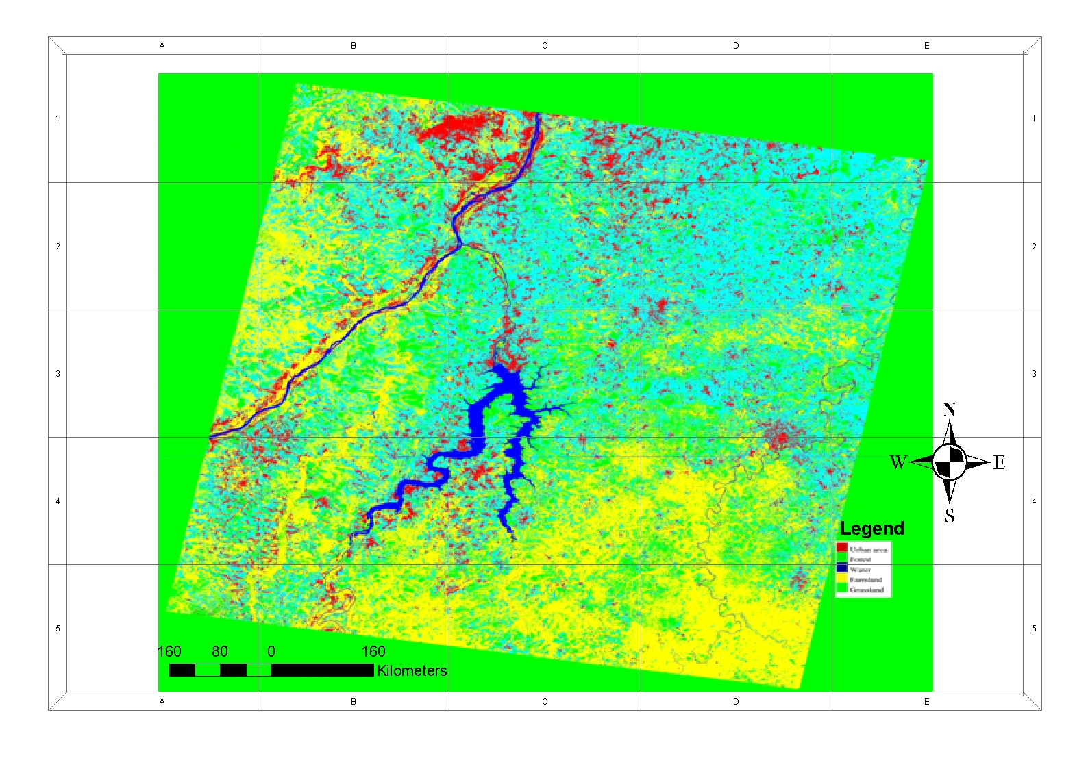

(Map.3) The classification of TM 2002 in Siby

Table 1. Demographic analysis

Years | Observed population inhabitant | Total absolute change growth (TACG) | Average annual absolute change (AAAC) | Total percent change growth (TPCG)
1987 | 41,654 | 21,367 | -1256.88 | 51.29
1998 | 15,150 | 2,137 | 302.17 | 14.10
1999 | 18,846 | 1,441 | 84.76 | 7.64
2001 | 18,983 | 1,304 | 76.70 | 6.86
2002 | 19,200 | 1,087 | 63.94 | 5.66
2004 | 20,287 | 113,833 | 70.19 | 561

Table 2. Statistic of land use type and statistic on the change of Land use in Siby from 1986 to 1999and 2002 (Unit: hectare)

1986 1999 2002 Change in 1986 -1999 Change in 1999-2002
Land Use Type Area ha % Area ha % Area ha % Area ha % Area ha %
Urban area 15018.75 15 16020 16 18022.5 18 1001.25 1 2002.5 2
Farmland 28936.12 28.9 33081.3 33.04 35043.75 35 4145.18 4.14 1962.45 1.96
Water 8010 08 7759.68 07.75 6007.5 6 - 250.32 - 0.75 -1752.18 5.22
Forest 14017.5 14 12765.93 12.75 90112.5 9 - 1251.57 - 1.25 77346.5 -3.75
Grassland 34142.62 34.10 33541.87 33.5 3204 32 - 600.75 - 0.6 -30337.8 -1.5

Table 3. Statistic of land use type and statistic on the change rate of Land use in Siby from 1986 to 1999 and 2002 (Unit: hectares).

Annual change ( ha ) |  |  | Annual change %
Land Use Type | 1986-1999 1999-2002 |  |  | 1986-1999 1999-2002
Urban area | 77.01 | 6007.5 |  | - 0.0769 |  | -0.66
Farmland | 318.86 | 11681.25 |  | -0.318 |  | -0.653
Water | - 19.25 | 2002.5 |  | 0.019 |  | -0.583
Forest | - 96.27 | 30037.5 |  | 0.096 | 1.25
Grassland | - 46.21 | 1068 |  | 0.046 | 0.5

Statistical analyses: According to the formula (4) our analysis we see that the matrix is 1 see the( (Table.4 and 5 ) in examining the correlation table, we note that the correlation between income and Farmland is -0.662 .The regression cannot capture a part of the smoothness of the scatter (Figure.3).The correlation coefficient is –0.662 (see the figure, above). This value of r suggests a strong negative linear correlation since the value is negative and close to –1. Since the above value of r suggests a strong negative linear correlation, the data points should be clustered closely about a negatively sloping regression line. This is consistent with the graph obtained (Figure.3). Correlation between population and forest is 0.433 and (p > 0.05); suggest that a correlation is positive; we have a relation population and forest.
The correlation coefficient is -0.764 between Grassland and income. This value of r suggests a strong negative linear correlation. Grassland and Farmland coefficient is 0.984 the value is positive, correlation is positive and strong (p < 0.05).The pints are fairly close to the regression line and the predictions based on it tend to be good. At the same time, the correlation coefficient between Grassland and population is 0.338 very weak positive correlations.

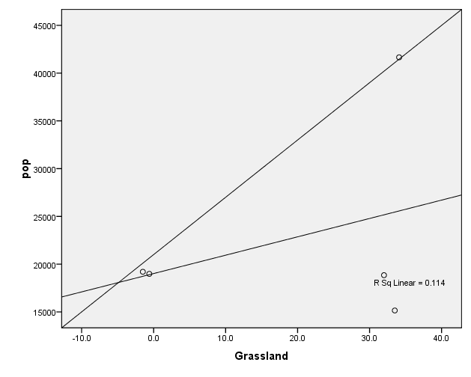
Figure 3. graphical illustration (Population -Forest)

Table 4. Correlation Results (Population –Forest)
 |  | Pop | Forest
pop | Pearson Correlation | 1 | .433
pop | Sig. (2-tailed) |  | .466
pop | N | 5 | 5
Forest | Pearson Correlation | .433 | 1
Forest | Sig. (2-tailed) | .466
Forest | N | 5 | 5

Table 5. Correlations Results
 |  | income | Farmland | Grassland | pop
income | Pearson Correlation | 1 | -.662 | -.764 | -.850
income | Sig. (2-tailed) |  | .223 | .132 | .068
income | N | 5 | 5 | 5 | 5
Farmland | Pearson Correlation | -.662 | 1 | .984** | .194
Farmland | Sig. (2-tailed) | .223 |  | .002 | .755
Farmland | N | 5 | 5 | 5 | 5
Grassland | Pearson Correlation | -.764 | .984** | 1 | .338
Grassland | Sig. (2-tailed) | .132 | .002 |  | .578
Grassland | N | 5 | 5 | 5 | 5
pop | Pearson Correlation | -.850 | .194 | .338 | 1
pop | Sig. (2-tailed) | .068 | .755 | .578
pop | N | 5 | 5 | 5 | 5
**. Correlation is significant at the 0.01 level (2-tailed).

CONCLUSION
Recent land use changes in Siby and its consequences on surrounding land use were evaluated, together with local perception of forest, grassland and water decline. The major conclusions drawn from this thesis work are: The result showed that Grassland, Farmland and Urban area was dominant type. The second objective after classification of the study was achieved by examining the statistical relationship between type of land use land cover and the demographic characteristics of the population. The result showed the significant relationship between lands (Geist & Lambin, 2001). use type and population, and poverty level. The result suggests that population; income per year and per personnel may be an important driving force in the land use land cover change, however, the nature of changes in the local economies remains important. A unit increase in the average household size resulted in cropland expansion. It also confirms that cropland expansion is in part driven by increase in demand for food by the increasing population. (Nelson et al., 2006). The local people depend on the forests to meet their subsistence, energy, income and medicinal needs, with distinct variability between gender, residence status, and ethnic group. The various stake-holders perceived that the region's forests are shrinking mainly due to agricultural expansion, population increases and climate variability as well as institutional and policy weaknesses IMF (2003). The analysis of variation in land cover and land use over time, as sources of information and geographical diagnosis at a regional scale, is central to improving knowledge of land-cover and land-use change in Siby (Mali) land.

ACKNOWLEDGEMENT
China Scholarship Council and China University of Geosciences supported this study. The author wishes to thank Associate Professor Liqin Zhang in Land Resources Management, China University of Geosciences (Wuhan) for this supervision and everyone who helped in one way or another.

Corresponding Author:
lansinekeita73@yahoo.fr
Phone: +86 (67885956),
Cellular: +86(15997484873

REFERENCES
- Coppin, P. & Bauer, M. 1996. Digital Change Detection in Forest Ecosystems withRemote Sensing Imagery. Remote Sensing Reviews. Vol. 13. p. 207-234
- Dembele, F., Picard, N., Karembé, M. & Birnbaum, P. (2006). Tree vegetation Patterns along a gradient of human disturbance in the Sahelian area of Mali. Journal of Arid Environments 64, 284-297.
- Diabaté, D., 1986, ‘Analyse des mécanismes de mutations socio-économiques au sein des societés rurales Sénoufo du Sud du Mali’, PhD thesis, Paris: École des Hautes Études en Sciences Sociales
- FAO (2000). Biophysical, socio-economic and environmental impacts of degradation. http://www.fao.org/landandwater/agll/madssea/topic3.htm. Accessed, May 16, 2004.
- Geist, H.J. & Lambin, E.F. (2001). What Drives Troipical Deforestation? A meta-analysis of proximate and underlying causes of deforestation based on subnational case study evidence. Report Series No. 4, CIACO LUCC. Louvain-la-Neuve, Belgium.
- Hurni, H. (1990). Degradation and conservation of the soil resources in the Ethiopian highlands. In: African Mountains and Highlands: Problems and Perspectives pp. 51-64, (Messerli, B. and Hurni, H. eds.). Marceline, Missouri (USA)
- IMF (2003). Mali – Sixth Review under the Poverty Reduction and Growth Facility Staff Report and Press Release on the Executive Board Discussion for Mali, Country Report no 03/246. International Monetary Fund, Washington, D.C.Kanté Salif (2001). Gestion de la fertilité des sols par classe d’exploitation auMali Sud, Documents sur la gestion des ressources tropicales, n° 38, Université de Wageningen, Pays-Bas, 237 p.
- Macleod & Congalton. 1998. A Quantitative Comparison of Change detection, algorithms for Monitoring Eelgrass from Remotely Sensed Data. Photogrammetric Engineering & Remote Sensing Vol. 64. No. 3. p. 207 - 216. Environmental Management 59, 47–69.
- Mbodj FB, 2005. Decentralized management of forest resources: economic and social space. The example of the rural commune of Siby. Masters dissertation, University Paris 1, Department of Geography
- Nelson, G.C., Bennett, E., Berhe, A.A., Cassman, K., DeFries, R., Dietz, T., Dobermann, A., Dobson, A., Janetos, A., Levy, M., Marco, D., Nakicenovic, N., O'Neill, B., Norgaard, R., Petschel-Held, G., Ojima, D., Pingali, P., Watson, R. & Zurek, M. (2006). Anthropogenic Drivers of Ecosystem Change: an Overview. Ecology and Society 11,29p.
- Singh, A. 1989. Digital Change Detection Techniques Using Remotely Sensed Data. International Journal of Remote Sensing. Vol.10, No. 6, p. 989-1003
- Tilman ,D., Fargione J., Wolff B., d’Antonio C., Dobson A., Howarth R., Schindler D.,Schlesinger W., SimberloffD., Swackhamer D ., Forecasting agriculturally driven global environmental change. Science,2001,vol.292,pp.281-284
- Turner II, B.L., Moss, R.H. & Skole, D.I. (1993). Relating land use and global land-cover change: a proposal for IGBP-HDP Core projet. IDBP report No. 24 and HDP report No. 5.
- Turner II, B.L., Scole, D., Sanderson, S., Fischer, G., Fresco, L. & Leemans, R. (1995). Land-use and land-cover change. Science/Research Plan. IGBP Report No. 35 and HDP Report No. 7. International Geosphere-Biosphere Programme and the human dimensions of Global Environmental Change Programme. Stockholm and Geneva.

Submission date: 18/03/ 2010

