Assessment of Aquifer Characteristics in Relation to Rural Water Supply in Part of Northern Nigeria

Isaac Oladejo Olaniyan¹, Jonah Chukwuemeka Agunwamba² and Joel O. Ademiluyi³

1. Department of Agricultural Engineering, Kaduna Polytechnic, Nigeria dejoolaniyan@yahoo.com
2. Department of Civil Engineering, University of Nigeria, Nsukka jcagunwamba@yahoo.com
3. Department of Civil Engineering, University of Nigeria, Nsukka doyenacademy@yahoo.com

Abstract. Data obtained from 91 successfully drilled and producing boreholes in the crystalline basement complex area of northern Nigeria were outlined and assessed statistically. Groundwater in exploitable quantities sufficient for rural water supply was found to occur in the study area in three forms: the river alluvium, the Newer basalts, and the weathered zone of the Basement Complex which is the most extensive, and oftentimes poorly aquiferous. The aquifer generally has low yield with an average yield of 45.77 l/min (or 65.91m³/day) of water, while higher yields only occur in fractured zones. From statistical evaluation, it was inferred that yield and specific capacity (or productivity) of aquifers are not related to regolith thickness and saturated thickness at the borehole points. Poor negative correlation coefficients and weak negative linear relationships were consistently obtained between pairs of parameters. The study suggests that regolith and saturated thicknesses do not play significant role as much as hydraulic characteristics of weathered zone in aquifer productivity. [Researcher. 2010; 2(3):22-27]. (ISSN: 1553-9865).
Keywords: aquifer, hydraulic parameters, statistical analysis, regolith

1. Introduction
The increase in demand for water has stimulated development of groundwater, especially for individual and rural supplies, leading to the rapid expansion of knowledge of groundwater hydrology and better means of extracting groundwater. Despite this, groundwater potential in the Basement rocks is not well defined as it occurs in a complex manner. Thus, borehole productivity is often associated with certain characteristics of the aquifer such as regolith thickness, bedrock type and structure, saturated thickness and measured hydraulic parameters like hydraulic conductivity, specific capacity, drawdown, transmissivity and storativity, among others (Chilton and Smith-Carington, 1984; Omorimbola, 1984 and McCann, 1991).
The main purpose of this paper is to assess the aquifer characteristics of the Galma River basin in Northern Nigeria in relation to rural water supply by outlining, evaluating and comparing the hydraulic and/or hydrogeologic properties obtained from production data of 91 successful wells drilled through the Basement rocks within the basin.
1.2 Physiography, Geology and Hydrogeology
The Galma river basin is situated mainly in Kaduna State with a small portion of it extending to Kano and Katsina States. The basin is geographically located on Sheets 102, 103, 124 and 125 on a scale of 1:100,000 of Nigeria Surveys topographical maps. It is situated between latitudes 10º 27’N and 11º 24’N, and longitudes 7º 23’E and 8º 45’E. Its total catchment area covers approximately 6,940 km² at its mouth. The Galma Basin lies on an extensive peneplain developed on crystalline Basement rocks, which extends continuously over most parts of northern Nigeria. It is located in a transition zone between the tropical hinterland and the tropical continental north. The mean monthly temperature varies between 20 ⁰C and 29 ⁰C, depending on the season, but may increase up to 35 ⁰C at the end of the dry season (Nassef and Olugboye, 1979).
The vegetation of the Galma basin is of the northern Guinea Savanna type, characterized by patches of woodland, herbs and grasses with few widely scattered deciduous trees, although continuous cultivation, bush burning and grazing activities have greatly modified the natural vegetation cover and composition. Large settlements in the basin include Zaria, Dutsen Wai, Soba, Damau and Anchau towns among others. Drainage pattern is dendritic and the streams are all subject to seasonal water level fluctuations (FMI, 2000). Figure 1 shows the entire catchment of Galma River with the drainage pattern and borehole locations.
Kaduna State is geologically underlain by the Precambrian migmatites and gneisses, the metasediments/metavolcanics and the Older Granites. The migmatites (mixed rocks, generally consisting of a metamorphic host invaded by granitic material), biotite and granitic gneisses are the largest group of rocks, extending from Birnin-Gwari area to Jema’a-Ikara areas. They are characterized by a variety of structures and textures, and they represent reactivated older metasediments. The metasediments /
metavolcanics are metamorphosed sedimentary and metavolcanic rock group which consists of ferruginous quartzites, (Banded Iron Formation), amphibolites and pelitic slightly migmatized schists. The Older (Pan African) granites are characterized by lofty topography and inselbergs with lithological varieties of rock formation believed to have been emplaced during the Late Palaeozoic era (550±100 my). They consist of coarse-grained porphyritic granite, biotite hornblende granite and fine-grained granites, and fayalite-quartz monzonite (Ajibade and Wright, 1988; Oluyide, 1995).
Groundwater in exploitable quantities sufficient for rural water supply occurs in the basin in three forms. The river alluvium which is irregularly distributed throughout the state, the Newer basalts with associated alluvial deposits which are limited to Kafanchan and Manchok areas in the south, and the weathered zone of the Basement Complex which is the most extensive, and often time poorly aquiferous (WAPDECO, 1991; Eduvie and Olaniyan, 2006).
2.0 Methodology
In order to provide potable water for the rural communities, the Kaduna State Government of Nigeria embarked on the construction of 400 boreholes under the auspices of the Kaduna State Agricultural Development Project. The boreholes were drilled into the Basement complex, and while some of them were abortive, at least 91 out of the successful ones were located within the Galma basin. The summary of the borehole logs were submitted in a report in 1994. A recent field investigation by the lead author in 2008 showed that many of the wells identified were still producing. Relevant data such as depth to basement, static water level, screen length, test pumping rate, drawdown, yield and saturated thickness were obtained from these sources, and were used to determine secondary data such as specific capacity, hydraulic conductivity and transmissivity. All these data were compiled for further analysis and interpretation toward the assessment of aquifer characteristics of the basin.
3.0 Results and Discussion
The depths to water table at the well points were used to prepare the piezometric surface contour map of the Galma Basin presented as Figure 2. This figure shows the variation in water table depths across the basin at the western, central and south-east parts. The depths to water table vary, in the western part of the basin from 3.0m at Panmadina-C to 10.3m at Tankarau-B, in the central part from 2.1m at Kuli-2 to 14.7m at Rangi and Ungwan Sarki-B, and in the south-eastern tip from 1.3m at Alwalo to 4.6m at Ungwan Goje. The contours are closer around the western and the central part of the Basin than at the south-eastern part. This indicates that the wells are deeper in the western and central parts and are shallower toward the south east of the Basin.
The aquifer hydraulic parameters obtained from boreholes within the basin are summarized in Table 1.

Table 1: Summary of Aquifer Hydraulic Parameters for Galma Basin
Parameter | Unit | Range of values and locations
 |  | Minimum values  Obtained | Maximum values obtained | Average
Depth to basement  Static water level  Screen length  Pumping rate  Drawdown  Yield  Regolith thickness  Saturated thickness  Specific capacity  Hydraulic cond.  Transmissivity | m  m  m  l/min  m  l/min  m  m  l/min/m  m/day  m^{2/}day | 3.0 at Panmadina  17.2 at Amana Gari  6.0 at Ashehu, U/Marhaba, U/Sarki, U/Tsoho & Turunku  15.0 at Sabon Layi-II  1.7 at U/Dankande  10.0 at Sabon Layi-II  5.0 at 4 locations  21.1 at Kafin Kubau  0.75 at Sabon Layi-II  0.30 at Sabon Layi-II  1.38 at Sabon Layi-II | 14.7 at U/Sarki-B  67.0 at U/Barau  45.0 at Zuntu-A  132.0 at Fagachi  20.8 at Yarkasuwa  190.0 at Sabon Gida  36.0 at U/Sarki-B  55.3 at Jenau  19.18 at U/Dankande  9.36 at Karofi  34.7 at U/Dankande | 38.16  6.56  16.16  40.13  11.22  45.77  16.17  34.68  4.45  2.13  8.24
Source: Olaniyan, 2010

3.1 Yields.
The yields of the boreholes in the basin range from 10 at Sabon Layi-II to 190 l/min at Sabon Gida, with an average of 45.77 l/min. The low values are typical of Basement rocks which are naturally poor aquifers, while the high values are believed to reflect the degree of fracturing of the parent bedrock.
3.2 Specific Capacity.
Specific capacity generally gives a better indication of aquifer performance than yield since it also reflects aquifer transmissivity and thickness (Uma and Kehinde, 1994). The range of calculated values for the basin is from 0.75 at Sabon Layi-II to 19.18 l/min/m at Ungwan Dankande, with an average value of 4.45 l/min/m. These values could also be attributed probably to the variations in degrees of fracturing, grain-size and texture of the bedrocks and of the regolith.
3.3 Transmissivity.
The calculated transmissivity, T, values of the aquifers range from 1.38 at Sabon Layi-II to 34.7 m²/day at Ungwan Dankande, with an average value of 8.24 m²/day. While low values are characteristic of crystalline aquifers, high values may be ascribed to the occurrence of prominent and cross-cutting fractures in the Basement rocks.
3.4 Cross-sections through Piezometric and Basement Rock Surfaces
Cross-sections were taken through the water table surface as well as the Basement complex rock surface to compare pictorially the relative positions of the water table with respect to the underlying Basement rocks. Figure 3 was taken in the north west–south east direction within the basin, while Figure 4 shows similar cross-section in the west–east direction in the basin as can be measured from Figure 1. Both figures 3 and 4 showed that there is a non-parallel relationship between the water table surface and the Basement rock surface in the Galma Basin.
4.0 Statistical Evaluation of Parameters
The Pearson Product Moment Correlation analysis was used to investigate the degree and nature of interrelationship among major parameters of interest which are yield and regolith thickness on one hand, and transmissivity and length of screen on the other hand. The result showed that there is a poor negative correlation with a value of -0.175 between yield and regolith thickness, and also a similar correlation with a value of -0.0579 between transmissivity and screen length. The deduction that can be made is that regolith thickness and screen length are not the major determinants of the yield of a borehole in crystalline Basement terrains, there are other factors that play more significant role.
The statistical evaluation was carried further by considering the linear relationship between parameters of interest using Regression Analysis. The regression line of specific capacity on regolith thickness gave a coefficient of -0.071 (figure 5); specific capacity on saturated thickness has a coefficient of -0.114 (figure 6); yield on regolith thickness has a coefficient of -0.173 (figure 7), while transmissivity on screen length gave a coefficient of -0.071 (figure 8). The regression coefficient showed low and negative values in all cases considered. The low values are indicative of weak relationship while the negativity suggested that as one parameter increases, the other is decreasing. This may not be probable in reality. The deduction that could be made from these is that the regolith and saturated thicknesses play minor roles in determining borehole yield in crystalline areas, although the true relationship between these parameters may require more than such a simplified linear model for more satisfactory results.

5.0 Conclusion
The data obtained from 91 successfully completed boreholes in the basin showed that the aquifer has an average yield of 45.77 l/min (or 65.91m³/day) of water while higher yields only occur in fractured zones. This is typical of Basement complex rocks. Contrary to prevailing opinion (Uma and Kehinde, 1994), there was no positive correlation between yield and regolith thickness, and there was no strong linear relationship between specific capacity and regolith thickness on one hand, and specific capacity and saturated thickness on the other hand. The results, therefore, suggested that regolith thickness and saturated thickness do not significantly affect the yield and specific capacity (or productivity) of regolith aquifers. Other factors such as the hydraulic properties of the weathered basement should be considered in selecting drilling points in crystalline basement areas.

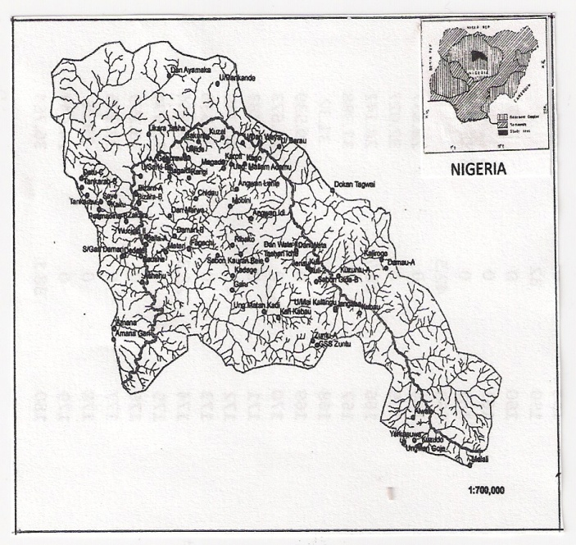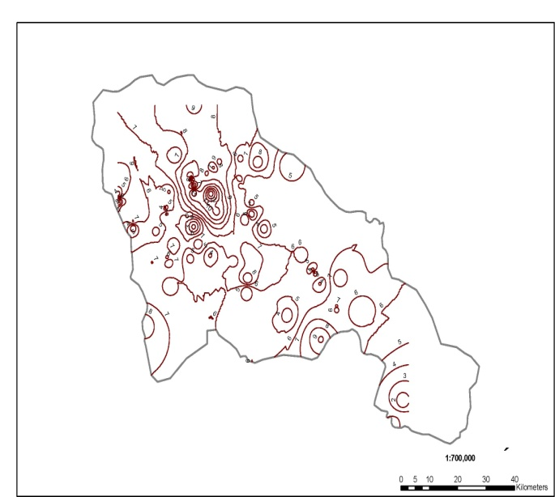
Figure 1: Drainage Map showing borehole locations Figure 2: Piezometric Surface Map of the basin

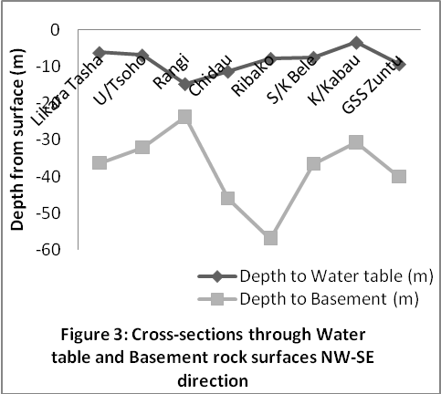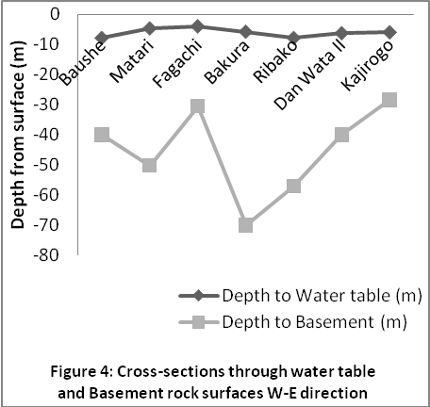

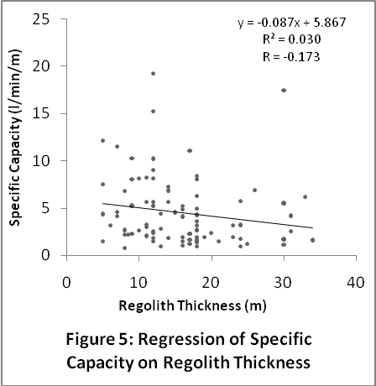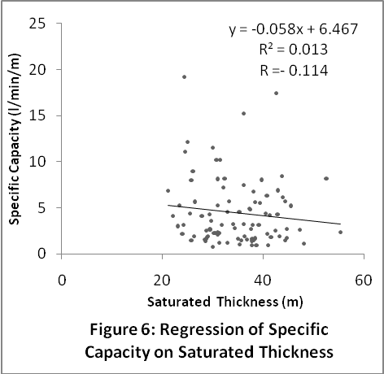

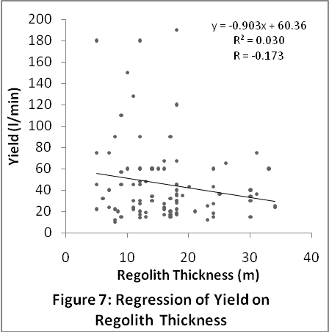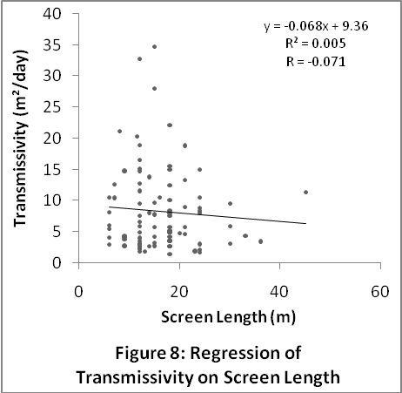

References
Ajibade, A.C. and Wright, J.B. (1988). Structural relationship in the schist belts of north-western Nigeria. In: Precambrian Geology of Nigeria. Geological Survey of Nigeria. pp. 103-109.
Chilton, J.P. and Smith-Carington, A.K. (1984). Characteristics of the weathered basement aquifer in Malawi in relation to rural water supplies. Challenges in African Hydrology and Water resources. IAHS Publ. No.144, pp.57-72.
Eduvie, M.O. and Olaniyan, I.O. (2006). Groundwater quality assessment in southern part of Kaduna State, Nigeria. Journal of Engineering Technology & Industrial Applications 2(2): 49-57, Engineering Technology Series, Kaduna, Nigeria.
Federal Ministry of Information (2000). NIGERIA: A people united, a future assured. Vol. 2, Survey of states.
McCann, B. (1991). Pump solution to North Nigeria water shortage. World Water and Environmental Engineer. Jan/Feb 1991:29-30.
Nassef, M.O. and Olugboye, M.O. (1979). The hydrology and hydrogeology of Galma Basin. Unpub, File Report, Federal Department of Water Resources, Nigeria.
Olaniyan, I.O. (2010). Groundwater flow modelling using finite element method. Ph.D Thesis, Department of Civil Engineering, University of Nigeria, Nsukka.

Oluyide, P.O.(1995). Mineral occurrences in Kaduna state and their geological environments Proceedings of workshop held by NMGS, Kaduna Chapter in collaboration with Kaduna state Government, 15 December, pp. 13-27.
Omorimbola, E.O. (1984). Groundwater resources in tropical African Regolith. Challenges in African Hydrology and Water resources. IAHS Publ. No.144, pp.15-23.
Uma, K.O. and Kehinde, M.O. (1994). Potentials of regolith aquifers in relation to water supplies to rural communities: A case study from parts of Northern Nigeria. Journal of Mining and Geology, 30 (1): 97-109.
WAPDECO (1991). Kaduna State Water Board rehabilitation study, Zaria water supply scheme. Final report of Water and Power Development Company Ltd. (WAPDECO) Part 1, 427pp.

3/1/2010

